

IPV4/IPV6 - IP Addressing Schemes

IP addressing and networking basics can be complex. In this presentation, we'll discuss IPV4 and IPV6, reserved ports, and the basics of

addressing schemes using clear examples.

**IPV4 Address Format**

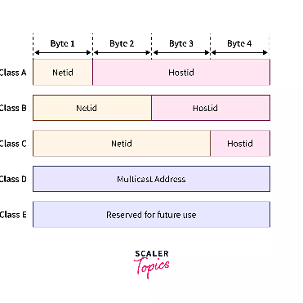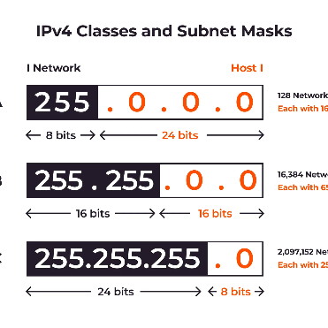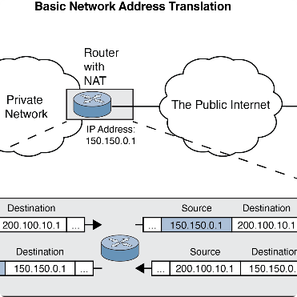

### IPv4 Format



IPV4 is a 32-bit address scheme. It uses four sets of numbers from 0-255, separated by dots. For example, 192.168.1.1 is a common IPV4 address.

### Subnet Mask

The subnet mask determines the number of bits used for network vs host identification. For example, 255.255.255.0 indicates that the first 24 bits are used for network identification.

### Public vs Private

Public IP addresses are available for internet- facing devices, while private IP addresses are used for internal network communication. Private IP ranges include 192.168.x.x, 10.x.x.x, and 172.16.x.x-172.31.x.x.



# IPV6 Address Format

**IPv6 Format**

IPV6 uses a 128-bit address scheme. It consists of eight sets of characters separated by colons. For example, 2001:0DB8:AC10:FE01:: is a common IPV6 address.

**Address Types**

IPV6 includes unicast, multicast, and anycast addresses. Unicast is used for individual devices, multicast for group communication, and anycast for the nearest device in a group.

**Benefits of IPV6**

IPV6 provides an almost unlimited amount of IP addresses, improved network performance, and enhanced security features compared to IPV4.



**IPv4 Addressing Scheme**

* Class A: First octet defines network, rest define host (e.g. 10.0.0.1)
* Class B: First two octets define network, rest define host (e.g. 172.16.0.1)
* Class C: First three octets define network, rest define host (e.g. 192.168.0.1)
* Class D: Used for multicasting
* Class E: Reserved for future use

# IPv6 Addressing Scheme

IPv6 addresses are divided into three parts: the prefix, the subnet ID, and the interface ID. The prefix is used to identify the network, the

subnet ID is used to identify subnets within the network, and the interface ID is used to identify the device.

# Reserved Ports

## Well-known vs Registered

Well-known ports range from 0-1023 and are standardized for commonly used applications. Registered ports range from 1024-49151 and are for less commonly used

applications.

**1**

**2**

**3**

## Port Numbers



Port numbers are used to keep track of application-specific data. They are used by the Transport Layer of the OSI model.

## Dynamic Ports

Dynamic ports range from 49152-65535 and are used for temporary connections and applications.

# Applications Using Reserved Ports

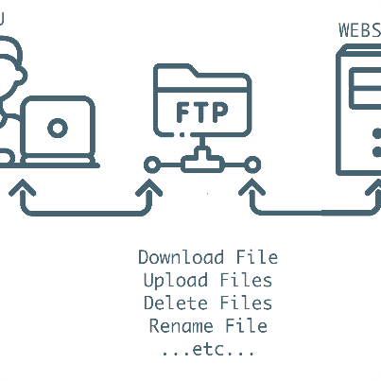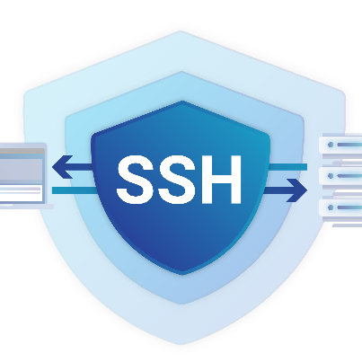

## Skype



Skype uses port 80 (HTTP) and port 443

(HTTPS) for communication.

**FTP**

FTP uses port 21 for control and port 20

for data transfer.

**SSH**

SSH uses port 22 for secure remote access.

# Applications Using Reserved Ports

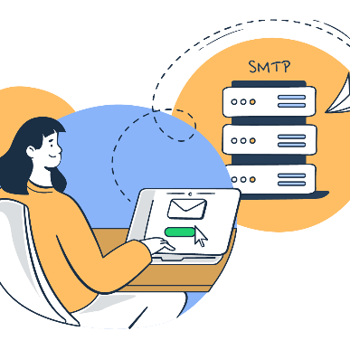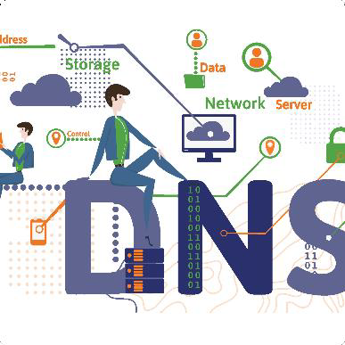

## SMTP



SMTP uses port 25 for email transmission.

**DNS**

DNS uses port 53 for name resolution.

## MySQL

MySQL uses port 3306 for database

management.

# Conclusion

## IPV4 and IPV6



**1**

Both IPV4 and IPV6 have their place in modern computer networking.

## Reserved Ports

Understanding reserved ports is essential to keeping applications running smoothly on a network.

**2**

## The Future of IP

**Addressing**

**3**

As technology evolves, we may see new addressing schemes and protocols emerge to handle the ever-increasing demand for network connectivity.