AT+CSQ

Meaning: Request signal quality. Returns the RSSI (signal strength) and BER (bit error rate).

Response:

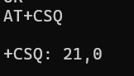

* 21 → RSSI (Received Signal Strength Indicator)
* 0 → Bit Error Rate is 0

AT+CPIN?

Meaning: Check the SIM card status.

Response:

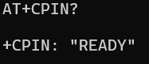

* Indicates the SIM is inserted and ready for use (not locked or missing)