--- SMS Test Log ---

1. Set Text Mode

Command: AT+CMGF=1

Response: OK

2. Send SMS

Command: AT+CMGS="9876543210"

Message: hi

Response:

+CMGS: 2

OK

3. Read SMS

Command: AT+CMGR=1

Response:

ERROR

Interpretation: The error is due to the emulator limitations

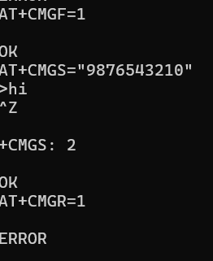

--- End of Log ---