EXPECTED RESULT :

Command:

AT+CMEE=2

Response:

OK

CME ERRORS

|  |  |  |  |
| --- | --- | --- | --- |
| SL NO | COMMAND | ERROR CODE | MEANING |
| 1 | AT+CMGFS | |  | | --- | |  |  |  | | --- | | +CME ERROR: 3 | | Operation not allowed – unsupported command |
| 2 | AT+CMGS | |  | | --- | |  |  |  | | --- | | +CME ERROR: 50 | | Incorrect parameters – missing phone number |
| 3 | AT+CPIN? | |  | | --- | |  |  |  | | --- | | +CME ERROR: 10 | | SIM not inserted or detected |
| 4 | AT+CMGR=999 | |  | | --- | |  |  |  | | --- | | +CME ERROR: 321 | | Invalid memory index – SMS index not valid |
| 5 | AT+ | |  | | --- | |  |  |  | | --- | | +CME ERROR: 50 | | Incorrect parameters – incomplete command |

ACTUAL RESULT :

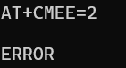 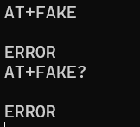

Interpretation: The response ERROR to the command AT+CMEE=2 means that the AT Emulator did not support these command