AI/ML RoadMap

1. Basic Math (Algebra, Probability and Statistics)
2. Python for Data Science ([link](https://cognitiveclass.ai/courses/python-for-data-science/))   
   - the above link consists of python basics and basic libraries.
3. Probabilities and Statistics for Data Science ([link](https://www.youtube.com/playlist?list=PLlpUUtQ9RrF76jvALwrTp0oOGfk0EGC3s))
4. For more libraries ([link](https://www.geeksforgeeks.org/libraries-in-python/))

- pandas, NumPy, matplotlib, SciPy, Scikit Learn, TensorFlow, PyTorch etc.

1. Types of Data in Python : Structure, Semi-Structure & Unstructured ([link](https://www.geeksforgeeks.org/difference-between-structured-semi-structured-and-unstructured-data/))
2. 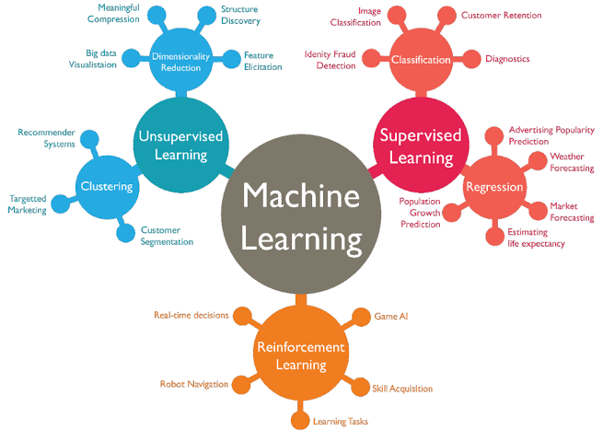Types of Learnings : Supervised, Unsupervised & Reinforcement Learning ([link](https://www.geeksforgeeks.org/machine-learning/supervised-vs-reinforcement-vs-unsupervised/))

([link](https://medium.com/@jaykrs/what-are-the-different-machine-learning-model-502878cf6ecc))

1. Basic ML Models

- Perceptron ([link](https://www.youtube.com/watch?v=X7iIKPoZ0Sw))

- Gradient Decent and cost functions ([link](https://youtu.be/vsWrXfO3wWw?si=bwzMowwzRPzyNX9s))

- Classification Models ([link](https://www.youtube.com/live/ETChs4iQa8g?si=b_NRWWLDAe4q4FSc))

- Linear Regression, Multi Linear Regression, Logistic, K-Means Clustering, Decision Tree, Random Forest, KNN Algorithm

([link](https://www.youtube.com/watch?v=9f-GarcDY58&list=PLEiEAq2VkUULYYgj13YHUWmRePqiu8Ddy&index=5)) start from 23:38 to 4:54:47.

* Dimensionality reduction: PCA and LDA ([link](https://medium.com/@seshu8hachi/pca-vs-lda-no-more-confusion-fc21fb8d06e9))
* Bagging and Boosting ([link](https://www.geeksforgeeks.org/machine-learning/bagging-vs-boosting-in-machine-learning/))
* summary ([link](https://youtu.be/E0Hmnixke2g?si=W9PNbcdcxkeqTBqg))

Beginners Guide for ML by GeeksforGeeks ([link](https://www.geeksforgeeks.org/100-days-of-machine-learning/))

1. Basics of Deep Learning Models ([link](https://www.coursera.org/articles/deep-learning-models))
2. Concepts of Deep Learning: Neural Networks, CNN and RNN ([link](https://youtu.be/ob1yS9g-Zcs?si=sOL-fHBOROYF7XC9))
3. Generative AI ([link](https://youtu.be/d4yCWBGFCEs?si=OjsF7ls930PVCA_N))
4. Agentic AI [Latest of 2025]