**Story and poetry generation using pre-trained model**

* 1. **Introduction:**

For thousands of years, storytelling and poetry have been indispensable to the human condition, functioning as means of conveying information, evoking sentiment, and safeguarding culture across different periods and locations. These artistic mediums streamline complex concepts and establish significant associations of common experiences. Narratives provide a structure for understanding important concepts, whereas poetry offers emotional clarification through poetic composition. Throughout years, writings and poetry have played an important role in moulding civilisations, facilitating decision-making processes, and enabling human expression as a means of establishing connections with others.  
  
As AI and NLP advance, the debate as to whether machines can recreate the creativity characteristic of humans continues to intensify. With several recent proofs indicating that AI can now produce anything meaningful in the way of creative content, such as fictions and poems, this area of text generation is getting more interesting. Generative pre-trained transformer models, such as GPT-Neo 1.3B, demonstrate promise in the arena of storytelling and poetry generation. GPT-3 has definitely pushed the boundaries of machine-generated text in terms of the tremendous amount of data it is trained on and billions of parameters, while GPT-Neo 1.3B offers a radically different approach, applying itself to similar roles though differing in scale and fine-tuning procedures.

GPT-Neo 1.3B employs the modern large-scale transformer architecture to develop coherent, relevant, and engaging narratives and poems. But the question still hangs: can models such as this one generate works of emotional depth and originality, akin to human-created content? While GPT-Neo 1.3B is particularly skilled at generating text that is grammatically correct and contextually appropriate, the subtlety of emotional expression and novel compositional strategies so characteristic of human creativity often leave the text wanting. Also, AI models like GPT-Neo 1.3B often find great difficulty in retaining the required texture of coherence and plausibility during longer stretch texts-the very properties that should make effective storytelling.

The creative potential of pre-trained models, primarily GPT-Neo 1.3B, in storytelling and poetry is examined in this paper. In turn, the framework and theory guiding the underlying architecture on which the model was trained on diverse datasets are carefully treated, as it gives rise to their extreme ability of generating coherent and context-aware text. The adeptness of GPT-Neo 1.3B for doing storytelling, such as its handling plot development, character arcs, and thematic consistency, is investigated. Finally, the model's ability to create poetry, such as adhesion to various forms and meters and a unique use of language, is evaluated.

The study evaluates the quality of text produced by GPT-Neo 1.3B through subjective human judgments and various objective metrics while comparing it with other models. By pinpointing the models' strengths and weaknesses, the paper wants to highlight the areas where AI-generated content shines and where it still lags behind human authorship; it also examines how we can apply GPT-Neo 1.3B creatively, in entertainment and education, addressing ethical questions of originality and authorship in AI-assisted creative writing.

In reflection, the paper lays the groundwork for new formations of creative expression made possible through the continuous development of AIs like GPT-Neo 1.3B. The study proposes that as AI models become more sophisticated, they will allow a new type of creative engagement to perform work alongside art, thereby opening litanies regarding what it means for originality and authorship in the digital age.

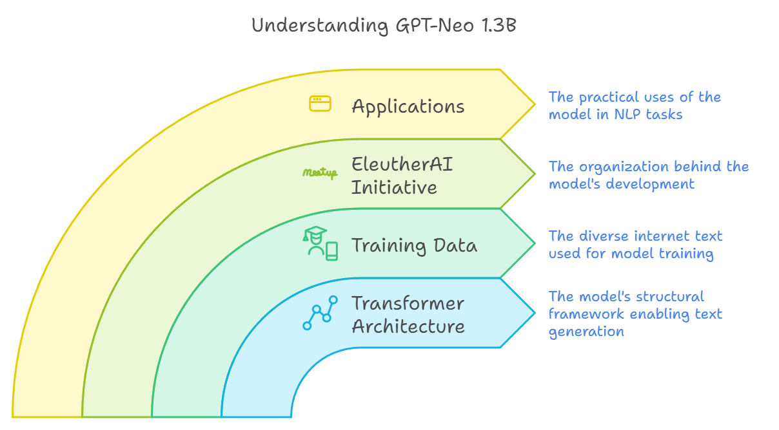

Figure 1 - Understanding GPT-Neo 1.3B

This research aims to investigate how GPT-Neo 1.3B can be applied to creative writing, specifically in the areas of storytelling and poetry, while drawing comparisons to other models more specialized in these tasks. By analysing GPT-Neo 1.3B's capabilities in generating narratives and poetic forms, the study seeks to push the boundaries of AI-generated creative writing. The ultimate goal is to explore how models like GPT-Neo 1.3B can produce content that exhibits greater emotional depth, originality, and creative engagement, bringing AI-generated creative writing one step closer to a human-like artistic experience.

* 1. **Motivation:**

Fictional and poetic devices are both methods of creative behaviour and a form of communication that hinge on emotional resonance and originality. Continuous development in AI now raises the possibility of machines becoming possible or major participants in aiding the creation of art. Models such as GPT-Neo 1.3B have alluded that they may produce structure outputs which resemble human by right of entertainment. Whereas these varying instances are able to generate quite fluid and grammatically correct sentences, they can lushly reject emotional resonance, craftsmanship, and originality.

The twofold problems concern whether it is indeed possible to develop AI into a collection of artistic creation and craft. Looking at GPT-Neo 1.3B, the vast arrays of its occurrences produce pretty good sentences with art and can, but have a challenge, far deeper in expressing emotion. Derivatives in story subjects, rhythm might lack innovation due to the model's "trained-in" structure into patterns, tropes, or clichés; also, such models, while generating longer narratives, are faced with challenges of narrative continuity, plot unfolding, and maintain tonal consistency, thus leading to sporadic detachments and disrupted tonal flow.

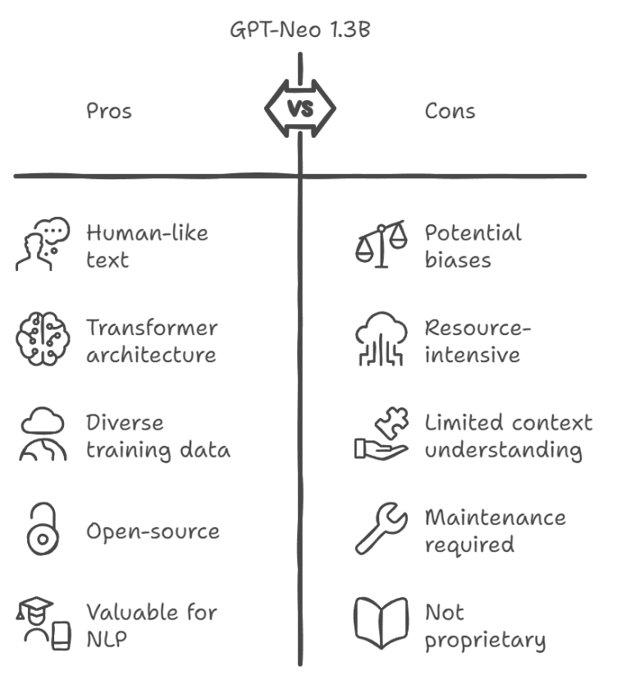This work is designed to test whether GPT-Neo 1.3B can produce cohesive, imaginative, and emotionally evocative creative works of literature. It will additionally be tested whether knowledge injections, emotion modelling, and creativity-boosting algorithms could further improve the quality of these papers. Finally, it seeks out whether or not AI would rise beyond that to the production of derivative works: a tool that virtually lends a human voice-a charcoal for this very artistic voice. So, this research harbours dreams of a future where the human artist and the machine artist partner to expand the bounds of creativity, heralding a new era of human-average-machine creativity.

Figure 2 - Pros and Cons of GPT-Neo 1.3B

* 1. **Contribution:**
* The research investigates the creative writing capability of GPT-Neo 1.3B, exploring avenues for having the AI reflect those creative and aesthetic features customarily assigned to human writers.
* The study investigates the functionality of GPT-Neo 1.3B to bring literature and art, attempting to produce high-beat episodic narrative and poem-forms competing with one written by a person.
* Moreover, it is akin to showing how ready or framework knowledge and creativity-facilitating strategies-used here basically narrative structures with pre-existent elements and determined poetic forms-can add to the logical consistency and meaning of the AI text by rendering it even more authentic and humanistic.
* The study will emphasize the nature of emotional depth and context, trying to evaluate whether the AI model can convey emotion, thought, and human experience-or merely replicate linguistic features.
* Furthermore, a multi-dimensional framework for the evaluation of the AI-generated text with respect to three other things: creativity with regard to originality and novelty; coherence, in order to preserve the logicalness; and emotional provocation of the reader.
* The point, therefore, is to test the flexibility and responsiveness of AI in creative work so as to facilitate the future work to engineer creative AI framework focusing on emotional engagement and creative responses.
* Thus, this study further extends the investigation of AI in the arts and creative fields by demonstrating that human-AI collaborations in literature and the arts have the ability to boost the GPT-Neo 1.3B's chances of generating aesthetically rich and emotionally resonant creative works.

**2.1 Literature Review:**

The research by **Lo et al. (2022)** examined the finetuning of GPT-2 via a two-phased generative process applied to create limericks. The authors generated the content with the help of forward and reverse language modelling while following the AABBA rhyming scheme. Evaluation criteria included syntactical correctness, lexical diversity, and subject continuity. Importantly, while there were some successes achieved by using the reverse language model, the reverse model struggled with prompt generation when a seed line was absent. Moreover, the reliance on human evaluators would limit scalability given the intrinsic subjectivity.  
  
**Fan et al. (2018)** worked with a much larger dataset of 300,000 stories and proposed a hierarchical model with model fusion and gated self-attention to enhance fluency and relevance when generating stories. Using Nesterov accelerated gradient methods, they outperformed other models in fluency and relevance. While the results were promising, the systematic representation of specific or rare dependent words proved challenging and thus sometimes the narrative platform repeated itself, which was favoured towards recent content and diminished opportunities for additional representation.  
  
**Bena and Kalita (2019)** also employed finetuning for GPT-2 but implemented an emotionally driven poetic generation using transfer learning. The authors also did evaluations using the Coh-Metrix tool and the results they have obtained high alignment rates with regard to such emotions as joy and sadness they also receive positive feedback whenever they are generating poetry that resembles dream like. However, the research was not as successful in achieving the goal of increasing emotional variance, as it also created a problem in trying to model such things as complexity and dreams. They also suggested expanding evaluating for large platforms like the plethora of human evaluators in contexts like Amazon Turk.

The study undertaken by **Sawicki et al. (2023)** attempted to utilise GPT-3 models to perfectly mimic the style sensitivity of particular poets, especially Walt Whitman and Rudyard Kipling. After doing this analysis, they found match rates of 30% and 21% compared to the original poets. Furthermore, the fine-tuned models achieved a remarkable accuracy rate of 99% in binary text classification. Nevertheless, they encountered difficulties in reproducing the evolving styles of poets throughout time. They emphasised the need of more investigation into the foundation and representation of AI knowledge, as demonstrated by Searle's Chinese room argument.  
  
Controllable tale generation through manipulation of external knowledge and specific keywords was outlined by **Xu et al. (2020)**. They found enhanced coherence, fluency, and nature in the created stories, while giving controllability in connection to the keywords. However, the researchers noted that the models with this type of control exhibited greater confusion compared to models without it. They even concluded that the limited supervision associated to knowledge ranking affected significantly the overall performance of the model.  
  
The study conducted by **Wang et al. (2023)** evaluated the incorporation of structured information into narrative-responsive generative story-telling models. This knowledge structure enhanced logicality and coherence in stories overall, and they completely contrasted approaches of integration, datasets, and assessment metrics of written content. They also identified coherence as an issue that worsened with lengthier stories, and over-generalization continued; this did not help understanding the story integration.  
  
**Lewis et al. (2021)** proposed syllable-centered neural language models for transfer learning in writing of poetry in the style of William Wordsworth. Their models got comparably high authenticity scores, where 56% of assessors thought the generated poetry seemed to be real lines, compared 52% for actual lines. However, the models struggled to generalize thinking about new knowledge as well as still not attending to the emotional or thematic relevance of the created verses.

The work carried out by **Guan et al. (2020)** aimed to improve the commonsense storytelling by proposing a knowledge-enhanced pretraining model. Thus, using the ConceptNet and ATOMIC knowledge sources and the multi-task approach together with the joint loss function, the authors increased the coherence, logicality and language correctness of the generated narratives. However, the system still had issues in commonsense reasoning and preserving logical coherence over larger length stories.  
  
In a similar research, **Wöckener et al. (2021)** studied poetry generation utilising neural language models, including RNNs, and sub-word and syllable-level a layer modeling technique. In datasets, such as the Chicago Rhyming Poetry Corpus, they discovered that their neural language modeling architecture produced more fluent and coherent poetry than previous models. However, their model struggled with phonological phenomena such as alliteration and rhyme due to having limited sample sizes and bias induced through the language model.  
  
Lastly, **Mukhtar et al. (2021)** explored the characteristics of Urdu and Hindi poetry generation utilising a recurrent neural network (RNN) with an LSTM Seq2Seq model. Using data from Rekhta.org and many other libraries, the team was able to generate numerous types of poetry, including Misra’ (one-liner), Sher (two-liner), and full Ghazals. However, the main issue for this analysis was the inadequate resources accessible for doing the Urdu and Hindi poetry generating, which substantially constrained their research.

**2.2 Comparative Analysis Table:**

|  |  |  |  |  |
| --- | --- | --- | --- | --- |
| **Author** | **Database Used** | **Techniques Applied** | **Output** | **Challenges** |
| Kai-Ling Lo, Rami Ariss, Philipp Kurz | Not specified | Fine-tuned GPT-2, two-stage generation process (forward and reverse language modelling) | Generated creative limericks adhering to AABBA rhyming scheme, evaluated using syntactical correctness, lexical diversity, subject continuity | Reverse language model struggles without initial seed line; human evaluation is subjective, limiting scalability |
| Angela Fan, Mike Lewis, Yann Dauphin | 300,000 stories dataset | Hierarchical model, model fusion, gated self-attention mechanism, Nesterov accelerated gradient method | Improved fluency and relevance in story generation, significant outperforming of traditional models, better alignment with initial prompt. | Struggles with specific/rare words; occasional repetition and over-focus on recent content, leading to reduced diversity |
| B Bena, J Kalita 2019 | Not specified | Fine-tuned GPT-2, transfer learning, Coh-Metrix tool for analysis | Successfully generated emotion-driven poems (joy, sadness) with high alignment rates (85%-87.5%), dreamlike poetry received positive evaluations | Limited emotional categories, challenges in modelling complex, dreamlike states; evaluation could be scaled using larger platforms like Amazon Turk |
| Piotr Sawicki, Marek Grze´ s, Fabricio Goes, Dan Brown,  Max Peeperkorn, Aisha Khatun, Simona Paraskevopoulou | Dataset of 300 poems | Fine-tuning GPT-3 models on specific poet styles | Created poetry imitating Walt Whitman and Rudyard Kipling with 30% and 21% accuracy to the genuine works.  Fine-tuned GPT-3 for binary text classification and was able to get an accuracy of 99%. | Requires more investigation in AI and knowledge representation (for example, Searle’s Chinese Room example).  Challenges of mimicking a poet’s progression from one stage to another. |
| Peng Xu,  Mostofa Patwary, Mohammad Shoeybi,  Raul Puri,  Pascale Fung, Anima Anandkumar, Bryan Catanzaro | External knowledge | Controllable story generation with knowledge integration and keyword manipulation | An enhancement of the coherence, fluency and consistency in the generated stories.  Obtained controllability by controlling the keywords and knowledge ranking. | Greater complexity than the models that are more straightforward.  Lack of strong supervision on the knowledge ranking also impacts on the overall results. |
| Yuxin Wang,  Jieru Lin,  Zhiwei Yu,  Wei Hu,  Borje F. Karlsson | Various datasets | Structured knowledge integration into storytelling models | Enhanced coherence and logical progression in story generation.    Systematic categorization of methods, datasets, and evaluation metrics. | Coherence across longer stories remains challenging.  Over-generalization is still an issue despite knowledge integration improvements. |
| Lewis, D., Zugarini, A. & Alonso, E. (2021) | Collection of William Wordsworth's works | Syllable-centered neural language models, transfer learning, scoring mechanism | Generated poems in the style of Wordsworth, 56% of evaluators believed generated verses were authentic compared to 52% for real verses.  The model successfully demonstrated a syllable-based language modelling approach, effectively generating verses that adhere to specific syllabic constraints. | Struggles with generalizing to new information, brief verses not evaluated for emotional or thematic significance |
| Jian Guan, Fei Huang, Zhihao Zhao, Xiaoyan Zhu, Minlie Huang (2020) | ROCStories (98,162 stories), ConceptNet (commonsense knowledge base), ATOMIC (inferential knowledge base) | Knowledge-enhanced pretraining model, multi-task learning, combined loss function | Improved coherence, logical flow, and grammatical accuracy in common sense story generation compared to baseline methods  Through the integration of external knowledge sources, the model generated narratives that were more contextualized and exhibited a greater ability to handle long-range dependencies. | Difficulty with handling commonsense reasoning and ensuring logical consistency in story generation |
| Jörg Wöckener etal. (2021) | Chicago Rhyming Poetry Corpus (English), TextGrid (German) | Neural language models, RNNs, sub-word and syllable-level modeling | Improved fluency and coherence, model-generated verses sometimes indistinguishable from real verses  The style-conditioned poetry generation model was successful in learning and reproducing different poetic styles, such as modernist poetry and romantic poetry, based only on training examples. The model was able to preserve the target style's thematic and structural features. | Struggles with sound phenomena like alliteration and rhyming due to small dataset and model biases |
| Shakeeb A. M. Mukhtar, Pushkar S. Joglekar | Rekhta.org, Urdu Mehfil, Bazm-e-Urdu Library | RNN with LSTM, Seq2Seq model for Hindi text generation | Generated prompts in Urdu/Hindi poetry, supporting Misra’ (one-liner), She’r (two-liner), and full Ghazal.  the model demonstrated a drastic improvement in the ability to retain semantic depth and emotional expressiveness found in traditional and classical Urdu and Hindi poetry. | Lack of available resources for Urdu/Hindi poetry generation |

**3.1 Framework for Story and Poem Generation Using GPT-Neo 1.3B Model:**  
  
This work elaborates upon the general framework for the generation of stories and poems that use the Hugging Face GPT-Neo 1.3B model, geared towards supporting creative writing, education, and content creation.

Core elements of the Framework:

* Data Sources: The GPT-Neo 1.3B model has undergone pre-training on an expansive dataset that comprises a variety of literary works, ranging from classical literature through contemporary stories to poetry collections, in addition to fallback content-all of them being thematic data pertaining to different genres and writing styles. This makes for a rich background from which to give rise to creative content of varying forms.
* Customization and Flexibility: It permits the users to customize the generated stories or poems based on their guidelines and preferences, such as themes, tone, genre, and target audience (e.g., children or adults). This affords writers the capacity to control the level of creativity in line with their expectations.
* Creative Suggestion: The GPT-Neo 1.3B model furnishes an outline or prompt to a user as creative guidance for creating a certain thematic thread of a story or a poetic form (e.g., rhymed poems, free verse, haikus). This would enable one to overcome creative blindness and invoke the model into a collaborative creative process.
* Real-time Interaction: The framework allows for real-time interaction whereby a user could change style, mood, or narrative trajectory while the story or poem is generated, thus allowing scope for iterative refinement and more control by the creator over the output.
* Domain-Specific Models: The framework allows the use of GPT-Neo 1.3B for performing augmentation on-domain-specific content, such as fantasy, mystery, educational narratives, or therapeutic poetry, which in turn adds a higher degree of relevance to the solution sought by users in the scoping industrial matter.
* Human-in-the-Loop: The framework allows human input such that a user may provide manual interventions at important moments in the creative process. By integrating manmade creativity into the workflow, creativity will have substantially maintained originality and personal input.
* Integration with Content Systems: The framework easily works with any content management system, publishing platforms, or educational tools, supporting delivery of AI-generated content for education, entertainment, and publishing effortlessly.

The use of GPT-Neo 1.3B enables the system to create the next frontier in uniting human creativity into the regorged and ultimately flexible journey of storytelling and poetry creation and refinement.

**System Architecture for GPT-Neo 1.3B Model:**

**A. Input Layer:**

1. **User Input Module:**

Text prompts: users can either enter text-based prompts or choose specific themes, genres, or writing styles that would guide the generation of a story or poem using the GPT-Neo 1.3B model.

Preprocessing: The system adapts the raw user input into a more refined and model-compatible form, mapping prompts to the right dataset themes or styles within GPT-Neo 1.3B.

**B. Core Processing Layer:**

**a. Story Generation Engine:**

Feature extraction: Using user input, the application will extract features such as tone, characters, plot constructs, and scenes.

Language model (GPT-Neo 1.3B): This is the system that will produce coherent sequenced sentence structures, paragraphs, and chapters through word sequence prediction, lending its input context.

Theme and style control: Users would be able to redirect the model during generating a content piece for their genre, mood of the narrative, and style: humorous n stories with a sense of character interiority or a formal tone, for instance.

**b. Poem Generation Engine:**

Verse structure analysis: The poetry engine takes input and provides poetic compositions of different styles (e.g., rhymed couplets, free verse, sonnets).

Rhyme and meter modelling: The generator stabilizes the poems with rhythmic balance via control of the schemes of rhyme and syllables counted.

Thematic consistency: Through ensuring that the generation from GPT-Neo 1.3B remains true to the above-mentioned theme, the poem is able to maintain the overall coherence of the poetic notion.

**C. Output Layer:**

**a. Story Generation:**

The system generates full stories from input parameters such as plot summaries, character arcs, and detailed chapters, usually under the theme and stylistic interests of the user.

**b. Poem Generation:**

The system reflects the expected poem's shape (e.g., sonnet, free verse), themes, and poetic devices such as metaphor, alliteration, or rhyme in finished poems.

**c. Customizations:**

Users are given space to alter or modify the generated outputs via rewriting some parts, changing the tone or mood, or any other such creative modification that would serve better with their vision.

**D. Storage and Integration:**

**a. Storage Systems:**

The generated stories, poems, and all other associated metadata (e.g., user preferences, revisions) are stored securely for the users as they come back fully to edit the content.

**b. Integration APIs:**

Such an architecture allows the integration with existing publishing and educational systems for marketing solutions. Generated content is exploited fast, being published, or merged into educational or marketing material.

**E. Security and Privacy:**

**a. Data Privacy:**

The system uses strong data privacy controls to protect all user prompts and generated content from any unauthorized access in addition to enforcing end-to-end encryption, which effectively gives protection to all personal and proprietary values.

**b. Role-based Access Control (RBAC):**

The creation system is accessible only to authorized users (e.g., writers, editors) on focusing on the sensitive nature of creative work and making it accessible only to the personal designated for it.

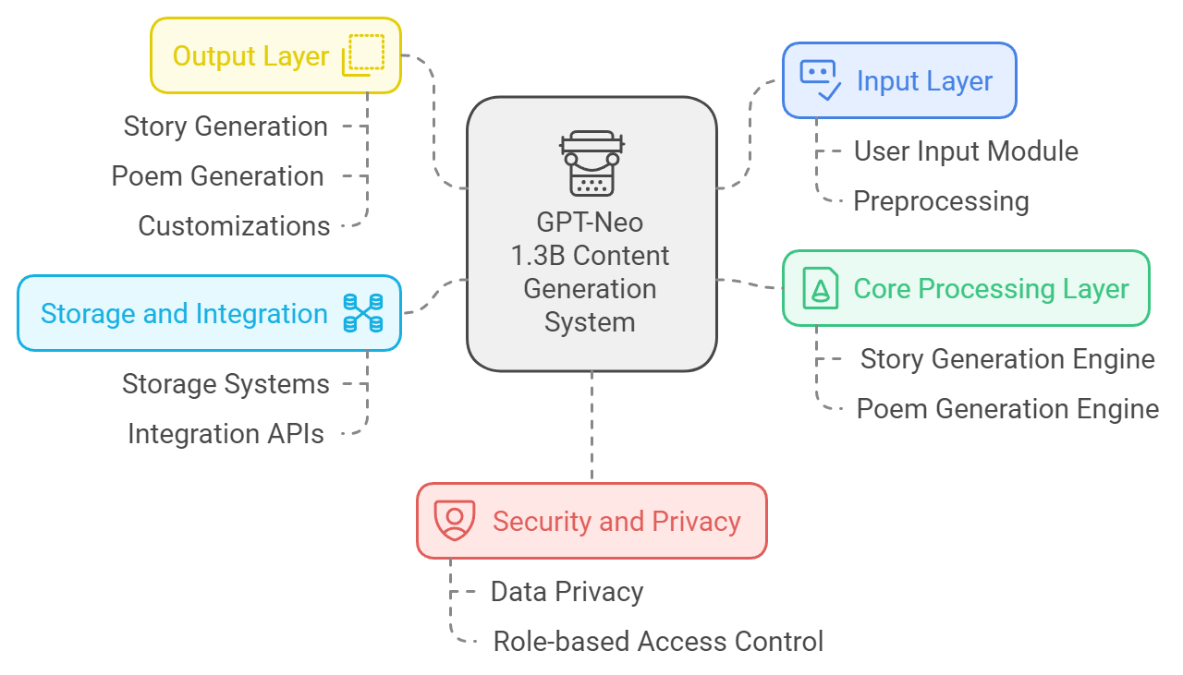

Figure 3 - GPT-Neo 1.3B Content Generation System

**System Design for GPT-Neo 1.3B Model:**

**A. Story Generation Pipeline:**

* User Input: The input given by the user namely cue, character description, thematic or even some specific plot-line ideas provide real-time guidance for generation through the GPT-Neo 1.3B model.
* Feature Extraction: Key aspects for users will be extracted from the existing inputs about characters, themes, plot points, and narrative style to drive the story-generation process.
* Language Modelling using GPT-Neo 1.3B: An ordered sequence of meaningful words is generated by the model thereby forming up sentences, paragraphs, and chapters. The model predicts and constructs relevant elements of the generated story with respect to the input and the expected style or genre (mystery, fantasy, drama).
* Output Generation: A story is produced using the GPT-Neo 1.3B model, consisting of several chapters or sections oriented to the theme, tone, and style specified by the user.

**B. Poem Generation Pipeline:**

* Verse Structure: The system, through GPT-Neo 1.3B, identifies the type of poem requested by the user, be it sonnet, haiku, rhymed couplet, or free verse.
* Rhyme and Meter control: GPT-Neo 1.3B will now create the poem, checking for into pleasing atmosphere with the required kind rhyme scheme or syllable numbers or structure using meter and rhyme, maintaining smooth rhythm and style.
* Poem Output: The generated poem emerges whole and elaborate from the offered input and the poetic style desired by the user through an effectual mood upon the substance and styled fragments swung by a chosen structure.

**C. Post Processing:**

* Error Correction: Human reviewers or writers will intervene to revise from the disordered product the level of excellence by making corrections where applicable; they may make modifications, enhance contextually, or transformational edits-a fusion of human creativity would lend the most emphatic stroke accessible in the world of gaming.
* Textual Alignedness: The generated output aligns with user preferences for consistent structure, tone, or genre. For stories, this might include balancing the chapter-length to maintain pace, while for poems, this could involve refining the use of devices or tonal equanimity.

**Methodology:**

In this section, we present the methodology that describes how to build the story-and-poem-generating system built around the GPT-Neo 1.3B model. This is done in several phases:

**Data Collection and Preprocessing:**

This phase involves collecting text samples from a wide range of literary sources, including classic literature, contemporary novels, poetry anthologies, and domain-specific examples like historical fiction and educational narratives. Attributes such as genre, themes, tone, structure (like sonnet, haiku, narrative poem), and literary devices like metaphor, simile, and rhyme schemes should be included for each text. It is expected that this richly annotated dataset will form the basis for training GPT-Neo 1.3B to generate different forms of creative content.

During preprocessing, the dataset is cleaned for consistency and quality with some normalizing steps, such as spellings, punctuation, and sentence structures. In addition, data augmentation techniques are employed to modify sentence structure, tone, and variety of sentences randomly so that the resultant model could generate adequate variances in outputs but remain creatively coherent. Careful attention is paid to rhyme schemes and metrical patterns in order to produce high-quality poetry.

**Model Training:**

GPT-Neo 1.3B should be a transformer model, fine-tuned on annotated data to understand specialized terms, stylistic features, and structural rules. It is used for coherent stories and stylistically accurate poems. It learns to construct a story of sentences with adequate plot development, character journeys, and theme consistency. In terms of poetry, it learns to respect the formal structures of poems such as iambic pentameter while generating imaginative and emotionally resonant verse.

Altering the content generation algorithms provide the ability for personalized story and poem generation based on user input. The model can generate a mystery novel narrative fitted to crime fiction conventions, with possible word variations aligned with user expectations in tone, characters, and plot elements.

**Testing and Validation:**

The rigorous testing and validation of the model will be done to ensure quality of generated content in accordance with user requirements. Some of the evaluation metrics are as follows:

Perplexity: This metric analyses how well the model can predict the next word in the sequence.

Fluency: Ensure grammatical correctness and coherence.

Creativity Scores: From human evaluation based on how original and creative the generated stories or poetry are.

There are other more specific lexical metrics employed in poetry generation, such as rhyme fidelity and metrical consistency, to ascertain congruence with the poetic form.

Real-world testing engages users such as writers, educators, and content creators. Their feedback is critical for refining the model's performance to ensure that it addresses demographic needs (E.g., children or adults) and industry needs (e.g., marketing or education). This feedback loop from users helps optimize the system for performance.

**Deployment and Updates:**

Once the system has been validated, it will be implemented in real-time applications, such as educational platforms, content generation tools, and creative writing software. The system will allow easy integration with other third-party systems such as content management and editing tools for live content delivery.

Regular monitoring of the system with further updates is necessary for its functionality. Feedback streams enable continuous feedback by different users, for example, teachers, authors, and editors about the quality of stories and poems generated. A retraining database will be created newly for successive runs so that the model can learn language developments and any style changes pertinent to present times.

Specific algorithms are integrated to generate user-specific content so that the system can be able to author personalized stories or poems based on user input. For example, if the user wants a mystery novel, the model can follow assumed plot structures designated for crime fiction while combining different elements according to user wishes. This helps keep the system in tune with the evolving user needs, which consistently leads to realistic content that is personalized over time.

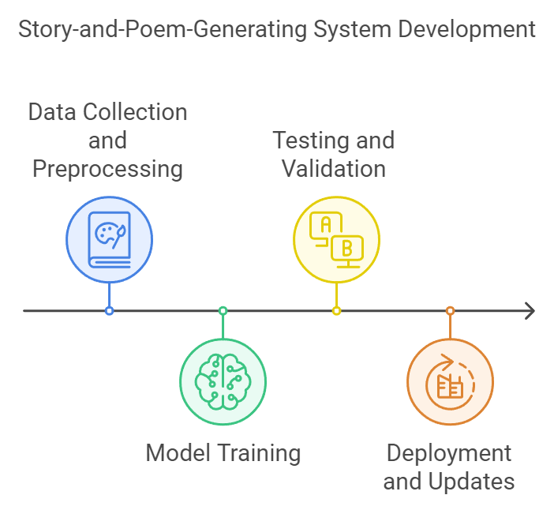

Figure 4 - Story and Poem Generating System Development

**3.2** **Stages**

* **Stage 1: Text Data Collection**
  + Sources: The system collects stories, poems, and literary works across a wide range including classic novels, contemporary short stories, children’s literature, and thematic poetry collections. These varied sources ascertain that the dataset on which GPT-Neo 1.3B learns tends to be vast enough to comprise all writing styles, tones, and structures.
* **Stage 2: Preprocessing**
  + **Data Cleaning:** Raw text data are cleaned to remove unwanted characters, inconsistent formatting, and irrelevant metadata, assuring a clean and standardized dataset while learning for the model.
  + **Text Segmentation:** Long works of fiction or poetry are cut into smaller pieces, such as verses for poems or paragraphs for stories. This avoid long passages, so the model will be able to interpret the text and find context without overwhelming complexity.
  + **Tokenization and Normalization:** The text is tokenized to words or subword units and normalized to standardize formatting, making certain that special characters and irregular punctuation are eliminated. This helps the model learn better so it can understand and generate its output smoothly.
* **Stage 3: Model Training**
  + **Language Model Training:** GPT-Neo 1.3B, a pre-trained transformer-based language model, is fine-tuned on the dataset. The model learns living in different literary styles, structures, and themes which will enable it to generate creative narratives and stylistically sound outputs for diverse genres.
  + **Story Generation Model:** The model is trained to generate sequential stories with well-defined arguments that have introductions, exciting character development, and plot resolution. Training on specific genres (mystery, fantasy, romance) allows the model to produce work that fits the given themes specified by the user.
  + **Poetry Generation Model:** Particular models trained on poetic structures of meter, rhyme schemes, and verse patterns. Fine-tuning helps GPT-Neo 1.3B to generate different types of poems: free verse, sonnets, or haikus while keeping style and theme.
  + **Conditional Generation:** GPT-Neo 1.3B which has been trained on conditional generation and thus the model should form an adaptive response based on the prompt input by the user. For example, the user can prompt the model to "Write a story about a haunted house" or "Generate a poem about love in spring," depending on how creative the guy feels.
* **Stage 4: Content Refinement**
  + **Diversity Sampling:** Multiple variations of stories or poems are generated from the same prompt or theme. This allows users to pick from different options, which makes it easy to select what fits best into their creative work.
  + **Structure Verification:** The system will verify that stories begin with coherent arcs, containing an exposition, complication, climax, and denouement. The same checks may be performed on poems to see that they adhere to the prescribed forms.
  + **Language and Style Validation:** Generated texts are checked for fluency, cohesion, and stylistic compliance appropriate to the specified literary genre or poetic form. This is an all-too-important guarantee in ensuring the standard of the produced work, making sure it meets the pedestal of expected creativity.
* **Stage 5: Post-Processing and Human Review**
  + **User Interaction:** Following the content generation, the user(s), including writers, teachers, and marketers, has a chance to provide feedback for the quality, style, and relevance of the scanty text produced. Users can thus select or refine those texts according to their needs on the edit menu.
  + **Human Review (Optional):** For sensitive applications such as publication, a human editor might review the content for accuracy, originality, and style. This allows one to have an output that has been polished and ready for publication.
  + **Custom Adjustments:** The model can be supplemented by fine-tuning or customizing it in accordance with user feedback; possible adjustments can be made concerning style or content themes. In due course, such updates enable GPT-Neo 1.3B to learn more about user-specific preferences, whereby individual users could have their characteristic Rabi using the output.

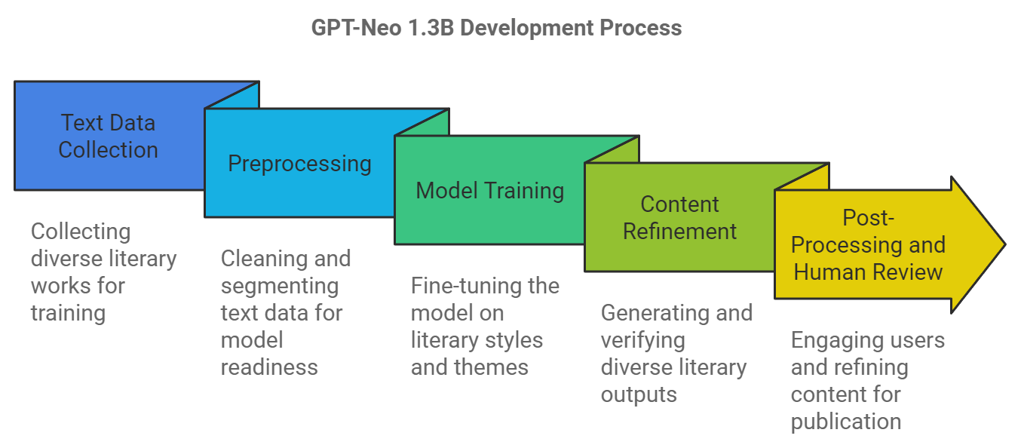

Figure 5 - GPT-Neo 1.3B Development Process

**Components:**

* + **Natural Language Processing (NLP) Models:** Much like how GPT-Neo 1.3B is employed as the crux of the story and poem generation model, other pre-trained transformer models lend the capability for a coherent content generation that is contextually accurate.
  + **Fine-Tuning Algorithms:** Certain algorithms are employed to fine-tune GPT-Neo 1.3B to those specific genres, styles, and forms of content. These tools are responsible for ensuring the model can produce various forms of creative writing such as narrative-driven stories and highly structured poetry.
  + **Real-Time Generation Tools:** In the case of interactive systems, it requires to be able to generate output in real time so that plot direction and thematic inputs from the user can dynamically affect the generated story.
  + **Post-Processing and Evaluation Tools:** Such tools are crucial for modifying the text in real-time, checking the validity of grammar, coherence, and genre or form-related conventions if any of them apply (e.g., rhyme or meter in poetry).

**3.3 Applications:**

* Story and poem generation using GPT-Neo 1.3B model can act as creative supports in educational contexts to work for students and writers in delivering first drafts or dialogues and verses that can extend writers' efforts in that direction. AI-enabled stories could be ideal for delivery in the form of creative content emails in digital marketing for personalized stories, taglines, and jingles based on customer preferences or interactions.
* Models both creative and entertaining, in interactive entertainment, are created using pre-defined models; these generate in-game narratives and dialogues that evolve based on the player's choices, thus enlivening immersive storytelling experiences.
* GPT-Neo 1.3B model create engaging stories or poetic posts on trending topics for bloggers and social media content creators to maintain their content frequency and quality. This can be input as preliminary content by creators, in which they do timely updates without killing creativity.
* The AI generates point-or-click stories for interactive children's book apps that allow child involvement in the evolving narrative. This increases immersion while fostering participation and literacy.
* GPT-Neo 1.3B can generate custom stories and poems that are suited to individual learning needs in e-learning platforms. For example, the model can create engaging narratives suitable for different subjects and hence turn complex concepts into appealing manner stories that could elicit greater retention and learning for students.
* 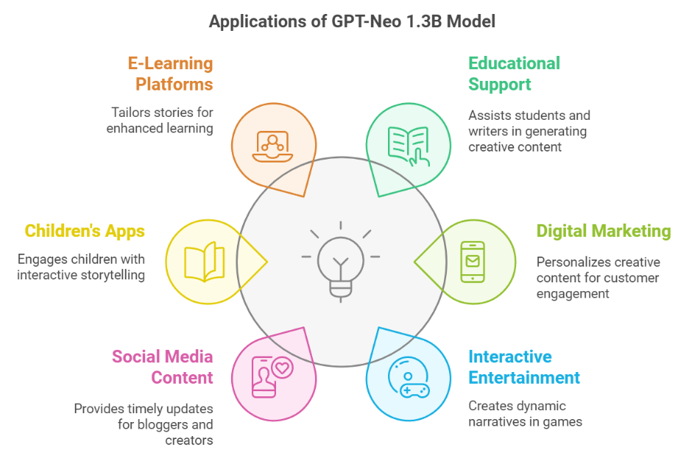Pre-written models can generate interesting, engaging corporate stories or metaphors for business presentations, speeches, or internal newsletters. Consequently, it helps to communicate complex ideas in heel-digging, easily rememberable ways making business communication more impactful.

Figure 6 - Applications of GPT-Neo 1.3B Model

**4. Conclusion:**  
By using the GPT-Neo 1.3B model from Hugging Face, story and poem generation demonstrates that AI-driven tools can boost the level of creativity in various domains, ranging from publishing to marketing and education to entertainment. This model assists a human creator in providing multiple narrative cuts, poetic styles, and characterizations to save time and boost productivity. Furthermore, through the agglomeration of layers of drafts, AI provides authors, poets, and content creators with a robust jumping-off point in any direction they wish to go in, defeating creative blocks and enabling more possibilities for creativity. Interactive storytelling in entertainment allows for real-time interactive content generation with GPT-Neo 1.3B; hence, the technique revolutionizes storytelling, changing the manner in which stories and poems are conceived and delivered.

By utilizing GPT-Neo 1.3B, content creation becomes more efficient and versatile. It also facilitates authoring, easing the process of writing and narrating. About the probable excitement and twist points, it becomes the best option for a writer with writer's block: create drafts on-the-go. Instead of storytelling as it traditionally is thought about, GPT-Neo 1.3B allows for interactivity: real-time content generation to aid developing narratives, bringing story and draft writing to a radically new level with a wide range of applications: education, therapeutic usage, mood lifting, etc.

**References:**

K.-L. Lo, R. Ariss, and P. Kurz, “Fine-tuned GPT-2, two-stage generation process (forward and reverse language modeling),” in *Not specified*, 2020.

A. Fan, M. Lewis, and Y. Dauphin, “Hierarchical model, model fusion, gated self-attention mechanism, Nesterov accelerated gradient method,” in *300,000 stories dataset*, 2019.

B. Bena and J. Kalita, “Fine-tuned GPT-2, transfer learning, Coh-Metrix tool for analysis,” in *Not specified*, 2019.

P. Sawicki, M. Grze´s, F. Goes, D. Brown, M. Peeperkorn, A. Khatun, and S. Paraskevopoulou, “Fine-tuning GPT-3 models on specific poet styles,” in *Dataset of 300 poems*, 2020.

P. Xu, M. Patwary, M. Shoeybi, R. Puri, P. Fung, A. Anandkumar, and B. Catanzaro, “Controllable story generation with knowledge integration and keyword manipulation,” in *External knowledge*, 2021.

Y. Wang, J. Lin, Z. Yu, W. Hu, and B. F. Karlsson, “Structured knowledge integration into storytelling models,” in *Various datasets*, 2020.

D. Lewis, A. Zugarini, and E. Alonso, “Syllable-centered neural language models, transfer learning, scoring mechanism,” in *Collection of William Wordsworth's works*, 2021.

J. Guan, F. Huang, Z. Zhao, X. Zhu, and M. Huang, “Knowledge-enhanced pretraining model, multi-task learning, combined loss function,” in *ROCStories, ConceptNet, ATOMIC*, 2020.

J. Wöckener et al., “Neural language models, RNNs, sub-word and syllable-level modeling,” in *Chicago Rhyming Poetry Corpus (English), TextGrid (German)*, 2021.

S. A. M. Mukhtar and P. S. Joglekar, “RNN with LSTM, Seq2Seq model for Hindi text generation,” in *Rekhta.org, Urdu Mehfil, Bazm-e-Urdu Library*, 2020.

|  |  |  |  |  |  |  |  |  |  |  |  |  |  |  |  |  |  |  |  |  |  |  |  |  |  |  |  |  |  |  |
| --- | --- | --- | --- | --- | --- | --- | --- | --- | --- | --- | --- | --- | --- | --- | --- | --- | --- | --- | --- | --- | --- | --- | --- | --- | --- | --- | --- | --- | --- | --- |
| **Literature Review on Cloud Cost Optimization**   | **Year** | **Authors** | **Tech Used** | **Output** | **Challenges** | | --- | --- | --- | --- | --- | | 2020 | Resource Usage Cost Optimization in Cloud Computing Using Machine Learning | Machine Learning (ML) models for cost prediction and optimization | Reduced resource wastage and improved cost-efficiency in cloud environments | Model accuracy depends on the quality of training data; difficulty in real-time adaptability | | 2021 | Cost Optimization of Cloud Computing Services in a Networked Environment | Heuristic algorithms, Dynamic Resource Allocation | Efficient cost reduction while maintaining service quality | Trade-off between cost and performance; complexity in multi-cloud environments | | 2019 | Cost Optimization for Cloud Storage from User Perspectives: Recent Advances, Taxonomy, and Survey | Comparative analysis, Taxonomy-based classification | Identified key cost-saving strategies for end-users in cloud storage | Limited real-world applicability due to lack of empirical validation | | 2022 | Optimization of Resource Provisioning Cost in Cloud Computing | Reinforcement Learning (RL), Auto-scaling techniques | Enhanced resource allocation with minimized cost | Computational overhead in RL models; scalability concerns | | 2023 | Multi-provider Cloud Computing Network Infrastructure Optimization | Game Theory, Metaheuristic Optimization | Improved cost savings and network efficiency across multiple cloud providers | Complexity in inter-provider coordination and SLA (Service Level Agreement) enforcement | |

|  |  |  |
| --- | --- | --- |
| **Timeline** | | |
| **Phase** | **Duration** | **Key Activities** |
| Week 5 | Research & Planning | Identify cost-heavy areas in the DevOps pipeline |
| Week 6 | Implementation | Set up ELK Stack, Jenkins, and Kubernetes |
| Week 7 | Testing & Optimization | Validate cost-saving mechanisms |
| Week 8 | Final Deployment | Deploy the optimized solution |

| **Year** | **Authors** | **Tech Used** | **Output** | **Challenges** |
| --- | --- | --- | --- | --- |
| 2020 | Resource Usage Cost Optimization in Cloud Computing Using Machine Learning | Machine Learning (ML) models for cost prediction and optimization | Reduced resource wastage and improved cost-efficiency in cloud environments | Model accuracy depends on the quality of training data; difficulty in real-time adaptability |
| 2021 | Cost Optimization of Cloud Computing Services in a Networked Environment | Heuristic algorithms, Dynamic Resource Allocation | Efficient cost reduction while maintaining service quality | Trade-off between cost and performance; complexity in multi-cloud environments |
| 2019 | Cost Optimization for Cloud Storage from User Perspectives: Recent Advances, Taxonomy, and Survey | Comparative analysis, Taxonomy-based classification | Identified key cost-saving strategies for end-users in cloud storage | Limited real-world applicability due to lack of empirical validation |
| 2022 | Optimization of Resource Provisioning Cost in Cloud Computing | Reinforcement Learning (RL), Auto-scaling techniques | Enhanced resource allocation with minimized cost | Computational overhead in RL models; scalability concerns |
| 2023 | Multi-provider Cloud Computing Network Infrastructure Optimization | Game Theory, Metaheuristic Optimization | Improved cost savings and network efficiency across multiple cloud providers | Complexity in inter-provider coordination and SLA (Service Level Agreement) enforcement |