**Data-Driven Milk Collection Forecasting**

* 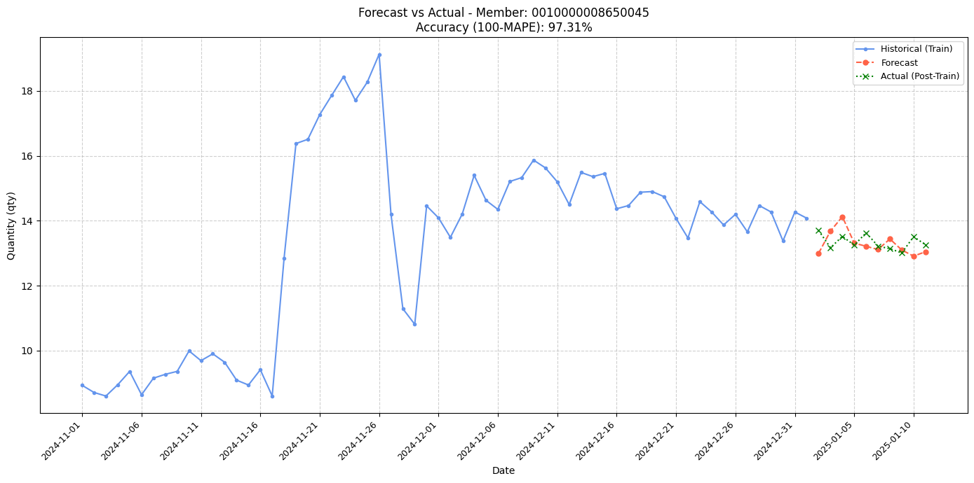**Accuracy for 0010000008650045: MAPE=2.69%, Accuracy=97.31%**
* 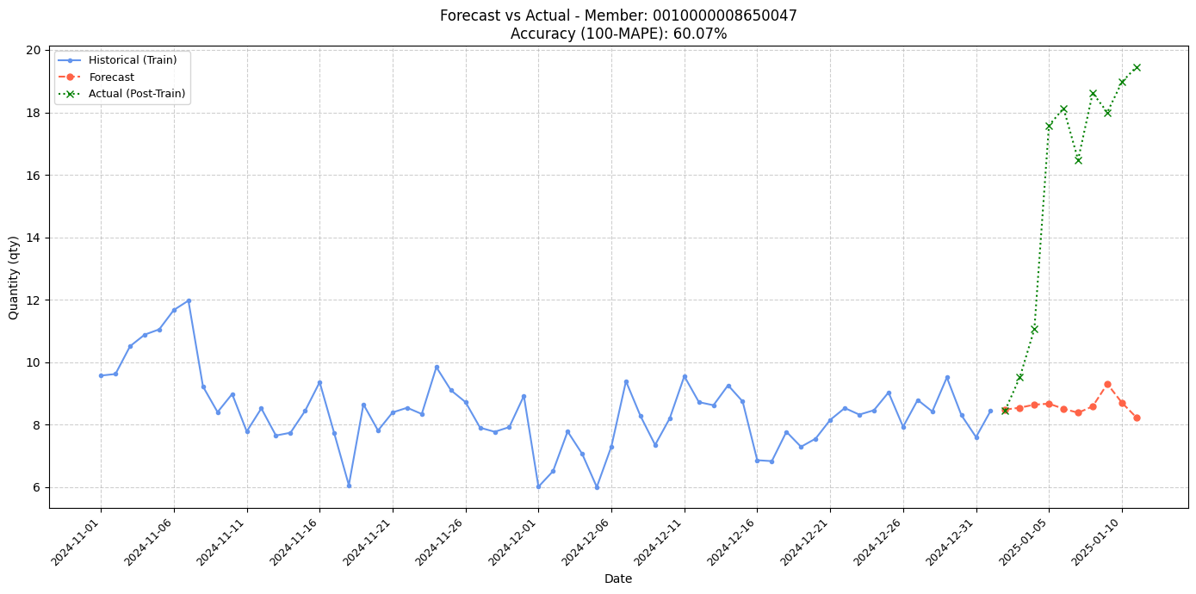**Accuracy for 0010000008650047: MAPE=39.93%, Accuracy=60.07%**
* 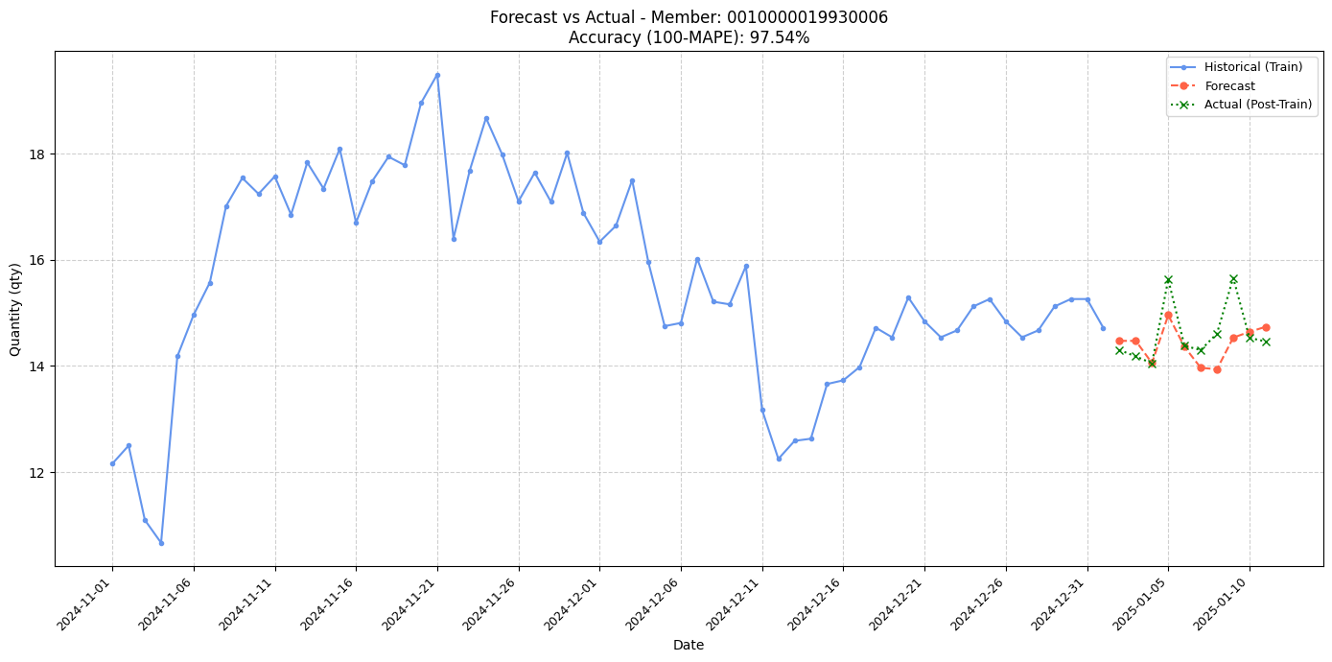**Accuracy for 0010000019930006: MAPE=2.46%, Accuracy=97.54%**
* 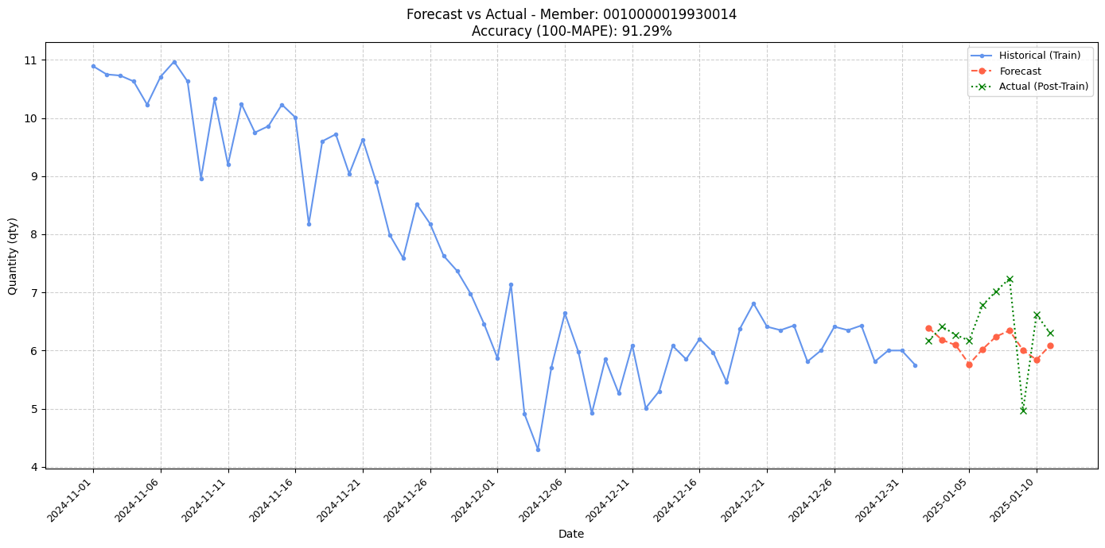**Accuracy for 0010000019930014: MAPE=8.71%, Accuracy=91.29%**
* 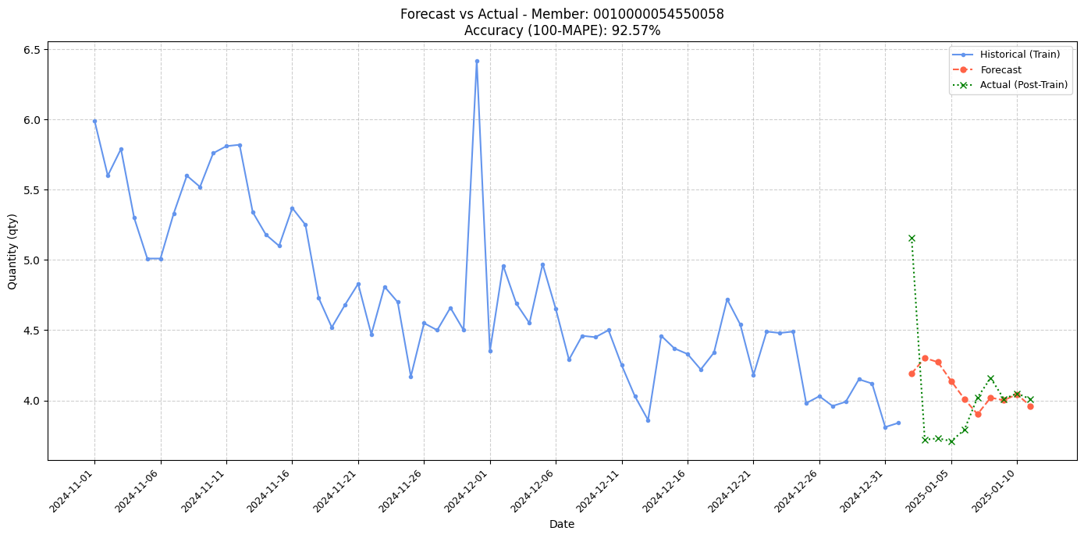**Accuracy for 0010000054550058: MAPE=7.43%, Accuracy=92.57%**
* 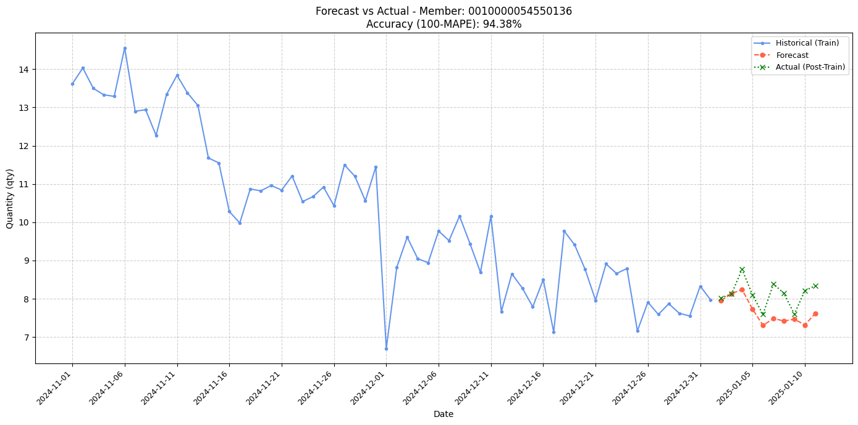**Accuracy for 0010000054550136: MAPE=5.62%, Accuracy=94.38%**
* 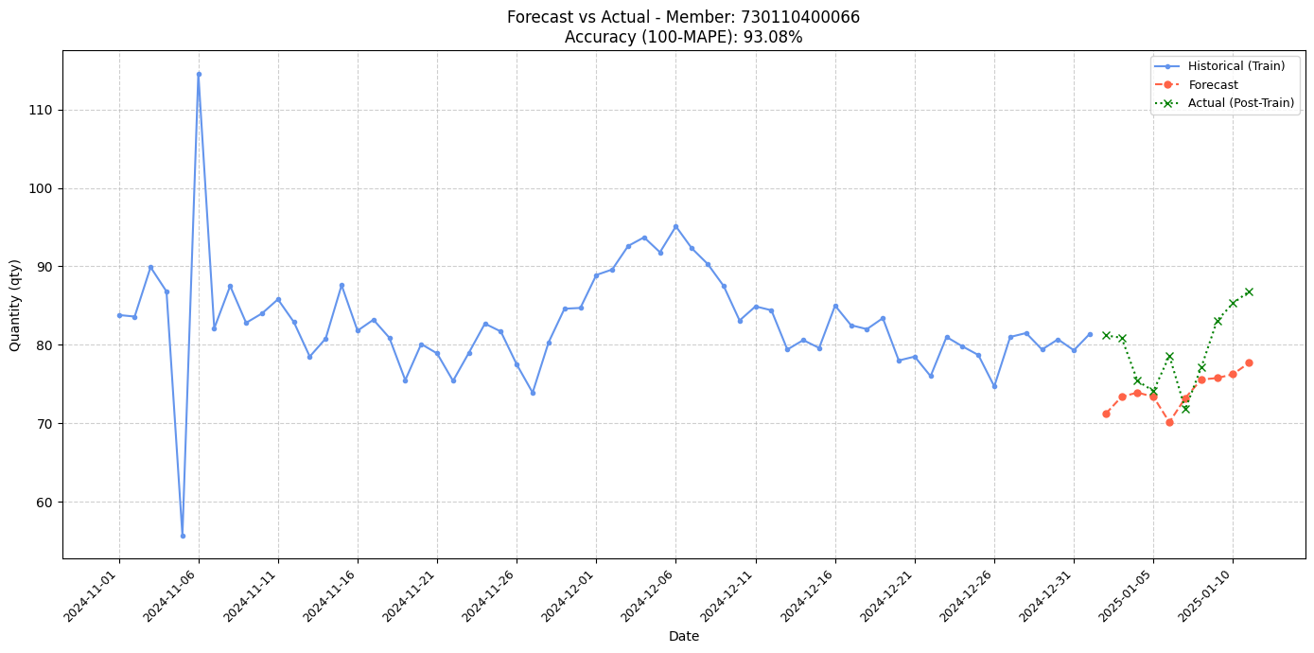**Accuracy for 730110400066: MAPE=6.92%, Accuracy=93.08%**
* 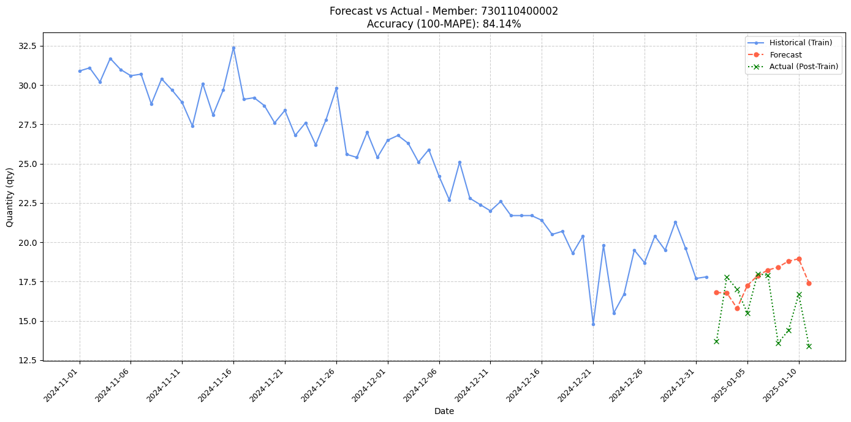**Accuracy for 730110400002: MAPE=15.86%, Accuracy=84.14%**
* 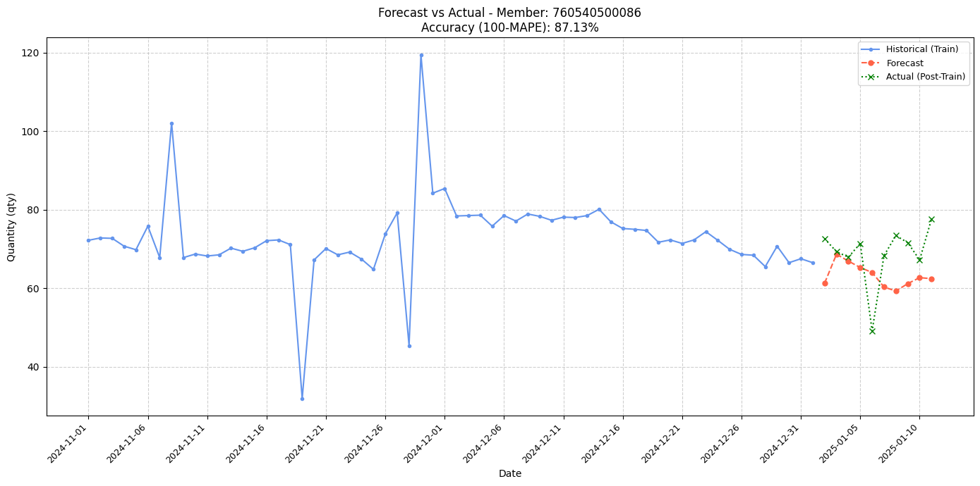**Accuracy for 760540500086: MAPE=12.87%, Accuracy=87.13%**
* **Accuracy for 760540500013: MAPE=18.80%, Accuracy=81.20%**

