# VISVESVARAYATECHNOLOGICALUNIVERSITY

## BELAGAVI–590018,Karnataka

## INTERNSHIP REPORT

#### ON

“SENTIMENTAL ANALYSIS”

***Submitted inpartialfulfilmentforthe awardofdegree(21CSI85)***

## BACHELOR OF ENGINEERING IN

## CSE

***Submitted by:***

#### KEITH VINCENT RAJ

#### 1ST21CS094

#### JEEVAN B

#### 1ST21CS086

#### KARTHIK KA

#### 1ST21CS091

#### VISHWANATH GOWDA K T

#### 1ST21CS240

#### VISHWAS N B

#### 1ST21CS241

LOGO : 

Conducted at

**VARCONS TECHNOLOGIES PVT LTD**



# SAMBHRAM INSTITUTE OF TECHNOLOGY

**CSE**

**AFFLIATED TO VTU , APPROVIED BY AICTE**

**Hesaraghatta Rd, Jalahalli East,** **Bengaluru, Karnataka 560097**

# SAMBHRAM INSTITUTE OF TECHNOLOGY

**CSE**

**AFFLIATED TO VTU , APPROVIED BY AICTE**

**Hesaraghatta Rd, Jalahalli East,** **Bengaluru, Karnataka 560097**



**CERTIFICATE**

This is to certify that the Internship titled **“SENTIMENTAL ANALYSIS”** carried out by **Mr.KEITH VINCENT RAJ,JEEVAN B,KARTHIK K A,VISHWANATH GOWDA KT,VISHWAS NB ,**abonafide student of sambhram Institute ofTechnology,inpartialfulfillmentfortheawardof**BachelorofEngineering**,in**CSE**underVisvesvarayaTechnologicalUniversity,Belagavi, during the year 2022-2023. It is certified that all corrections/suggestions indicated have beenincorporatedin thereport.

TheprojectreporthasbeenapprovedasitsatisfiestheacademicrequirementsinrespectofInternshipprescribedfor thecourse Internship/ProfessionalPractice (21CSI85)

#### 

# DECLARATION

I, **KEITH VINCENT RAJ,JEEVAN B,KARTHIK K A,VISHWANATH GOWDA KT,VISHWAS NB** , first year students of CSE,SAMBHRAM INSTITUTE OF TECHNOLOGY - 560097, declare that the Internship has been successfully completed ,in. **VARCONS TECHNOLOGIES PVT LTD**

This report is submitted in partial fulfillment of the requirements for award of Bachelor Degree in Branch CSE, during the academic year2022-2023.

Date:16-11-2022 :

Place :BANGLORE

# ACKNOWLEDGEMENT

ThisInternshipisaresultofaccumulatedguidance,directionandsupportofseveralimportant persons.We take this opportunityto expressour gratitude to all who have helpedustocompletetheInternship.

WeexpressoursincerethankstoourPrincipal,forprovidingusadequatefacilitiestoundertakethisInternship.

We would like to thank our Head of Dept –branch code, for providing us anopportunityto carryoutInternshipandfor hisvaluableguidanceandsupport.

We would like to thank our (Lab assistant name) Software Services forguidingusduringtheperiodofinternship.

We express our deep and profound gratitude to our guide, Guide name,Assistant/Associate Prof,forherkeeninterestandencouragementat every step in completingtheInternship.

We would liketo thank all the faculty members of our department for the support extendedduringthecourse ofInternship.

We would like to thank the non-teaching members of our dept, forhelping us duringtheInternship.

Last but not the least, we would like to thank our parents and friends without whose constanthelp,thecompletion ofInternshipwould have notbeenpossible.

# TableofContents

|  |  |  |
| --- | --- | --- |
| **Slno** | **Description** | **Pageno** |
| 1 | Company Profile | 01 |
| 2 | About theCompany | 02-05 |
| [3](https://1.bp.blogspot.com/-dODuK8N5h1Q/Wlnyb3V9HFI/AAAAAAAACL4/WxQtCJ1pM5wccDABg4wIrTBUB0vlikXQQCLcBGAs/s1600/poly1.jpg) | Introduction | 06-07 |
| [4](https://1.bp.blogspot.com/-dODuK8N5h1Q/Wlnyb3V9HFI/AAAAAAAACL4/WxQtCJ1pM5wccDABg4wIrTBUB0vlikXQQCLcBGAs/s1600/poly1.jpg) | SystemAnalysis | 08 |
| [5](https://1.bp.blogspot.com/-dODuK8N5h1Q/Wlnyb3V9HFI/AAAAAAAACL4/WxQtCJ1pM5wccDABg4wIrTBUB0vlikXQQCLcBGAs/s1600/poly1.jpg) | RequirementAnalysis | 09 |
| 6 | Design[Analysis](https://4.bp.blogspot.com/-IOOxgPaXMVc/Wlj3LWvcnjI/AAAAAAAACKE/UeTFYvAxDmUDel5UBjdifeWaApB3-dXVgCLcBGAs/s1600/img1.jpg) | 10 |
| 7 | [Implementation](https://4.bp.blogspot.com/-IOOxgPaXMVc/Wlj3LWvcnjI/AAAAAAAACKE/UeTFYvAxDmUDel5UBjdifeWaApB3-dXVgCLcBGAs/s1600/img1.jpg) | 11 |
| 8 | Snapshots | 12-14 |
| 9 | Conclusion | 15 |
| 10 | References | 16 |

# COMPANYPROFILE

A Brief History ofVARCONS TECHNOLOGIES PVT LTD

Varcons Technologies, was incorporated with a goal ”To provide high quality andoptimal Technological Solutions to business requirements of our clients”. Every business is adifferent and has a unique business model and so are the technological requirements. Theyunderstand this and hence the solutions provided to these requirements are different as well.They focus on clients requirements and provide them with tailor made technological solutions.They also understand that Reach of their Product to its targeted market or the automation ofthe existingprocess intoe-client andsimpleprocess arethe keyfeaturesthat ourclientsdesire from Technological Solution they are looking for and these are the features that wefocuson whiledesigningthesolutionsfortheirclients.

Sarvamoola Software Services. is a Technology Organization providing solutions for all webdesign and development, MYSQL, PYTHON Programming, HTML, CSS, ASP.NET andLINQ. Meeting the ever increasing automation requirements, Sarvamoola Software Services.specializeinERP,Connectivity,SEOServices,ConferenceManagement,effectivewebpromotionandtailor-madesoftwareproducts,designingsolutionsbestsuitingclientsrequirements.

Varcons Technologies, strive to be the front runner in creativity and innovation insoftware development through their well-researched expertise and establish it as an out of theboxsoftwaredevelopmentcompanyinBangalore,India.Asasoftwaredevelopmentcompany, they translate this software development expertise into value for their customersthroughtheirprofessional solutions.

They understand that the best desired outputcan be achievedonly by understandingtheclients demand better. Varcons Technologies work with their clients and help them todefiinetheirexactsolutionrequirement.Sometimeseventheywonderthattheyhavecompletely redefined their solution or new application requirement during the brainstormingsession, and here they position themselves as an IT solutions consulting group comprising ofhighcaliberconsultants.

They believe that Technology when used properly can help any business to scale and achievenew heights of success. It helps Improve its efficiency, profitability, reliability; to put itin one sentence ” Technology helps you to Delight your Customers” and that is what we wanttoachieve.

**01**

1. **ABOUTTHECOMPANY**



Varcons Technologies is a Technology Organization providing solutions for all webdesign and development, MYSQL, PYTHON Programming, HTML, CSS, ASP.NET andLINQ. Meeting the ever increasing automation requirements, Compsoft TechnologiesspecializeinERP,Connectivity,SEOServices,ConferenceManagement,effectivewebpromotionandtailor-madesoftwareproducts,designingsolutionsbestsuitingclientsrequirements.The organization where they have a right mix of professionals as a stakeholderstohelpusserveourclientswithbestofourcapabilityandwithatparindustrystandards.They have young, enthusiastic, passionate and creative Professionals to develop technologicalinnovations in the field of Mobile technologies, Web applications as well as Business andEnterprise solution. Motto of our organization is to “Collaborate with our clients to providethem with best Technological solution hence creating Good Present and Better Future for ourclient which will bring a cascading a positive effect in their business shape as well”. Providing a Complete suite of technical solutions is not just our tag line, it is Our Vision for Our Clients and for Us, Westrivehard toachieveit.

## ProductsofVarcons Technologies.

**AndroidApps**

It is the process by which new applications are created for devices running the Androidoperating system. Applications are usually developed in Java (and/or Kotlin; or other suchoption) programming language using the Android software development kit (SDK), but otherdevelopment environments are also available, some such as Kotlin support the exact sameAndroidAPIs(and bytecode),whileotherssuchasGohave restricted APIaccess.

The Android software development kit includes a comprehensive set of development tools.These include a debugger, libraries, a handset emulator based on QEMU, documentation,sample code, and zutorials. Currently supported development platforms include computersrunning Linux (any modern desktop Linux distribution), Mac OS X 10.5.8 or later, andWindows 7 or later. As of March 2015, the SDK is not available on Android itself, butsoftwaredevelopmentis possible by using specializedAndroidapplications 02

**Web Application**

It is a client–server computer program in which the client (including the user interface andclient- sidelogic) runsina webbrowser.Commonwebapplications includewebmail,online

03

retail sales, online auctions, wikis, instant messaging services and many other functions. webapplicationsusewebdocumentswritteninastandardformatsuchasHTMLandJavaScript,whicharesupportedbyavarietyofwebbrowsers.Webapplicationscanbeconsideredasaspecifificvariantofclient–serversoftwarewheretheclientsoftwareisdownloadedtotheclientmachinewhenvisitingtherelevantwebpage,usingstandardprocedures such as HTTP. The Client web software updates may happen each time the webpageisvisited.Duringthesession,thewebbrowserinterpretsanddisplaysthepages,andacts as the universal client for any web application. The use of web application frameworkscan often reduce the number of errors in a program, both by making the code simpler, and byallowing one team to concentrate on the framework while another focuses on a specifified usecase. In applications which are exposed to constant hacking attempts on the Internet, security-relatedproblemscan becausedby errorsin theprogram.

FrameworkscanalsopromotetheuseofbestpracticessuchasGETafterPOST.Therearesomewhoviewawebapplicationasatwo-tierarchitecture.Thiscanbea“smart”clientthatperformsalltheworkandqueriesa“dumb”server,ora“dumb”clientthatreliesona“smart”server.Theclientwouldhandlethepresentationtier,theserverwouldhavethedatabase(storagetier),andthebusinesslogic(applicationtier)wouldbeononeofthemoronboth.Whilethisincreasesthescalabilityoftheapplicationsandseparatesthedisplayandthedatabase,itstilldoesn‟tallowfortruespecializationoflayers,somostapplicationswilloutgrowthismodel.Anemergingstrategyforapplicationsoftwarecompaniesistoprovidewebaccesstosoftwarepreviouslydistributedaslocalapplications.Dependingonthetypeofapplication,itmayrequirethedevelopmentofanentirelydifferentbrowser-basedinterface,ormerelyadaptinganexistingapplicationtousedifferentpresentationtechnology.Theseprogramsallowtheusertopayamonthlyoryearlyfeeforuseofasoftwareapplicationwithouthavingtoinstallitonalocalharddrive.Acompanywhichfollowsthisstrategyisknownasanapplicationserviceprovider(ASP),andASPsarecurrentlyreceivingmuchattention inthesoftwareindustry.

Security breaches on these kinds of applications are a major concern because it can involveboth enterprise information and private customer data. Protecting these assets is an importantpart of any web application and there are some key operational areas that must be included inthedevelopmentprocess. Thisincludesprocessesforauthentication,authorization,assethandling, input, and logging and auditing. Building security into the applications from thebeginningcanbemoreeffective andless disruptive in thelong run.

**Web design**

It is encompasses many different skills and disciplines in the production and maintenance ofwebsites. The different areas of web design include web graphic design; interface design;authoring,includingstandardizedcodeand 04

search engine optimization. The term web design is normally used to describe the designprocess relating to the front-end (client side) design of a website including writing mark up.Web design partially overlaps web engineering in the broader scope of web development.Web designers are expected to have an awareness of usability and if their role involvescreatingmarkupthentheyarealsoexpectedtobeuptodatewithwebaccessibilityguidelines. Webdesign partially overlapsweb engineering inthe broader scope of webdevelopment.

## Departmentsandservicesoffered

Varcons Technologies plays an essential role as an institute, the level of education,development of student’s skills are based on their trainers. If you do not have a good mentorthen you may lagin many things from others and that is why we at VarconsTechnologies gives youthe facility of skilled employeesso thatyou donot feelunsecured aboutthe academics. Personality development and academic status are some of those things whichlie on mentor’s hands. If you are trained well then you can do well in your future andknowing itsimportance ofVarcons Technologies alwaystriestogiveyou thebest.

They have a great team of skilled mentors who are always ready to direct their trainees in thebestpossiblewaytheycanandtoensuretheskillsofmentorsweheldmanyskilldevelopment programs as well so that each and every mentor can develop their own skillswiththedemandsofthecompaniesso that theycan prepare acompletepackagedtrainee.

## ServicesprovidedbyVarcons Technologies.

* CoreJava and Advanced Java
* Web servicesanddevelopment
* Dot NetFramework
* Python
* SeleniumTesting
* Conference /EventManagement Service
* AcademicProjectGuidance
* OnTheJob Training
* Software Training

05

06

1. **INTRODUCTION**

## IntroductiontoML

Machine learning has become an integral part of many commercial applications and research projects, but this field is not exclusive to large companies with extensive research teams. If you use Python, even as a beginner, this book will teach you practical ways to build your own machine learning solutions. Machine learning is a type of artificial intelligence (AI) that provides computers with the ability to learn without being explicitly programmed. Machine learning focuses on the development of Computer Programs that can change when exposed to new data. In this article, we’ll see basics of Machine Learning, and implementation of a simple machine learning algorithm using python. Machine learning involves a computer to be trained using a given data set, and use this training to predict the properties of a given new data. For example, we can train a computer by feeding it 1000 images of cats and 1000 more images which are not of a cat, and tell each time to the computer whether a picture is cat or not. Then if we show the computer a new image, then from the above training, the computer should be able to tell whether this new image is a cat or not.   
The process of training and prediction involves the use of specialized algorithms. We feed the training data to an algorithm, and the algorithm uses this training data to give predictions on a new test data. One such algorithm is [K-Nearest-Neighbor](https://www.geeksforgeeks.org/k-nearest-neighbours/) classification (KNN classification). It takes a test data, and finds k nearest data values to this data from test data set. Then it selects the neighbor of maximum frequency and gives its properties as the prediction result.

## ProblemStatement

* **Spam Detection**: Given email in an inbox, identify those email messages that are spam and those that are not. Having a model of this problem would allow a program to leave non-spam emails in the inbox and move spam emails to a spam folder. We should all be familiar with this example

.

* **Credit Card Fraud Detection**: Given credit card transactions for a customer in a month, identify those transactions that were made by the customer and those that were not. A program with a model of this decision could refund those transactions that were fraudulent.
* **Digit Recognition**: Given a zip codes hand written on envelops, identify the digit for each hand written character. A model of this problem would allow a computer program to read and understand handwritten zip codes and sort envelops by geographic region.
* **Speech Understanding**: Given an utterance from a user, identify the specific request made by the user. A model of this problem would allow a program to understand and make an attempt to fulfil that request. The iPhone with Siri has this capability.
* **Face Detection**: Given a digital photo album of many hundreds of digital photographs, identify those photos that include a given person. A model of this decision process would allow a program to organize photos by person. Some cameras and software like iPhoto has this capability.

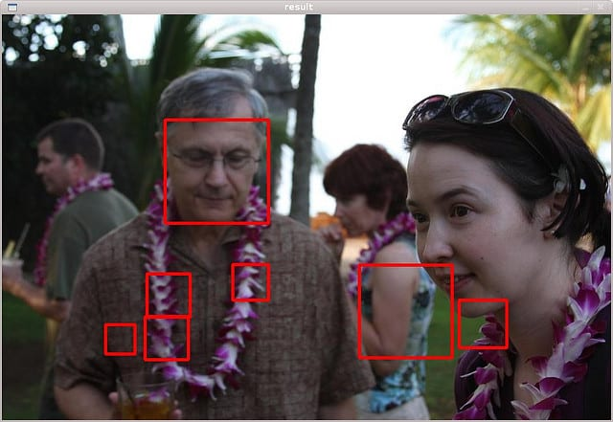

07

**4.SYSTEMANALYSIS**

## ExistingSystem

A key part of system analysis of the existing system is gathered in gall relevant information about the present system. The system analyst has to find out how the current system works. He must know what information together, where to find it.

## ProposedSystem

System analysis is conducted for the purpose of studying a system or its parts in order to identify its objectives. It is a problem solving technique that improves the system and ensures that all the components of the system work efficiently to accomplish their purpose. Analysis specifies what the system should do.

## ObjectiveoftheSystem

System analysis is conducted for the purpose of studying a system or its parts in order to identify its objectives. It is a problem solving technique that improves the system and ensures that all the components of the system work efficiently to accomplish their purpose. Analysis specifies what the system should do.

08

**5.REQUIREMENTANALYSIS**

## HardwareRequirementSpecification

 The Hardware Requirements Specification (SRS) captures the complete Hardware requirements for the system, or a portion of the system. Following is a typical SRS outline for a project using only traditional natural-language style requirements – with no use-case modeling.

## SoftwareRequirementSpecification

**Software Requirement Specification (SRS) Format** as name suggests, is complete specification and description of requirements of software that needs to be fulfilled for successful development of software system. These requirements can be functional as well as non-functional depending upon type of requirement. The interaction between different customers and contractor is done because its necessary to fully understand needs of customers.

09

1. **DESIGN&ANALYSIS**

**Data Analysis** is the technique to collect, transform, and organize data to make future predictions, and make informed data-driven decisions. It also helps to find possible solutions for a business problem. There are six steps for Data Analysis. They are:

* Ask or Specify Data Requirements
* Prepare or Collect Data
* Clean and Process
* Analyze
* Share
* Act or Report

Each step has its own process and tools to make overall conclusions based on the data.

In this article, we will discuss how to do data analysis with Python. We will discuss all sorts of data analysis i.e. analyzing numerical data with NumPy, Tabular data with Pandas, data visualization Matplotlib, and Exploratory data analysis

## Analyzing Numerical Data with NumPy

[NumPy](https://www.geeksforgeeks.org/python-numpy/) is an array processing package in Python and provides a high-performance multidimensional array object and tools for working with these arrays. It is the fundamental package for scientific computing with Python.

### Arrays in NumPy

[NumPy Array](https://www.geeksforgeeks.org/basics-of-numpy-arrays/) is a table of elements (usually numbers), all of the same type, indexed by a tuple of positive integers. In Numpy, the number of dimensions of the array is called the rank of the array. A tuple of integers giving the size of the array along each dimension is known as the shape of the array.

10

1. **IMPLEMENTATION**

Implementation is the stage where the theoretical design is turned into a working system. Themost crucial stage in achieving a new successful system and in giving confidence on the newsystemfor theusersthat itwillworkefficiently andeffectively.

The system can be implemented only after thorough testing is done and if it is found to workaccording to the specification. It involves careful planning, investigation of the currentsystem and it constraints on implementation, design of methods to achieve the change overandanevaluationofchangeovermethods apartfromplanning.

Two major tasks of preparing the implementation are education and training of the users andtesting of the system. The more complex the system being implemented, the more involvedwillbethesystem analysisanddesigneffortrequiredjustfor implementation.

The implementation phase comprises of several activities. The required hardware andsoftware acquisition is carried out. The system may require some software to be developed.For this, programs are written and tested. The user then changes over to his new fully testedsystemandtheold system isdiscontinued.

## TESTING

The testing phase is an important part of software development. It is the Information zedsystem will help in automate process of finding errors and missing operations and also acomplete verification to determine whether the objectives are met and the user requirementsaresatisfied.Software testing is carriedout inthree steps:

1. The first includes unit testing, where in each module is tested to provide itscorrectness,validity and also determine any missing operations and to verify whether theobjectiveshave been met. Errors arenoteddownandcorrected immediately.
2. Unit testing is the important and major part of the project. So errors are rectified easily inparticular module and program clarity isincreased. In this project entire system is dividedinto several modules and is developed individually. So unit testing is conducted toindividualmodules.
3. The second step includes Integration testing. It need not be the case, the software whosemodules when run individually and showing perfect results, will also show perfectresultswhenrunasawhole.

11

* 1. **SNAPSHOTS**

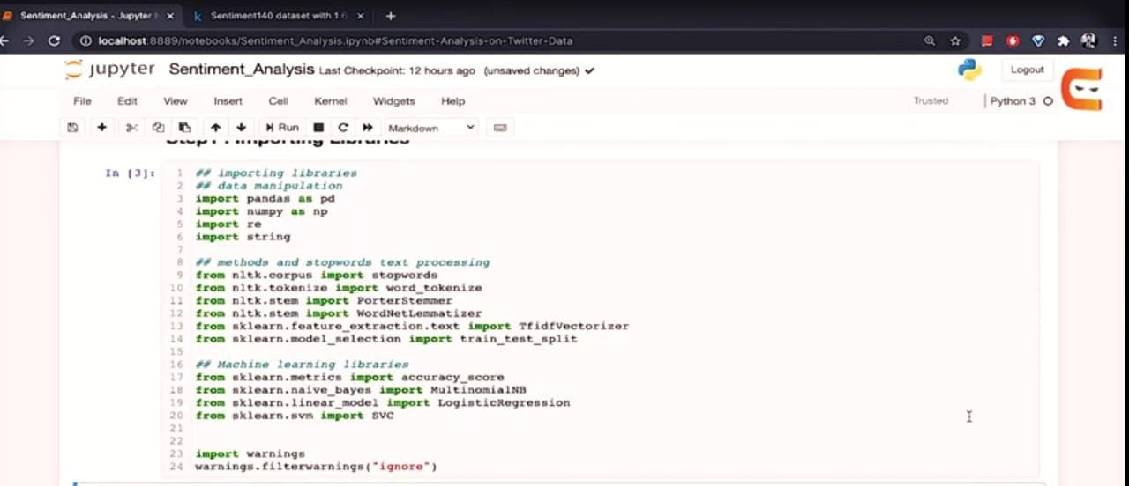

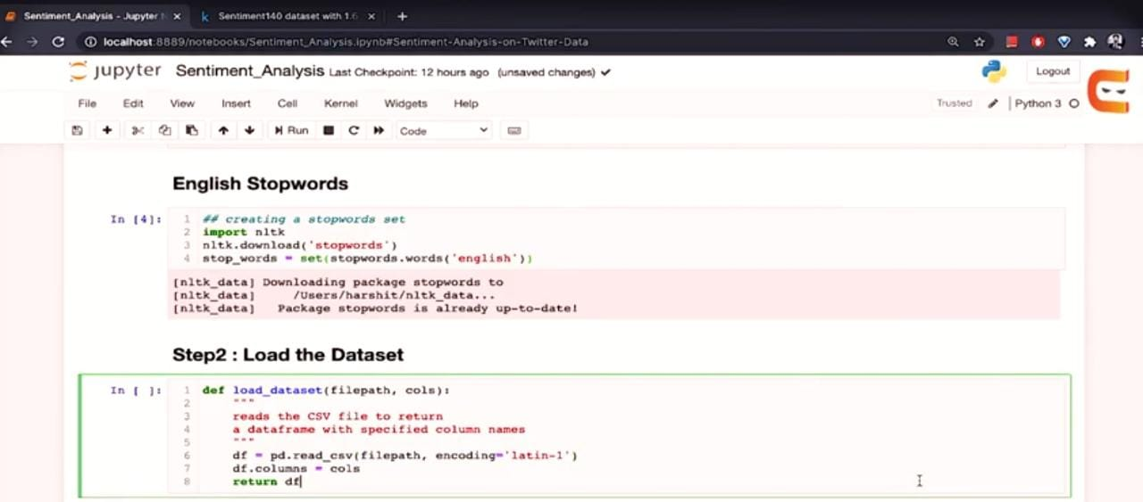

12

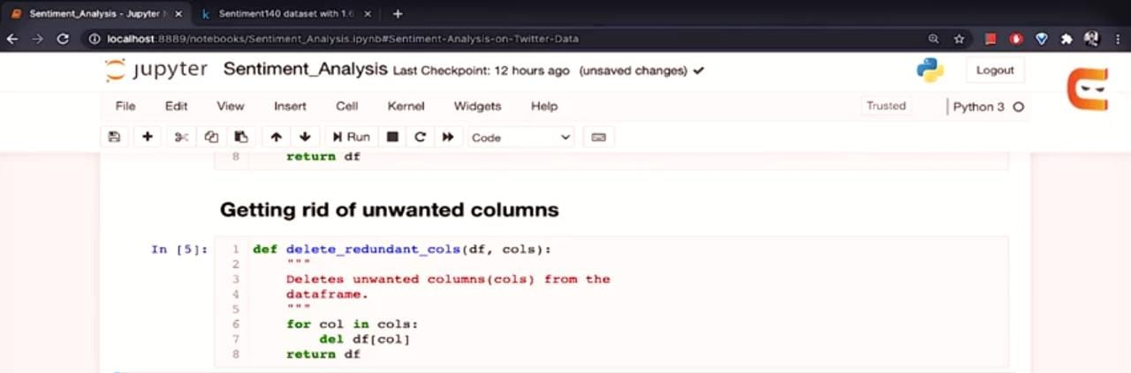

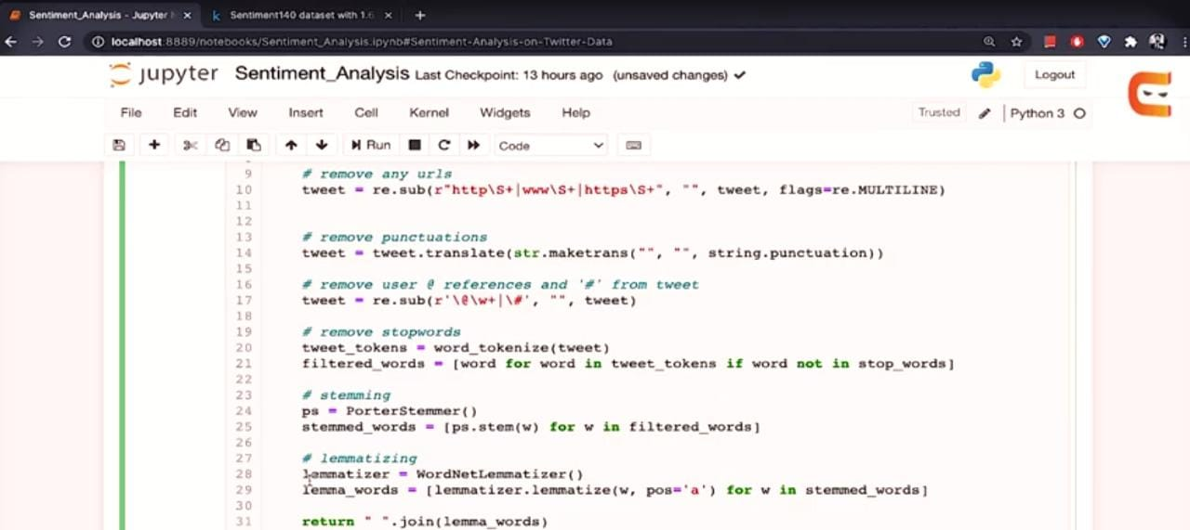

13

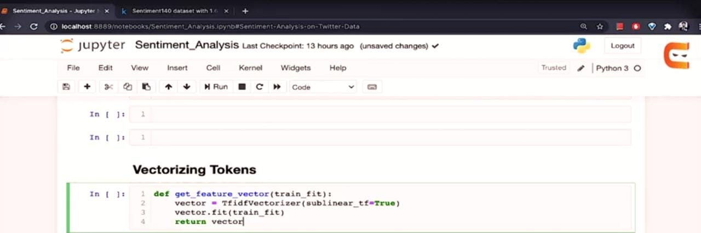

14

* 1. **CONCLUTION**

The package was designed in such a way that future modifications can be done easily. Thefollowing conclusionscan bededucedfromthedevelopmentoftheproject:

* Automationoftheentire systemimprovestheefficiency
* It provides a friendly graphical user interface which proves to be better when comparedtotheexistingsystem.
* Itgivesappropriateaccessto theauthorizedusersdependingon theirpermissions.
* Iteffectivelyovercomesthedelayin communications.
* Updatingofinformationbecomes so easier
* Systemsecurity,datasecurityandreliability arethestrikingfeatures.
* TheSystemhasadequatescope formodificationinfuture ifitis necessary.

15

# REFERENCE

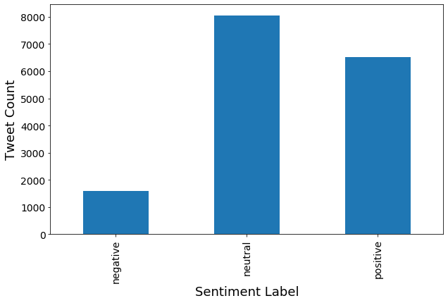

16