1.Introduction

ESTIMATION OF BUSINESS EXPENSES

1.1 Overview

 Estimating business expenses involves forecasting the costs associated with running your business. This includes fixed costs like rent, utilities, and salaries, as well as variable costs such as raw materials or marketing expenses. One-time expenses, like equipment purchases, should also be considered. A comprehensive budget helps in planning and ensuring financial stability for your business.

1.2 Purpose

The purpose of estimating business expenses is to gain a clear understanding of the financial requirements associated with running your business. It helps in: 1. **Financial Planning:** Allows you to plan for future expenditures and allocate resources accordingly. 2. **Budgeting:** Helps in creating a budget to manage and control spending, preventing financial surprises. 3. **Decision-Making:** Informs strategic decisions by providing insights into the financial implications of various choices. 4. **Investor and Stakeholder Communication:** Provides a transparent view of the financial needs of the business when communicating with investors or stakeholders. 5. **Risk Management:** Identifies potential financial risks and allows for contingency planning. In essence, estimating business expenses is a crucial aspect of financial management, contributing to the overall sustainability and success of the enterprise.

1.3 Important Characteristics

The important characteristics of estimating business expenses include: 1. **Accuracy:** Striving for precision in predicting costs to ensure realistic financial planning. 2. **Comprehensiveness:** Considering all relevant costs, including fixed, variable, and one-time expenses. 3. **Flexibility:** Being adaptable to changes in the business environment or unexpected circumstances. 4. **Regular Review:** Periodically reassessing and adjusting estimates to reflect changes in the business. 5. **Detail-Oriented:** Paying attention to the specifics of each cost category to avoid overlooking essential expenses. 6. **Realism:** Grounding estimates in realistic assumptions and market conditions. 7. **Purpose-Driven:** Aligning estimates with the specific goals and needs of the business. 8. **Transparency:** Providing clear and transparent documentation of how estimates were derived. By embodying these characteristics, the process of estimating business expenses becomes a valuable tool for effective financial management.

2. Problem Definition & Design Thinking'

2.1 Empathy Map

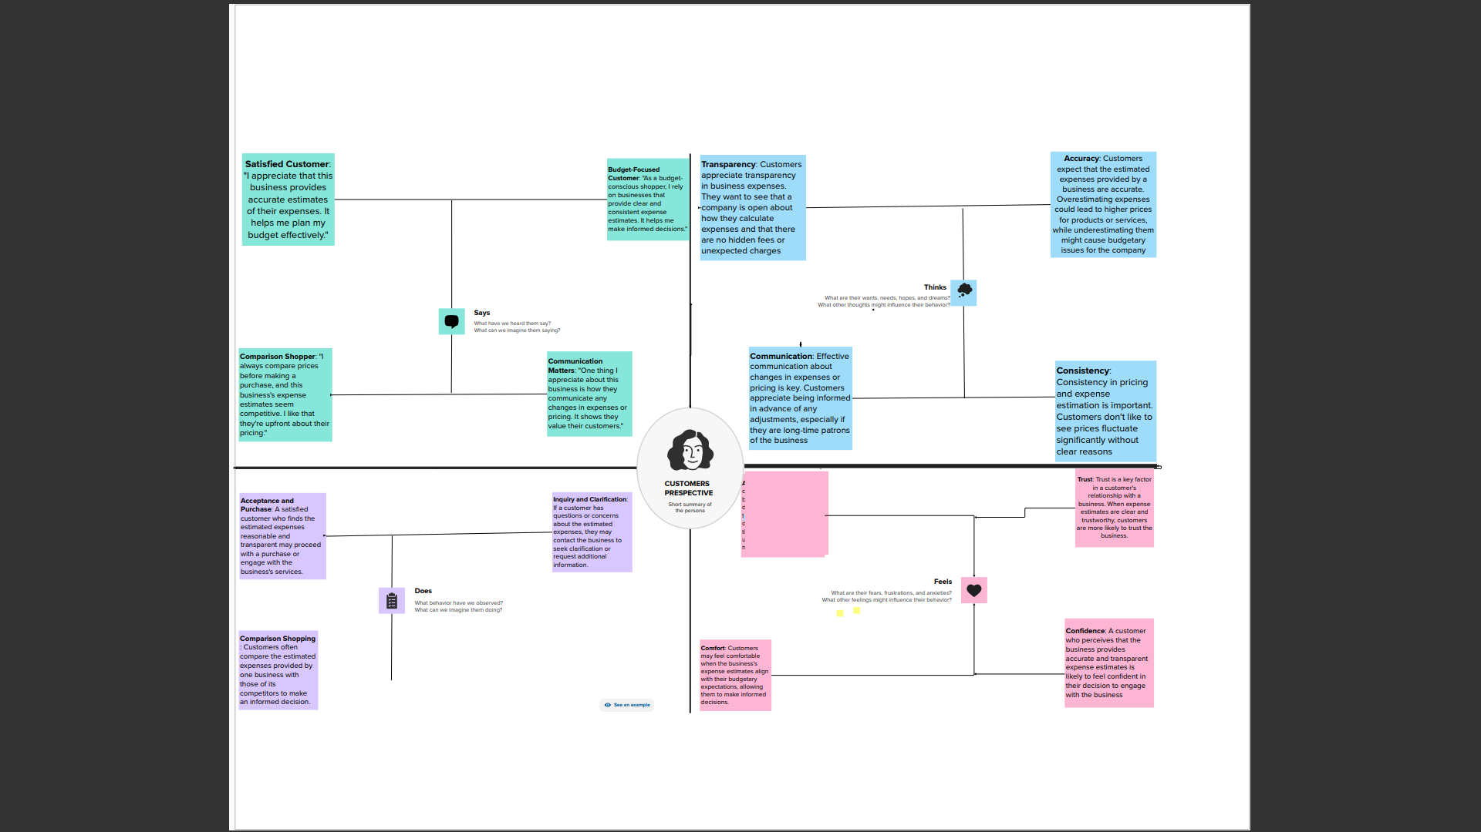

2.2 Ideation & Brainstorming Map

* 3 Result Dashboard

Story

* 4 ADVANTAGES:
* Estimating business expenses offers several advantages, including: 1. **Financial Planning:** Helps in creating a roadmap for allocating resources and managing finances effectively. 2. **Budget Formation:** Facilitates the development of a budget to control and monitor expenditures. 3. **Resource Allocation:** Enables businesses to allocate resources efficiently based on the prioritization of expenses. 4. **Decision Support:** Provides insights into the financial implications of various decisions, aiding in strategic planning. 5. **Risk Management:** Identifies potential financial risks and allows for the development of contingency plans. 6. **Performance Evaluation:** Serves as a benchmark for evaluating actual expenses against projected estimates. 7. **Investor Confidence:** Builds confidence among investors and stakeholders by showcasing a well-thought-out financial plan. 8. **Cost Control:** Fosters a proactive approach to managing costs, preventing overspending and ensuring financial stability. 9. **Operational Efficiency:** Encourages efficiency by highlighting areas where cost-saving measures can be implemented. 10. **Continuous Improvement:** Offers a basis for continuous improvement by learning from past estimates and refining future projections. In summary, estimating business expenses is a valuable practice that contributes to effective financial management, strategic decision-making, and the overall success of a business.

DISADVANTAGES

While estimating business expenses provides numerous benefits, it also has some potential disadvantages, including: 1. **Uncertainty:** Estimations are based on assumptions, and if these assumptions are inaccurate, the estimates may not reflect actual expenses. 2. **Complexity:** Estimating expenses can be a complex process, especially for businesses with diverse operations and numerous cost categories. 3. **Time-Consuming:** Creating accurate estimates requires time and resources, and the process may be time-consuming for businesses with limited staff. 4. **External Factors:** External factors such as changes in the economy or industry conditions can impact the accuracy of estimates. 5. **Rigidity:** In some cases, a rigid adherence to estimated figures may hinder adaptability to changing business conditions. 6. **Overemphasis on Short-Term:** The focus on short-term estimations may lead to neglecting long-term strategic considerations. 7. **Dependence on Historical Data:** Estimations often rely on historical data, which may not accurately predict future changes or disruptions. 8. **Over-Optimism:** There may be a tendency to be overly optimistic, leading to underestimation of costs. 9. **Inflexibility:** A too-strict adherence to estimated figures may hinder flexibility in responding to market changes or opportunities. 10. **Resource Intensive:** For smaller businesses with limited resources, the process of detailed estimation may be resource-intensive. It's important for businesses to be aware of these potential disadvantages and to continually refine and adapt their estimation processes to improve accuracy and effectiveness.

* 5 APPLICATIONS:
* **Expense estimation finds application in budget creation, aiding businesses in setting financial goals and resource allocation. It plays a vital role in strategic decision-making by providing insights into the financial implications of various choices. Accurate estimates contribute to effective risk management, identifying potential financial risks and facilitating contingency planning. Expense estimation supports performance evaluation, acting as a benchmark for assessing actual expenses against projections. It is instrumental in investor presentations, building confidence by demonstrating a clear understanding of financial needs and plans.**
* CONCLUSION:
* **In conclusion, mastering the art of business expense estimation is imperative for financial stability and strategic decision-making. As technology advances, the integration of AI and real-time analytics will refine the accuracy of predictions. A proactive approach to adapting and improving estimation processes will be crucial for businesses navigating dynamic markets. Enhanced automation and cloud-based solutions will streamline operations, allowing for more efficient resource allocation. Ultimately, businesses that embrace evolving techniques in expense estimation will be better positioned for sustained success in the future.**
* 7 FUTURE SCOPE:
* The future scope of business expense estimation is likely to be enhanced by advancements in artificial intelligence and machine learning, enabling more accurate predictions. Integration of real-time data analytics will provide businesses with dynamic insights for agile financial decision-making. Cloud-based solutions will facilitate collaborative and efficient expense estimation processes. Increasing automation will streamline repetitive tasks, allowing finance professionals to focus on strategic aspects. The future may also see the development of predictive models that leverage big data for more precise expense forecasting.
* APENDIX
* <https://public.tableau.com/views/Book3_16974599382310/Dashboard3?:language=en-US&:display_count=n&:origin=viz_share_link>
* <https://public.tableau.com/views/Book1_16974597660690/Story1?:language=en-US&:display_count=n&:origin=viz_share_link>