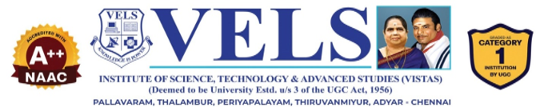
CARA: A GENAI-POWERED MULTI-AGENT CAREER READINESS ASSISTANT WITH ADAPTIVE MOCK INTERVIEW
S. Dharshana – [24619110]
S. Prisha – [24619148]
L. Nancy Jeba Sheela – [24619123]
MINI PROJECT REPORT
Submitted to the
SCHOOL OF ENGINEERING
DEPARTMENT OF ARTIFICIAL INTELLIGENCE AND MACHINE LEARNING
in Partial fulfillment of the requirements for the award of the degree of
BACHELOR OF TECHNOLOGY CSE
IN
ARTIFICIAL INTELLIGENCE AND MACHINE LEARNING
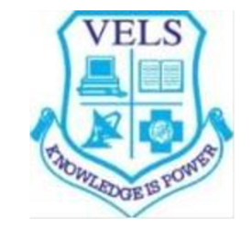
VELS INSTITUTE OF SCIENCE, TECHNOLOGY AND ADVANCED STUDIES (VISTAS)
CHENNAI – 600 117
OCTOBER 2026
BONAFIDE CERTIFICATE
This project report entitled “CARA: A GenAI-Powered Multi-Agent Career Readiness Assistant with Adaptive Mock Interview” is hereby certified to be the bonafide project of S. DHARSHANA – [24619110], S. PRISHA – [24619148] and L. NANCY JEBA SHEELA – [24619123], conducted under my guidance. It is further certified that, to the best of my knowledge, the project undertaken by them has not been undertaken elsewhere, nor used to obtain a degree/diploma/certificate from any other University/Institution on any other occasion.

SIGNATURE OF THE HOD  Dr. K. Ulaga Priya M.E., Ph.D  Associate Professor & Head  Department of AI&ML  School of Engineering  VISTAS, Chennai | SIGNATURE OF THE SUPERVISOR  Ms. P. Mohana Priya, M.E., (Ph.D)  Assistant Professor  Department of AI&ML  School of Engineering  VISTAS, Chennai

Submitted for the Project Work and Viva-Voce examination held on ……………… at Vels Institute of Science, Technology and Advanced Studies (VISTAS), Chennai – 600 117.

INTERNAL EXAMINER | EXTERNAL EXAMINER

ACKNOWLEDGEMENT
It is an immense pleasure and an honor to recognize the contribution and motivation that we have received from different minds all around us that made this endeavor a success. The infrastructural support and laboratory facilities provided by the institution have always acted as a booster in completing this project work. We express our heartfelt gratitude to our Founder & Chairman, Shri. Dr. Ishari K. Ganesh for the same.
Our sincere thanks to our Head of the Department, Dr. K. Ulaga Priya for her unwavering support throughout the project right from the initial advisory and contacts at the early stage of the conceptualization till today through her constant guidance and encouragement.
We extend our heartfelt thanks to the Project Guide, Ms. P. Mohana Priya, M.E., (Ph.D), Assistant Professor, who has guided us guidance, assistance, mentoring, and motivation during the inception of CARA.
We express our gratitude to the participants for the resume data and interview answers they provided us with to check the system out and their valuable feedback in the improvement of the project. We would like to thank the staff members, the Librarian and the non-teaching staff of the Computer Centre for their support and contribution through this endeavour of ours.
Lastly, we extend our gratitude towards our parents and friends who have been our greatest supporters and inspirations and have motivated us to keep striving for our projects.

S. DHARSHANA – [24619110]
S. PRISHA – [24619148]
L. NANCY JEBA SHEELA – [24619123]

TABLE OF CONTENTS
CHAPTER NO. | TABLE OF CONTENT | PAGE NO.
 | ABSTRACT | ii
1 | CHAPTER 1 – INTRODUCTION | 1
 | 1.1 Overview of the Project | 1
 | 1.2 Scope and Objective | 3
2 | CHAPTER 2 – LITERATURE REVIEW | 6
 | 2.1 Literature Review | 6
 | 2.2 Research Summary | 6
3 | CHAPTER 3 – SYSTEM DESIGN | 10
 | 3.1 Existing System | 10
 | 3.2 Proposed System | 10
 | 3.3 System Architecture | 12
 | 3.3.1 Resume Intelligence Agent | 14
 | 3.3.2 Explainable ATS Agent | 15
 | 3.3.3 Evidence-Based Skill Verification Agent | 15
 | 3.3.4 Personalized Learning Roadmap Agent | 15
 | 3.3.5 Context-Adaptive Mock Interview Agent | 15
 | 3.3.6 HR Decision Support Agent | 16
 | 3.4 Hardware Requirements | 16
 | 3.5 Software Requirements | 16
4 | CHAPTER 4 – IMPLEMENTATION | 18
 | 4.1 Methodology | 18
 | 4.2 Implementation | 19
 | 4.2.1 Resume Intelligence Agent | 19
 | 4.2.2 Explainable ATS Agent | 20
 | 4.2.3 Skill Verification Agent | 20
 | 4.2.4 Personalized Learning Roadmap Agent | 20
 | 4.2.5 Adaptive Mock Interview Agent | 21
 | 4.2.6 HR Decision Support Agent | 21
 | 4.3 Agent Communication and Integration | 21
5 | CHAPTER 5 – RESULTS, CONCLUSION AND FUTURE WORK | 22
 | 5.1 Results and Evaluation | 22
 | 5.2 Discussion | 23
 | 5.3 Challenges and Limitations | 24
 | 5.4 Conclusion | 24
 | 5.5 Future Work | 25
 | REFERENCES | 30

ABSTRACT
Job seekers today live in a job market that always wants more, even though the tools evaluating their resumes haven’t kept pace. Most of these tools still rely on keywords, returning a single score without explanation and no chance to bridge the gap. That’s why we’re launching CARA. CARA is an AI multi-agent platform to replace single scoring with continuous mentoring. At its core is a semantic encoder that compares a resume with a job posting, looking at meaning rather than exact words. Six agents then handle the rest: checking if the skills mentioned are backed by projects or work experience, decomposing the match score into its components, guiding the candidate through a roadmap, conducting a spoken mock interview via a talking avatar that assesses answers by meaning, tying every phase into one job-readiness plan, and delivering a hiring assessment from a recruiter’s viewpoint. Unlike ATSs that miss rephrased skills, or AI-based analyzers that score resumes without checking the claims made, CARA checks the evidence and explains its reasons at each stage. The current system uses pre-trained models without domain-specific fine-tuning and has been evaluated on a small set of resumes. Deeper analysis of voice tone and facial expression is still underway. In an era when a single missed callback can spell the end of a candidate’s dreams, CARA has been designed to make sure every candidate walks into the interview knowing exactly where they stand.
Keywords: Career readiness; Explainable AI; Resume verification; DistilBERT; ATS

CHAPTER 1. INTRODUCTION

1.1 OVERVIEW OF THE PROJECT
1.1.1 Introduction
The modern hiring process requires the use of computers as companies have many more applications than available positions. The traditional ATS help in reducing the load on hiring teams through automatic classification of resumes based on keywords, qualifications, and experience. However, exact matching is not always possible; the candidate with skills “developed models using Python” may fit the position that demands “machine-learning model development” despite the absence of these words in his/her CV.
Modern intelligent tools apply language models, which understand the meaning of the texts and calculate semantic similarity between the ideas. However, there is a problem with many of these systems – they provide just one number or a short list of candidates but fail to provide explanations for their scores. The applicant receives the result and does not understand its grounds or how he/she can improve in the future. To solve these problems, the project CARA – a GenAI-Powered Multi-Agent Career Readiness Assistant with Adaptive Mock Interview was created.
CARA receives the resume along with the job description and categorizes the information in the resume into skills, education, projects, certifications, work experience, roles and achievements. There is a semantic understanding component that matches the description in the resume to the requirements of the job. CARA thus finds the related experience irrespective of the mismatch in the vocabulary of the candidate and the hiring company. There are specialized agents that verify the skill claims using evidence, explain the score, create a learning plan, conduct an adaptive mock interview and finally generate a job readiness report.
1.1.2 Problem Statement
The existing resume screening and career guidance solutions have some deficiencies including:
- Keyword dependence: Existing ATS systems do a simple word-to-word matching and do not recognize any skills expressed in other words or contexts.
- Unexplained scores: Most applications provide a single score without identifying which skills are covered, which ones are lacking and the reasoning behind the particular score.
- Unverified statements: The skills indicated in a resume are taken as they are without verifying if there is any project, internship, certification or job experience that proves them. This increases the level of overestimation of preparedness.
- Disjointed preparation: Resume check, learning tips and mock interviews are all offered by separate applications, meaning that the candidates don’t get a seamless preparation process.
- Fixed mock interviews: Mock interviews in most applications contain pre-defined questions that are not based on the resume or previous responses of the candidate.
The main challenge here is the lack of an integrated, explainable and evidence-based mentorship from the beginning until the end of the interview.
1.1.3 Objective of the Project
The objectives of this project include:
- Comparing the resumes with the job description through semantic meaning rather than keyword matching using semantic encoding.
- Parsing out skills, education, projects, certification and experience of the resume available in PDF/DOCX/plaintext format.
- Validating whether the skills stated by the candidate have been validated through projects, internships, certification or any work experience.
- Decomposing the match score into understandable segments so that the candidate can understand their strong points and weak points.
- Creating a personalized learning map based on what to learn, what projects to do, what certifications to achieve and practice interview-wise.
- Performing an adaptive interview simulation taking into account the context and evaluating the response in terms of relevancy, completeness, accuracy and clarity.
- Aggregating all these phases together to produce a Career Readiness Score and a decision report for the recruiter.
1.1.4 System Description
CARA was designed using the architecture of multiple agents controlled by the Generative AI. The agents operate in a sequential manner within one context, which is the Resume Intelligence Agent, the Explainable ATS Agent (Semantic ATS Matching), the Skill Verification Agent, the Personalized Learning Roadmap Agent, the Adaptive Mock Interview Agent (Feedback-based) and the HR Decision Support Agent. The output from one agent serves as input for the other, and the last agent ties it all together and creates the final readiness assessment.
Advantages of the System
- Understanding the meaning of text means that no rephrased skills are overlooked.
- Each score comes with explanation rather than one number without.
- Checking the evidence behind every skill means that there is no over-estimation based on keywords.
- Weaknesses are turned into a personalized learning plan.
- Interview practice is adaptive to the candidate’s resume and previous answers.
Applications of the Project
- Students and fresh graduates for placements and entry level jobs.
- Professional people who wish to get insight into whether they are suited for a particular position.
- Training and placement cells of various colleges for resume optimization and interview preparation.
- Recruiters and managers who require an explainable and evidence-based evaluation of candidates.
1.1.5 Expected Results
This project is expected to produce a prototype which takes a resume and a job description as input and outputs an explainable report on match, verifies skillset, provides a personalized roadmap, conduct adaptive interview simulation and outputs a Career Readiness Score along with an HR decision report.
1.1.6 Future Scope
Future versions of CARA will have multilingual resume support, integration with live job portals, video interview analysis, enhanced security of data, fairness and bias inspection of algorithms, enriched career knowledgebase and suitable learning material recommendation.

1.2 SCOPE AND OBJECTIVE
1.2.1 Purpose of Study
This research will develop a new AI model that transforms the traditional practice of resume evaluation into a continual process of preparing for one’s career. This research will explore the integration of the semantic embedding, evidence-based verification, and adaptive interviewing in a multi-agent framework and analyze how such a framework can be explainable to both candidates and recruiters.
1.2.2 General Objective
Development of an explainable, multi-agent, GenAI-based career readiness platform, which evaluates the candidate’s resume against the job description through meaning, verifies claims of the resume, creates a personalized learning roadmap, and measures the readiness level through the adaptive mock interview.
1.2.3 Specific Objective
- Resume Intelligence: Parsing of the PDF/DOCX/text resumes and extraction of structured information, such as skills, education, projects, certifications, and work experience.
- Explainable ATS: Encoding of the resume and job description through Sentence-Transformer (DistilBERT with pooling), calculation of cosine similarity and decomposition of the score in skill, education, experience, and project components.
- Skill Verification: Classification of every claimed skill as verified, partially supported, unsupported, and missing based on the evidence.
- Learning Roadmap: Comparison of verified skills with the requirements and recommendation of topics, projects, certifications, and learning steps.
- Mock Interview: Generate role-based competency and HR questions, collect answers orally and analyze them semantically.
- HR Decision Support: Consolidate the output of all agents into Career Readiness Score and a report for a recruiter.
1.2.4 Project Scope
A. Input scope. The system processes resumes in PDF, DOCX and text-only format along with job descriptions specified by the user. It can also process career aspirations and a desired role.
B. Functional scope. The system provides functionality related to resume parsing, job description analysis, semantic resume-job matching, skills evaluation, score justification, mock interview, creation of learning plan and job readiness report.
C. Application scope. The system is aimed mostly at students, fresh graduates and people in the initial career stage. It helps job seekers directly and can produce reports for recruiters as well. The first version will use pre-trained models and a small number of examples without industry customization.
1.2.5 System Functionality Overview
Table 1.1 Functional overview of the CARA agents
Agent | Main Input | Main Output
Resume Intelligence | Resume (PDF/DOCX/text) | Structured feature vector of the candidate
Explainable ATS | Candidate features, job description | Semantic match score and its components
Skill Verification | Claimed skills, projects, certificates, experience | Verified / partial / unsupported / missing skills
Learning Roadmap | Skill gaps, career goals | Personalized preparation plan
Adaptive Mock Interview | Resume, role, skills, earlier answers | Question set, answer evaluation, interview score
HR Decision Support | Outputs of all agents | Career Readiness Score and recruiter report

1.2.6 Hardware and Software Specification
CARA is a Python web application operating on a regular computer. Since it works with pre-trained models for inference only, there is no need for any particular training hardware. More details on the hardware and software requirements can be found in Sections 3.4 and 3.5.
Advantages of the Proposed System
- Candidates will receive an informed feedback instead of a mere score.
- Recruiters will get a transparent understanding of how readiness assessment was carried out.
- Preparation is a continuous process that involves matching, gap analysis, learning, and interview practice in one pipeline.
1.2.7 Issues and Limitation
Currently, the proposed system does not make use of domain-specific fine-tuned pre-trained models and is tested only on a few resumes. The assessment of voice tone and facial expression is still work-in-progress, and multi-language capabilities have not been added yet. These issues are elaborated in Section 5.3.
1.2.8 Future Improvements
Multilingual resume analysis, security and privacy of user data, compatibility with other recruitment services and job boards, fairness and bias checking, career information enrichment, learning resources recommendations, and ongoing updates of job readiness information are among the planned improvements.
1.2.9 Expected Outcome
The objective of this project is to prove that the explainable design of multiple agents can provide a better and more insightful understanding of their preparedness compared to traditional keyword searches.

CHAPTER 2. LITERATURE REVIEW

2.1 LITERATURE REVIEW
The implementation of artificial intelligence in recruitment has advanced from the basic technique of using keyword filters to semantic models that allow the meaning of the text to be derived. The earliest resume screening systems used simple keyword matching and various statistics, including Term Frequency-Inverse Document Frequency (TF-IDF). Later approaches widely adopted the use of word representations, named entity recognition for skill extraction, and even newer techniques, including transformer models like BERT and Sentence-BERT, that allow representing entire sentences or documents in vector form. At the same time, scientists started to apply generative AI in the development of mock interview systems and to consolidate several steps of career preparation into multi-agent platforms. In this literature review, the aforementioned related literature is analyzed in order to highlight the gap that is addressed by CARA. This review serves the following purposes:
- Evaluate the implementation of natural language processing used for resume parsing, skill extraction and resume-job matching;
- Evaluate the performance of keyword-based, embedding-based, and deep learning-based methods;
- Examine the current state of multi-agent career platforms and AI-based mock interview systems;
- In order to discover the gaps in the research area of explainability, evidence-based skills verification and integration.

2.2 RESEARCH SUMMARY
In this section, literature is summarised thematically by ideal insight in resume screening with NLP, embedding and deep learning methods, multi-agent employment platforms, and AI applications in mock interview systems.
2.2.1 The Role of AI in Recruitment and Resume Screening
In the paper by Saranya et al. [1], an algorithmic procedure was designed which implements techniques of NLP, spaCy and Word2Vec, thus enhancing resume screening and job matching processes. Methods for the extraction of skills and resumes via the application of keyword matching and vectorisation were implemented in this work. The paper discusses a positive impact of AI on making recruitment processes more accessible and fair.
Amir Hussin and his colleagues designed their online intelligent application—Progressive Web Application (PWA)—consisting of two modules, one for recruiters and one for job-seekers [2]. The skill extraction process relies on named entity matching using spaCy. Additional semantic matching techniques rely on Semantic BERT model with cosine similarity metrics being used as the main one. According to the evaluation, the application succeeded in user-acceptance tests and showed 100% rate of accuracy for semantic match, 97.5 for skill extraction precision, 87.7% for recall, and F1-score amounting to 92.2%.
[5] The use of tokenization, stop-word removal and lemmatization transforms documents to TF-IDF vectors, and calculates the normalized cosine similarity score. Such method is a simple and effective baseline as large pre-trained models are not required. The Resume Analyzer based on Artificial Intelligence and Machine Learning employs [7] TF-IDF for extracting features, cosine similarity for matching and random forest classifier, thus achieving an accuracy rate of 86%. The authors suggest that further investigations should pay attention to deep learning and multilingual capabilities. [10] The major concept such as NLP, TF-IDF and cosine similarity was used as well in the research study “Intelligent Resume Screening and Job Relevance Analysis” to make recruitment effective and relevant.
2.2.2 Embedding and Deep Learning Approaches
The paper presented during the 5th International Conference on Pervasive Computing and Social Networking explores resumes and matches them with job offers by using: BERT embeddings, TF-IDF and K-Nearest Neighbours. It is claimed that using these technologies resulted in state-of-the-art match accuracy and processing time as well as decreased human prejudices created by utilizing the transformer context.
[6] uses both transformer embeddings and large language models which have been modified through the LoRA technique. This method has resulted in a job recommendation accuracy of 91.3%, which is higher than 74.2% of the results obtained through TF-IDF, 86.4% from BERT, and 90.1% achieved by SBERT. Moreover, the authors mention the areas of cross-lingual analysis and biases reduction as future research areas. Results show the efficiency of using the semantic encoders based on transformers as opposed to keyword-based approaches.
2.2.3 Multi-Agent Career Platform
Sharma et al. [3] developed the Smart Career Advisor, which is a multi-agent career platform that incorporates resume analysis, hybrid job recommendation, mock interview, career planning, and feedback generation. The platform itself has been constructed using FastAPI, React, MongoDB, Redis, and RabbitMQ and it is capable of assessing candidates on their abilities, skills, and HR capabilities.
2.2.4 The Artificial Intelligence Based System of Mock Interview Training
The mock interview training tool using artificial intelligence was developed by Agarwal et al. [8]. It uses a real-time question generation mechanism and speech and facial expression recognition technology in order to assess both technical skills and confidence level. Due to multimodal feedback mechanisms, it is more effective than text-based systems.
Intervalyze is an automatic mock interview testing system based on speech emotion detection and semantics analysis [9]. Speech transcription and emotion detection are carried out using Wav2Vec2 models and semantics analysis is done using the BERT model.
2.2.5 Summary of Related Work
Table 2.2.5 Summary of the reviewed studies
Ref. | Technique | Key Contribution | Gap with respect to CARA
[1] | spaCy, Word2Vec | Data-driven screening and job matching | Keyword/vector based; no skill verification or interview stage
[2] | NER, SBERT, cosine, TF-IDF fallback | Dual-module PWA; 97.5% precision in skill extraction | Matching only; no evidence check or roadmap
[3] | Multi-agent, FastAPI, React | End-to-end advisor with interviews and roadmap | Focus on workflow; claim verification not emphasised
[4] | BERT, TF-IDF, KNN | Better accuracy and speed than conventional methods | No explanation of score components
[5] | TF-IDF, cosine similarity | Simple baseline scorer | Lexical; misses rephrased skills
[6] | SBERT + LoRA LLM | 91.3% job-recommendation accuracy | Recommendation only; no interview or verification
[7] | TF-IDF, random forest | 86% accuracy | Single-stage screening
[8] | Generative AI, speech and face analysis | Multimodal adaptive mock interview | Interview only; not linked to resume evidence
[9] | Wav2Vec2, BERT similarity | Emotion and semantic interview assessment | Interview only
[10] | NLP, TF-IDF, cosine | Resume–job relevance analysis | Keyword based; no feedback loop

2.2.6 Identified Gap in Research
- Not being explainable: Current systems generate a score or a ranking without decomposition into understandable parts.
- Not being verified by evidence: Skills are taken as given since they are mentioned on the resume; only a tiny number of systems try to verify if projects, certifications, or work experience prove the existence of such skills.
- Not being integrated: Resume analysis, learning assistance and interview practice are usually provided as standalone systems.
- Not being personalized: Interview questions and learning recommendations are typically not related to the candidate’s verified strengths and gaps.
- Not assisting recruiters: Only a few systems convert the candidate’s workflow into a form suitable for the recruiter’s assessment.
2.2.7 Literature Results Summary
The literature reveals a trend in shifting from keyword matching to transformer-based semantic matching with the increasing accuracy and the emergence of multi-agent and multimodal career preparation solutions. However, explainable scoring, evidence-based verification of skills and a unified pipeline from matching to learning and interviewing are still underexplored areas. CARA will fill precisely this gap with a combination of six specialized agents performing claims verification, explainability and coaching.

CHAPTER 3 – SYSTEM DESIGN

3.1 Existing System
The current resume analysis and career preparation system can be broadly classified into three categories.
Traditional Applicant Tracking Systems. These analyze and filter resumes based on the keywords, credentials, and years of experience. The systems are fast but only consider the exact matches and ignore similar skills. A resume that states “developed models using Python” would rank low for “machine-learning model development” position.
AI-based resume analyzers. These employ embedding or classification techniques to rate the resume based on the job description and are less strict as compared to keyword filtering systems. However, these systems output either a single score or short list of suggestions without disclosing the logic behind the score. Furthermore, they rely on the skills stated in the resume without considering whether the candidate’s project/internship/previous experience is relevant or not.
Preparation tools in isolation. Mock interview applications, learning course recommender systems and resume generation systems solve a part of the problem independently of each other. Thus, the interview questions are not related to the resume, and learning recommendations are not linked to the gap analysis.
Limitations of the Existing System
- The dependency on exact keywords results in missed matches and rejection of resumes.
- A one-time unexplained score does not give any opportunity for improvement.
- The claimed skills are not verified for evidence and thus readiness may be overrated.
- The processes of resume analysis, personal learning recommendations and interview training are not linked together.
- Mock interviews are static and do not adapt to the candidates’ background and responses.
- The recruiters get scores without a clear explanation.

3.2 Proposed System
CARA is a Multi-Agent Career Readiness Assistant based on generative AI. This system takes as input a resume in one of three formats – PDF, DOCX and plain text and job description and passes this input through six agents sharing the same context. Rather than providing just a score, CARA explains this score, verifies claimed skills for the evidence, develops a personalized plan, conducts adaptive mock interviews and finally provides a consolidated Career Readiness Score (CRS).
Main Features
- Semantic Matching: It implies comparing the resume and job description using Sentence-Transformer based on the DistilBERT technology by calculating the cosine similarity metric.
- Match Score Explanation: Match score includes skills match score, education match score, experience match score, and project match score.
- Skills Verification: Each skill has verification status, indicating whether it is verified, partially verified, unverified, or not mentioned.
- Personalized Roadmap: Discrepancies refer to learnable aspects, projects that can be built, certificates that need to be received, and interviews that should be prepared.
- Adaptive Mock Interview: The questions are generated according to the resume, position, skills, and previously asked questions.
- HR Recommendation System: All of the above-mentioned features are implemented within the CRS and are partly incorporated in Human Resource Assessment process.
Advantages over the Existing System
Table 3.1 Comparison of the existing and proposed systems
Aspect | Existing Systems | Proposed System (CARA)
Matching method | Keyword or lexical matching | Semantic matching using DistilBERT embeddings
Score explanation | Single score, no reasons | Score decomposed into components with strengths and gaps
Skill claims | Accepted as written | Verified against projects, certificates, education and experience
Guidance | None or generic | Personalized learning roadmap
Interview practice | Fixed questions, separate tool | Context-aware adaptive interview within the same system
Recruiter view | Ranked list only | Evidence-based HR decision report with CRS
Workflow | Fragmented tools | Single integrated six-agent pipeline

3.3 SYSTEM ARCHITECTURE
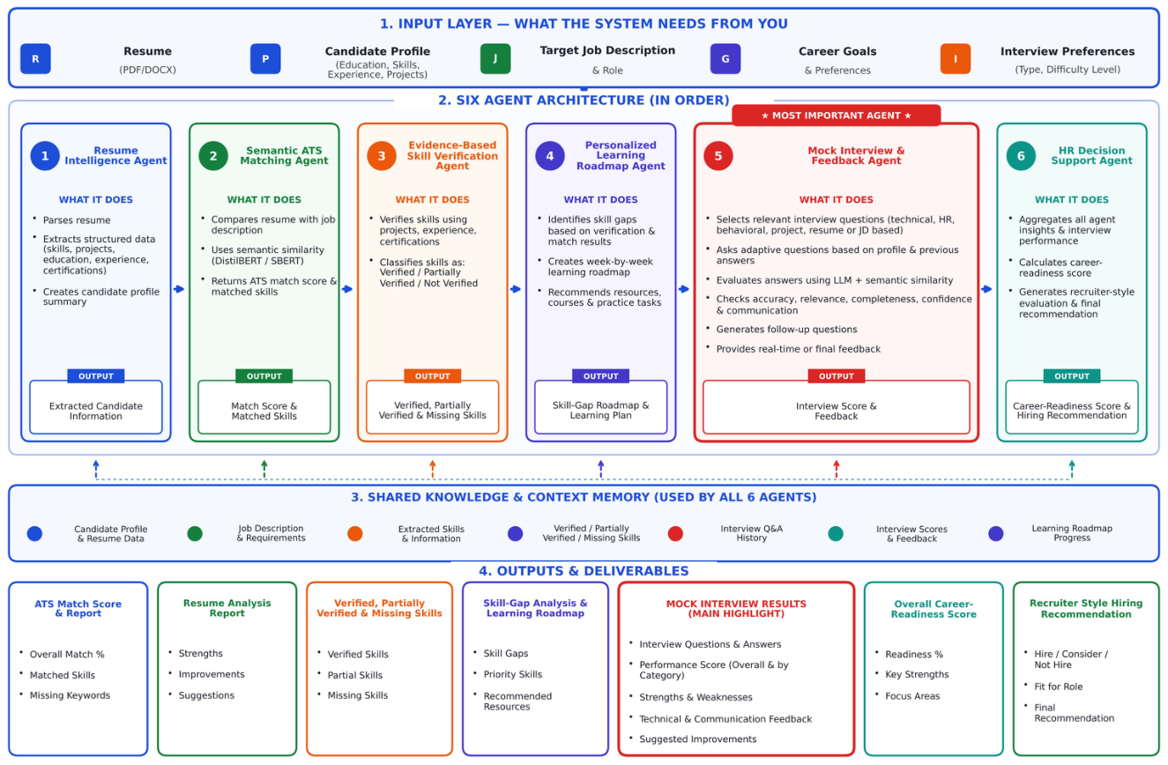
Figure 1. System architecture of CARA.
Architectural Overview
The CARA system architecture uses a multi-agent design. In this design several specialized agents carry out stages of the career-readiness process. This CARA architecture lets the system accept candidate information process a resume and job requirements, analyze skills and experience give recommendations run a flexible mock interview and produce an overall career-readiness assessment.
The system takes as inputs the candidate’s resume profile details, skills, education, experience, career goals and preferences. A job description can also be entered if the candidate wishes to see how well the resume fits a role. The architecture has an input layer, an AI processing layer, a multi-agent layer, a shared knowledge and context layer a backend communication layer and an output layer. The agents talk to each other through the backend and share candidate data so that the results, from one stage can feed into the stage.
Step 1: Candidate Input
The system starts by gathering the details needed for career-readiness analysis. The candidate can upload a resume that’s in supported formats like PDF or DOCX and also share more information about their profile. The main things that are collected include:
- Resume
- Candidate profile
- Skills
- Educational qualifications
- Work experience
- Projects and certifications
- Career goals
- Career preferences
- Job description if needed
The job description is not required because the system can do a resume and career analysis even if a specific job description is not given. The information that is gathered is sent to the backend, for processing.
Step 2: Resume Processing and Information Extraction
The resume that was uploaded is processed to find and arrange details about the candidate. Natural Language Processing methods are used to pull out information from the resume. The processing involves finding:
- Skills
- Education
- Work experience
- Projects
- Certifications
- Roles and responsibilities
- Achievements
spaCy is used for resume parsing and for getting information using natural language processing. The information that is found is organized so that it can be used by the parts of the system in the next steps. This step changes the resume that has no structure into information, about the candidate that the system can work with.
Step 3: Semantic Analysis and Matching
After pulling out the needed details CARA goes through a semantic analysis phase. This step helps the system understand what the candidate’s resume really means and how it connects to the job requirements that have been chosen. To do this CARA uses DistilBERT. Sentence embeddings. These tools turn the text into a format that captures meaning, not words. Than just looking for exact keywords the system tries to find deeper connections between the candidate’s background and what the job is asking for.
When a job description is given the system compares the resume and the job description using cosine similarity. This measure shows how similar the two pieces of text are in terms of meaning. It helps judge how well the candidate fits the role. This semantic processing stage gives the information for the next steps. These include ATS screening, skill verification and checking career readiness. All these stages depend on understanding the match, between the candidate and the job.
Step 4: Multi-Agent Processing
Once the candidate data has been processed, it is put in front of six agents, each with a dedicated role in the career-readiness workflow.
3.3.1 Resume Intelligence Agent
This agent takes the uploaded resume and puts the key information in order. It will parse out
- candidate’s skills
- education
- Experience
- projects
- certifications
- achievements.
The resulting structure is then made available to the other agents for their own analysis.
3.3.2 Explainable ATS Agent
To see how well a given resume fits the bill for a particular job, the Explainable ATS Agent measures compatibility and produces an ATS Match Score. More than just a number, the agent provides an explanation of what is driving that score by looking at such things as project relevance, education and work history. In this way the candidate can see where the resume aligns with the position and where there is room for improvement.
3.3.3 Evidence-Based Skill Verification Agent
The purpose of this agent is to verify that the skills a candidate puts forward are backed up in the resume. The evidence can include:
- Projects
- Internships
- Work experience
- Certifications
- Other relevant experiences
It can tell which abilities have evidence to support them and which might need some further confirmation.
3.3.4 Personalized Learning Roadmap Agent
The Personalized Learning Roadmap Agent uses the identified skill gaps and the candidate’s career goals to generate suitable learning recommendations. The recommendations can help the candidate understand:
- Which skills need improvement
- What areas should be learned
- What type of projects can be undertaken
- Which areas require additional preparation
The purpose of this agent is to convert identified weaknesses into an actionable learning path.
3.3.5 Context- Adaptive Mock Interview Agent
The Context-Aware Adaptive Mock Interview Agent is useful because it provides a text-based mock interview that matches a candidates profile and career goals. The Context-Aware Adaptive Mock Interview Agent writes interview questions. Checks a candidates responses, for the following aspects:
- Relevance
- Completeness
- Correctness
- Clarity
The Context-Aware Adaptive Mock Interview Agent can change its later questions based on a candidates earlier answers making the interview more context-aware.
3.3.6 HR Decision Support Agent
The HR Decision Support Agent combines the information generated by the other agents to provide an overall assessment of the candidate. The HR Decision Support Agent pulls together the data that other agents produce. The HR Decision Support Agent looks at the ATS analysis the skill verification, the skill-gap analysis, the learning recommendations and the mock interview performance. The HR Decision Support Agent then uses all those results to calculate a Career Readiness Score (CRS). The HR Decision Support Agent delivers a HR-oriented assessment of the candidate.

3.4 HARDWARE REQUIREMENTS
Component | Minimum specification
Processor | Intel Core i5 (8th Gen) / AMD Ryzen 5 or equivalent
RAM | 8 GB (16 GB recommended for running transformer models locally)
Storage | 5 GB free space
Microphone | Needed for the voice mock interview
Internet connection | Needed for the Gemini API calls

3.5 SOFTWARE REQUIREMENTS
Category | Technology Used
Operating System | Windows 10/11, macOS, or Linux
Frontend | React.js, Vite, HTML5, CSS3, JavaScript
Backend | Python, FastAPI, Flask (Agent 5), CORS for API communication
Agent 1 — Resume Intelligence | Python, NLP, resume parsing, PDF/DOCX processing
Agent 2 — Semantic ATS Matching | Python, DistilBERT, NLP, cosine similarity
Agent 3 — Skill Verification | Python, NLP, evidence-based verification
Agent 4 — Learning Roadmap | Python, NLP, skill-gap analysis, personalised roadmap
Agent 5 — Adaptive Mock Interview | Flask, Google Gemini API (Gemini 3.1 Flash-Lite), Web Speech API
Agent 6 — HR Decision Support | Python, FastAPI, Career Readiness Score, agent-wise analysis
Voice Interaction | Web Speech API — SpeechSynthesis (TTS) and SpeechRecognition (STT)
Database | MySQL
Development Tools | VS Code, Git

CHAPTER 4 – IMPLEMENTATION

4.1 METHODOLOGY
CARA is built on a multi-agent system using Generative AI to convert a resume and job description into a structured evaluation of how ready the candidate is for the role. First, the resume (can be in PDF or DOCX format) is uploaded along with the job description.
The Resume Intelligence agent extracts entities from the resume using spaCy. It uses PyMuPDF and python-docx to extract and parse the contents of the resume. This includes skills, education, projects, certifications and work experience. All these attributes make up a feature vector that gets passed to the other agents.
The Semantic ATS Matching agent then matches the candidates features against the job description. Both resume and job description get converted into vectors using the Sentence-Transformer model (DistilBERT with mean pooling). This will create a contextual vector representation of the text. The similarity between the resume and job description is calculated using cosine similarity:
Cosine Similarity (A, B) = (A · B) / (|A| × |B|) (1)
A · B = dot product of vectors A and B
|A| = magnitude (norm) of vector A
|B| = magnitude (norm) of vector B
where A is the embedding vector of the resume and B is the embedding vector of the job description. The cosine similarity ranges from -1 to 1: a value of 1 means a perfect match (same meaning), 0 means no similarity, and -1 means opposite meaning. The higher the value, the better the candidate matches the requirements of the job description. The resulting ATS match score, A, forms the basis for the assessment of job-matching readiness.
Each claimed skill is validated based on the evidence provided by the projects, certifications, work experience and education. A classification will be given for each skill (verified, partially supported, no support and missing). This ensures we do not inflate readiness score by just looking at keywords.
The Mock Interview & Feedback Agent will generate interview questions that are relevant to the role. These will include aptitude and HR based questions. The candidates verbal answers will be recorded using the browsers Web Speech API. The text version will be assessed to determine if it is relevant, accurate and well communicated based on their claims in their resume. This is done using a transformer-based language model. This will give us an interview score (I) which will be used to calculate the overall readiness score.
The Learning Roadmap Agent will identify any skill gaps based on the validated skills and the requirements from the job description. It will provide targeted recommendations. Finally, the HR Decision Support Agent collects the outputs of all agents and computes an overall Career Readiness Score (CRS):
CRS = w₁R + w₂A + w₃S + w₄I (2)
where R is the Resume Intelligence score, A is the ATS match score, S is the Skill Verification score, and I is the Interview performance score. The weights are all positive and sum to 1, as in Equation (3); each weight shows how important that agent’s score is to the final result.
w₁ + w₂ + w₃ + w₄ = 1 (3)
The formula combines the scores from the different agents into one overall Career Readiness Score (CRS).

4.2 IMPLEMENTATION
CARA has been implemented using a modular multi-agent approach. There are 6 distinct agents each designed to complete specific tasks within a career readiness process. We have used React.js and Vite for our frontend and a Python backend with FastAPI and Flask. We have also used MySQL for our database. Our resume analysis, semantic matching, skills validation, recommendation for learning and interviews have all been made possible using NLP and AI. Each agent work together using an API to share information about candidates. Each agent completes the task required in their respective role.
4.2.1 Resume Intelligence Agent
The Resume Intelligence Agent is used to parse the candidate resume and extract relevant information. It has been implemented using Python, NLP and resume parsing techniques. The resumes in PDF/DOCX format are given as input to the Resume Intelligence Agent and it parses out the necessary information such as skills, education, experience, projects, certifications etc. This information is structured as a Candidate Profile and passed on to the other agents.
Technologies used:
Python, NLP, resume parsing, PDF/DOCX processing.
Output:
Extracted candidate information and candidate profile summary.
4.2.2 Explainable ATS Matching Agent
This agent compares the candidate and job description by using semantic analysis to look at how well the candidate matches the target job description. It uses technologies such as DistilBERT and Natural Language Processing (NLP) to analyse the text of the resume and job description. This will calculate how similar the texts are using cosine similarity. It will also give a matching score and identify which skills have matched to help the candidate see why they match well with the job role.
Technologies Used:
Python DistilBERT NLP Cosine Similarity
Outputs:
ATS Match Score Skills Matched Matching Information
4.2.3 Evidence-Based Skill Verifier
This agent looks at the skills that have been claimed and determines whether there is any evidence provided in the resume to back up these claims. The evidence can be provided through projects, certificates, internships and work experience. The skills are grouped based on how much evidence is present and which skills need more verification. This gives a clearer understanding of what skills have been shown and where they could improve.
Technologies Used: Python, NLP, Evidence Based Verification
Output: Verified Skills, Partially Verified Skills and Skills to Verify.
4.2.4 Personalized Learning Roadmap Agent
This agent generates a learning roadmap, using Python and NLP to analyze a candidates skill gaps and career goals. It will prioritize the skill gaps that have been identified and recommend the appropriate learning activities and resources to complete. This gives the candidate a roadmap they can use to prepare for the requirements of their desired career.
Technologies Used:
- Python
- NLP
- Skill Gap Analysis
- Personalized Roadmap Generation
Output:
- Skill Gap Analysis
- Personalized Learning Roadmap
4.2.5 Adaptive Mock Interview and Feedback Agent
This is used for helping prepare candidates for interviews by generating relevant questions and giving feedback on their answers to these. Technologies used include; Flask, Google Gemini API, Gemini 3.1 Flash-Lite and Web Speech API.
This uses the information provided about the candidate and context relating to the job to generate relevant questions to ask during an interview. It then analyses how the candidate answered to give them feedback and recommendations. Further questions can also be generated depending on how they answered previous questions.
Technologies shown: Flask, Google Gemini API, Gemini 3.1 Flash-Lite, Web Speech API.
Output: Interview questions, answer evaluation, feedback, and interview performance information.
4.2.6 HR Decision Support Agent
This HR Decision Support Agent takes all the outputs of the other agents to give an overall look at how career ready the candidate is. This uses Python and FastAPI. It takes information regarding how well they matched on ATS, if their skills are verified, their learning recommendations and how they performed in interviews. It then produces a Career Readiness Score and an individual analysis of each agent, highlighting areas the candidate is good at and areas they need to work on.
Technologies Used: Python, FastAPI, Career Readiness Score, Individual Analysis.
Outputs: Career Readiness Score, Overall Analysis, Recommendations (in an HR Style).
4.3 Agent Communication and Integration
Frontend was created using React.js, Vite, HTML, CSS & JavaScript. This allows users to enter information as a candidate and view the results from agents. The backend was built using Python, FastAPI & Flask. Frontend and backend are able to communicate with each other due to CORS being used, this allows for cross origin resource sharing. Frontend can send requests using API. The database uses MySQL to store structured data. The Frontend, Backend, Database & specialised agents all work together to create a connected career readiness process.
Technologies Used: React.js, Vite, HTML, CSS, JavaScript, Python, FastAPI, Flask, CORS & MySQL.

CHAPTER 5 – RESULTS, CONCLUSION AND FUTURE WORK

5.1 RESULTS AND EVALUATION
CARA is built to integrate six career readiness functions in an integrated process, including Resume Intelligence, Explainable ATS Matching, Evidence-Based Skill Verification, Personalized Learning Roadmap, CAIA (Context-Aware Adaptive Interview Agent), and HR Decision Support. In the evaluation of the prototype, it needs to be checked whether each individual agent generates a valuable output and whether the outputs generated by each individual agent are combined and presented on the dashboard properly. The following evaluation topics can be considered for the current system design:
- Resume Intelligence: It needs to be checked whether the relevant information, including education, skills, projects, and experience are pulled out of the resume and structured in a profile.
- Explainable ATS Matching: It needs to be checked whether the system finds out what requirements are matched, partially matched, and not matched at all.
- Evidence-based skill verification: examine whether the claimed skills differ from the skills backed up with project, certification or portfolio evidence.
- Learning roadmap that’s personalized: examine whether the suggestions take into account the gaps revealed for the selected target job.
- CAIA adaptive mock interview: examine whether the questions and follow-up questions use the target job and answers received previously and provide feedback based on a certain rubric.
- HR decision support and dashboard: examine whether the summary corresponds with the agent outputs and shows the weighted components properly.
In this project, the following weights have been defined for the readiness framework: Resume Intelligence – 10%, ATS Matching – 20%, Skill Verification – 15%, Learning Roadmap – 15%, CAIA Interview – 20%, and HR Decision Support – 20%. When each of the agents receives the score that ranges from 0 to 100, the formula for the overall score is:
Readiness Score = 0.10R + 0.20A + 0.15S + 0.15L + 0.20I + 0.20H
Where R, A, S, L, I, and H stand for the scores of the six agents in the order mentioned above. The weights and output handling for each component should be stated consistently. The evaluation results need to be provided after prototyping.. The final report should include screenshots of the dashboard and agent outputs, a table of test cases and pass/fail outcomes, and any measured values such as response time. No measured accuracy or performance value is claimed in this draft.
Table 5.1: Core functional evaluation checklist.
Test case | Evaluation scenario | Expected outcome | Observed result
Resume Intelligence | Resume extraction | Key resume fields are extracted and uncertain fields are flagged. | Resume details were extracted and displayed.
T02 | Job-description matching | Matched and missing requirements are listed with explanations. | The job match score and matching details were displayed.
T03 | Skill evidence review | Unsupported skill claims are not treated as verified evidence. | Skill verification results were displayed based on the available evidence.
T04 | Learning roadmap | Prioritization of actions is made according to the chosen role and the detected gaps.. | A personalized learning roadmap was generated.
T05 | CAIA interview | Follow-up questions and feedback reflect the role and previous answer. | Interview questions were generated based on the candidate's profile.
T06 | HR Decision Support Agent | Candidate evaluation results should be displayed according to the assessment results and weighted scores. | Candidate evaluation results and weighted scores were displayed according to the assessment results.
T07 | Final Progress Dashboard | Dashboard aggregation should display available component results and weighted scores properly. | Available component results and weighted scores were shown on the dashboard.

5.2 DISCUSSIONS:
The primary achievement of CARA is the integration of various career readiness-related tasks within one system. The six-agents approach ensures clear task separation, but allows the output of each agent to contribute to a unified career readiness assessment of the user’s profile. This architecture could enable a user to get not only an assessment of how closely his/her profile corresponds to the vacancy requirements, but also see what is missing and what needs to be learned and practiced.The readiness score gives the user a quick way to see the results, whereas the results obtained by each agent give additional information about the score. It should be noted that the readiness score cannot be considered an indicator of the user’s employability or placement success. For example, textual similarity means the degree of match between the resume and the job description, but not skill demonstration.
Effectiveness of the proposed framework will depend on the consistency of agents' outputs and the accuracy of explanations presented to users. The dashboard needs to allow tracing recommendations back to underlying data as well as identifying missing or ambiguous pieces of information. Effectiveness discussion needs to be finalized after completion of test cases and recording of results..

5.3 CHALLENGES AND LIMITATIONS:
- Resumes diversity: resumes might be written using different formats, headings, and vocabulary.
- Unclear job requirements: the skill requirements of the job might be too general or broad.
- Low evidence quality: the evidence for the claimed skill might be lacking in support to confirm practical proficiency.
- Generative-AI variability: the generated explanations and feedback provided during the interview are different each time and have to be evaluated based on a rubric.
- Score normalization: since the skills’ scores can reflect different evidences of skills' level, they must be normalized according to their meaning.
- System integration and outputs absence: problems with API or agents integration can cause interruption of the flow of actions; the system must inform the user of the problem instead of providing a value for the missing score.
- Evaluation: any claim regarding the accuracy, fairness, response time, or user satisfaction requires experimental verification and cannot be inferred from the design of the solution.
- Privacy and fairness: the resume and the answers during the interview might contain private information. The system must minimize the collection of data and ensure security of credentials as well as provide explanation of its recommendation avoiding irrelevant personal characteristics.

5.4 CONCLUSION
CARA – A Gen AI-Powered Multi-Agent Career Readiness Assistant with Adaptive Mock Interview – will help students and young candidates in their preparation journey. CARA consists of six agents: resume analysis, explainable job matching, skill evidence evaluation, personal learning recommendation, adaptive mock interview, and HR decision support.
React and Vite as frontend technologies, FastAPI as backend, NLP-based approach to data processing, cosine similarity matching, and agent coordination represent a modular structure of the pipeline for CARA. The weighted readiness score is supposed to capture the differences between several readiness assessments, providing an opportunity to look into every single factor separately. CAIA plays an important role in the whole workflow due to its purpose of adapting the mock interview to the candidate’s position and his/her answers before that.
In order to show the practical applicability of CARA, there should be end-to-end testing, documentation, and feedback from target users. This means that screenshots and testing results should be included in the report, as well as the division between realized and planned functions. CARA will be used as a tool for preparation, not as a substitute for human judgement in recruitment.

5.5 FUTUREWORK:
- Implement database integration for candidate profile, assessment history and learning progression in case this feature is kept within the scope of the project.
- Develop repeatable evaluation dataset for measuring resume extraction accuracy, jobmatching quality, consistency of the agent results and general robustness of the workflow.
- Enhance CAIA algorithm using role-specific interview questions, scoring guides and controlled adaptation of question difficulty levels.
- Introduce tracking of user’s progress so that they would be able to update their skills evidence and monitor the changes in readiness assessment.
- Make the assessment more explainable connecting matches, gaps and recommendations to the particular resume or job description evidence.
- Make sure that validation and fail-safe handling for missing or malformed agent outputs are implemented.
- Make sure that the system is secure and private: implement secure handling of files and access controls, keep API keys secret, have clear policies for data retention.
- Perform usability testing with the help of students and career mentors and adjust the dashboard and recommendations accordingly.
- Test the system on different fields of expertise and resume formats and find potential gaps in coverage and bias.
- Securely deploy the application only after

RESULTS:
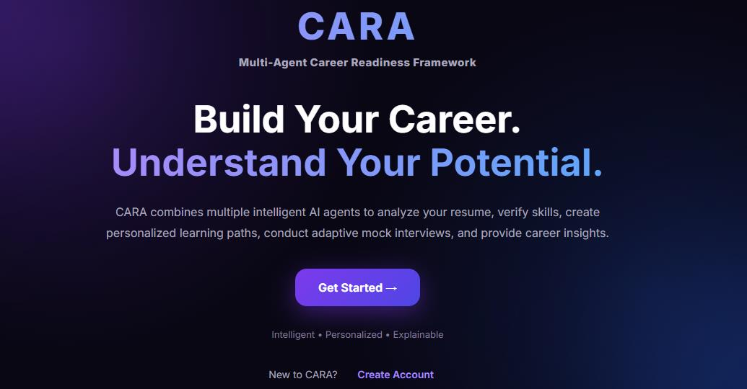
figure 5.1 Cara landing page
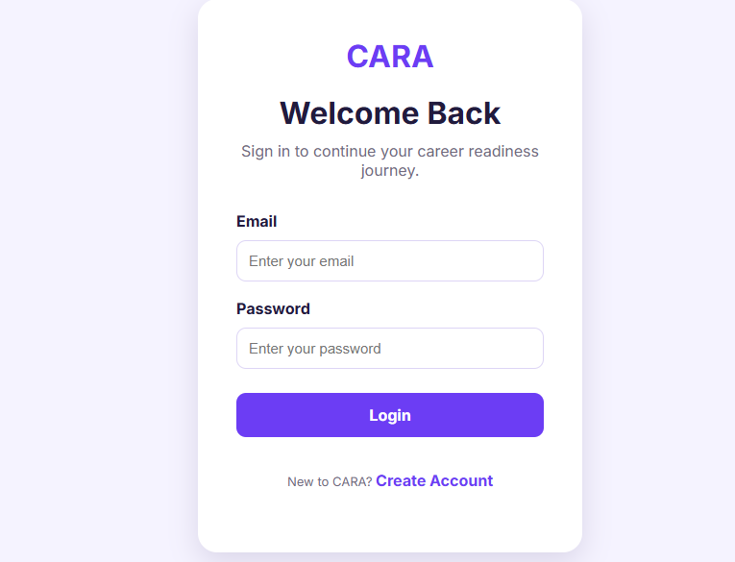
Figure 5.2 Cara login page
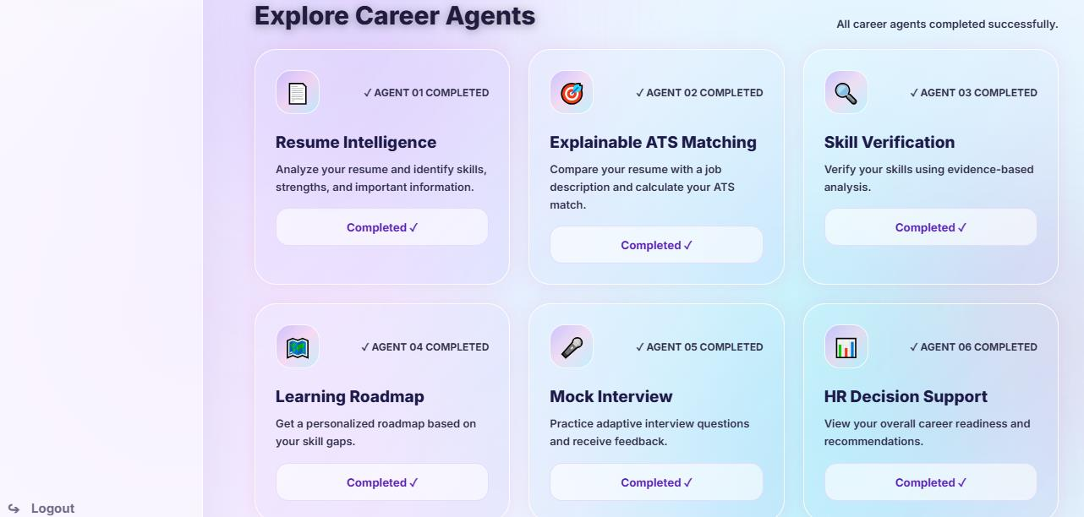
Figure 5.3 Cara dashboard
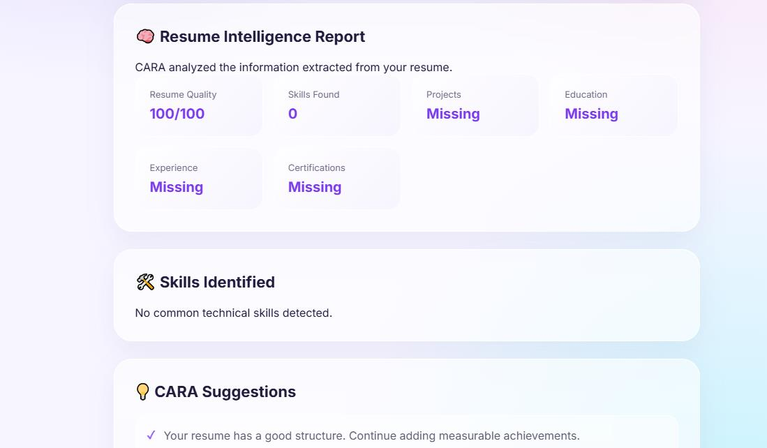
Figure 5.4 resume intelligent agent
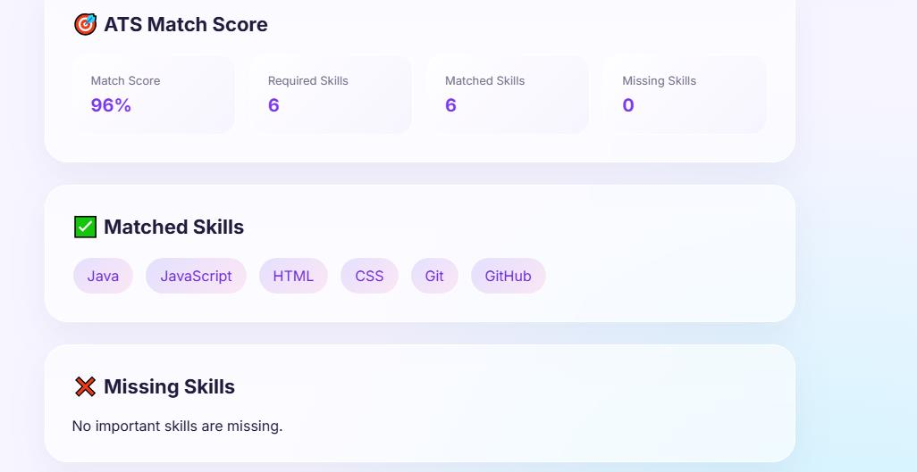
Figure 5.5 ATS score agent
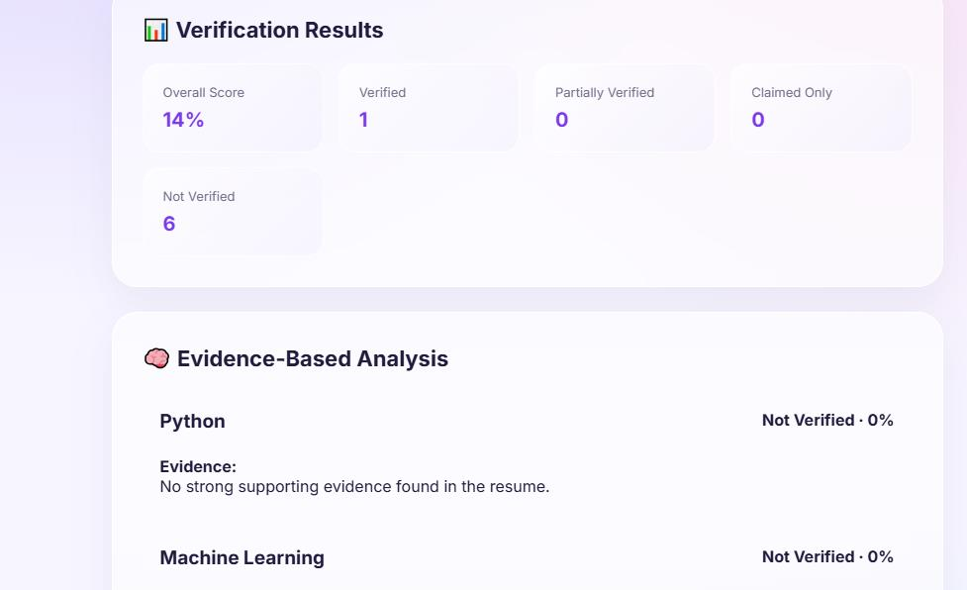
Figure 5.6 Skill verification agent
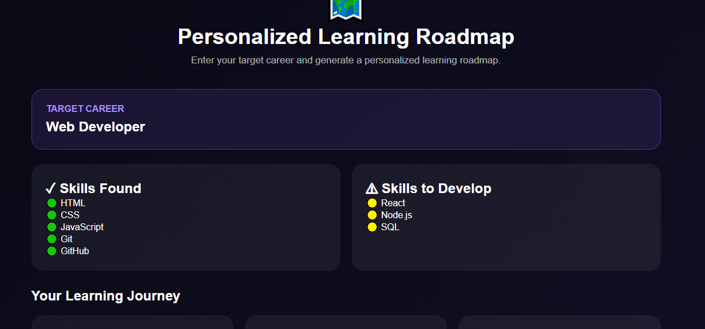
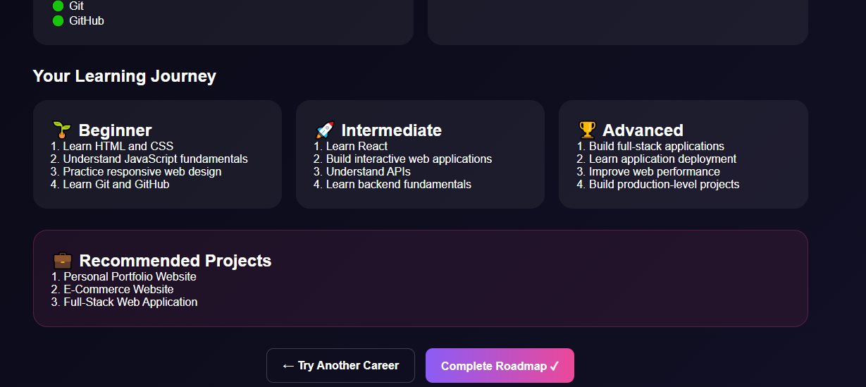
Figure 5.7 Learning Roadmap agent
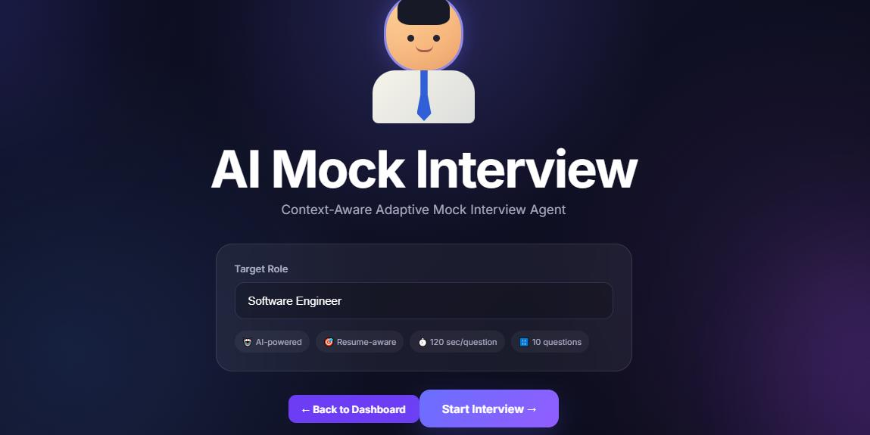
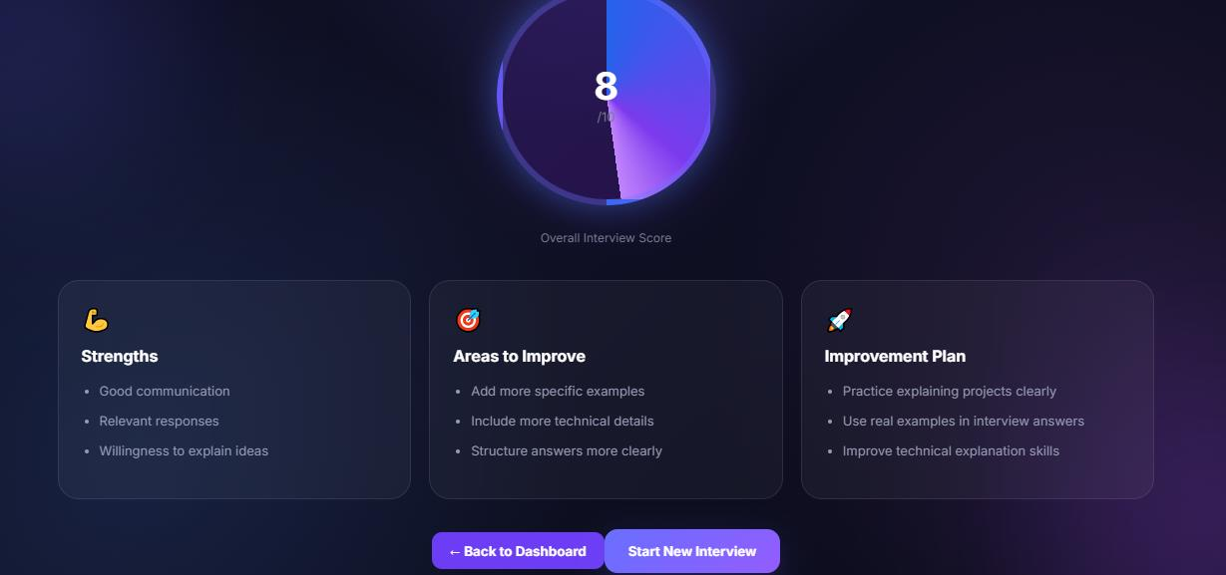
Figure 5.8 Mock interview agent
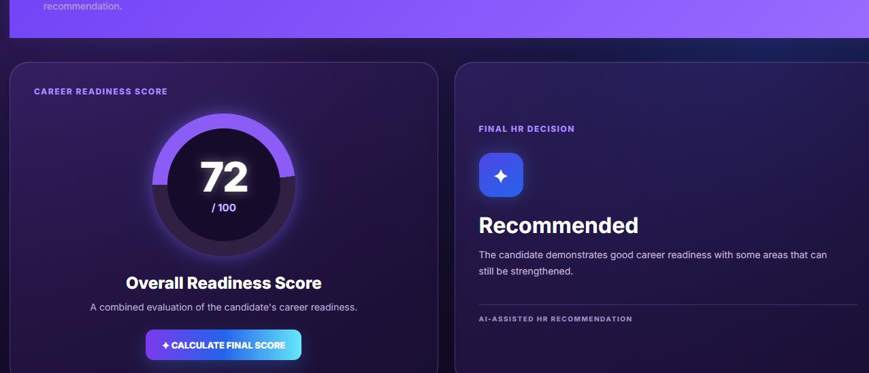
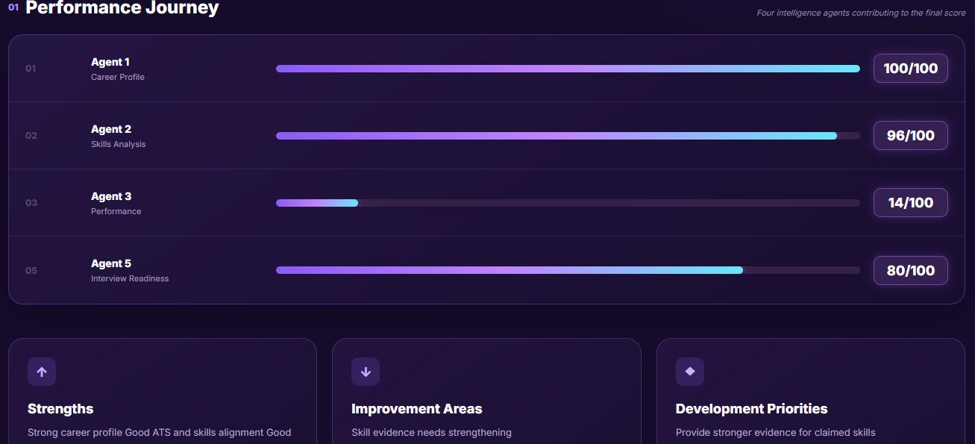
Figure 5.9 HR agent
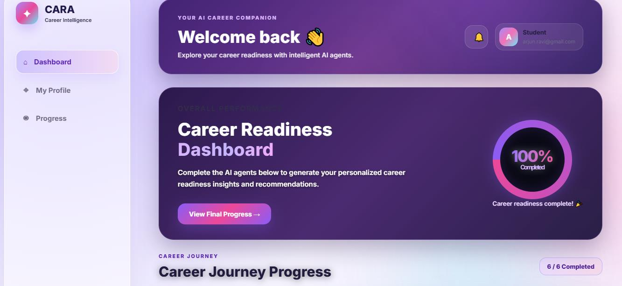
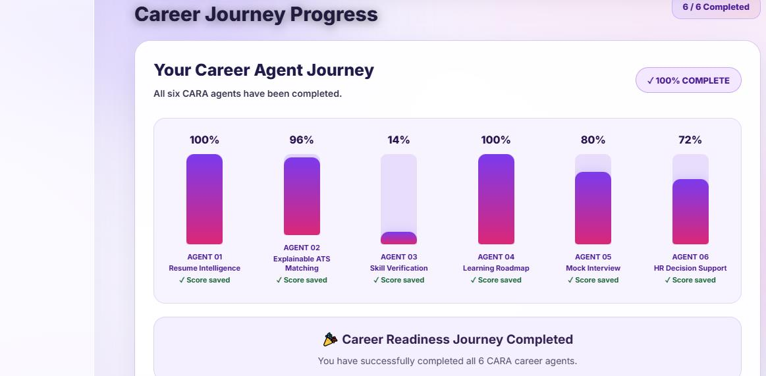
Figure 5.10 Cara final progress

REFERENCE:
[1] I. Sutskever, G. E. Hinton, and G. W. Taylor, "The recurrent temporal restricted Boltzmann machine," in Advances in Neural Information Processing Systems, vol. 21, 2008.
[2] S. Hochreiter and J. Schmidhuber, "Long short-term memory," Neural Computation, vol. 9, no. 8, pp. 1735–1780, Nov. 1997, doi: 10.1162/neco.1997.9.8.1735.
[3] N. Srivastava, E. Mansimov, and R. Salakhutdinov, "Unsupervised learning of video representations using LSTMs," in Proc. 32nd Int. Conf. Machine Learning, vol. 37, 2015, pp. 843–852.
[4] X. Shi, Z. Chen, H. Wang, D.-Y. Yeung, W.-K. Wong, and W.-C. Woo, "Convolutional LSTM network: A machine learning approach for precipitation nowcasting," in Advances in Neural Information Processing Systems, vol. 28, 2015.
[5] J. Devlin, M.-W. Chang, K. Lee, and K. Toutanova, "BERT: Pre-training of deep bidirectional transformers for language understanding," in Proc. NAACL-HLT, 2019.
[6] G. V. Barath, R. Sanjeev, and S. Saranya, "AI-driven recruitment: Resume screening and skill matching with NLP," in 2025 IEEE Int. Conf. Comput., Electron. Electrical Engineering & Their Applications (ICE3), 2025.
[7] Sundaram, S. A. Aleeyah, and H. S. Rushidha, "An intelligent NLP-based system for resume screening and applicant tracking systems (ATS)-optimised resume generation," International Journal on Perceptive and Cognitive Computing, vol. 12, no. 2, pp. 129–134, 2026.
[8] T. Satyanarayana and I. Lakshmi Manikamba, "CareerMind: An AI-powered intelligent career agent for automated job search and interview simulation," International Journal for Research in Applied Science and Engineering Technology (IJRASET), 2026, doi: 10.22214/ijraset.2026.84456.
[9] Bharath Kumar P and G. K. Chellamani, "Retrieval augmented generation for resume screening using sentence transformers," in 2025 IEEE 7th Int. Conf. Computing, Communication and Automation (ICCCA), 2025, doi: 10.1109/ICCCA66364.2025.11325309.
[10] A. Samsun and A. Angel Ceril, "Resume parser using natural language processing and machine learning," International Journal of Advance Research in Multidisciplinary, vol. 3, no. 2, 2025.
[11] C. Gan, Q. Zhang, and T. Mori, "Application of LLM agents in recruitment: A novel framework for automated resume screening," Journal of Information Processing, vol. 32, pp. 881–893, 2024.
[12] E. Tayade, P. Pajare, D. Aher, and S. Chaudhari, "A hybrid explainable framework for resume screening and candidate-job matching using semantic similarity," Open Access International Journal of Science and Engineering, vol. 9, no. 5, pp. 38–53, 2026, doi: 10.65521/oaijse.v9i5.3185.
[13] M. H. Ajam and H. S. Al-Raweshidy, "AI-driven semantic similarity-based job matching framework for recruitment systems," Information Sciences, vol. 724, art. no. 122728, pp. 1–17, 2025, doi: 10.1016/j.ins.2025.122728.
[14] M. Kalpana Devi Bai et al., "AI-powered resume matching and recommendation system," International Journal of Engineering Research & Technology, vol. 15, no. 4, 2026.
[15] Z. Cao, T. Simon, S.-E. Wei, and Y. Sheikh, "Realtime multi-person 2D pose estimation using part affinity fields," in Proc. IEEE Conf. Computer Vision and Pattern Recognition (CVPR), 2017.
[16] Agarwal et al., "Generative AI-powered mock interview system with real-time multimodal feedback & skill matching," in 2025 IEEE Int. Conf. Contemporary Computing (IC3), 2025.
[17] F. S. M. P. et al., "AI-based real time mock interview system using generative and conversational agents," in 2026 4th Int. Conf. Inventive Computing and Informatics (ICICI), Bangalore, India, 2026, pp. 1381–1388, doi: 10.1109/ICICI68773.2026.11581247.
[18] K. Selvaraj, R. Pandiarajan, and A. S. Nadar, "Intelligent resume screening and job relevance analysis using natural language processing," in 2026 1st Int. Conf. AI, Data Science, Cyber Security and Smart Manufacturing for Sustainable Development (ICADCS), 2026.
[19] J. Swapna et al., "Enhanced resume analysis and job alignment using BERT," in 2025 5th Int. Conf. Pervasive Computing and Social Networking (ICPCSN), 2025.
[20] N. Venetik, A. Kolesnikov, and G. Kogan, "NLP-based screening for IT job vacancies: A case study," in CEUR Workshop Proceedings, vol. 3477, 2023.
[21] "Deep learning-based resume analyzer with LoRA-enhanced LLMs," IEEE Conference Paper, 2026.
[22] R. Villegas, J. Yang, S. Hong, X. Lin, and H. Lee, "Decomposing motion and content for natural video sequence prediction," arXiv preprint arXiv:1806.04166, 2018.
[23] C. Finn, I. Goodfellow, and S. Levine, "Unsupervised learning for physical interaction through video prediction," in Advances in Neural Information Processing Systems, vol. 29, 2016.
[24] Y. Wang, M. Long, J. Wang, Z. Gao, and P. S. Yu, "PredRNN: Recurrent neural networks for predictive learning using spatiotemporal LSTMs," in Advances in Neural Information Processing Systems, vol. 30, 2017.
[25] Y. Wang, Z. Gao, M. Long, J. Wang, and P. S. Yu, "PredRNN++: Towards a resolution of the deep in-time dilemma in spatiotemporal predictive learning," in Proc. 35th Int. Conf. Machine Learning, vol. 80, 2018, pp. 5123–5132.
[26] S. Oprea et al., "A review on deep learning techniques for video prediction," IEEE Trans. Pattern Analysis and Machine Intelligence, vol. PP, pp. 1–1, Dec. 2020.

