EchoGenesis: A Longitudinal, Degradation-Robust Framework for Voice Preservation in Speech Loss
S.Upendiran¹, B.Lokesh², Saiyuj.S³, Dr.G.Revathy⁴
⁴Assistant Professor, ^{1,2,3}UG Scholar

Department of CSE (Artificial Intelligence and Machine Learning), Vels Institiue of Science, Technology and Advanced Studies, Pallavaram, India

Email id= upendiransekaran@gmail.com¹, lokeshbarani2023@gmail.com², saiyujsaies@gmail.com³, revathy.se@vistas.ac.in⁴

Abstract— EchoGenesis is a voice preservation solution for people whose speech changes because of conditions such, as amyotrophic lateral sclerosis ALS, Parkinson’s disease, stroke cancer treatments, or laryngectomy. Current voice cloning solutions and text-to-speech systems are mostly built around healthy speech and do not sufficiently consider longitudinal changes in the voice of a person. EchoGenesis is capable of preserving the unique voice of a speaker even when his/her speech becomes worse further. EchoGenesis uses degradation-robust speaker encoder which detects the speaker from damaged speech samples, and it compares more recent samples with those recorded voice earlier, while the speaker had a healthy voice. Natural speech is then generated from a limited number of voice samples through few-shot text-to-speech model, and prosody aware chunked synthesis and is used for longer sentences. Evaluation of the system is done using metrics for measuring speaker similarity, word error rate, and degradation robustness curve which is a proof-of-concept embedding-drift study shows that the drift signal increases with the degradation level and proves the variability between different sessions.
Keywords— Voice Cloning, Artificial Intelligence, Deep Learning, Amyotrophic Lateral Sclerosis, Throat Cancer, Speech Preservation, Personalized Voice Model, Word Error Rate.
I. INTRODUCTION
A person's voice is a vital part of their identity, as well as helping them with their communication. People whose condition is characterized by the increasing development of the disease, such as Amyotrophic lateral sclerosis (ALS), Parkinson’s disease, Stroke, laryngectomy, dysarthria, or cancer treatment, may lead themselves lose their voice clearly and simply. As the disease increases gradually, the person's fluency, loudness, pronunciation, speech rate, and other characteristics may change, making it uneasy to communicate even when they are able to form words and understand what is said to them.
Both current voice-cloning and text-to-speech (TTS) systems can synthesize customized speech given with sufficient, high-quality recordings from a target speaker. The limitation of such systems is that a voice model created on healthy recordings cannot naturally adapt to the person’s voice as it changes with time. On the other hand, using later diseased recordings for direct synthesis might cause voice degradation and poor similarity to the original speaker. To avoid this limitation, a longitudinal method is proposed, which helps to maintain previously recorded, healthy observations as an identity reference while later recordings are used for transformation information.
RESEARCH GAP
The reviewed literature provides separate building blocks for speaker encoding, voice cloning, dysarthric speech synthesis, speech recognition, speech enhancement, and AAC technology, together with a small number of single-stage voice-banking studies for progressive conditions. The specific contribution of EchoGenesis is to connect these ideas through a longitudinal voice-preservation workflow in which the earlier, healthy voice is retained as the identity reference while later, affected recordings are compared against that reference rather than simply replacing only once. The project therefore targets continuous preservation of speaker identity across changing speech conditions.
PROBLEM STATEMENT
Progressive speech disorders can lead to a loss of two main attributes: speaker’s speech clarity and understandable vocal characteristics. Current voice-cloning approaches can synthesize personalized speech from target recordings; however, a single voice model might fail sometimes to account for gradual changes in speech patterns during the progression of the disorder. The challenges the authors address is creating a degradation-strong, longitudinal voice-preservation model, which can utilize partially degraded speech recordings, retain the speaker’s original identity based on prior recordings, and produce clear, personalized speech from text throughout the speech disorder progression.
OBJECTIVE
- Design and development of EchoGenesis, an AI-enabled voice preservation system for individuals at risk of losing their voices.
- Allow individuals to preserve their voice identity using decaying speech samples.
- Reproduce high-quality, natural-sounding versions of the user's voice.
- Adapt to the user's changing vocal patterns due to conditions such as ALS, laryngectomy, or dysarthria.
- Enable users to maintain their voice identity and communicate confidently despite their illness.
EchoGenesis is presented as a longitudinal, degradation-robust voice preservation system, which records and stores the user’s healthy voice as a reference. The system includes a speaker encoder to extract speaker representations from the recordings. Then, given new observations, both healthy and diseased, they are compared to the initial speaker encoder recordings to preserve the original voice identity. A few-shot TTS model is used to generate speech from text input using the extracted preserved speaker representation. For long sentences, a prosody-aware chunked synthesis is used, in which the input text is divided into smaller parts, which are later then recombined into smooth speech.
Once their condition advances to the point where they can no longer speak clearly, they would be able to provide additional recordings for adaptation and input the message as text for the system to synthesize it into personalized speech. The usefulness of this method is then evaluated based on the similarity to the original speaker, the intelligibility of the synthesized speech, and preservation of voice identity in higher input speech degradation.
II. LITERATURE SURVEY
A. Speech Synthesis
The field of speech synthesis has seen the development of speaker-conditioned architectures which gives a speaker representation as input to a text-to-speech system. Jia et al. suggested a transfer-learning approach that separates a speaker's representation from the steps of speech synthesis and waveform generation. This approach uses a speaker encoder trained with an end-to-end loss [2] and a synthesizer built on Tacotron2 [3]. A vocoder called WaveNet [1]. This separation gave a basis for adapting a general speech-synthesis system to a target speaker based on speaker-embedding information only, an approach that has been carried forward in a number of few-shot voice-cloning approaches that learn a new speaker from a handful of reference observations [4] and reflected in related speaker-conditioned TTS work on Indian- and Western-accented voices [5] and an alternative multi-speaker transfer-learning formulation [6].
B. Voice Preservation for Increasing and Declining Speech Disorders
A smaller body of work which focuses on the specific case of preserving voice for people with increasing or losing voice conditions. Veaux et al. have explored that synthetic voices can be constructed from a set of healthy speech recordings and later fine-tuned to account for the disorder’s effects on the voice after diagnosis [7]. More recently, Regondi et al. have investigated the use of AI-generated patient- a specific voice for people with ALS through fine-tuning a HiFi-GAN synthesis pipeline on set of banked recordings, finding that the results were same from the original recordings [8]. Thus, the existing literature displays that voice preservation is a usable assistive technology in the context of degenerative speech disorders, typically requiring only one round of voice banking before the symptoms.
C. Voice Cloning and Dysarthric Speech
Recent works have explored voice cloning for dysarthric speech under few-shot settings, mostly based on the TORGO database of dysarthric and control speech [9]. Moell and Aronsson investigated voice cloning of dysarthric speech using TORGO and revealed limitations caused by the small number of available samples and unnatural or linguistically incorrect results [10]. Works direct fairness in dysarthric speech synthesis have investigated F5-TTS based on dysarthric and healthy speakers from TORGO, considering accessibility, speaker similarity, prosody and fairness across several levels [11]. These motivate the focus in EchoGenesis, on isolating the effects of speech damaged from stable speaker characteristics.
D. Voice Cloning and Speech Recognition
Zero-shot voice cloning has also been looked into as a way to create speech that sounds like dysarthric speech. For the purpose of automatic speech recognition, Singh et al. evaluated the effectiveness of zero-shot voice cloning as a low-effort data augmentation technique and assessed the quality of the synthesized speech in terms of word error rate and cross-corpus generalization [12]. This research contributes to the idea that personalized synthetic speech can be beneficial in the absence of sufficient target data, but performance is heavily tied to the severity of impairment.
E. Speech Recognition and Enhancement
Automatic speech recognition (ASR) models can be utilized to assess whether the synthesized speech is understandable. Radford et al. introduced a large scale weakly managed speech-recognition approach trained on a multilingual audio-transcript collection [13] related CTC and segmental CRF work gives additional background for speech-recognition [14]. EchoGenesis can utilize an ASR component to convert generated speech back to text and compute word error rate. Speech enhancement is also relevant as the quality of the affected recordings can influence the speaker representation.
F. Assistive Augmentative Communication Technology
Apart from the topic of voice cloning, the text and the AAC input stage of EchoGenesis are also closely related to the field of augmentative and alternative communication (AAC). This literature serves as the motivation to consider typed text and AAC input as first-class entry points into EchoGenesis, alongside the recorded speech.

Author | Methodology | limitations | Addresses
[5] | Trogram Generation, WaveRNN, LSTM Voice Encoding, Mel-Spectogram reduction. | Ability to reproduce emotions and natural expression in speech was limited. | Difficulty in creating a cloned voice that shows emotional expression.
[10] | Voice Cloning, Performance Analysis. | Limited speech samples, English-only data, and speech that may sound unnatural. | Difficulty in preserving a person’s voice identity when they have a speech impairment,

III. METHODOLOGY
A. Collection of Input Voice
The initial step in EchoGenesis is the creation of the user’s original voiceprint. A set of healthy or clear speech samples are recorded, then stored as the primary reference for the speaker’s voice, capturing the user’s vocal characteristics prior to significant decline. Later recordings, which may be short, are accepted as second sets representing different stages of the same speaker’s voice rather than as different voices. In addition to speech samples, the input pipeline supports the typed text or AAC input followed by cleaning and normalization and characters-to-phonetics and different word-embedding processing.
B. Preprocessing
The audio collected is preprocessed before model processing (conversion into a common audio format and sampling frequency, removal of unacceptable silences, normalizing, and noise reduction where appropriate). This is to minimize the differences due to the recording conditions and thus provide the speaker encoder with more consistent inputs, for which the exact parameters will be reported at the time of publication.
C. Degradation-Robust Speaker Encoder
A degradation-robust speaker encoder helps to extract speaker characteristics that identify the speaker. SpeechBrain with a pretrained ECAPA-TDNN backbone [17] is adopted as the speaker-encoder base. The encoder generates an embedding of the speech signal, and the key requirement is that this representation will be useful even if a later recording is partially degraded. Initial healthy recordings provide the main identity representation, but later recordings give additional evidence about the same speaker under altered speech conditions. The architecture also includes a condition encoder representing the voice or disease stage and an identity-fusion stage that generates the preserved voice identity.
D. Longitudinal Comparison
The system compares recent recordings with previous, healthier counterparts, not to copy the degradation into the final synthetic voice, but to understand how the current speech representation relates to the stable speaker's identity. The former voice is retained for reference, while the latter provides information for adaptation. The dynamic voice bank is organized so that recordings are sorted from earliest, healthy samples to later, more damaged ones, supporting progress comparison from the latest recording to the earliest reference.
E. Few-Shot Text-to-Speech System
After obtaining the speaker representation, the few-shot TTS model takes an input of user text with the preserved speaker representation and outputs the corresponding speech. A fine-tuned FastSpeech2 [18] or SpeechT5 [19] model is proposed as the acoustic model. With Coqui TTS being considered as the possible source for fine-tuning, the specific choice will be left to the implementation details and training process. The TTS model is fed with the user input along with the preserved speaker representation and outputs the corresponding acoustic features.
F. Prosody-Aware Chunked Synthesis
Long sentences could be challenging to synthesize smoothly with a personalized TTS system in one go. EchoGenesis therefore comprises prosody-aware chunking, in which a long text input is split into smaller meaningful segments. Each segment is synthesized individually while preserving speaker conditioning and prosodic continuity and then joined into the final observations. This stage aims to minimize robotic, broken, or unnatural transitions and to enhance clarity for longer message.
G. Final Output with a Vocoder
The acoustic output of the TTS model is converted into an audio waveform with a neural vocoder. We use the HiFi-GAN [20] vocoder for this step. The resulting audio waveform is the final synthetic voice that can be played back to communicate. The backend provides inference as an API via FastAPI while the frontend is implemented in React Native to record, input text, and play the speech.
IV. SYSTEM ACTIVITY
EchoGenesis is designed for continuous use as an assistive communication system. In the initial stage, the user records relatively healthy voice using the app. The recordings are saved and processed to create an individual voice profile. If the user’s ability to speak is damaged, they can be compared with the previously healthy voice, and the original voice is kept as the main. When the user wants to communicate, they type the desired sentence as text, for instance, from the frontend, instead of speaking it. A long text is divided into appropriate pieces that are synthesized using the personalized speaker representation. The generated segments are combined and converted to waveform audio, after which the final speech may be played out via the device. In this way, the user does not have to record each sentence that he/she wishes to communicate with.
V. IMPLEMENTATION AND TECHNOLOGY STACK
Table I synthesizes the technology stack proposed for EchoGenesis.
Table I. Technology Stack
Component | Technology / Proposed Choice
Speaker Encoder (TTS Based) | PyTorch is used; SpeechBrain with a pretrained ECAPA-TDNN model, or Coqui TTS as a fine-tuning base.
Acoustic Model | Fine-tuned FastSpeech2, SpeechT5 Hugging Face Transformers.
Vocoder | HiFi-GAN
Backend | FastAPI (Python)
Frontend | React Native for recording, text input.
Storage | PostgreSQL is used for session metadata and also for embeddings, with S3-style blob storage for storing audio.

Fig. 1 shows the proposed training pipeline. Speech-and-text paired data is cleansed and augmented with noise and codec variation prior to encoder training. The ECAPA-TDNN speaker encoder is fine-tuned to achieve robustness to the augmented conditions, and the SpeechT5-based acoustic model is further fine-tuned to decouple linguistic content from speaking style using the reference speaker’s voice.
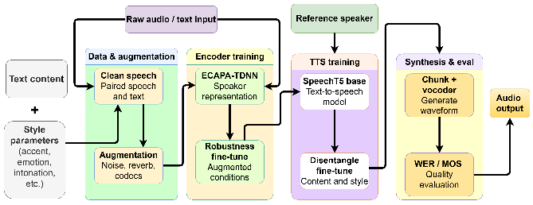
Fig. 1. Pipeline for the trained EchoGenesis model
VI. RESULT ANALYSIS
The TORGO dataset [9] is used as the main input for our experimental work and the degradation-robustness analysis. TORGO contains recordings of dysarthric and healthy speakers, thus directly related to our focus on speech impairment. The final version of our paper will report the specific subset of data used, the number of speakers, recordings, the train-test split, and preprocessing protocol, plus any additional datasets we may have had to record ourselves in the acquisition process. The full word-error-rate experiment and the Mean Opinion Score experiment on TORGO are currently, in progress and will be reported in due course in the final version of this paper.
A. Speaker Similarity
Speaker Similarity is used to evaluate the quality of the synthesized speech in terms of preserving the characteristics of the target speaker. A speaker-embedding model, such as the generalized end-to-end loss [2], is a method that helps evaluate the performance of a system from start to finish. The generalized end-to-end loss offers a comprehensive view of the entire process, is used to extract embeddings from the reference and generated speech, and a similarity is computed between them. An early, lightweight version of this score is the preliminary embedding-drift score presented in Section IX-E.
B. Word Error Rate
The Word Error Rate WER is a measurement that shows how clear the speech that is created by comparing the reference transcript against the hypothesis transcript obtained by feeding the generated speech to an ASR system; the lower it is, the fewer recognition errors are produced. The final paper will report the ASR model, the utterances tested, and the resulting WER.
C. Mean Opinion Score
Mean Opinion Score (MOS) can be used to gather human judgments of naturalness and intelligibility, if the user evaluation is included. In such a case, the final paper should contain information about the tested group of participants, the used rating scale, and the evaluation procedure.
D. Degradation Robustness Curve
The degradation-robustness curve is plotted to illustrate the behavior of the evaluated representation or the generated voice at different levels of distorted input. The curve is obtained by calculating the selected metric at different degradation levels and plotting them as the function of distortion; the curve using dysarthric TORGO recordings and the final speaker encoder will be defined in the implementation part of the paper.
E. Preceding Robustness Results
Before doing the full TORGO-based evaluation, we had a lightweight demo (run in a Google Colab notebook, ECHOGENESIS.ipynb) to see whether there's such thing as an embedding-based drift score that makes sense on a controlled degradation. Embedding drift score is defined here as the distance in the speaker encoder's embedding space between a candidate recording's embedding and an anchor embedding (from the speaker's original, healthy reference recording) the bigger the drift, the more the candidate embedding differs from what we expect from the reference identity.
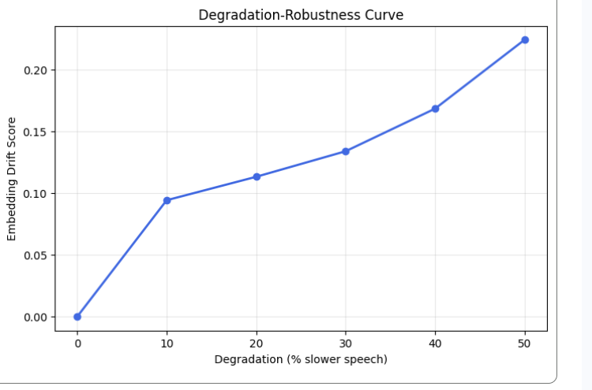
Fig. 3. Embedding drift score over Degradation (speech slowed by 0–50%).
Fig. 3 plots drift score as a function of degradation severity, with the latter being measured as the amount of slowdown of a single synthetic degradation. Drift increased with degradation severity, from 0 to roughly 0.22 at 50% slowdown, with the greatest increase between 0% and 10%. This demonstrates the expected monotonicity of the relationship: the more degraded an audio clip is, the farther it drifts from the original identity embedding.
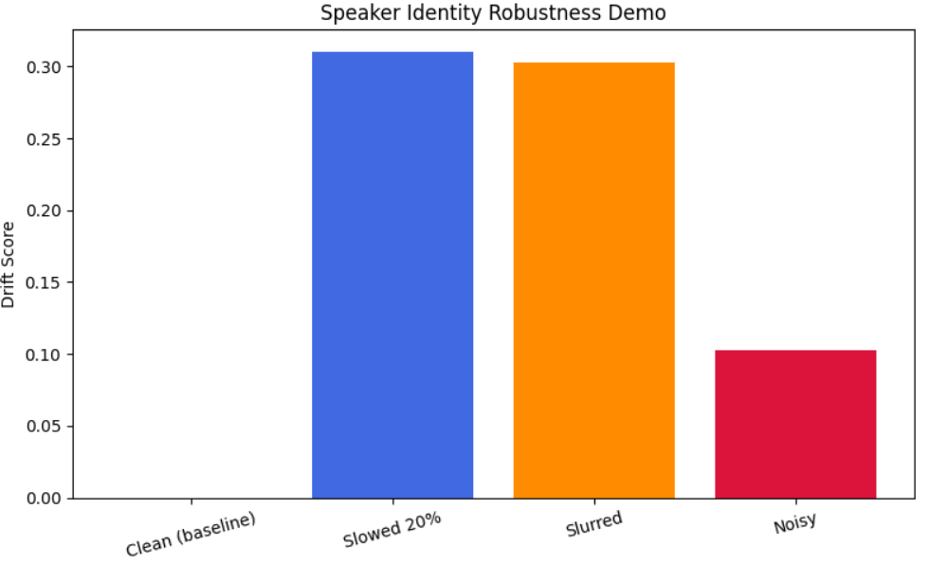
Fig. 4. Drift score from Speaker Identity Robustness
A second experiment compared the drift scores between synthetic degraded versions of the same speaker, including audio slowed by 20%, an artificially slurred version, and a noisy version, against a clean baseline fixed at zero drift (Fig. 4). The slowed and slurred conditions produced similar, relatively high drift (approximately 0.31 and 0.30, respectively), while the noisy condition produced a much smaller drift (approximately 0.10). This indicates that different degradation types affect the embedding space unevenly.

XIII. CONCLUSION
EchoGenesis presents a novel idea of preserving one’s identity in the case of a progressive loss of their ability to speak. The framework makes use of an earlier, healthy recording to capture a person’s speaker characteristics with a degradation-robust speaker encoder. Then, later, degraded samples are compared to it, not the other way around, which allows updating the identity reference. The few-shot TTS stage is applied to the resulting representation to synthesize speech from text, with prosody-aware chunked synthesis used to speak longer utterances. The approach is intended for patients, with lateral sclerosis Parkinson’s disease patients, stroke, dysarthria, or other conditions that lead to degradation of the quality of their speech or even render them mute after surgery. The evaluation will be carried out by testing all the speakers’ similarity, WER, and speaker degradation-robustness with the final configurations used in the experiment.
REFERENCES
[1] Y. Jia, Y. Zhang, R. J. Weiss, Q. Wang, J. Shen, F. Ren, Z. Chen, P. Nguyen, R. Pang, I. L. Moreno, and Y. Wu, “Transfer learning from speaker verification to multi-speaker text-to-speech synthesis,” arXiv: 1806.04558., 2018/2019.

[2] L. Wan, Q. Wang, A. Papir, and I. L. Moreno, “Generalized end-to-end loss for speaker verification,” arXiv:1710.10467, 2018.

[3] J. Shen, R. Pang, R. J. Weiss, M. Schuster, N. Jaitly, Z. Yang, Z. Chen, Y. Zhang, Y. Wang, R. Skerry-Ryan, R. A. Saurous, Y. Agiomyrgiannakis, and Y. Wu, ``Natural tts synthesis by conditioning wavenet on mel spectrogram predictions,"arXiv:1712.05884, 2018.

[4] S. Ö. Arik, J. Chen, K. Peng, W. Ping, and Y. Zhou, “Neural voice cloning with a few samples,” arXiv:1802.06006, 2018.

[5] V. R, H. D, L. D. Vijay Anand, and D. J. Reji, “Empowering communication: Speech technology for Indian and western accents through AI-powered speech synthesis,” arXiv:2401.11771, 2024.

[6] G. Ruggiero, E. Zovato, L. Di Caro, and V. Pollet, “Voice cloning: A multi-speaker text-to-speech synthesis approach based on transfer learning,” arXiv:2102.05630, 2021.

[7] C. Veaux, J. Yamagishi, and S. King, “Towards personal synthesized voices for individuals with vocal disabilities: Voice banking and reconstruction,” in Proc. 4th Workshop on Speech and Language Processing for Assistive Technologies (SLPAT), Grenoble, France, 2013, pp. 107–111.

[8] S. Regondi, G. Donvito, E. Frontoni, M. Kostovic, F. Minazzi, S. Bratieres, M. Filosto, and R. Pugliese, “Artificial intelligence empowered voice generation for amyotrophic lateral sclerosis patients,” Scientific Reports, vol. 15, no. 1, 2025.
[9] F. Rudzicz, A. K. Namasivayam, and T. Wolff, “The TORGO database of acoustic and articulatory speech from speakers with dysarthria,” Language Resources and Evaluation, vol. 46, no. 4, pp. 523-541, 2012.

[10] B. Moell and F. S. Aronsson, “Voice cloning for dysarthric speech synthesis: Addressing data scarcity in speech-language pathology,” arXiv:2503.01266, 2025.

[11] A M Anuprabha, K Gurugubelli and A K Vuppala "Fairness in dysarthric speech synthesis: Understanding bias, in dysarthric speech cloning using F5 TTS " arXiv 2508 05102 2025.

[12] S. Singh, Q. Wang, Z. Zhong, C. Mendes M. Hasegawa-Johnson, W. Abdulla and S. R. Shahamiri, "Low-burden data augmentation for ASR, via zero-shot voice cloning " arXiv:2606.19823, 2026.

[13] A Radford, J W Kim, T Xu, G Brockman C McLeavey and I Sutskever " speech recognition, via large-scale weak supervision " arXiv 2212 04356 2022.

[14] L. Lu, L. Kong, C. Dyer and N. A. Smith "Multitask learning with CTC and segmental CRF, for speech recognition " arXiv:1702.06378, 2017.

[15] S. Lee, S. Cheong, S. Han and J. W. Shin titled "FlowSE: Flow matching-based speech enhancement”. The paper is listed as arXiv:2508.06840.

