
VERISELF: NEUTRALIZING AI THREATS TO PERSONAL PRIVACY
KEERTHIVASAN N – 24619216
SAIGANESH M – 24619243
AJAY KUMAR S – 24619248
MINI PROJECT REPORT
Submitted to
SCHOOL OF ENGINEERING
DEPARTMENT OF ARTIFICIAL INTELLIGENCE AND MACHINE LEARNING
in partial fulfillment of the requirements for the award of the degree of
BACHELOR OF TECHNOLOGY CSE
IN
ARTIFICIAL INTELLIGENCE AND MACHINE LEARNING

VELS INSTITUTE OF SCIENCE, TECHNOLOGY AND ADVANCED STUDIES (VISTAS)
CHENNAI – 600 117
OCTOBER 2026
BONAFIDE CERTIFICATE
Certified that this project report “VERISELF: NEUTRALIZING AI THREATS TO PERSONAL PRIVACY” is the bonafide work of KEERTHIVASAN N – 24619216, SAIGANESH M – 24619243 and AJAY KUMAR S – 24619248, who carried out the project work under my supervision. Certified further that, to the best of my knowledge, the work reported herein does not form part of any other project report or dissertation on the basis of which a degree or award was conferred on an earlier occasion.

SIGNATURE OF THE HOD  Dr. Ulaga Priya K M.E., Ph.D  Associate Professor & Head  of Department AI&ML  School of Engineering  VISTAS, Chennai. | SIGNATURE OF THE SUPERVISOR  Dr. Ulaga Priya K M.E., Ph.D  Associate Professor & Head  of Department AI&ML  School of Engineering  VISTAS, Chennai.
Submitted for the Project Work and Viva-Voce examination held on ……………………… at Vels Institute of Science, Technology and Advanced Studies (VISTAS), Chennai – 600 117.

INTERNAL EXAMINER EXTERNAL EXAMINER
ACKNOWLEDGEMENT
It is a great delight and a proud privilege for us to acknowledge the help and support we received from many people in making this project a success. This work would not have been possible without the infrastructure, encouragement and guidance provided by the institution and by everyone mentioned below.
We express our sincere gratitude to our Founder & Chairman, Dr. Ishari K.Ganesh, for providing the facilities and an environment in which we couldcarry out this work. We thank the Head of the Department, Dr.
Ulaga Priya K M.E., Ph.D, for the constant support and for the opportunity to take up this project.
We are deeply thankful to our Internal Guide, Dr. Ulaga Priya K M.E., Ph.D
, for her continuous guidance, valuable suggestions and encouragement at every stage, from the selection of the topic to the preparation of this report and the conference paper that accompanies it. We also thank the faculty members, librarians and non-teaching staff of the department for their help during the project.
Last but not least, we thank our parents and friends for their motivation and support, which kept us going throughout this work.
KEERTHIVASAN N – 24619216
SAIGANESH M – 24619243
AJAY KUMAR S – 24619248
TABLE OF CONTENTS
CHAPTER NO. | TABLE OF CONTENT | PAGE NO.
 | ABSTRACT | i
 | LIST OF FIGURES | ii
 | LIST OF ABBREVIATIONS | iii
1 | INTRODUCTION | 1
 | 1.1 Overview of the Project | 1
 | 1.2 Scope and Objectives | 2
2 | LITERATURE REVIEW | 4
 | 2.1 Overview | 4
 | 2.2 Literature Survey | 4
 | 2.3 Research Gap | 5
3 | SYSTEM DESIGN | 7
 | 3.1 Existing System | 7
 | 3.2 Proposed System | 7
 | 3.3 System Architecture | 7
 | 3.4 Hardware Requirements | 9
 | 3.5 Software Requirements | 9
4 | IMPLEMENTATION | 10
 | 4.1 Methodology | 10
 | 4.2 Implementation of Modules | 10
 | 4.3 Security and Privacy Design | 12
 | 4.4 Evaluation Plan | 13
5 | RESULTS, CONCLUSION AND FUTURE WORK | 14
 | 5.1 Results | 14
 | 5.2 Conclusion | 15
 | 5.3 Future Work | 16
 | 5.4 Source Code | 16
 | REFERENCES | 19

ABSTRACT
Photographs and videos can now be copied, altered and republished with very little effort, and a person does not need to be famous to become a target. Existing identity-protection services concentrate on passwords, credit records and breach alerts, which leaves a person’s visual identity largely unprotected. This project presents VeriSelf, a browser-first, privacy-preserving platform that helps ordinary users protect their photographs, verify image matches and build tamper-evident evidence against misuse of their face.The prototype is organised into seven modules: local protection of the browser working copy, face and landmark scanning, forensic indicators, SHA-256 evidence hashing, perceptual verification and comparison, case-evidence packaging with a response draft for human review, and an optional FastAPI backend with SQLite and SQLAlchemy. Photos are processed on the user’s device, and every automated output is treated as evidence, a confidence-scored indicator, and never as a “confirmed fake” verdict. The wider framework also describes an EfficientNet-B0 image classifier, a CNN–LSTM video analyser and similarity-search monitoring of authorised public sources. The work is motivated by the proactive-protection idea of the base paper NullSwap and by the gaps left by existing defences. All seven prototype modules have been completed; integration, testing and quantitative evaluation are the next steps.

Keywords: Deepfake, visual identity protection, perceptual hashing, SHA-256 evidence, face detection, digital forensics, privacy, human-in-the-loop.
LIST OF FIGURES
FIGURE NO | TITLE | PAGE NO
Figure 1 | Proposed VeriSelf system architecture | 8
Figure 2 | Data flow diagram of VeriSelf | 8
Figure 3 | End-to-end workflow of modules M1 to M7 | 10
Figure 4 | Perceptual-hash distance interpretation | 11
Figure 5 | Evidence review and response path | 12
Figure 6 | Planned image and video analysis pipelines | 12
Figure 7 | Local photo protection output | 14
Figure 8 | Face detection with box and landmarks | 14
Figure 9 | Forensic indicators and perceptual-hash comparison | 15
Figure 10 | Case evidence JSON and response draft | 15
LIST OF ABBREVIATIONS
ABBREVIATION | EXPANSION
AI | Artificial Intelligence
API | Application Programming Interface
CNN | Convolutional Neural Network
DFD | Data Flow Diagram
FAISS | Facebook AI Similarity Search
JSON | JavaScript Object Notation
LSTM | Long Short-Term Memory
MTCNN | Multi-task Cascaded Convolutional Network
ORM | Object-Relational Mapping
pHash | Perceptual Hash
SHA-256 | Secure Hash Algorithm, 256-bit
SQL | Structured Query Language
UI | User Interface
C2PA | Coalition for Content Provenance and Authenticity
OSN | Online Social Network

CHAPTER 1
INTRODUCTION
1.1 OVERVIEW OF THE PROJECT
Introduction
A person does not need to be famous to become a target of image misuse. A public photograph can be copied, altered, used in a fake profile, inserted into misleading content or combined with generative AI to create a manipulated image or video. As editing and generation tools become easier to use, such misuse can happen quickly and at scale, and the harm to a person’s reputation and privacy can be serious [1], [22].
Most identity-protection tools in use today focus on passwords, credit records and breach alerts. They tell a person that a credential or a financial record has been exposed, but they do not watch the one thing that deepfakes target: the person’s face. VeriSelf extends protection to a person’s visual identity and digital media presence. It combines local protection of photographs, face and landmark scanning, forensic indicators, tamper-evident hashing, perceptual comparison and guided, human-reviewed reporting in one browser-first platform.
Problem Statement
Protecting a face online is difficult for ordinary users for the following reasons:
- Hard to distinguish: deepfakes are difficult to tell apart from real media, which leaves people open to reputation-damaging fake content.
- Manual search fails: the same content resurfaces under different names, crops and edits, far too fast to track by hand.
- Reactive protection: current tools alert only after a breach of password or credit data, not after misuse of photos and videos.
- Partial technical defences: proactive cloaking such as the base paper NullSwap [1] protects only images that were cloaked before upload, so photos already online stay exposed.
- No usable workflow: a non-technical user has no simple way to register, track and act on violations, and detection research often relies on complex computation.
Table 1: Existing identity tools compared with VeriSelf
Aspect | Existing identity tools | VeriSelf
What is protected | Passwords and credentials, credit records | Photos and videos of the person’s face
Type of protection | Alerts only after a breach | Proactive protection, monitoring and alerts
Threat covered | Account and financial fraud | Face misuse, impersonation, morphing, deepfakes
Target users | Account holders | Anyone, not only public figures

1.2 SCOPE AND OBJECTIVES
Aim of the Project
The aim of this project is to design and build a browser-first, privacy-preserving platform that protects a person’s visual identity from unauthorised use, manipulation and deepfake exposure, and that gives ordinary users a simple register, track and act path.
Objectives
- To protect a person’s visual identity, meaning photographs and videos of their face, from unauthorised use, manipulation and deepfake exposure.
- To build a browser-first, privacy-preserving pipeline made of local protection, a face and landmark scan, forensic indicators, SHA-256 evidence and perceptual verification.
- To detect forged faces with spatial (CNN) and temporal (LSTM) analysis in a hybrid model designed for real-life settings, as set out in the framework.
- To bundle case evidence and draft a response for human review, with confidence-scored output and never a false “confirmed fake” claim.
- To give ordinary, non-technical users a simple way to register, track and act on violations.
Scope of the Project
VeriSelf is designed as an assistive tool for the person whose face is at risk, not as an automatic judge. The main scope points are:
- Browser-first processing: protection, face scan, forensics, hashing and comparison run on the browser working copy; the backend is optional.
- Evidence, not verdicts: forensic indicators are confidence-scored and are never reported as a confirmed fake.
- Human in the loop: a response draft is reviewed by a person before anything is sent.
- Authorised sources only: monitoring in the wider framework is limited to public sources that the deployment is permitted to access.
- Out of scope for this version: audio and voice-clone detection, large-scale embedding search and automated takedown submission are left as future work.
Advantages of the System
- Privacy by design: photos are processed on the device, so they need not be uploaded to a server.
- Tamper-evident evidence: SHA-256 hashing shows whether a file has been altered since it was recorded.
- Robust matching: perceptual hashing recognises resized or recompressed copies that a byte-level hash would miss.
- Transparent results: confidence-scored indicators keep the user informed without overstating certainty.
- Modular design: each module can be improved or replaced without changing the others.
Applications
- Individuals who share photographs on social platforms and want to protect them before upload.
- Students and professionals with public profiles who may be impersonated through fake accounts.
- Checking suspected copies or edited versions of a personal photograph and documenting the findings.
- Preparing a clear evidence file when reporting misuse to a platform or to the concerned authority.
Expected Outcomes
The project is expected to deliver a working prototype of all seven modules, a tamper-evident evidence bundle for each case, and a reviewed response draft. After integration and testing, the system should let a non-technical user protect a photograph, compare it with a suspected copy and document the result in a few simple steps.
CHAPTER 2
LITERATURE REVIEW
2.1 OVERVIEW
Research on Deepfake defence follows two broad directions. Passive detection tries to tell real from fake media after a manipulation has taken place, and it is reaching limits as generative models improve [1], [16]. Proactive defence inserts signals or perturbations into a benign image in advance so that later manipulation is disrupted. This chapter reviews the proactive methods that motivated the project, describes the base paper NullSwap in detail, and then summarises the supporting work on face localisation, classification, video analysis, similarity search and provenance that shapes the VeriSelf framework.
2.2 LITERATURE SURVEY
Table 2: Summary of the surveyed literature
No. | Paper (venue) | Authors | Problem concerned | Concept | Limitations
1 | Disrupting Deepfakes (ECCV Workshops 2020) [2] | Ruiz et al. | GAN-based facial edits | Gradient-based, imperceptible perturbation added to the image to distort edits | Element-wise addition causes visible artifacts; not designed for face swapping
2 | Initiative Defense (AAAI 2021) [3] | Huang et al. | Deepfake face manipulation | A surrogate model imitates the Deepfake to craft a poison perturbation | Needs grey-box surrogates; largely fails to nullify face swapping (similarity about 0.9)
3 | Anti-Forgery (IJCAI 2022) [4] | Wang et al. | Perturbations that are visible to the human eye | Perturbation added to Lab colour-space channels | Needs attribute information that is not always available; still fails to nullify face swapping
4 | CMUA-Watermark (AAAI 2022) [5] | Huang et al. | Defence that must work across multiple Deepfake models | Cross-model universal adversarial watermark | White-box training assumption; heavy compute; identity similarity stays high
5 | DF-RAP (IEEE TIFS 2024) [6] | Qu et al. | Protection that survives OSN compression | A compression-approximation GAN sub-module models OSN compression | Effective mainly against SimSwap; poor generalisation to other swap models
6 | FaceForensics++ (ICCV 2019) [7] | Rössler et al. | Passive detection of manipulated facial images | Benchmark dataset with baseline CNNs | Passive detection only; no registration, monitoring, alerting or takedown workflow

2.2.1 Base Paper: NullSwap
NullSwap [1] (ICCV 2025) argues that in face swapping the real victim is the person whose face is used as the source identity, not the target video. Earlier proactive methods add perturbations to the image by direct element-wise addition, which can degrade visual quality, and they usually need white-box or grey-box access to a generative model during training. NullSwap instead cloaks the source identity under a pure black-box setting, so that identity extractors inside face-swapping models such as SimSwap [21] read a wrong identity and the swapped output no longer matches the victim.
The network has four parts. An Identity Extraction module with convolution and squeeze-and-excitation residual blocks analyses the source image. A Perturbation Block turns the identity features into an identity-guided perturbation with a learnable random-noise term. A Feature Block extracts shallow image features, and a Cloaking Block fuses the perturbation with those features to reconstruct the image, so the perturbation is embedded in latent features and not added to pixels. A Dynamic Loss Weighting strategy balances the identity losses of several face-recognition tools according to their variance and relative progress.
The paper trains on CelebA-HQ and validates on LFW. It reports a PSNR of 41.31, an SSIM of 0.9864 and an LPIPS of 0.0049 for visual quality, which is better than the four compared methods. Against four face-recognition tools the average top-5 and top-1 accuracies fall to 0.711 and 0.565, and across five face-swapping models the identity similarity of the swapped result falls to about 0.33 [1]. NullSwap, however, protects only images that are cloaked before they are shared; photos that are already online stay exposed. VeriSelf takes this proactive idea as its starting point and adds the monitoring, verification and evidence workflow that NullSwap does not cover.
2.2.2 Supporting Work for Detection, Monitoring and Provenance
- Face localisation: RetinaFace [8] and MTCNN [9] locate faces and landmarks in unconstrained images. VeriSelf keeps localisation separate from the authenticity classifier so that each can be tested on its own.
- Efficient classification: EfficientNet [10] balances depth, width and resolution through compound scaling, and EfficientNet-B0 is adopted in the framework as a lightweight backbone.
- Video analysis: Sabir et al. [11] combine convolutional features with recurrent models for manipulated faces in video, and LSTM networks [12] model the temporal relationship between frames. The DeepFake Detection Challenge dataset [15] shows the scale and diversity such detectors face.
- Generalisation and evasion: Face X-Ray [14], studies of CNN-generated images [17], and work on real-world detection and detector-evasion attacks [19], [20] show that a detector can fail when compression, source or post-processing changes, so its output should be treated as one piece of evidence.
- Similarity search and provenance: FAISS [13] supports fast nearest-neighbour search over large vector collections, and the C2PA specification [18] defines tamper-evident content credentials that can be kept as an extra evidence channel.
- 2.3 RESEARCH GAP
The survey shows that most existing work solves one part of the problem. The gaps that VeriSelf addresses are:
- Proactive defences protect only images cloaked before upload and often target a single manipulation type such as face swapping.
- Many defences need grey-box or white-box model access, or generalise poorly beyond the model they were tested on.
- Passive detectors give a score but offer no registration, monitoring, alerting or reporting workflow.
- Detection research seldom keeps the evidence chain, with hashes, versions and review status, that a person needs to act on a violation.
- Few systems are designed so that a non-technical user can use them, with a human reviewing the result before any action.
CHAPTER 3
SYSTEM DESIGN
3.1 EXISTING SYSTEM
At present a person who finds, or fears, misuse of their photographs relies on a mix of manual and partial tools:
- Identity-monitoring services watch passwords, credentials and credit records and raise alerts only after a breach, not after misuse of a face.
- Manual reverse search depends on the user searching for the same image again and again, and fails when the content reappears under different names, crops or edits.
- Passive deepfake detectors classify a given file as real or fake, but do not register a reference copy, search for copies or produce a reviewable evidence file.
- Proactive cloaking research such as NullSwap [1] protects images only if they were cloaked before upload and is not packaged as a tool for non-technical users.
Drawbacks of the existing system: protection is reactive, the visual identity is not covered, evidence is not preserved in a tamper-evident form, and there is no simple path from detection to reporting.
3.2 PROPOSED SYSTEM
VeriSelf is a browser-first, privacy-preserving evidence pipeline with an optional backend. The user supplies a photograph, and the system works on a working copy inside the browser: it applies local protection, scans the face and its landmarks, computes forensic indicators, records a SHA-256 hash, compares the photograph with candidate images by perceptual hash, and bundles everything into a case-evidence file. A response draft is prepared for a person to review.
The design rests on four principles. Privacy first: photos stay on the device unless the optional backend is used. Evidence, not verdicts: results are confidence-scored indicators and the wording never claims a “confirmed fake”. Human in the loop: no response is sent without review. Modularity: seven independent modules share a common case record, so a detector can be upgraded without changing the rest.
Beyond the prototype, the framework describes consent-aware registration of reference media, EfficientNet-B0 image analysis, CNN–LSTM video analysis and similarity-search monitoring of authorised public sources, all reporting to a central Core Platform that keeps the evidence traceable. These parts are described in Section 4.2.8 and are listed as future work where they are not yet implemented.
3.3 SYSTEM ARCHITECTURE
Figure 1 shows the architecture. The user interacts only with the browser. Modules M1 to M6 run client-side on the working copy and pass their results down a single chain, and the final case evidence and response draft go to a human reviewer. The optional backend, module M7, offers server-side registration, storage and comparison through a FastAPI service backed by SQLite and SQLAlchemy.
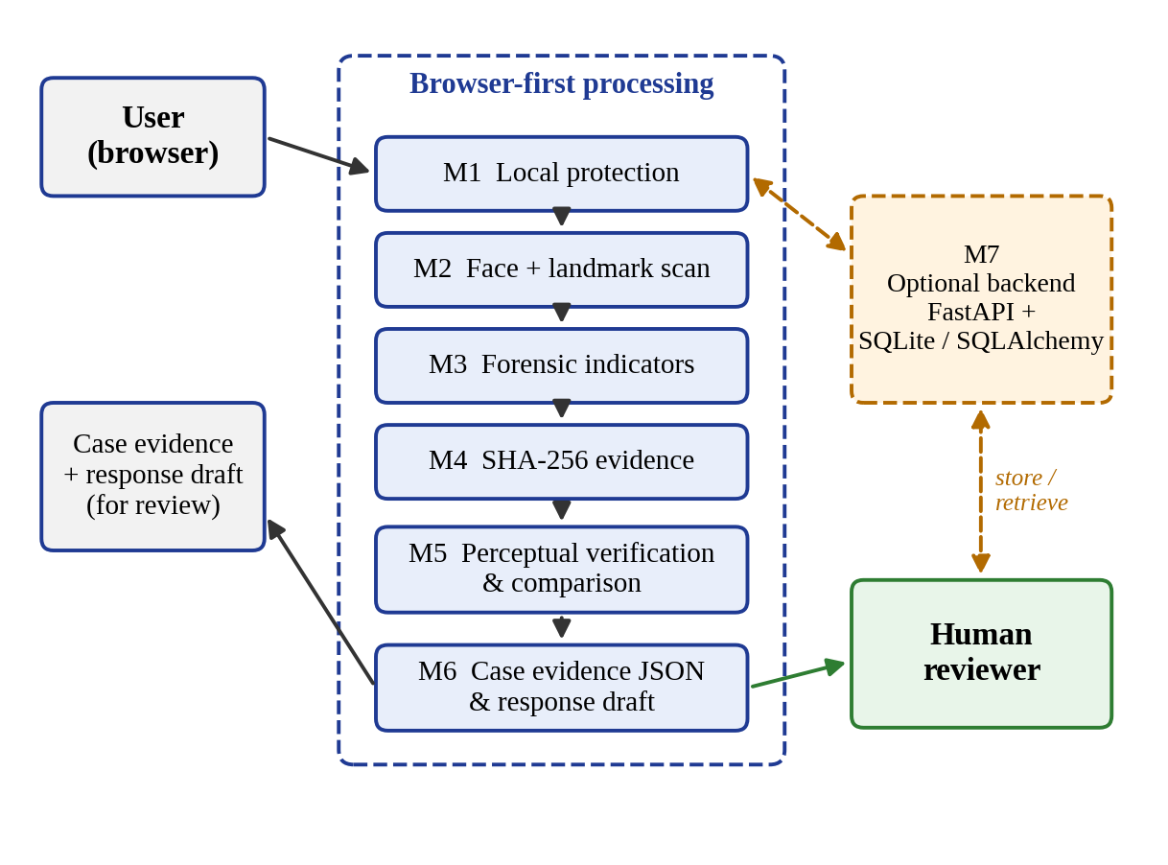
Figure 1: Proposed VeriSelf system architecture
The data flow in Figure 2 follows the same idea. The photograph enters process 1.0, which produces a protected working copy. Process 2.0 scans the face and landmarks, process 3.0 computes forensic indicators, and process 4.0 records the hash and compares it with candidate images. Process 5.0 packages everything into the case evidence that goes to the reviewer. The working copy lives in browser memory (D1), and the case store (D2) is used only when the optional backend is enabled.
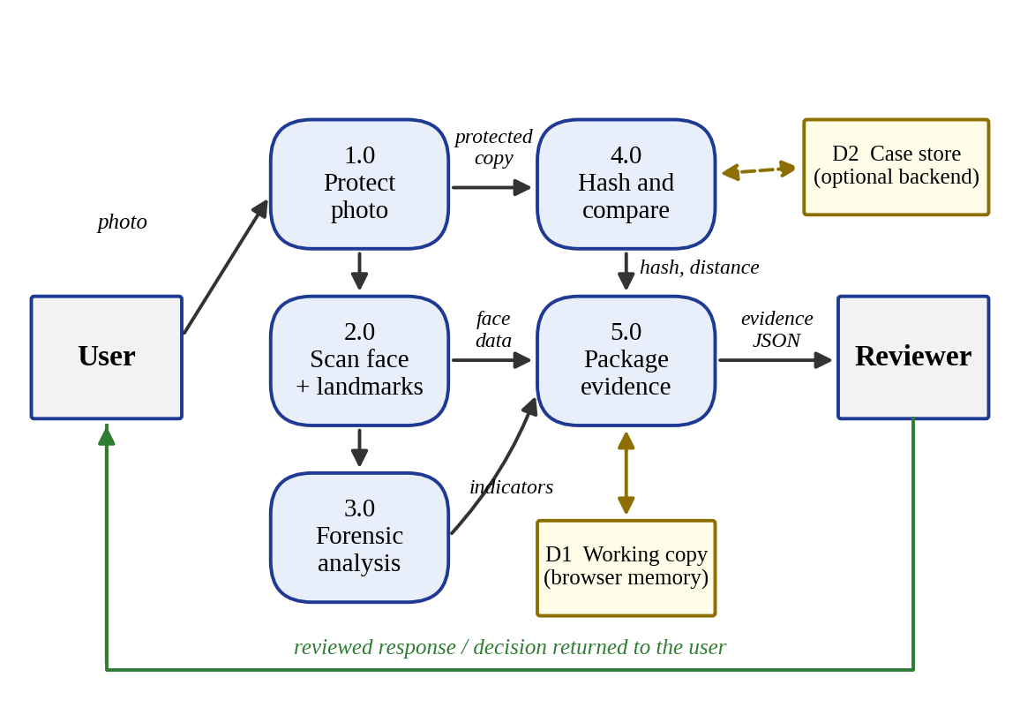
Figure 2: Data flow diagram of VeriSelf
3.4 HARDWARE REQUIREMENTS
Because processing happens in the browser, the hardware needs are modest. The values below are indicative and can be adjusted to the machine used for the demonstration.
Table 3: Hardware requirements
Component | Requirement
Processor | Intel Core i3 / AMD Ryzen 3 or higher
Memory (RAM) | 4 GB minimum, 8 GB recommended
Storage | About 1 GB free disk space
Display | Standard monitor of 1366 × 768 or higher
Network | Internet connection for browser access and the optional backend

3.5 SOFTWARE REQUIREMENTS
Table 4: Software requirements
Component | Requirement
Operating system | Windows 10/11, Linux or macOS
Client | Modern web browser; all analysis runs on the browser working copy
Backend (optional) | FastAPI service in Python 3
Database (optional) | SQLite with the SQLAlchemy ORM
Integrity and matching | SHA-256 hashing and perceptual hashing for comparison
Face analysis | Face detection using MTCNN (facenet-pytorch library); face embedding using InceptionResnetV1 (VGGFace2 weights)
Planned (framework) | EfficientNet-B0 classifier, CNN–LSTM video model, FAISS similarity index
CHAPTER 4
IMPLEMENTATION
4.1 METHODOLOGY
The project followed an incremental, module-by-module method. Requirements and the problem analysis came first, followed by the design of the evidence pipeline, development of modules M1 to M7, and then integration and testing, which are planned for October 2026. Figure 3 shows the order in which a photograph moves through the system.
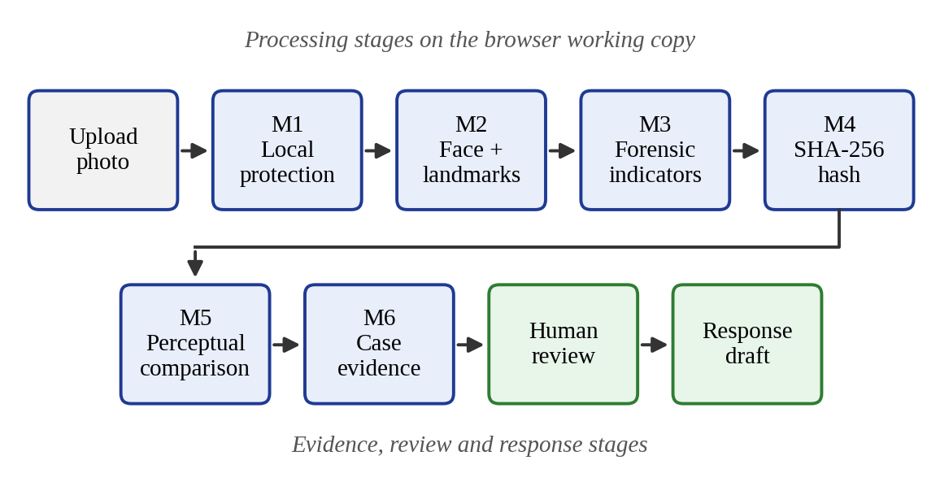
Figure 3: End-to-end workflow of modules M1 to M7
Three kinds of representation are used so that each answers a different question. A cryptographic hash (SHA-256) answers whether two files are byte-for-byte identical. A perceptual hash answers whether two images look alike even when their bytes differ, for example after resizing or compression. In the wider framework an embedding supports approximate retrieval from a large collection. None of these alone decides ownership or misuse, so each result is stored as evidence for a person to interpret.
4.2 IMPLEMENTATION OF MODULES
4.2.1 Module M1: Local Protection
Process: this module applies protection to the browser working copy of the photograph, so the original file is not changed and nothing needs to leave the device. It follows the proactive-protection idea of the base paper [1], which is to protect an image before it is shared. Advantage: protection is applied client-side and keeps the user in control. Output: a protected working copy of the photograph. Technique: an invisible signature is embedded in the luminance (Y) channel of the image using the discrete cosine transform (DCT). A 32-byte token made of a 4-byte marker, the 4-byte identity number, an 8-byte random nonce and a 16-byte HMAC-SHA-256 tag is converted into 256 bits. Each bit is written into one 8 × 8 pixel block by ordering two mid-frequency coefficients, (2,3) and (3,2), with a margin of 25. The image must therefore contain at least 256 such blocks (about 128 × 128 pixels).
4.2.2 Module M2: Face and Landmark Scan
Process: the module detects the face in the photograph and maps facial landmarks. Advantage: the detected region is the basis for later analysis, and failures are visible, because a missing face means the later checks cannot be trusted. Output: a detection confidence, a face box and landmark points, which are stored in the case evidence.
4.2.3 Module M3: Forensic Indicators
Process: the module computes simple manipulation indicators on the image. The Laplacian variance measures sharpness and edge detail, and unusually low values can point to blur or smoothing. The colour drift compares colour statistics across the image, and the texture signal looks at fine texture in the face region. Advantage: these are quick, explainable measurements that need no heavy model. Output: a set of indicator values. They are indicators only and are never presented as a “confirmed fake” verdict.
4.2.4 Module M4: SHA-256 Evidence
Process: a SHA-256 digest is computed for the file. Because the digest depends on every byte, even a one-bit change gives a completely different value. Advantage: it gives tamper-evident proof that the file was not altered after it was recorded. Output: a 256-bit hash stored with the case. The hash identifies the exact file only, so a resized or recompressed copy will have a different digest, which is why module M5 is needed.
4.2.5 Module M5: Perceptual Verification and Comparison
Process: a perceptual hash of the photograph is compared with that of a candidate image, and the number of differing bits is the Hamming distance. A distance of 0 to 8 bits is read as a close match and anything above 8 as more distinct, as shown in Figure 4. In the demonstration the two images differed by 4 bits, a close match. Advantage: it recognises related images even after resizing or compression. Output: the distance and a plain-language reading. The threshold should be checked on a validation set before it is relied on.
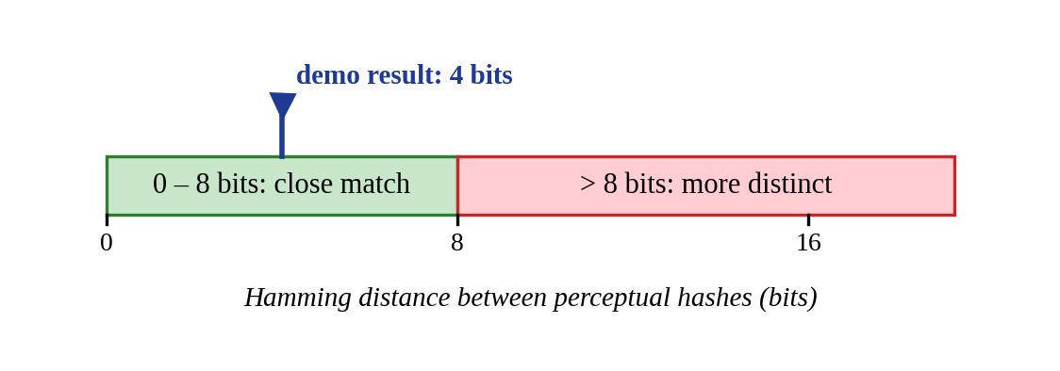
Figure 4: Perceptual-hash distance interpretation
4.2.6 Module M6: Case Evidence and Response
Process: the module bundles the results of the earlier modules, such as the face-scan data, forensic indicators, SHA-256 hash and comparison distance, into a case evidence JSON file and prepares a response draft for human review. Advantage: the user gets one organised file and a ready draft instead of scattered results. Output: the evidence file and the draft. The path from analysis to response, shown in Figure 5, always includes a human review step before notification.
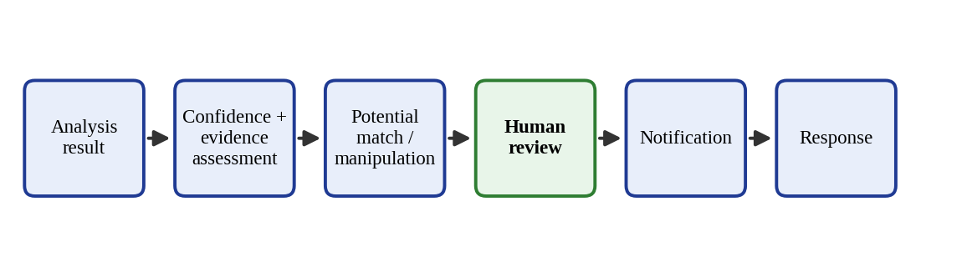
Figure 5: Evidence review and response path

4.2.7 Module M7: Optional Backend
Process: an optional FastAPI service with an SQLite database accessed through SQLAlchemy provides server-side registration, storage and comparison. Advantage: it supports saving cases and comparing against stored references, while the core pipeline still works in the browser without it. Output: stored case records that can be retrieved later.

4.2.8 Planned Analysis Components of the Framework
The conference paper that accompanies this report describes a fuller framework in which a face detector such as RetinaFace or MTCNN passes cropped faces to an EfficientNet-B0 classifier for images, and representative video frames pass through a CNN and an LSTM to model temporal changes. Authorised public sources are monitored through embedding-based similarity search such as FAISS, and matches go to human review. Figure 6 shows the two analysis pipelines. These components are part of the design and the future scope, and the prototype status is reported in Chapter 5.
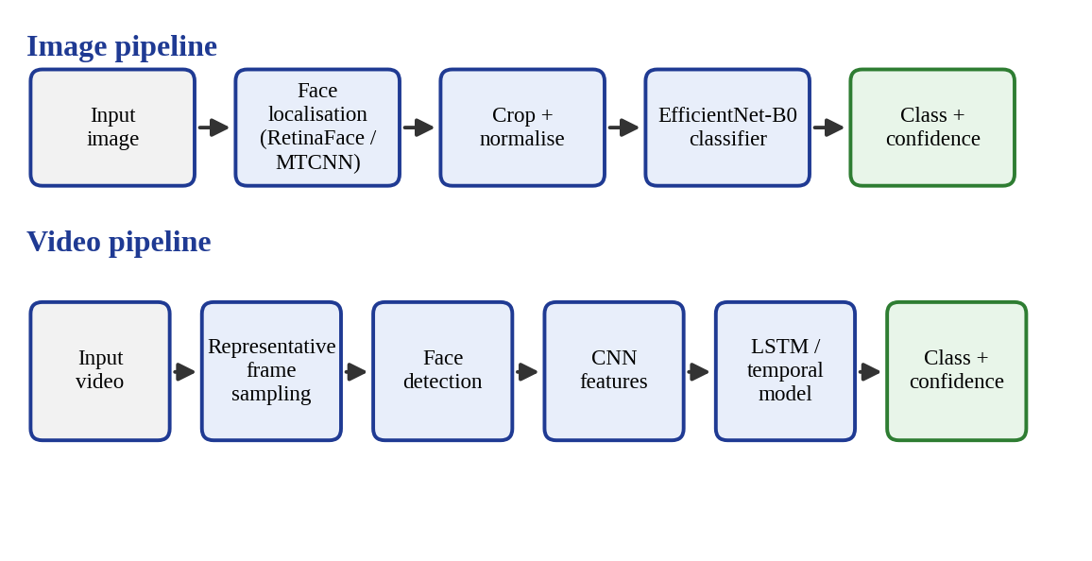
Figure 6: Planned image and video analysis pipelines
4.3 SECURITY AND PRIVACY DESIGN
Registered photographs, derived hashes and reviewer notes can all reveal personal information, so privacy is treated as part of the architecture and not as an add-on. The following controls are part of the design:
- Local processing: protection, scanning, forensics, hashing and comparison run in the browser, and the backend is optional.
- Encryption and access control: stored media and records are protected in storage and in transit, and only authorised users and services can reach them.
- Consent and data minimisation: media is processed only as the user permits, and each service receives only the data its task needs.
- Retention control: media and metadata are deleted when the retention period ends.
- Authorised monitoring: only sources the deployment is allowed to access are used.
- Human review: automated output supports a decision and never makes a consequential decision silently.
The design also considers misuse of the system itself. A file might be replaced after registration, an image might be recompressed or cropped to evade a detector [19], or a derived value might be altered. To limit these risks, hashes are tied to the case record, model and preprocessing versions are stored with each result, and predictions are always handled as evidence and not as truth.

4.4 EVALUATION PLAN
The prototype modules are complete, and structured testing is planned for October 2026. Each module will be tested in a controlled setting and then the whole workflow will be tested from the photograph to the response draft. For the image and video analysis components, a benchmark such as FaceForensics++ [7] can be used with accuracy, precision, recall, F1-score and ROC-AUC, with compression and resizing added to test robustness. For monitoring, Precision@K, Recall@K, search delay and false-positive rate will be reported.

Table 5: Planned fingerprinting test cases and expected behaviour
Test case | Expected behaviour
Original file | Exact SHA-256 match; perceptual distance of 0
Resized image | Perceptual similarity (close match)
Compressed image | Perceptual similarity (close match)
Cropped image | Partial similarity identified
Unrelated image | Low similarity (more distinct)

Table 6: Reporting format for the completed evaluation
Component | Metric | Result
Face detection | Detection rate / precision | To be measured
Forensic indicators | Agreement with known edits | To be measured
Perceptual comparison | Match rate at the 8-bit threshold | To be measured
Image manipulation (framework) | Accuracy / F1 | To be measured
End-to-end workflow | Time per case | To be measured

CHAPTER 5
RESULTS, CONCLUSION AND FUTURE WORK
5.1 RESULTS
Project Status
As of 29 September 2026, all seven modules, M1 to M7, have been completed. Integration, testing and preparation for review are planned for October 2026. The prototype outputs observed so far are summarised in Table 7.
Table 7: Summary of prototype outputs
Module / check | Observed output
Local photo cloaking (M1) | Protection applied locally to the browser working copy
Face detection (M2) | Face detected, with a confidence value, a face box and landmarks
Perceptual hash (M5) | 0 to 8 bits is a close match and above 8 is more distinct; the demonstration gave 4 bits
Forensic check (M3) | Laplacian variance, colour drift and texture signal reported as indicators, not as a verdict
SHA-256 evidence (M4) | Tamper-evident hash recorded for the file

Prototype Screenshots

Figure 7: Local photo protection output
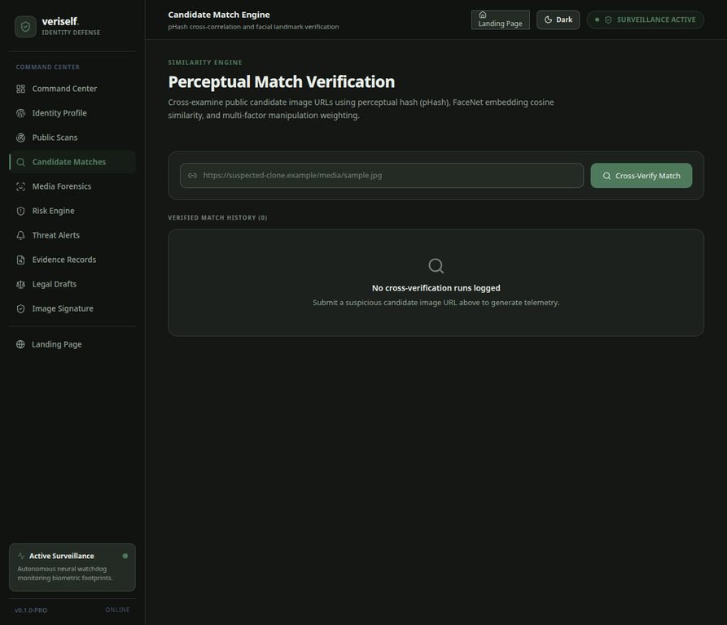
Figure 8: Face detection with box and landmarks
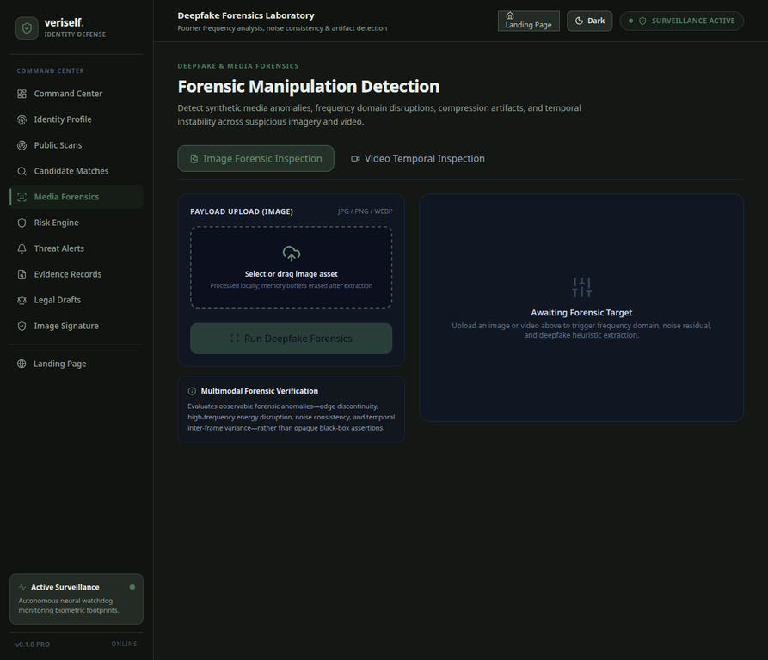
Figure 9: Forensic indicators and perceptual-hash comparison

Figure 10: Case evidence JSON and response draft
Impact
- Identity protection is extended beyond passwords and credit records to a person’s visual identity.
- The design is privacy-preserving, because photos are processed on the device and the backend is optional.
- Tamper-evident SHA-256 evidence and perceptual-hash comparison help users document suspected misuse.
- A human reviews the confidence-scored indicators and the response draft before anything is sent.
- Ordinary users get a practical register, monitor, alert and takedown path.
Quantitative results such as detection accuracy and retrieval metrics have not yet been measured, and they will be reported after the planned testing (Table 6).
5.2 CONCLUSION
VeriSelf is a browser-first, privacy-preserving platform that helps ordinary people protect their photographs, verify image matches and build tamper-evident evidence against misuse. Starting from the proactive-protection idea of the base paper NullSwap and the weaknesses of existing defences, the project adds a complete workflow around the image: a local protection step, a face and landmark scan, forensic indicators, SHA-256 and perceptual-hash evidence, and a human-reviewed response draft.
All seven modules are complete. The design keeps automated analysis separate from the final human decision, treats model scores as evidence, and builds consent, access control and data minimisation into the architecture. Integration, testing and review preparation are planned for October 2026, and the quantitative evaluation will show where the system works well and where it needs improvement.
5.3 FUTURE WORK
- Audio deepfake and voice-clone detection, and full CNN–LSTM temporal analysis for video.
- FAISS-based large-scale embedding search across many authorised sources.
- Automated takedown-request drafting and submission, with user review and approval before sending.
- A mobile app with real-time push alerts, and multi-language support for reporting and takedown channels.
- Confidence calibration and uncertainty estimation so that outputs support review without hiding uncertainty.
- Robustness testing against compression, resizing, cropping and unseen manipulation methods, and use of provenance data such as C2PA credentials where available.
5.4 SOURCE CODE
The core functions of the Python prototype are listed below, one group for each module. The listings are shortened by compacting whitespace and leaving out helper code; the logic is unchanged.
M1 - Local protection (app/services/protection_service.py)
MAGIC = b"VS11"
NONCE_SIZE = 8
SIGNATURE_SIZE = 16
DCT_DELTA = 25.0
COEFF_A = (2, 3)
COEFF_B = (3, 2)

def _build_token(identity_id: int) -> bytes:
nonce = secrets.token_bytes(NONCE_SIZE)
identity_bytes = identity_id.to_bytes(4, byteorder="big", signed=False)
unsigned = MAGIC + identity_bytes + nonce
signature = hmac.new(_get_secret(), unsigned,
hashlib.sha256).digest()[:SIGNATURE_SIZE]
return unsigned + signature

def _modify_dct_bit(block, bit):
dct = cv2.dct(block.astype(np.float32) - 128.0)
a = float(dct[COEFF_A])
b = float(dct[COEFF_B])
if bit == 1:
if a <= b + DCT_DELTA:
midpoint = (a + b) / 2.0
dct[COEFF_A] = midpoint + DCT_DELTA / 2.0
dct[COEFF_B] = midpoint - DCT_DELTA / 2.0
else:
if b <= a + DCT_DELTA:
midpoint = (a + b) / 2.0
dct[COEFF_B] = midpoint + DCT_DELTA / 2.0
dct[COEFF_A] = midpoint - DCT_DELTA / 2.0
return np.clip(cv2.idct(dct) + 128.0, 0, 255)

# inside embed_invisible_signature(): one bit is written per 8 x 8 block
for by in range(blocks_y):
for bx in range(blocks_x):
if bit_index >= len(bits):
break
y1, x1 = by * 8, bx * 8
ycrcb = cv2.cvtColor(output[y1:y1 + 8, x1:x1 + 8], cv2.COLOR_BGR2YCrCb)
modified = _modify_dct_bit(ycrcb[:, :, 0], bits[bit_index])
ycrcb[:, :, 0] = np.clip(modified, 0, 255).astype(np.uint8)
output[y1:y1 + 8, x1:x1 + 8] = cv2.cvtColor(ycrcb, cv2.COLOR_YCrCb2BGR)
bit_index += 1
M2 - Face scan (app/ml/face_detector.py)
_FACE_DETECTOR = MTCNN(image_size=160, margin=20, keep_all=True,
post_process=False)

def detect_faces(file_path: str) -> list[tuple[int, int, int, int]]:
image = Image.open(Path(file_path)).convert("RGB")
boxes, probabilities = _FACE_DETECTOR.detect(image)
if boxes is None:
return []
faces = []
for box, probability in zip(boxes, probabilities):
if probability is None or probability < 0.90:
continue
x1, y1, x2, y2 = box
faces.append((int(x1), int(y1),
max(0, int(x2 - x1)), max(0, int(y2 - y1))))
return faces
M3 - Forensic indicators (app/ml/manipulation_detector.py)
def _calculate_texture_variation(image: np.ndarray) -> float:
gray = cv2.cvtColor(image, cv2.COLOR_BGR2GRAY)
variance = float(cv2.Laplacian(gray, cv2.CV_64F).var())
return _normalize(variance, 20.0, 1000.0)

# inside analyze_image(): weighted combination of the five indicators
manipulation_score = (noise_score * 0.35 + texture_score * 0.20
+ channel_score * 0.20 + edge_score * 0.10
+ metadata_score * 0.15)

if manipulation_score >= 0.75:
risk_level = "CRITICAL"
classification = "HIGH_MANIPULATION_INDICATORS"
elif manipulation_score >= 0.55:
risk_level = "HIGH"
classification = "POSSIBLE_MANIPULATION"
elif manipulation_score >= 0.30:
risk_level = "MEDIUM"
classification = "SUSPICIOUS"
else:
risk_level = "LOW"
classification = "NO_STRONG_MANIPULATION_INDICATORS"
M4 - SHA-256 evidence (app/services/protection_service.py)
def _sha256_file(file_path: str) -> str:
digest = hashlib.sha256()
with open(file_path, "rb") as file:
while True:
chunk = file.read(1024 * 1024)
if not chunk:
break
digest.update(chunk)
return digest.hexdigest()

M5 - Perceptual verification (app/ml/phash_matcher.py)
STRONG_PHASH_DISTANCE = 8

def calculate_phash(file_path: str) -> str:
with Image.open(Path(file_path)) as image:
return str(imagehash.phash(image.convert("RGB")))

def phash_hamming_distance(hash_a: str, hash_b: str) -> int:
value_a = imagehash.hex_to_hash(hash_a)
value_b = imagehash.hex_to_hash(hash_b)
return int(value_a - value_b)

def is_strong_phash_match(distance: int) -> bool:
return distance <= STRONG_PHASH_DISTANCE
M6 - Case evidence (app/services/evidence_service.py)
evidence_data = {
"identity_id": match.identity_id,
"match_id": match.id,
"finding_id": finding.id,
"candidate_url": match.candidate_url,
"phash_distance": match.phash_distance,
"face_similarity": match.face_similarity,
"combined_score": match.combined_score,
"classification": match.classification,
"risk_level": match.risk_level,
"risk_score": finding.risk_score,
"finding_type": finding.finding_type,
"match_evidence": match_evidence,
}
# stable hash of the evidence package itself
serialized = json.dumps(evidence_data, sort_keys=True,
ensure_ascii=False).encode("utf-8")
content_hash = hashlib.sha256(serialized).hexdigest()
M7 - FastAPI service and database (app/main.py, app/db/database.py)
DATABASE_URL = "sqlite:///./veriself.db"
engine = create_engine(DATABASE_URL, connect_args={"check_same_thread": False})
SessionLocal = sessionmaker(bind=engine, autoflush=False, autocommit=False)

Base.metadata.create_all(bind=engine)

app = FastAPI(title="VeriSelf", version="0.1.0")
app.add_middleware(RateLimitMiddleware)
app.add_middleware(SecurityHeadersMiddleware)
app.include_router(router)
REFERENCES
[1] T. Wang, S. Niu, H. Cheng, X. Zhang, and Y. Wang, “NullSwap: Proactive identity cloaking against deepfake face swapping,” in Proc. IEEE/CVF Int. Conf. Computer Vision (ICCV), 2025, pp. 9945–9954.
[2] N. Ruiz, S. A. Bargal, and S. Sclaroff, “Disrupting deepfakes: Adversarial attacks against conditional image translation networks and facial manipulation systems,” in Computer Vision – ECCV 2020 Workshops, 2020, pp. 236–251.
[3] Q. Huang, J. Zhang, W. Zhou, W. Zhang, and N. Yu, “Initiative defense against facial manipulation,” in Proc. AAAI Conf. Artificial Intelligence, 2021.
[4] R. Wang, Z. Huang, Z. Chen, L. Liu, J. Chen, and L. Wang, “Anti-Forgery: Towards a stealthy and robust deepfake disruption attack via adversarial perceptual-aware perturbations,” in Proc. 31st Int. Joint Conf. Artificial Intelligence (IJCAI), 2022, pp. 761–767.
[5] H. Huang et al., “CMUA-Watermark: A cross-model universal adversarial watermark for combating deepfakes,” in Proc. AAAI Conf. Artificial Intelligence, vol. 36, no. 1, 2022, pp. 989–997.
[6] Z. Qu, Z. Xi, W. Lu, X. Luo, Q. Wang, and B. Li, “DF-RAP: A robust adversarial perturbation for defending against deepfakes in real-world social network scenarios,” IEEE Trans. Information Forensics and Security, 2024.
[7] A. Rössler, D. Cozzolino, L. Verdoliva, C. Riess, J. Thies, and M. Nießner, “FaceForensics++: Learning to detect manipulated facial images,” in Proc. IEEE/CVF ICCV, 2019, pp. 1–11.
[8] J. Deng, J. Guo, E. Ververas, I. Kotsia, and S. Zafeiriou, “RetinaFace: Single-shot multi-level face localisation in the wild,” in Proc. IEEE/CVF CVPR, 2020, pp. 5203–5212.
[9] K. Zhang, Z. Zhang, Z. Li, and Y. Qiao, “Joint face detection and alignment using multitask cascaded convolutional networks,” IEEE Signal Process. Lett., vol. 23, no. 10, pp. 1499–1503, 2016.
[10] M. Tan and Q. Le, “EfficientNet: Rethinking model scaling for convolutional neural networks,” in Proc. ICML, vol. 97, 2019, pp. 6105–6114.
[11] E. Sabir, J. Cheng, A. Jaiswal, W. AbdAlmageed, I. Masi, and P. Natarajan, “Recurrent convolutional strategies for face manipulation detection in videos,” in Proc. CVPR Workshops, 2019, pp. 80–87.
[12] S. Hochreiter and J. Schmidhuber, “Long short-term memory,” Neural Computation, vol. 9, no. 8, pp. 1735–1780, 1997.
[13] J. Johnson, M. Douze, and H. Jégou, “Billion-scale similarity search with GPUs,” IEEE Trans. Big Data, vol. 7, no. 3, pp. 535–547, 2021.
[14] L. Li, J. Bao, T. Zhang, H. Yang, D. Chen, F. Wen, and B. Guo, “Face X-ray for more general face forgery detection,” in Proc. IEEE/CVF CVPR, 2020.
[15] B. Dolhansky et al., “The DeepFake Detection Challenge dataset,” arXiv:2006.07397, 2020.
[16] Y. Mirsky and W. Lee, “The creation and detection of deepfakes: A survey,” ACM Comput. Surv., vol. 54, no. 1, 2021.
[17] S.-Y. Wang, O. Wang, R. Zhang, A. Owens, and A. A. Efros, “CNN-generated images are surprisingly easy to spot… for now,” in Proc. IEEE/CVF CVPR, 2020.
[18] Coalition for Content Provenance and Authenticity, “C2PA technical specification,” 2024.
[19] N. Carlini and H. Farid, “Evading deepfake-image detectors with white- and black-box attacks,” in Proc. CVPR Workshops, 2020.
[20] M. Hulzebosch, S. I. de Wit, M. M. B. Blom, and P. H. N. de With, “Detecting CNN-generated facial images in real-world scenarios,” in Proc. CVPR Workshops, 2020.
[21] R. Chen, X. Chen, B. Ni, and Y. Ge, “SimSwap: An efficient framework for high fidelity face swapping,” in Proc. 28th ACM Int. Conf. Multimedia, 2020, pp. 2003–2011.
[22] F. Juefei-Xu, R. Wang, Y. Huang, Q. Guo, L. Ma, and Y. Liu, “Countering malicious deepfakes: Survey, battleground, and horizon,” Int. J. Computer Vision, vol. 130, no. 7, pp. 1678–1734, 2022.
CONFERENCE PAPER CERTIFICATE





