DemandIQ: AI-Driven Retail Demand Forecasting and Inventory Optimization System
L VARSHINI, S J KAVITHA
Department of Computer Science and Engineering (AI & ML)
Vels Institute of Science, Technology and Advanced Studies (VISTAS), Pallavaram, Chennai - 600117, India
Email: 24619234@vistas.ac.in
Abstract—Small retail stores often struggle to maintain optimal inventory levels, leading to stock shortages or excess unsold goods. This project, DemandIQ, presents an AI-driven retail demand forecasting and inventory optimization system that predicts future product demand using historical sales data. Many small retailers still rely on manual estimation and traditional forecasting methods, which often lead to inaccurate demand predictions, stock shortages, overstocking, increased inventory costs, and poor business decision-making. By combining machine learning with time-series features such as lagged sales and moving averages, the system analyzes past sales patterns to estimate future demand and provide optimal restocking recommendations. This helps retailers reduce stockouts, minimize overstocking, and manage inventory more efficiently. The proposed system demonstrates how artificial intelligence can be applied to real-world retail challenges, providing a practical, low-cost solution for small businesses to optimize inventory management and support better business decision-making.
Keywords—Inventory Management; Demand Forecasting; Machine Learning; Time-Series Forecasting; Retail Analytics; Predictive Modeling.

I. INTRODUCTION
Retail inventory decisions involve two competing needs: keeping products available and avoiding unnecessary accumulation of stock. For a small shop, an incorrect estimate can leave a frequently purchased item unavailable or leave money tied up in products that sell slowly. A forecasting system can provide an additional data-based reference when deciding how much stock may be required.
Daily sales are not constant. The quantity sold can differ across dates, stores, and products, while recent sales may contain useful information about the following day's demand. DemandIQ therefore does not rely only on a fixed average. It extracts calendar information and previous observations from each store-item series so that the forecasting model receives both date-related and recent-demand information.
Because the value being predicted is the number of units sold, the project treats demand estimation as a regression problem. DemandIQ uses a Random Forest Regressor. The model builds several decision trees and combines their outputs, allowing it to represent nonlinear relationships between the input variables and sales without requiring a single manually specified equation.
After forecasting is completed, DemandIQ passes the result to a separate inventory layer. This layer uses sales history together with user-entered stock and supplier lead-time values. The purpose is to translate a predicted demand value into practical indicators such as reorder point, safety stock, and replenishment quantity.
The objective is not to replace inventory management software but to provide a compact decision-support workflow. A store user can choose a store and item, enter the current inventory information, and view the predicted demand together with the calculated stock position. The Streamlit interface keeps the model output and inventory calculations in the same place.

II. RELATED WORK
Retail forecasting research covers statistical methods, machine learning, and combinations of several forecasting techniques. Fildes, Ma, and Kolassa reviewed the development and practical use of retail forecasting and highlighted the importance of selecting methods according to the forecasting situation [1]. This provides the broader background for using historical sales as the starting point for DemandIQ.
Machine learning models are useful when sales depend on several interacting variables. Instead of manually defining every relationship, a model can learn patterns from examples in the training data. In DemandIQ, the inputs include store and item identifiers, calendar variables, and recent sales statistics. These variables are supplied to a regression model to estimate the next sales value.
Random Forest was introduced by Breiman as an ensemble method that combines multiple decision trees [2]. Its regression form is appropriate for DemandIQ because the target is a continuous sales quantity. The implementation uses 30 trees with a maximum depth of 15, a fixed random seed of 42, and parallel execution.
Forecasting is only one part of the inventory problem. A retailer also needs an indication of when available stock has fallen below a useful level. DemandIQ uses a reorder point together with safety stock. The reorder point represents expected demand during the supplier lead period plus the additional buffer calculated by the project.
The current implementation deliberately concentrates on information that is available in the supplied sales dataset. It does not use promotion records, weather, competitor prices, or other external signals. This keeps the workflow straightforward and makes the system easier to reproduce with the available data.

III. DATASET AND DATA PREPARATION
A. Dataset
The working dataset contains daily observations for multiple stores and products. Its original fields are date, store, item, and sales. A row records the number of units sold for one item at one store on a particular date. The dataset contains approximately 913,000 original records before the feature-engineering stage.

TABLE I. DATASET FIELDS
Field | Description
date | Date of the sales record
store | Store identifier
item | Product identifier
sales | Number of units sold

B. Data Preparation
First, the date field is converted to a datetime representation and the observations are maintained in chronological order. The records are processed separately for each store-item combination because the previous sales of one product at one store should not be mixed with another series. This arrangement is required for generating meaningful lag variables.
The feature set is built from the original date and sales columns. Day, month, year, weekday, and a weekend flag describe the calendar position. Two historical-sales variables are also generated. lag_1 contains the preceding day's sales, while lag_7 represents the sales value seven days earlier for the same store and item.
To represent the recent level of demand more smoothly, DemandIQ calculates a seven-day rolling average from earlier observations. The rolling calculation is shifted so that the sales value being predicted cannot enter its own input. Records that do not yet have enough historical observations are removed before model training.

IV. PROPOSED METHODOLOGY
The complete DemandIQ pipeline can be viewed as five connected steps: obtain the sales history, prepare the records, construct forecasting features, estimate demand, and convert the estimate into inventory guidance. The trained model is stored as a file and loaded by the dashboard when a prediction is requested.
Ten variables are supplied to the forecasting model: store, item, day, month, year, day of the week, weekend flag, lag_1, lag_7, and rolling_mean_7. The response variable is sales. These inputs give the model information about the product/store identity, calendar position, and recent demand behavior.
The forecasting model is a Random Forest Regressor. The selected configuration contains 30 trees and a maximum depth of 15, with random_state set to 42 and n_jobs set to -1. The individual trees produce estimates that are combined into the final regression output.
Testing follows the time direction of the data rather than randomly shuffling the rows. The first 80% of the prepared observations are used for training and the remaining 20% are reserved for evaluation. This arrangement reduces the risk of allowing later observations to influence training for an earlier prediction period.
Model performance is reported with three measures. Mean Absolute Error (MAE) gives the average size of the absolute prediction difference. Root Mean Square Error (RMSE) responds more strongly when an individual prediction has a large error. R² describes the proportion of target variation accounted for by the fitted model relative to a constant-prediction baseline.
The inventory calculations use average daily sales, maximum daily sales, lead time, maximum lead time, and the current stock entered by the user. The project calculates safety stock as (Maximum Daily Sales × Maximum Lead Time) − (Average Daily Sales × Lead Time). Reorder Point is then calculated as (Average Daily Sales × Lead Time) + Safety Stock. The suggested replenishment is the positive difference between reorder point and current stock.

V. EXPERIMENTAL RESULTS
The final model was assessed using the last 20% of the time-ordered prepared records. The resulting values are summarized in the table below.

TABLE II. TEST PERFORMANCE OF THE MODEL
Evaluation measure | Test value
MAE | 6.5353
RMSE | 8.5242
R² | 0.9270

The test set produced an MAE of 6.5353 and an RMSE of 8.5242. In practical terms, the MAE indicates an average absolute difference of roughly 6.54 sales units between the predicted and observed values. The larger RMSE shows that some larger errors have a greater influence on the squared-error measure.
The obtained R² was 0.9270. In this evaluation, that value indicates that the fitted model accounts for about 92.7% of the variation in the target relative to a constant baseline. It is important to distinguish this interpretation from calling the model 92.7% accurate, because R² is not an accuracy percentage.
The evaluation indicates that the engineered variables contain useful predictive information for this dataset. Recent-sales variables provide short-term demand context, while the calendar variables allow the model to distinguish between different positions in the week and year.
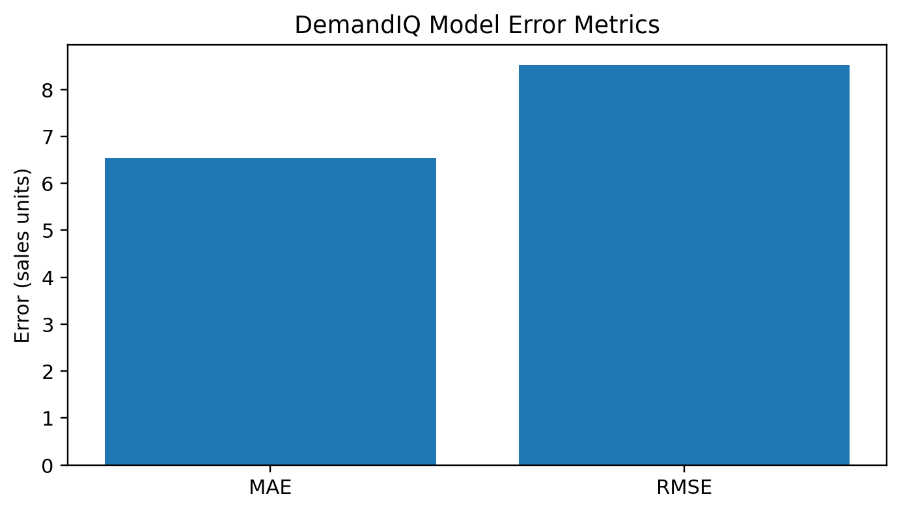
Fig. 1. Error measures obtained from the DemandIQ model.
The first graph places MAE and RMSE side by side. Their values are 6.5353 and 8.5242 sales units respectively. Because RMSE gives greater influence to larger deviations, its value is above the MAE for this test set.

VI. INVENTORY OPTIMIZATION
A sales forecast by itself does not indicate whether the quantity currently on a store shelf is sufficient. DemandIQ therefore follows the prediction stage with a separate inventory calculation stage.
Safety stock acts as a buffer against higher-than-average demand during the replenishment period. In this implementation it is derived from the maximum and average daily sales values together with the selected lead-time values. The reorder point is then formed by adding the expected lead-time demand to that safety-stock buffer.
The dashboard compares the entered stock quantity with the calculated reorder point. When available stock is lower than that threshold, DemandIQ reports that replenishment is required and estimates the additional quantity. When stock is above the threshold, the system does not request a replenishment action.
For the example store-item case, the average daily sales value is approximately 20 units and the maximum daily sales value is 50 units. With a lead time of approximately 7 days and a maximum lead time of 10 days, the calculated safety stock is about 359.98 units and the reorder point is 500 units.
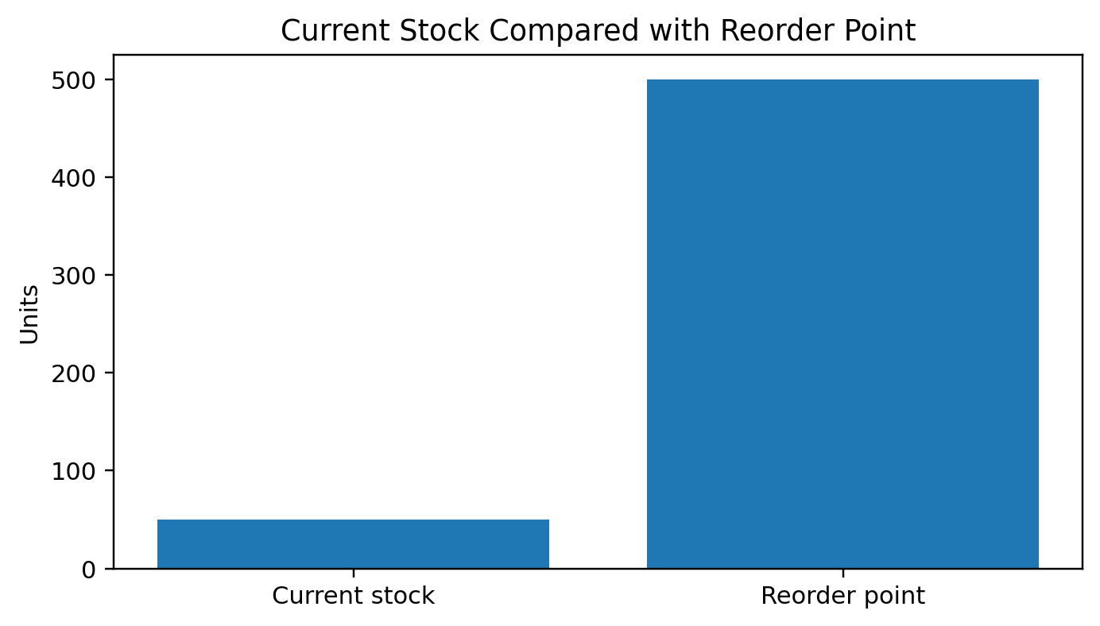
Fig. 2. Example comparison of current stock and reorder point.
The second graph illustrates the inventory example. Only 50 units are currently available, compared with a reorder threshold of 500 units. Since the current quantity is substantially below the calculated threshold, the dashboard marks the item for replenishment.

TABLE III. INVENTORY EXAMPLE
Inventory measure | Example value
Average daily sales | 20 units
Maximum daily sales | 50 units
Safety stock | 359.98 units
Reorder point | 500 units
Current stock | 50 units
Decision | Restocking required

VII. APPLICATION IMPLEMENTATION
The trained model was integrated into a Streamlit application [3]. This gives the project a browser-based interface in which Python model outputs, inventory calculations, tables, and charts can be displayed together.
The user interface provides controls for selecting the store and item and for entering current stock and supplier lead time. When analysis is requested, the application loads the saved model, prepares the latest required features, generates the demand estimate, and calculates the corresponding inventory values.
The resulting page summarizes the forecast and inventory position using metrics and status messages. A recent-demand chart provides additional context, while the report/download option allows the user to retain the displayed information. The intention is to avoid making the user perform the model and inventory calculations manually.
The application was first tested in the local development environment and was subsequently published using Streamlit Community Cloud. The project files include the application code, trained model, dataset, and package requirements. The source code is maintained in a GitHub repository, while the deployment provides access to the dashboard through a web browser.

VIII. DISCUSSION
DemandIQ combines two related tasks: estimating upcoming demand and interpreting that estimate for stock planning. A forecast such as a numerical sales value is useful, but a shop owner generally also needs to know whether the current inventory is sufficient. The inventory layer provides that second step.
The reported evaluation values describe performance on the project dataset and its chronological test portion. They should not be interpreted as a guarantee of the same performance on every retail environment. A change in products, stores, purchasing behavior, or market conditions could alter the model's performance.
The historical-sales variables are central to the present model. lag_1 and lag_7 provide direct information from earlier dates, while the seven-day rolling average summarizes the recent level of sales. Together, these features allow the model to use short-term history rather than relying only on calendar variables.
The dashboard forms the user-facing part of the system. Instead of requiring a store user to run Python scripts or calculate the stock formulas separately, the interface accepts a small number of inputs and displays the forecast and inventory indicators in one workflow.

IX. LIMITATIONS
The current model is restricted to the variables available in the project dataset. It does not account for promotions, discounts, holidays, weather conditions, competitor pricing, or other external events that may change demand.
The stock-planning equations are also simplified representations. A production inventory system could additionally consider service-level requirements, demand variability, supplier reliability, minimum order quantities, holding costs, and ordering costs. Those factors are not part of the current implementation.
Store and item values are numeric identifiers in the supplied dataset. As a result, the present dashboard identifies them with their numerical IDs rather than business-friendly store names or product names.
Only the Random Forest model is used in the current forecasting implementation. A fuller comparison could evaluate additional algorithms using the same chronological train-test procedure and the same evaluation measures.

X. FUTURE WORK
An expanded version could incorporate additional demand signals when suitable data is available. Examples include promotional activity, selling-price changes, holiday indicators, and weather information.
Further experiments could compare the present Random Forest approach with other tree-based and boosting methods as well as dedicated time-series techniques. Keeping the same chronological evaluation procedure would make such comparisons more meaningful.
The inventory component could be made more flexible by modeling demand variability and selecting a target service level when determining safety stock. This would allow the buffer to be adjusted according to the desired level of product availability.
The dashboard could later support direct CSV uploads, descriptive product and store names, multiple-store views, automatic low-stock notifications, historical inventory tracking, and downloadable business reports.

XI. SYSTEM ARCHITECTURE AND WORKFLOW
A. Overall Workflow
DemandIQ follows a sequential workflow that connects historical sales data, feature engineering, demand prediction, and inventory decision support. The process begins with the daily sales records containing date, store, item, and sales information. The records are ordered chronologically and processed separately for each store-item combination. Calendar variables and historical-sales variables are then generated before the prepared observations are supplied to the forecasting model. The predicted demand is subsequently passed to the inventory layer, where stock position and replenishment requirements are calculated from sales statistics and user-provided inventory information.
B. Forecasting Layer
The forecasting layer treats the number of units sold as a continuous regression target. Ten input variables are used: store, item, day, month, year, day of the week, weekend flag, lag_1, lag_7, and rolling_mean_7. The historical variables provide short-term demand context, while the calendar variables represent the position of an observation within the week and year. A Random Forest Regressor combines the outputs of multiple decision trees to obtain the final demand estimate. The selected implementation uses 30 trees, maximum depth 15, random_state 42, and parallel execution.
C. Inventory Decision Layer
The second layer converts the numerical demand information into practical inventory guidance. Average daily sales and maximum daily sales are combined with lead-time values to calculate safety stock. The implementation uses the expression (Maximum Daily Sales × Maximum Lead Time) − (Average Daily Sales × Lead Time) for safety stock. Reorder Point is then obtained by adding lead-time demand to the safety-stock value. Finally, the system compares current stock with the reorder point and recommends replenishment when the available quantity is below the calculated threshold.
D. User Interaction
The Streamlit dashboard keeps forecasting and inventory calculations within one workflow. A user selects a store and item and enters current stock and supplier lead time. The application loads the saved model, prepares the required latest features, generates the demand estimate, and calculates the corresponding inventory indicators. The resulting interface presents the forecast, inventory position, recent-demand information, and report/download functionality so that the user does not need to execute the model or inventory equations manually.

XII. DETAILED MODEL EVALUATION AND PRACTICAL INTERPRETATION
A. Chronological Evaluation
The evaluation procedure follows the time direction of the prepared sales records. The first 80% of observations are used for training and the remaining 20% are reserved for testing. Unlike a randomly shuffled split, this arrangement preserves the chronological relationship between earlier and later observations and reduces the risk of using later information while evaluating an earlier forecasting period. The reported results therefore describe the model behaviour on the held-out chronological portion of the supplied dataset.
B. Performance Measures
Three measures are used to evaluate the forecasting model. Mean Absolute Error (MAE) describes the average absolute difference between predicted and observed sales values. Root Mean Square Error (RMSE) gives greater influence to larger prediction errors. R² describes the proportion of target variation accounted for by the fitted model relative to a constant-prediction baseline. On the test portion, DemandIQ obtained an MAE of 6.5353, an RMSE of 8.5242, and an R² of 0.9270. The R² value should not be interpreted as a percentage of prediction accuracy; it describes explained variation under this evaluation setup.
C. Inventory Example
The paper's example store-item case illustrates how the forecast-related inventory layer supports a practical decision. Average daily sales are approximately 20 units and maximum daily sales are 50 units. With a lead time of approximately 7 days and a maximum lead time of 10 days, the calculated safety stock is about 359.98 units and the reorder point is 500 units. Current stock is 50 units, which is substantially below the reorder threshold. The dashboard therefore marks the item as requiring replenishment. This example demonstrates the transition from a numerical sales forecast to an operational stock-planning indicator.
D. Reproducibility and Deployment
The trained model is stored as a file and loaded by the dashboard when a prediction is requested. The application was tested in a local development environment and subsequently published using Streamlit Community Cloud. The project files include the application code, trained model, dataset, and package requirements, while the source code is maintained in a GitHub repository. This arrangement provides a reproducible workflow in which the prepared data, model, and application are kept as connected parts of the prototype.
E. Practical Scope
DemandIQ is designed as a compact decision-support workflow rather than a complete enterprise inventory management platform. Its current scope deliberately uses the information available in the supplied sales dataset. Promotions, discounts, holidays, weather conditions, competitor prices, supplier reliability, service-level requirements, minimum order quantities, holding costs, and ordering costs are outside the present implementation. These limitations define clear directions for future improvement while keeping the current system straightforward to reproduce and evaluate.
XIII. IMPLEMENTATION CONSIDERATIONS AND SYSTEM BENEFITS
A. Data-to-Decision Flow
B. Benefits for Small Retailers
C. Reliability of the Current Prototype
The results demonstrate useful predictive behaviour on the supplied dataset, but the system should be treated as a prototype rather than a universal forecasting solution. The chronological evaluation provides a more appropriate test arrangement for the time-ordered data, while the reported MAE, RMSE, and R² quantify performance on the held-out portion. Changes in product mix, store behaviour, market conditions, or external demand factors may affect future performance. Therefore, deployment in a different retail environment would require validation using that environment's historical records.
D. Extensibility
The architecture leaves clear opportunities for further development. Additional demand signals such as promotions, prices, holidays, and weather can be incorporated when reliable data is available. Alternative forecasting algorithms can also be compared using the same chronological evaluation procedure. On the inventory side, the simplified safety-stock calculation can be extended to account for demand variability, service-level targets, supplier reliability, and ordering constraints. These extensions can improve the usefulness of the system while preserving the existing forecasting-to-inventory workflow.
XIV. CONCLUSION
DemandIQ was implemented as a compact machine-learning workflow that links sales forecasting with inventory planning. Historical store-item records are transformed into calendar and recent-sales features, and a Random Forest Regressor is used to estimate demand while preserving the chronological nature of the data.
On the held-out chronological portion, the model obtained an MAE of 6.5353, an RMSE of 8.5242, and an R² of 0.9270. These measurements indicate that the selected variables captured useful patterns in the supplied sales records, although the results apply specifically to this dataset and evaluation setup.
The forecasting result is subsequently used by the inventory component. Safety stock and reorder point are calculated from the sales statistics and lead-time inputs, and the difference between available stock and the reorder threshold is used to determine whether replenishment is suggested.
The final implementation places these functions inside a Streamlit dashboard and makes the application available as a deployed web interface. The system remains a prototype: external demand drivers, richer inventory policies, and alternative forecasting models are areas for future development.

ACKNOWLEDGMENT
The author would like to express her sincere gratitude to Ms. S. J. Kavitha, Assistant Professor, School of Engineering, VISTAS, for her valuable guidance, constant motivation, and technical support throughout this research work. The author would also like to thank the Department of AI & ML, VISTAS, for providing the necessary infrastructure and support to carry out this study.

REFERENCES
[1] R. Fildes, S. Ma, and S. Kolassa, “Retail forecasting: Research and practice,” International Journal of Forecasting, vol. 38, no. 4, pp. 1283–1318, 2022, doi: 10.1016/j.ijforecast.2019.06.004.
[2] L. Breiman, “Random Forests,” Machine Learning, vol. 45, pp. 5–32, 2001, doi: 10.1023/A:1010933404324.
[3] Streamlit, “Streamlit Documentation,” 2026. Available: https://docs.streamlit.io/

