
SMART PARK: IoT AND ML BASED REAL-TIME PARKING SLOT AVAILABILITY SYSTEM
Suganthen P – 24619228
Sathish Kumar K – 24619264
Chandru K – 24619238
MINI PROJECT REPORT
Submitted to the
SCHOOL OF ENGINEERING
DEPARTMENT OF ARTIFICIAL INTELLIGENCE AND MACHINE LEARNING
in Partial fulfillment of the requirements for the award of the degree of
BACHELOR OF TECHNOLOGY CSE
IN
ARTIFICIAL INTELLIGENCE AND MACHINE LEARNING

VELS INSTITUTE OF SCIENCE, TECHNOLOGY AND ADVANCED STUDIES (VISTAS)
CHENNAI – 600 117
OCTOBER 2026
BONAFIDE CERTIFICATE
Certified that this project report “SMART PARK: IoT AND ML BASED REAL-TIME PARKING SLOT AVAILABILITY SYSTEM” is the bonafide work of SUGANTHEN P – 24619228, SATHISH KUMAR K – 24619264 and CHANDRU K – 24619238. They carried out this project under the guidance and supervision of the Department of Artificial Intelligence and Machine Learning, School of Engineering, Vels Institute of Science, Technology & Advanced Studies (VISTAS), Chennai.
The report explains the design and the prototype of a smart parking system. The system uses IoT sensors to watch the parking slots, a mobile app, time-based booking and machine learning to guess the free slots.
SIGNATURE OF THE HOD  Dr. K. Ulaga Priya M.E., Ph.D  Associate Professor & Head  of Department AI&ML  School of Engineering  VISTAS, Chennai. | SIGNATURE OF THE SUPERVISOR  DR N MEENAKSHI M.Tech., Ph.D  Assistant Professor  Department of AI&ML  School of Engineering  VISTAS, Chennai.
Submitted for the Project Work and Viva-Voce examination held on ____________________ at Vels Institute of Science, Technology and Advanced Studies (VISTAS), Chennai – 600 117.
INTERNAL EXAMINER EXTERNAL EXAMINER
ACKNOWLEDGEMENT
We thank Vels Institute of Science, Technology & Advanced Studies (VISTAS), Chennai, for giving us a good place to study and the facilities we needed to do this project.
We are very thankful to Dr. K. Ulaga Priya M.E., Ph.D, Associate Professor and Head of the Department of Artificial Intelligence and Machine Learning, for her support and encouragement during the project.
We sincerely thank our project supervisor, DR N MEENAKSHI M.Tech., Ph.D Assistant Professor, Department of Artificial Intelligence and Machine Learning, for her guidance and useful suggestions. Her help made it easy for us to shape the project and to write this report.
We also thank our faculty members, friends and everyone who helped us with the development, the hardware setup, the app testing and the project demo.
Last of all, we thank our families for their love and support all through this work.

SUGANTHEN P - 24619228
SATHISH KUMAR K - 24619264
CHANDRU K - 24619238

CHAPTER NO. | TABLE OF CONTENT | PAGE NO.
 | ABSTRACT | i
 | LIST OF FIGURES | ii
 | ABBREVIATIONS | iii
1 | INTRODUCTION | 1
 | 1.1 Overview of the Project | 1
 | 1.2 Problem Statement | 1
 | 1.3 Objectives | 1
 | 1.4 Scope of the Project | 2
 | 1.5 Applications and Expected Outcomes | 2
2 | LITERATURE REVIEW | 3
 | 2.1 Background | 3
 | 2.2 Existing Approaches | 3
 | 2.3 Research Gap | 3
 | 2.4 Proposed Contribution | 4
3 | SYSTEM DESIGN | 5
 | 3.1 System Architecture | 5
 | 3.1.1 Overall Data Flow | 6
 | 3.2 Hardware Components | 6
 | 3.3 Software Architecture | 7
 | 3.4 Data and Reservation Flow | 8
 | 3.5 Machine Learning Design | 8
4 | IMPLEMENTATION | 9
 | 4.1 Hardware Implementation | 9
 | 4.2 Administrator Dashboard and Sensor States | 9
 | 4.3 Customer Application and Live Data | 11
 | 4.4 Reservation Workflow | 12
 | 4.4.1 Step-by-Step Customer Booking | 12
 | 4.5 Core Logic Summary | 13
 | 4.6 Testing and Observations | 13
 | 4.7 Source Code Implementation | 14
 | 4.8 Results and Discussion | 17
5 | CONCLUSION AND FUTURE WORK | 19
 | 5.1 Conclusion | 19
 | 5.2 Limitations | 19
 | 5.3 Future Enhancements | 19
 | 5.4 Final Remark | 20
 | APPENDIX A - CONFERENCE PAPER CERTIFICATES | 21
 | REFERENCES | 23

ABSTRACT
Finding a free parking space in a busy campus takes time. Drivers go round and round the lot, and this causes traffic and stress. SMART PARK is a small parking system made to solve this problem. It uses IoT sensors and machine learning ideas to show which parking slots are free and to let a user book a slot.
In our prototype, an IR sensor is fixed at every parking slot. An ESP32 board reads the sensors and sends the slot status through Wi-Fi to a cloud database. A mobile app then shows the parking lot, a live slot map, the vehicle choice, the booking time and the charge. Before a booking is confirmed, the app checks the chosen time. The payment step is only a demo, so no real money is taken. Our screenshots show how the status of two slots changes and how the app screens look.
The project also describes a Random Forest model. It can use old parking records and details like day, time and weather to guess how many slots will be free later. This guess is only a help for planning. The live sensor reading is always the main source. We have not given any accuracy number for the model because we did not test it fully in this work.
Keywords: Smart Parking, Internet of Things, ESP32, IR Sensor, Real-Time Occupancy, Mobile Application, Time-Based Booking, Cloud Database, Random Forest.

FIGURE NO | TITLE | PAGE NO.
Figure 1 | Overall architecture of SMART PARK | 5
Figure 2 | Data flow from sensor to application | 6
Figure 3 | Hardware prototype of the smart parking system | 9
Figure 4 | Admin dashboard with both slots available | 10
Figure 5 | Dashboard with one slot occupied | 10
Figure 6 | Dashboard with both slots occupied | 10
Figure 7 | Customer app home screen | 11
Figure 8 | Lot details and live slot map | 11
Figure 9 | Reservation screens: time selection, slot selection, vehicle and confirmation | 12
Figure 10 | Supabase Client Setup | 14
Figure 11 | Booking Request Function | 15
Figure 12 | Live Database Updates | 15
Figure 13 | Parking Slot Display and Selection | 16
Figure 14 | IoT Sensor and Controller Setup | 16
Figure 15 | Parking Slot Database Structure | 17

Abbreviation | Full Form
AI | Artificial Intelligence
API | Application Programming Interface
ESP32 | Espressif 32-bit Microcontroller Board
HOD | Head of the Department
IoT | Internet of Things
IR | Infrared
ML | Machine Learning
PGIS | Parking Guidance and Information System
RF | Random Forest
SQL | Structured Query Language
UI | User Interface
VISTAS | Vels Institute of Science, Technology and Advanced Studies
Wi-Fi | Wireless Fidelity

CHAPTER 1. INTRODUCTION

1.1 OVERVIEW OF THE PROJECT
Parking is a big problem in colleges and other places where many vehicles come at the same time. A driver often has to go round the lot to find an empty space. This wastes time and fuel and creates traffic. If the driver could see the free slots on a phone before reaching the lot, the problem would be much smaller.
SMART PARK is a connected parking prototype. It joins IoT sensors, an ESP32 board, a cloud database, a mobile app for customers and a booking system. The sensors tell us which slot is filled. The app shows the lot and each slot, so the user can check before booking.
Our project paper describes the system as a Parking Guidance and Information System (PGIS) for a campus. An IR sensor watches each slot. The ESP32 reads the sensors and sends the data through Wi-Fi to the cloud. The app reads this data and shows the live status. Booking with a start time and an end time helps the user plan for a later time.

1.2 PROBLEM STATEMENT
In most parking areas, the driver has to search for a free space alone, or a guard tells him where to go. The driver cannot see how many slots are free. There is also no easy way to book a slot for a later time. Sometimes it is hard to tell the difference between a slot that is filled right now and a slot that is booked for later.
This project tries to build one simple system that can do four things: (i) find the slot status with sensors, (ii) send the status to an app, (iii) show the live free slots, and (iv) let the user pick a slot and a time without clashing with another booking. Another aim in our paper is to guess the future free slots from old records.

1.3 OBJECTIVES
- To build a parking prototype with IR sensors and an ESP32 board.
- To send the slot status to a cloud database through Wi-Fi.
- To make an app where users can see parking lots and free slots.
- To allow booking with a date, start time, time length and vehicle.
- To check for booking clashes before a booking is confirmed.
- To save parking session details and old records for later study.
- To explain a Random Forest idea for guessing future free slots from old records and daily conditions.
- To show how the system works with photos of the hardware and screenshots of the app.

1.4 SCOPE OF THE PROJECT
The prototype covers one small parking lot with two slots. It has sensors that detect filled slots, an admin dashboard and a customer booking screen. Our screenshots show the slots S-001 and S-002 as free or occupied. They also show the customer steps, from finding the lot to choosing a slot and a demo confirmation.
Our project paper also explains a prediction part. It uses old parking records, day of the week, time, weather and past occupancy. We have not measured any accuracy for it, so in this report we treat it as a design idea and do not give any accuracy percentage. The payment page in the app clearly says that it is a demo payment and that no real money is taken.

1.5 APPLICATIONS AND EXPECTED OUTCOMES
- College campus parking, where students, staff and visitors want to know the free slots.
- Small shops, offices and other small parking areas.
- Parking admins who want a quick view of filled and free slots.
- Booking a slot in advance.
- Study of old parking records to guess the future demand.
We expect the prototype to make slot details easy to see, to save the time spent on checking slots by hand, and to show how sensors, an app and booking can work together. For real use, the system needs more field testing, careful sensor setup and regular monitoring.

CHAPTER 2. LITERATURE REVIEW

2.1 BACKGROUND
Many smart parking studies use the same basic parts. Sensors find out whether a slot is filled. A network carries this data. A central database stores it. A dashboard or a mobile app shows it to the user. Some systems also add booking and prediction, so that the driver can plan ahead and does not depend only on the present status.
Our project paper uses the survey “Survey of Smart Parking Systems” by M. G. Diaz Ogás, R. Fabregat and S. Aciar [1] as a main reference. The survey groups parking systems by their purpose, sensor type, algorithm and stage of development. Two of the groups are Parking Guidance and Information Systems and Parking Reservation Systems. SMART PARK has both a live guidance part and a booking part, so this survey suits our work. Other reviews of smart parking are given in [2] and [11].

2.2 EXISTING APPROACHES
A simple parking guidance system only tells whether a slot is free or filled. The sensors can be infrared, ultrasonic, magnetic and so on. How well they work depends on where they are fixed, how they are set up, the weather and how well the data reaches the server [5]. An IoT board can connect many sensors and send their data to a cloud database.
Mobile parking apps show lot details and free slots in a simple way. Apps with booking also take a start time and an end time and compare them with the earlier bookings. Here the system must keep two things separate: the present status of the slot and the future booking. A slot may be empty now but booked for a later time.
Machine learning has also been used to guess the parking demand [3], [4]. Our paper suggests Random Forest as the model. It uses the day, time, weather and past occupancy. Such a guess should only help in planning. The current sensor reading must always be treated as the correct live status. Studies on campus parking demand and prediction are also given in [6], [9] and [10]. Some other prototypes join hardware, a cloud service and a phone app, for example [7] and [8].

2.3 RESEARCH GAP
Our paper points to a gap between sensing, live information, booking and future prediction. A system with only sensors shows the present status but does not help a user plan a visit. A system with only booking can reserve a time, but it may not match what is really happening in the lot if it is not linked to sensors. A system with only prediction may become wrong when the conditions change.
SMART PARK tries to fill this gap in a small way. It links the sensor setup with an app that shows the live status and allows time-based booking. The screenshots show the main functions working. A bigger system would need proper tests for update delay, sensor errors, booking clashes and prediction quality.

2.4 PROPOSED CONTRIBUTION
- Slot-wise monitoring with IR sensors and an ESP32 board.
- A Wi-Fi connection to send the slot status to a cloud service.
- An admin dashboard to see the total and slot-wise status.
- A customer app for finding a lot, seeing the live slot map and booking by time.
- A machine learning idea that uses old records to guess the future free slots.
The main contribution is joining all these parts into one campus parking workflow. The proof we have for this report is our project paper, our review presentation, the project folder structure and the prototype screenshots. We have not made any claim about numbers that we did not measure.

CHAPTER 3. SYSTEM DESIGN

3.1 SYSTEM ARCHITECTURE
SMART PARK has four connected layers: (1) sensing and control, (2) wireless communication, (3) cloud data and app logic, and (4) mobile screens for customers and admins. The layers keep the physical detection separate from the booking work, but the screens still show everything together. Figure 1 shows the overall architecture.
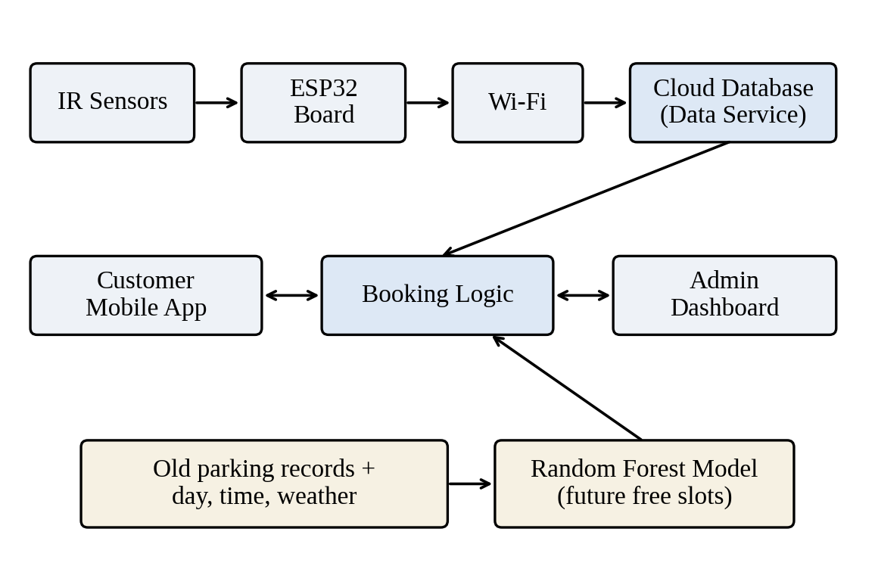
Figure 1 - Overall architecture of SMART PARK
Table 1 - Layers of the system
Layer | Main part | Work done
Sensing | IR sensor at each slot | Finds out whether a vehicle is in the slot.
Controller | ESP32 board | Reads the sensors and sends updates through Wi-Fi.
Data service | Cloud database | Stores the slot status, booking details and old records.
Customer app | Mobile application | Shows lot details, live slot map, date, time and booking buttons.
Admin view | Live parking dashboard | Shows free and occupied totals, slot status, bookings and revenue.
Prediction | Random Forest model | Guesses future free slots from old records and daily conditions.

3.1.1 Overall Data Flow
- An IR sensor checks whether a parking slot is filled.
- The ESP32 reads the sensor and sends the update through Wi-Fi.
- The cloud service stores the current slot status.
- The admin dashboard and the customer app read the status and update the screen.
- A customer chooses a lot, time, slot and vehicle for a booking.
- The booking part checks for clashes. If the request is fine, it goes to the demo payment and confirmation step.
- The prediction part can use the old records to guess the future free slots.
Figure 2 shows this flow from the sensor to the app and the booking.
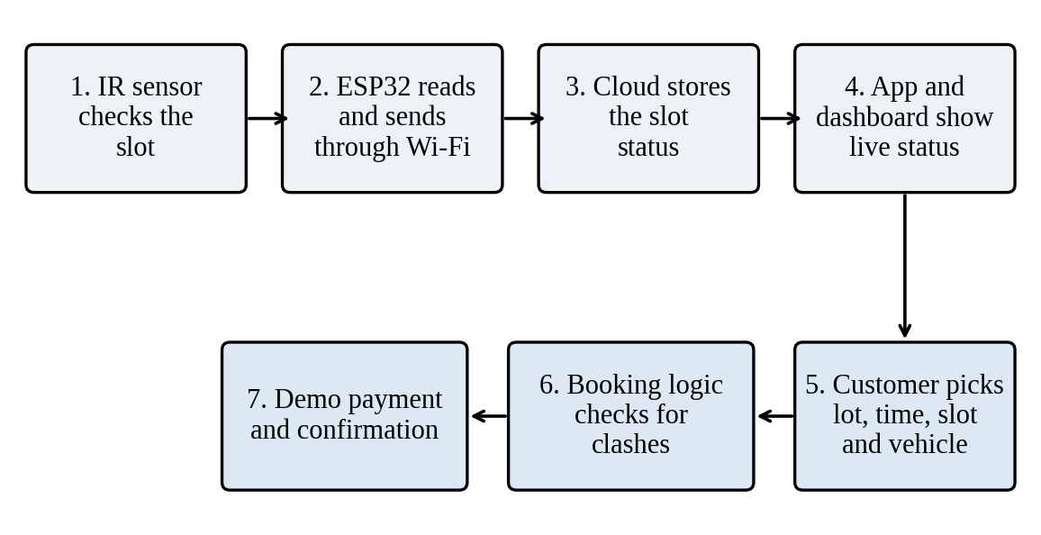
Figure 2 - Data flow from sensor to application

3.2 HARDWARE COMPONENTS
The hardware parts used in the prototype are given in Table 2.
Table 2 - Hardware components
Component | Role in the prototype
ESP32 development board | The main controller. It reads the sensors and gives the Wi-Fi connection.
IR proximity sensors | Find out whether a vehicle or object is present at each slot.
Connecting wires | Carry power and signals between the parts.
Power source | Gives power to the controller and the sensors.
Servo motor / gate | Seen in the hardware setup as a part of the parking demo. How the gate works should be checked with the firmware before real use.
Prototype board | Holds the parts and wires for the demo.

The hardware photo shows a controller board, sensor modules, wires, a power pack and a servo motor fixed on a demo board. Our paper names IR sensors and the ESP32 for slot monitoring. The pin numbers used in the code are shown in Section 4.7.

3.3 SOFTWARE ARCHITECTURE
The app is built as an Expo and React Native project. The project folder has the src folder, the hardware/smart_parking folder and the supabase folder, along with the app settings and some helper scripts. The README mentions Expo Router and TypeScript for the app setup. The cloud database is Supabase. Table 3 lists the software parts.
Table 3 - Software parts of the system
Software part | Purpose in the system
Mobile application | Shows parking search, live slot status, lot details and booking controls.
Cloud database | A shared place to keep the slot status and the booking data.
Hardware firmware | Reads the slot sensors and sends the status changes through the ESP32.
Booking logic | Checks the chosen slot and time against earlier bookings and shows the confirm step.
Prediction part | Uses old records and daily conditions in the Random Forest idea from our paper.

3.4 DATA AND RESERVATION FLOW
The system must keep two ideas apart: whether a slot is filled right now, and whether a slot is booked for some time. The sensor tells us if the slot is filled at the time of reading. The booking record tells us if the slot is kept for a customer for a chosen time. So the app can show a live map and also ask the user for a date, a start time, a time length and a vehicle.
Our booking screenshot shows a selected slot, the vehicle choices, a one hour total of ₹20 and a button named “Pay ₹20 & confirm”. The screen also says that the payment is a demo and that no real money is taken. Another screenshot shows a late start time with a warning that the lot closes at 23:59. This shows that the app checks the time limit.

3.5 MACHINE LEARNING DESIGN
Our paper describes a Random Forest model that guesses how many parking slots will be free at a future time. The inputs are the day of the week, time, weather and past occupancy. A Random Forest is a group of many decision trees. It can learn how these inputs are linked to the free slots and then give a number for the chosen time.
The steps for the model are: collect the old occupancy records; clean the missing or wrong entries; make the time and weather features; split the data into training and testing parts; train a Random Forest regression model; test it on the data kept aside; and show the predicted free slots separately from the live sensor status.
Our paper mentions about two weeks of old records. We have not given any dataset size beyond this, any train and test split or any score, because we did not measure them in this work.

CHAPTER 4. IMPLEMENTATION

4.1 HARDWARE IMPLEMENTATION
We built the prototype on a base board. The controller, sensor modules, servo motor and power source are joined with jumper wires. The controller connects the sensors to the data service used by the app. During the demo, we change the sensor state and check whether the dashboard shows the same slot status.
The photos show the hardware and three dashboard states: both slots free, one slot filled and both slots filled. These show that the slot status is displayed correctly in a demo. They are not a large field test and they do not measure the sensor accuracy.
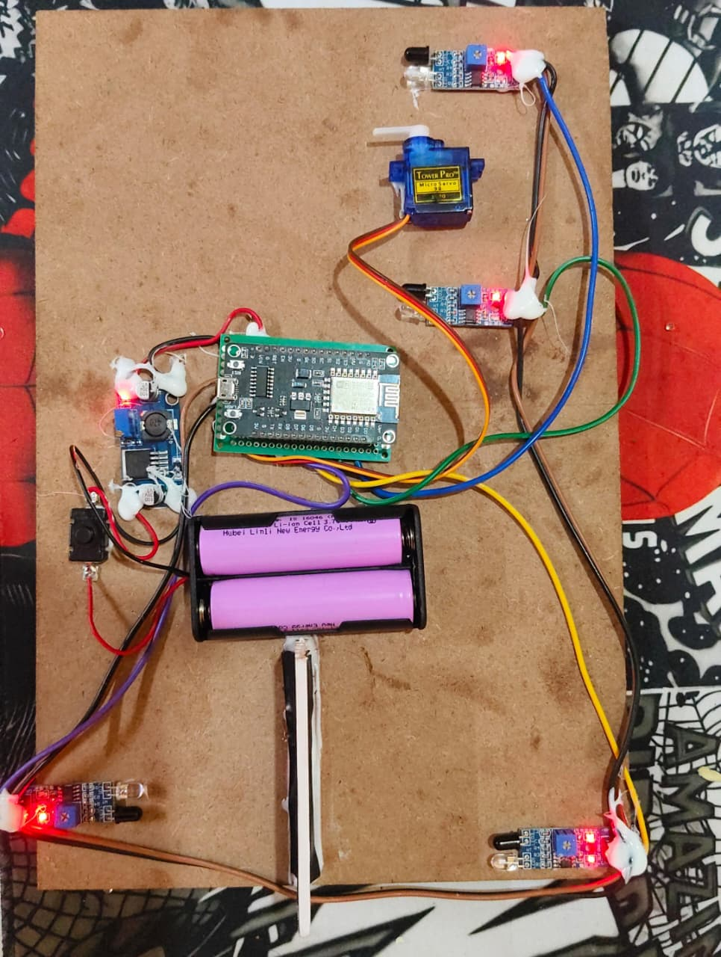
Figure 3 - Hardware prototype of the smart parking system
Figure 3 shows the prototype board with the controller, sensors, power pack, wires and servo motor. It is the base for testing the slot sensing and the controller. The sensor readings are turned into a free or filled status, and the app screens show this result. A real installation would need strong fixing, a steady power supply and sensor calibration.

4.2 ADMINISTRATOR DASHBOARD AND SENSOR STATES
The admin screen shows the status of the lot and of each slot. In the screenshots the lot is named “Vels clg lot” and the slots are S-001 and S-002. The dashboard shows the totals of free and filled slots, the bookings today and the revenue, and also a status panel for each slot.
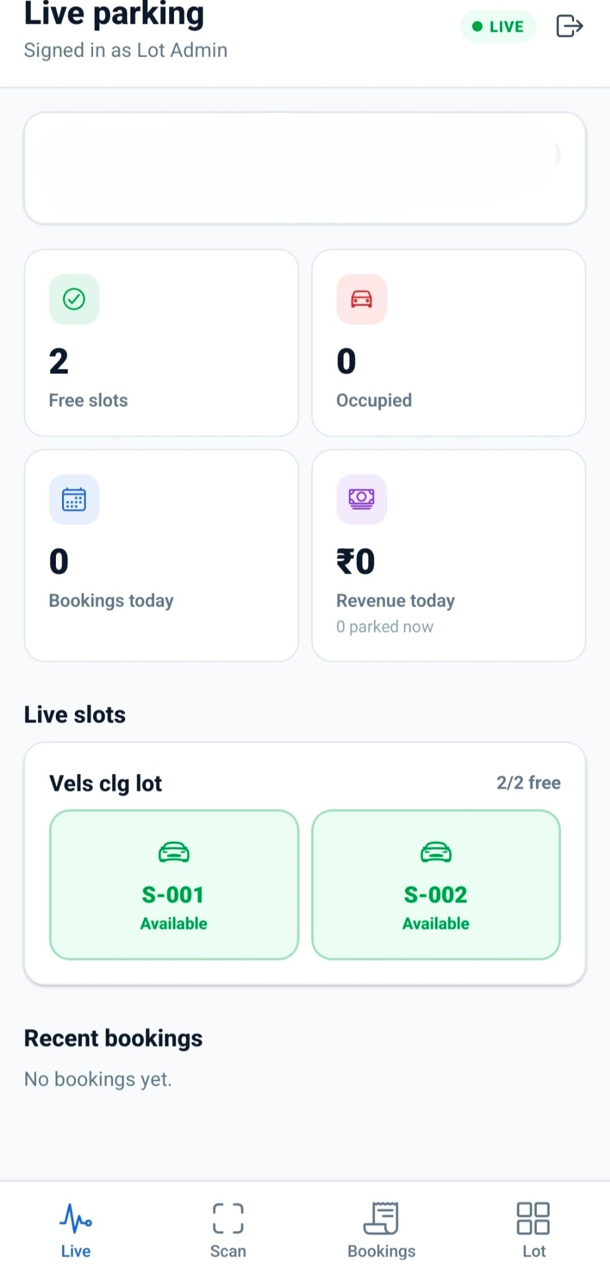  Figure 4 - Admin dashboard with both slots available | 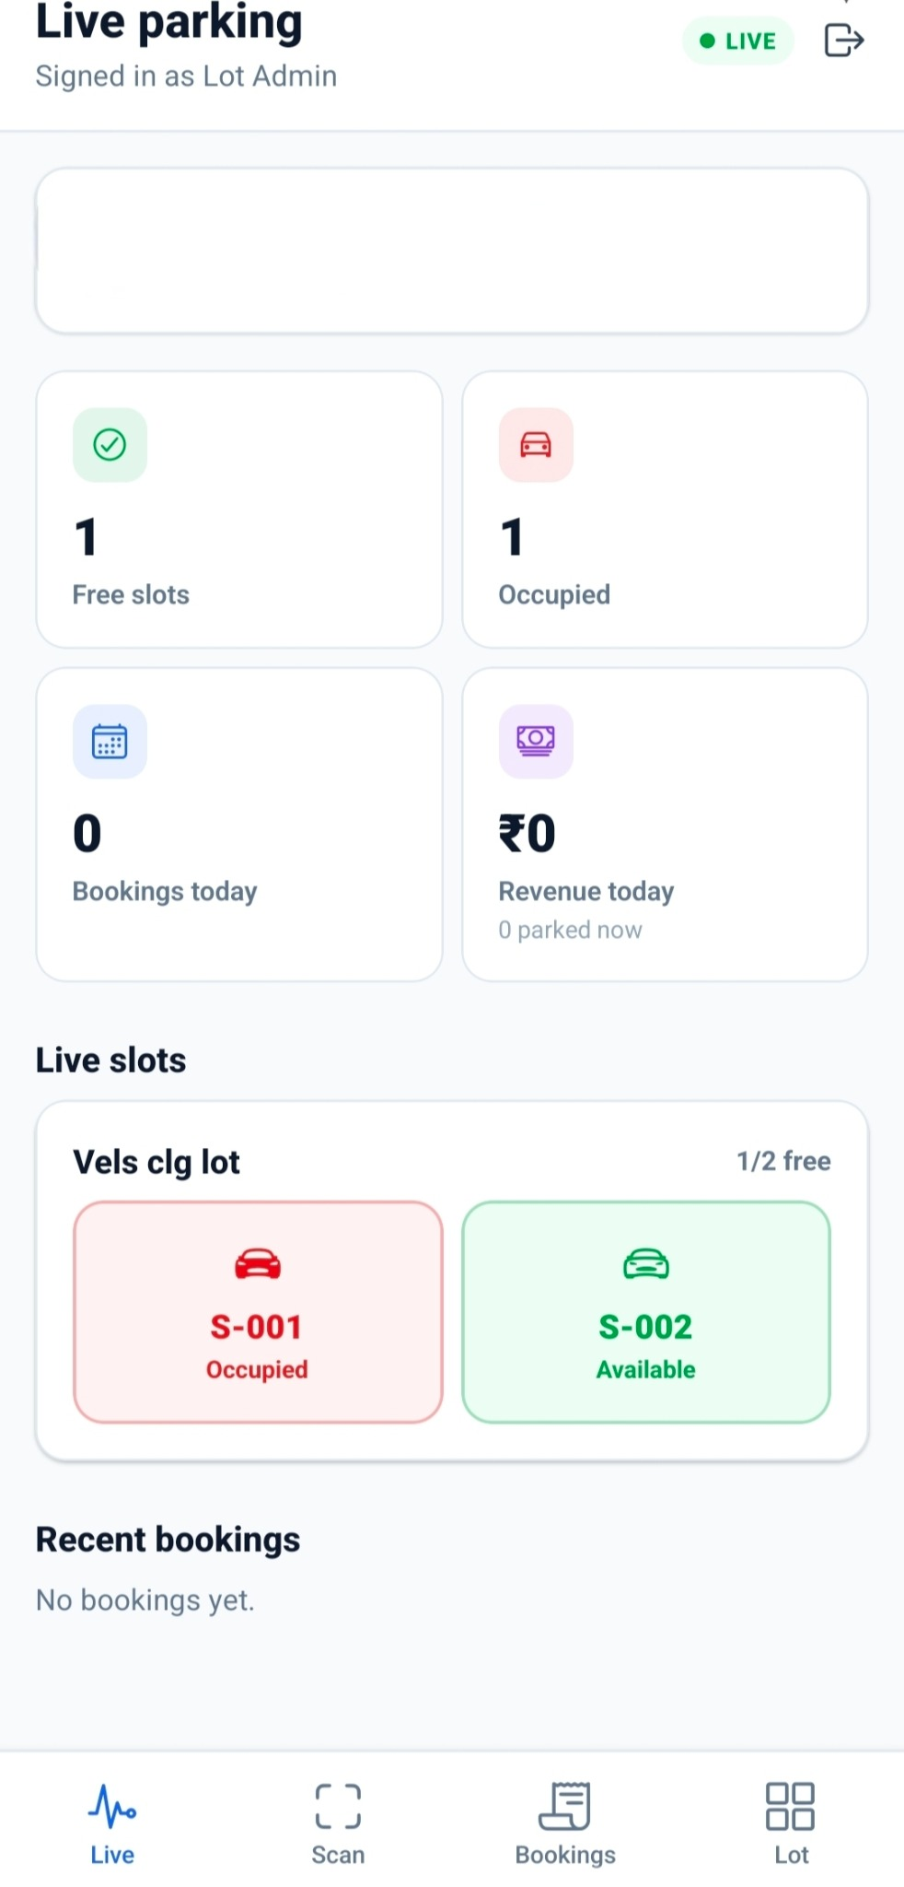  Figure 5 - Dashboard with one slot occupied | 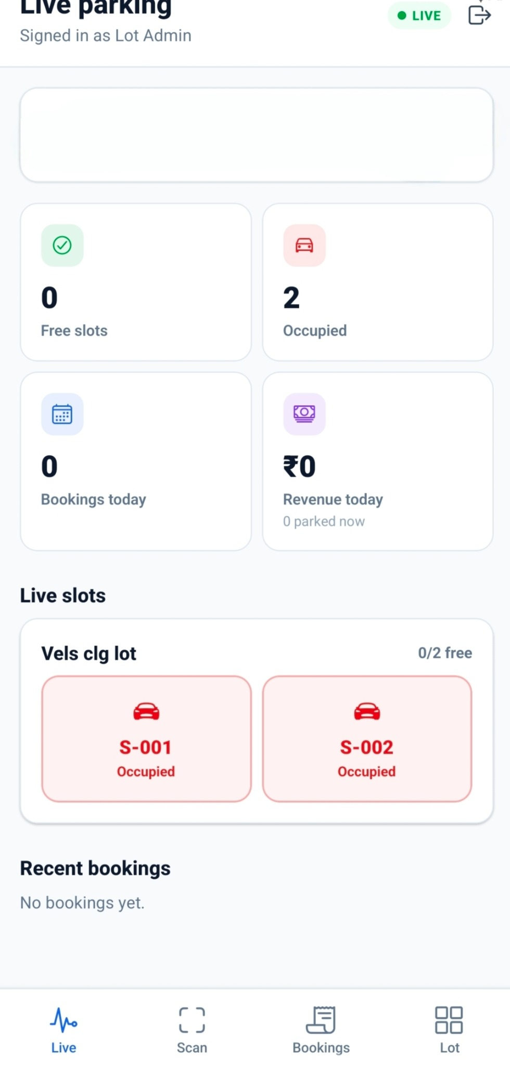  Figure 6 - Dashboard with both slots occupied

Figure 4 shows two free slots and zero filled slots. S-001 and S-002 are both available. This is the starting state that we compare with the later changes. The sensor reading comes from smart_parking.ino and the slot boxes come from slot-grid.tsx.
Figure 5 shows one free slot and one filled slot. S-001 is filled and S-002 is free. This shows that the dashboard can show a mixed state and not only the total count. In real use, the screen depends on the sensor update reaching the database and on the dashboard refreshing. The live refresh is done by useRealtimeSync.ts.
Figure 6 shows zero free slots and two filled slots. Both S-001 and S-002 are marked occupied. The totals and the slot panel match. This is the full lot case, where a customer can see that no slot is free. The screenshot shows only the result on the screen. It does not measure the delay or the reliability. The same code files as in Figure 4 give this output.

4.3 CUSTOMER APPLICATION AND LIVE DATA
The customer app opens with a home screen that greets the user and shows how many spaces are free in the lot. The user can search for parking, open a lot and see its details page. The screens show the location, opening hours, hourly price and the current slot status.
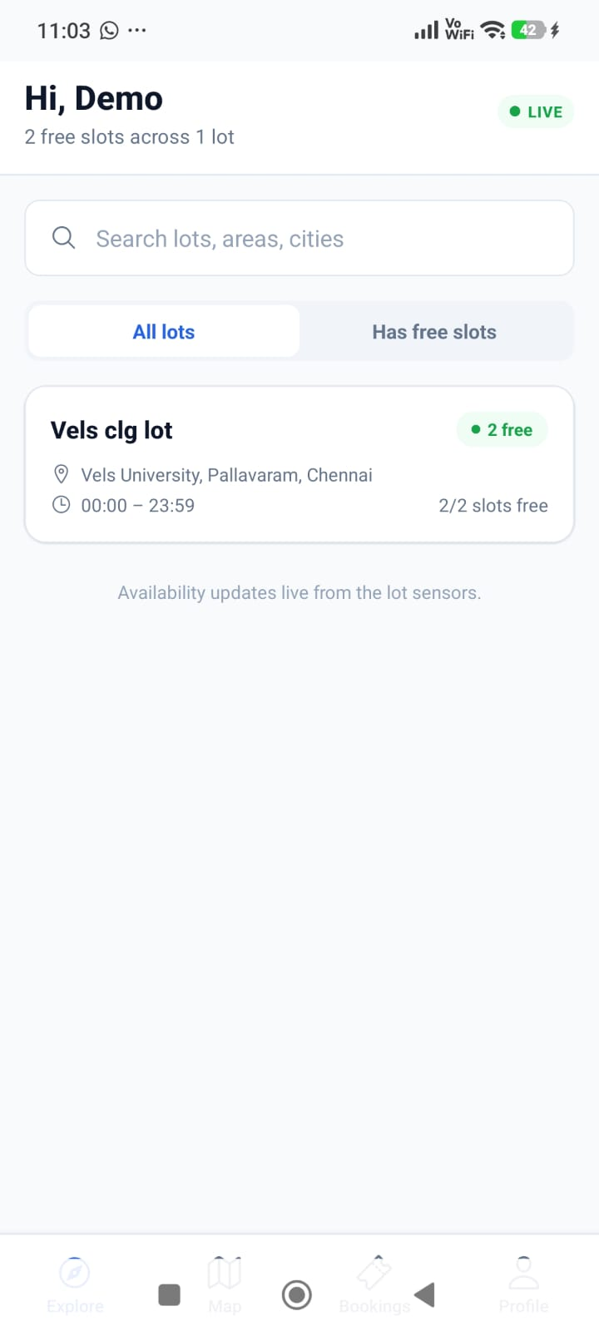  Figure 7 - Customer app home screen | 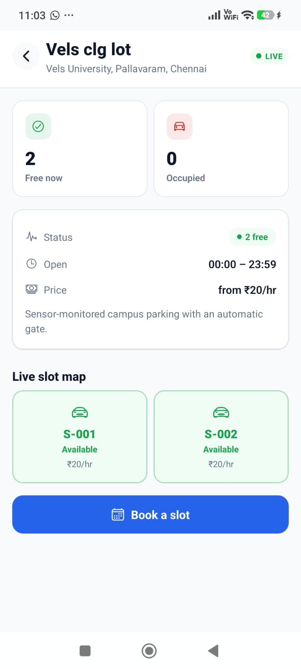  Figure 8 - Lot details and live slot map

Figure 7 shows the home screen with the number of free slots and a card for Vels clg lot. The screen also says that the status is updated live from the lot sensors. The user can start from here and check the lot before opening its details. The live count comes from useRealtimeSync.ts through the Supabase connection in supabase.ts.
Figure 8 shows the details of Vels clg lot with the location, opening hours, starting rate and a live map of two slots. Both S-001 and S-002 are free here. The “Book a slot” button takes the user from viewing to booking. The live map lets the user see the slot status before trying to book. The slot map is drawn by slot-grid.tsx.

4.4 RESERVATION WORKFLOW
On the booking screen, the customer chooses a date, start time, time length, parking slot and vehicle. The screen shows a one hour total of ₹20 for the chosen slot and a button to confirm. If the stay would go past the closing time of the lot, which is 23:59, the time screen shows a warning.
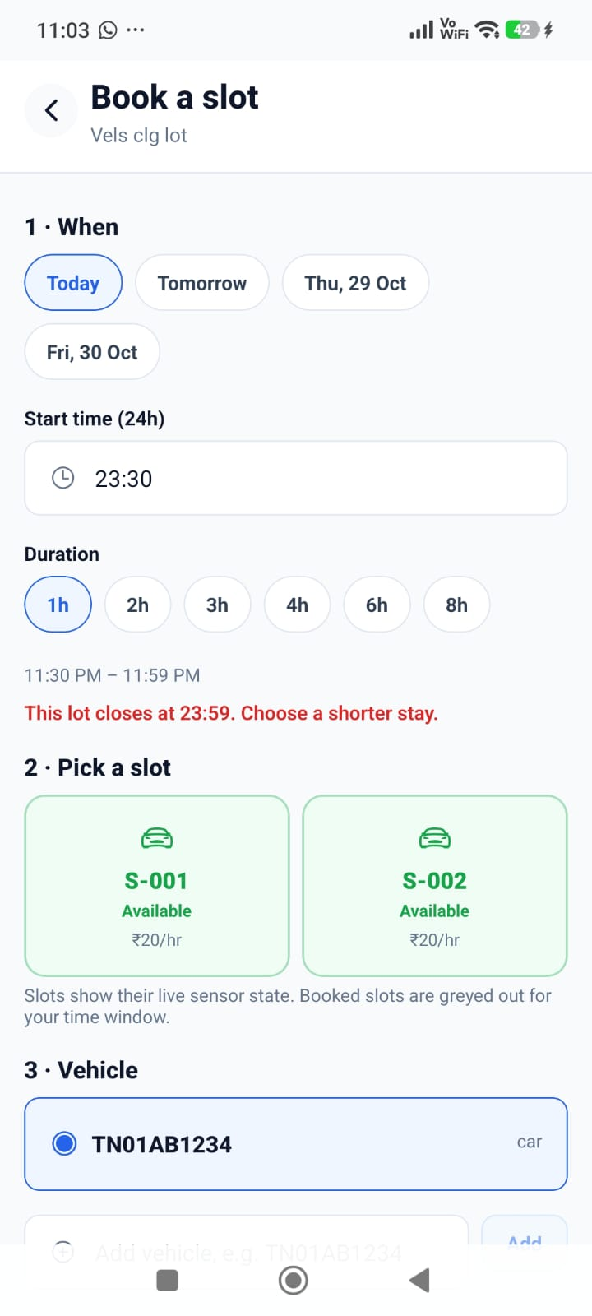 | 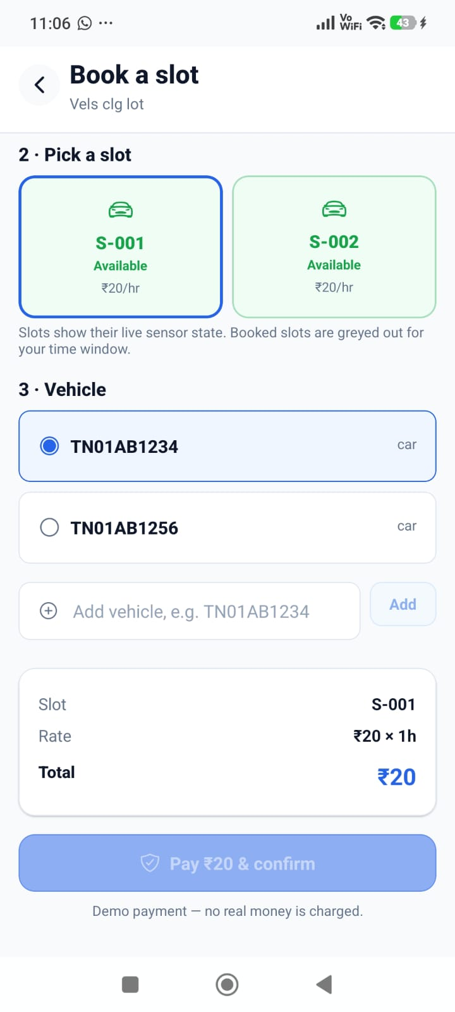
Figure 9 - Reservation screens: time selection, slot selection, vehicle and confirmation
Figure 9 joins the two booking screenshots. The first one shows the chosen date and time and the closing time warning. The second one shows S-001 selected, the vehicle options, the hourly rate and the demo payment button. The screen says that no real money is taken, so this is only a demo payment and not a real payment system. The booking request is sent by the bookSlot function in bookings.ts.

4.4.1 Step-by-Step Customer Booking
- Open the customer app and see the parking lots on the home screen.
- Select Vels clg lot to see its address, opening hours, hourly rate and live slot map.
- Tap “Book a slot” to open the booking page.
- Choose the date, start time and time length. The app shows a warning if the stay goes past the closing time.
- Select a free slot such as S-001.
- Select a saved vehicle number or add a new vehicle.
- Check the total amount and tap the demo payment and confirm button.
- The booking part is meant to check the chosen time against the earlier bookings before the booking is confirmed.

4.5 CORE LOGIC SUMMARY
The logic below is a short summary of how the system works. It is not copied from the source code. We wrote it in plain steps to explain the working.
Slot monitoring
- Read each slot sensor.
- Change the sensor state to available or occupied.
- Send the slot ID and its current state through Wi-Fi.
- Update the shared slot record.
- Refresh the admin and customer slot screens.
Booking check
- Receive the slot, start time, end time and vehicle.
- Check that the chosen time is inside the working hours of the lot.
- Find the earlier bookings of the chosen slot.
- If the new time overlaps with a booking, reject it or ask for another time.
- Otherwise, work out the charge and go to the demo confirmation.
Future availability
- Prepare the old occupancy records and the daily condition features.
- Train a Random Forest model on the old records.
- Predict the number of free slots for the chosen future time.
- Show the prediction separately from the live sensor status.

4.6 TESTING AND OBSERVATIONS
Table 4 lists what we observed in the demo and the figure that shows it.
Table 4 - Test cases and observations
Test case | Figure | Observation
Initial availability | Figure 4 | Dashboard shows 2 free and 0 occupied. Both slots are available.
Single slot occupied | Figure 5 | Dashboard shows 1 free and 1 occupied. S-001 is occupied.
Full occupancy | Figure 6 | Dashboard shows 0 free and 2 occupied. Both slots are occupied.
Customer lot discovery | Figure 7 | Home screen shows the lot and the free slot summary.
Live slot details | Figure 8 | Lot page shows the slot status and the booking button.
Booking input and amount | Figure 9 | Date, time, length, slot, vehicle and the ₹20 one hour demo total are shown.
Closing time check | Figure 9 | A warning shows for a stay that goes past the 23:59 closing time.

These observations show that the slot status display and the customer booking screens work in the demo. We did not record a sensor accuracy test, update delay, booking test logs or a machine learning evaluation table. So we do not give numbers for these.

4.7 SOURCE CODE IMPLEMENTATION
This section shows the core code files of our project as plain text. Each code part has its file name and a short explanation. The code is linked to the results in Section 4.8. The environment file is not included because it may have private settings.
Figure 10 - Supabase Client Setup
File Name: src/lib/supabase.ts
import { createClient } from '@supabase/supabase-js';
import AsyncStorage from '@react-native-async-storage/async-storage';
import { AppState } from 'react-native';

const supabaseUrl = process.env.EXPO_PUBLIC_SUPABASE_URL || '';
const supabaseAnonKey = process.env.EXPO_PUBLIC_SUPABASE_ANON_KEY || '';

if (!supabaseUrl || !supabaseAnonKey) {
console.warn('Supabase URL or Anon Key is missing. Ensure they are set in your environment variables.');
}

export const supabase = createClient(supabaseUrl, supabaseAnonKey, {
auth: {
storage: AsyncStorage,
autoRefreshToken: true,
persistSession: true,
detectSessionInUrl: false,
},
});
Explanation: This file connects the mobile app to Supabase using settings from the environment. It also saves the login session on the phone.
Figure 11 - Booking Request Function
File Name: src/api/bookings.ts
export interface BookSlotInput {
lotId: string;
slotId: string;
vehicleId: string;
date: string;
start: string; // HH:MM
end: string; // HH:MM
}

export const bookSlot = (i: BookSlotInput) =>
rpc<{ booking_id: string; booking_reference: string; qr_token: string; amount: number }>('book_slot', {
p_lot_id: i.lotId,
p_slot_id: i.slotId,
p_vehicle_id: i.vehicleId,
p_date: i.date,
p_start: i.start.length === 5 ? `${i.start}:00` : i.start,
p_end: i.end.length === 5 ? `${i.end}:00` : i.end,
});
Explanation: This function sends the chosen lot, slot, vehicle and time to the booking function in the database. It adds seconds to the time when they are missing.
Figure 12 - Live Database Updates
File Name: src/hooks/useRealtimeSync.ts
export function useRealtimeSync(channelName: string, tables: Table[], queryKeys: QueryKey[]) {
const queryClient = useQueryClient();
const tablesKey = tables.join(',');
const keysKey = JSON.stringify(queryKeys);

useEffect(() => {
let channel = supabase.channel(channelName);
for (const table of tablesKey.split(',')) {
channel = channel.on('postgres_changes', { event: '*', schema: 'public', table }, () => {
for (const queryKey of JSON.parse(keysKey) as QueryKey[]) {
queryClient.invalidateQueries({ queryKey });
}
});
}
channel.subscribe();
return () => { supabase.removeChannel(channel); };
}, [channelName, tablesKey, keysKey, queryClient]);
}
Explanation: This hook listens for changes in the chosen database tables. When a row changes, it tells the app to load the related data again.
Figure 13 - Parking Slot Display and Selection
File Name: src/components/slot-grid.tsx
{slots.map((slot) => {
const tone = SLOT_TONE[slot.status];
const blocked = disabledIds?.has(slot.id) ||
slot.status === 'maintenance' || slot.status === 'disabled';
const selected = selectedId === slot.id;
return (
<Pressable
key={slot.id}
disabled={!onSelect || blocked}
onPress={() => onSelect?.(slot)}
accessibilityRole="button"
accessibilityLabel={`Slot ${slot.slot_number}, ${tone.label}`}
>
<Text>{slot.slot_number}</Text>
<Text>{disabledIds?.has(slot.id) ? 'Booked' : tone.label}</Text>
{showPrice ? <Text>{formatMoney(slot.hourly_price)}/hr</Text> : null}
</Pressable>
);
})}
Explanation: This part of the code shows every slot with its current status. It does not let the user select a slot that is blocked, disabled or under maintenance.
Figure 14 - IoT Sensor and Controller Setup
File Name: hardware/smart_parking/smart_parking.ino
#include <ESP8266WiFi.h>
#include <ESP8266HTTPClient.h>
#include <WiFiClientSecure.h>
#include <Servo.h>
#include "secrets.h"

const int IR_ENTRY = D1;
const int IR_EXIT = D2;
const int IR_SLOT1 = D6;
const int IR_SLOT2 = D7;
const int SERVO_PIN = D5;

const unsigned long SLOT_DEBOUNCE = 1000;
const unsigned long RETRY_DELAY = 4000;
const unsigned long RESYNC_INTERVAL = 60000;
const int SERVO_CLOSED = 0;
const int SERVO_OPEN = 90;
Explanation: This NodeMCU code sets the pins for the entry, exit and slot sensors. It also sets the time values used to avoid unstable readings and to retry updates.
Figure 15 - Parking Slot Database Structure
File Name: supabase/migrations/20261019130000_schema.sql
CREATE TYPE slot_status AS ENUM
('available', 'occupied', 'reserved', 'maintenance', 'disabled');

CREATE TABLE parking_slots (
id UUID PRIMARY KEY DEFAULT gen_random_uuid(),
parking_lot_id UUID NOT NULL REFERENCES parking_lots(id) ON DELETE CASCADE,
slot_number TEXT NOT NULL,
slot_type slot_type NOT NULL DEFAULT 'regular',
vehicle_type vehicle_type NOT NULL DEFAULT 'car',
floor TEXT NOT NULL DEFAULT '1',
status slot_status NOT NULL DEFAULT 'available',
hourly_price NUMERIC(10, 2) NOT NULL CHECK (hourly_price >= 0),
created_at TIMESTAMPTZ NOT NULL DEFAULT now(),
updated_at TIMESTAMPTZ NOT NULL DEFAULT now(),
UNIQUE (parking_lot_id, slot_number)
);
Explanation: The database keeps a fixed list of slot states. Each slot is linked to a parking lot and stores its number, type, status and hourly price.

4.8 RESULTS AND DISCUSSION
The prototype shows a clear path from the live slot status to the start of a booking. The admin view gives a quick summary and shows each slot separately. The customer app shows the same status in a simpler way, with lot details and a “Book a slot” button. The booking page collects the details needed for a time-based booking and shows the demo charge before confirming.
The screenshots also show why checking the working hours matters. A late start time gives a warning because the lot closes at 23:59. This stops bookings that go beyond the working time. In a real system the server should also apply the same rule, so that nobody can skip the check by using only the app screen.
The Random Forest part in our paper is meant to help in advance planning by guessing the free slots from old records and daily conditions. The live sensor data is still needed because the real status may differ from the guess. A full test should report the sensor accuracy, the time taken for an update to reach the app, the booking clash results and the machine learning error values on test data.
Table 5 links each result to the code files that gave the output.
Table 5 - Results and the code files behind them
Result | Figure | Main code file(s)
Hardware prototype and sensor reading | Figure 3 | smart_parking.ino
Admin dashboard slot states | Figures 4, 5, 6 | smart_parking.ino, useRealtimeSync.ts, slot-grid.tsx
Customer home screen with live free slots | Figure 7 | useRealtimeSync.ts, supabase.ts
Lot details and live slot map | Figure 8 | slot-grid.tsx, useRealtimeSync.ts
Booking and slot selection | Figure 9 | bookings.ts, slot-grid.tsx, schema.sql

CHAPTER 5. CONCLUSION AND FUTURE WORK

5.1 CONCLUSION
SMART PARK is a campus parking system that joins an ESP32 sensor prototype, a mobile app and a time-based booking screen. The hardware photo shows how the prototype is built. The dashboard screenshots show the two slots changing from both free, to one filled, to both filled. The customer screenshots show finding the lot, the live slot map and the booking steps.
The system helps with a real parking problem. It makes the free slots easy to see and lets a user book a slot for a chosen time. The booking page has slot and vehicle selection, the charge and a demo payment button. It also warns the user when the stay goes past the closing time of the lot.
Our paper explains a Random Forest model to guess the future free slots using old records and daily conditions. We have written about this part in the report, but we have not given any accuracy result for it. From our prototype, we can say that the hardware and the app screens work as a demo. More testing is needed before we can say anything about big lots, prediction accuracy or use in the real world.

5.2 LIMITATIONS
- The screenshots are from a demo lot with only two slots. Bigger lots and many users at the same time need more testing.
- We did not measure the sensor error, the total update delay or the uptime.
- We do not have a checked accuracy value for the Random Forest model, so we do not claim any.
- The payment step is only a demo, and the app says that no real money is taken.
- For real use, the system needs a security check, server-side checks, recovery from failures, sensor calibration and protection of user and vehicle data.

5.3 FUTURE ENHANCEMENTS
- Extend the prototype to more parking slots and more than one lot.
- Record the sensor readings with vehicles in different positions and in different weather.
- Measure the time taken from sensor detection to the customer app.
- Build a repeatable test set for overlapping bookings, cancellation, closing time and many users booking at the same time.
- Collect a longer parking history and compare Random Forest with simple forecasting methods.
- Show the predicted availability separately from the live status, with a note about how sure the prediction is.
- Add real payment only after proper work on security and transaction handling.
- Add monitoring, offline handling and a clear message when a sensor or the network is not working.

5.4 FINAL REMARK
SMART PARK gives a practical base for a connected campus parking solution. It joins slot-wise monitoring, a clear app status and a time-based booking path. This shows how IoT and data methods can make parking easier. The next steps are proper field testing and model evaluation, so that the system can be used in the real world.

APPENDIX A - CONFERENCE PAPER CERTIFICATES

Certificate 1 - P. Suganthen

Certificate 2 - K. Sathish

Certificate 3 - K. Chandru

Certificate 4 - Dr. N. Meenakshi

REFERENCES
[1] M. G. Diaz Ogás, R. Fabregat, and S. Aciar, “Survey of smart parking systems,” Appl. Sci., vol. 10, no. 11, p. 3872, 2020, doi: 10.3390/app10113872.
[2] S. S. Channamallu, S. Kermanshachi, J. M. Rosenberger, and A. Pamidimukkala, “A review of smart parking systems,” Transp. Res. Procedia, vol. 73, pp. 289–296, 2023, doi: 10.1016/j.trpro.2023.11.920.
[3] F. M. Awan, Y. Saleem, R. Minerva, and N. Crespi, “A comparative analysis of machine/deep learning models for parking space availability prediction,” Sensors, vol. 20, no. 1, p. 322, 2020, doi: 10.3390/s20010322.
[4] M. A. Kuhail, M. Boorlu, N. Padarthi, and C. Rottinghaus, “Parking availability forecasting model,” in Proc. IEEE Int. Smart Cities Conf. (ISC2), Casablanca, Morocco, 2019, pp. 619–625, doi: 10.1109/ISC246665.2019.9071688.
[5] T. Perković, P. Šolić, H. Zargariasl, D. Čoko, and J. J. P. C. Rodrigues, “Smart parking sensors: State of the art and performance evaluation,” J. Cleaner Prod., vol. 262, p. 121181, 2020, doi: 10.1016/j.jclepro.2020.121181.
[6] S. Paudel, M. Vechione, and O. Gurbuz, “Predicting university campus parking demand using machine learning models,” Transp. Res. Rec., vol. 2678, no. 6, pp. 14–26, 2024, doi: 10.1177/03611981231193417.
[7] A. O. Elfaki, W. Messoudi, and A. Bushnag, “A smart real-time parking control and monitoring system,” Sensors, vol. 23, no. 24, p. 9741, 2023, doi: 10.3390/s23249741.
[8] R. K. Kodali, K. Y. Borra, S. S. G. N. Sharan, and H. J. Domma, “An IoT based smart parking system using LoRa,” in Proc. 2018 Int. Conf. Cyber-Enabled Distrib. Comput. Knowl. Discovery (CyberC), Zhengzhou, China, 2018, doi: 10.1109/CyberC.2018.00039.
[9] E. I. Vlahogianni, K. Kepaptsoglou, V. Tsetsos, and M. G. Karlaftis, “A real-time parking prediction system for smart cities,” J. Intell. Transp. Syst., vol. 20, no. 2, pp. 192–204, 2016, doi: 10.1080/15472450.2015.1037955.
[10] J. Arjona Martínez, M. P. Linares, J. Casanovas-Garcia, and J. J. Vázquez, “Improving parking availability information using deep learning techniques,” Transp. Res. Procedia, vol. 47, pp. 385–392, 2020, doi: 10.1016/j.trpro.2020.03.113.
[11] F. Al-Turjman and A. Malekloo, “Smart parking in IoT-enabled cities: A survey,” Sustain. Cities Soc., vol. 49, p. 101608, 2019, doi: 10.1016/j.scs.2019.101608.

