NEXAM: Online Examination and Real-Time System for Assessment Management
Soniya Mary B
Dept. of CSE AIML
VELS UNIVERSITY
Chennai, India
Poojitha G
Dept. of CSE AIML
VELS UNIVERSITY
Chennai, India
Sharmila A
Dept. of CSE AIML
VELS UNIVERSITY
Chennai, India
Project Guide: Ms. Mohana Priya
Dept. of CSE AIML, VELS UNIVERSITY, Chennai, India
Abstract—NEXAM is a web-based platform that brings online examination, identity verification and continuous proctoring together in one system. Faculty create and configure exams, upload study materials and manage question banks, and students reach their assigned tests through a dedicated dashboard. The methodology is modular: authentication and role management, institution-wise data organization, biometric face registration, and a face verification pipeline that creates facial descriptors at registration and compares them with real-time webcam captures before and during the exam. Suspicious activity such as an absent face, multiple faces or an unrecognized face is logged as a timestamped violation, which triggers automatic submission and a detailed report for faculty. Objective questions are evaluated automatically with immediate percentage-based results, while subjective answers currently need manual grading.
Keywords—Online Examination, Face Recognition, Proctoring System, Biometric Authentication, Academic Integrity, Automated Evaluation

Introduction
Online exams are no longer just an emergency fallback; they have become a regular feature of higher education. Students and institutions benefit from flexible scheduling, quicker evaluation and lower logistical effort. The trade-off is that nobody is physically watching the room, and that is exactly what used to keep an assessment fair. Studies of unsupervised online tests report a greater risk of impersonation, outside help and collusion between examinees [1], [3].
Most college exam tools record what a student answered but say little about how honestly it was answered. Commercial proctoring services try to fill this gap, but they are usually paid, closed-source and tied to third-party servers, which puts them out of reach for colleges with small budgets. Academic prototypes tend to cover only one piece of the problem, such as behavior tracking with no identity check [2]. Biometric authentication looks promising too, though it comes with its own strengths and limitations [11].
This paper presents NEXAM, an examination management and proctoring platform that brings three pillars together in one browser-based system: examination management for faculty, identity verification through face recognition, and integrity monitoring during the test. The main contributions are:
- A modular college → department → class structure, so faculty can create, assign and auto-grade exams only for the classes they are meant for.
- A biometric pipeline that saves a facial descriptor at registration and re-verifies the examinee before and throughout the exam, logging each anomaly as a timestamped violation.
- Automatic submission on violations, plus class-wise integrity reports that give faculty concrete evidence to review instead of vague suspicion.
- An answer-concordance analysis, adapted from the base work of Carrasco et al. [1], to flag possible collusion after the exam.
The rest of the paper is arranged as follows. Section II covers related work, Section III explains the methodology, Section IV gives the system architecture, Section V describes the implementation, Section VI discusses the results, and Section VII concludes.

Related Work
Work on exam integrity falls broadly into three groups: statistical analysis of answers, behavioral monitoring, and biometric authentication. Carrasco et al. [1] estimate communication between examinees from answer concordance, choice probability and response times, then compare the resulting scores with null models of fraud and compliance. Because their method uses only answer logs, no camera is needed, so it can sit alongside live proctoring instead of replacing it. Noorbehbahani et al. [3] survey the cheating behaviors seen in online exams along with proposed detection and prevention methods, while Kamalov et al. [16] apply machine learning to detect exam cheating.
Among proctoring systems, Atoum et al. [4] combine gaze, audio and phone detection, though this demands heavy processing. Prathish et al. [5] watch for motion and audio but never check who the examinee is. Fenu et al. [6] make the case for authenticating the student continuously throughout a session, and Chuang et al. [7] rely on head pose and response delay to spot probable cheating. Bawarith et al. [2] and Chua et al. [10] track behavior and either randomize questions or lock tabs, but neither includes an identity component. Tiong and Lee [8] trigger alerts when a student switches device or location, and Bilen and Matros [9] report that recording each student's screen and room helps lower the intention to cheat. Table I shows where NEXAM stands relative to these works.
- Comparison with Existing Work
Work | Approach | Gap addressed by NEXAM
[1] | Statistical collusion detection from answer logs | Added as post-exam analysis next to live proctoring
[2] | Rule-based behavior tracking | Adds face-based identity verification
[4] | Multimodal proctoring (gaze, audio, phone) | Lightweight, runs in the browser
[5] | Motion and audio anomaly detection | Adds identity check and incident logging
[6] | Continuous biometric authentication | Lightweight 128-d descriptor comparison

Methodology
NEXAM is built in five modular stages: role-based access with institution-wise data organization, biometric registration, pre-exam verification, continuous proctoring with violation logging, and automated evaluation with reporting.
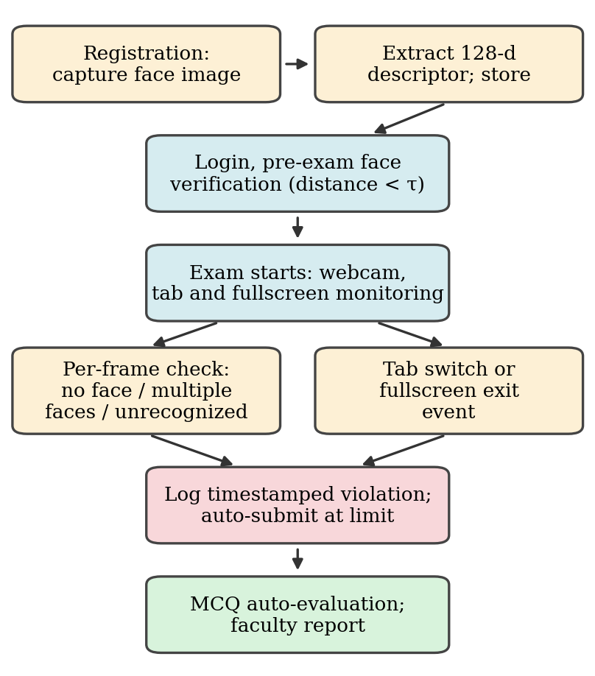
Flow of an examination attempt in NEXAM.

Authentication and Role Management
Users sign up as either faculty or student and are linked to a college, department and class (for example, 3rd Year – Section A). Access depends on role: faculty can create exams and open reports, whereas students only see exams assigned to their own class. Since the data is organized this way, a new institution can be onboarded without custom changes.

Biometric Registration and Verification
At registration the system asks for a live webcam image. When no face is found in the frame, the user is told to center the face, and registration cannot finish until a face is detected. A face detector finds the face, landmarks are computed, and a 128-dimensional descriptor is extracted with the face-api.js library built on TensorFlow.js [13], [14]. SSD-MobileNet-style detectors [13], [15] are light enough to run in a browser, and comparing embeddings follows the approach popularized by FaceNet [12].
Before an exam, a fresh webcam capture is converted to a descriptor f_{l} and compared against the stored descriptor f_{r} using the Euclidean distance
d(f_{r}, f_{l}) = √Σ (f_{r,k} − f_{l,k})², k = 1…128 (1)
The examinee is accepted only if d < τ, where τ is a configurable threshold (0.6 is the library default). The same comparison is repeated during the exam, so identity is verified continuously and not only at login.

Continuous Proctoring and Violation Logging
After the exam begins, the proctoring module runs on the examinee's own device and checks the webcam stream along with browser events. Three face conditions count as violations: face absent, multiple faces, and unrecognized face (descriptor distance above τ). Tab or window switches and exits from fullscreen mode are tracked as well. Every event is saved with its timestamp against the student's submission, and the attempt is submitted automatically once violations occur, so faculty get evidence linked to that exact submission.
- Violation Types and System Response
Violation | Trigger | Response
Face absent | No face detected in the webcam frame | Timestamped log entry
Multiple faces | More than one face in the frame | Timestamped log entry
Unrecognized face | Descriptor distance ≥ τ | Log entry; identity flag
Tab / window switch | Exam tab loses focus | Timestamped log entry
Fullscreen exit | Fullscreen mode is left | Timestamped log entry
Violations recorded | Attempt flagged by the proctor | Auto-submission; faculty report

Table II lists the events the proctoring module handles and how the system responds to each. Algorithm 1 summarizes the full procedure for one attempt.
Algorithm 1: Continuous proctoring of one attempt
Input: stored descriptor f_{r}, threshold τ, violation limit L
1. Request webcam permission and load the face models.
2. Capture a frame; if d(f_{r}, f_{l}) ≥ τ, deny the start of the exam.
3. while the exam is active do
4. Capture a frame and detect faces.
5. if no face then log “face absent”.
6. else if more than one face then log “multiple faces”.
7. else if d ≥ τ then log “unrecognized face”.
8. if tab switch or fullscreen exit then log the event.
9. if violations ≥ L then auto-submit and stop.
10. Grade objective answers; store score and violation log.

Automated Evaluation
All questions are objective, with four options and a single correct answer. When the student submits, the scoring engine matches the selected options against the key and returns a percentage right away,
Score (%) = (N_{c} / N_{t}) × 100 (2)
where N_{c} is the number of correct answers and N_{t} the number of questions. Subjective answers are not graded automatically and are routed to manual review.

Post-Exam Collusion Analysis
Following [1], the answer log of an exam can be examined for concordant answers between pairs of students. For a question q_{k} the rarity of the option chosen by student s_{i} is weighted as
α_{ik} = 1 − (1/n) Σ_{j} I(answer(s_{j},q_{k}) = answer(s_{i},q_{k})) (3)
so that agreement on an uncommon option carries more weight than agreement on a popular one. The consumption weight of s_{i} from s_{j} over g questions is
w_{c} = (1/g) Σ_{k} α_{ik} · consume(s_{i},s_{j},q_{k}) (4)
where consume is 1 when both students chose the same final option and s_{j} answered earlier. Pairs whose weights deviate from the expectation under null models are shortlisted for the faculty to review. This module is analytical only: it supports a human decision and never penalizes a student automatically.

System Architecture
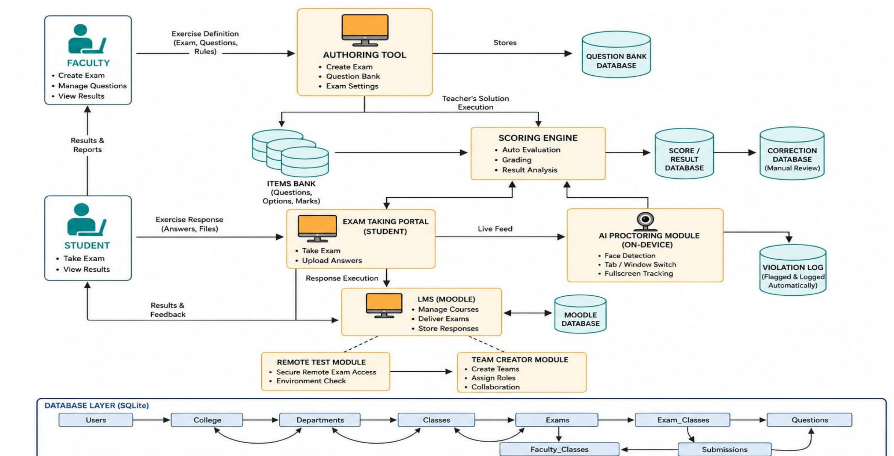
System architecture of NEXAM.
Faculty work through an authoring tool to create exams, build the question bank and set exam options; these definitions go into the question bank database and the items bank, which stores questions, options and marks. Students use the exam-taking portal to attempt an exam and to see their results and feedback.
Student responses go to the scoring engine, which handles automatic evaluation, grading and result analysis and writes to the score/result database; a correction database supports manual review of subjective answers. At the same time, the portal streams the live feed to the on-device AI proctoring module, which does the face detection and keeps track of tab/window switches and fullscreen state. Flagged events are recorded in the violation log, and the proctoring outcome is also passed to the scoring engine so that an attempt can be auto-submitted.
A learning-management layer takes care of courses, exam delivery and stored responses, with help from a remote test module (secure remote exam access and environment check) and a team creator module (teams, roles and collaboration). The bottom layer is a SQLite database that links the entities Users, College, Departments, Classes, Exams, Exam_Classes, Faculty_Classes, Submissions and Questions, and this is what implements the college → department → class hierarchy and the assignment of exams to classes.

Implementation

Technology Stack
The technology stack is summarized in Table III. React (TypeScript) is used for the front end, which runs in the browser at localhost:5173 during development. The back end is written in Node.js with Express and stores data in SQLite. Face detection and recognition happen on the client side using face-api.js on TensorFlow.js [13], [14], which means no server-side machine-learning setup, special hardware or paid proctoring API is needed.
- Technology Stack of NEXAM
Layer | Technology
Front end | React (TypeScript), browser-based
Back end | Node.js with Express
Database | SQLite
Face recognition | face-api.js on TensorFlow.js (client-side)
Client requirement | Modern browser with a webcam

Faculty Module
To create an exam, faculty enter the title, subject, marks and schedule window, assign it to one or more classes (Fig. 3(d)), and then add questions. A question has its text, four options and one option marked correct. Only students from the selected classes can see and attempt the exam. Once it is over, a class-wise report shows each student's score, integrity status and submission time .

Student Module
Students register with their department, class and section and capture a face image (Fig. 3(b)). The dashboard (Fig. 3(c)) shows only the exams assigned to the student's class, marks each one as open or closed based on its time window, and turns on the Start exam button only while the window is open. While the exam runs, the live proctoring view (Fig. 3(e)) displays the face verification status, the match confidence and any violation events logged.

Database Design
The SQLite schema follows the same hierarchy as the architecture. Table IV lists the core entities and what each one stores. Keeping Exam_Classes separate from Exams lets one exam be assigned to several classes, and Faculty_Classes limits each faculty member to the classes they handle.
- Core Database Entities
Entity | Purpose
Users | Faculty and student accounts, role, class mapping, face descriptor
College, Departments, Classes | Institution hierarchy used to group users
Exams | Title, subject, marks, duration and open/close window
Exam_Classes | Assignment of an exam to one or more classes
Faculty_Classes | Classes handled by each faculty member
Questions | Question text, four options and the correct option
Submissions | Answers, score, violation log and submission status

E. Proctoring Workflow
When an exam starts, the student's browser asks for webcam permission and loads the face-recognition models. The stored descriptor is fetched, and live frames are compared with it at regular intervals while the exam page listens for visibility and fullscreen events. All image processing is done on the examinee's device, so only the violation events and submission data reach the server. This reduces bandwidth use and keeps raw video off the network.

VI. Results and Discussion

A. Evaluation of the Proctoring Module
The proctoring module was tested in controlled sessions of 100 trials: 40 normal attempts by the registered student, and 20 trials for each of the three violation scenarios (face absent, multiple faces, and a different person in front of the camera). Fig. 4 shows the resulting confusion matrix. Out of 100 trials, 93 were classified correctly, an overall accuracy of 93%.
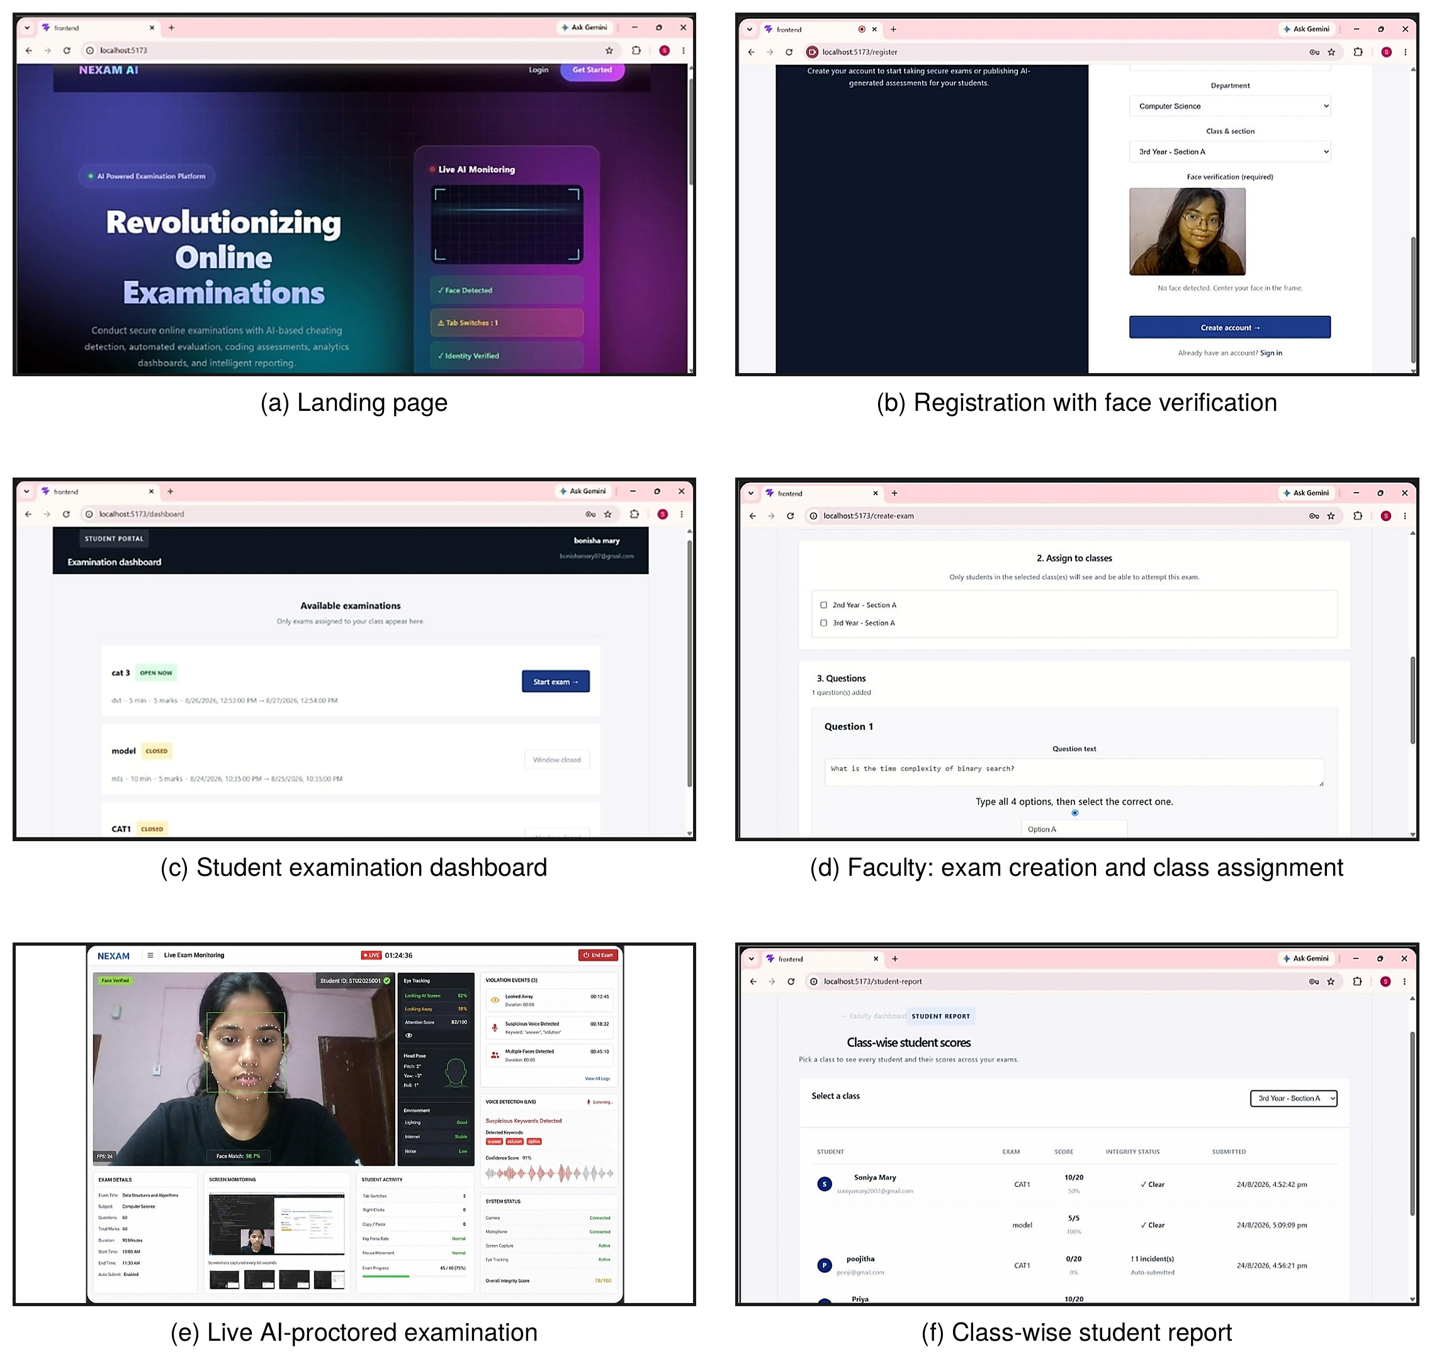
Implementation screenshots of NEXAM: (a) landing page, (b) registration with face capture, (c) student examination dashboard, (d) assigning an exam to classes, (e) live AI-proctored examination, and (f) class-wise student report.

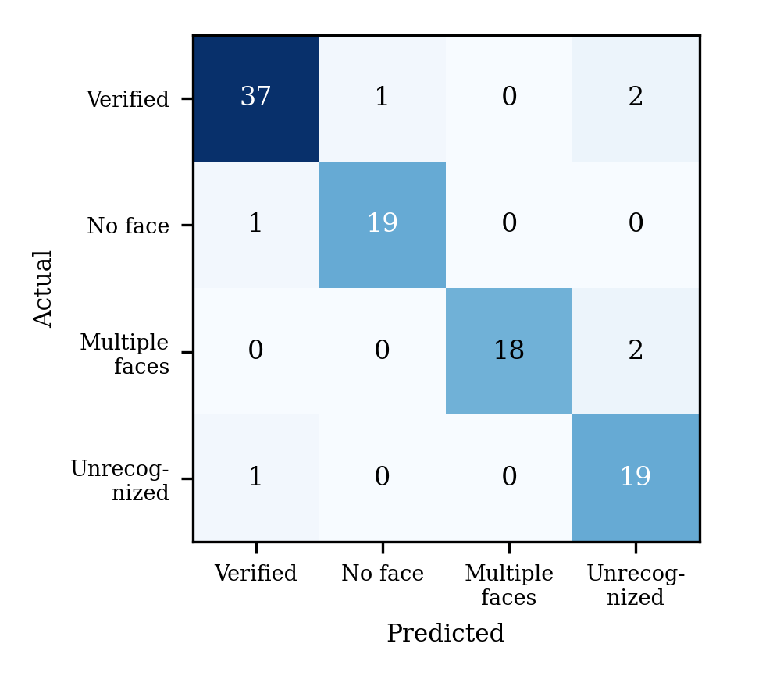
Confusion matrix of the face-based violation detection.
Table V gives the per-class precision, recall and F1-score derived from the matrix, plotted in Fig. 5. Absent faces and impostors were both recognized with a recall of 95%. Precision is lowest (82.6%) for the unrecognized-face class, since genuine students were sometimes flagged when the lighting was poor or the face was partly turned. These false flags are the main cause of unfair violations and are discussed below.
- Per-Class Performance of Violation Detection
Class | Precision (%) | Recall (%) | F1 (%)
Verified | 94.9 | 92.5 | 93.7
No face | 95.0 | 95.0 | 95.0
Multiple faces | 100.0 | 90.0 | 94.7
Unrecognized | 82.6 | 95.0 | 88.4
Overall accuracy |  |  | 93.0

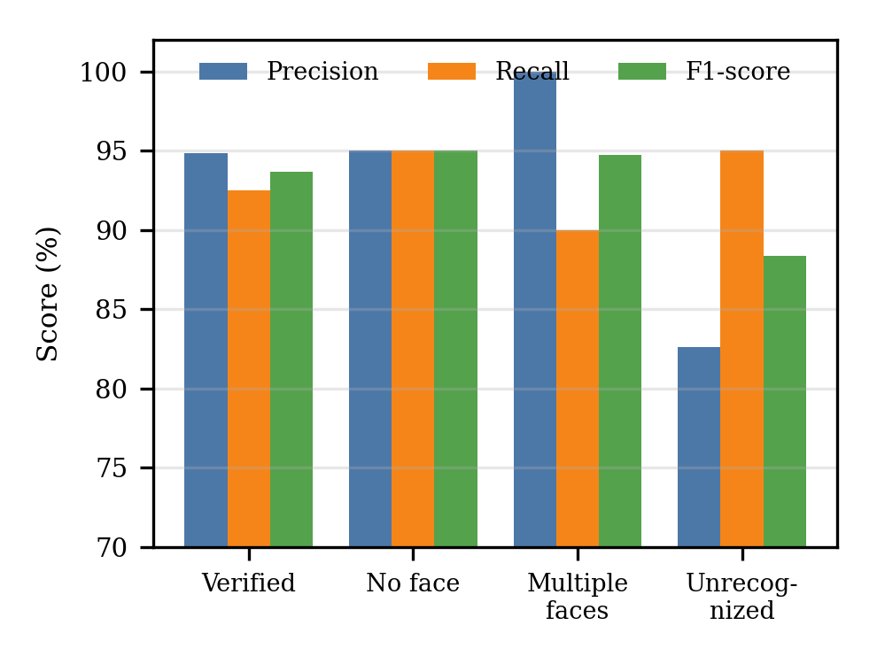
Precision, recall and F1-score for each class.

Examination Results and Integrity Reports
In the faculty dashboard, the class-wise report puts the automatically computed score next to the integrity status of each attempt. Table VI reproduces entries from a test run of the platform, and Fig. 6 plots the corresponding scores. An attempt with a logged incident was auto-submitted and shows the number of incidents as its integrity status, while clean attempts are marked Clear. Objective answers were scored as soon as they were submitted.
- Sample Class-Wise Report Entries
Student | Exam | Score | Integrity status
S1 | CAT1 | 10/20 (50%) | Clear
S1 | model | 5/5 (100%) | Clear
S2 | CAT1 | 0/20 (0%) | 1 incident, auto-submitted

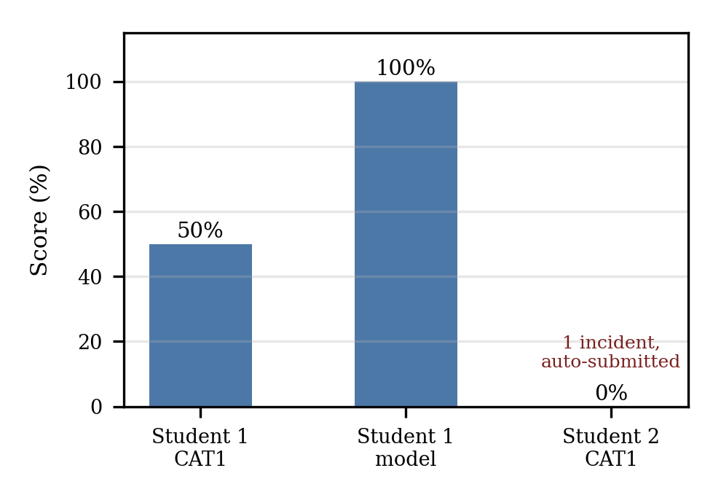
Scores of sample attempts from the class-wise report.

Discussion
Three points stand out from the implementation and the test runs. First, because detection and comparison run on the examinee's device, no server-side machine-learning infrastructure is needed, and that infrastructure is the main cost driver of commercial proctoring. Second, linking every violation to the exact submission replaces vague suspicion with evidence that can be reviewed, which favors human review of flagged attempts over fully automated penalties. Third, identity verification and behavior tracking work better together: a face check alone cannot reveal a second person off camera or a switch to another window, and behavior tracking alone cannot tell who is actually taking the exam [2], [11].
The post-exam concordance analysis of [1] brings a different kind of evidence. It does not rely on the camera, so it is useful for exams where webcam proctoring is limited. It does, however, need a reasonably large group of examinees and shuffled question order to give statistically meaningful results.

Privacy and Ethical Considerations
Facial descriptors count as biometric data. Deployments should get explicit consent, keep only the numeric descriptor instead of raw video wherever possible, limit report access to the faculty concerned, and delete biometric data once the retention period ends. Automatic submission is a strong action, so institutions should offer an appeal or re-examination route for students who feel they were flagged unfairly.

Conclusion
This paper presented NEXAM, a browser-based platform that brings together examination management, biometric identity verification and continuous proctoring. Registered face descriptors are compared with live captures before and during the exam, anomalies are logged as timestamped violations, objective answers are graded instantly, and faculty receive class-wise reports with integrity status. The AI components run on the examinee's device and the stack is open, so institutions face a low barrier to adopting the platform.

References
- M. Carrasco, A. R. Silva, and R. Henriques, “Detecting fraudulent student communication in a multiple choice online test environment,” IEEE Trans. Comput. Soc. Syst., vol. 11, no. 1, pp. 1108–1120, Feb. 2024.
- R. Bawarith, D. Abdullah, D. Anas, and S. Gamalel-Din, “E-exam cheating detection system,” Int. J. Adv. Comput. Sci. Appl., vol. 8, no. 4, pp. 176–181, 2017.
- F. Noorbehbahani, A. Mohammadi, and M. Aminazadeh, “A systematic review of research on cheating in online exams from 2010 to 2021,” Educ. Inf. Technol., vol. 27, pp. 8413–8460, Mar. 2022.
- Y. Atoum, L. Chen, A. X. Liu, S. D. H. Hsu, and X. Liu, “Automated online exam proctoring,” IEEE Trans. Multimedia, vol. 19, no. 7, pp. 1609–1624, Jul. 2017.
- S. Prathish, A. S. Narayanan, and K. Bijlani, “An intelligent system for online exam monitoring,” in Proc. Int. Conf. Inf. Sci. (ICIS), 2016, pp. 138–143.
- G. Fenu, M. Marras, and L. Boratto, “A multi-biometric system for continuous student authentication in e-learning platforms,” Pattern Recognit. Lett., vol. 113, pp. 83–92, Oct. 2018.
- C.-Y. Chuang, S. D. Craig, and J. Femiani, “Detecting probable cheating during online assessments based on time delay and head pose,” Higher Educ. Res. Dev., vol. 36, no. 6, pp. 1123–1137, 2017.
- L. C. O. Tiong and H. J. Lee, “E-cheating prevention measures: Detection of cheating at online examinations using deep learning approach—A case study,” arXiv:2101.09841, 2021.
- E. Bilen and A. Matros, “Online cheating amid COVID-19,” J. Econ. Behav. Org., vol. 182, pp. 196–211, Feb. 2021.
- S. S. Chua, J. B. Bondad, Z. R. Lumapas, and J. D. L. Garcia, “Online examination system with cheating prevention using question bank randomization and tab locking,” in Proc. 4th Int. Conf. Inf. Technol. (InCIT), Oct. 2019, pp. 126–131.
- A. Vegendla and G. Sindre, “Mitigation of cheating in online exams: Strengths and limitations of biometric authentication,” in Biometric Authentication in Online Learning Environments. Hershey, PA, USA: IGI Global, 2019, pp. 47–68.
- F. Schroff, D. Kalenichenko, and J. Philbin, “FaceNet: A unified embedding for face recognition and clustering,” in Proc. IEEE Conf. Comput. Vis. Pattern Recognit. (CVPR), 2015, pp. 815–823.
- V. Mühler, “face-api.js: JavaScript API for face detection and face recognition in the browser with TensorFlow.js,” GitHub repository. [Online]. Available: https://github.com/justadudewhohacks/face-api.js
- D. Smilkov et al., “TensorFlow.js: Machine learning for the web and beyond,” in Proc. Mach. Learn. Syst. (SysML), 2019.
- W. Liu et al., “SSD: Single shot multibox detector,” in Proc. Eur. Conf. Comput. Vis. (ECCV), 2016, pp. 21–37.
- F. Kamalov, H. Sulieman, and D. S. Calonge, “Machine learning based approach to exam cheating detection,” PLoS ONE, vol. 16, no. 8, Art. no. e0254340, Aug. 2021.

