Shoolin AI: An AI-Assisted School Entry Monitoring System for ID Card, Uniform, Belt and Shoe Compliance Using YOLO and OpenCV
Jabarinathan V, Sivanesan M, Tharun S
Guide: S. J. Kavitha
Department of Computer Science and Engineering (Artificial Intelligence), School of Engineering
Vels Institute of Science, Technology & Advanced Studies (VISTAS), Chennai – 600 117, India

Abstract—Schools usually check student ID cards, uniforms, belts and shoes by eye at the entrance, which is slow, inconsistent and poorly recorded when many students arrive together. This paper presents Shoolin AI, a proposed AI-assisted entry-monitoring system. An image from a camera or an authorised upload is validated with OpenCV, and a YOLO object detector looks for four classes (id_card, uniform, belt, shoes). A transparent, configurable rule engine converts detections and confidence scores into item-wise states (detected, uncertain, not detected) and an overall status, and uncertain cases are routed to a staff member for manual review. Every check is stored with a timestamp for later review on a staff dashboard. We describe the architecture, the dataset and training plan, the decision logic and the privacy design, and we report the current implementation status honestly: the rule engine has been implemented and verified on synthetic inputs, whereas training and evaluation of the custom detector and parent notifications are pending and are presented as future work. No detection accuracy is claimed in this draft.
Keywords—school entry monitoring, object detection, YOLO, OpenCV, uniform compliance, human-in-the-loop, student privacy.
I. INTRODUCTION
The school entrance is where daily discipline begins. Staff or prefects verify that each student wears an identity card, the approved uniform, a belt and proper shoes, and note late arrivals. During peak arrival times this manual process creates queues, depends on individual judgement and leaves paper records that are hard to search or summarise, so repeated compliance issues are difficult to notice.
Computer vision can reduce this repetitive effort. Modern one-stage detectors such as YOLO [1] localise several object classes in one pass and run fast enough for camera use, and open-source toolkits [2], [7] make such detectors accessible to student projects. However, a school-entry setting differs from generic benchmarks: the objects of interest (a small ID card, a belt, shoes) are specific to the school, a missed detection is not proof that an item is absent, and the subjects are children whose images are personal data [8].
We therefore propose Shoolin AI as an assistive system and not an automatic gatekeeper. The contributions of this draft are: (i) a modular architecture for image-based entry checking with a manual-review path; (ii) a transparent three-state rule engine that separates “missing” from “uncertain”; (iii) a dataset, training and evaluation plan for four school-specific classes; and (iv) a privacy-conscious logging design, together with a clear statement of what has and has not been implemented.
II. RELATED WORK
Classical detection. Viola and Jones [4] made real-time face detection practical with boosted cascades, and Dalal and Triggs [9] used histograms of oriented gradients for pedestrian detection. These hand-crafted approaches work for rigid, well-defined objects but generalise poorly to items such as belts or uniforms that vary in colour, pose and occlusion.
Deep detectors. Region-based detectors such as Faster R-CNN [3] first propose regions and then classify them, which gives strong accuracy at higher computational cost. YOLO [1] formulates detection as a single regression from the full image to boxes and class probabilities, trading a little accuracy for speed. Maintained implementations with pretrained weights, training and validation tools are provided by the Ultralytics framework [2].
Datasets and metrics. Pretrained detectors are usually trained on general datasets such as COCO [5], which contains a “person” class but not school ID cards, belts or uniforms; a custom labelled dataset is therefore unavoidable. Detectors are evaluated with precision, recall, F1 [10] and mean average precision (mAP) following the Pascal VOC protocol [6].
Privacy. Processing images of children is regulated; for example, India’s Digital Personal Data Protection Act, 2023 [8] imposes obligations including parental consent for children’s data. Many prototype systems ignore these issues. Shoolin AI treats privacy as a design requirement (Section IV-E). The authors should confirm the exact legal obligations with their institution before any real deployment.
Existing entry-checking practice. Table I contrasts the methods commonly used at school gates with the proposed approach. None of the common methods both checks the four items and produces a reviewable, timestamped record.
TABLE I. SCHOOL-ENTRY CHECKING METHODS
Method | Strength | Limitation
Manual check | Flexible, no setup | Slow, inconsistent, paper records
CCTV | General monitoring | Not built for item checks; needs a watcher
ID / RFID card | Identifies student | Does not check uniform; proxy use
Attendance software | Digital arrival log | No appearance check
Shoolin AI (proposed) | Item-wise check, log, review | Needs custom training and privacy controls

III. SYSTEM ARCHITECTURE
Shoolin AI is a pipeline of independent modules (Fig. 1), so that each stage can be built, tested and replaced separately.
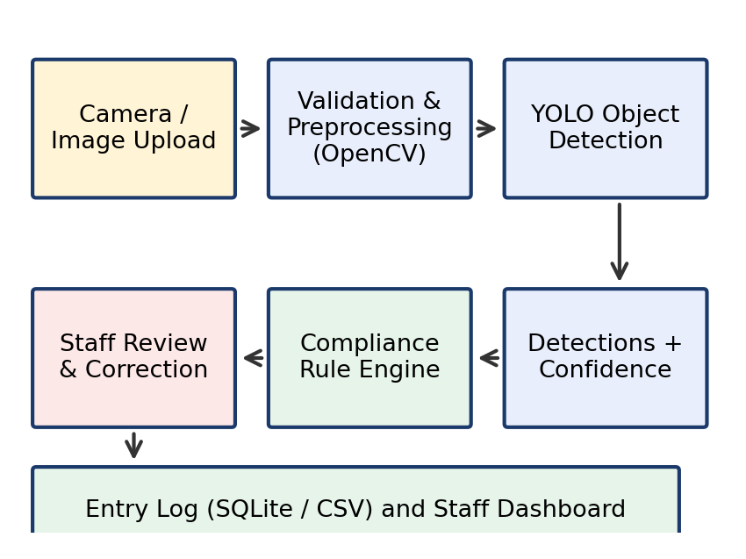
Fig. 1. Proposed Shoolin AI pipeline. Parent notification is future scope and is not implemented.
• Image input and validation (OpenCV). A webcam frame or an authorised upload is checked for readability, brightness and blur; unusable images trigger a request to retake the photo.
• Detection (YOLO). A custom-trained model returns bounding boxes, class names and confidence scores for id_card, uniform, belt and shoes (and optionally person).
• Compliance rule engine. Detections are combined with school-configured thresholds to produce item-wise and overall status with a short reason.
• Entry log and dashboard. The student identifier, timestamp, item-wise results, overall status and review status are stored; staff review, correct and confirm entries.
Operating scenario. A student steps into the designated checking area and a photograph is taken (or an authorised image is uploaded). Within the same screen the staff member sees the four item states with confidence values, the overall status and a short reason such as “check: belt, shoes”. For a compliant result the staff member simply confirms the entry; for an uncertain result the staff member looks at the student, corrects the item state if needed and then confirms. Because every action is logged with a timestamp, the history can later be searched by student, date or status.
IV. METHODOLOGY
A. Dataset preparation
Images of the school’s actual uniform, ID card, belt and shoes are collected only with school and parental authorisation. Duplicates and unnecessary personal information are removed, and each image is labelled with bounding boxes for the four classes. The data are divided into training, validation and, for an unbiased final evaluation, a separate test split; label files follow the YOLO format of class index plus normalised box coordinates.
B. Detector training
A small YOLO model initialised from pretrained weights is fine-tuned on the labelled data with the Ultralytics toolkit. We observed that the pretrained model detects a person, but it must not be assumed to detect the four custom classes before training. Because ID cards, belts and shoes are small objects, the training plan includes varied lighting, camera angles, clothing and partial occlusion, and an image size large enough to preserve small objects.
Labelling guidelines. To keep labels consistent across annotators, boxes are drawn tightly around the visible item only; an item hidden by a bag or a hand is not labelled; the meaning of “uniform” (which garments are included) is fixed by the school before labelling starts; and images with no required item are included as negative examples so that the detector learns when not to fire. Duplicate and near-duplicate frames are removed so that the validation and test splits do not leak information from the training split.
Table II summarises the planned starting configuration, which is taken from our training script and will be tuned on the validation split.
TABLE II. PLANNED TRAINING CONFIGURATION
Setting | Planned value
Initial weights | Pretrained small YOLO model
Epochs / batch size | 50 / 16 (to be tuned)
Input size | 640 × 640 pixels
Augmentation | Brightness, contrast, scale, small rotation, horizontal flip
Splits | Train / validation / separate test
Selection | Best validation weights

C. Rule engine
For each required class the highest confidence among its detections, σ, decides the item state using two configurable thresholds (Table III). The overall status is then derived from the four item states (Table IV and Algorithm 1). The design keeps “uncertain” separate from “not detected” because the absence of a detection can be caused by blur, occlusion or a model miss rather than by a missing item.
TABLE III. ITEM STATE FROM CONFIDENCE σ
Condition | Item state
σ ≥ T_high (default 0.60) | detected
T_low ≤ σ < T_high (0.30–0.60) | uncertain
σ < T_low (0.30) or no box | not detected

TABLE IV. OVERALL STATUS FROM ITEM STATES
Condition | Overall status
No person found / image unusable | MANUAL REVIEW
All four items detected | ALLOWED / COMPLIANT
Any item uncertain | MANUAL REVIEW
No item uncertain, ≥1 not detected | DEFAULTER – CHECK

The complete decision procedure is given as Algorithm 1 and visualised in Fig. 2. Thresholds are stored in the settings screen, so a school can make the system stricter or more lenient without changing the code.
Algorithm 1: Compliance decision
Input: detections D={(c,s)}, T_low, T_high
if no person or image unusable:
return MANUAL REVIEW
for c in {id_card, uniform, belt, shoes}:
s_c = max{s : (c,s) in D}, 0 if none
if s_c >= T_high: state[c] = detected
elif s_c >= T_low: state[c] = uncertain
else: state[c] = not detected
if all state[c] == detected: return ALLOWED
if any state[c] == uncertain:
return MANUAL REVIEW
return DEFAULTER - CHECK

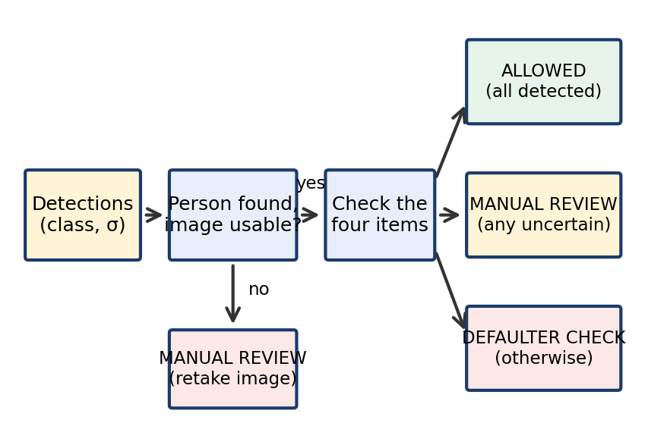
Fig. 2. Compliance decision logic. σ denotes detection confidence.
The status is advisory. A student is never denied entry solely because the detector missed an item; staff see the explanation and can override the result.
D. Entry logging
Each check is written to a SQLite table (or a CSV file in the simplest prototype) holding the student identifier, timestamp, four item states, overall status and review status. If a write fails, the system reports the error and does not claim that the entry was saved. A defined rule handles duplicate submissions.
E. Privacy and ethics
• Only authorised images are used; identifiable student images are not published.
• All processing and storage are local to the school; dashboards are not public and require authorised staff access.
• Only the minimum data needed for the purpose is stored, with a configurable retention period.
• A human reviews uncertain results and makes the final decision.
F. Dashboard and database design
The staff interface has five screens: (1) a dashboard with the number of checks, compliant entries, entries needing review and recent records; (2) an entry-check screen for the student identifier, image upload or capture, item-wise results with confidence, timestamp and overall status; (3) a detection-result view that shows each of the four items separately as detected, not detected or uncertain; (4) a searchable entry history with review status; and (5) settings for school rules, thresholds, data retention and authorised users. Status colours and plain labels are used, and private student details are never shown on a public page.
A small relational schema (Table V) is sufficient for the prototype; phone numbers and other sensitive data are excluded from any public repository.
TABLE V. PROPOSED DATABASE TABLES
Table | Main fields
students | student_id, student_name, class_name
entry_checks | check_id, student_id, check_timestamp, four item states, overall_status, review_status
detections | detection_id, check_id, class_name, confidence_score, detection_status
notifications (optional) | notification_id, student_id, check_id, sent_timestamp, delivery_status

V. IMPLEMENTATION STATUS
Table VI separates completed work from pending work so that this draft does not overstate the system.
TABLE VI. IMPLEMENTATION STATUS
Component | Status | Evidence
Architecture, workflow | Designed | Sec. III
Rule engine (Python) | Implemented | Sec. VI
Entry log (SQLite) | Code written | not yet run
Staff checklist demo | Prepared | run to confirm
Custom YOLO model | Pending | needs dataset
Detector evaluation | Pending | needs test set
Parent notification | Future scope | –

The “staff checklist” demonstration lets a staff member tick the four items manually and shows the resulting status. It does not analyse images automatically and must not be presented as AI detection.
VI. EXPERIMENTAL SETUP AND RESULTS
A. Planned evaluation
After training, the detector will be evaluated on the held-out test split, reporting precision, recall, F1, mAP and inference time per class, since small items such as belts and ID cards are expected to be harder than uniforms. System-level tests will cover clean images, each item missing in turn, blurry and occluded images, no person in view, duplicate submissions and storage failure. The actual outcome, pass/fail status and evidence will be recorded for each case.
Detector quality will be computed from true positives (TP), false positives (FP) and false negatives (FN) at an IoU threshold of 0.5:
P = TP/(TP+FP), R = TP/(TP+FN) (1)
F1 = 2PR/(P+R) (2)
mAP = (1/N) Σ AP_c, N = 4 classes (3)
Table VII lists the system-level test cases that will be run, and Table VIII is the per-class result table that will be completed from the independent test split. Both are intentionally empty in this draft.
TABLE VII. SYSTEM TEST PLAN (RESULTS PENDING)
Test case | Expected behaviour | Result
All four items clear | Compliant | pass
ID card missing | Check / review | pass
Uniform missing or wrong | Flag for review | pass
Belt missing | Flag for review | pass
Shoes missing | Flag for review | pass
Blurry image | Retake / review | pass
Item occluded | Mark uncertain | pass
No person detected | Request new image | pending
Duplicate submission | Apply duplicate rule | pending
Database write fails | Show error, not saved | pending

TABLE VIII. PER-CLASS DETECTOR RESULTS (PENDING)
Class | P | R | F1 | mAP
id_card | N/A | N/A | N/A | N/A
uniform | N/A | N/A | N/A | N/A
belt | N/A | N/A | N/A | N/A
shoes | N/A | N/A | N/A | N/A

B. Rule-engine verification (synthetic inputs)
To verify the decision logic independently of any model, the rule engine was run on four hand-written lists of (class, confidence) pairs. These are logic checks and not measurements of detector accuracy.
TABLE IX. RULE-ENGINE CHECKS ON SYNTHETIC INPUTS
Input confidences | Expected | Output
ID .90, uniform .80, belt .70, shoes .75 | Compliant | ALLOWED
ID .90, uniform .80, belt .40, shoes none | Review | MANUAL REVIEW
ID .90, uniform .80, belt none, shoes none | Check | DEFAULTER – CHECK
No person detected | Review | MANUAL REVIEW

In all four cases the output matched the expected status, showing that the thresholds and the uncertain/not-detected distinction behave as designed. This verifies the logic only; whether real images produce the right confidences depends on the model that is yet to be trained.
C. Planned usability evaluation
Beyond detector accuracy, the practical value of the system depends on whether it actually helps staff. We therefore plan to time how long staff need per student with the manual method and with the dashboard, to count how often staff override the system’s suggestion, and to collect short feedback from the staff who use it. These measurements have not been made yet, and no speed-up is claimed in this draft.
VII. DISCUSSION AND LIMITATIONS
• Custom training is required. Reliable detection of school-specific items cannot be assumed from pretrained weights.
• Small objects and conditions. ID cards, belts and shoes are small; lighting, angle and occlusion will reduce accuracy.
• False and missed detections can produce incorrect statuses, which is why uncertain results go to staff.
• Scope. The prototype is designed for one student at a time and does not verify identity automatically.
• Threats to validity. A dataset collected at one school, in one season and at one gate may not represent other sites; per-class results must therefore be reported with the dataset size and conditions, and the test split must stay unseen during training and threshold tuning.
• Threshold choice. The default values of T_low and T_high in Table III are starting points and should be tuned on the validation split, not on the test split.
• Deployment. A real deployment needs privacy approval, parental consent, security and reliability testing, and school-defined policies for each status.
VIII. ETHICAL AND FAIRNESS CONSIDERATIONS
A system that judges children’s appearance can cause harm if it is used carelessly, so the following safeguards are part of the design and not afterthoughts.
• Assistive, not punitive. The output is a suggestion for staff. Policies on what happens to a student with a “DEFAULTER – CHECK” status are decided by the school, and automatic denial of entry is not part of the design.
• Fairness across students. Students differ in height, skin tone, hairstyle, religious or cultural dress and physical disability, and some families cannot afford a replacement item immediately. The dataset must therefore be diverse, performance should be examined across groups where this is ethically possible, and false alarms must have a quick and respectful correction path.
• Transparency. Students and parents should be told what is captured, why, who can see it and for how long it is kept.
• Data minimisation. Images are processed locally and need not be stored once the result has been logged; only the log fields in Table V are kept, for a limited period.
• Limits of the technology. A missing detection is evidence of nothing more than a missing detection; this is why the uncertain state and manual review exist.
IX. CONCLUSION AND FUTURE WORK
We presented Shoolin AI, an assistive school-entry monitoring design that combines a YOLO detector, a transparent three-state rule engine, a manual-review path and a privacy-conscious entry log. The architecture and rule logic are implemented and verified on synthetic inputs, while detector training, evaluation and parent notification remain to be done; no accuracy claims are made. Future work includes collecting and labelling an authorised dataset, training and per-class evaluation of the detector, live-camera and multi-student support, staff login and a student database, parent alerts through an approved provider with consent, and analytics on recurring issues.
ACKNOWLEDGMENT
The authors thank their guide and the Department of Computer Science and Engineering (Artificial Intelligence), VISTAS, for their support.
REFERENCES
[1] J. Redmon, S. Divvala, R. Girshick and A. Farhadi, “You only look once: Unified, real-time object detection,” in Proc. IEEE CVPR, 2016, pp. 779–788.
[2] Ultralytics, “Ultralytics YOLO documentation.” [Online]. Available: https://docs.ultralytics.com
[3] S. Ren, K. He, R. Girshick and J. Sun, “Faster R-CNN: Towards real-time object detection with region proposal networks,” in Advances in Neural Information Processing Systems, 2015.
[4] P. Viola and M. Jones, “Rapid object detection using a boosted cascade of simple features,” in Proc. IEEE CVPR, 2001, pp. I-511–I-518.
[5] T.-Y. Lin et al., “Microsoft COCO: Common objects in context,” in Proc. ECCV, 2014, pp. 740–755.
[6] M. Everingham, L. Van Gool, C. K. I. Williams, J. Winn and A. Zisserman, “The Pascal visual object classes (VOC) challenge,” Int. J. Comput. Vis., vol. 88, no. 2, pp. 303–338, 2010.
[7] G. Bradski, “The OpenCV library,” Dr. Dobb’s Journal of Software Tools, 2000.
[8] Government of India, “The Digital Personal Data Protection Act, 2023.”
[9] N. Dalal and B. Triggs, “Histograms of oriented gradients for human detection,” in Proc. IEEE CVPR, 2005, pp. 886–893.
[10] D. M. W. Powers, “Evaluation: From precision, recall and F-measure to ROC, informedness, markedness and correlation,” J. Mach. Learn. Technol., vol. 2, no. 1, pp. 37–63, 2011.

