NeuroCalc: An AI-Powered Mathematical Problem-Solving and Learning Assistant
SriSaiSaran A  Dept. of Computer Science and Engineering  Vels Institute of Science, Technology and Advanced Studies (VISTAS)  Chennai, Tamil Nadu, India  [e-mail to be inserted] | Varun K  Dept. of Computer Science and Engineering  Vels Institute of Science, Technology and Advanced Studies (VISTAS)  Chennai, Tamil Nadu, India  [e-mail to be inserted] | Dhanush V  Dept. of Computer Science and Engineering  Vels Institute of Science, Technology and Advanced Studies (VISTAS)  Chennai, Tamil Nadu, India  [e-mail to be inserted] | Mohana Priya P  Dept. of Computer Science and Engineering  Vels Institute of Science, Technology and Advanced Studies (VISTAS)  Chennai, Tamil Nadu, India  career.mohanapriya@gmail.com
*Corresponding author.

Abstract—Calculators give exact answers but no explanation, while conversational language models explain well yet sometimes get the arithmetic wrong. NeuroCalc, a web-based mathematical assistant, handles this by keeping understanding, computation and explanation as separate responsibilities. An intent-classification layer examines each natural-language query and sends it down one of three paths: deterministic symbolic computation in SymPy, conceptual explanation by a large language model, or SymPy computation followed by a model-written explanation of the result. The system consists of a Next.js/React frontend, a FastAPI backend and an SQLite/SQL Alchemy persistence layer that keeps users, conversations and messages between sessions. The paper describes the architecture, the query-processing and routing methodology, and the implementation of the current prototype. No quantitative evaluation has been done yet; instead, the paper sets out a protocol for measuring mathematical accuracy, routing accuracy, response latency and explanation quality.
*Keywords*—Artificial intelligence; mathematical problem solving; large language models; symbolic computation; SymPy; natural language processing; educational technology; conversational AI tutoring.
I. Introduction
Mathematics underpins most technical subjects, but a conventional calculator returns a number without showing how it was obtained. That is of limited use to a student who is trying to learn a method rather than collect answers. Large language models (LLMs) offer something different, since they can read a question written in ordinary language and walk through the steps. Explaining well is not the same as computing correctly, however. Models are known to fail at multi-step arithmetic even on simple word problems [1], and chain-of-thought prompting reduces this weakness without removing it [2], [3]. Symbolic engines such as SymPy cover the computational side deterministically, but they expect a well-formed expression rather than a sentence, and they cannot explain a result in prose. Most existing work improves one side of this problem, so a learner-facing tool that combines reliable computation with natural-language explanation remains to be built and examined.
NeuroCalc rests on the view that these two capabilities should live in different components instead of a single model. The language model is responsible for understanding and explaining, SymPy for computing, and a routing layer decides which of them takes charge of each incoming message. The paper makes four contributions: (1) an architecture in which language understanding and symbolic computation are kept apart and can be verified independently; (2) a design for intent classification and routing with three processing paths, where SymPy is the authoritative source of the value for every operation it supports; (3) a persistence layer that keeps conversations available across sessions, which calculator-style tools generally do not provide; and (4) an evaluation protocol covering mathematical accuracy, routing accuracy, latency and explanation quality.
The remainder of the paper is organized as follows. Section II reviews related work, Section III presents the methodology, and Section IV describes the implementation of the current prototype. Section V defines the evaluation protocol, Section VI discusses implications and limitations, and Sections VII and VIII give the conclusion and future work. The paper reports no quantitative evaluation results.
II. Related Work
A. AI and Automated Mathematical Reasoning
Wei et al. showed that prompting a model to write out intermediate steps, rather than answer directly, noticeably improves its reasoning [2]. The GSM8K benchmark revealed that even large models fail a considerable share of grade-school word problems, which led its authors to train a separate verifier [1]. Minerva took a different route and improved reasoning on university-level problems through pretraining alone, with no external tool [3]. Taken together, these studies indicate that mathematical reasoning in language models has improved but still does not match the reliability of a deterministic engine. NeuroCalc is designed around that remaining gap.
B. Program- and Tool-Augmented Language Models
A closer precedent comes from work that moves computation out of the model and into an external runtime. In Program-Aided Language Models (PAL), the model turns a problem into a short program that a Python interpreter executes, so the model only has to decompose the problem [4]. Tool former instead trains a model to decide on its own when to call an external tool, a calculator being one example [5]. NeuroCalc applies a similar principle, but the decision is made once for a whole query and not during text generation.
C. Symbolic Computation Engines
SymPy is an open-source computer-algebra system written in Python, with support for algebraic manipulation, equation solving, calculus and simplification [6]. For any well-formed expression it supports, it returns an exact and reproducible result. This avoids the unreliability that arises when a language model chains several arithmetic operations without any check.
D. AI-Assisted Mathematics Education
Research on intelligent tutoring systems indicates that tutoring which responds to a learner’s intermediate steps, and not only the final answer, comes close to the effectiveness of human tutoring [7]. LLMs are increasingly suggested as the front end for such interaction. Surveys of their use in education caution, though, that a fluent but occasionally incorrect model can mislead a learner who has no independent means of checking it [8]. NeuroCalc’s separation of computation from explanation responds directly to this concern.
E. Positioning of NeuroCalc
Most existing systems improve one aspect of the problem: reasoning quality, general tool calling, symbolic accuracy or tutoring pedagogy. The contribution of NeuroCalc is architectural. It takes the routing idea underlying PAL and Toolformer and applies it to a complete learner-facing web application, working on whole queries and not within a single model call. The paper does not show that this arrangement outperforms the alternatives, since no evaluation has been carried out.
III. Methodology
A. System Architecture and Design
NeuroCalc uses a layered client–server design, shown in Fig. 1. The client layer is a browser-based interface where users sign in and hold conversations with the system. The application layer is a FastAPI backend, which exposes the conversation API, validates and normalizes each message, classifies its intent, routes it, and assembles the final response. Beneath it sits the intelligence and computation layer, made up of the SymPy engine for deterministic symbolic computation and an LLM for language understanding and explanation. The data layer is an SQLite database accessed through SQL Alchemy.
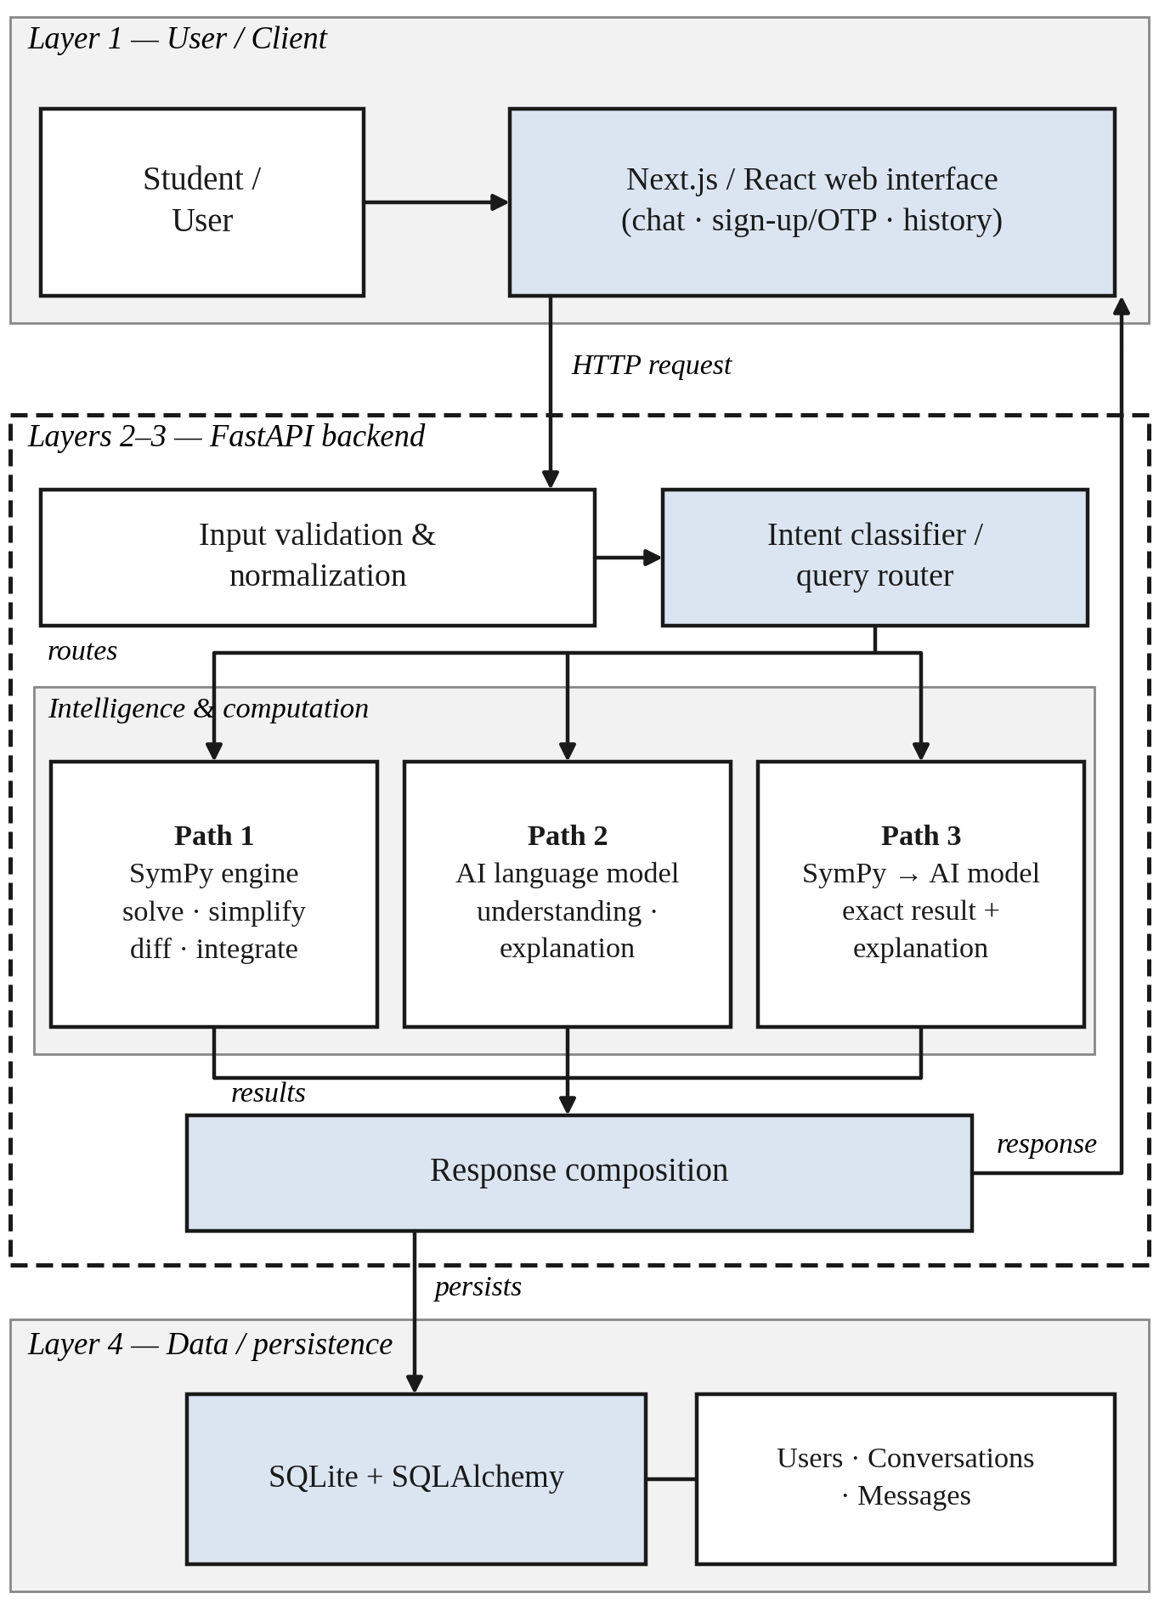
Fig. 1. Architecture of the proposed NeuroCalc system.
The design splits apart three tasks that a single model would otherwise carry out together: understanding what the user is asking, deterministic computation of the answer, and explanation of that answer in prose. The classifier and the language model handle understanding, SymPy alone handles computation, and the language model handles explanation. For any operation SymPy supports, the LLM is therefore never treated as the authoritative calculator. All communication goes through the backend: the frontend never calls SymPy or the model directly, SymPy never writes prose, and the model is never the source of the value for an operation SymPy supports. The processing steps that run on this architecture are described in Sections III-C to III-H and summarized in Fig. 2.
B. User Interaction and Authentication
The inputs to this stage are registration details, credentials and sign-in requests; its output is an authenticated session tied to a user record. A new user registers on the frontend’s sign-up page, after which the backends’ email service sends a one-time-password (OTP) verification e-mail, and the user completes verification on the OTP page.Sign-in is handled by the authentication module, and credentials are stored only in hashed form. The backend authenticates every request before it enters the query-processing pipeline, and each conversation and message created during a session refers to its owning user. This link between records and owner confines a user’s history to that user’s own data and makes retrieval across sessions possible (Section III-H).
C. Query Processing
The input is the raw message q typed by the user together with the identifier of the current conversation; the output is a normalized query q′ and the conversation context h. The frontend sends the message to the conversation API as an HTTP request. The backend first validates it, rejecting empty or malformed submissions before they reach any later component, and then normalizes it by trimming stray whitespace and unifying inconsistent notation:
q′ = N(V(q)) (1)
where V denotes validation and N normalization. These steps come before classification because the later stages, especially the classifier and the SymPy parser, assume a well-formed input string. The backend also loads the earlier messages of the same conversation as context h, so that a follow-up question can be read in light of what was asked before. The pair (q′, h) is then passed to the intent classifier.
D. Intent Classification and Routing
The input to this stage is (q′, h), and the output is a class label k together with the selected processing path (Fig. 2). The classifier C assigns each query to one of three classes: a mathematical computation request (M), a conceptual question (K), or a general remark (G):
k = C(q′, h), k ∈ {M, K, G} (2)
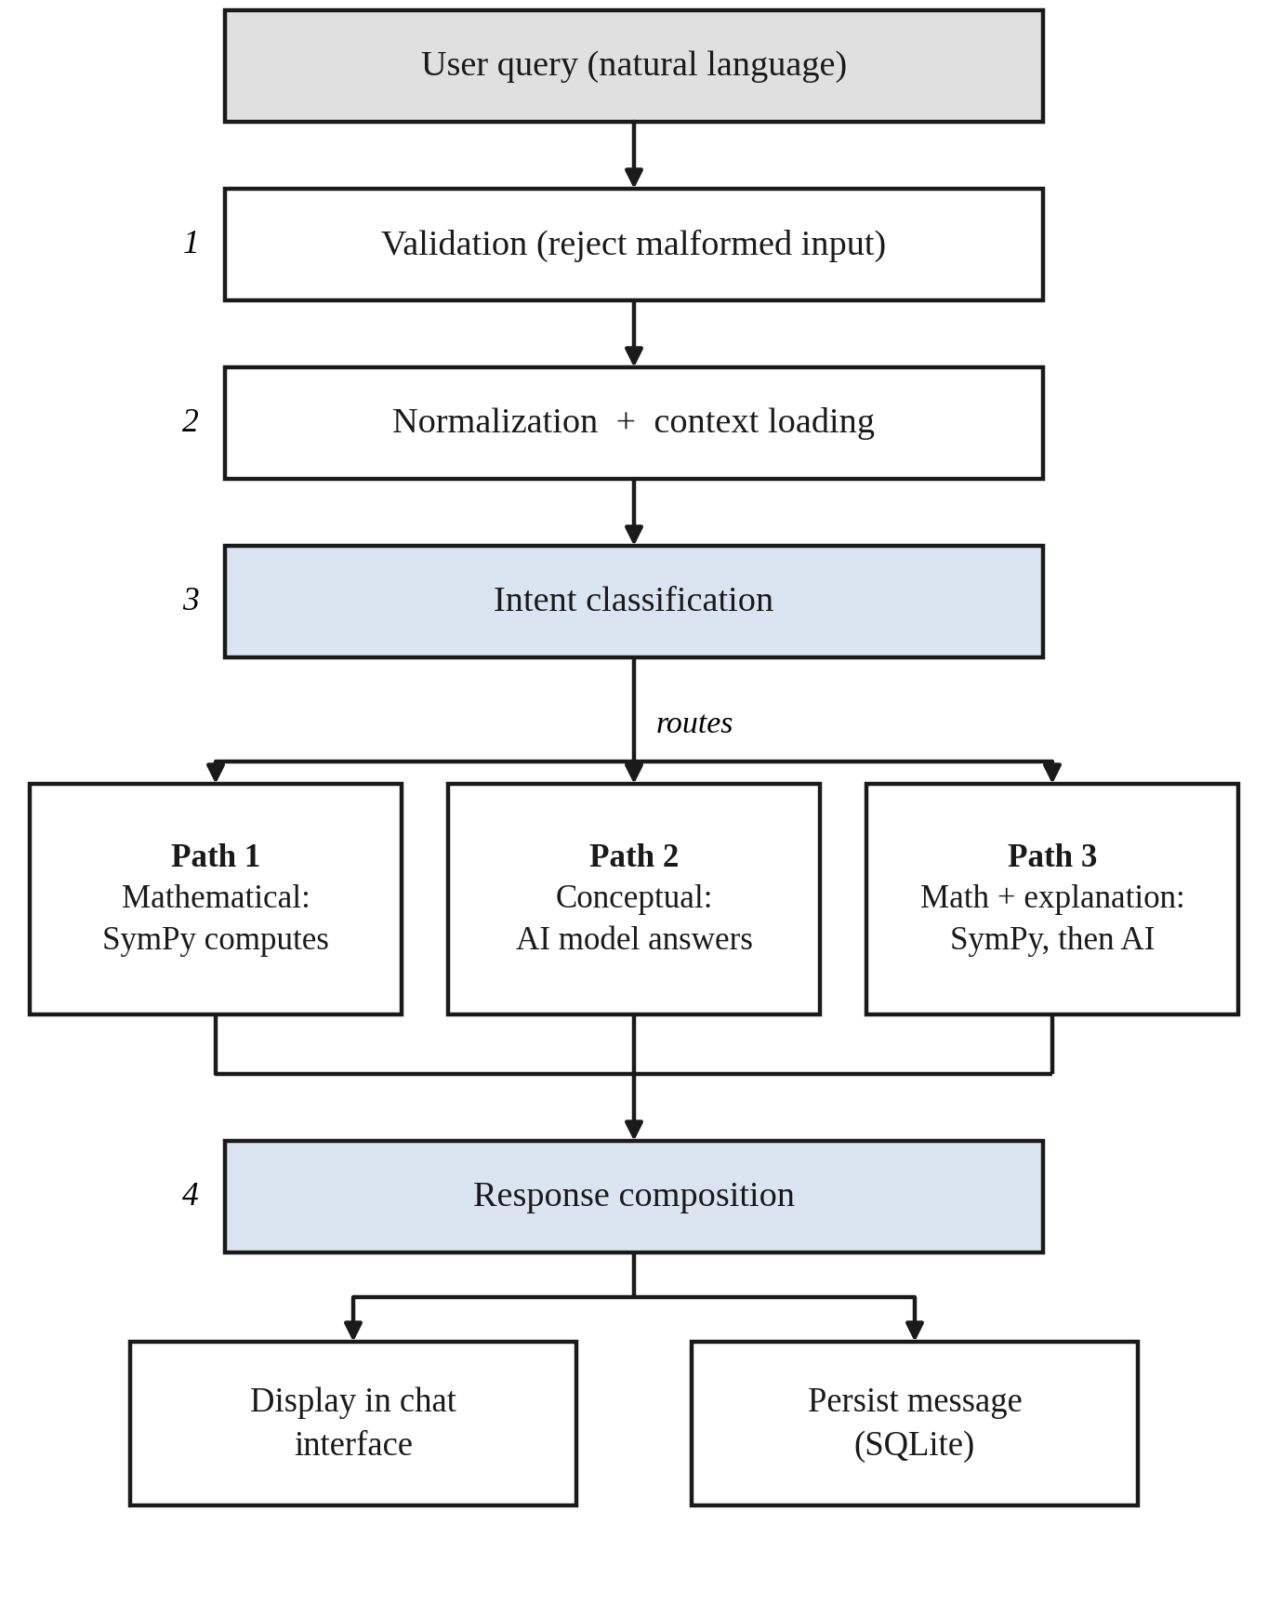
The class determines one of three paths, summarized in Table I. In Path 1, a class-M query is evaluated by SymPy and the exact result is returned. In Path 2, a class-K or class-G query is answered by the language model, because there is no single deterministic value to compute. In Path 3, a class-M query that also needs a worked explanation is first evaluated by SymPy, and the result is handed to the language model, which writes the explanation around it.
TABLE I. Query classes and processing paths
Path | Query class | Authoritative for | Output
1 | Mathematical (M) | Value: SymPy | Exact result
2 | Conceptual (K), general (G) | Content: language model | Natural-language explanation
3 | Mathematical (M) with explanation | Value: SymPy; wording: model | Exact result with step-by-step explanation

What the user sees is not strictly divided by path, since a computational query usually also receives a short explanation; classification determines which component is authoritative for the value. SymPy is the only source of the final value for every operation it supports. If a class-M query uses an unsupported operation or cannot be parsed, the language model answers it alone, and the deterministic guarantee does not hold for that response. The routing decision is made before any computation and does not depend on either computation module, so each path can be tested separately (Section V).
E. Mathematical Computation
The input is a class-M query q′, and the output is an exact symbolic result y together with any intermediate structure useful for explanation. The query is parsed into a SymPy expression or equation P(q′) and passed to the routine matching the requested operation (solve, simplify, diff, integrate), which evaluates it deterministically:
y = S(P(q′)) (3)
As an example, for q = “solve x² − 5x + 6 = 0” the engine returns the factored form (x − 2)(x − 3) and the solutions x = 2 and x = 3; differentiating x³ gives 3x², and integrating x² gives x³/3 up to a constant of integration. Because evaluation involves no sampling, the same input always produces the same result, and the routing design depends on this property. Coverage is limited to the operations that have been connected: algebraic manipulation, equation solving, differentiation, integration and simplification. The result and its intermediate structure (for example, the factored form or the differentiation rule applied) are serialised and passed to response composition and, in Path 3, to the explanation stage.
F. AI-Based Explanation
The inputs are q′, the context h and, in Path 3, the SymPy result y; the output is a natural-language explanation a. The language component covers what SymPy cannot: informal queries, conceptual questions without a single numeric answer, and the conversion of a bare symbolic result into step-by-step prose:
a = L(q′, y, h) (4)
In Path 3, y is given to the model as a fixed input, and the model is asked to explain it and not to recompute it; in Path 2 no y exists, so the model answers from q′ and h alone. The component is accessed through a single provider-agnostic interface, which means any model that takes a prompt and returns text, whether hosted locally or reached through an external API, can be used without changing the routing logic.
G. Response Composition
The inputs are y and/or a; the output is one response object that is sent back to the frontend:
r = F(y, a) (5)
where y is absent on Path 2 and a is absent on Path 1. On Path 1 the response holds the formatted result, on Path 2 the explanation, and on Path 3 the SymPy result followed by its explanation. The backend converts the outputs of both components into this common form, so the frontend renders every response identically whatever path produced it. The composed response is then returned to the client and also passed to the persistence layer.
H. Conversation Persistence
The input is the user’s message and the composed response r; the output is a set of stored records that can be retrieved later. The backend writes each exchange to SQLite through SQLAlchemy. A user owns conversations, and each conversation owns an ordered sequence of messages (Table II); the query and the composed response are both stored as messages. For a learning assistant, persistence has two uses: a learner can return to earlier worked problems, and the stored history gives the backend the context h of Section III-C for follow-up questions. Stored history is also a prerequisite for the personalized features listed in Section VIII.
TABLE II. Core database entities
Entity | Purpose | Relationship
User | Account credentials and profile information | Owns many conversations
Conversation | One learner-facing thread of related messages | Belongs to one user; owns ordered messages
Message | A single query or response within a conversation | Belongs to one conversation

IV. Implementation
This section describes the implemented prototype, and Figs. 3–6 show the corresponding interface. Only functionality verified to work is described as implemented; everything else appears under Future Work.
A. Frontend
The client is a Next.js application written in TypeScript, with React for components and Tailwind CSS for styling. This stack was chosen to keep the chat-style interface responsive and to let the authentication and conversation views share components. An application shell hosts the chat page, which includes a conversation component (ChatWindow) that renders the message list and submits the user’s input. TypeScript interfaces define the shape of chat requests and responses, so the components and the API calls follow one contract. The sign-up and OTP verification pages are separate routes within the same shell. Fig. 3 shows the landing and sign-in interface, and Fig. 4 shows the conversational interface in which users submit mathematical problems and receive the generated response.
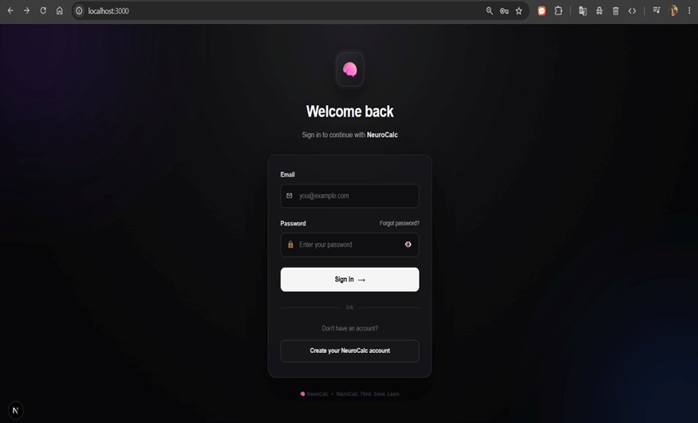

Fig. 3. NeuroCalc landing and sign-in interface.
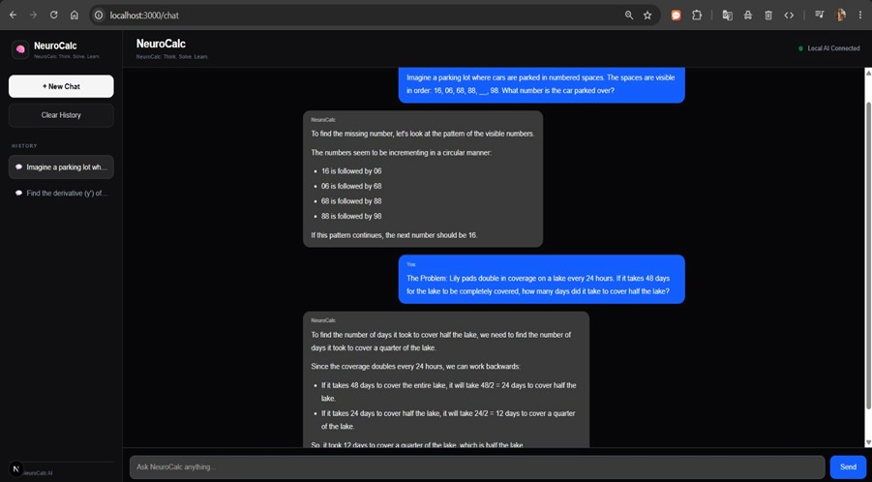

Fig. 4. NeuroCalc chat interface showing a submitted mathematical query and the returned response.
B. Backend
The backend is a FastAPI service launched from a single Python entry point, and the application object mounts the conversation API routes. One conversation route is the single entry to the pipeline of Section III: it authenticates the request, loads the conversation context, calls the intent classifier, and passes the result to the intent router. The router dispatches to the response-engine module, which wraps the SymPy and language-model calls; the route then receives a normalized response, stores it and returns it. The classifier, router, response engines, conversation-memory component, database layer and e-mail service are separate Python modules, so any of them can be changed without editing the others. Typed request and response models document the API surface and allow the frontend and backend to be deployed independently.
C. AI Model Integration
The AI component is accessed through the provider-agnostic interface of Section III-F rather than a single vendor’s SDK. As a result, a locally hosted open-weight model has been trialled alongside a hosted API without changes to the surrounding code. The configuration for a public deployment is a release-time decision and is not fixed at design time.
D. SymPy Integration
A mathematical query is parsed into a SymPy expression, evaluated by the relevant routine (solve, diff, integrate or simplify) and serialised back together with whatever intermediate structure, such as the factored form or the derivative rule, helps the explanation step. Fig. 5 shows a solved problem with its step-by-step explanation, produced through Path 3.
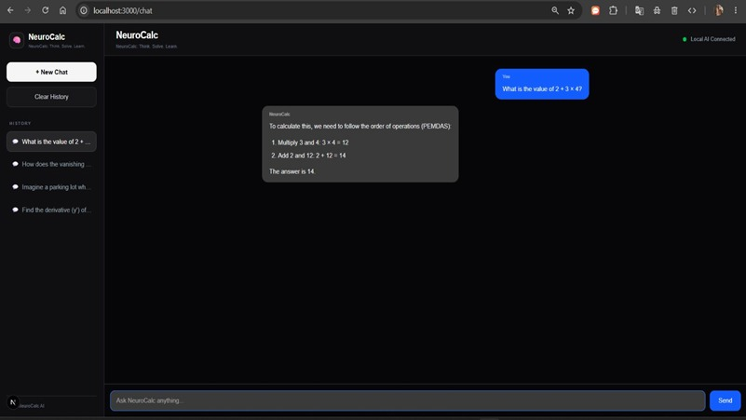

Fig. 5. Mathematical solution computed by SymPy and explained step by step.
E. Authentication
Registration and sign-in read and write the User table of Table II. Sign-up triggers the verification e-mail through the backend e-mail service, and verification is completed on the OTP page. Credentials are stored only as hashes, and every conversation and message points back to its owner.
F. Database and Conversation Management
The data model is declared as SQLAlchemy models for User, Conversation and Message, and a database layer provides persistence for the backend. SQLite was chosen for the prototype because it does not need a separate database server. Fig. 6 shows the conversation-history view, from which a user can return to an earlier conversation.
V. Evaluation Methodology
The protocol below is intended to be run once NeuroCalc is deployed for testing. The test runs had not been completed at the time of writing, so evaluation remains to be done; only the metrics and design are given here, and quantitative results will be reported after deployment testing.
A. Mathematical Accuracy
A pool of test problems covering the categories in Table III will be submitted, and each result will be compared with an independently known correct answer:
Accuracy = (N_{correct} / N_{total}) × 100% (6)
TABLE III. Mathematical test categories
Category | Example
Arithmetic | 25 + 37
Algebra | x² − 5x + 6 = 0
Differentiation | d/dx (x³)
Integration | ∫ x² dx
Simplification | Algebraic expression reduction
Equation solving | Linear / quadratic equations

To measure the effect of routing, the same problems will also be submitted to the language model alone.
B. Routing Accuracy
A separately labelled set of clearly mathematical, clearly conceptual and ambiguous queries will be used to test whether the class assigned by the classifier agrees with that of a human annotator:
Routing accuracy = (N_{match} / N_{total}) × 100% (7)
Results will be reported per query type and overall, together with a confusion matrix over the classes M, K and G.
C. Response Latency
Latency will be measured separately for mathematical, conceptual and general queries and reported as minimum, maximum and mean, since a local SymPy call and a network round trip to a language model are expected to behave differently. The model configuration in use (local or hosted) will be recorded with each measurement.
D. Explanation Quality
Judging explanation quality requires human raters. A small panel of students will score the generated explanations for correctness, relevance, clarity, completeness and overall understandability. The aim is to reveal any gap between a correct answer and an explanation that actually helps.
VI. Discussion
A. Architectural Implications
The central design choice, keeping computation and language generation on separate paths, is what sets NeuroCalc apart from a model that is merely asked to “show its work.” A single model can write a fluent explanation that rests on an arithmetic slip it never notices, which is the failure GSM8K was built to expose [1]. Sending supported operations to SymPy removes this source of error for them, because the value shown to the user comes from a deterministic, reproducible procedure rather than sampled text. The architecture is meant to reduce computational errors, not to eliminate errors altogether, and this expectation has yet to be tested (Section V-A).
The language model remains useful for what deterministic computation cannot do: interpreting informal phrasing, answering conceptual questions with no single numeric answer, and presenting a symbolic result as a worked explanation. Its role is therefore limited to language, where imprecision is less damaging than a wrong value, although it is not harmless (Section VI-C).
Separating the paths makes the intent classifier an important dependency. A class-M query mislabelled as K is answered by the model alone and loses the deterministic guarantee, while a class-K query mislabelled as M may be sent to SymPy even though no well-formed expression exists. For this reason, routing accuracy is treated as a first-class metric in Section V-B.
B. Trade-offs
Determinism and flexibility pull in opposite directions. SymPy gives an exact, repeatable result, but only for expressions it can parse and operations that have been connected, whereas the language model accepts almost any phrasing but offers no such guarantee. The routing layer gives up some flexibility on the computable subset to obtain that guarantee, and falls back on flexibility elsewhere. Latency follows the same split: a local SymPy call is expected to be fast, while a model response depends on the chosen model, local or hosted, and on network conditions, so Paths 2 and 3 are expected to dominate response time. This has not yet been measured (Section V-C).
A correct answer is also not the same as a useful explanation. SymPy can return x = 2 and x = 3 without helping a student see why factoring works, and a model can write a convincing account of a result it was handed without that account being pedagogically sound. The deterministic engine secures the correctness of the value, but whether the explanation helps a learner can only be judged by human raters (Section V-D).
For a learning-oriented assistant, conversation persistence matters for more than convenience. Stored history lets a learner revisit worked problems and lets follow-up questions be read in context, and it is the data on which adaptive features such as personalised learning paths would have to be built. It also creates an obligation to store and protect user data, which a stateless calculator does not have.
C. Limitations
First, the evaluation is incomplete: no accuracy, routing, latency or explanation-quality results are reported, so the advantages discussed above are design intentions and not measured outcomes, and no comparison with other systems has been made. Second, routing performance needs empirical testing, particularly for ambiguous queries. Third, deterministic coverage depends on the operations implemented with SymPy; unsupported or unparsable mathematical requests are handled by the language model alone and carry no deterministic guarantee. Fourth, explanation quality depends on the language model selected, and the architecture cannot stop an explanation from misdescribing a correct result. Fifth, latency may vary with the model configuration. Finally, the prototype has not undergone large-scale user testing.
VII. Conclusion
Learners who use conversational models for mathematics get explanations they cannot easily check, while calculators that can be trusted explain nothing. This paper presented NeuroCalc, a web-based assistant designed and implemented to combine the two without asking either component to do the other’s job. Its main architectural contribution is an intent-based routing layer that decides, before any computation, whether a query is evaluated by SymPy, explained by a language model, or evaluated by SymPy and then explained. SymPy thus remains the authoritative source of the value for every supported operation. These stages sit behind a conversational Next.js/React interface and a FastAPI backend, and an SQLite/SQLAlchemy layer stores users, conversations and messages so that work can be revisited across sessions.
The prototype demonstrates that this pipeline can be built from a React frontend, a FastAPI backend, SymPy, a provider-agnostic language-model interface and SQLite. It does not yet show that the approach is more accurate, faster or more helpful than alternatives, because no quantitative results have been collected. The immediate next steps are to run the protocol of Section V and to widen the set of operations covered by SymPy. The extensions in Section VIII build on this foundation but are not part of the present implementation.
VIII. Future Work
The following extensions are proposed; none of them is part of the current implementation.
- Handwritten equation recognition via OCR;
- Voice-based interaction for spoken problems;
- Multilingual query support;
- Adaptive explanations tuned to a learner’s level;
- Diagnosis of errors in a student’s own attempted solution;
- Personalized learning paths built from conversation history;
- Automatic practice-quiz generation; and
- Interactive concept maps linking the topics covered.
Together with a larger-scale version of the evaluation in Section V, these extensions outline a route toward a more fully personalised mathematics tutor.
References
[1] N. Chondamrongkul, G. Hristov, and P. Temdee, "Addressing technical challenges in large language model-driven educational software system," IEEE Access, vol. 13, pp. 12846–12858, 2025, doi: 10.1109/ACCESS.2025.3531380.
[2] P. Haindl and G. Weinberger, "Students' experiences of using ChatGPT in an undergraduate programming course," IEEE Access, vol. 12, pp. 43519–43529, 2024, doi: 10.1109/ACCESS.2024.3380909.
[3] M. D. Idris, X. Feng, and V. Dyo, "Revolutionizing higher education: Unleashing the potential of large language models for strategic transformation," IEEE Access, vol. 12, pp. 67738–67757, 2024, doi: 10.1109/ACCESS.2024.3400164.
[4] W.-H. Kim and J.-H. Kim, "Individualized AI tutor based on developmental learning networks," IEEE Access, vol. 8, pp. 27927–27937, 2020, doi: 10.1109/ACCESS.2020.2972167.
[5] C. N. Hang, C. W. Tan, and P.-D. Yu, "MCQGen: A large language model-driven MCQ generator for personalized learning," IEEE Access, vol. 12, pp. 102261–102273, 2024, doi: 10.1109/ACCESS.2024.3420709.
[6] G. Attigeri, A. Agrawal, and S. Kolekar, "Advanced NLP models for technical university information chatbots: Development and comparative analysis," IEEE Access, vol. 12, pp. 29633–29647, 2024, doi: 10.1109/ACCESS.2024.3368382.
[7] F. Ren and S. Xue, "Intention detection based on Siamese neural network with triplet loss," IEEE Access, vol. 8, pp. 82242–82254, 2020, doi: 10.1109/ACCESS.2020.2991484.
[8] P. Babakhani, A. Lommatzsch, T. Brodt, D. Sacker, F. Sivrikaya, and S. Albayrak, "Opinerium: Subjective question generation using large language models," IEEE Access, vol. 12, pp. 66085–66099, 2024, doi: 10.1109/ACCESS.2024.3398553.
[9] D. Zhelezniakov, V. Zaytsev, and O. Radyvonenko, "Online handwritten mathematical expression recognition and applications: A survey," IEEE Access, vol. 9, pp. 38352–38373, 2021. (I did not find its DOI.)
[10] S.-V. Oprea and A. Bara, "Transforming education with large language models: Trends, themes, and untapped potential," IEEE Access, vol. 13, 2025, doi: 10.1109/ACCESS.2025.3570649. (I did not find the page range.)

