
NEUROCALC: AN AI-POWERED MATHEMATICAL LEARNING AND PROBLEM-SOLVING ASSISTANT
SRI SAI SARAN A – 24623129
VARUN K – 24623131
DHANUSH V – 24623107
BATCH-12
THIRD YEAR
MINI PROJECT REPORT
Submitted to the
SCHOOL OF ENGINEERING
DEPARTMENT OF ARTIFICIAL INTELLIGENCE AND MACHINE LEARNING
in Partial fulfillment of the requirements for the award of the degree of
BACHELOR OF TECHNOLOGY
IN ARTIFICIAL INTELLIGENCE AND MACHINE LEARNING

VELS INSTITUTE OF SCIENCE, TECHNOLOGY AND ADVANCED STUDIES (VISTAS)
CHENNAI – 600 117
Academic Year-2024-2028
OCTOBER 2026

BONAFIDE CERTIFICATE
Certified that this project report "NEUROCALC: AN AI-POWERED MATHEMATICAL LEARNING AND PROBLEM-SOLVING ASSISTANT" is the Bonafide work of VARUN K – 24623131, SRI SAI SARAN A – 24623129 and DHANUSH V – 24623107, who carried out the project under my supervision. Certified further that, to the best of my knowledge, the work reported herein does not form part of any other project report or dissertation on the basis of which a degree or award was conferred on an earlier occasion on this or any other candidate.

SIGNATURE OF THE HOD  Dr. K. ULAGA PRIYA, M.E., Ph.D.  Associate Professor & Head  Department of AI&ML  School of Engineering  VISTAS, Chennai | SIGNATURE OF THE SUPERVISOR  Ms. P. Mohana Priya, M.E, (Ph.D.)  Assistant Professor  Department of AI&ML  School of Engineering  VISTAS, Chennai

Submitted for the Project Work and Viva-Voce examination held on 30.10.2026 at Vels Institute of Science, Technology and Advanced Studies (VISTAS), Chennai – 600 117.

INTERNAL EXAMINER | EXTERNAL EXAMINER

DECLARATION
We hereby declare that the mini project report entitled "NEUROCALC: AN AI-POWERED MATHEMATICAL LEARNING AND PROBLEM-SOLVING ASSISTANT", submitted to Vels Institute of Science, Technology and Advanced Studies (VISTAS), Chennai, in partial fulfillment of the requirements for the award of the degree of Bachelor of Technology in artificial intelligence and machine learning, is a record of original work carried out by us under the guidance of Ms. P. Mohana Priya, M.E, (Ph.D.), Assistant Professor, Department of Artificial Intelligence and Machine Learning. The work has not been submitted, in part or in full, for the award of any other degree or diploma.

Place: Chennai
Date: 30.10.2026

VARUN K – 24623131
SRI SAI SARAN A – 24623129
DHANUSH V – 24623107

ACKNOWLEDGEMENT
It is a great pleasure and privilege to acknowledge the help and support we received in completing this project. The infrastructure and laboratory facilities provided by our FOUNDER & CHAIRMAN, Shri. Dr. ISHARI K. GANESH, have been a constant source of motivation, and we take this opportunity to thank him. We are grateful to our HEAD OF THE DEPARTMENT, Dr. K. ULAGA PRIYA, M.E., Ph.D., for her continuous support and encouragement throughout the project. We extend our sincere thanks to our INTERNAL GUIDE, Ms. P. Mohana Priya, M. E, (Ph.D.), Assistant Professor, Department of AI&ML, who patiently guided us and gave us invaluable advice at every stage of the work. We also thank the faculty members, librarian and non-teaching staff of the department for their help. Finally, we thank our parents and friends for their support and encouragement, without which this project would not have been possible.

VARUN K – 24623131
SRI SAI SARAN A – 24623129
DHANUSH V – 24623107

ABSTRACT
NeuroCalc is an AI-powered mathematical learning and problem-solving assistant designed to help students solve mathematical problems while understanding the concepts behind their solutions. The system addresses the limitations of traditional calculators, which primarily provide numerical results with limited conceptual explanation, and of Large Language Models (LLMs), which may generate inaccurate mathematical answers. NeuroCalc combines symbolic mathematical computation with locally generated natural-language explanations to provide a more reliable and accessible learning experience. The application integrates SymPy for symbolic mathematical computation and Ollama for running local language models that generate natural-language explanations. The backend is developed using FastAPI, which manages requests and routes supported mathematical expressions to SymPy while directing conceptual queries to the locally running language model. The web interface is developed using Next.js and React, while SQLite and SQLAlchemy support database operations. This hybrid architecture aims to reduce dependence on cloud-based AI services and to support students who have limited or unreliable internet connectivity. The system is designed to provide mathematical solutions alongside understandable explanations, helping students develop a stronger conceptual understanding of mathematical topics. However, its performance may be limited when processing complex mathematical expressions and lengthy reasoning tasks, and the effectiveness of the language-model component depends on the selected model and the available hardware. Advanced capabilities, including personalized learning paths, student mistake diagnosis, automatically generated quizzes and concept maps, are identified as future enhancements. NeuroCalc demonstrates a hybrid approach to mathematical problem-solving by integrating symbolic computation and local language-model capabilities within a unified learning assistant, providing accessible, understandable and privacy-conscious mathematical support, particularly for students in environments with limited internet connectivity.

Keywords: mathematical learning assistant, symbolic computation, SymPy, Large Language Models, Ollama, local inference, FastAPI, Next.js, query routing.
TABLE OF CONTENTS
CHAPTER NO. | TITLE | PAGE NO.
 | ABSTRACT | i
 | LIST OF FIGURES AND TABLES | iii
 | LIST OF ABBREVIATIONS | iv
1 | CHAPTER 1 – INTRODUCTION | 1
 | 1.1 Overview of the project | 1
 | 1.2 Scope and objective | 2
2 | CHAPTER 2 – REVIEW OF THE LITERATURE | 4
 | 2.1 Literature overview | 4
 | 2.2 Research summary | 4
3 | CHAPTER 3 – SYSTEM DESIGN | 6
 | 3.1 Existing system | 6
 | 3.2 Proposed system | 6
 | 3.3 System architecture | 7
 | 3.4 Data flow / workflow | 8
 | 3.5 Hardware requirements | 10
 | 3.6 Software requirements | 11
4 | CHAPTER 4 – IMPLEMENTATION | 12
 | 4.1 Methodology | 12
 | 4.2 Implementation | 12
 | 4.2.1 User Interface Module | 12
 | 4.2.2 Backend API Module | 12
 | 4.2.3 Query Classification and Routing Module | 13
 | 4.2.4 Symbolic Computation Module | 13
 | 4.2.5 Local Language Model Module | 14
 | 4.2.6 Database and Conversation Module | 14
 | 4.2.7 Authentication Module | 15
 | 4.2.8 Graph Plotting Module | 15
 | 4.3 Module integration | 15
5 | CHAPTER 5 – RESULTS, CONCLUSION AND FUTURE WORK | 17
 | 5.1 Results and evaluation | 17
 | 5.2 Discussion | 21
 | 5.3 Challenges and limitations | 21
 | 5.4 Conclusion | 22
 | 5.5 Future work | 22
 | REFERENCES | 23
LIST OF FIGURES
FIGURE NO. | TITLE | PAGE NO.
3.1 | Use-case diagram of NeuroCalc | 7
3.2 | System architecture of NeuroCalc | 8
3.3 | Request workflow for a chat message | 9
3.4 | Query-routing flowchart (as implemented) | 10
4.1 | Database tables as implemented | 14
4.2 | Frontend-backend interaction for a chat message | 15
5.1 | NeuroCalc sign-in page | 17
5.2 | Chat interface on start-up | 18
5.3 | Response to an arithmetic query (2 + 3 × 4) | 18
5.4 | Response to a conceptual question | 19
5.5 | Response to a programming question | 19
5.6 | Responses to logical-reasoning questions | 20
LIST OF TABLES
TABLE NO. | TITLE | PAGE NO.
2.1 | Summary of related studies | 5
3.1 | Existing mathematical help tools | 6
3.2 | Features of the proposed system and implementation status | 6
3.3 | Hardware requirements | 10
3.4 | Software requirements | 11
4.1 | Backend API endpoints | 13
5.1 | Observed results from the running application | 17
5.2 | Functional test cases | 20
LIST OF ABBREVIATIONS
ABBREVIATION | FULL FORM
AI | Artificial Intelligence
API | Application Programming Interface
CAS | Computer Algebra System
CORS | Cross-Origin Resource Sharing
CPU | Central Processing Unit
GPU | Graphics Processing Unit
HMAC | Hash-based Message Authentication Code
HTTP | Hypertext Transfer Protocol
JSON | JavaScript Object Notation
LLM | Large Language Model
OCR | Optical Character Recognition
ORM | Object Relational Mapper
OTP | One-Time Password
PAL | Program-aided Language Model
PBKDF2 | Password-Based Key Derivation Function 2
RAM | Random Access Memory
SHA | Secure Hash Algorithm
SQL | Structured Query Language
SSE | Server-Sent Events
UI | User Interface

CHAPTER 1 – INTRODUCTION

1.1 OVERVIEW OF THE PROJECT
Introduction
Mathematics is a foundational subject in every engineering programme, and it is one of the areas in which students most often look for help outside the classroom. A student who is simplifying an expression or solving an equation usually needs two things: a correct answer to check against, and an explanation of why the answer is correct. Calculators and computer algebra systems give exact answers but little explanation, while chat assistants based on Large Language Models (LLMs) explain fluently but can produce incorrect mathematics [1].
NeuroCalc is an AI-powered mathematical learning and problem-solving assistant that brings these two capabilities together. It uses the SymPy symbolic mathematics library for exact computation [2] and a language model running locally through Ollama for natural-language explanation [3]. A FastAPI backend decides which component handles each query, and a Next.js and React web interface presents the result to the student. Because both the computation engine and the language model run on the student's own machine, NeuroCalc reduces dependence on cloud-based AI services.
Problem Statement
Students who need help with mathematics currently face a trade-off between correctness and understanding:
- Calculators and computer algebra tools give numerical or symbolic answers with little conceptual explanation.
- LLM-based assistants explain concepts well but may produce mathematically incorrect results that still sound convincing [1], [4].
- Cloud AI services need a reliable internet connection and send every query to an external server.
The problem addressed by this project is to build a mathematical learning assistant that returns reliable results together with understandable explanations while reducing dependence on cloud-based AI services.
System Overview
NeuroCalc integrates five components:
- Web interface (Next.js and React): sign-in, registration, email verification and a chat page with conversation history.
- Backend (FastAPI): authentication, chat and conversation endpoints, and the query router.
- Symbolic computation (SymPy): exact evaluation of supported expressions.
- Local language model (Ollama, llama3.2:3b): natural-language answers and explanations.
- Database (SQLite with SQLAlchemy): users, conversations and messages.
Advantages of the System
- Reliable computation path: expressions handled by SymPy are computed exactly rather than predicted by a language model.
- Understandable explanations: the local model answers conceptual questions in simple language.
- Reduced cloud dependence and privacy: computation and explanation run on the local machine; only email OTP verification needs the internet.
- Open-source stack: Python, FastAPI, SymPy, Ollama, Next.js, React, SQLite and SQLAlchemy have no license cost.

1.2 SCOPE AND OBJECTIVE
Purpose of the Study
The purpose of the project is to design and implement a locally run assistant that separates exact computation from explanation, so that students can obtain answers they can trust and explanations they can follow, even with limited internet connectivity.
Objectives
- To develop a web-based assistant that accepts mathematical expressions and conceptual questions.
- To integrate SymPy for exact symbolic computation of supported expressions.
- To integrate a locally running language model through Ollama for natural-language explanations.
- To implement a query router in a FastAPI backend that directs each query to the appropriate component.
- To store users, conversations and messages in SQLite through SQLAlchemy.
- To reduce dependence on cloud AI services for students with limited or unreliable connectivity.
Scope of the Project
- Functional scope: typed queries through a chat interface; exact evaluation of supported expressions; model-generated explanations; account registration with email OTP; saved conversation history; simple graph plotting.
- Technical scope: Next.js 16, React 19 and TypeScript on the frontend; Python, FastAPI and Uvicorn on the backend; SymPy; Ollama with llama3.2:3b; SQLite with SQLAlchemy.
- Out of scope: handwritten or image input, voice interaction, multilingual explanations, personalized learning paths, quizzes, mistake diagnosis and concept maps. These are future work (Section 5.5).

CHAPTER 2 – REVIEW OF THE LITERATURE

2.1 LITERATURE OVERVIEW
This chapter reviews work that informs the design of NeuroCalc. It covers traditional computational tools, the use of LLMs for mathematical problem-solving and their known weaknesses, symbolic computation, and program-aided and tool-augmented language models that combine a language model with a deterministic interpreter. The review identifies the research gap that NeuroCalc addresses.

2.2 RESEARCH SUMMARY
Traditional Computational Tools
Scientific calculators evaluate numerical expressions reliably but show only final values. Computer algebra systems extend this to symbolic manipulation: expressions containing variables can be simplified, factored, differentiated, integrated and solved exactly Web engines such as Wolfram Alpha made such computation widely accessible [5], but their output is organized around results rather than teaching, and they need an internet connection.
Large Language Models in Mathematics
Cobbe et al. introduced the GSM8K benchmark of grade-school work problems and found that even large models made frequent multi-step arithmetic errors [6]. Hendrycks et al. introduced the MATH dataset of competition problems and reported low accuracy for the models tested [7]. Chain-of-thought prompting, in which the model writes intermediate steps, improves performance in large models [8], and Minerva, a model further trained on mathematical text, improved results on quantitative reasoning benchmarks [9]. In all of these the arithmetic is still produced by the language model and can be wrong. Ji et al. describe this tendency to generate fluent but incorrect content as hallucination [1], and Frieder et al. found that ChatGPT's mathematical performance was inconsistent and well below expert level on advanced material [4].
Symbolic Computation
SymPy is an open-source computer algebra system written in Python. It represents expressions as trees of symbolic objects and transforms them with exact rules, with modules for calculus, equation solving, simplification and matrices [2]. Because it is a Python library, it can be embedded directly in a Python web backend and runs entirely on the local machine.
Program-Aided and Tool-Augmented Language Models
Gao et al. proposed Program-aided Language Models (PAL), in which the language model writes a Python program as its reasoning steps and an interpreter performs the computation [10]. PAL outperformed chain-of-thought prompting on several mathematical and symbolic reasoning benchmarks. Chen et al. proposed the related Program of Thoughts approach, which also separates computation from reasoning [11]. Schick et al. presented Toolformer, a model that learns when to call external tools such as a calculator [12]. The common lesson is that a language model should not perform exact computation when a reliable interpreter is available.
Table 2.1: Summary of related studies
Ref. | Study | Key idea | Relevance to NeuroCalc
[2] | Meurer et al., 2017 | SymPy computer algebra system | Exact computation engine
[6] | Cobbe et al., 2021 | GSM8K benchmark | LLM errors in multi-step arithmetic
[7] | Hendrycks et al., 2021 | MATH benchmark | Limits of LLM mathematical reasoning
[8] | Wei et al., 2022 | Chain-of-thought prompting | Motivates step-wise explanations
[10] | Gao et al., 2023 | PAL: computation by an interpreter | Core motivation for delegating computation
[11] | Chen et al., 2023 | Program of Thoughts | Separating computation from reasoning
[12] | Schick et al., 2023 | Toolformer | Language models that call tools
[1] | Ji et al., 2023 | Survey of hallucination | Reliability risk of LLMs
[4] | Frieder et al., 2023 | Mathematics of ChatGPT | Inconsistent LLM mathematics

Research Gap
- Program-aided and tool-augmented methods are mostly evaluated on benchmark accuracy rather than packaged as learning tools that pair exact results with explanations for students.
- Most capable assistants rely on cloud-hosted models, which limits access for students with poor connectivity.
- Students usually switch between a calculator for answers and a chatbot for explanations, with no single interface combining both.
NeuroCalc addresses these gaps by combining SymPy computation and locally generated explanations in a single web application intended for students.

CHAPTER 3 – SYSTEM DESIGN

3.1 EXISTING SYSTEM
Students currently use separate tools for answers and for explanations. Table 3.1 summarizes them.
Table 3.1: Existing mathematical help tools
Category | Strength | Limitation for learners
Scientific calculators | Fast, reliable numerical results | No explanation of method or concept
Computer algebra systems (SymPy, Mathematica, Maple) | Exact symbolic manipulation | Terse output; no conceptual explanation
Wolfram Alpha | Exact results with some step displays | Internet required; detailed steps may be paid
Cloud LLM chat assistants | Fluent natural-language explanations | May give incorrect mathematics; internet required; queries leave the device

Limitations of the Existing System
- Answer without understanding: calculators and computer algebra systems compute results but do not explain the method in a form suitable for learners.
- Understanding without guaranteed correctness: LLM assistants explain well, but their fluency can hide calculation errors [1], [4].
- Connectivity dependence: cloud engines and assistants are unusable without a reliable internet connection.
- Privacy: queries sent to cloud services are processed on external servers.
- Fragmented workflow: students switch between separate tools for answers and for explanations.

3.2 PROPOSED SYSTEM
NeuroCalc proposes a hybrid, locally run architecture in which each kind of task is handled by the component best suited to it: SymPy for exact computation and a local language model for explanation, coordinated by a rule-based router in a FastAPI backend. Table 3.2 lists the features and their status in the current implementation, as established from the project source code.

Table 3.2: Features of the proposed system and implementation status
Feature | Status in current implementation
Next.js / React chat interface with history sidebar | Implemented
FastAPI backend with chat, conversation and authentication endpoints | Implemented
Rule-based query classification and routing | Implemented (keyword and pattern rules)
Exact computation with SymPy | Partly implemented: sympify evaluation for messages beginning with "solve"
Local language model through Ollama (llama3.2:3b) | Implemented
SymPy result explained by the language model | Not yet implemented
Sign-up with email OTP (Resend) and login | Implemented; no session token
Conversation storage in SQLite | Implemented; not linked to user accounts
Streaming responses | Partly implemented: full answer sent as one event
Graph plotting | Implemented: Matplotlib window on the backend machine

3.3 SYSTEM ARCHITECTURE
NeuroCalc follows a three-tier architecture, shown in Figure 3.2. The client tier is the Next.js frontend served at localhost:3000. The application tier is the FastAPI backend run by Uvicorn at 127.0.0.1:8000, which contains the endpoints (main.py), the Intent Classifier and Intent Router, and three processing engines. The data tier is the SQLite file neurocalc.db. Ollama runs as a separate local service on port 11434, and the Resend email API is the only external service.
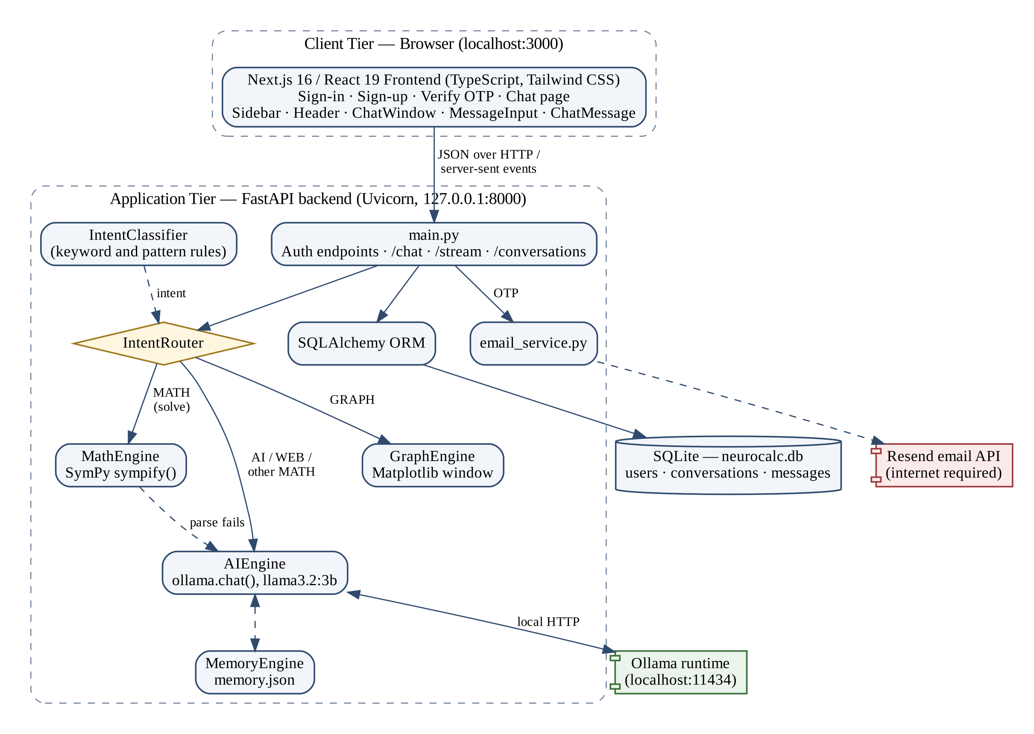
Figure 3.2: System architecture of NeuroCalc
The frontend sends JSON requests to the backend and receives answers as server-sent events. main.py passes each chat message to the Intent Router, which uses the Intent Classifier to label it GRAPH, MATH, WEB or AI. MATH messages that begin with "solve" are evaluated by the MathEngine with SymPy; GRAPH messages are plotted by the Graph Engine; all other messages, and any expression SymPy cannot parse, go to the AI Engine, which calls llama3.2:3b through Ollama and uses the Memory Engine to add stored user facts to its prompt. Conversations, messages and users are stored through SQLAlchemy, and OTP emails are sent through the Resend API.

3.4 DATA FLOW / WORKFLOW
Figure 3.3 shows the processing of one chat message through the /stream endpoint used by the frontend.
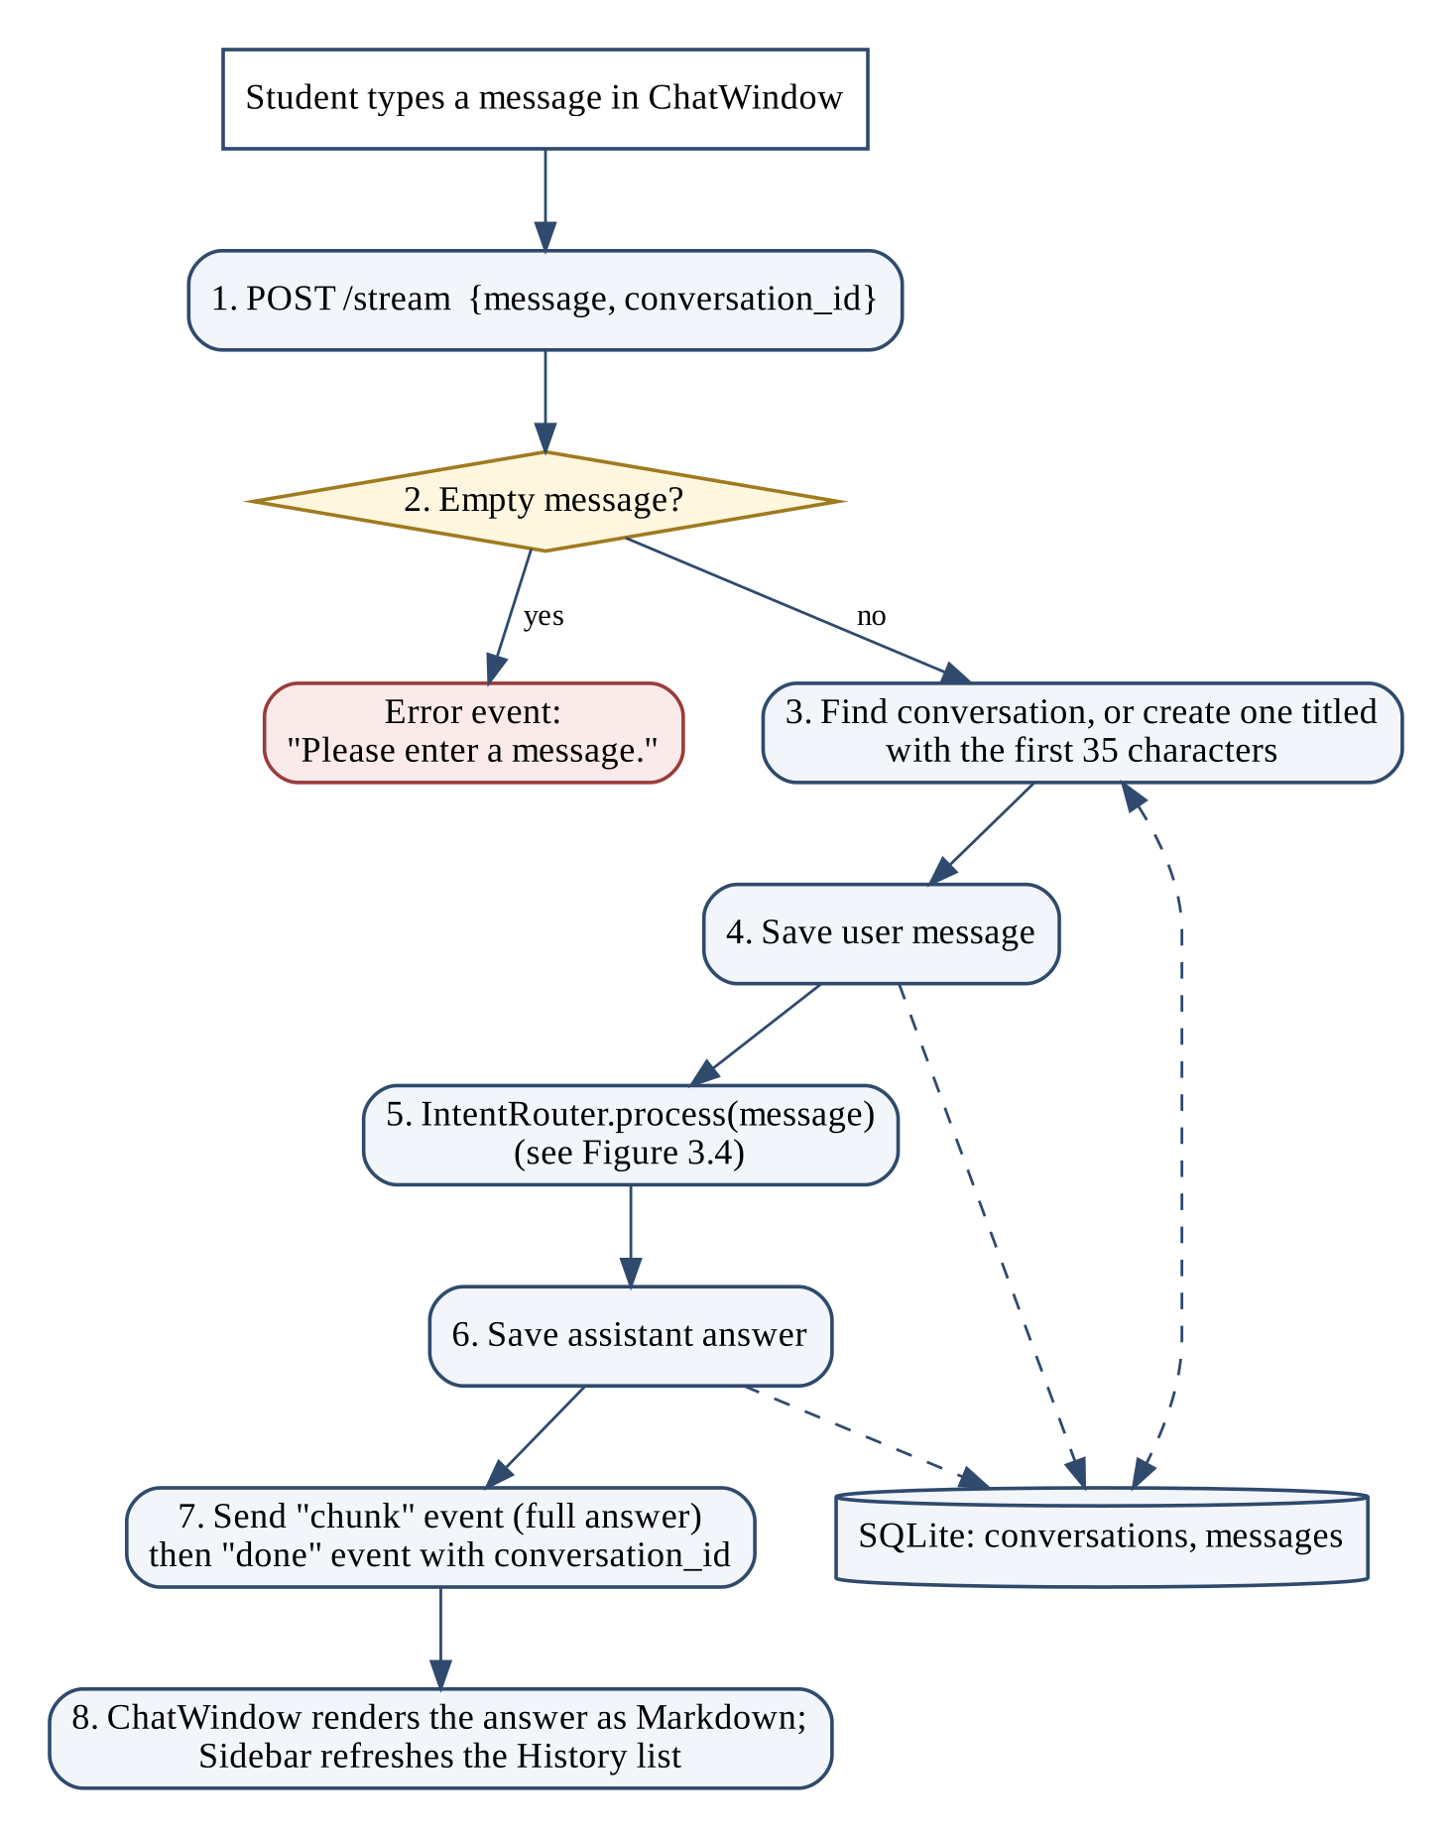
Figure 3.3: Request workflow for a chat message
The classifier applies its rules in order. A message containing "graph" or "plot" is plotted. A message beginning with simplify, factor, expand, solve, integrate, differentiate, derivative or limit, or consisting only of digits, the letter x, brackets, a decimal point and operators, is labeled MATH. Only the "solve" branch calls SymPy; the rest of the text is passed to sympify, which evaluates expressions (for example "solve 2+3*4" returns 14) but cannot parse an equation containing "=", which then falls back to the language model. The simplify, factor and expand branches call methods that are not defined in the MathEngine class and end in an error message. Every other message, including WEB queries (no search engine is implemented), is answered by the language model.

3.5 HARDWARE REQUIREMENTS
Table 3.3: Hardware requirements
Component | Minimum | Recommended
Processor | 64-bit quad-core CPU | Recent multi-core CPU
RAM | 8 GB (llama3.2:3b, about 3 billion parameters) | 16 GB or more
Storage | About 5 GB free for the model and application | SSD
GPU | Not required; CPU inference is slower | GPU supported by Ollama
Network | Needed only for OTP email and initial downloads | Broadband

The language model is the main computational load; the web application and SymPy are lightweight. These figures are indicative and were not benchmarked.

3.6 SOFTWARE REQUIREMENTS
Table 3.4: Software requirements
Software | Version | Purpose
Operating system | Windows 11 | Development machine
Python | 3.14.3 | Backend language
FastAPI / Uvicorn | 0.141.1 / 0.52.4 | API framework and server
SymPy | 1.14.0 | Symbolic mathematics
Ollama / ollama (Python) | 0.33.2 / 0.6.2 | Local model runtime and client
Language model | llama3.2:3b | Explanations and answers
SQLAlchemy / SQLite | 2.0.52 / SQLite 3 | ORM and embedded database
Node.js / npm | 3.24 | Frontend runtime
Next.js / React / TypeScript | 16.3.2 / 19.2.8 / 5.9.3 | Web frontend
Tailwind CSS, react-markdown | 4.3.3, 10.1.0 | Styling and Markdown rendering
Tools | VS Code, Git, GitHub | Development

Software Modules
- main.py: FastAPI application, CORS, request models, password hashing and all endpoints.
- intent_classifier.py / intent_router.py: query classification and dispatch to the engines.
- math_engine.py: SymPy evaluation. ai_engine.py: Ollama client and system prompt. graph_engine.py: Matplotlib plotting. memory_engine.py: stored user facts.
- email_service.py: OTP emails through Resend. database/models.py, database.py: SQLAlchemy models and session.

CHAPTER 4 – IMPLEMENTATION

4.1 METHODOLOGY
The project followed a modular, incremental development approach. Each module was built and checked separately and then integrated through the FastAPI backend. The stages were:
- Requirement analysis: identifying the need for exact results with explanations, and the constraint of limited connectivity.
- Design: three-tier architecture, routing rules and database schema (Chapter 3).
- Backend development: FastAPI endpoints, routing, SymPy and Ollama engines, and the database layer.
- Frontend development: authentication pages and the chat interface in Next.js.
- Integration: connecting the frontend to the backend over HTTP with CORS.
- Testing: checking modules through the interface and the API (Chapter 5).

4.2 IMPLEMENTATION

4.2.1 User Interface Module
The frontend is written in TypeScript and styled with Tailwind CSS [13], [14]. It has four pages in the Next.js app directory: sign-in (app/page.tsx), registration (app/signup/page.tsx), email verification (app/verify-otp/page.tsx) and chat (app/chat/page.tsx). The chat page combines Sidebar.tsx ("New Chat", "Clear History" and the History list), Header.tsx and ChatWindow.tsx, which uses MessageInput.tsx and ChatMessage.tsx. Answers are rendered as Markdown with react-markdown and remark-gfm, and code blocks are highlighted with react-syntax-highlighter. No mathematics renderer such as KaTeX is used, so expressions appear as plain text. The "Local AI Connected" label in the header is fixed text and does not check Ollama.
const response = await fetch(`${API_URL}/stream`, {
method: "POST",
headers: { "Content-Type": "application/json" },
body: JSON.stringify({ message: cleanText, conversation_id: conversationId }),
});
const reader = response.body.getReader(); // read server-sent events
Excerpt from frontend/components/ChatWindow.tsx (API_URL is http://127.0.0.1:8000)

4.2.2 Backend API Module
All endpoints are defined in backend/main.py (FastAPI application "NeuroCalc API", version 3.0) [15]. Request bodies are validated by Pydantic models, and a missing or wrongly typed field returns HTTP 422. No endpoint requires an authentication token.
Table 4.1: Backend API endpoints
Method and path | Request | Response
POST /signup | name, email, password | 200 user; 400 invalid input or email registered; 500 email not sent
POST /verify-otp | email, otp | 200; 404 user not found; 400 invalid or expired OTP
POST /login | email, password | 200 user {id, name, email}; 401 invalid credentials
POST /forgot-password, /reset-password | email (, otp, new password) | 200; 404; 400 (not reachable from the interface)
POST /chat | message, conversation_id (optional) | 200 response, conversation_id
POST /stream | message, conversation_id (optional) | Server-sent events: chunk, done, error
GET /conversations | – | List of {id, title, created_at}, newest first
GET /conversations/{id}/messages | id (path) | List of messages, oldest first
DELETE /conversations/{id} | id (path) | success, message
GET /, GET /test | – | Health check

4.2.3 Query Classification and Routing Module
IntentClassifier.detect() (backend/intent_classifier.py) returns GRAPH, MATH, WEB or AI using the rules in Figure 3.4; no trained classifier is involved. IntentRouter.process() (backend/intent_router.py) then calls the corresponding engine.
math_keywords = ["simplify", "factor", "expand", "solve", "integrate",
"differentiate", "derivative", "limit"]
if any(text.startswith(keyword) for keyword in math_keywords):
return "MATH"
math_pattern = r"^[\d\s\+\-\*\/\^\(\)\.\=xX]+$"
if re.match(math_pattern, text):
if any(op in text for op in ["+", "-", "*", "/", "^", "="]):
return "MATH"
...
if text.startswith("solve"):
expression = message[len("solve"):].strip()
result = self.math.calculate(expression)
if result["success"]:
return f"**Result:** {result['result']}"
return self.ai.generate_response(message)
Excerpt from backend/intent_classifier.py and backend/intent_router.py

4.2.4 Symbolic Computation Module
MathEngine.calculate() (backend/math_engine.py) passes the text to SymPy's sympify, which parses and evaluates it [16]. No other normalization is applied: "^" is not converted to "**", and text containing "=" cannot be parsed. sympify is currently the only SymPy function called; standard functions such as solve, diff, integrate and simplify are available in SymPy but not yet used. Because sympify uses Python evaluation internally, it should not be given untrusted input.
def calculate(self, expression: str):
try:
result = sp.sympify(expression)
return {"success": True, "result": str(result)}
except Exception as e:
print(f"Math Error: {e}")
return {"success": False, "result": None}
Excerpt from backend/math_engine.py

4.2.5 Local Language Model Module
AIEngine.generate_response () (backend/ai_engine.py) calls ollama. chat () with the model llama3.2:3b, a temperature of 0.3 and a 4,096-token context window [3]. Each request contains a system prompt, the earlier messages of the conversation and the new question. If Ollama cannot be reached, it returns "Sorry, I couldn't generate a response right now." The system prompt identifies the assistant as NeuroCalc and instructs it to answer directly, keep simple answers short, use simple language, give numbered steps when asked, not invent facts and say when it is uncertain; a USER MEMORY section is filled from memory. json by the MemoryEngine. The prompt does not mention SymPy, because SymPy results are not currently passed to the model.

4.2.6 Database and Conversation Module
SQLAlchemy models (backend/database/models.py) define three tables in backend/neurocalc.db, created automatically at start-up [17], [18]. Figure 4.1 shows them.
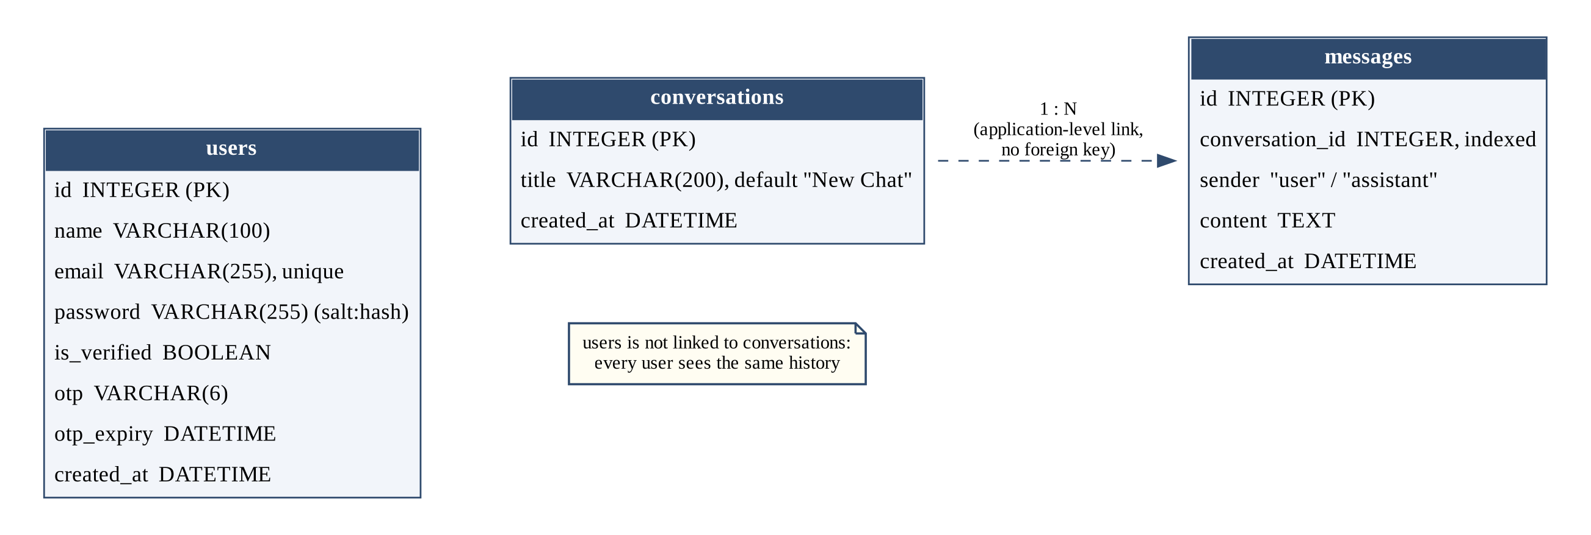
Figure 4.1: Database tables as implemented
The /chat and /stream endpoints save both the user's message and the answer. The sidebar lists conversations from GET /conversations, opens one with GET /conversations/{id}/messages, and "Clear History" deletes each with DELETE /conversations/{id}. Conversations persist across restarts, but because the conversations table has no user identifier, every user sees the same history.

4.2.7 Authentication Module
POST /signup checks the name, email and password (at least 6 characters), stores the password as a PBKDF2-HMAC-SHA256 hash with a random 16-byte salt and 100,000 iterations, and emails a six-digit OTP valid for 10 minutes through the Resend API (backend/email_service.py). POST /verify-otp marks the account verified, and POST /login compares the hash in constant time. No session token is issued: the frontend stores the returned user details in localStorage, login does not require a verified account, and the "Forgot password?" button only shows "Password reset will be available soon."

4.2.8 Graph Plotting Module
When a message contains "graph" or "plot", the IntentRouter passes the expression to the GraphEngine (backend/graph_engine.py), which evaluates it over a range of x values and draws the curve with Matplotlib. The plot opens in a window on the machine running the backend rather than in the browser, so it is visible only when the backend and the browser run on the same computer. The expression is evaluated with Python's eval(), which is discussed in Section 4.3.

4.3 MODULE INTEGRATION
Figure 4.2 shows how the modules cooperate to answer one chat message.
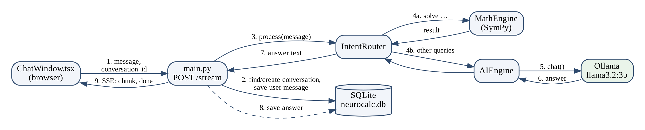
Figure 4.2: Frontend-backend interaction for a chat message
ChatWindow sends the message to POST /stream (1). main.py finds or creates the conversation and saves the user message (2), then calls the IntentRouter (3), which uses either the MathEngine (4a) or the AIEngine (4b); the AIEngine obtains the answer from Ollama (5, 6). The answer is returned to main.py (7), saved (8) and sent to the browser as server-sent events (9).
The modules are integrated through the FastAPI backend. The frontend calls the backend at http://127.0.0.1:8000, a URL written directly in the frontend source. CORS in main.py allows the origins localhost:3000, 127.0.0.1:3000, localhost:3001 and 127.0.0.1:3001 with all methods and headers; these are development settings. Errors are reported to the student as messages: "Please enter a message." for empty input, "Sorry, I encountered an error while processing your request." when processing fails, the Ollama fallback message above, and "Sorry, I couldn't connect to the NeuroCalc backend." when the backend is unreachable.
Two security points require attention before use outside a trusted machine: the GraphEngine evaluates the user's expression with Python's eval(), which can run arbitrary code, and sympify should likewise receive only sanitized input. Restricting parsing (for example with SymPy's parse_expr and lambdify) would remove this risk.

CHAPTER 5 – RESULTS, CONCLUSION AND FUTURE WORK

5.1 RESULTS AND EVALUATION
The application was run locally with the frontend at localhost:3000, and the screenshots below were captured from the running system. Table 5.1 records what each screenshot shows. These are observations, not formal test passes.
Table 5.1: Observed results from the running application
Query or screen | Component that answered | Observed result | Figure
Sign-in page | Frontend | Email/password form, "Create your NeuroCalc account" link | 5.1
Chat page on start | Frontend | Greeting, New Chat and History sidebar | 5.2
"What is the value of 2 + 3 × 4?" | Language model (contains words and ×) | Answer 14 with order-of-operations steps | 5.3
"What is NeuroCalc?" | Language model | Description of NeuroCalc as a local AI assistant | 5.4
Python program for a sum of multiples | Language model | Working Python program with explanation | 5.5
Two logical-reasoning puzzles | Language model | Responses did not reach the correct answers | 5.6

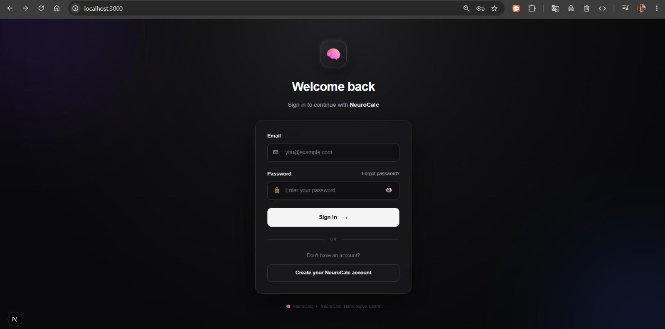
Figure 5.1: NeuroCalc sign-in page
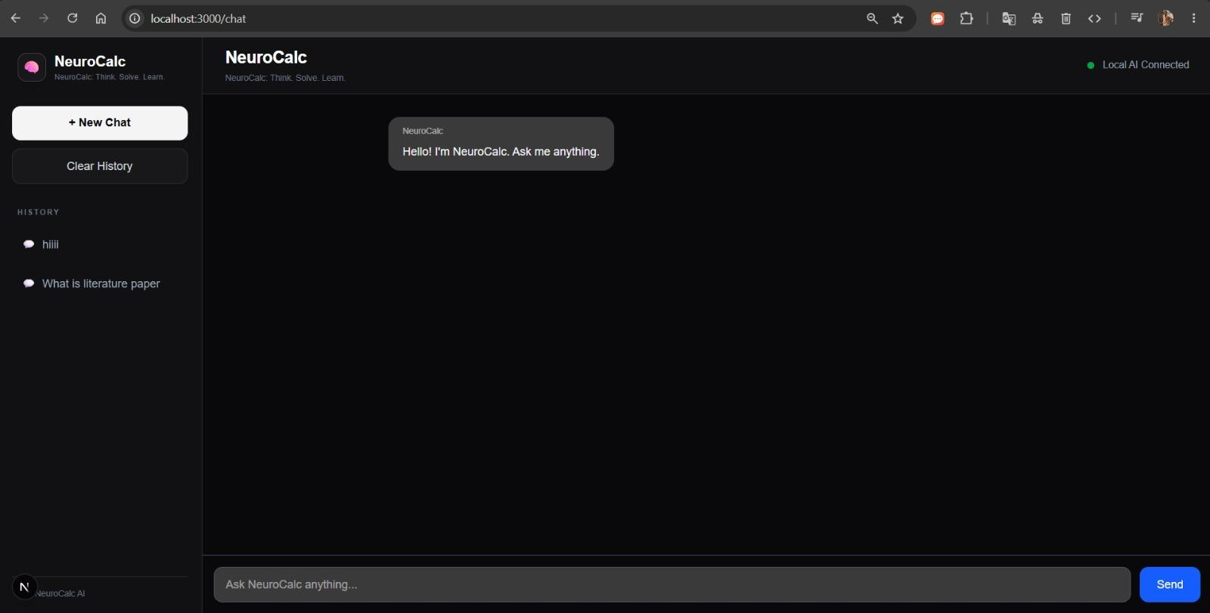
Figure 5.2: Chat interface on start-up
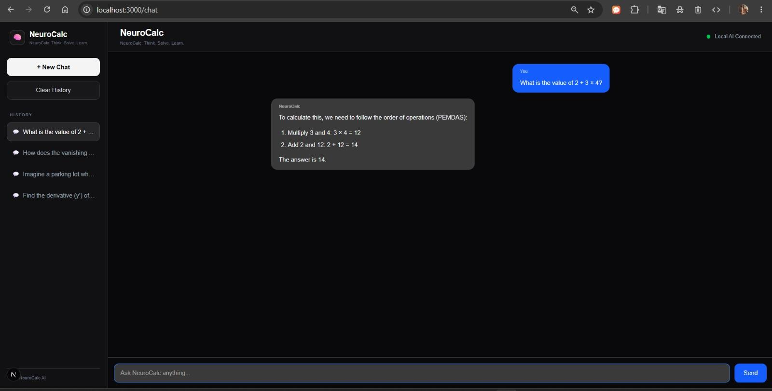
Figure 5.3: Response to an arithmetic query (2 + 3 × 4)
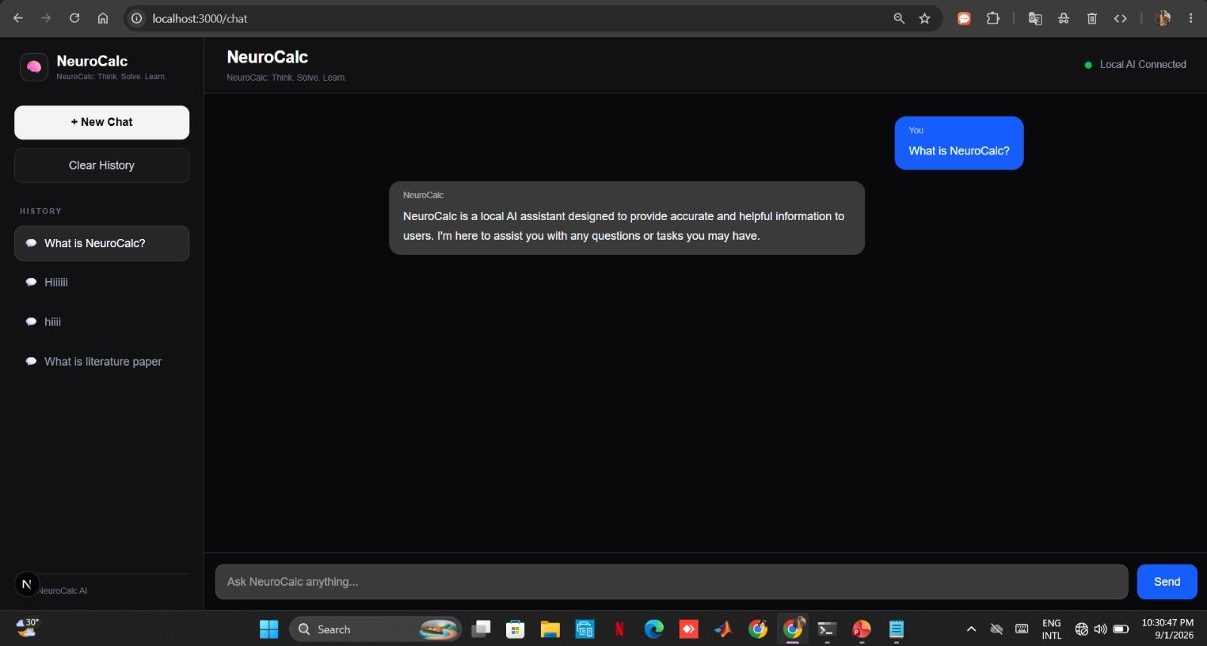
Figure 5.4: Response to a conceptual question
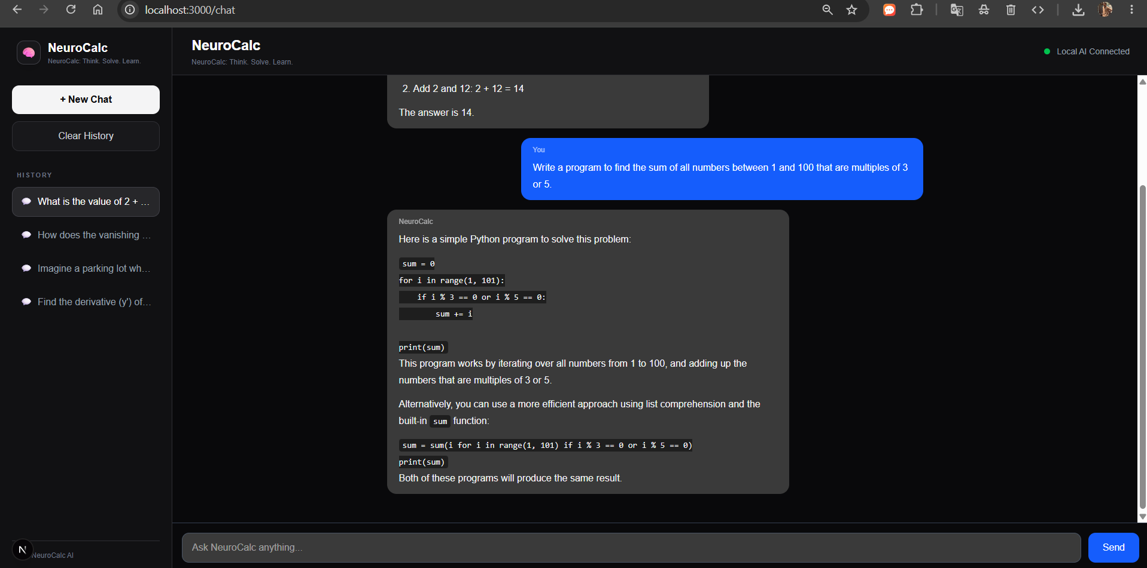
Figure 5.5: Response to a programming question
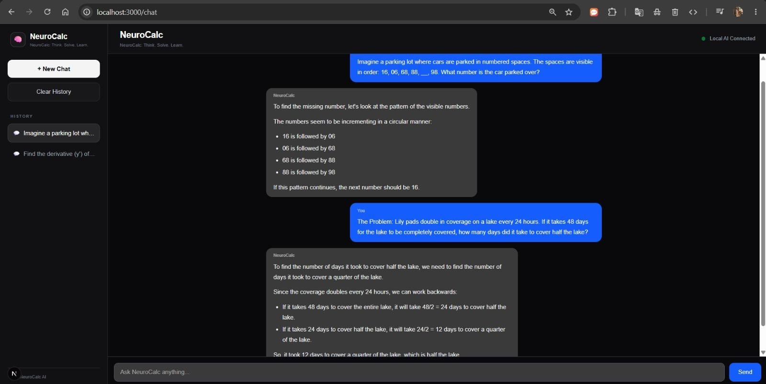
Figure 5.6: Responses to logical-reasoning questions
Evaluation Approach
Evaluation combines module checks through the API (the FastAPI documentation page at /docs), system checks through the web interface, and qualitative review of model answers. For computation cases the expected output is the exact mathematical value, which can be checked independently; for model answers the criterion is a relevant, correct and non-contradictory explanation. Once the tests are run, the pass rate will be reported as (passed tests ÷ executed tests) × 100, excluding unexecuted tests. No response-time or accuracy figures are reported, because none were measured.
Table 5.2 lists the planned functional test cases. Formal execution has not yet been recorded, so the status of each is pending; the team should run each case and replace the status with Pass or Fail. The last column notes the outcome expected from the current code.
Table 5.2: Functional test cases
ID | Scenario | Input | Expected (design) | Expected from current code | Status
TC01 | Arithmetic via SymPy | solve 2**10 + 3*7 | 1045 | SymPy returns 1045 | Pending
TC02 | Fraction via SymPy | solve 1/3 + 1/6 | 1/2 | SymPy returns 1/2 | Pending
TC03 | Equation | solve x**2 - 4 = 0 | x = -2, 2 | "=" fails in sympify; answered by LLM | Pending
TC04 | Simplify | simplify sin(x)**2 + cos(x)**2 | 1 | Undefined method; error message | Pending
TC05 | Derivative | derivative of x**3 | 3*x**2 | Answered by LLM | Pending
TC06 | Conceptual question | What is a derivative? | Explanation | Answered by LLM | Pending
TC07 | Empty message | (empty) | Error message | "Please enter a message." | Pending
TC08 | Malformed API request | POST /chat without message | HTTP 422 | HTTP 422 | Pending
TC09 | Sign-up and OTP | New email address | OTP email; verified | Needs Resend key and internet | Pending
TC10 | History persistence | Two messages, reload page | Messages kept | Kept in neurocalc.db | Pending
TC11 | Ollama stopped | Any LLM question | Clear message | "Sorry, I couldn't generate…" | Pending
TC12 | Graph request | plot x**2 | Graph shown | Matplotlib window on backend machine | Pending

5.2 DISCUSSION
The screenshots show that the integrated system works end to end: the frontend authenticates the user, sends queries to the backend, stores conversations and displays answers from the local model without any cloud AI service. The arithmetic example (Figure 5.3) was answered correctly, but by the language model rather than SymPy, because the query contains words and the × sign and is therefore not classified as MATH. The logical-reasoning example (Figure 5.6) shows the model failing to reach the correct answers. This is the limitation that motivates NeuroCalc's design: answers produced by a language model alone do not carry the correctness guarantee of a SymPy result [1], [10]. In the current version only messages beginning with "solve" receive that guarantee, so widening the SymPy path is the most important next step.

5.3 CHALLENGES AND LIMITATIONS
- Limited SymPy coverage: only sympify is used; equations with "=", calculus and the simplify, factor and expand commands do not yet receive exact computation.
- No result explanation path: SymPy results are returned without a model explanation.
- Model capability and hardware: llama3.2:3b is small enough to run locally but makes reasoning errors; larger models need more memory.
- Authentication and history: no session token, and conversations are shared between all users.
- Internet for OTP: email verification through Resend requires connectivity, so the system is offline-oriented rather than fully offline.
- Security: eval() in the GraphEngine and unsanitized sympify input are unsafe on untrusted networks.
- Testing: formal test results and response-time measurements have not yet been recorded.

5.4 CONCLUSION
NeuroCalc demonstrates a hybrid, locally run approach to mathematical assistance. A Next.js and React interface, a FastAPI backend, a rule-based router, SymPy, a llama3.2:3b model served by Ollama and an SQLite database have been integrated into a working application with sign-up, OTP verification, saved conversations and model-generated explanations. The project shows that useful mathematical help can be delivered without sending queries to cloud AI services, which benefits students with limited connectivity and keeps their questions on their own machine. The observed results also confirm the project's premise: the language model explains well but is not reliable on its own, so the deterministic SymPy path must carry the computation. Extending that path is the clearest route to the project's full objective.

5.5 FUTURE WORK
- Wider exact computation: route equations, derivatives, integrals and limits to SymPy solve, diff, integrate and limit, and implement the simplify, factor and expand methods.
- Explain computed results: pass each SymPy result to the model with a prompt that treats it as the authoritative answer.
- Secure parsing and sessions: replace eval () with a restricted parser, add session tokens and link conversations to users.
- True streaming and math rendering: use token-by-token streaming and render expressions with KaTeX.
- Learning features: personalized learning paths, mistake diagnosis, generated quizzes and concept maps.
- New input and output modes: handwritten equation recognition (OCR), voice interaction and multilingual explanations.

REFERENCES
[1] Z. Ji, N. Lee, R. Frieske, T. Yu, D. Su, Y. Xu, E. Ishii, Y. J. Bang, A. Madotto, and P. Fung, "Survey of hallucination in natural language generation," ACM Computing Surveys, vol. 55, no. 12, Art. no. 248, 2023.
[2] A. Meurer, C. P. Smith, M. Paprocki, O. Čertík, S. B. Kirpichev, M. Rocklin, et al., "SymPy: symbolic computing in Python," PeerJ Computer Science, vol. 3, p. e103, 2017.
[3] Ollama, "Ollama: get up and running with large language models locally." [Online]. Available: https://github.com/ollama/ollama
[4] S. Frieder, L. Pinchetti, R.-R. Griffiths, T. Salvatori, T. Lukasiewicz, P. Petersen, and J. Berner, "Mathematical capabilities of ChatGPT," in Advances in Neural Information Processing Systems (Datasets and Benchmarks Track), vol. 36, 2023.
[5] Wolfram Research, "Wolfram|Alpha." [Online]. Available: https://www.wolframalpha.com
[6] K. Cobbe, V. Kosaraju, M. Bavarian, M. Chen, H. Jun, L. Kaiser, et al., "Training verifiers to solve math word problems," arXiv preprint arXiv:2110.14168, 2021.
[7] D. Hendrycks, C. Burns, S. Kadavath, A. Arora, S. Basart, E. Tang, D. Song, and J. Steinhardt, "Measuring mathematical problem solving with the MATH dataset," in Proc. NeurIPS Datasets and Benchmarks Track, 2021.
[8] J. Wei, X. Wang, D. Schuurmans, M. Bosma, B. Ichter, F. Xia, E. Chi, Q. Le, and D. Zhou, "Chain-of-thought prompting elicits reasoning in large language models," in Advances in Neural Information Processing Systems, vol. 35, 2022.
[9] A. Lewkowycz, A. Andreassen, D. Dohan, E. Dyer, H. Michalewski, V. Ramasesh, et al., "Solving quantitative reasoning problems with language models," in Advances in Neural Information Processing Systems, vol. 35, 2022.
[10] L. Gao, A. Madaan, S. Zhou, U. Alon, P. Liu, Y. Yang, J. Callan, and G. Neubig, "PAL: Program-aided language models," in Proc. 40th Int. Conf. Machine Learning (ICML), PMLR, vol. 202, pp. 10764–10799, 2023.
[11] W. Chen, X. Ma, X. Wang, and W. W. Cohen, "Program of thoughts prompting: Disentangling computation from reasoning for numerical reasoning tasks," Transactions on Machine Learning Research, 2023 (arXiv:2211.12588).
[12] T. Schick, J. Dwivedi-Yu, R. Dessì, R. Raileanu, M. Lomeli, L. Zettlemoyer, N. Cancedda, and T. Scialom, "Toolformer: Language models can teach themselves to use tools," in Advances in Neural Information Processing Systems, vol. 36, 2023.
[13] Vercel, "Next.js documentation." [Online]. Available: https://nextjs.org/docs
[14] Meta Open Source, "React documentation." [Online]. Available: https://react.dev
[15] S. Ramírez, "FastAPI documentation." [Online]. Available: https://fastapi.tiangolo.com
[16] SymPy Development Team, "SymPy documentation." [Online]. Available: https://docs.sympy.org
[17] SQLAlchemy, "SQLAlchemy documentation." [Online]. Available: https://docs.sqlalchemy.org
[18] SQLite, "SQLite documentation." [Online]. Available: https://www.sqlite.org/docs.html

