
BHARATVOICE AI: A MULTILINGUAL VOICE ASSISTANT FOR GROUNDED, EVERYDAY CITIZEN SERVICES IN FIVE INDIAN LANGUAGES
SRI RAM RAJENDRAKUMAR R – 24623156
JONATHAN DAVID D – 24623150
JOE ANTO PRAKASH J – 24623149
BATCH NO. 19
MINI PROJECT REPORT
Submitted to the
SCHOOL OF ENGINEERING
DEPARTMENT OF ARTIFICIAL INTELLIGENCE AND MACHINE LEARNING
in Partial fulfillment of the requirements for the award of the degree of
BACHELOR OF TECHNOLOGY
IN
COMPUTER SCIENCE AND ENGINEERING (ARTIFICIAL INTELLIGENCE)

VELS INSTITUTE OF SCIENCE, TECHNOLOGY AND ADVANCED STUDIES (VISTAS)
CHENNAI – 600 117
OCTOBER 2026

BONAFIDE CERTIFICATE
Certified that this project report "BHARATVOICE AI: A MULTILINGUAL VOICE ASSISTANT FOR GROUNDED, EVERYDAY CITIZEN SERVICES IN FIVE INDIAN LANGUAGES" is the bonafide work of SRI RAM RAJENDRAKUMAR R – 24623156, JONATHAN DAVID D – 24623150 and JOE ANTO PRAKASH J – 24623149, who carried out the project under my supervision. Certified further that, to the best of my knowledge, the work reported herein does not form part of any other project report or dissertation on the basis of which a degree or award was conferred on an earlier occasion on this or any other candidate.

SIGNATURE OF THE HOD  Dr. K. ULAGA PRIYA, M.E., Ph.D.  Associate Professor & Head  Department of AI&ML  School of Engineering  VISTAS, Chennai | SIGNATURE OF THE SUPERVISOR  Ms. VP. ANITHA  Assistant Professor  Department of AI&ML  School of Engineering  VISTAS, Chennai

Submitted for the Project Work and Viva-Voce examination held on 30.10.2026 at Vels Institute of Science, Technology and Advanced Studies (VISTAS), Chennai – 600 117.

INTERNAL EXAMINER | EXTERNAL EXAMINER
DECLARATION
We hereby declare that the mini project report entitled "BHARATVOICE AI: A MULTILINGUAL VOICE ASSISTANT FOR GROUNDED, EVERYDAY CITIZEN SERVICES IN FIVE INDIAN LANGUAGES", submitted to Vels Institute of Science, Technology and Advanced Studies (VISTAS), Chennai, in partial fulfillment of the requirements for the award of the degree of Bachelor of Technology in Computer Science and Engineering (Artificial Intelligence), is a record of original work carried out by us under the guidance of Ms. VP. Anitha, Assistant Professor, Department of Artificial Intelligence and Machine Learning. The work has not been submitted, in part or in full, for the award of any other degree or diploma.

Place: Chennai
Date: 30.10.2026

SRI RAM RAJENDRAKUMAR R – 24623156
JONATHAN DAVID D – 24623150
JOE ANTO PRAKASH J – 24623149
ACKNOWLEDGEMENT
It is a great pleasure and privilege to acknowledge the help and support we received in completing this project. The infrastructure and laboratory facilities provided by our FOUNDER & CHAIRMAN, Shri. Dr. ISHARI K. GANESH, have been a constant source of motivation, and we take this opportunity to thank him.
We are grateful to our HEAD OF THE DEPARTMENT, Dr. K. ULAGA PRIYA, for her continuous support and encouragement throughout the project. We extend our sincere thanks to our INTERNAL GUIDE, Ms. VP. ANITHA, Assistant Professor, Department of AI&ML, who patiently guided us and gave us invaluable advice at every stage of the work, from the choice of problem to the conference paper.
We also thank the faculty members, librarian and non-teaching staff of the department for their help. Finally, we thank our parents and friends for their support and encouragement, without which this project would not have been possible.

SRI RAM RAJENDRAKUMAR R – 24623156
JONATHAN DAVID D – 24623150
JOE ANTO PRAKASH J – 24623149

ABSTRACT
BharatVoice AI is a voice-first web assistant for everyday citizen needs in Tamil, Hindi, Telugu, Kannada and English. Many people in India would rather ask a question out loud in their own language than search an English government portal, and when they type, they often write in Roman letters with English words mixed in, as in "PAN card kaise banaye". The assistant covers a small, fixed set of everyday needs: identity documents and where to obtain them, emergency helplines, weather, mandi crop prices, reminders, arithmetic and unit conversion, and a question bank with cited answers on banking, online fraud, welfare schemes, travel, education, jobs and hospitals.
No large language model is used. Speech is captured in the browser through the Web Speech API, and a FastAPI backend processes each request rules-first. A four-stage cascade (Unicode script share, romanized cue words, a fine-tuned MuRIL classifier and a statistical fallback) identifies the language, emergency requests are matched before any classifier is consulted, and every factual reply either names its source or states that the assistant does not know. Two fine-tuned MuRIL classifiers, one for intent and one for language, extend the rules and are trusted only above a confidence floor. Every heavy component has a light substitute, so the system runs on an ordinary laptop without a GPU.
The application is built with React 18 and Vite 5 on the client and Python 3.12, FastAPI, SQLAlchemy and SQLite on the server, with Alembic migrations. It also offers optional sign-in with per-user history, reminders delivered through Web Push after the browser tab is closed, and tap-to-call helpline numbers that are guarded by a server-side rule so that a price or a sum is never turned into a phone link.
On a held-out test set written during development, intent accuracy rose from 67% with rules alone to 89% with MuRIL, and language-identification accuracy from 60% to 95%; these figures are indicative, since the test set was not written by independent native speakers. All 752 automated backend tests and 45 frontend tests pass, and a short hands-on probe with romanized questions exposed real gaps in romanized emergency phrases, weather words and morning times that guide further work. By making reliable public information reachable by voice in a user's own language, the project supports more equal access to digital services.
Keywords: Indian Languages, Voice User Interface, Code-Mixed Text, Language Identification, MuRIL, Citizen Services, Grounded Response Generation, Selective Prediction, FastAPI, React.
TABLE OF CONTENTS
CHAPTER NO. | TITLE | PAGE NO.
 | ABSTRACT | i
 | LIST OF FIGURES AND TABLES | iii
 | LIST OF ABBREVIATIONS | iv
1 | CHAPTER 1 – INTRODUCTION | 1
 | 1.1 Overview of the project | 1
 | 1.2 Scope and objective | 2
2 | CHAPTER 2 – REVIEW OF THE LITERATURE | 4
 | 2.1 Literature overview | 4
 | 2.2 Research summary | 4
3 | CHAPTER 3 – SYSTEM DESIGN | 7
 | 3.1 Existing system | 7
 | 3.2 Proposed system | 7
 | 3.3 System architecture | 9
 | 3.4 Data flow / workflow | 11
 | 3.5 Hardware requirements | 15
 | 3.6 Software requirements | 16
4 | CHAPTER 4 – IMPLEMENTATION | 17
 | 4.1 Methodology | 17
 | 4.2 Implementation | 18
 | 4.2.1 User Identity and Ownership | 18
 | 4.2.2 Speech Capture and Input Handling | 18
 | 4.2.3 Language Identification Cascade | 18
 | 4.2.4 Intent Arbitration and Entity Extraction | 19
 | 4.2.5 Source-Aware Response Policy | 20
 | 4.2.6 Everyday Skills and Curated Content | 21
 | 4.2.7 Live Data Adapters | 21
 | 4.2.8 Reply Rendering and Tap-to-Call Helplines | 21
 | 4.2.9 Reminder Scheduling and Web Push Delivery | 22
 | 4.2.10 Accounts, Persistence and Schema Migration | 22
 | 4.3 Module integration | 23
5 | CHAPTER 5 – RESULTS, CONCLUSION AND FUTURE WORK | 24
 | 5.1 Results and evaluation | 24
 | 5.2 Discussion | 29
 | 5.3 Challenges and limitations | 30
 | 5.4 Conclusion | 30
 | 5.5 Future work | 30
 | REFERENCES | 32
LIST OF FIGURES
FIGURE NO. | TITLE | PAGE NO.
3.1 | Use-case diagram of BharatVoice AI | 9
3.2 | Layered system architecture of BharatVoice AI | 10
3.3 | Processing of a single request, from utterance to stored reply | 12
3.4 | Level 0 data-flow diagram (context diagram) | 13
3.5 | Level 1 data-flow diagram | 13
3.6 | Entity-relationship diagram of BharatVoice AI | 14
3.7 | Flowchart of the language-identification cascade | 15
4.1 | Project review schedule (Gantt chart from the project review presentation) | 17
5.1 | Automated backend tests by module (before MuRIL integration) | 25
5.2 | Accuracy with rules only and with rules + MuRIL (development test set) | 26
5.3 | Home screen after a question typed in Tamil script, showing the reply in Tamil and the official-portal source link | 28
5.4 | Conversation view: a Tamil-script document question, a romanized Hindi–English PAN card question answered in Hindi, and an English reminder request with its extracted date and time | 28
5.5 | Emergency helpline reply with tap-to-call numbers and source links | 29
LIST OF TABLES
TABLE NO. | TITLE | PAGE NO.
2.1 | Comparison with existing work | 5
2.2 | Research gaps and how BharatVoice AI addresses them | 6
3.1 | Functional requirements | 7
3.2 | Modules and their principal components | 10
3.3 | Core database entities | 14
3.4 | Indicative hardware requirements | 15
3.5 | Software requirements | 16
4.1 | Model-based components and their light substitutes | 18
4.2 | Stages of the language-identification cascade | 19
4.3 | Response policy by situation | 20
4.4 | Curated content and live data coverage | 21
4.5 | Security and delivery parameters | 22
5.1 | Automated backend test suite before MuRIL integration | 24
5.2 | Representative behaviours covered by the automated tests | 25
5.3 | Accuracy on the development test set (indicative) | 26
5.4 | Informal probe with romanized and code-mixed queries (rule-based stages) | 26
LIST OF ABBREVIATIONS
ABBREVIATION | FULL FORM
AI | Artificial Intelligence
API | Application Programming Interface
ASR | Automatic Speech Recognition
CPU | Central Processing Unit
DFD | Data-Flow Diagram
ER | Entity-Relationship
GPU | Graphics Processing Unit
HTTP | Hypertext Transfer Protocol
ID | Identity / Identification
IMD | India Meteorological Department
JSON | JavaScript Object Notation
LID | Language Identification
LLM | Large Language Model
MuRIL | Multilingual Representations for Indian Languages
NHD | National Hospital Directory
NLU | Natural-Language Understanding
OGD | Open Government Data
PAN | Permanent Account Number
SDG | Sustainable Development Goal
SHA | Secure Hash Algorithm
SQL | Structured Query Language
TTS | Text-to-Speech
UI | User Interface
URL | Uniform Resource Locator
UTC | Coordinated Universal Time
VAPID | Voluntary Application Server Identification
WER | Word Error Rate

CHAPTER 1 – INTRODUCTION

1.1 OVERVIEW OF THE PROJECT
Introduction
More and more public services in India are offered through websites and mobile applications, and most of them expect the visitor to read English or Hindi, move through several levels of menus and type a search query. A farmer in Madurai who wants an Aadhaar record corrected, or a retired teacher in Mysuru who has just received a suspicious call about a bank account, may not be comfortable with any of those steps. Research on interfaces for low-literate users found long ago that speech and simple visual cues help [1], and city-level chatbot deployments suggest that people will use a conversational channel when one exists [2].
The building blocks for such a channel in Indian languages are now openly available: speech recognisers [3]–[6], pretrained Indian-language encoders [7]–[9], translation for all 22 scheduled languages [10] and the national BHASHINI platform [11]. BharatVoice AI was developed as a working student prototype that combines these ideas into a single voice-first assistant for five languages: Tamil, Hindi, Telugu, Kannada and English. It accepts native-script, romanized and code-mixed input, identifies the language and the intent, and answers only from curated content or named live sources.
Problem Statement
Citizens who want short, reliable answers to everyday service questions in their own language face four practical difficulties:
- Language barrier: most portals are in English or Hindi and assume the visitor can read them and navigate menus.
- Mixed typing: text such as "PAN card kaise banaye" is written in Latin letters with an English noun inside. A script check sees only ASCII, and a general-purpose language identifier usually labels it English, so the reply comes back in the wrong language. Romanized Indic language identification is still an open problem [12], and standard models lose accuracy on code-switched text [13], [14].
- Wrong answers hurt: a confident wrong answer about a government document, a scheme or a helpline can cost a wasted trip or a fee that was not owed, and text generators are known to state things no source supports [15].
- Heavy models: large speech and language models usually need a GPU, which small teams, offices and ordinary users may not have.
The problem addressed by this project is to design and implement a voice assistant that understands Indian languages, including romanized and code-mixed typing, gives only answers it can back with a source, refuses when it cannot, and still runs on ordinary hardware.
System Overview
BharatVoice AI is a React web client backed by a FastAPI server and a SQLite database. The user taps a large orb and speaks, or chooses "Type instead". The browser converts speech to text in the language chosen in the header. On the server, the request is first assigned an owner (a signed-in user, a guest or nobody). The natural-language understanding (NLU) pipeline then identifies the language with a four-stage cascade, decides the intent with emergency patterns checked first, and extracts places, dates, times and quantities. The request is routed to one of four kinds of handler: local skills, curated content, live data adapters or the reminder store. Every handler's output passes through the same source-aware response policy, so the reply is a curated answer with its source, a live value with its source and fetch time, or an explicit refusal that points to the official portal. The reply is shown and spoken in the detected language, helpline numbers become tap-to-call links, and the exchange is saved with its language, intent, entities and sources.
Advantages of the System
- Five languages, three writing styles: native script, romanized and code-mixed input are all handled, and the reply comes back in the user's language.
- Grounded answers: every factual sentence was either written and checked in advance or came from a named live source; otherwise the assistant says it does not know.
- Safety first: emergency requests are matched before any classifier, so whether someone receives helpline numbers never depends on how sure a model feels.
- Runs on ordinary hardware: every model-based component has a light substitute, so the system runs on a laptop with no GPU, and removing a model weakens answers but crashes nothing.
- Explainable: the language, intent, entities and sources chosen for each message are stored with it, so any reply can be explained afterwards.
- Useful after the tab is closed: reminders are delivered through Web Push exactly once, and helpline numbers can be tapped to call.
These advantages are design properties of the implementation; the report does not claim measured improvements in access to services or in user satisfaction.

1.2 SCOPE AND OBJECTIVE
Purpose of the Study
The purpose of the project is to design and implement a voice-first assistant that lets citizens ask everyday service questions in their own language and writing style, and that answers only from curated content or named live sources, so that every reply can be trusted or is an honest refusal, even on ordinary hardware without a GPU.
Objectives
- To accept voice or text input in Tamil, Hindi, Telugu, Kannada and English, including romanized and code-mixed input.
- To identify the language with an inspectable cascade and the intent with emergency requests handled before anything else, using fine-tuned MuRIL classifiers only above a confidence floor.
- To answer only from curated content or live sources, and to show the source with every fact or refuse with a pointer to the official portal.
- To provide everyday skills: identity-document guidance, emergency helplines, weather, mandi prices, reminders, a safe calculator and unit conversion.
- To deliver reminders once, both in the open page and through Web Push after the page is closed, and to make only server-marked helpline numbers tappable.
- To run on ordinary hardware without a GPU and to save every reply with its language, intent, entities and sources, with optional accounts and per-user history.
Scope of the Project
- Functional scope: voice or typed questions in Tamil, Hindi, Telugu, Kannada and English, including romanized and code-mixed text; language, intent and entity identification; identity-document guidance; tap-to-call emergency helplines; weather, mandi prices and hospital lookup with sources; curated question bank; calculator and unit conversion; reminders with Web Push; optional accounts with saved history; spoken replies.
- Technical scope: React 18 and Vite 5 on the frontend; Python 3.12, FastAPI, Pydantic 2 and uvicorn on the backend; two fine-tuned MuRIL classifiers with PyTorch and Hugging Face Transformers on CPU; SQLite with SQLAlchemy and Alembic; browser Web Speech API and Web Push.
- Out of scope: deciding eligibility, fees or processing times; server-side speech recognition as the default path; translation beyond the curated Tamil–English fallback; languages other than the five listed; mobile applications. These are treated as future work (Section 5.5).
Accuracy has been measured only on a development test set written by the team, speech recognition has not been measured, and no user study or public deployment has been carried out, so the report makes no claim about real-world accuracy or impact.

CHAPTER 2 – REVIEW OF THE LITERATURE

2.1 LITERATURE OVERVIEW
The research relevant to BharatVoice AI covers speech recognition for Indian languages, language identification and code-mixed text, multilingual encoders and translation, and the reliability of generated answers. This chapter summarises the works cited in the BharatVoice AI conference paper and identifies the gap that the project addresses. Findings are reported as the cited authors describe them.

2.2 RESEARCH SUMMARY
Interfaces for Low-Literate Users and Citizen Chatbots
Medhi Thies reviews two decades of interface design for low-literate and novice users and finds that speech, audio feedback and simple visual cues reduce the dependence on reading and typing [1]. Zhou et al. study citizens' perceptions of a city 311 chatbot and show that people will use a conversational channel for public services when one exists, while also expecting accurate and accountable answers [2]. These studies motivate a voice-first assistant for citizen services; they do not show that any particular assistant improves access, and BharatVoice AI makes no such claim.
Speech Recognition for Indian Languages
Whisper showed that one model trained on a very large amount of loosely labelled audio can transcribe many languages without per-language tuning [3]. Work focused on Indian languages has followed three directions: self-supervised pretraining on about 17,000 hours of audio in forty languages [4], a shared benchmark with fine-tuned recognisers for twelve languages [5], and a collection of 7,348 hours of natural speech from 16,237 speakers [6]. Running the larger models at conversational speed, however, usually needs a GPU. BharatVoice AI therefore uses the browser's Web Speech API by default and keeps Whisper as an optional server-side component.
Language Identification and Code-Mixed Text
MuRIL was pretrained on transliterated text pairs as well as native-script text, which is why it is often recommended for romanized input [7]. IndicNLPSuite and IndicBERT v2 extended coverage to more languages and tasks [8], [9]. MASSIVE provides intent and slot labels for assistant commands in 51 languages [18] but contains no romanized Indic text. IndicLID identifies both native and romanized text for 22 languages, and its authors note that romanized input remains hard because labelled data is scarce and neighbouring languages are easily confused [12]. GLUECoS measured the accuracy standard models lose on code-switched text [13], a hand-labelled corpus shows how freely Tamil–English speakers switch languages [14], and Aksharantar released transliteration data for 21 Indic languages [19]; none of these was designed to sit inside a working assistant. IndicTrans2 provides translation for all 22 scheduled languages [10], and BHASHINI offers national language services [11].
Grounded Answers and Selective Prediction
Ji et al. distinguish generated content that contradicts its source from content the source never contained [15]. Retrieval augmentation gives the generator passages to work from [16], and Rashkin et al. ask whether each generated statement can be traced to an identified source [17]; most of that work targets English, encyclopaedia-style questions. An older idea fits this setting well: Chow's reject option, in which a classifier may decline to decide, trading coverage for fewer errors [20]. Geifman and El-Yaniv carried the same trade-off over to deep networks as selective classification [21]. BharatVoice AI applies the idea to whole answers rather than single labels. Speech synthesis for Indian languages has also improved [22]. Table 2.1 positions BharatVoice AI against the cited works.
Table 2.1: Comparison with existing work
Ref. | Approach | Limitation | Position of BharatVoice AI
[3] | Whisper: large-scale weakly supervised speech recognition | Larger models need a GPU for conversational speed | Browser speech by default; Whisper optional on the server
[4] | Self-supervised ASR pretraining, ~17,000 h, 40 languages | Heavy compute and model size | Light fallback for every heavy component
[7] | MuRIL encoder with transliterated text pairs | Needs labelled data to fine-tune | Fine-tuned for intent and language ID, used rules-first
[12] | IndicLID: native and romanized LID, 22 languages | Romanized input still hard; little labelled data | Four-stage cascade that passes when unsure
[13] | GLUECoS benchmark for code-switched NLP | Benchmark only, not a running assistant | Handles code-mixed queries in a live system
[10] | IndicTrans2 translation for 22 languages | Large model for a small deployment | Curated replies in all five languages; IndicTrans2 optional
[15] | Survey of hallucination in generation | Generators state facts no source supports | No generator: every fact has a source, or a refusal

Research Gap
The literature provides strong components: recognisers, encoders, language identifiers, translation models and a principled way to abstain. What is less common is a complete, citizen-facing system that copes with romanized and code-mixed input, refuses when it has no source and still runs on modest hardware. BharatVoice AI addresses this combination within the scope of a student prototype. Table 2.2 maps each gap to the way it is handled in the implementation.
Table 2.2: Research gaps and how BharatVoice AI addresses them
Gap in existing work | How BharatVoice AI addresses it
Romanized and code-mixed text labelled as English | Cue-word stage and fine-tuned MuRIL language classifier; mixed labels such as ta-en
Language identifiers forced to guess | Each cascade stage may abstain and pass the decision on
Emergency handling depends on a model | Safety patterns are matched before any classifier (confidence 0.95)
Generated answers without sources | No generator; source is part of the reply's data type, so no source means a refusal
Live data failures reported as facts | Missing key, timeout or error becomes a refusal or an omitted line
Large models need a GPU | Light substitute for every model-based component, selected at start-up
Numbers in replies mistaken for phone numbers | Only helpline numbers the server marks become tap-to-call links
Reminders lost when the page is closed | Server-side worker sends Web Push; delivered exactly once

CHAPTER 3 – SYSTEM DESIGN

3.1 EXISTING SYSTEM
Citizens currently look for service information in several general-purpose ways: government portals and apps organised by department, mostly in English or Hindi; web search, which returns pages of mixed reliability; helpline call centres with limited hours and waiting times; and general-purpose chatbots and voice assistants, which may answer fluently but without stating where an answer came from. Language identifiers in common use are trained mostly on single-language text and treat romanized Indian-language input as English.
Limitations of the Existing System
- Portals assume literacy in English or Hindi and the ability to navigate menus and type a query.
- Romanized and code-mixed input is usually detected as English, so replies come back in the wrong language.
- Answers often carry no source, so a citizen cannot tell a checked fact from a guess.
- Large speech and language models need a GPU and a large download.
- Emergency numbers, reminders and document guidance are scattered across separate apps and pages.

3.2 PROPOSED SYSTEM
BharatVoice AI brings voice and text input, language and intent identification, grounded answers, reminders and helplines together in one browser-based assistant. Table 3.1 lists its functional requirements with their status, following the module description in the BharatVoice AI conference paper and the project review.
Table 3.1: Functional requirements
ID | Requirement | Status
FR1 | Accept speech (Web Speech API) or typed text up to 2,000 characters in five languages | Implemented
FR2 | Identify language with a four-stage cascade, including mixed labels (e.g. ta-en) | Implemented
FR3 | Match emergency requests before any classifier and list helplines | Implemented
FR4 | Detect intent with ordered rules, using MuRIL only above a calibrated floor | Implemented
FR5 | Extract places, dates, times and quantities; store reminder times in UTC | Implemented
FR6 | Answer identity-document and question-bank queries in all five languages with source links | Implemented
FR7 | Report live weather with source and fetch time; add IMD warnings of yellow or higher | Implemented (IMD unverified)
FR8 | Report mandi prices from AGMARKNET or refuse when no key is set | Implemented (unverified)
FR9 | Look up hospitals from the National Hospital Directory | Implemented (unverified)
FR10 | Calculate safely and convert units | Implemented
FR11 | Set reminders; deliver once by in-page polling or Web Push | Implemented
FR12 | Render replies with headings and bullets; make only server-marked helplines tap-to-call | Implemented
FR13 | Speak replies in the reply language with formatting marks removed | Implemented
FR14 | Optional sign-in and registration; per-owner history; guest data moves to the account | Implemented
FR15 | Save each message with language, intent, entities, sources and dialable numbers | Implemented
FR16 | Server-side speech recognition as the default path | Proposed
FR17 | Password reset and sign-in rate limiting | Proposed

The main non-functional properties are reliability (every factual reply carries a source or is a refusal), safety (emergency requests bypass the classifiers), portability (no GPU needed; Docker Compose optional), explainability (every decision is stored with the message), security (scrypt password hashes, hashed session tokens, allow-listed push endpoints) and accessibility (voice-first screen, spoken replies with markers stripped for screen readers). Performance and scalability have not been measured. Figure 3.1 shows the actors and use cases: the citizen, who may be a guest or a signed-in user, and the external live-data and browser push services.
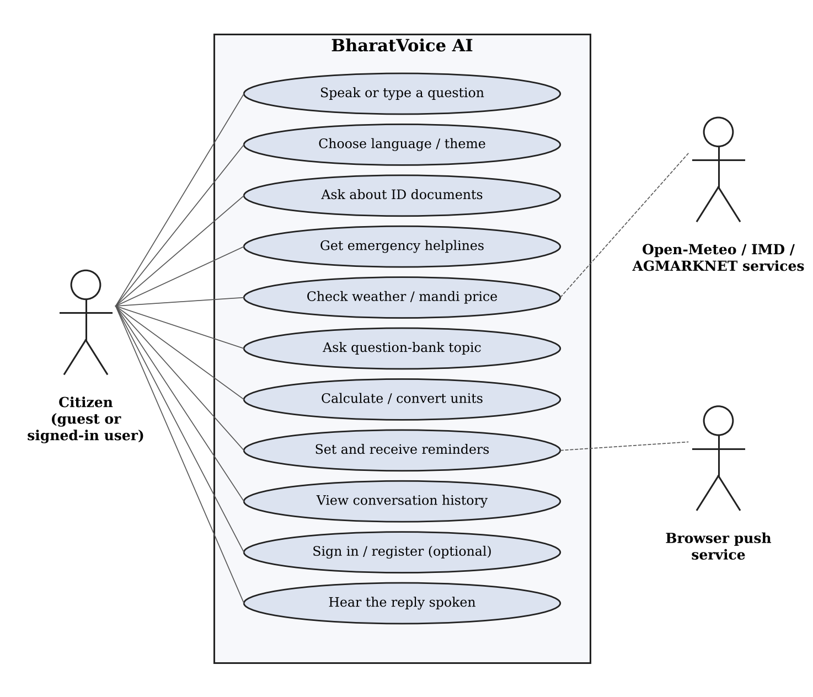
Figure 3.1: Use-case diagram of BharatVoice AI

3.3 SYSTEM ARCHITECTURE
BharatVoice AI follows a layered architecture (Figure 3.2). In the browser, the React client renders the voice-first screen, records and plays speech through the Web Speech API and registers a service worker so that it can receive push notifications. On the server, FastAPI first establishes who is calling. The NLU pipeline then determines the language, intent and entities, and the request is routed to local skills, curated content, live data adapters or the reminder store. Every handler's output passes through the same source-aware response policy before it is returned. Underneath sits a SQLite database accessed through SQLAlchemy and versioned with Alembic.
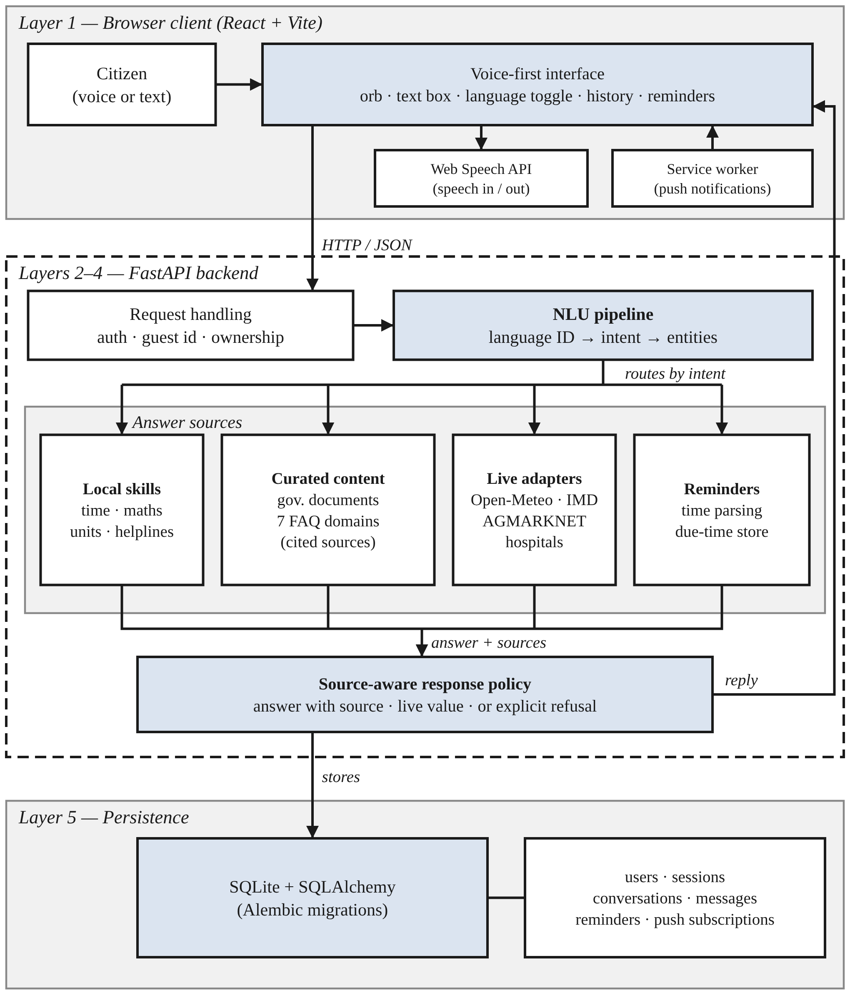
Figure 3.2: Layered system architecture of BharatVoice AI
Two constraints shaped most of the design. The first was hardware: the system had to run on an ordinary laptop with no GPU and without downloading several gigabytes of models, so each heavy component sits behind an interface that also has a light implementation, selected at start-up if the heavy one is not installed (Table 4.1). The second was explainability: the language, intent, entities and sources chosen for each message are saved with it. Table 3.2 lists the modules and their principal components as named in the project source.
Table 3.2: Modules and their principal components
Module | Principal components | Interacts with
Voice-first interface | App.jsx; AssistantOrb, MicButton, InputBar, ChatWindow, LanguageToggle, ThemeToggle; useSpeechRecognition, useSpeechSynthesis hooks | API layer, browser speech
API and routing | FastAPI main.py; routers for chat, speech, language, intent, translate, history, reminders, accounts, push | All services
NLU pipeline | nlupipeline.py; languagedetection.py; intentdetection.py; entityextraction.py; timeparse.py | Handlers, MuRIL models
Local skills | skills.py (time, date, safe calculator, units, helplines, ID documents); about.py | Response policy
Curated content | knowledge.py, answers.py (18 question-bank topics, 5 languages, sources) | Response policy
Live data adapters | weather.py (Open-Meteo, IMD), mandi.py (AGMARKNET), hospital lookup | External services
Response policy | response_generator.py; translation.py | All handlers, client
Speech | speechtotext.py (optional Whisper); texttospeech.py, tts_bhashini.py (optional) | Client, chat route
Reminders and push | Reminder store; background worker (20 s); Web Push with VAPID; service worker | Browser push service
Persistence | database.py, models.py; SQLAlchemy 2; Alembic migrations | All modules

3.4 DATA FLOW / WORKFLOW
Figure 3.3 traces one request through the system, from the spoken or typed utterance through speech-to-text, the language-identification cascade, intent arbitration and entity extraction to the grounding decision (curated, live or unavailable), the reply in the detected language and the stored message.
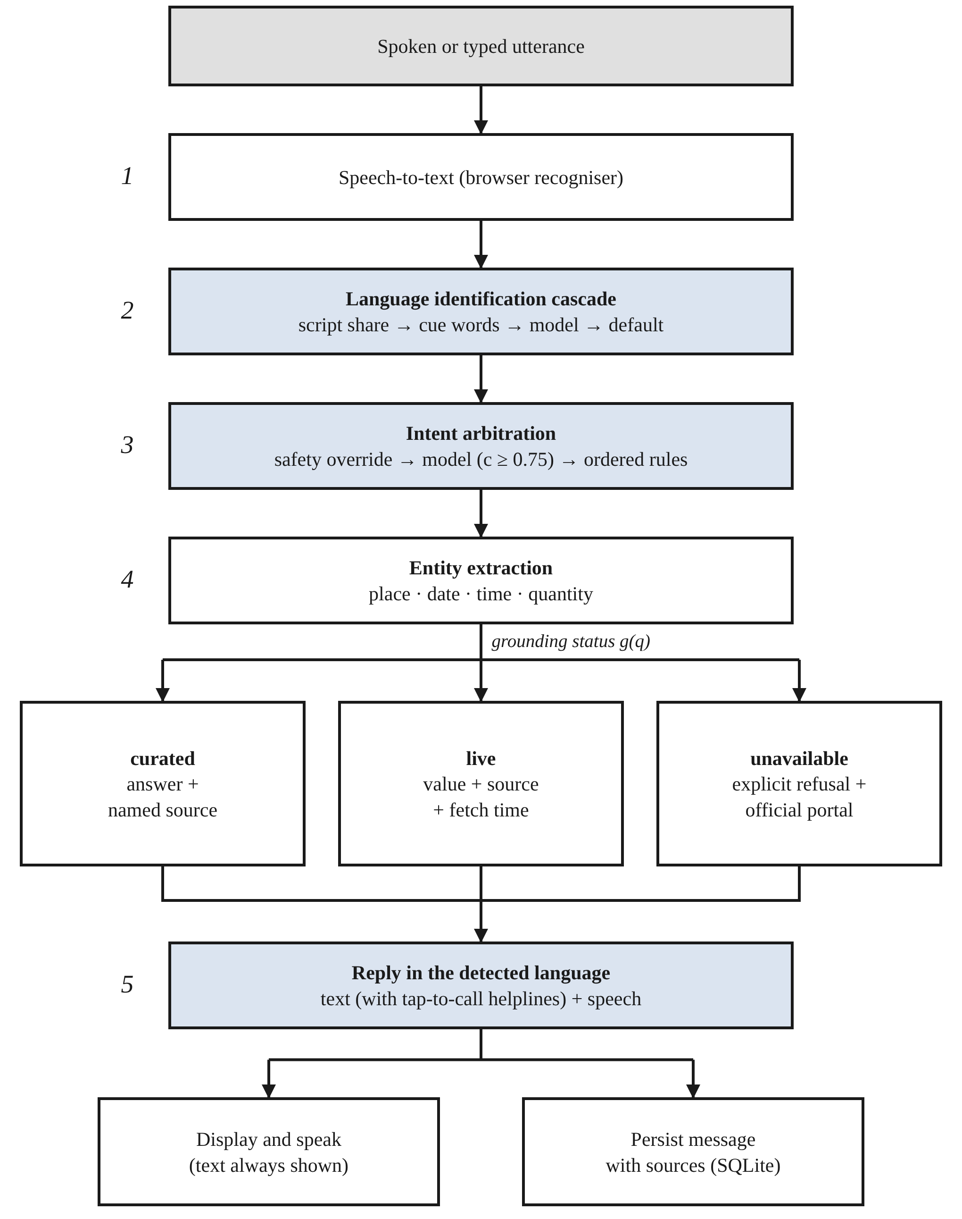
Figure 3.3: Processing of a single request, from utterance to stored reply
The context diagram (Figure 3.4) treats BharatVoice AI as one process exchanging data with the citizen, the live data services, the browser push service and the optional models. The level-1 diagram (Figure 3.5) decomposes it into eight processes and five data stores; the language and intent processes (3.0 and 4.0) read no store, the handler process (5.0) reads curated content and writes reminders, and the delivery process (8.0) reads the reminder and push-subscription stores independently of any user request.
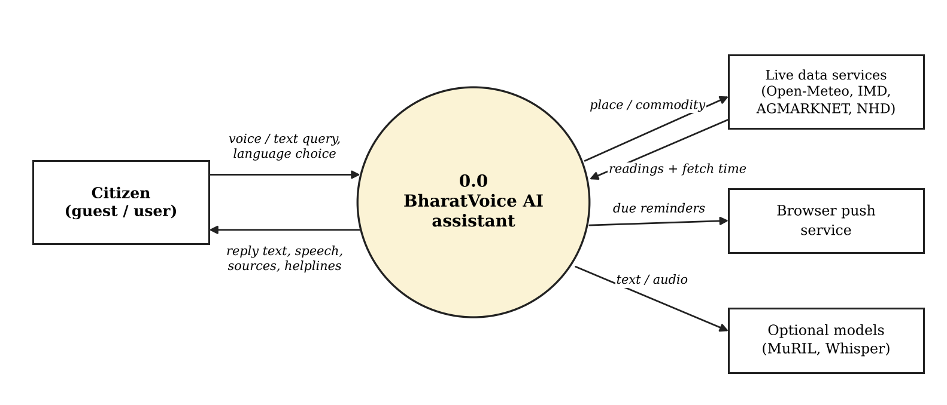
Figure 3.4: Level 0 data-flow diagram (context diagram)
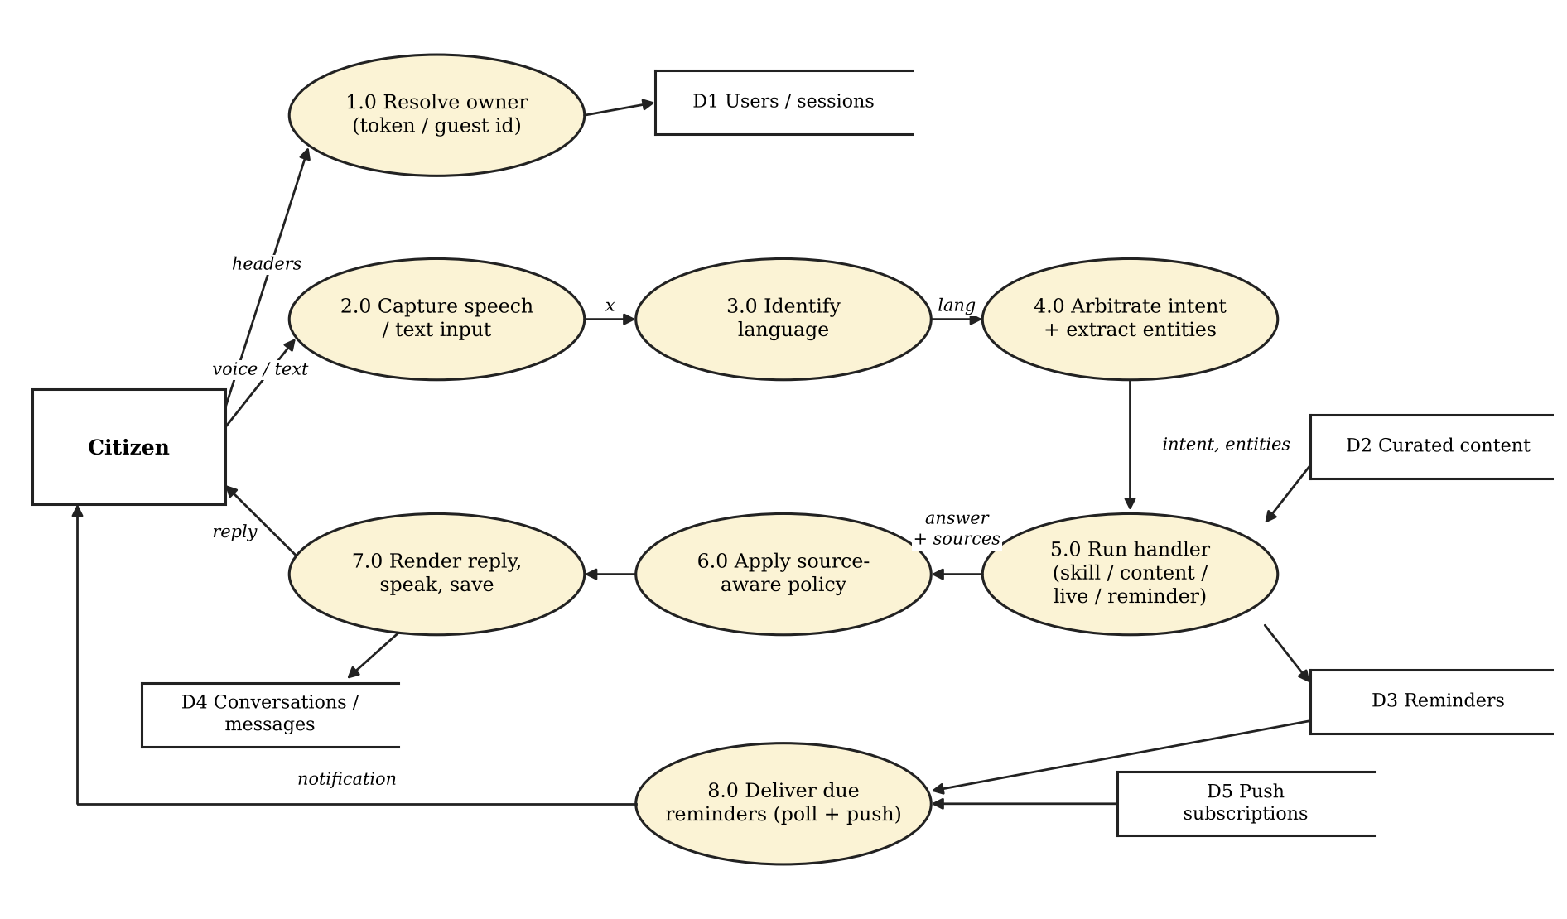
Figure 3.5: Level 1 data-flow diagram
Figure 3.6 shows the main database entities and their relationships. Conversations, reminders and push subscriptions carry an owner label (user:u or guest:g), so every query on an owned table filters on the caller. Each message stores its language, intent, entities, sources and dialable numbers, so an old reply opened from the history drawer can still be explained and its helplines remain tappable. Field-level definitions should be confirmed against models.py and the Alembic migrations.
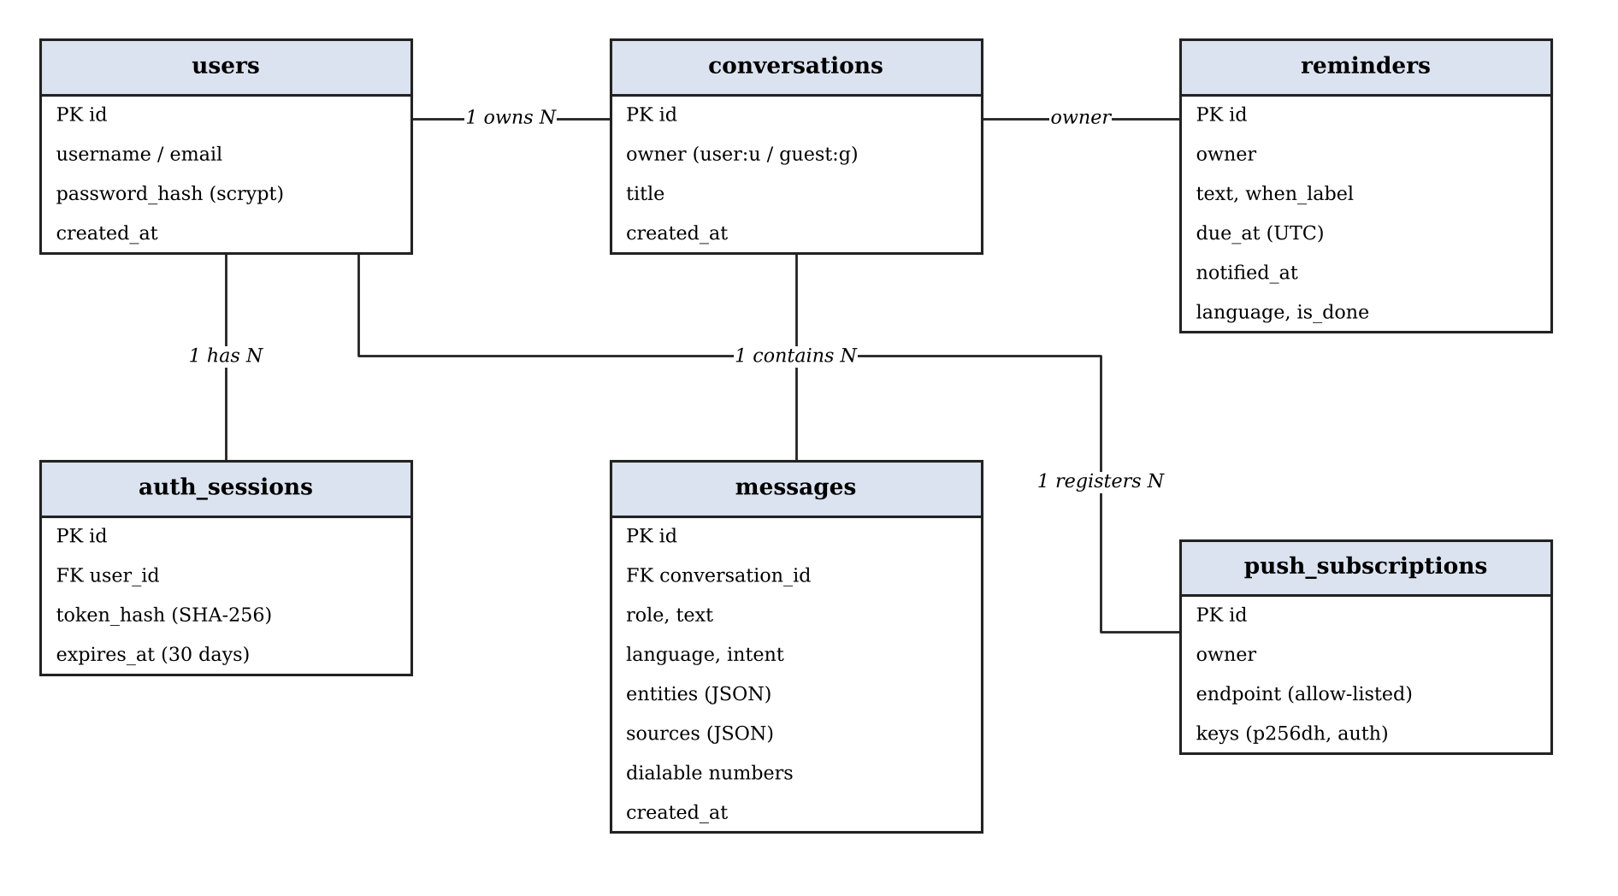
Figure 3.6: Entity-relationship diagram of BharatVoice AI
Table 3.3: Core database entities
Entity | Purpose
users, auth_sessions | Optional accounts with scrypt password hashes; session tokens stored only as SHA-256 hashes, expiring after 30 days
conversations | Owner label and title; groups the messages of one session
messages | Role and text with detected language, intent, entities, sources and dialable helpline numbers
reminders | Owner, original text, human-readable time, due time in UTC, notified time and status
push_subscriptions | Owner and allow-listed push endpoint with its keys, used by the delivery worker

Figure 3.7 gives the flowchart of the language-identification cascade, which is specified mathematically in Section 4.2.3.
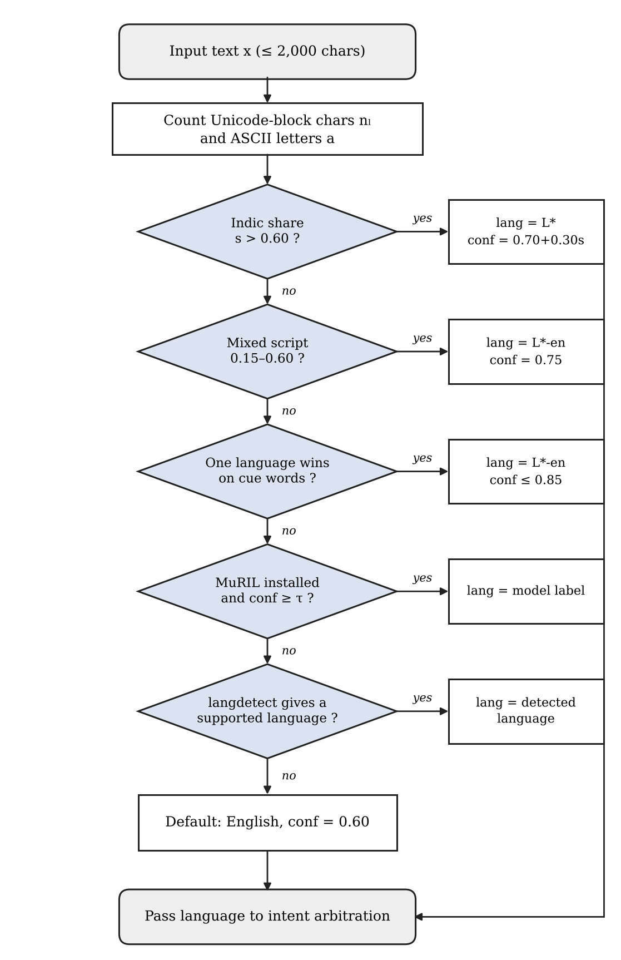
Figure 3.7: Flowchart of the language-identification cascade

3.5 HARDWARE REQUIREMENTS
Table 3.4: Indicative hardware requirements
Component | Requirement
Server / development machine | Ordinary laptop or desktop able to run Python 3.12 and Node.js; no GPU needed
Memory and storage | Enough for the project, the SQLite file and, optionally, the two fine-tuned MuRIL models
Client device | Computer, laptop or phone with a modern browser (Chrome or Edge recommended)
Microphone | Required on the client for voice input
Speakers or headphones | Required on the client for spoken replies
Network | Internet access for browser speech recognition, live data services and Web Push

The conference paper does not specify exact memory or processor figures; these are indicative requirements that have not been benchmarked.

3.6 SOFTWARE REQUIREMENTS
Table 3.5: Software requirements
Layer | Technology
Backend language / framework | Python 3.12; FastAPI 0.115; Pydantic 2; uvicorn
Database | SQLite through SQLAlchemy 2; Alembic migrations run at start-up
Machine learning runtime | PyTorch and Hugging Face Transformers on CPU; two fine-tuned MuRIL classifiers; langdetect
Front end | React 18, Vite 5, axios, framer-motion, lucide-react, plain CSS
Speech | Browser Web Speech API and speechSynthesis; optional Whisper, BHASHINI or Coqui XTTS
Notifications | Service worker; Web Push protocol with VAPID keys [23], [24]
Live data | Open-Meteo [25]; AGMARKNET on the OGD platform [26]; IMD warnings [27]; National Hospital Directory
Testing and quality | pytest and ruff (backend); Vitest, Testing Library and ESLint (frontend); GitHub Actions
Deployment | Single start script or Docker Compose (optional)

Software Modules
- main.py and routers/: FastAPI application and the chat, speech, language, intent, translate, history, reminders, accounts and push endpoints.
- nlu_pipeline.py: runs languagedetection.py, intentdetection.py and entity_extraction.py (with timeparse.py) in order.
- skills.py, about.py: time, date, safe calculator, unit conversion, helplines, identity documents and questions about the assistant.
- knowledge.py, answers.py: curated question bank in five languages with sources. response_generator.py, translation.py: source-aware reply building.
- weather.py, mandi.py: Open-Meteo, IMD and AGMARKNET adapters. speech_to_text.py, text_to_speech.py, tts_bhashini.py: optional server-side speech.
- database.py, models.py: SQLAlchemy models and session, with Alembic migrations. frontend/src: App.jsx, components, speech hooks and services/api.js.

CHAPTER 4 – IMPLEMENTATION

4.1 METHODOLOGY
BharatVoice AI was built with a modular approach: a FastAPI backend with separate routers and services, and a React client with separate components and hooks. Cross-cutting rules (language identification, intent arbitration, the response policy and reminder delivery) are kept in their own modules so that each decision can be inspected and tested. The descriptions in this chapter are based on the BharatVoice AI conference paper and the project source. Rules were chosen to run first because they need no GPU, every decision can be inspected afterwards, and a rule can say "not sure" instead of guessing. The project followed six stages:
- Requirement analysis: identifying the target users, the everyday questions they ask and the languages and writing styles they use.
- System design: designing the layered architecture, the NLU pipeline, the response policy and the database structure.
- Module development: building the voice interface, language and intent identification, entity extraction, skills, curated content, live adapters, reminders and accounts.
- Model training and integration: fine-tuning the MuRIL intent and language classifiers and placing them behind the rules with a confidence floor.
- Testing and validation: automated backend and frontend tests, a development test set for the classifiers and an informal probe of romanized input.
- Documentation and dissemination: project reviews, this report and the conference paper.
Figure 4.1 shows the project review schedule from July to October 2026, from the abstract and base-paper submission through problem analysis, design and implementation, testing and final results to the draft report, journal paper and final submission.
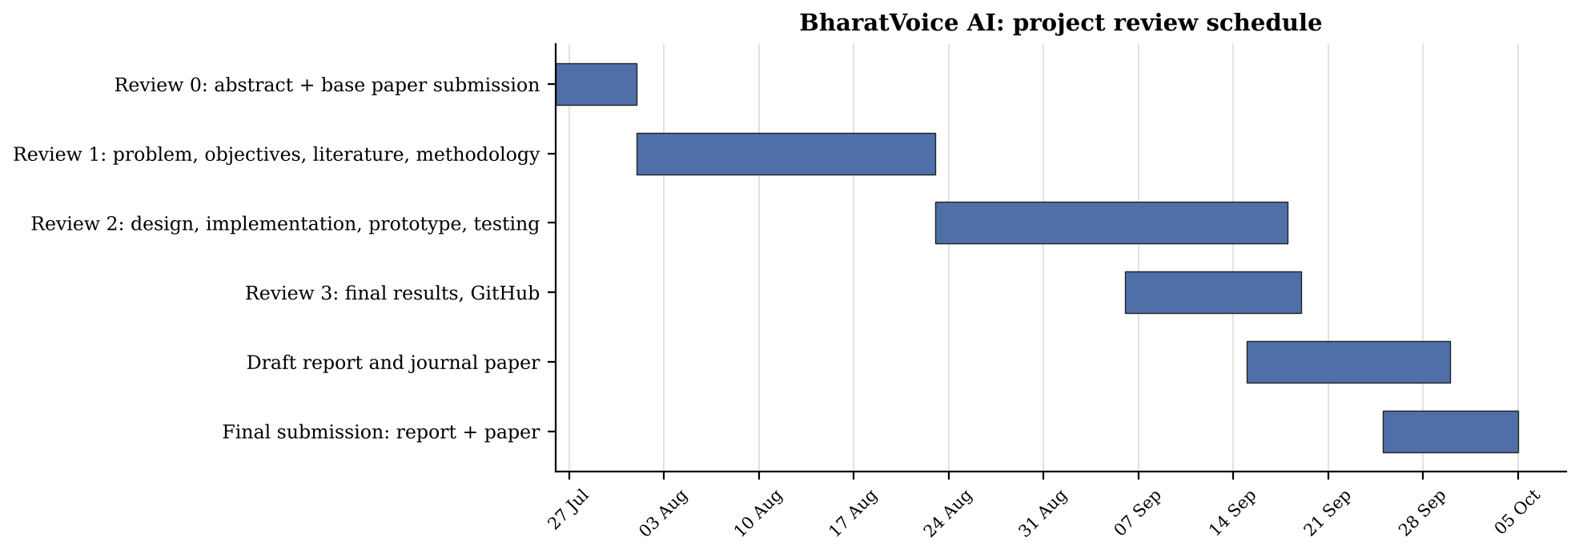
Figure 4.1: Project review schedule (Gantt chart from the project review presentation)
Table 4.1 lists the model-based components and the light substitutes that are selected automatically when a model is not installed.
Table 4.1: Model-based components and their light substitutes
Stage | Model-based component | Light substitute
Speech input | Whisper on the server (optional) | Browser Web Speech API (default)
Language ID | Fine-tuned MuRIL classifier (in use) | Script share and cue words
Intent | Fine-tuned MuRIL classifier (in use) | Ordered keyword and parse rules
Translation | IndicTrans2 (optional) | Curated Tamil–English dictionary
Speech output | BHASHINI or Coqui XTTS (optional) | Browser speech synthesis, tried first

4.2 IMPLEMENTATION

4.2.1 User Identity and Ownership
Input: the request headers. Processing: accounts are optional, so no sign-up form stands between a first-time user and the microphone. A signed-in user sends a bearer token; a guest sends an identifier the browser generated on first use and kept in local storage; a request with neither, such as a command-line test, sees only unowned rows. For an account u and guest identifier g, the owner of request r is
o(r) = user:u if a valid token names u; guest:g if only g is sent; ∅ otherwise (4.1)
Every query on an owned table filters on o(r). An expired token returns HTTP 401 rather than silently falling back to guest access. When a guest signs in or registers, everything owned by guest:g moves to the account, so nothing done before sign-up is lost. Output: an owner label that decides whose conversations, reminders and push subscriptions the caller can see.

4.2.2 Speech Capture and Input Handling
Input arrives as microphone audio or typed text and is turned into a string x of at most 2,000 characters. By default the browser's Web Speech API performs recognition, so audio never reaches the server. Because the browser recogniser listens for one locale at a time, the user picks the spoken language with a header toggle, and automatic detection runs afterwards on the text. If Whisper is installed on the server, recorded audio can be uploaded and transcribed there instead. Permission refusal, a missing microphone and an unavailable recognition service each get their own message (useSpeechRecognition.js and VoiceStatus.jsx).

4.2.3 Language Identification Cascade
This step maps x to a language label ℓ and a confidence. The label is one of the five languages or a mixed label such as ta-en. Four tests are tried from cheapest to most expensive, and each may pass the decision to the next (Table 4.2 and Figure 3.7).
Stage 1, script share. Devanagari, Tamil, Telugu and Kannada each occupy a contiguous Unicode block Bₗ. For each language L in {hi, ta, te, kn} the characters of x in its block are counted, and ASCII letters a are counted separately:
nₗ = |{ t ∈ x : t ∈ Bₗ }|, N = Σₗ nₗ + a (4.2)
Vowel signs and the virama are included, since counting only alphabetic characters undercounts Indic words. Let L* be the language with the highest count and s = nₗ* / N its share. Then
ℓ = L*, conf = 0.70 + 0.30s if s > 0.60 (4.3)
ℓ = L*-en, conf = 0.75 if a > 0 and 0.15 ≤ (Σₗ nₗ) / N ≤ 0.60 (4.4)
Rule (4.3) handles ordinary native-script text, so a sentence written fully in Tamil receives a confidence of 1.0. Rule (4.4) catches sentences that genuinely mix an Indic script with Latin letters and labels them as mixed rather than forcing a choice.
Stage 2, romanized cue words. When text is entirely in Latin letters, Stage 1 cannot help. Stage 2 uses a short list Cₗ of words that speakers of L use often and that rarely occur in English. With W(x) the set of lower-case words in x, each language scores kₗ = |W(x) ∩ Cₗ|. Writing k(1) and k(2) for the highest and second-highest scores,
ℓ = L*-en, conf = min(0.55 + 0.10·k(1), 0.85) if k(1) > k(2) (4.5)
If two languages tie or no cue word appears, the stage passes. Confidence is capped at 0.85 so that the word list cannot outrank a trained model. Stages 3 and 4. When the first two stages pass, the fine-tuned MuRIL language classifier is consulted, and its label is kept only if its confidence clears a floor τ calibrated on held-out data. Stage 4 runs the langdetect library and keeps its answer only when it is one of the five languages. If nothing has fired, the text is treated as English with confidence 0.60.
Table 4.2: Stages of the language-identification cascade
Stage | Evidence used | Answers when | Confidence
1. Script share | Unicode block counts | Indic script present | 0.70–1.00; 0.75 if mixed
2. Cue words | Per-language word lists | One language wins | 0.65–0.85
3. Model | Fine-tuned MuRIL classifier | Model confidence ≥ τ | Model output
4. Statistical | langdetect | Label is a supported language | Identifier output
Default | None | All stages abstain | 0.60 (English)

4.2.4 Intent Arbitration and Entity Extraction
Two principles guide this step. Whether someone receives emergency numbers must never depend on how sure a model feels, and a classifier is often confidently wrong rather than unsure, so a low-confidence guess is discarded instead of acted on. Let S be the set of safety patterns, R the rule classifier and M the trained MuRIL classifier, which returns a label with confidence c. The system works rules-first:
î = emergency (0.95) if x matches S; R(x) if a rule reaches a specific intent; M(x) if c ≥ τ; general query (0.55) otherwise (4.6)
The rule classifier applies its checks in a fixed order, and the order matters. Questions about the assistant itself come first; otherwise "where does your weather information come from?" contains the word weather and receives a temperature. Keyword patterns run before the calculator; otherwise "remind me on 3/4/2026 to renew my passport" is read as a division. The question bank is checked last. Confidence reflects how a label was reached: 0.95 for a safety match, 0.90 when a sum or conversion parses, 0.85 for a keyword pattern and 0.80 for a question-bank hit.
Both MuRIL classifiers were fine-tuned with PyTorch and Hugging Face Transformers (scripts trainmurilintent.py and trainmurillangid.py). The intent model was trained on 6,458 labelled rows covering 19 intents and the language model on 3,712 rows, both spanning all five languages in native script, romanized form and code-mixed text. The Hindi, Telugu and Kannada rows have not yet been reviewed by native speakers. Entity extraction then identifies places, dates, times and quantities; for a reminder, the date and time are resolved into one absolute instant stored in UTC, so the reminder survives a page reload or server restart.

4.2.5 Source-Aware Response Policy
Every handler returns the same kind of object: the reply text, a list of sources and a flag that marks a refusal. A source has a title, a link and, where known, the date the information was last checked. Small talk and values the system computes itself, such as the time, a sum or a conversion, need no source; everything else must carry at least one. Each query q is assigned a grounding class g(q) according to where an answer could come from, and the reply is built as
A(q) = answer + source if g = curated; value + source + fetch time if g = live; refusal + official portal if g = unavailable (4.7)
When a live service cannot be reached, because no API key is set or the call failed, the assistant says so and points to the official website instead of guessing. Questions about eligibility, fees or processing times are deliberately not answered, since those details change often and do the most harm when mistranslated. Table 4.3 lists the behaviour in each situation.
Table 4.3: Response policy by situation
Situation | What the assistant does
Identity-document question | Explains the document and names the issuing portal; no verdict on eligibility, fees or processing time
Question-bank topic | Returns curated text in the user's language with its source link
Weather, service reachable | Returns the reading with its source and fetch time
IMD warning in force | Adds a warning line only for yellow or higher
Mandi price, no API key | States that live prices are off and points to agmarknet.gov.in
Hospital directory result | Lists names and numbers, notes the registry is not a guarantee, repeats 108
Upstream failure or unknown topic | Says it cannot answer reliably and refers to the official portal

4.2.6 Everyday Skills and Curated Content
Local skills answer the time and date, convert units and evaluate arithmetic. The calculator walks a restricted syntax tree with a fixed list of operators instead of evaluating text. The curated content covers six identity documents, nine emergency helplines and 18 question-bank topics; every answer exists in all five languages, and Hindi, Telugu and Kannada strings not yet checked by a native speaker are flagged in the code (Table 4.4).
Table 4.4: Curated content and live data coverage
Content | Coverage
Identity documents (6) | Aadhaar, PAN, voter ID, ration card, passport, driving licence
Emergency helplines (9) | 112, 100, 101, 108, 1091, 1098, 14567, 1930, 104 (tap to call)
Question bank (18 topics) | Education, banking, scam awareness, travel, welfare schemes, jobs, health facilities
Weather | Open-Meteo, no key needed; asks which place if the name is ambiguous
Mandi prices | AGMARKNET dataset on the Open Government Data platform (key required)
Warnings and hospitals | IMD district warnings; National Hospital Directory

4.2.7 Live Data Adapters
Weather comes from Open-Meteo [25], mandi prices from the AGMARKNET dataset on the Open Government Data platform [26], district warnings from the India Meteorological Department [27], and hospital lookups from the National Hospital Directory. All four adapters treat a missing key, timeout, HTTP error, malformed response or empty result as "nothing", which the response policy turns into a refusal or an omitted line; a failed IMD request omits the warning line rather than claiming there are no warnings. The IMD and hospital adapters were written from published documentation and the mandi field names have not been confirmed against a live response, so all three are treated as implemented but unverified.

4.2.8 Reply Rendering and Tap-to-Call Helplines
The backend sends plain text with simple markers for headings, bullets and numbered steps, plus a fixed line format for helpline rows. The client renders these as blocks (ReplyText.jsx, replyFormat.js) and strips the markers before the text is spoken, so a screen-reader user never hears stray symbols. Many numbers in a reply are not phone numbers: "That's 100" may be a sum and ₹1930 a price, yet 100 is the police number and 1930 the cyber-fraud helpline. With each reply the backend therefore sends the set D(q) of helpline numbers it deliberately placed in the text, and a token t becomes a link only if
link(t) ⇔ t ∈ D(q) and t consists of 3 to 5 digits (4.8)
Replies from the calculator, weather and price handlers always carry an empty D. The set is stored with the message, so an old reply opened from the history drawer remains tappable.

4.2.9 Reminder Scheduling and Web Push Delivery
A reminder matters most when the app is closed, so it is delivered in two ways. While the page is open, it polls the server for due reminders every 30 seconds. Separately, a background worker on the server wakes every 20 seconds and sends due reminders through the browser vendor's push service using the Web Push protocol [23], with messages signed by a VAPID key pair [24]. The service worker then shows a system notification, or passes the reminder to the page if the app is open. To ensure a reminder m with due time d(m) fires only once, both paths apply the same test at time t:
deliver(m, t) ⇔ d(m) ≤ t and notified(m) = ∅; then notified(m) ← t (4.9)
Whichever path arrives first marks the reminder as sent. To stop the server from being made to contact arbitrary addresses, it accepts only push endpoints belonging to Google, Mozilla, Microsoft and Apple.

4.2.10 Accounts, Persistence and Schema Migration
Passwords are hashed with scrypt [28] from Python's standard library. The server stores only the SHA-256 hash of each session token, and sessions expire after 30 days. Each saved message keeps its text with the detected language, intent, entities, sources and dialable numbers. An earlier hand-written routine that patched missing columns was replaced with Alembic; the first migration can adopt a database created before migrations existed, and migrations run automatically at start-up. Table 4.5 summarises the security and delivery parameters.
Table 4.5: Security and delivery parameters
Mechanism | Parameter
Password storage | scrypt hash (Python standard library)
Session token | Stored only as a SHA-256 hash; expires after 30 days
Expired token | HTTP 401, no silent fallback to guest access
Input length | At most 2,000 characters
In-page reminder polling | Every 30 seconds
Server push worker | Every 20 seconds; Web Push with VAPID signing
Push endpoints | Only Google, Mozilla, Microsoft and Apple push services accepted
Tap-to-call | Only server-marked numbers of 3 to 5 digits

4.3 MODULE INTEGRATION
The chat route ties the modules together. It resolves the owner, runs language identification, intent arbitration and entity extraction through one orchestration module (nlu_pipeline.py), calls the right handler, applies the response policy, saves the exchange and returns it. All persistent data is stored in a single SQLite database through SQLAlchemy, versioned with Alembic. The client talks to the backend through one API module (services/api.js) and renders the reply, its sources and its tappable helplines; the speech hooks handle recognition and synthesis in the selected language. The reminder module serves both the in-page polling path and the background push worker through the same once-only test. The project runs from one script or under Docker Compose, and a GitHub Actions workflow runs the tests, linters and a production build on every push. SQLite and a single server process are suitable for a prototype; a server database and further hardening would be needed for public deployment.

CHAPTER 5 – RESULTS, CONCLUSION AND FUTURE WORK

5.1 RESULTS AND EVALUATION
Testing combines the automated backend and frontend test suites, an evaluation of the MuRIL classifiers on a held-out development test set, and an informal hands-on probe with romanized and code-mixed questions. A feature is called implemented only if it has been exercised by the automated tests or by running the app, and code that has never talked to its real external service is marked unverified.
Software Verification
Table 5.1 breaks down the 693 backend tests that existed before the MuRIL classifiers were integrated. With the MuRIL work the backend suite has grown to 752 tests, and the frontend has 45; all pass. Passing tests show that the code behaves as designed, not how often it understands a real person; the IMD and hospital tests, for example, use recorded or hand-built responses.
Table 5.1: Automated backend test suite before MuRIL integration
Module | Tests | Result
Self-description of the assistant | 265 | Pass
Curated question bank | 159 | Pass
Core pipeline and skills | 116 | Pass
Voice input and output | 35 | Pass
Helplines and IMD warnings | 33 | Pass
Accounts and ownership | 31 | Pass
Push delivery | 29 | Pass
Hospital lookup | 19 | Pass
Schema migrations | 6 | Pass
Total | 693 | All passing

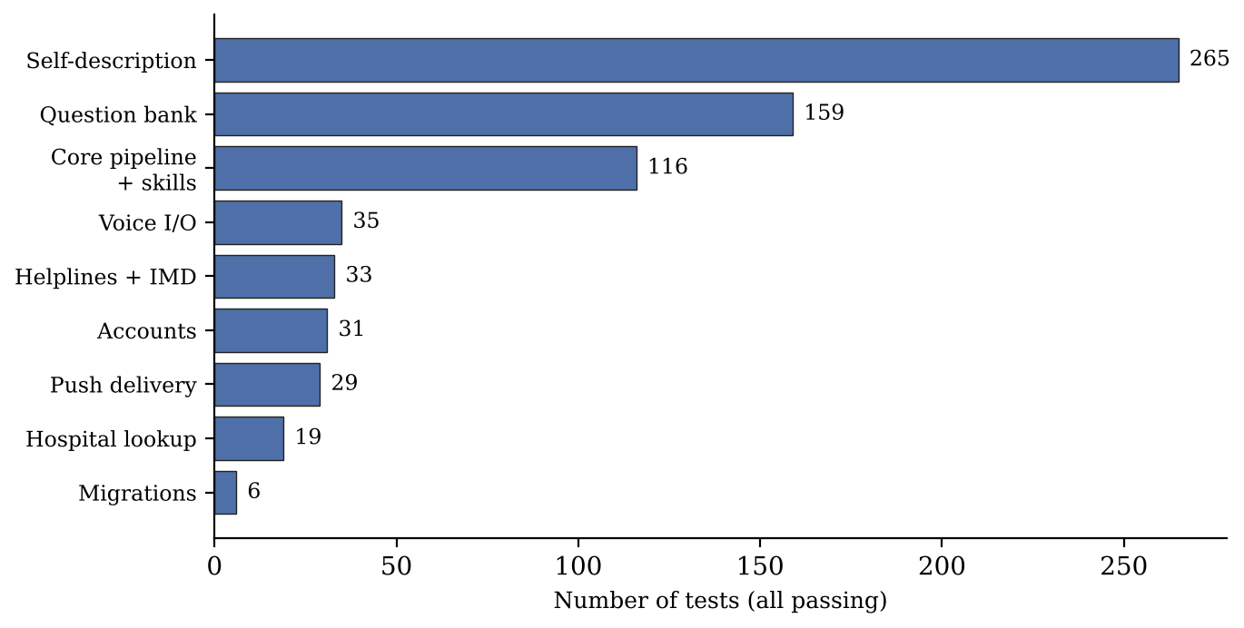
Figure 5.1: Automated backend tests by module (before MuRIL integration)
Table 5.2: Representative behaviours covered by the automated tests
ID | Module | Scenario | Expected result | Status
TC01 | Response policy | Same question asked in each of the five languages | Reply selected in the detected language | Pass
TC02 | Curated content | Every question-bank topic in every language | Translated content present with source | Pass
TC03 | Response policy | Live service unreachable or unknown topic | Explicit refusal with official portal | Pass
TC04 | Accounts | Guest and signed-in user read history | Each sees only their own rows | Pass
TC05 | Migrations | Database created before migrations existed | Upgraded to the current schema | Pass
TC06 | Reminders | Due reminder reached by polling and push | Delivered exactly once | Pass
TC07 | Push | Subscription with an unknown endpoint host | Rejected | Pass
TC08 | Tap-to-call | Sum "100" and price "₹1930" in a reply | Not turned into phone links | Pass

MuRIL Classifiers on a Development Test Set
Both MuRIL classifiers were evaluated on a held-out test set, kept apart from the training rows, and compared with the rule-based stages alone. Accuracy is the share of test sentences labelled correctly:
Accuracy = (N_correct / N_total) × 100% (5.1)
Table 5.3 and Figure 5.2 show the result. Adding MuRIL behind the rules raised intent accuracy from 67% to 89% and language-identification accuracy from 60% to 95%, while out-of-scope questions were still left alone (88 and 87 of 90). MuRIL mostly helps with rephrased and romanized questions that the rules miss. These numbers should be read as indicative only: the test set was written during development by the same process as the training data rather than by independent native speakers, so accuracy on real users' input is likely to be lower.
Table 5.3: Accuracy on the development test set (indicative)
Measure | Rules only | Rules + MuRIL
Intent detection, 190 questions (19 intents) | 127 (67%) | 170 (89%)
Language identification, 92 sentences (native, romanized, mixed) | 55 (60%) | 87 (95%)
Out-of-scope questions left alone, of 90 | 88 | 87

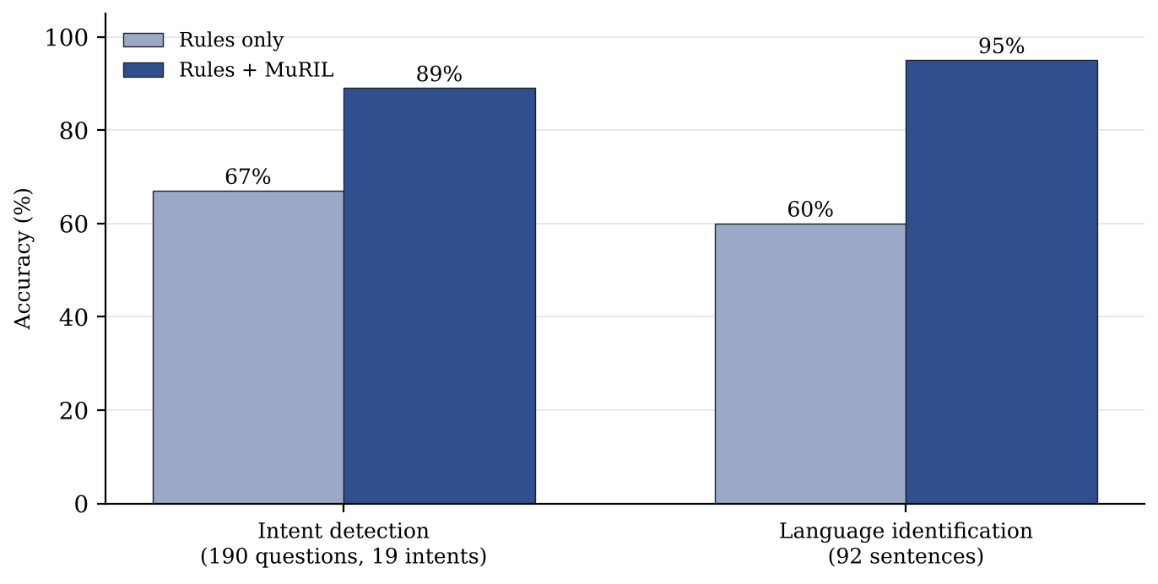
Figure 5.2: Accuracy with rules only and with rules + MuRIL (development test set)
Informal Probe of Romanized and Code-Mixed Input
To see behaviour outside the test suite, nine romanized and code-mixed questions were typed into the running prototype and the language and intent it returned were recorded (Table 5.4). The probe was run before the MuRIL classifiers were added, so it reflects the rule-based stages alone. It illustrates the kinds of mistakes made; it is neither a sample of real users nor an accuracy figure.
Table 5.4: Informal probe with romanized and code-mixed queries (rule-based stages)
Query (meaning) | Language | Intent | Outcome
PAN card kaise banaye (how to get a PAN card) | hi-en | Document help | Correct, reply in Hindi
Chennai la weather epdi irukku? (weather in Chennai) | ta-en | Weather | Correct; refused while service unreachable
kal Delhi mein mausam kaisa rahega (weather tomorrow) | hi-en | General query | Language right, intent missed
naalaikku Madurai la mazhai varuma (rain tomorrow) | en | General query | Both missed
Bengaluru alli hawamana hege ide (weather in Bengaluru) | en | General query | Both missed
mujhe bachao, aag lagi hai (help, there is a fire) | hi-en | General query | Emergency missed
police helpline number | en | Emergency | Correct, helpline list
tomato mandi price | en | Mandi price | Correct; refused, no key
remind me tomorrow at 9 am to pay electricity bill | en | Reminder | Correct, 09:00 next day

The probe exposed three weaknesses. The weather patterns lacked romanized words such as mausam, mazhai and hawamana. Romanized Tamil and Kannada without any cue word fell through to langdetect, which guessed English or an unsupported language. Most seriously, a romanized Hindi cry for help with no English keyword was not caught by the safety patterns. It was also found that "காலை 9" (kaalai, Tamil) and "सुबह 9" (subah, Hindi), both meaning nine in the morning, were scheduled for 9 p.m.
Planned Evaluations
Native speakers who have not seen the cue-word lists or training data will write an independent test set, and the comparison of Table 5.3 will be repeated on it per language and writing style, with a confusion matrix and the abstention rate of each cascade stage. A second set will mix answerable questions with questions the system has no reliable source for; with U the set of unanswerable questions and F the set actually refused,
Refusal recall = |F ∩ U| / |U|, Refusal precision = |F ∩ U| / |F| (5.2)
Speech recognition will be measured with real microphones on at least two common Android phones and one laptop in every language, using the word error rate
WER = (S + D + I) / N (5.3)
where S, D and I count substitutions, deletions and insertions against a reference transcript of N words. No outcome of these planned evaluations is claimed in this report.
Application Screenshots
The following screenshots were captured from the running application and are reproduced from the conference paper and the project review presentation.
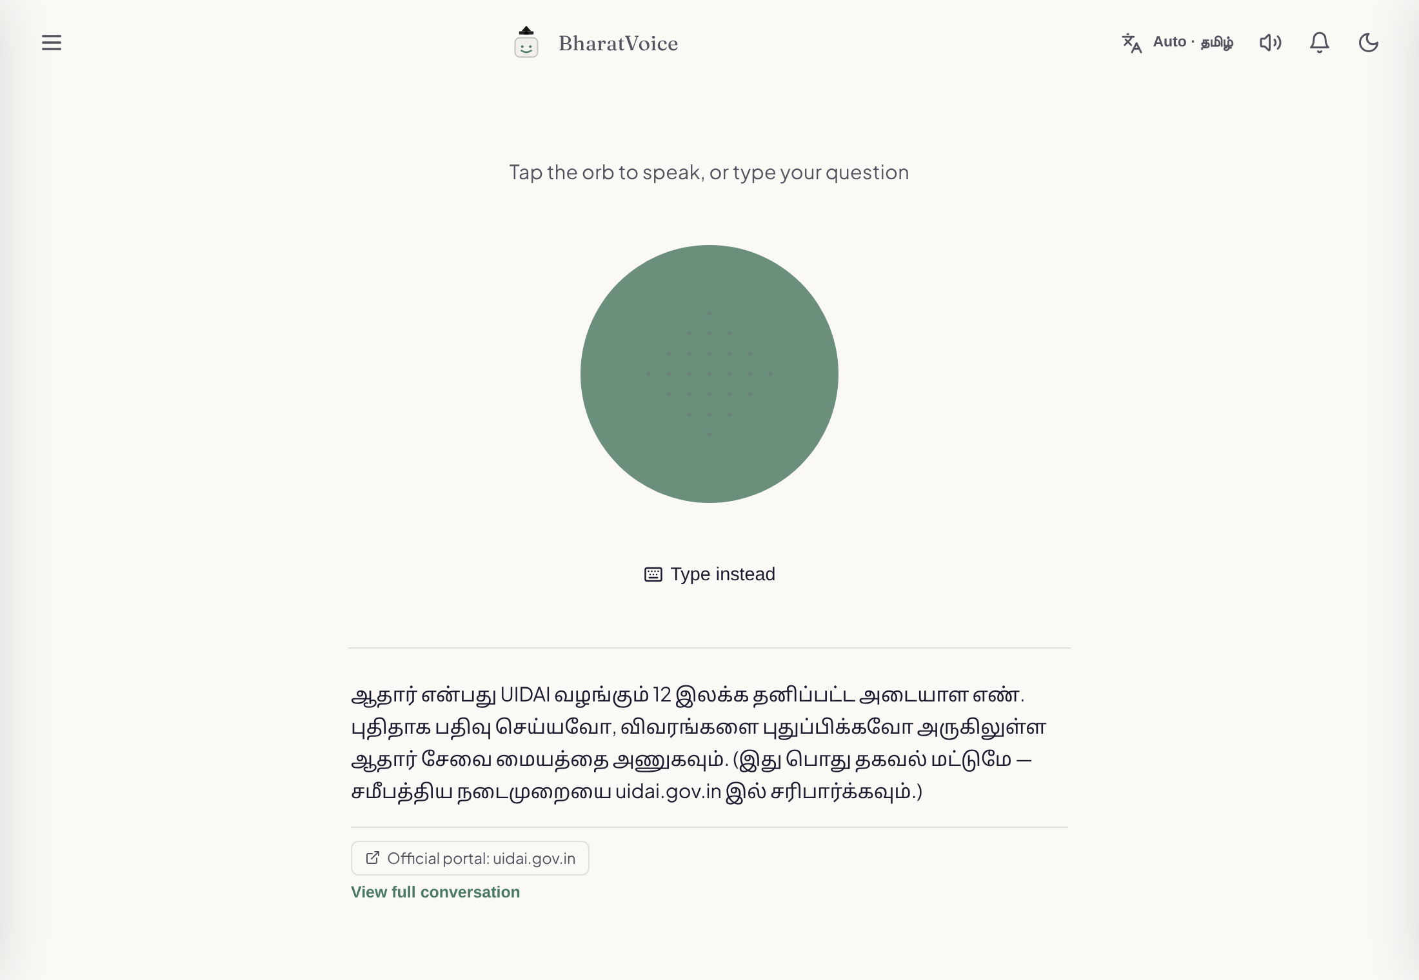
Figure 5.3: Home screen after a question typed in Tamil script, showing the reply in Tamil and the official-portal source link
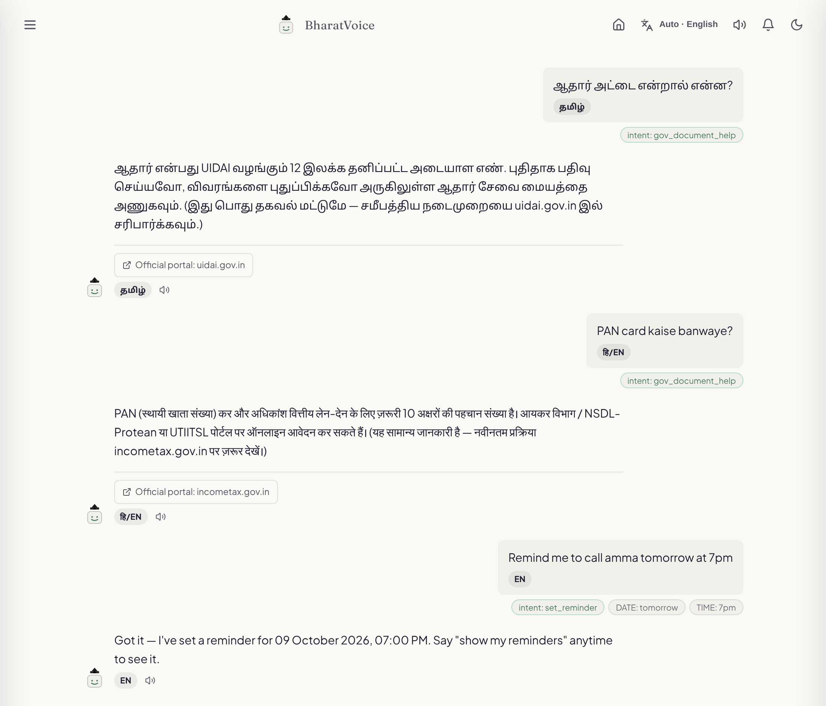
Figure 5.4: Conversation view: a Tamil-script document question, a romanized Hindi–English PAN card question answered in Hindi, and an English reminder request with its extracted date and time
The home screen (Figure 5.3) centres on a large orb that starts listening when tapped, with a smaller "Type instead" button; the header holds the language toggle, a switch for spoken replies, the reminders panel and a light/dark theme switch. The conversation view (Figure 5.4) shows every turn with the detected language, intent and entities, which keeps the pipeline easy to follow for users and reviewers. Figure 5.5 shows a helpline reply in which each number can be tapped to call.
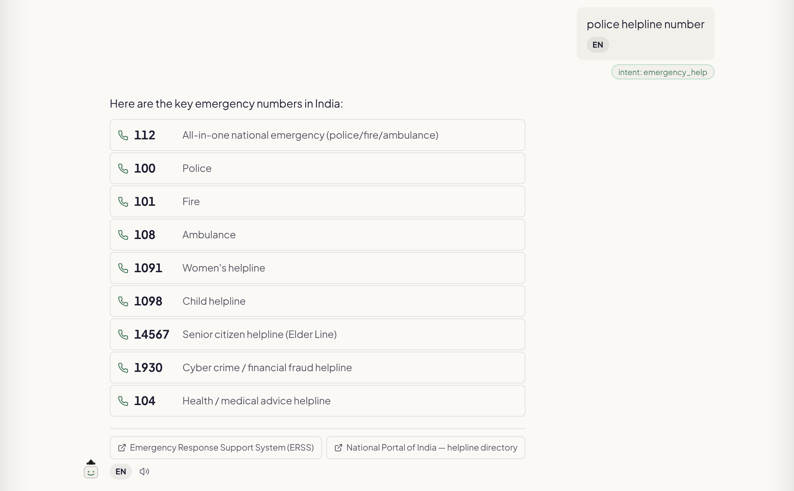
Figure 5.5: Emergency helpline reply with tap-to-call numbers and source links

5.2 DISCUSSION
The central choice was to leave out a generative model and allow the assistant to refuse. For the questions BharatVoice AI targets, this pays off: every factual sentence a user sees was either written and checked in advance or came from a named live source, and the saved record shows which. The cost is coverage, since a question outside the patterns receives a request for detail or a refusal where a generative system would at least try.
The cascade and the intent arbiter behave like Chow's reject option [20], [21]: each stage answers only when its evidence is strong and otherwise hands the decision on. For native script this works well, because Stage 1 is exact and most native-script input never reaches a model. The probe in Section 5.1 shows the weak side of the rules on romanized Tamil and Kannada, and the MuRIL results suggest that a fine-tuned encoder, used only above a confidence floor, closes much of that gap without giving up the inspectable rule path, although this still has to be confirmed on independent data. Refusing is safer than guessing here, but frequent refusals may discourage use, which is why refusal precision is part of the evaluation plan. Browser speech recognition keeps audio off the server and avoids a GPU, but quality varies by browser and device, and only one language can be heard at a time. On privacy, the system stores conversation text, reminders and optional account data; a deployment should obtain consent and restrict access, and audio is not sent to the server by default.

5.3 CHALLENGES AND LIMITATIONS
- Recognition accuracy has not yet been measured on independent data for any language, in text or in speech; the MuRIL figures come from a development test set and are indicative.
- Romanized emergency phrases such as "mujhe bachao, aag lagi hai" and romanized weather words were missed by the rule-based stages, and the probe has not yet been re-run with MuRIL in place.
- Morning times given in Tamil or Hindi words (kaalai, subah) were scheduled for the evening.
- The translation fallback covers only Tamil and English, and about 190 Hindi, Telugu and Kannada strings, as well as the corresponding MuRIL training rows, still need native-speaker review.
- The mandi, IMD and hospital adapters have not been confirmed against live responses, and the helpline numbers have not been re-checked against official sites.
- Accounts have no password reset or sign-in rate limit, so the system should not be exposed on the public internet as it stands.
- The system has not been tested with real users, on a range of devices or with screen readers.

5.4 CONCLUSION
BharatVoice AI turns the idea of a voice-first, multilingual assistant for citizen services into a working application for Tamil, Hindi, Telugu, Kannada and English that runs on ordinary hardware and refuses when it has no source. Language is identified by a cascade that is exact for native script and abstains when unsure, emergency requests are handled before any classifier, fine-tuned MuRIL classifiers extend the rules only above a confidence floor, and each factual answer carries its source. On a development test set, MuRIL raised intent accuracy from 67% to 89% and language-identification accuracy from 60% to 95%. The system also offers optional accounts with per-user history, versioned migrations, reminders that arrive after the page is closed, and tap-to-call helplines guarded by a server-side rule. By making reliable public information reachable by voice in a user's own language, the work contributes to more equal access to digital services, in line with SDG 10 (reduced inequalities) and target 16.10 (public access to information). Its real-world accuracy and impact have not yet been measured and are topics for the planned evaluations.

5.5 FUTURE WORK
The following are proposed enhancements; none is implemented in the current code.
- Add romanized and code-mixed emergency phrases to the safety patterns and test them separately.
- Recognise romanized weather and price words such as mausam, mazhai and hawamana, and morning and evening words (kaalai, subah, maalai, shaam) in reminder times.
- Evaluate the MuRIL classifiers on an independent, native-speaker test set and re-run the romanized probe with them in place.
- Complete native-speaker review of the Hindi, Telugu and Kannada replies and training rows, and re-check every helpline number.
- Move speech recognition to a server-side model through BHASHINI or Whisper, so the spoken language can be detected from the audio.
- Confirm the mandi, IMD and hospital adapters against live responses, add password reset and sign-in limits, and run a task-based study with first-time users, including older people and screen-reader users.

REFERENCES
[1] I. Medhi Thies, "User interface design for low-literate and novice users: Past, present and future," Foundations and Trends in Human–Computer Interaction, vol. 8, no. 1, pp. 1–72, 2015.
[2] J. Zhou, R. Shen, Y. You, C. DiSalvo, L. Dombrowski, and C. MacLellan, "Improving public service chatbot design and civic impact: Investigation of citizens' perceptions of a metro city 311 chatbot," arXiv:2506.12259, 2025.
[3] A. Radford, J. W. Kim, T. Xu, G. Brockman, C. McLeavey, and I. Sutskever, "Robust speech recognition via large-scale weak supervision," in Proc. Int. Conf. Machine Learning (ICML), PMLR, vol. 202, 2023, pp. 28492–28518.
[4] T. Javed, S. Doddapaneni, A. Raman, K. S. Bhogale, G. Ramesh, A. Kunchukuttan, P. Kumar, and M. M. Khapra, "Towards building ASR systems for the next billion users," in Proc. AAAI Conf. Artificial Intelligence, vol. 36, no. 10, 2022, pp. 10813–10821.
[5] K. S. Bhogale, S. Sundaresan, A. Raman, T. Javed, M. M. Khapra, and P. Kumar, "Vistaar: Diverse benchmarks and training sets for Indian language ASR," in Proc. INTERSPEECH, 2023, pp. 4384–4388.
[6] T. Javed, J. A. Nawale, E. I. George, et al., "IndicVoices: Towards building an inclusive multilingual speech dataset for Indian languages," in Findings of the Association for Computational Linguistics: ACL 2024, 2024.
[7] S. Khanuja, D. Bansal, S. Mehtani, S. Khosla, A. Dey, B. Gopalan, et al., "MuRIL: Multilingual representations for Indian languages," arXiv:2103.10730, 2021.
[8] D. Kakwani, A. Kunchukuttan, S. Golla, G. N. C., A. Bhattacharyya, M. M. Khapra, and P. Kumar, "IndicNLPSuite: Monolingual corpora, evaluation benchmarks and pre-trained multilingual language models for Indian languages," in Findings of the Association for Computational Linguistics: EMNLP 2020, 2020, pp. 4948–4961.
[9] S. Doddapaneni, R. Aralikatte, G. Ramesh, S. Goyal, M. M. Khapra, A. Kunchukuttan, and P. Kumar, "Towards leaving no Indic language behind: Building monolingual corpora, benchmark and models for Indic languages," in Proc. 61st Annu. Meeting of the Association for Computational Linguistics (ACL), 2023.
[10] J. Gala, P. A. Chitale, R. AK, V. Gumma, S. Doddapaneni, et al., "IndicTrans2: Towards high-quality and accessible machine translation models for all 22 scheduled Indian languages," Transactions on Machine Learning Research, 2023.
[11] Ministry of Electronics and Information Technology, Government of India, "Digital India BHASHINI: National Language Translation Mission," 2022. [Online]. Available: https://bhashini.gov.in
[12] Y. Madhani, M. M. Khapra, and A. Kunchukuttan, "Bhasha-Abhijnaanam: Native-script and romanized language identification for 22 Indic languages," in Proc. 61st Annu. Meeting of the Association for Computational Linguistics (Short Papers), 2023.
[13] S. Khanuja, S. Dandapat, A. Srinivasan, S. Sitaram, and M. Choudhury, "GLUECoS: An evaluation benchmark for code-switched NLP," in Proc. 58th Annu. Meeting of the Association for Computational Linguistics (ACL), 2020, pp. 3575–3585.
[14] B. R. Chakravarthi, V. Muralidaran, R. Priyadharshini, and J. P. McCrae, "Corpus creation for sentiment analysis in code-mixed Tamil-English text," in Proc. Joint Workshop SLTU and CCURL, LREC, 2020.
[15] Z. Ji, N. Lee, R. Frieske, T. Yu, D. Su, Y. Xu, E. Ishii, Y. J. Bang, A. Madotto, and P. Fung, "Survey of hallucination in natural language generation," ACM Computing Surveys, vol. 55, no. 12, art. 248, 2023.
[16] P. Lewis, E. Perez, A. Piktus, F. Petroni, V. Karpukhin, N. Goyal, et al., "Retrieval-augmented generation for knowledge-intensive NLP tasks," in Advances in Neural Information Processing Systems, vol. 33, 2020, pp. 9459–9474.
[17] H. Rashkin, V. Nikolaev, M. Lamm, L. Aroyo, M. Collins, D. Das, S. Petrov, G. S. Tomar, I. Turc, and D. Reitter, "Measuring attribution in natural language generation models," Computational Linguistics, vol. 49, no. 4, pp. 777–840, 2023.
[18] J. FitzGerald, C. Hench, C. Peris, et al., "MASSIVE: A 1M-example multilingual natural language understanding dataset with 51 typologically-diverse languages," in Proc. 61st Annu. Meeting of the Association for Computational Linguistics (ACL), 2023.
[19] Y. Madhani, S. Parthan, P. Bedekar, G. N. C., et al., "Aksharantar: Open Indic-language transliteration datasets and models for the next billion users," in Findings of the Association for Computational Linguistics: EMNLP 2023, 2023.
[20] C. K. Chow, "On optimum recognition error and reject tradeoff," IEEE Transactions on Information Theory, vol. 16, no. 1, pp. 41–46, Jan. 1970.
[21] Y. Geifman and R. El-Yaniv, "Selective classification for deep neural networks," in Advances in Neural Information Processing Systems, vol. 30, 2017.
[22] P. S. Varadhan, A. Sankar, G. Raju, and M. M. Khapra, "Rasa: Building expressive speech synthesis systems for Indian languages in low-resource settings," in Proc. INTERSPEECH, 2024.
[23] M. Thomson, E. Damaggio, and B. Raymor, "Generic event delivery using HTTP push," IETF RFC 8030, Dec. 2016.
[24] M. Thomson and P. Beverloo, "Voluntary application server identification (VAPID) for web push," IETF RFC 8292, Nov. 2017.
[25] Open-Meteo, "Weather forecast API documentation." [Online]. Available: https://open-meteo.com/en/docs
[26] Government of India, "Open Government Data (OGD) Platform India." [Online]. Available: https://data.gov.in
[27] India Meteorological Department, "Mausam: District-wise weather warnings." [Online]. Available: https://mausam.imd.gov.in
[28] C. Percival and S. Josefsson, "The scrypt password-based key derivation function," IETF RFC 7914, Aug. 2016.

