

VELS INSTITUTE OF SCIENCE, TECHNOLOGY & ADVANCED STUDIES
(VISTAS), PALLAVARAM, CHENNAI – 600 117
SCHOOL OF ENGINEERING
DEPARTMENT OF COMPUTER SCIENCE AND ENGINEERING
(ARTIFICIAL INTELLIGENCE)
MINI PROJECT REPORT
SKIN CANCER DETECTION USING MACHINE LEARNING
A CNN-BASED PRELIMINARY SCREENING SYSTEM
Submitted in partial fulfilment of the requirements for the award of the degree of
BACHELOR OF TECHNOLOGY
IN COMPUTER SCIENCE AND ENGINEERING (ARTIFICIAL INTELLIGENCE

Project Guide Submitted by
Ms. SANGEETHA G ELAKKIYAN R
KABIL A
SRIDHAR S P

OCTOBER 2026

BONAFIDE CERTIFICATE
Certified that this mini project report entitled “SKIN CANCER DETECTION USING MACHINE LEARNING: A CNN-BASED PRELIMINARY SCREENING SYSTEM” is the bonafide work carried out by ELAKKIYAN.R(24623108),KABIL.A(24623151),SRIDHAR.S.P(246231) under the guidance of DR.G.SANGEETHA, Department of Computer Science and Engineering (Artificial Intelligence), Vels Institute of Science, Technology & Advanced Studies (VISTAS), Chennai.
The work presented in this report is submitted in partial fulfilment of the requirements for the award of the degree of Bachelor of Technology in Computer Science and Engineering (Artificial Intelligence).
SIGNATURE OF THE HOD | SIGNATURE OF THE PROJECT GUIDE
Name: DR.K.Ulaga Priya M.E.,Ph.D  Department of CSE (AI) | DR.G.SANGEETHA  Project Guide
Submitted for the Project Work and Viva-Voce examination held on: __________________
INTERNAL EXAMINER | EXTERNAL EXAMINER

ACKNOWLEDGEMENT
We express our sincere gratitude to Vels Institute of Science, Technology & Advanced Studies (VISTAS), Chennai, for providing the opportunity and facilities required to carry out this mini project.
We thank the Head of the Department and the faculty members of the Department of Computer Science and Engineering (Artificial Intelligence) for their encouragement and academic support.
We express our special thanks to our project guide, Ms. Sangeetha G, for her valuable guidance, suggestions and support throughout the preparation of this project. Her guidance helped us understand the project workflow, machine-learning approach and the importance of presenting predictions responsibly.
We also thank our parents and friends for their encouragement and support during the completion of this work.
ELAKKIYAN R(24623108)
KABIL A(24623151)
SRIDHAR S P(246231)

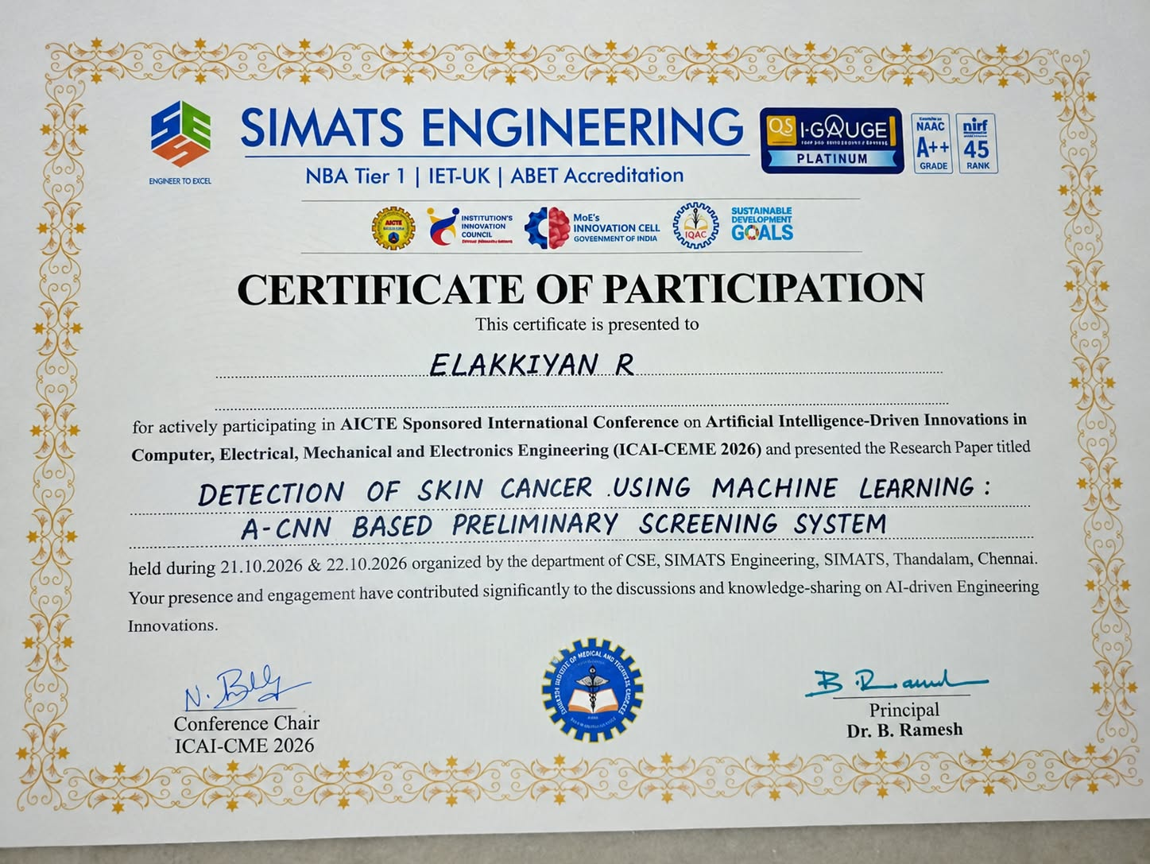

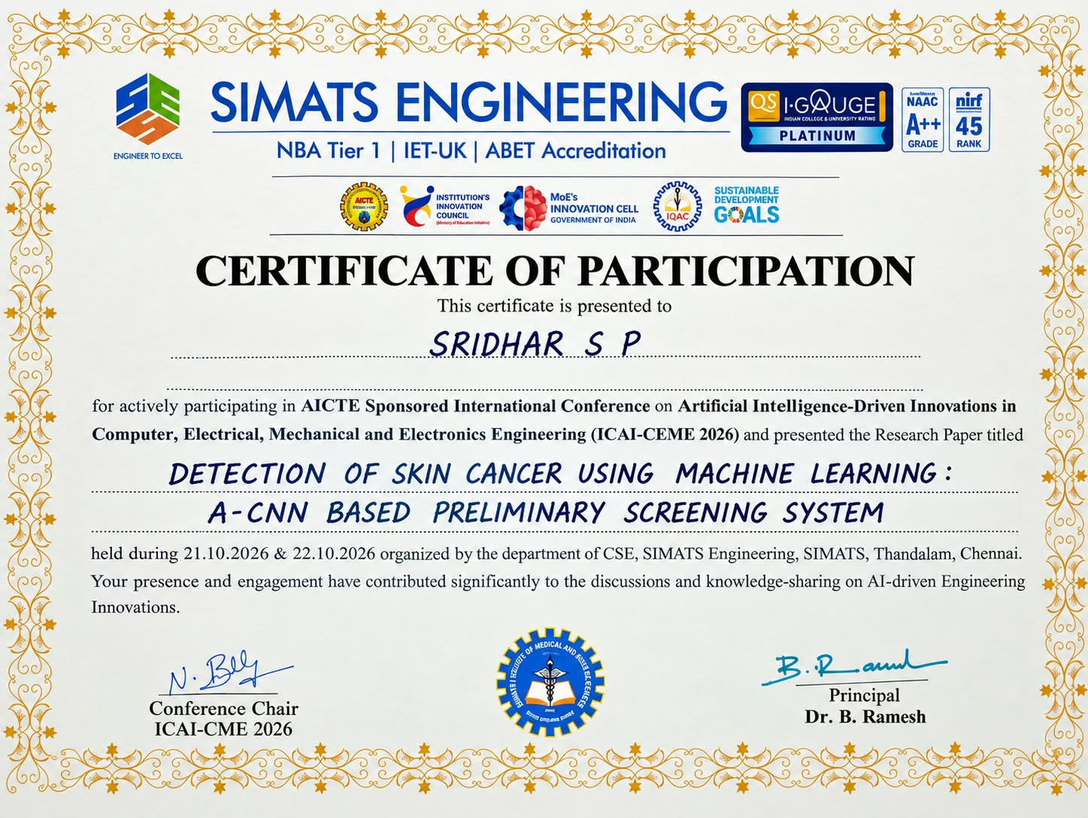


TABLE OF CONTENTS
SECTION | PAGE (APPROX.)
ABSTRACT | i
LIST OF FIGURES | ii
ABBREVIATIONS | iii
CHAPTER 1 – INTRODUCTION | 1
1.1 Overview of the Project | 1
1.2 Problem Statement | 2
1.3 Objectives | 2
1.4 Scope of the Project | 3
CHAPTER 2 – LITERATURE REVIEW | 4
2.1 Literature Overview | 4
2.2 Related Work and Research Gap | 4
CHAPTER 3 – SYSTEM DESIGN | 6
3.1 Existing System | 6
3.2 Proposed System | 7
3.3 System Architecture | 8
3.4 Hardware Requirements | 9
3.5 Software Requirements | 9
CHAPTER 4 – IMPLEMENTATION | 10
4.1 Methodology | 10
4.2 Image Preprocessing | 11
4.3 CNN Classification | 11
4.4 Grad-CAM Explainability | 12
4.5 Flask Web Application | 12
4.6 Testing and Results | 13
CHAPTER 5 – CONCLUSION AND FUTURE WORK | 15
5.1 Conclusion | 15
5.2 Limitations | 15
5.3 Future Work | 16
REFERENCES | 17

ABSTRACT
Early identification of suspicious skin lesions can support timely medical assessment, but access to dermatology services and specialist evaluation may not always be immediate. This project, “Skin Cancer Detection Using Machine Learning,” presents a prototype that analyses a user-provided skin-lesion image and produces a preliminary benign/malignant classification. The workflow includes image upload, image preprocessing, deep-learning inference and result display through a Flask-based web interface. A Convolutional Neural Network (CNN) learns visual patterns from labelled lesion images. The application is designed to provide a simple interface and, where supported by the trained model, a Grad-CAM heatmap to highlight image regions that influenced the prediction. A key motivation is to encourage evaluation across diverse skin tones, because dataset imbalance and differences in image appearance can affect model performance. The output is intended only for preliminary screening support and must not be treated as a medical diagnosis. Model performance should be assessed using a held-out test set and metrics such as accuracy, precision, recall, F1-score and a confusion matrix. Further work is required for broader dataset validation, improved explainability and independent clinical evaluation.
Keywords— Skin Cancer Detection, Machine Learning, Convolutional Neural Network, Skin Lesion Classification, Image Preprocessing, Grad-CAM, Flask, Explainable AI.
(i)

LIST OF FIGURES
FIGURE NO. | TITLE
Figure 1 | Proposed system architecture
Figure 2 | Image preprocessing and prediction workflow
Figure 3 | CNN classification and result generation
Figure 4 | Grad-CAM heatmap explanation
Figure 5 | Skin lesion prediction web interface

ABBREVIATIONS
ABBREVIATION | FULL FORM
AI | Artificial Intelligence
ML | Machine Learning
CNN | Convolutional Neural Network
RGB | Red, Green, Blue
GUI | Graphical User Interface
API | Application Programming Interface
Grad-CAM | Gradient-weighted Class Activation Mapping
TP | True Positive
FP | False Positive
FN | False Negative
TN | True Negative
HTML | HyperText Markup Language
CSS | Cascading Style Sheets

CHAPTER 1 – INTRODUCTION

1.1 Overview of the Project
Skin cancer is a condition in which abnormal skin cells grow uncontrollably. Early professional assessment of a suspicious lesion is important. Image-based machine learning can help analyse visible patterns in lesion images and provide a preliminary result that may encourage a person to seek appropriate medical advice.
This project demonstrates a basic computer-vision workflow for skin-lesion image classification. A user selects an image through a web page. The image is prepared in the same format expected by the trained model, passed to the model, and the predicted class is displayed. A Grad-CAM visualisation is included as an explainability feature when the model architecture and implementation support it.
The project is an educational prototype. It is not a replacement for a dermatologist, biopsy, or other clinical assessment. A model prediction can be wrong, and its reliability depends on the training data, image quality and validation process.

1.2 Problem Statement
Manual assessment of skin lesions requires trained medical professionals. Image-based machine-learning tools may help with preliminary screening, but their performance can be affected by limited datasets, class imbalance, lighting, image quality and under-representation of darker skin tones. A simple, accessible prototype is therefore needed to demonstrate lesion-image classification while clearly communicating its limitations.

1.3 Objectives
To build a machine-learning prototype that accepts skin-lesion images and returns a preliminary class prediction.
To preprocess input images consistently before model inference.
To integrate the trained model into a simple Flask web application.
To display the result in a clear and user-friendly format.
To use Grad-CAM, where supported, to provide a visual explanation of regions influencing the model output.
To identify the need for balanced skin-tone representation and careful testing before any real-world use.

1.4 Scope of the Project
The current scope covers image upload, preprocessing, inference using a trained CNN-based classifier, result display and a visual explanation feature. It focuses on a small prototype that can be run locally for demonstration. It does not perform clinical diagnosis, does not replace medical consultation and should not be used to decide treatment.

1.5 Expected Outcome
The expected outcome is a working prototype that accepts a lesion image and displays a preliminary prediction through a web interface. Testing should document successful uploads, invalid file handling, prediction display and heatmap generation. Quantitative performance values must be taken from actual evaluation output rather than assumed.

CHAPTER 2 – LITERATURE REVIEW

2.1 Literature Overview
Deep learning has become an important method for image classification because convolutional layers can learn visual features such as edges, textures, shapes and colour patterns. In dermatology-related research, models are trained on labelled skin-lesion images and evaluated on data not used during training. The reliability of such systems depends not only on the model architecture but also on data quality, label quality and the similarity between training images and real-world inputs.

2.2 Related Work
AREA | COMMON APPROACH | RELEVANCE TO THIS PROJECT | LIMITATION TO CONSIDER
Traditional image analysis | Colour, border and texture features with a conventional classifier | Shows that visible lesion features can be represented computationally | Hand-designed features may not capture complex patterns
CNN-based classification | Convolutional layers learn image features from labelled examples | Forms the main classification approach in this prototype | Requires representative data and careful testing
Transfer learning | A pretrained image model is adapted to a target dataset | Can reduce training requirements when data is limited | Performance still depends on domain match and fine-tuning
Explainable AI | Grad-CAM-style heatmaps visualise influential image regions | Can help users inspect what the model focuses on | A heatmap is not proof that a prediction is medically correct
Dataset diversity | Testing across different skin tones and image sources | Motivates the project's fairness and generalisation focus | Requires suitable, ethically sourced and well-labelled data

2.3 Research Gap
A major concern in skin-lesion classification is whether the training and evaluation data represent different skin tones, lesion types, camera conditions and clinical settings. A model can perform well on one dataset yet perform less reliably on images that differ from its training distribution. Another concern is that a class prediction alone does not explain which image regions influenced the output. This project addresses these concerns at prototype level by highlighting diverse-data evaluation as a priority and incorporating a Grad-CAM visualisation where supported.

2.4 Summary
The literature motivates combining image preprocessing, CNN classification and a user-facing interface. It also shows why transparent limitations, representative data and independent evaluation are essential before a screening tool can be considered for practical clinical use.

CHAPTER 3 – SYSTEM DESIGN

3.1 Existing System
In a conventional workflow, a suspicious lesion is inspected by the person and assessed by a healthcare professional. Online image resources can provide general information, but they do not offer a personalised medical diagnosis. Some automated image classifiers are available, yet their accuracy and suitability can vary across datasets and user populations.

3.1.1 Limitations of Existing Approaches
Professional assessment may not be immediately accessible in every setting.
Manual visual inspection requires specialist knowledge.
Automated classifiers may be affected by class imbalance and poor image quality.
Models trained on narrow datasets may not generalise to all skin tones or clinical populations.
A prediction without explanation may be difficult for a user to interpret.

3.2 Proposed System
The proposed system is a web-based preliminary screening prototype. It accepts a skin-lesion image, validates the upload, converts and resizes the image to the model's required input format, performs model inference, and displays the predicted class. The interface can also display a Grad-CAM heatmap to help visualise image regions associated with the prediction.

3.2.1 Main Features
Image upload through a simple Flask web interface.
Input validation and preprocessing before prediction.
CNN-based classification into the model's configured classes, described in this report as benign and malignant.
Prediction result shown on the web page.
Grad-CAM heatmap display where supported by the selected model.
Clear notice that results are preliminary and require professional medical assessment.

3.3 System Architecture
The architecture follows a sequential pipeline. Each module has a specific responsibility, making it easier to test and maintain the prototype.
STAGE | PROCESS | OUTPUT
1. Image Input | User uploads a skin-lesion image through the web page | Selected image file
2. Validation | Check file type and whether the upload is valid | Accepted image or error message
3. Preprocessing | Decode image, convert to RGB, resize and normalise as required | Model-ready image array
4. CNN Inference | Load trained model and compute class scores | Predicted class and score, if available
5. Grad-CAM | Calculate activation map for a supported convolutional layer | Heatmap overlay
6. Flask Result Page | Render prediction and explanation in the interface | Result shown to user
Figure 1. Proposed System Architecture
Image Upload → Validation & Preprocessing → CNN Model → Prediction
↓
Grad-CAM Heatmap
↓
Flask Result Interface

3.4 Hardware Requirements
COMPONENT | BASIC REQUIREMENT
Processor | Intel Core i3 / equivalent or higher
RAM | 8 GB recommended
Storage | Space for source code, model file and dataset
Input device | Laptop webcam is optional; image upload is supported
GPU | Optional; may improve training or inference speed

3.5 Software Requirements
SOFTWARE / LIBRARY | PURPOSE
Python | Main programming language
TensorFlow / Keras | CNN model loading, training and inference, depending on the model
Flask | Web application and result page
Pillow / OpenCV | Image reading and processing, depending on implementation
NumPy | Image-array and numerical operations
HTML and CSS | Web page structure and presentation
Matplotlib | Optional visualisation support for model analysis and heatmaps

3.6 Functional Requirements
The system should allow a user to choose and upload a supported image.
The system should reject unsupported or invalid uploads with a readable message.
The system should preprocess the image using the same input conventions as the trained model.
The system should display the model's output without presenting it as a confirmed diagnosis.
The system should display a heatmap only when heatmap generation succeeds.

CHAPTER 4 – IMPLEMENTATION

4.1 Methodology
The project follows a modular workflow: dataset preparation, image preprocessing, model training or loading, evaluation, web integration and functional testing. The exact dataset split, model version and measured metrics should be recorded from the experiment used for the final demonstration.
Dataset preparation: arrange labelled lesion images into the classes supported by the model and keep training, validation and test data separate.
Preprocessing: convert images to RGB, resize to the model's expected dimensions and apply the correct normalisation or model-specific preprocessing function.
Model development: train a CNN or load the selected trained model. Use validation data to monitor learning and avoid choosing a model based only on training performance.
Evaluation: use a held-out test set and record accuracy, precision, recall, F1-score and the confusion matrix.
Application integration: load the model in the Flask application and connect the upload form to the prediction function.
Explainability: generate a Grad-CAM heatmap using a suitable convolutional layer, then display it with the input image if successful.
Testing: test valid images, unsupported files, empty submissions, prediction display and heatmap generation.

4.2 Image Preprocessing Module
Image preprocessing makes the input compatible with the model. The application checks the uploaded file, opens the image, converts it to RGB and resizes it to the input size expected by the model. The pixel values are then normalised or transformed using the model-specific preprocessing function. Preprocessing used during inference must match the preprocessing used during model training.

4.3 CNN Classification Module
A Convolutional Neural Network learns spatial patterns from images through convolution and pooling operations. The extracted features are passed to dense layers that produce the model's class scores. The predicted class is commonly selected from the highest output score. The model's output is only a machine-learning estimate and should be interpreted with caution.
For this prototype, the output labels are presented as benign and malignant only if those are the labels used by the trained model. If the model was trained using different labels or a different class order, the mapping must be checked in the code before presenting results.

4.4 Grad-CAM Explainability Module
Grad-CAM (Gradient-weighted Class Activation Mapping) uses gradients associated with a target class to create a coarse localisation map over a convolutional feature layer. The map is resized and overlaid on the original image. This can help inspect which areas influenced a prediction, but it does not establish that the model has identified a medically meaningful feature. Heatmap generation depends on the model architecture and correct selection of the target layer.

4.5 Flask Web Application
Flask connects the image-upload form to the Python prediction code and returns an HTML page containing the uploaded image, predicted label and optional heatmap. The user interface should display a clear message that the result is for demonstration and preliminary screening only. File handling should use a safe upload workflow and should not expose arbitrary server paths.

4.6 Testing and Validation
TEST CASE | EXPECTED BEHAVIOUR | STATUS TO RECORD
Valid lesion image | Image is accepted and a prediction is displayed | Fill after running the application
Unsupported file | Application shows a validation message | Fill after testing
No file selected | Application asks user to select an image | Fill after testing
Grad-CAM generation | Heatmap is shown for supported model/layer | Fill after testing
Invalid or corrupted image | Application handles the error without crashing | Fill after testing
Model evaluation | Metrics are generated from a held-out test set | Insert actual measured values

4.7 Results
The prototype is intended to demonstrate the complete flow from image upload to model prediction and result display. The report does not assume a numerical accuracy value because no verified evaluation output was supplied with the report template. Insert the actual classification report and confusion matrix produced by the final model before submission.
METRIC | VALUE
Accuracy | Insert measured value
Precision | Insert measured value
Recall / Sensitivity | Insert measured value
F1-score | Insert measured value
Test-set size | Insert actual number of test images
Figure 2. Screenshot of image upload and prediction result (insert project screenshot)
Figure 3. Grad-CAM heatmap output (insert successful heatmap screenshot)

CHAPTER 5 – CONCLUSION AND FUTURE WORK

5.1 Conclusion
The mini project, “Skin Cancer Detection Using Machine Learning,” demonstrates an image-based preliminary screening workflow using a CNN classifier and a Flask web interface. The application accepts a skin-lesion image, preprocesses it, obtains a model prediction and presents the result to the user. Grad-CAM is included as an explainability feature where supported by the selected model. The project also highlights important concerns such as data diversity, class imbalance, model validation and responsible communication of results.
The system is an educational prototype and must not be treated as a medical diagnostic tool. Reliable use would require larger and more representative datasets, rigorous independent evaluation and assessment by qualified medical professionals.

5.2 Limitations
Prediction quality depends on the quality, size, class balance and representativeness of the training data.
Images with poor lighting, blur, unusual angles or irrelevant backgrounds may affect performance.
Performance may differ across skin tones, lesion categories, cameras and clinical settings.
Grad-CAM provides a visual explanation but does not prove that a prediction is correct.
Numerical performance claims must be supported by measured results on a separate test set.
The prototype is not a medical diagnosis and must not be used to make treatment decisions.

5.3 Future Work
Expand and evaluate datasets that represent diverse skin tones, ages, lesion categories and image sources.
Perform external validation using independent data and report class-wise precision, recall and confusion matrices.
Improve the user interface with clearer confidence information and responsible-use messages.
Improve Grad-CAM reliability and compare explanations across model layers and image examples.
Add secure record handling and privacy protections if the project is extended beyond a local demonstration.
Seek expert review and appropriate clinical validation before any real-world deployment.

REFERENCES
[1] T. J. Brinker et al., “Skin Cancer Classification Using Convolutional Neural Networks: Systematic Review,” literature on deep learning for dermatologic image analysis. Verify exact bibliographic details before formal submission.
[2] N. C. F. Codella et al., “Skin Lesion Analysis Toward Melanoma Detection: A Challenge at the International Symposium on Biomedical Imaging (ISBI) 2016,” 2016.
[3] P. Tschandl, C. Rosendahl, and H. Kittler, “The HAM10000 dataset, a large collection of multi-source dermatoscopic images of common pigmented skin lesions,” Scientific Data, vol. 5, 180161, 2018.
[4] M. Tan and Q. V. Le, “EfficientNet: Rethinking Model Scaling for Convolutional Neural Networks,” Proceedings of the International Conference on Machine Learning, 2019.
[5] R. R. Selvaraju et al., “Grad-CAM: Visual Explanations from Deep Networks via Gradient-Based Localization,” Proceedings of the IEEE International Conference on Computer Vision, 2017.
[6] F. Chollet et al., Keras documentation. https://keras.io/
[7] Pallets Projects, Flask documentation. https://flask.palletsprojects.com/
[8] TensorFlow documentation. https://www.tensorflow.org/

APPENDIX A – PROJECT DETAILS
ITEM | DETAIL
Project Title | Skin Cancer Detection Using Machine Learning: A CNN-Based Preliminary Screening System
Project Guide | Ms. Sangeetha G
Institution | Vels Institute of Science, Technology & Advanced Studies (VISTAS), Chennai
Programme | B.Tech – Computer Science and Engineering (Artificial Intelligence)
Student 1 | Elakkiyan Raj
Student 1 Email | elakkiyan15432@gmail.com
Student 2 | Antony Kabil
Student 2 Email | antonykabil55@gmail.com

APPENDIX B – IMPORTANT NOTE FOR DEMONSTRATION
Before final submission, replace the result placeholders with genuine screenshots from the working application and insert the actual evaluation metrics from the trained model. Confirm the class-label mapping, model input size, preprocessing method and Grad-CAM target layer against the final source code. Do not claim that the prototype diagnoses skin cancer or is clinically validated.

