**OUTPUT Day 5:**

**Console if there are errors: Console if there is no error:**

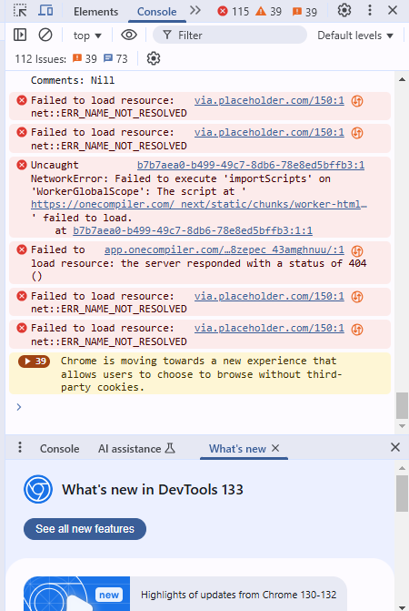 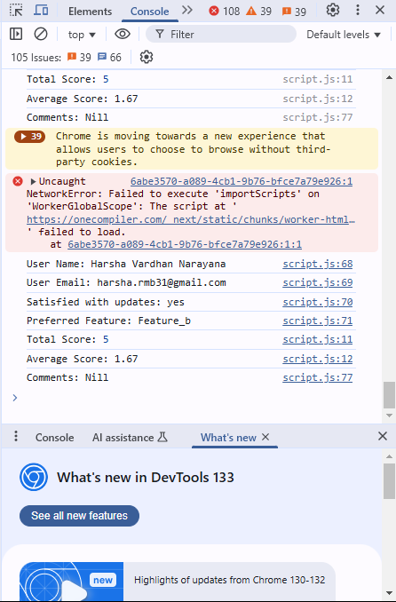

**Shows Error if name is Empty:**

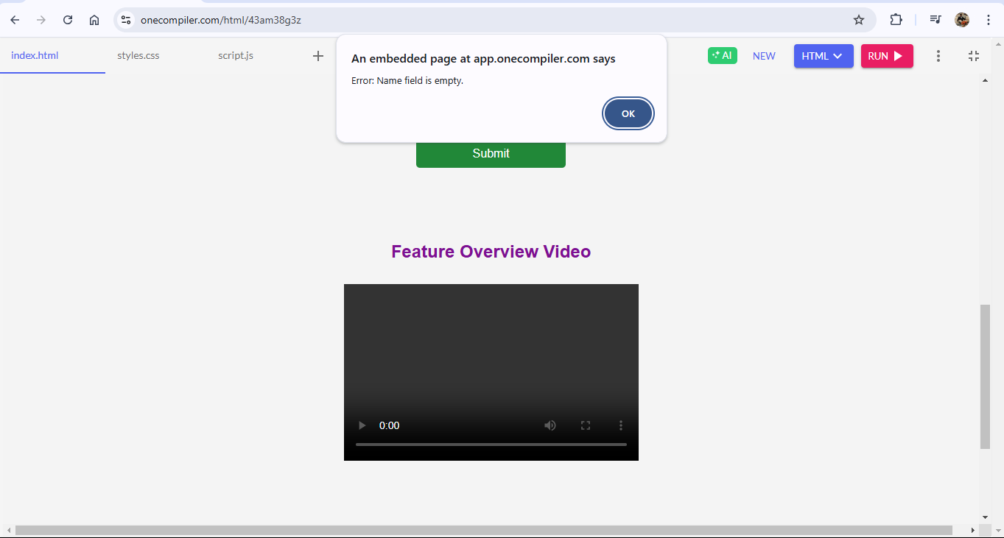

**Triggers errors if gmail is not of required form**

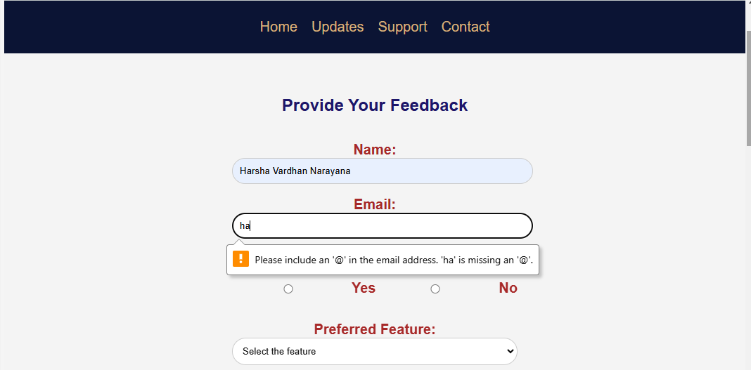

**Triggers error if feature is not selected**

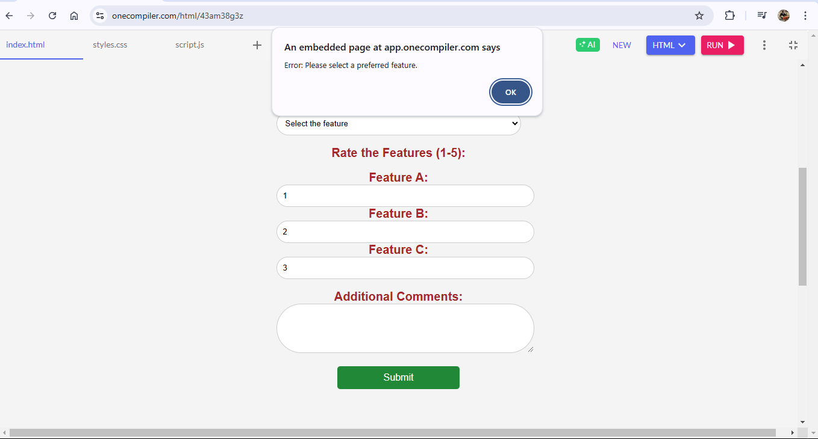

**Shows error if range is above 5**

