**CSE326 - INTERNET AND WEB PROGRAMMING LAB**

**Activity – *1***

**Date: *19/01/2016***

|  |  |  |  |  |  |  |  |  |  |  |  |  |  |  |  |
| --- | --- | --- | --- | --- | --- | --- | --- | --- | --- | --- | --- | --- | --- | --- | --- |
| **Description** | Create a simple web page for publishing your resume on internet. Design your resume template in Word or Libre Office document format then proceed with HTML script. Also visualize the HTML script in Tree Structure to understand the Document Object Model (DOM). Your resume content should be developed by using the following HTML Tags.   |  |  | | --- | --- | | **Comments Tag :** | Describe Author, Date and Description | | **Header Tags :** | Name, Email ID, URL, Address, Section etc. | | **Image:** | Your Profile Picture (Passport Size) | | **Paragraph :** | Your Objective or Summary | | **Tables :** | Your educational qualification | | **Lists :** | List out your Technical Expertise etc. | | **Hyperlinks :** | Link your hobbies or any relevant information to appropriate web content | |
| **Source Code (HTML/CSS/JS/PHP/SQL)** | <!DOCTYPE HTML>  <html>  <title>Resume</title>  <header>  <h2> <b>Name:</b> Abhishek Balaji</h2>  <h3> <b>Email ID:</b> <a href="mailto:abhishek.balaji2@gmail.com">abhishek.balaji2@gmail.com</a> </h3>  <h3> <b>Website: </b><a href="http://booleanbalaji.in">http://www.booleanbalaji.in</a></h3>  <p><h2> <b>Address: </b></h2><address> H-123, VIT Men's Hostel, VIT University, Vellore-632014</address></p>  <br>  <img src="\assets\images\img01.png"> </img>  <br>  <h3> Objectives </h3>  <p> The objectives of this resume are to develop a document which would accurately describe the skills and achievements of the person above. </p>  <table style="width=80%", border="1">  <thead>  <tr>  <th>Degree</th>  <th>Institute</th>  <th>Year of Completion</th>  <th>Marks/Grade</th>  <tr>  </thead>  <body>  <tr>  <td>10th grade</td>  <td>P.S Senior Secondary School</td>  <td>2011</td>  <td>96%</td>  </tr>  <tr>  <td>12th Grade</td>  <td>P.S Senior Secondary School</td>  <td>2013</td>  <td>80%</td>  </tr>  <tr>  <td>B.Tech Computer Science and Engineering</td>  <td>VIT University, Vellore</td>  <td>2017 (Expected)</td>  <td> 7.54 (CGPA)</td>  </tr>  </body>  </table>  <h3>Skills</h3>  <ul style="list-style-type:circle">  <li> Adobe Photoshop </li>  <li> Adobe Illustrator </li>  <li> HTML/CSS </li>  <li> JS </li>  </ul>  <h3> Links: </h3>  <a href="http://www.wikipedia.org/en/Adobe_Photoshop"> Photoshop </a> <br>  <a href="http://www.wikipedia.org/en/HTML"> HTML </a> <br>  <a href="http://www.booleanbalaji.in"> Website </a> <br>  </html> |
| **Sample I/O or Screen Shots** |  |

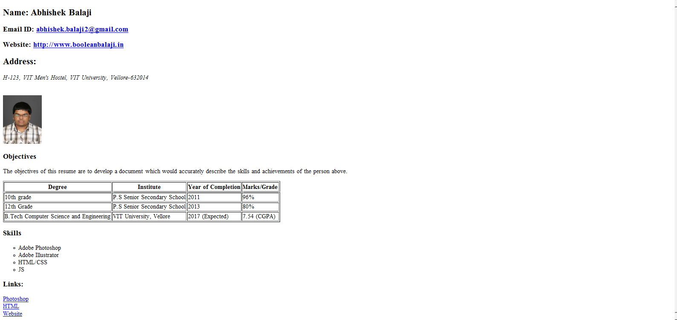

**General Instructions**

* This document should be uploaded for every lab to Moodle for continuous assessment.
* Recommended Font and Size: Time New Roman ,12
* Line Spacing :1.15