**CSE326 - INTERNET AND WEB PROGRAMMING LAB**

**Activity – *2***

**Date: *19/01/2016***

|  |  |
| --- | --- |
| **Description** | Creating a HTML form and using various input tags |
| **Source Code (HTML/CSS/JS/PHP/SQL)** | <!DOCTYPE HTML>  <html>  <header> <h2>HTML FORMS </h2></header>  <body>  <form action="\php\index.php" method="post" target="_blank" accept-charset="UTF-8"  enctype="application/x-www-form-urlencoded" autocomplete="on">  <fieldset>  <legend> Basic Information </legend>  First Name: <br>  <input type="text" name="firstname"><br>  Last Name: <br>  <input type="text" name="lastname"><br>  Email ID: <br>  <input type="email" name="emailid"><br>  Contact Number: <br>  <input type="tel" name"phone"><br>  Date Of Birth: <br>  <input type="date" name="dob"><br>  </fieldset>  <fieldset>  <legend>Course information</legend>  Course: <br>  <select name="course">  <option value="cse"> Computer Science and Engineering</option>  <option value="ece"> Electronics and Communication Engineering</option>  <option value="mech"> Mechanical Engineering</option>  <option value="bio"> BioTechnology </option>  </select>  <br>  Write your comments on the course: <br>  <textarea name="comments" rows="20" cols="30">  </textarea>  <br>  Year of Study: <br>  <input type="text" name="yos"><br>  </fieldset>      <fieldset>  <legend> Security Information </legend>  Username: <br>  <input type="text" name="username"><br>  Password: <br>  <input type="password" name="p1" maxlength="10"><br>  Repeat Password: <br>  <input type="password" name="p2" maxlength="10"><br>    </fieldset>  <fieldset>  <legend>Select all the options which apply</legend>  <input type="checkbox" name="course1" value="OOPS"> OOPS <br>  <input type="checkbox" name="course2" value="DSA"> DSA <br>  <input type="checkbox" name="course3" value="Spanish"> Spanish <br>  </fieldset>  <input type="submit" value="Submit"><br>  <input type="button" onclick="alert('You support Net Neutrality!')" value="Net Neutrality"> I support Net Neutrality <br>  <input type="file" value="upload resume"> Upload resume <br>  </form>  </body>  </html> |
| **Sample I/O or Screen Shots** |  |

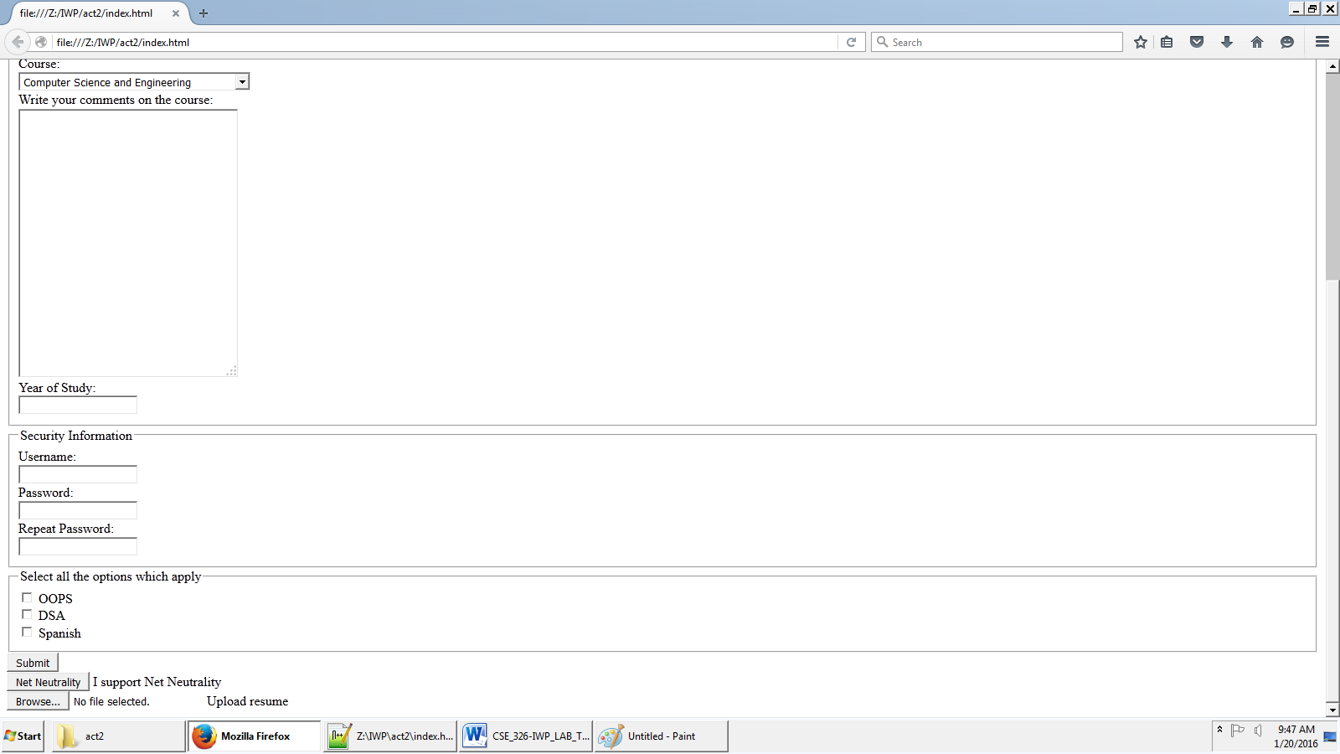

**General Instructions**

* This document should be uploaded for every lab to Moodle for continuous assessment.
* Recommended Font and Size: Time New Roman ,12
* Line Spacing :1.15