1. Download git from <https://git-scm.com/downloads> and install
2. Download node js from [https://nodejs.org/en/download/](https://nodejs.org/en/download/%20) and install.
3. Restart your machine.
4. Login to Bluemix.
   1. Catalog --> Alchemyapi --> Create
   2. Click on service credentials and copy the apikey.....

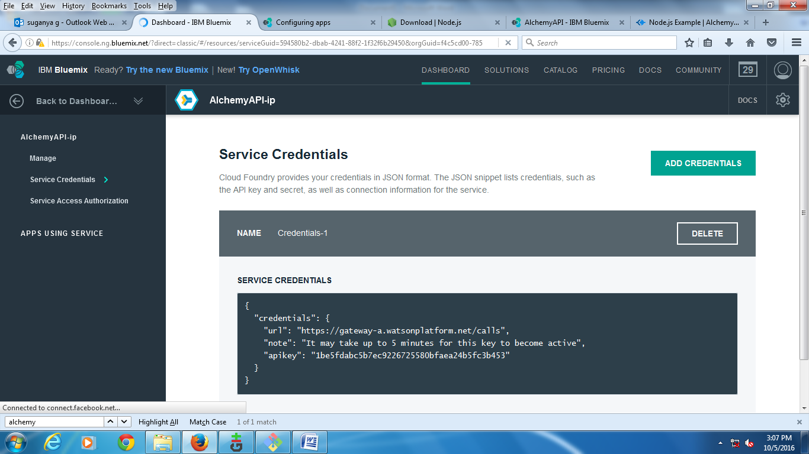

1. Start menu --> Git
2. click on "Create Repository". select the folder as "D:/"
3. Click on Repository menu --> click on Git bash
4. Clone the repository using,

$ git clone https://github.com/alchemyapi/alchemyapi_node

If it asks for username and password, login to github, else create one.

1. move to the directory by giving,

$ cd alchemyapi_node

$ pwd and check for current working directory

1. set nodejs path using,

$ path="C:\Program Files\nodejs"

$ npm install

1. $ node alchemyapi.js <apikey> {which you get from step 4}
2. $ node js

Check whether you are getting,

Express server listening on port 3000

To view the example, point your favorite browser to: localhost:3000

GET / 200 9101ms - 13.89kb

GET / 200 18440ms - 84.03kb

1. open browser and type, localhost:3000

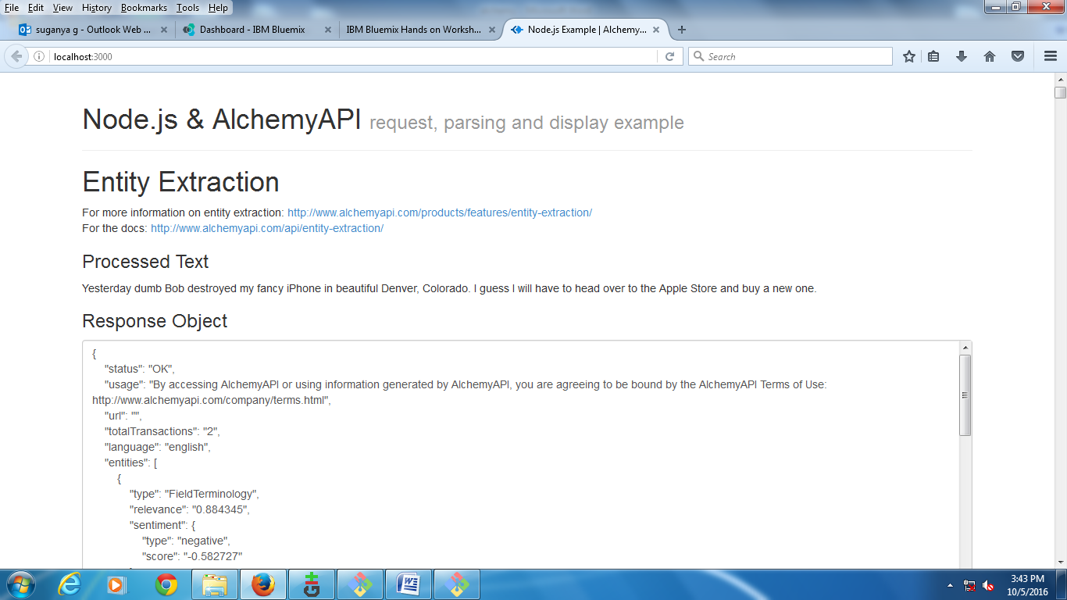

1. Now, to push alchemyapi to bluemix,
   1. open Git cmd prompt
   2. change to directory " D:/" as given in step 6.
   3. d:/> cd alchemyapi_node
   4. check for target using,

cf t

* 1. push application using,

cf push alchs

1. Open browser and check using alchs.mybluemix.net