**Configuring git:**

git config –global user.name “your_username_on_github”

git config –global user.email “your_email_on_github”

git config –global color.ui “your_color_on_github”

**Commands for admin:**

* Create Remote Repository on GitGub.com:

You can create your repository by going to “repositories” and by clicking “new”

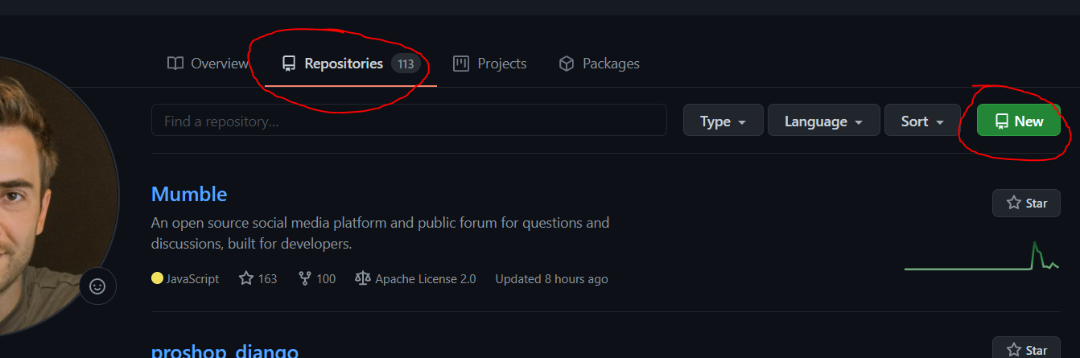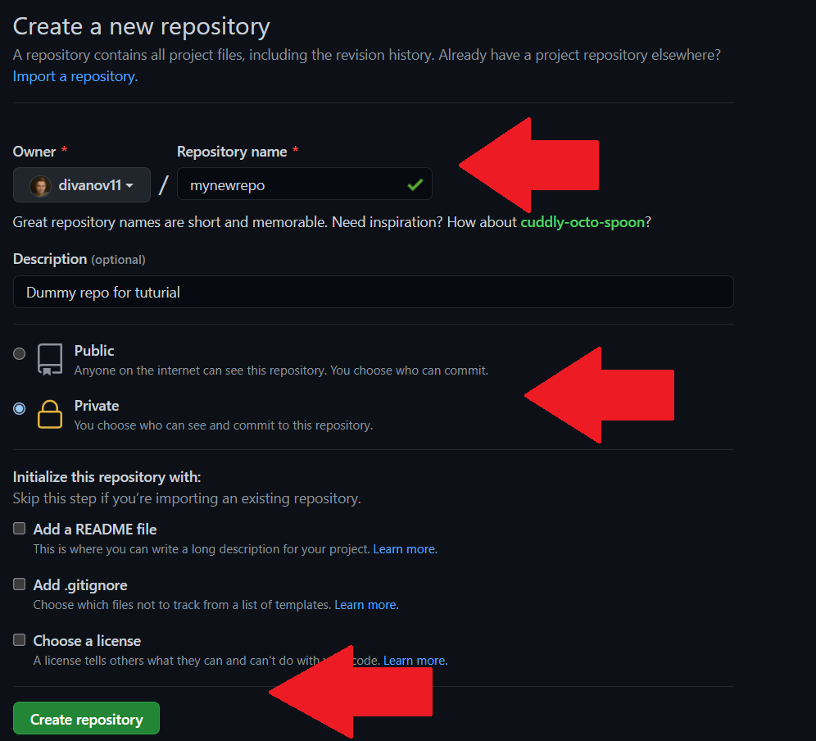

* Initialize new local git repository:

cd into your project folder and initialize a local repo:

cd projectname

git init

make sure to check hidden item in the file explorer to make sure you can see .git file

**Commands for other users(and admin):**

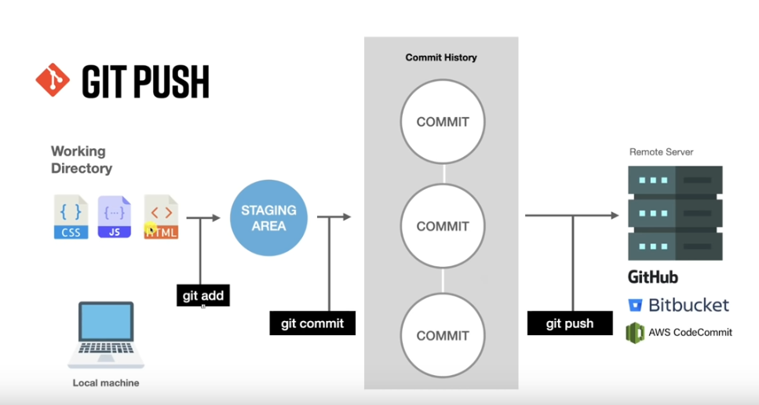

1.Clone a repo: copy the url of the repo you want to clone and simply run “git clone <repo url>

2.if you have already have the repository, you can update it instead “ git pull origin <branch name>”

branch name is: master by default

3.every time you make a change to the repository(adding files, modifying files) run “git add .”  
the “ . ” is equivalent to “ * ” it means adding all files or you can simply put only the file name that you modified.

4.Commit Changes | git commit -m “Your custom note”

5.Set remote | git remote add origin <repo url> : most of the times this command is unnecessary

6.Push to remote | git push -u origin <branch name>