CSR Analysis – Weekly Passenger Flows & Energy Estimates

1. Weekly Passenger Flow Overview
- Low weeks (Green – Not busy):
  - Typical early-year weeks (January–February) and late-year (November–December).
  - Passenger numbers: ~130k–170k per week, energy ~65–85k kWh.
- Moderate weeks (Yellow – Busy):
  - Spring and fall transition weeks (March–May, December).
  - Passenger numbers: ~180k–200k per week, energy ~90–100k kWh.
- Peak weeks (Red – Very busy):
  - Summer and key holiday weeks.
  - Passenger numbers: ~200k–230k per week, energy ~100–115k kWh.

2. Patterns & Insights
- Seasonality is clear:
  - Winter weeks are consistently green (off-peak).
  - Summer weeks (June–August) show Red peaks.
  - Spring (April–May) and autumn (October) are mostly Yellow with some Red spikes.
- Energy correlation:
  - Weekly energy consumption scales directly with passenger numbers:
    - Green ~50% less than Red weeks.
    - Yellow ~10–15% below Red weeks.
- Special events/holidays:
  - Peaks around late April, July, and December–January indicate high holiday traffic.

3. Operational Recommendations
- Staffing & resources:
  - Red weeks require full staffing and operational readiness.
  - Yellow weeks: moderate resources.
  - Green weeks: minimal staffing; ideal for maintenance and optimization.
- Energy efficiency:
  - Consider dynamically scaling lighting, HVAC, and equipment based on weekly passenger estimates.

4. Yearly Overview – 2026 Monthly Status
Month | Status (Predominant)
January | Less Busy (Green)
February | Less Busy / Busy (Mixed)
March | Less Busy / Busy (Mixed)
April | Busy / Very Busy (Yellow & Red)
May | Very Busy (Red dominates)
June | Very Busy (Red dominates)
July | Very Busy (Red dominates)
August | Very Busy / Busy (Mostly Red, some Yellow)
September | Very Busy / Busy (Red early, Yellow later)
October | Busy (Yellow dominates)
November | Less Busy (Green dominates)
December | Busy (Yellow dominates, approaching holiday peaks)

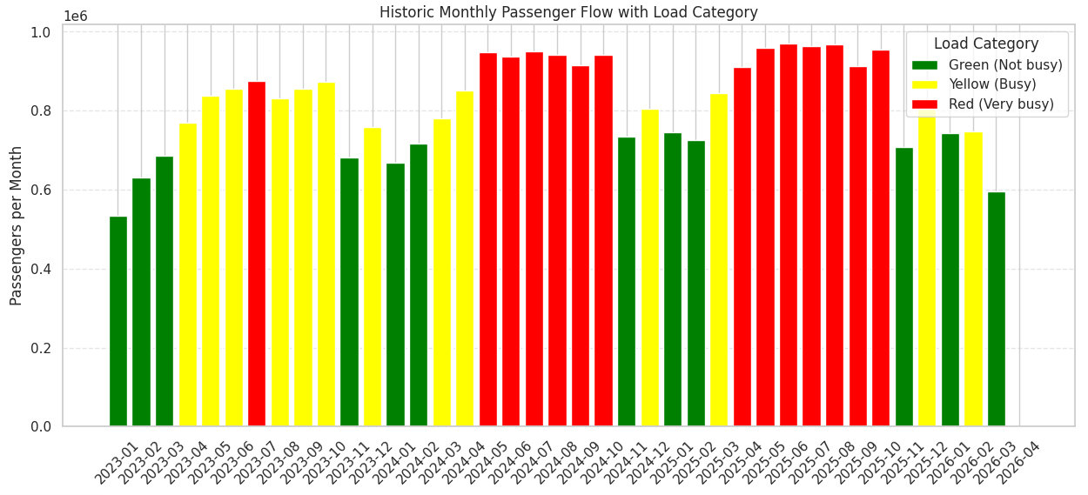

5. Predictions for 2026 Based on Historical Data
- January–February: Low traffic, mostly Green weeks → minimal staffing needed.
- March–April: Transition from Green to Yellow → moderate staffing; anticipate energy usage rising.
- May–August: Peak months; Red weeks dominate → full operational readiness and peak energy consumption expected.
- 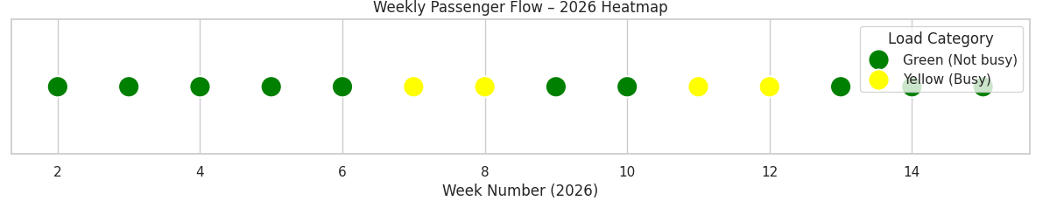

- September–October: Slight decrease, Yellow weeks dominate → plan for moderate operations.
- November–December: Traffic rises in December (holiday season) → anticipate busy weeks; late November quieter.
Insights for planning:
- Energy demand is expected to mirror passenger flows.
- Red weeks require advanced coordination of staff, energy systems, and maintenance schedules.
- Historical trends suggest late April, summer holidays, and end-of-year weeks will consistently be Very Busy.

