Description:

The tool takes two inputs, a shapefile with corresponding geodatabase files of InSAR data and an excel spreadsheet containing information of culverts. The tool then generates a list of potential deteriorating culverts based on two analyses. One is based on surface area stability, which approximates the surface area of culverts using the initial heights in geodatabase, and finds the largest deviation among all data acquisition time stamps. A warning is given if the percentage area change is more than the default 2 percent, which can be modified in GeneralDisplay.py by changing TRI_THRESHOLD parameter. The other is based on permutation tests on median velocities of the group of points within culvert radius and the group of points in the surrounding area. Warnings are given if the test results show significant incoherent movements between individual culvert and its surrounding area, i.e. the p-value of the permutation test is less than the default significance level 0.01, which can be modified in GeneralDisplay.py by changing PERM_ALPHA parameter. The surrounding area is defined as outside culvert radius but within an outer radius, proportional to the culvert radius. The ratio can be modified in ProcessShapeFile.py by changing OUTER_RADIUS_RATIO. The default simulation number of permutation test 10,000, which can be modified in ProcessShapeFile.py by changing PERM_NUM parameter.

Installation:

The tool only requires correct environments. Additional package installations may be required.

Requirements:

Python Version:

Python 2.7.10 |Anaconda 2.3.0 (32-bit)

Required Packages:

ogr, osr, Scipy, os, math, matplot.pyplot, numpy, xlrd

Required column names for input excel spreadsheet of culverts:

Federal Structure ID, Year Built, Culvert Rating, Latitude, Longitude

Use:

Run “python GUI.py” in command line to get the following window:

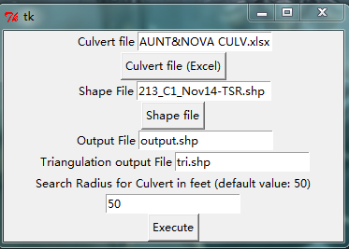

1. Enter the paths of both input files in the designated fields by either typing or clicking the button to select.
2. Enter the name of output shapefiles, “Output File” is for all InSAR features within culvert radius. ”Triangulation output File” is for triangulation meshes generated from surface stability analyses. Each triangle has a time series of percentage area change stored with it. Search Radius defines the radius of culverts that would be used for analysis.
3. Click “Execute” button and wait for results.

Output:

The tool outputs:

Two shapefiles: one contains all InSAR features within culvert radius of all input culverts (Figure 2 a & b), and the other containing triangulation mesh generated by Delaunay triangulation algorithm (Figure 3).

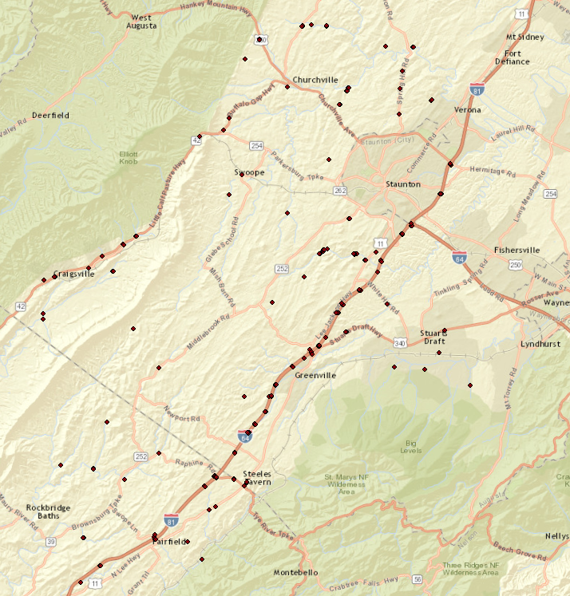

Figure 2 a

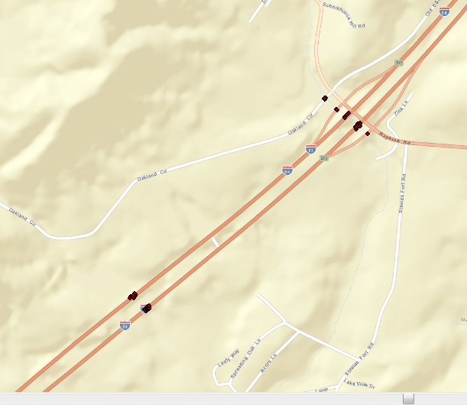

Figure 2 b

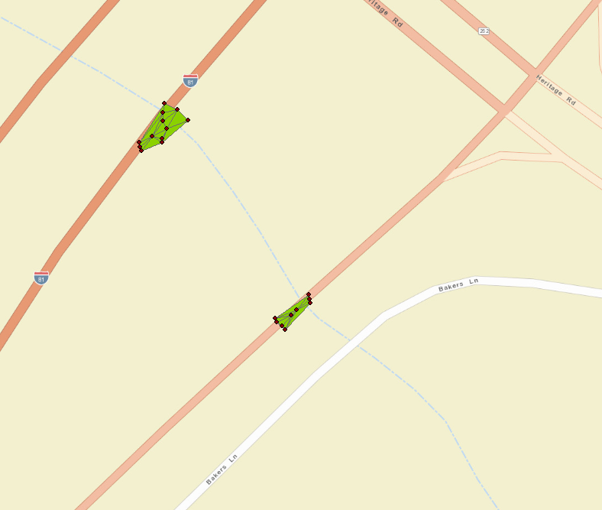

Figure 3

A list of federal structure numbers of potential deteriorating culverts and the type of analysis associated with each of them as python standard output

Triangulation plot of all culverts that trigger fluctuation warnings with color map based on percentage area change (Figure 5)

A plot of all culverts with their surrounding InSAR features and warnings if there is any associated with them.

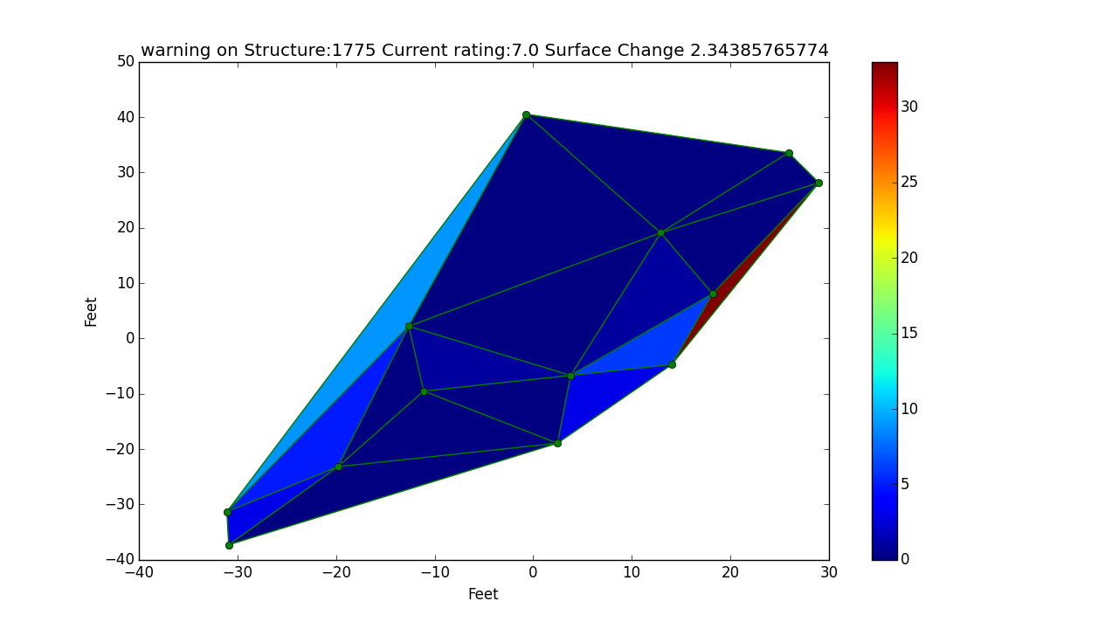

Figure 5