**Call_Centre_Lead_IBOB_Data_Process**

**Login Process**

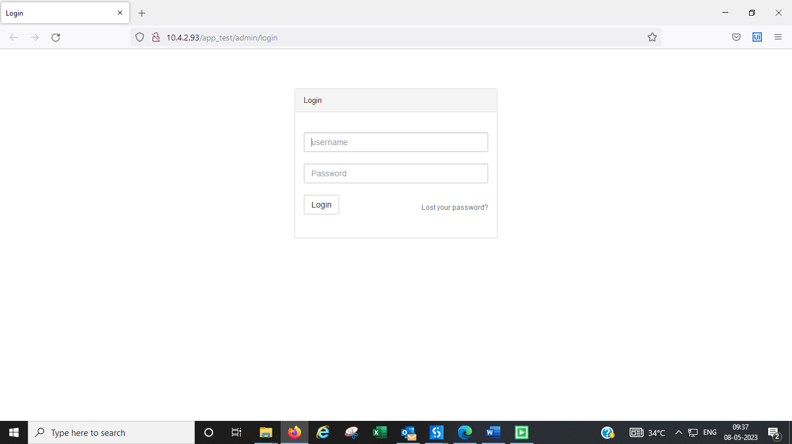

**Download Report**

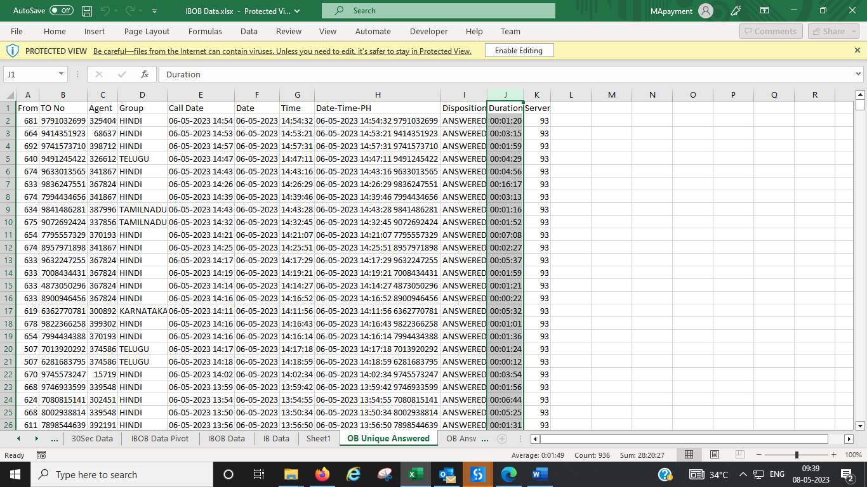

**Pivot**

**Mail**

