
Portfolio & CVGenerator
Submitted in Partial Fulfillment of Requirements for the Degree of Bachelor of Science
(Computer Science Hons) By
Vivekanand Ashok Shahu
Seat No: 31011123054
Guide
Dr. Sunita A. Yadav

S K Somaiya College
Somaiya Vidyavihar University
Vidyavihar, Mumbai - 400 077
2021-24
Somaiya Vidyavihar University
S K Somaiya College
Certificate
Department of Information Technology & Computer Science Year 2024-25 Page 1

This is to certify that the project report on the dissertation entitled "Pharmacy Management System" is a bonafide record of the dissertation work done by Vivekanand Ashok Shahu in the year 2024-25 under the guidance of Dr. Sunita A. Yadav, Department of Information Technology and Computer Science, in partial fulfillment of the requirements for the Bachelor of Computer Science (Hons.) degree of Somaiya Vidyavihar University.

_____________ _________________ Guide Programme Coordinator ______________ ___________ Head of the Department Director
Date:
Place: Mumbai-77
Somaiya Vidyavihar University
S K Somaiya College
Certificate of Approval of Examiners
This is to certify that the project report on the dissertation entitled "Pharmacy Management System" is a bonafide record of the dissertation work done by Vivekanand Ashok Shahu in partial fulfillment of the requirements for the Bachelor of Science degree in Computer Science (Hons.) of Somaiya Vidyavihar University.
Department of Information Technology & Computer Science Year 2024-25 Page 2
______________________ ____________________ External Examiner /Expert Internal Examiner/ Guide
Date:
Place: Mumbai-77
Somaiya Vidyavihar University
S K Somaiya College
DECLARATION
I declare that this written report submission represents the work done based on my and / or others’ ideas with adequately cited and referenced the original source. I also declare that I have adhered to all principles of academic honesty and integrity as I have not misinterpreted or fabricated or falsified any idea/data/fact/source/original work/ matter in my submission.
I understand that any violation of the above will be cause for disciplinary action by the college and may evoke the penal action from the sources which have not been properly cited or from whom proper permission is not sought.
_______________________________
Signature of the Student
Vivekanand Ashok Shahu
________________________________
Name of the Student
31011123054
_______________________________
Seat No.
Department of Information Technology & Computer Science Year 2024-25 Page 3
Date:
Place: Mumbai-77
Acknowledgement
I am profoundly grateful to S.K Somaiya College for providing me with an excellent academic environment and the necessary resources to pursue my studies and conduct my final project. This institution has been a place of learning and also a venue where I could push myself beyond my comfort zone.
I extend my heartfelt thanks to the Director, CA. Monica Lodha, for her unwavering support and encouragement.
My gratitude goes to Dr. Swati Maurya, Head of the Department of Information Technology & Computer Science for her invaluable guidance and encouragement. I would also like to extend my thanks to Ms. Minal Dive, Coordinator of the Department whose assistance and support played a crucial role in the successful completion of my project
A special note of thanks to my project guide, Dr Sunita A. Yadav whose expertise and understanding were instrumental in shaping the direction and execution of this project. Her patience and commitment to excellence have greatly inspired and motivated me.
Lastly, I cannot forget the incredible support of my parents and friends, whose encouragement and faith in me have been my pillars of strength. Their constant support and optimism have helped me navigate through challenges and stay focused on my goals.
Department of Information Technology & Computer Science Year 2024-25 Page 4
Abstract
In today’s fast-paced healthcare industry, an efficient and well-structured Pharmacy Management System is essential for managing medical inventories, prescriptions, and sales operations. This project, titled "Pharmacy Management System," is a Windows application developed using .NET Framework (C#) to streamline pharmacy operations, ensuring accurate stock management and seamless customer transactions.
The system allows pharmacy administrators to add, update, and manage medicine inventory, track expiry dates, generate bills, and maintain customer records. It also features user authentication to ensure secure access. Built with Windows Forms and SQL Server, the application ensures data integrity, security, and efficiency, providing a reliable solution for pharmacy businesses.
This Pharmacy Management System is particularly beneficial for small to medium-sized pharmacies, enabling them to automate manual tasks and reduce human errors in inventory and billing. The project highlights the importance of digital transformation in the pharmaceutical industry, ensuring faster service delivery and better record-keeping.
This report documents the complete development lifecycle, including requirement analysis, system design, implementation, testing, and results. The project is developed as part of the Bachelor of Science (Computer Science Hons.) curriculum, demonstrating proficiency in software development, database management, and user experience design.
Index
1. Title of the Project
2. Introduction
3. Objectives
4. Scope of the Project
5. Proposed Methodology
6. System Architecture (if applicable)
7. Modules Description
8. Feasibility Study
9. Expected Outcome
10. Tools and Technologies Used
11. Timeline
12. Conclusion
13.Final Review and Submission
14. Codes and Outputs
Department of Information Technology & Computer Science Year 2024-25 Page 5
# 1.Title/Topic: Pharmacy Management System using .NET (C#) Windows Forms
# 2. Introduction
Efficient pharmacy management is crucial for maintaining accurate stock levels, tracking expiry dates, and streamlining the sales process. This project, Pharmacy Management System, is developed using .NET (C#) Windows Forms to automate the management of pharmaceutical inventories, prescriptions, and billing.
This project was chosen because automation in pharmacies is essential to reduce manual errors, save time, and improve service efficiency. The system provides features like medicine stock tracking, sales management, and billing generation, making it an essential tool for small and medium-sized pharmacies.
# 3. Objectives
- To develop a user-friendly pharmacy management system.
- To automate the inventory management process for medicines.
- To implement secure sales and billing functionalities.
- To provide expiry date tracking for medicines.
- To generate detailed reports for better decision-making.

#4. Scope of the Project
-Inclusions:
- Medicine inventory management (adding, updating, deleting stock).
- Sales and billing system with automated receipt generation.
- Expiry date tracking and alerts.
- User authentication for secure access.

-Exclusions:
- Online prescription verification.
- Integration with external pharmacy databases.
- Mobile application support.
# 5. Proposed System(Point 5 in Theory):The Pharmacy Management System aims to simplify and automate pharmacy operations. It allows pharmacists to easily manage medicines, monitor stock levels, and process sales efficiently. The system ensures that medicines are well-stocked, sales are recorded systematically, and expired medicines are flagged in time.
# 6. Proposed Methodology
- Research: Study existing pharmacy management systems and identify key features.
- Development: Build the system using C# (.NET Windows Forms) and SQL Server for backend storage.
- Testing: Perform unit testing, integration testing, and user acceptance testing.
- Deployment: Implement the system in a test environment before full-scale use.

Department of Information Technology & Computer Science Year 2024-25 Page 6
# 7. System Architecture:
The system follows a modular architecture consisting of:
- User Interface Module: Developed using Windows Forms for ease of use.
- Database Module: Uses SQL Server for storing medicine, sales, and user data.
- Processing Module: Manages transactions like sales, stock updates, and reports.
# 8. Modules Description(Design displayed in last)
- Medicine Management Module – Add, update, or delete medicines from inventory.
- Sales and Billing Module – Process customer purchases and generate invoices.
- Expiry Date Tracker Module – Alert the pharmacist about medicines nearing expiration.
- User Authentication Module – Ensures only authorized users can access the system.
#9. Feasibility Study:
This project is technically feasible as it utilizes widely available tools like Visual Studio 2022 and SQL Server. It is economically feasible, as it eliminates the need for costly third-party pharmacy software.

#10. Expected Outcome:
- A fully functional pharmacy management system.
- Efficient medicine inventory tracking with alerts for expired medicines.
- Automated sales and billing process for better customer service.
- Improved pharmacy operations through digital record-keeping and reports.
#11. Tools and Technologies Used:
- Development Tools: Visual Studio 2022, .NET Framework (C#)
- Database: Microsoft SQL Server
- Testing Tools: Manual Testing, White Box & Black Box Testing
- Platform: Windows

#12. Timeline:
Week | Task | Duration
1 | Planning and Requirement Gathering | 2 Days
1 | Designing the Web application | 2 Days
1-2 | Backend Development | 5 Days
2-3 | Adding Arts / Illustration Section | 5 Days
4 | Testing and Debugging | 1 Week
5 | Deployment and Documentation | 1 Week

#13. Conclusion

The Pharmacy Management System is designed to streamline the process of managing medicine inventory, sales, and pharmacy operations efficiently. This project provides a user-friendly interface for pharmacists to add, update, and track medicines, ensuring accuracy and reliability. The system simplifies stock management, minimizes human errors, and improves record-keeping for better operational efficiency.

This project demonstrates my proficiency in C#, .NET, Windows Forms, and SQL Server while showcasing my ability to develop a real-world software solution. It serves as a valuable contribution to digital pharmacy management, making the process more systematic and accessible.

#14. Final Review and Submission (1 Day)
Before the final submission, the project underwent a thorough review, ensuring that all functionalities were implemented correctly. The system was tested for any bugs, errors, or missing features. Necessary refinements were made to enhance performance, user experience, and security. After the final validation, the project was successfully submitted.

Department of Information Technology & Computer Science Year 2024-25 Page 7
##Extras
#1. Existing Project: A Pharmacy Management System is a well-established and essential software solution in the healthcare sector. Managing pharmaceutical inventory, tracking sales, and ensuring accurate record-keeping are critical for pharmacies. Many existing pharmacy management solutions are available, but this project aims to provide a simplified, user-friendly, and efficient alternative, focusing on inventory control, billing, and reporting.
This project highlights the necessity of digital transformation in pharmacy operations, ensuring faster service, reduced human errors, and improved overall management.

Codes and Output Part
Name: Vivekanand Ashok Shahu
Seat No: 31011123054
.Net Project: Pharmacy Management System(C# Windows Forms)
Code:Form1.cs
using System;
using System.Collections.Generic;
using System.ComponentModel;
using System.Data;
using System.Drawing;
using System.Linq;
using System.Text;
using System.Threading.Tasks;
using System.Windows.Forms;

namespace PMS
{
public partial class Form1 : Form
{
function fn = new function();
String query;
DataSet ds;

public Form1()
{
InitializeComponent();
}

private void panel1_Paint(object sender, PaintEventArgs e)
{

}

private void panel2_Paint(object sender, PaintEventArgs e)
{

}

private void label2_Click(object sender, EventArgs e)
{

}

private void button2_Click(object sender, EventArgs e)
{
query = "select * from users";
ds = fn.getData(query);
if (ds.Tables[0].Rows.Count == 0)
{
if(txtUsername.Text == "vivek" && txtPassword.Text == "pass")
{
Dashboardwin dbw = new Dashboardwin("vivek");
dbw.Show();
this.Hide();
}
}

else
{
query = "select * from users where username = '"+txtUsername.Text+"' and pass = '"+txtPassword.Text+"'";
ds = fn.getData(query);
if(ds.Tables[0].Rows.Count != 0)
{
String role = ds.Tables[0].Rows[0][1].ToString();
if (role == "Administrator")
{
string adminUser = txtUsername.Text;
string adminPass = txtPassword.Text;
//Profile p = new Profile(adminUser);

Administrator adminForm = new Administrator(adminUser, adminPass);
Dashboardwin db = new Dashboardwin(adminUser);
AddUser au = new AddUser(adminUser);
//Profile pp = new Profile(adminUser);
adminForm.Show();
this.Hide();
}

else if (role == "Pharmacist")
{
Pharmacist ph = new Pharmacist();
ph.Show();
this.Hide();
}

}
else
{
MessageBox.Show("Wrong username or passwrod", "Error", MessageBoxButtons.OK, MessageBoxIcon.Error);
}
}

/*if (txtUsername.Text == "vivek" && txtPassword.Text == "pass")
{
Administrator am = new Administrator();
am.Show();
this.Hide();
}
else {

MessageBox.Show("Wrong Username OR Password","Error",MessageBoxButtons.OK,MessageBoxIcon.Error);
}*/
}

private void btnExit_Click(object sender, EventArgs e)
{
Application.Exit();
}

private void btnReset_Click(object sender, EventArgs e)
{
txtUsername.Clear();
txtPassword.Clear();
}
}
}

Summary of Form1.cs:
- User Authentication
  - Checks if the entered username and password exist in the database.
  - Allows default login if no users exist (vivek / pass).
- Role-Based Access
  - Administrator → Opens Admin Panel, Dashboard, and User Management.
  - Pharmacist → Opens Pharmacist dashboard.
- Error Handling
  - Displays "Wrong username or password" if credentials are incorrect.
- UI Features
  - Reset Button → Clears the username and password fields.
  - Exit Button → Closes the application.
Output:
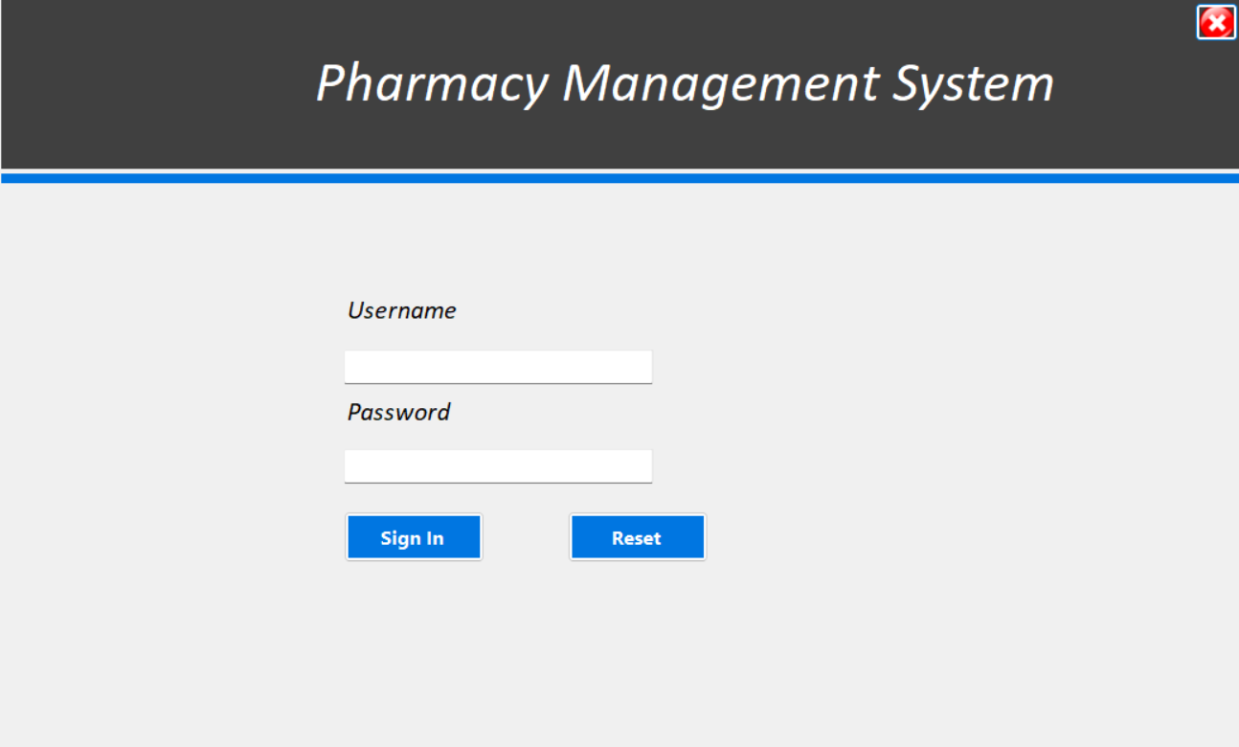
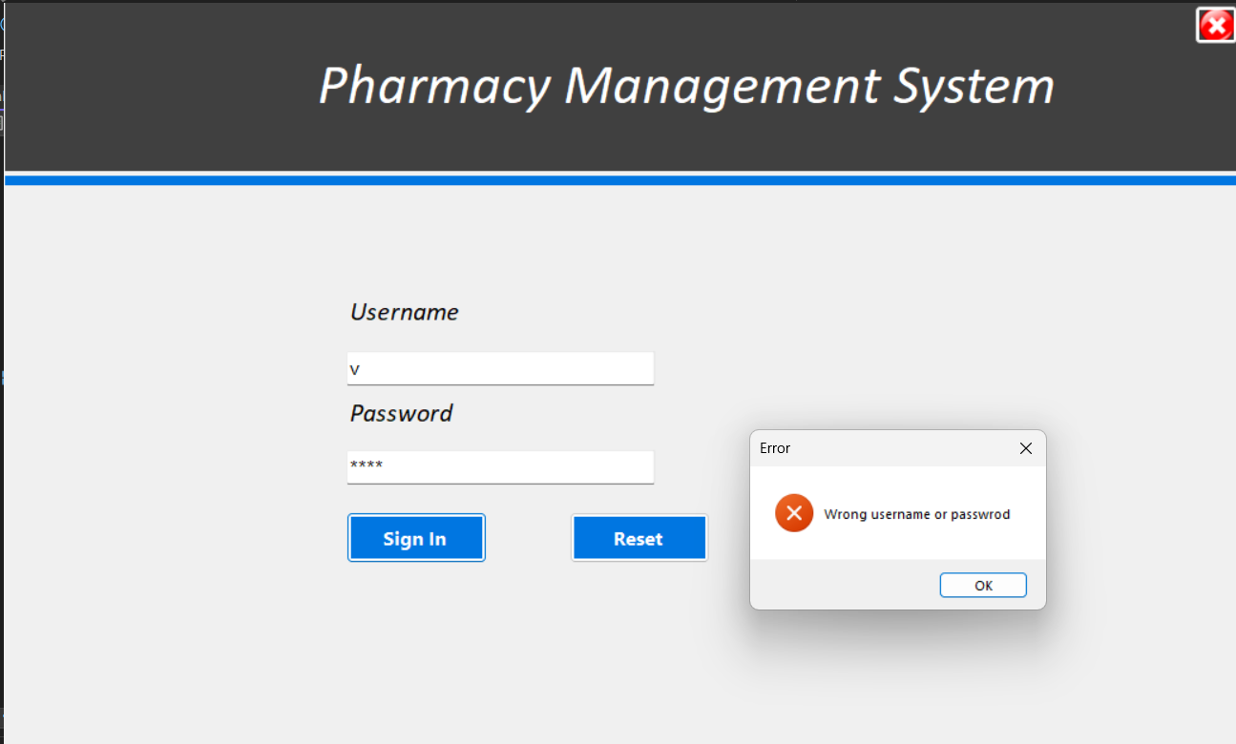
If Signed in as an Administrator then:
Code:Administrator.cs

using System;

using System.Collections.Generic;

using System.ComponentModel;

using System.Data;

using System.Drawing;

using System.Linq;

using System.Text;

using System.Threading.Tasks;

using System.Windows.Forms;

namespace PMS

{

public partial class Administrator : Form

{

public static string username ;

public static string password;

public Administrator()

{

InitializeComponent();

}

public Administrator(string user, string pass)

{

InitializeComponent();

username = user;

password = pass;

}

private void Administrator_Load(object sender, EventArgs e)

{

}

private void button5_Click(object sender, EventArgs e)

{

Form1 fm1 = new Form1();

fm1.Show();

this.Hide();

}

private void button1_Click(object sender, EventArgs e)

{

Dashboardwin db = new Dashboardwin(username);

db.Show();

this.Hide();

}

private void button2_Click(object sender, EventArgs e)

{

AddUser ad = new AddUser(username);

ad.Show();

this.Hide();

}

private void button3_Click(object sender, EventArgs e)

{

ViewUser vu = new ViewUser(username);

vu.Show();

this.Hide();

}

private void button4_Click(object sender, EventArgs e)

{

MessageBox.Show("Username before opening Profile: " + username);

Profile p = new Profile(username);

p.Show();

this.Hide();

}

}

}

Summary of Administrator.cs:
Purpose:
- Acts as the main parent form for the Administrator panel in the application.
- Provides navigation to different sections via side panel buttons.
Static Variables:
- Stores username and password for maintaining user session.
Constructors:
- Default Constructor: Initializes the form without user credentials.
- Parameterized Constructor: Stores the logged-in username and password.
Button Functionalities:
- button1 → Dashboard → Opens Dashboardwin.
- button2 → Add User → Opens AddUser.
- button3 → View Users → Opens ViewUser.
- button4 → Profile → Opens Profile (shows username before opening).
- button5 → Logout → Returns to Form1 (Login screen).
UI Inheritance:
- Other side panel components inherit its design properties, maintaining a consistent UI.

Output:


Code:Dashboardwin.cs

using System;

using System.Collections.Generic;

using System.ComponentModel;

using System.Data;

using System.Drawing;

using System.Text;

using System.Windows.Forms;

namespace PMS

{

public partial class Dashboardwin : PMS.Administrator

{

String query;

DataSet ds;

function fn = new function();

public Dashboardwin(string lginun)

{

InitializeComponent();

//btnload.PerformClick();

username = lginun;

}

private void panel3_Paint(object sender, PaintEventArgs e)

{

}

private void label3_Click(object sender, EventArgs e)

{

}

private void label5_Click(object sender, EventArgs e)

{

}

private void label13_Click(object sender, EventArgs e)

{

}

private void button2_Click(object sender, EventArgs e)

{

AddUser ad = new AddUser(username);

ad.Show();

this.Hide();

}

private void button3_Click(object sender, EventArgs e)

{

ViewUser vu = new ViewUser(username);

vu.Show();

this.Hide();

}

private void Dashboardwin_Load(object sender, EventArgs e)

{

query = "select count(userRole) from users where userRole = 'Administrator'";

ds = fn.getData(query);

if (ds.Tables[0].Rows.Count != 0)

{

coadmin.Text = ds.Tables[0].Rows[0][0].ToString();

}

else

{

coadmin.Text = "0";

}

query = "select count(userRole) from users where userRole = 'Pharmacist'";

ds = fn.getData(query);

if (ds.Tables[0].Rows.Count != 0)

{

copharma.Text = ds.Tables[0].Rows[0][0].ToString();

}

else

{

copharma.Text = "0";

}

}

}

}

Summary of Dashboardwin.cs:
- Inheritance:
  - Dashboardwin inherits from Administrator, meaning it uses the parent class's properties and design.
- Constructor:
  - Takes lginun (logged-in username) as a parameter and assigns it to username.
- Database Queries (Dashboardwin_Load):
  - Counts the number of administrators from the users table and displays it in coadmin.
  - Counts the number of pharmacists from the users table and displays it in copharma.
- Button Functionalities:
  - button2 → Add User → Opens AddUser form.
  - button3 → View Users → Opens ViewUser form.
- Purpose:
  - Serves as the main dashboard displaying admin and pharmacist count.
  - Provides quick access to user management functionalities.
This class is essential for the Administrator's dashboard in the Pharmacy Management System (PMS).

Output:
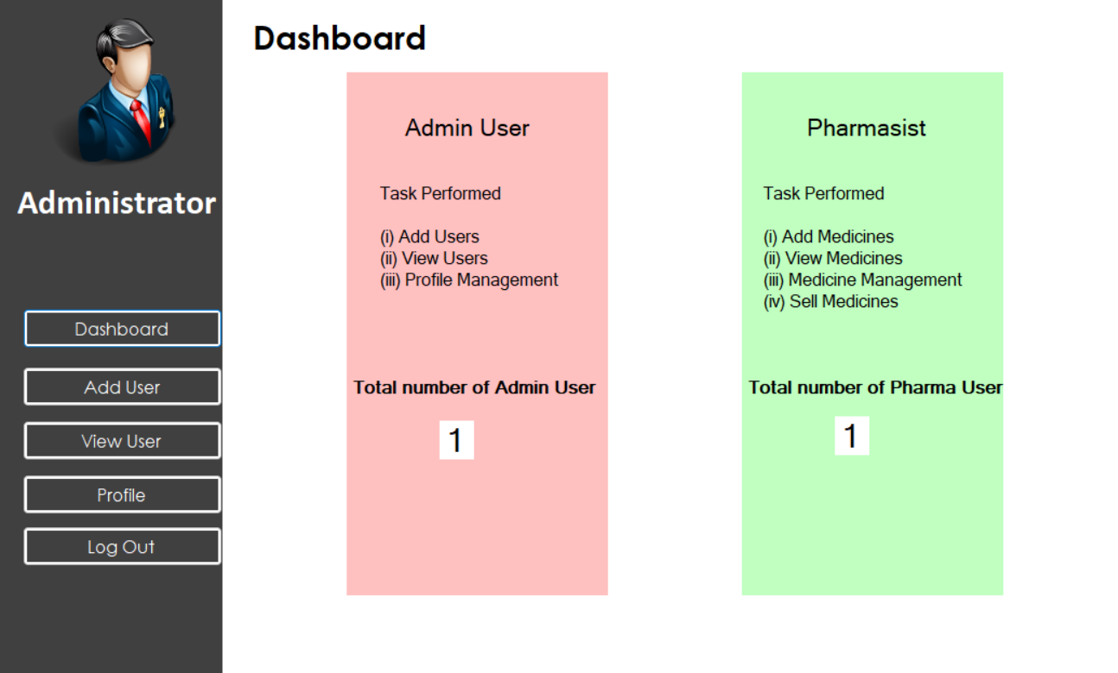

Code:AddUser.cs

using System;

using System.Collections.Generic;

using System.ComponentModel;

using System.Data;

using System.Data.SqlClient;

using System.Diagnostics;

using System.Drawing;

using System.Linq;

using System.Text;

using System.Windows.Forms;

namespace PMS

{

public partial class AddUser : PMS.Administrator

{

function fn = new function();

String query;

string un = username;

public AddUser(string lginun)

{

InitializeComponent();

un = lginun;

}

private void label2_Click(object sender, EventArgs e)

{

}

private void panel3_Paint(object sender, PaintEventArgs e)

{

}

private void btnReset_Click(object sender, EventArgs e)

{

txtUserRole.SelectedIndex = -1;

txtDob.Value = DateTime.Now;

txtName.Clear();

txtMobileNo.Clear();

txtEmail.Clear();

txtUsername.Clear();

txtPassword.Clear();

txtcp.Clear();

}

private void btnSignUp_Click(object sender, EventArgs e)

{

String role = txtUserRole.Text;

String name = txtName.Text;

String dob = txtDob.Text;

string mobile = txtMobileNo.Text;

String email = txtEmail.Text.Trim();

String username = txtUsername.Text;

String pass = txtPassword.Text;

String confirmpass = txtcp.Text;

if (!mobile.All(char.IsDigit) || mobile.Length != 10)

{

MessageBox.Show("Invalid mobile number.", "Error", MessageBoxButtons.OK, MessageBoxIcon.Error);

return;

}

if(txtUserRole.SelectedIndex == -1)

{

MessageBox.Show("Please select role from the suggetion.", "Validation Error", MessageBoxButtons.OK, MessageBoxIcon.Warning);

return;

}

if (name.Length < 2 || !name.All(char.IsLetter))

{

MessageBox.Show("Invalid name! It must contain only alphabets and be at least 2 characters long.",

"Error", MessageBoxButtons.OK, MessageBoxIcon.Error);

return;

}

if (username.Length < 3 || !username.All(c => char.IsLetterOrDigit(c) || c == '_'))

{

MessageBox.Show("Invalid username! It must be at least 3 characters long and contain only letters, numbers, and underscores (_).",

"Error", MessageBoxButtons.OK, MessageBoxIcon.Error);

return;

}

if (!email.Contains("@") || !email.Contains(".") || email.Length <= 6)

{

MessageBox.Show("Invalid email address!", "Error", MessageBoxButtons.OK, MessageBoxIcon.Error);

return;

}

if(pass != confirmpass) {

MessageBox.Show("Confirm your passwrd again", "Error", MessageBoxButtons.OK, MessageBoxIcon.Error);

return;

}

query = $"insert into users (userRole, name, dob, mobile, email, username, pass) values ('{role}', '{name}', '{dob}', '{mobile}', '{email}', '{username}', '{pass}')";

fn.setData(query, "Sign Up Successful.");

}

}

}

Summary of the AddUser Class
- Inheritance:
  - AddUser inherits from Administrator, meaning it can access the parent class properties and design.
- Constructor:
  - Takes lginun (logged-in username) and assigns it to un.
- Button Functionalities:
  - btnReset_Click → Clears all input fields and resets selections.
  - btnSignUp_Click → Performs user validation and inserts a new user into the users table.
- User Input Validations in btnSignUp_Click:
  - Mobile Number → Must be 10 digits and contain only numbers.
  - User Role → Must be selected from predefined options.
  - Name → Must contain only alphabets and be at least 2 characters long.
  - Username → Must be at least 3 characters long and contain only letters, numbers, or underscores.
  - Email → Must contain @, . and be at least 7 characters long.
  - Password Confirmation → Ensures password and confirm password match.
- Database Operation:
  - Inserts a new user into the users table if all validations pass.
  - Uses fn.setData(query, "Sign Up Successful.") to execute the query.

Purpose:
This class allows administrators to add new users to the Pharmacy Management System (PMS) while ensuring data validation and preventing incorrect entries.

Output:
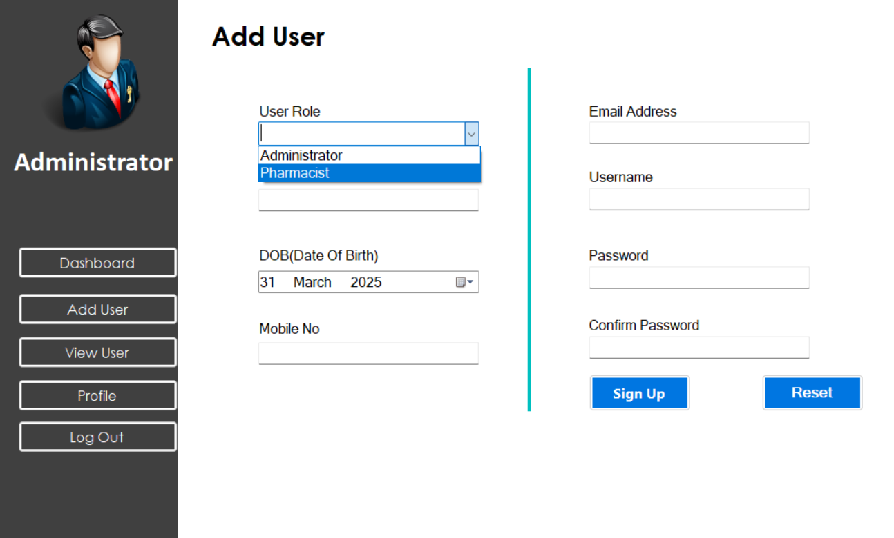

Code:ViewUser.cs

using System;

using System.Collections.Generic;

using System.ComponentModel;

using System.Data;

using System.Data.SqlClient;

using System.Drawing;

using System.Text;

using System.Windows.Forms;

namespace PMS

{

public partial class ViewUser : PMS.Administrator

{

function fn = new function();

string query;

string uid;

public ViewUser(string username1)

{

InitializeComponent();

username = username1;

}

private void ViewUser_Load(object sender, EventArgs e)

{

query = "select * from users";

DataSet ds = fn.getData(query);

dataGridView1.DataSource = ds.Tables[0];

}

private void txtUsername_TextChanged(object sender, EventArgs e)

{

query = $"select * from users where username like '{txtUsername.Text}%'";

DataSet ds = fn.getData(query);

dataGridView1.DataSource = ds.Tables[0];

}

private void label2_Click(object sender, EventArgs e)

{

}

private void dataGridView1_CellClick(object sender, DataGridViewCellEventArgs e)

{

try

{

uid = dataGridView1.Rows[e.RowIndex].Cells[0].Value.ToString();

//MessageBox.Show("Selected ID: " + meddid);

}

catch

{

}

}

private void button6_Click(object sender, EventArgs e)

{

if (dataGridView1.SelectedRows.Count == 0)

{

MessageBox.Show("Please select a row to delete.", "Warning", MessageBoxButtons.OK, MessageBoxIcon.Warning);

return;

}

DialogResult result = MessageBox.Show($"The selected id is {uid} .Are you sure you want to delete this record?", "Confirm Delete", MessageBoxButtons.YesNo, MessageBoxIcon.Warning);

if (result == DialogResult.Yes)

{

try

{

string query = $"delete from users WHERE id = {uid}";

fn.setData(query, "Record deleted successfully!");

ViewUser_Load(sender, null);

}

catch (Exception ex)

{

MessageBox.Show("Error: " + ex.Message, "Deletion Failed", MessageBoxButtons.OK, MessageBoxIcon.Error);

}

}

}

}

}

Summary of the ViewUser Class
- Inheritance
  - ViewUser inherits from Administrator, allowing access to parent class properties and design.
- Constructor
  - Accepts username1 (logged-in user) and assigns it to username.
- Functionalities
  - ViewUser_Load (Form Load Event)
    - Fetches and displays all users from the users table in a DataGridView.
  - txtUsername_TextChanged (Search Users)
    - Filters user records in real-time based on username input.
  - dataGridView1_CellClick (User Selection)
    - Captures the id of the selected row (user) and stores it in uid.
  - button6_Click (Delete User)
    - Ensures a row is selected before attempting deletion.
    - Displays a confirmation message before deleting the user.
    - Deletes the selected user from the database.
    - Reloads the updated user list after deletion.
    - Handles errors if deletion fails.
- Purpose
  - View, search, and delete users in the Pharmacy Management System (PMS).
  - Provides an easy interface for administrators to manage user accounts efficiently.

Output:
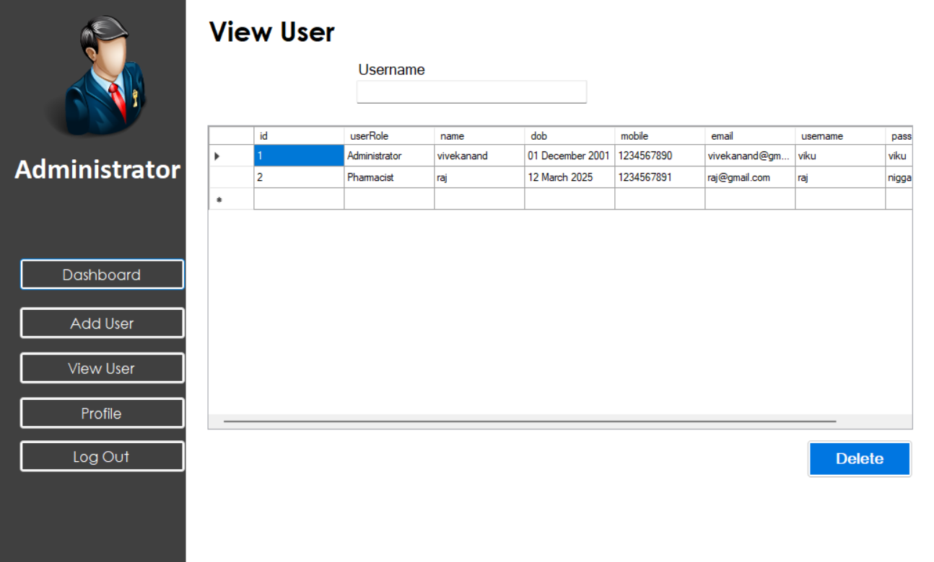
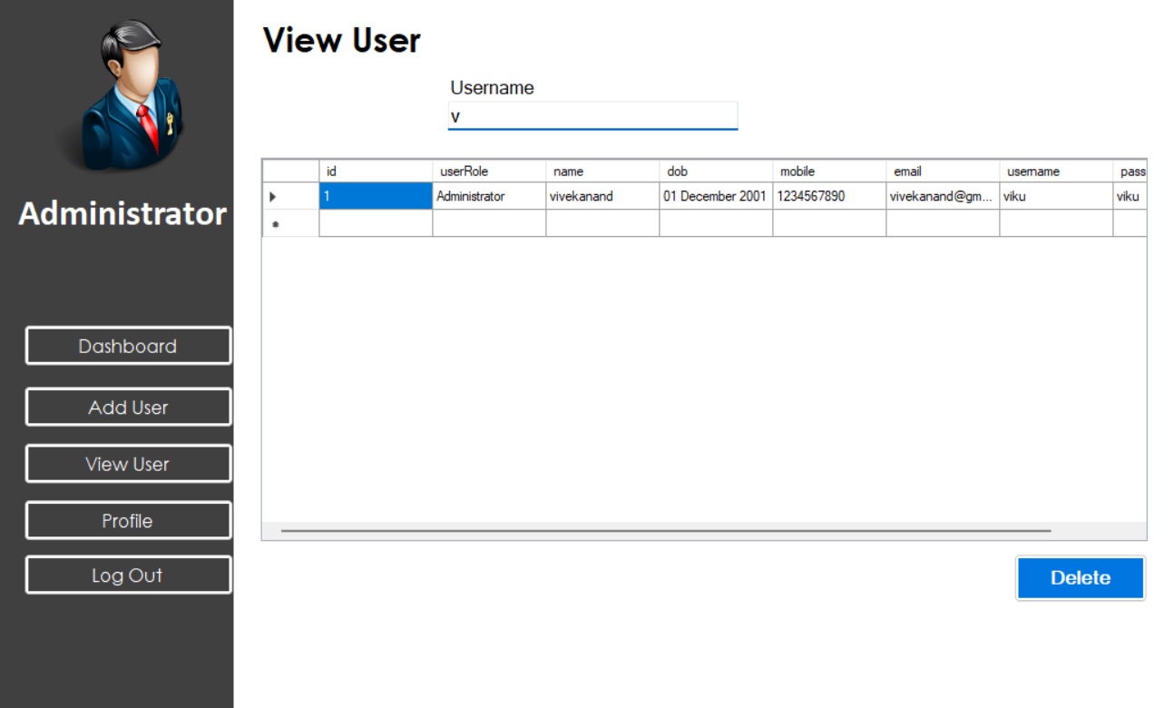
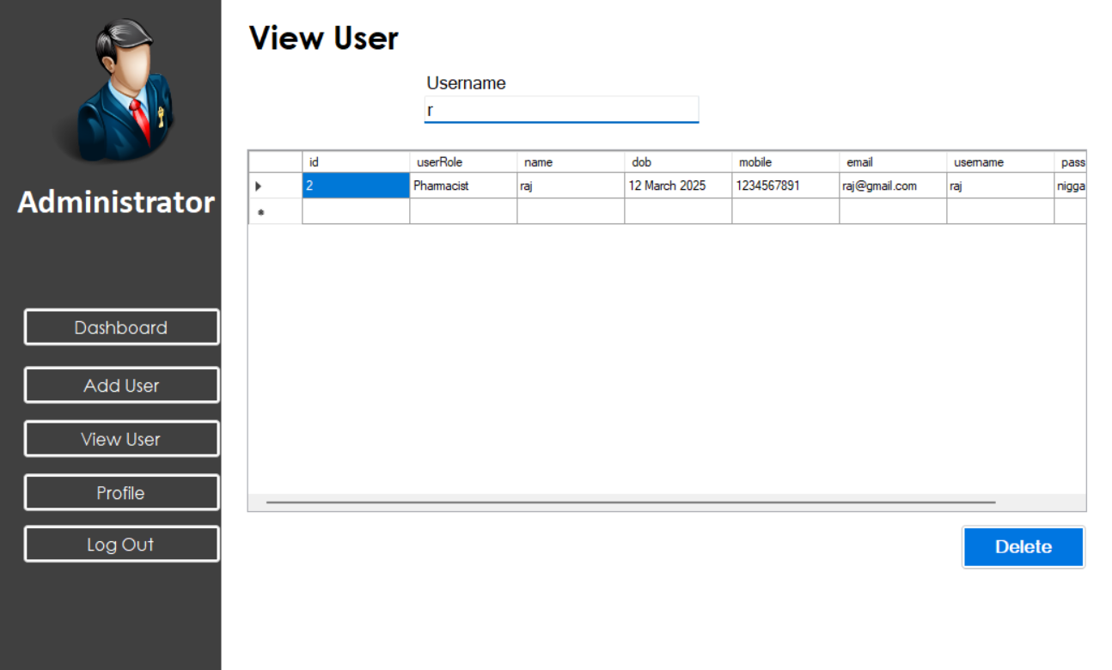

Code:Profile.cs

using System;

using System.Data;

using System.Windows.Forms;

namespace PMS

{

public partial class Profile : Administrator

{

private string username;

function fn = new function(); // Using function class

public Profile(string loginUsername)

{

InitializeComponent();

username = loginUsername;

}

private void Profile_Load(object sender, EventArgs e)

{

try

{

string query = $"SELECT name, email, username, pass, userRole, mobile, dob FROM users WHERE username = '{username }'";

DataSet ds = fn.getData(query);

if (ds.Tables[0].Rows.Count > 0)

{

DataRow row = ds.Tables[0].Rows[0];

txtName.Text = ds.Tables[0].Rows[0]["name"].ToString();

txtEmail.Text = ds.Tables[0].Rows[0]["email"].ToString();

txtUsername.Text = ds.Tables[0].Rows[0]["username"].ToString();

txtPassword.Text = ds.Tables[0].Rows[0]["pass"].ToString();

txtUserRole.Text = ds.Tables[0].Rows[0]["userRole"].ToString();

txtMobile.Text = ds.Tables[0].Rows[0]["mobile"].ToString();

dtpDOB.Text = ds.Tables[0].Rows[0]["dob"].ToString();

}

}

catch (Exception ex)

{

MessageBox.Show("Error loading profile: " + ex.Message, "Error", MessageBoxButtons.OK, MessageBoxIcon.Error);

}

}

private void btnUpdate_Click(object sender, EventArgs e)

{

string name = txtName.Text;

string email = txtEmail.Text;

string password = txtPassword.Text;

string role = txtUserRole.Text;

string mobile = txtMobile.Text;

string dob = dtpDOB.Value.ToString("yyyy-MM-dd");

if (name=="" || email == "" || password == "")

{

MessageBox.Show("Please fill in all fields!", "Validation Error", MessageBoxButtons.OK, MessageBoxIcon.Warning);

return;

}

try

{

string query = $"update users set name='{name}', email='{email}', pass='{password}', userRole='{role}', mobile='{mobile}', dob='{dob}' where username='{username}'";

fn.setData(query, "Profile Updated Successfully!");

}

catch (Exception ex)

{

MessageBox.Show("Error updating profile: " + ex.Message, "Error", MessageBoxButtons.OK, MessageBoxIcon.Error);

}

}

private void btnReset_Click(object sender, EventArgs e)

{

Profile_Load(sender, e);

}

}

}

The Profile class in the Pharmacy Management System (PMS) allows users to view and update their profile information.
- Constructor: It initializes the profile form and stores the logged-in username for fetching and updating data.
- Profile Load Event: When the form loads, it retrieves the user's name, email, username, password, role, mobile number, and date of birth from the database and displays them in the respective fields. If there's an error in data retrieval, an error message is displayed.
- Update Profile: When the user clicks the update button, the system checks if the name, email, and password fields are filled. If they are valid, an update query modifies the profile information in the database, and a success message is shown. Otherwise, an error message appears.
- Reset Profile Data: If the user clicks the reset button, the original data is reloaded from the database, discarding any unsaved changes.
This class ensures a smooth and user-friendly experience for managing user profiles in the PMS system.

Output:
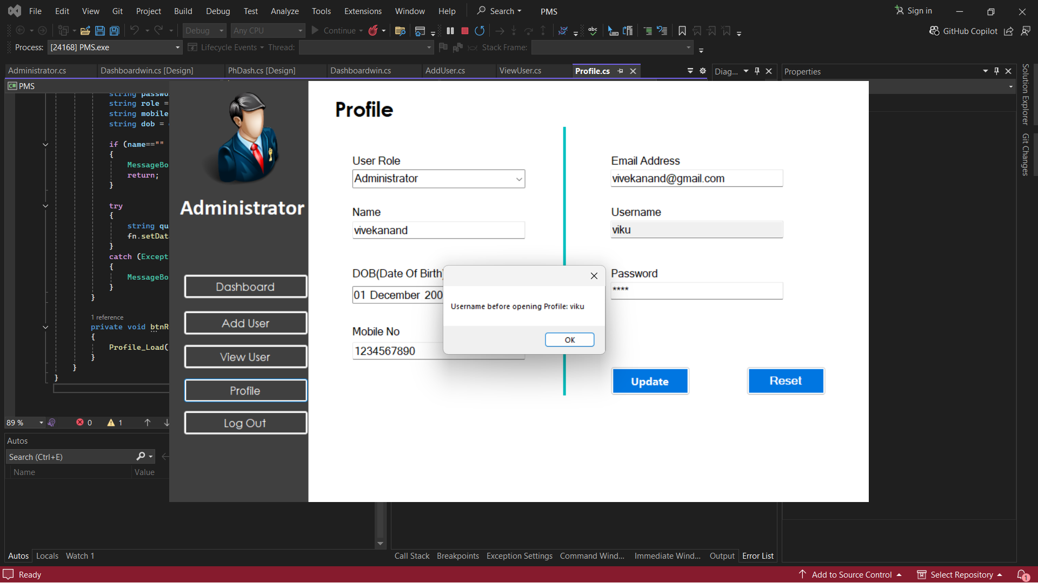
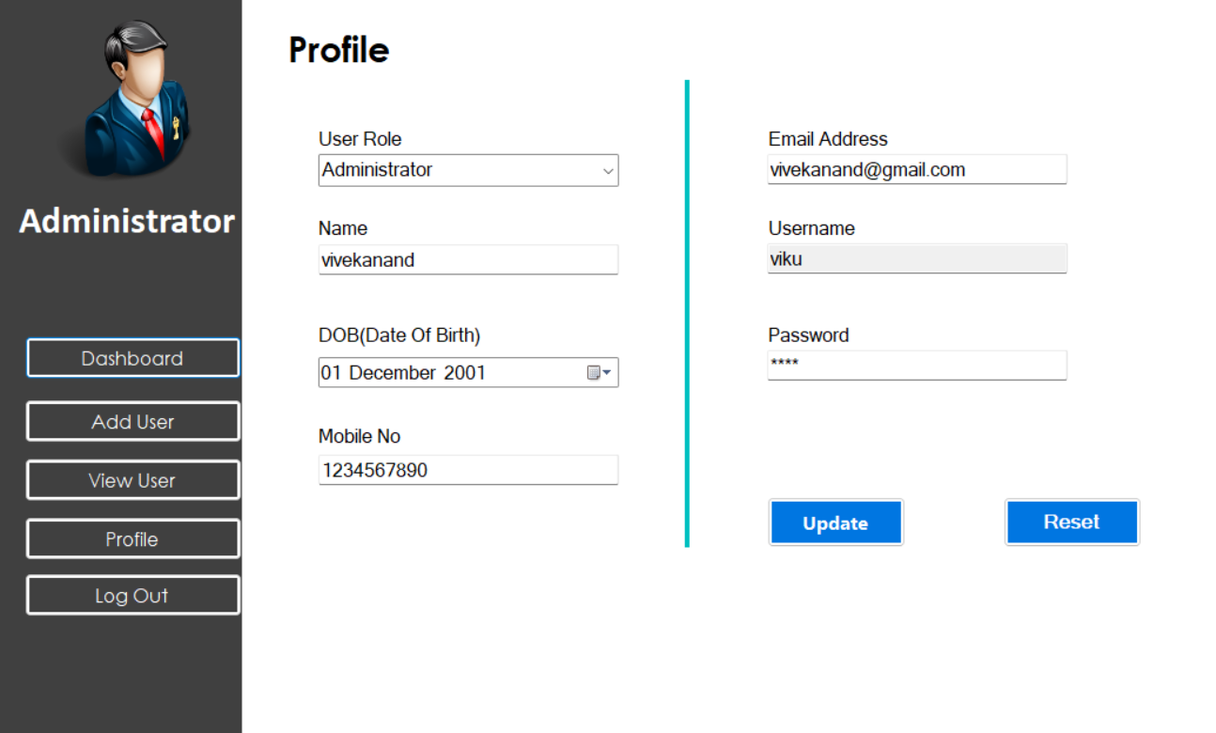

If Logged In as Pharmacist then: The application takes you to the Pharmacist page.
Code:Pharmacist.cs
using System;
using System.Collections.Generic;
using System.ComponentModel;
using System.Data;
using System.Drawing;
using System.Linq;
using System.Text;
using System.Threading.Tasks;
using System.Windows.Forms;

namespace PMS
{
public partial class Pharmacist : Form
{
public Pharmacist()
{
InitializeComponent();
}

private void Pharmacist_Load(object sender, EventArgs e)
{
//button1.PerformClick();

}

private void button5_Click(object sender, EventArgs e)
{
Form1 f = new Form1();
f.Show();
this.Hide();
}

private void button1_Click(object sender, EventArgs e)
{
PhDash d = new PhDash();
d.Show();
this.Hide();
}

private void button2_Click(object sender, EventArgs e)
{
AddMed addMed = new AddMed();
addMed.Show();
this.Hide();
}

private void button3_Click(object sender, EventArgs e)
{
ViewMed viewMed = new ViewMed();
viewMed.Show();
this.Hide();
}

private void button6_Click(object sender, EventArgs e)
{
UpdateMed um = new UpdateMed();
um.Show();
this.Hide();
}

private void button4_Click(object sender, EventArgs e)
{
Sales s = new Sales();
s.Show();
this.Hide();
}
}
}

The Pharmacist page in the Pharmacy Management System (PMS) serves as a navigation dashboard similar to the Administrator page. It allows the pharmacist to access different functionalities, including:
- Dashboard Access – Opens the pharmacist's main dashboard (PhDash).
- Medicine Management – Enables adding (AddMed), viewing (ViewMed), and updating (UpdateMed) medicines.
- Sales Management – Allows access to the sales section (Sales).
- Logout Option – Redirects back to the login page (Form1).
This page ensures efficient medicine management and sales tracking, but unlike the Administrator page, it does not handle user management.

Output:


Code:PhDash.cs
using System;
using System.Collections.Generic;
using System.ComponentModel;
using System.Data;
using System.Drawing;
using System.Text;
using System.Windows.Forms;

namespace PMS
{
public partial class PhDash : PMS.Pharmacist
{
public PhDash()
{
InitializeComponent();
}

private void PhDash_Load(object sender, EventArgs e)
{
LoadChartData();
}

private void chart1_Click(object sender, EventArgs e)
{

}

public void LoadChartData()
{
function fn = new function();
string query = "SELECT eDate FROM medic";
DataSet ds = fn.getData(query);

int emc = 0, vmc = 0;
DateTime today = DateTime.Now;

foreach (DataRow row in ds.Tables[0].Rows)
{
DateTime expiryDate = Convert.ToDateTime(row["eDate"]);
if (expiryDate < today) emc++;
else vmc++;
}

chart1.Series.Clear();// used to clear previous data chart

chart1.Series.Add("Expired Medicines");
chart1.Series.Add("Valid Medicines");

// uisedd to adding data points
chart1.Series["Expired Medicines"].Points.AddY(emc);
chart1.Series["Valid Medicines"].Points.AddY(vmc);

}

}
}

Summary of the PhDash Page
The PhDash (Pharmacist Dashboard) page in the Pharmacy Management System (PMS) serves as the main dashboard for pharmacists. It provides visual insights into medicine stock by displaying a chart that categorizes medicines based on their expiration status.

Key Functionalities:
- Chart Data Loading (LoadChartData Method)
  - Retrieves medicine expiry dates from the database (medic table).
  - Counts the number of expired and valid medicines.
  - Displays this data in a chart with two categories:
    - Expired Medicines
    - Valid Medicines
- Automatic Chart Update (PhDash_Load Method)
  - Calls LoadChartData() when the page loads to refresh the chart with the latest data.
- Chart Interaction (chart1_Click Method)
  - (Currently unused but can be expanded for interactivity).
This page helps pharmacists monitor medicine expiration trends and manage inventory efficiently.

Output:
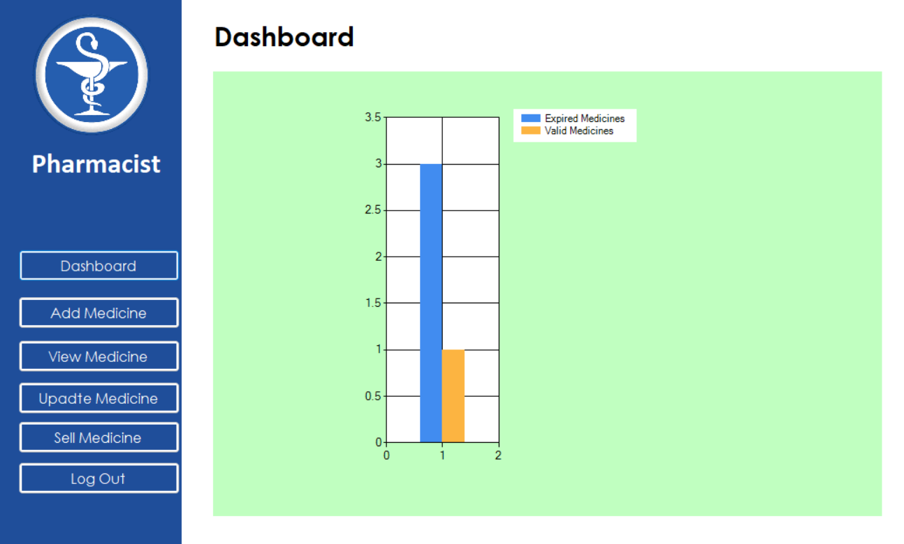

Code:AddMed.cs

using System;

using System.Collections.Generic;

using System.ComponentModel;

using System.Data;

using System.Drawing;

using System.Data.SqlClient;

using System.Text;

using System.Windows.Forms;

namespace PMS

{

public partial class AddMed : PMS.Pharmacist

{

function f = new function();

String query;

public AddMed()

{

InitializeComponent();

}

private void btnAdd_Click(object sender, EventArgs e)

{

if (txtMedID.Text != "" && txtMedName.Text != "" && txtMedNo.Text != "" && txtMedQuant.Text != "" && txtMedppu.Text != "")

{

String mid = txtMedID.Text;

String midName = txtMedName.Text;

String midNo = txtMedNo.Text;

String midQuant = txtMedQuant.Text;

String midppu = txtMedppu.Text;

String midmfg = dtpMedMgf.Value.ToString("yyyy-MM-dd");

String midexp = dtpMedExp.Value.ToString("yyyy-MM-dd");

query = $"INSERT INTO medic (mid, mname, mnumber, mDate, eDate, quantity, perUnit) " +

$"VALUES ('{mid}', '{midName}', '{midNo}', '{midmfg}', '{midexp}', '{midQuant}', '{midppu}')";

try

{

f.setData(query, "Medicine added successfully!");

}

catch (Exception ex)

{

MessageBox.Show("Error: " + ex.Message, "Error", MessageBoxButtons.OK, MessageBoxIcon.Error);

}

}

else

{

MessageBox.Show("Please fill all the required fields.", "Validation Error", MessageBoxButtons.OK, MessageBoxIcon.Warning);

}

}

private void btnReset_Click(object sender, EventArgs e)

{

txtMedID.Text = "";

txtMedName.Text = "";

txtMedNo.Text = "";

txtMedQuant.Text = "";

txtMedppu.Text = "";

dtpMedMgf.Value = DateTime.Now;

dtpMedExp.Value = DateTime.Now;

}

private void AddMed_Load(object sender, EventArgs e)

{

}

}

}

Summary of the AddMed Page
The AddMed page in the Pharmacy Management System (PMS) allows pharmacists to add new medicines to the database. It ensures proper data entry for medicines, including their details, manufacturing date, and expiry date.

Key Functionalities:

1. Adding Medicine (btnAdd_Click Method)
- Checks if all required fields (Medicine ID, Name, Number, Quantity, and Price per Unit) are filled.
- Captures medicine details from input fields:
  - Medicine ID, Name, Number, Quantity, Price per Unit.
  - Manufacturing Date & Expiry Date (selected using date pickers).
- Inserts this data into the medic table in the database using an INSERT SQL query.
- Displays a success message if the medicine is added successfully.
- Shows an error message if there is a problem inserting data.

2. Resetting the Form (btnReset_Click Method)
- Clears all input fields.
- Resets the Manufacturing Date and Expiry Date to the current date.

3. Page Load (AddMed_Load Method)
- Currently unused but can be expanded to initialize settings when the form loads.

Output:
- If successful, a confirmation message:
"Medicine added successfully!"
- If a required field is missing, a validation warning appears.
- If an error occurs while inserting data into the database, an error message is displayed.
This page ensures proper medicine inventory management by allowing pharmacists to add new medicines efficiently.

Output:
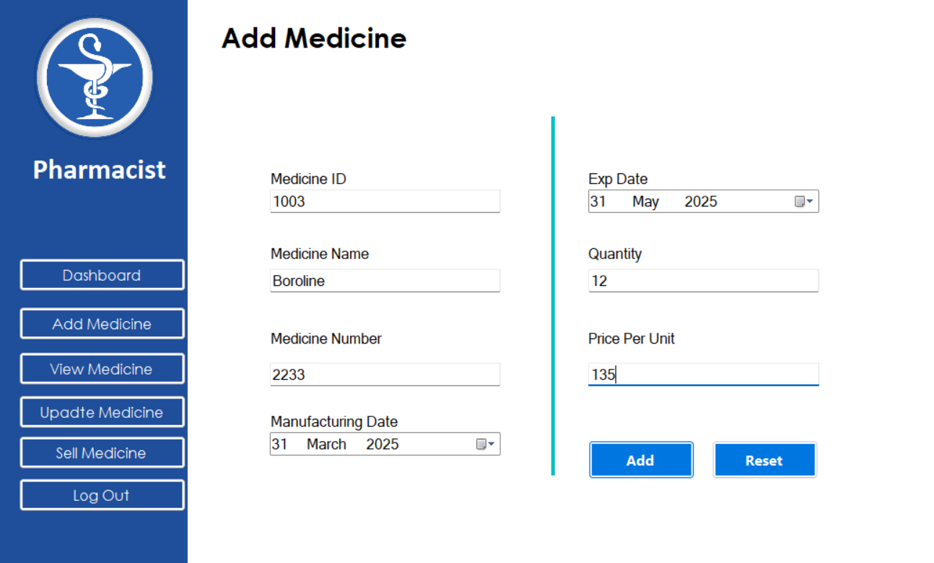
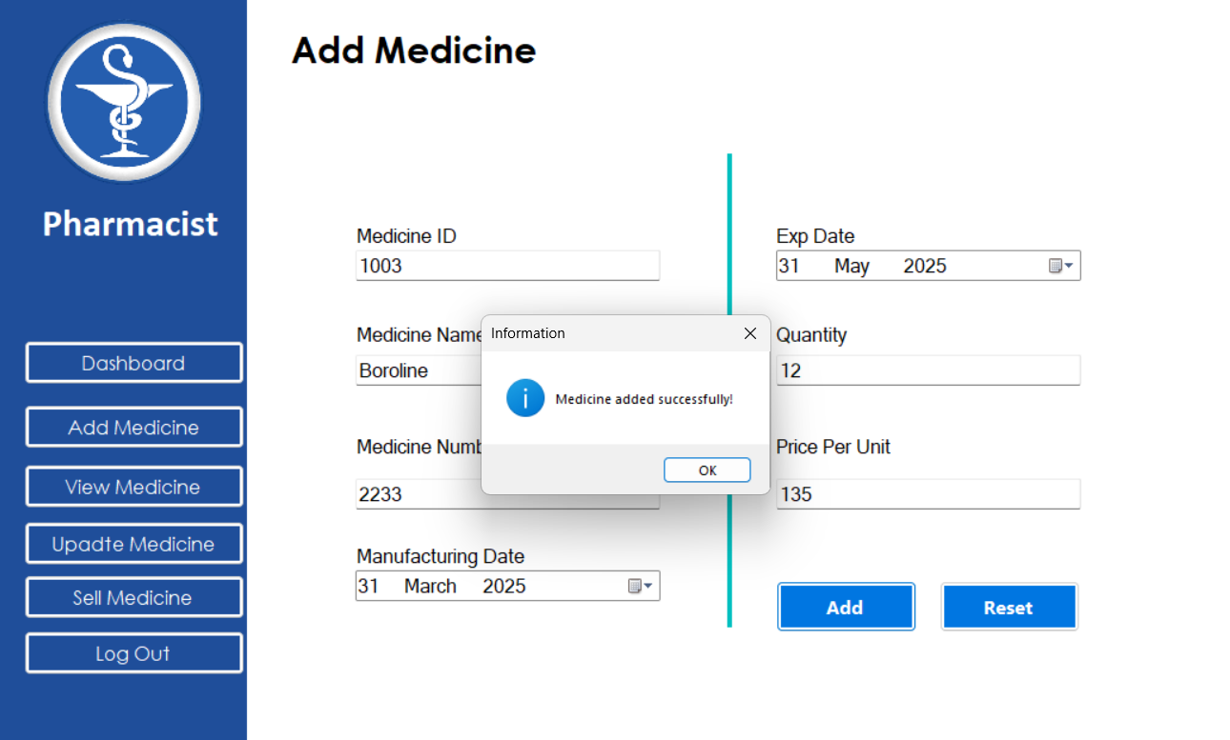

Code:ViewMed.cs

using System;

using System.Collections;

using System.Collections.Generic;

using System.ComponentModel;

using System.Data;

using System.Drawing;

using System.Text;

using System.Web;

using System.Windows.Forms;

namespace PMS

{

public partial class ViewMed : PMS.Pharmacist

{

function fn = new function();

string query;

string meddid;

public ViewMed()

{

InitializeComponent();

}

private void ViewMed_Load(object sender, EventArgs e)

{

query = "select * from medic";

DataSet ds = fn.getData(query);

dataGridView1.DataSource = ds.Tables[0];

}

private void textBox1_TextChanged(object sender, EventArgs e)

{

query = "select * from medic where mname like '" + textBox1.Text + "%'"; //a%

DataSet ds = fn.getData(query);

dataGridView1.DataSource = ds.Tables[0];

}

private void dataGridView1_CellClick(object sender, DataGridViewCellEventArgs e)

{

try

{

meddid = dataGridView1.Rows[e.RowIndex].Cells[0].Value.ToString();

//MessageBox.Show("Selected ID: " + meddid);

}

catch

{

}

}

private void button6_Click(object sender, EventArgs e)

{

if (dataGridView1.SelectedRows.Count == 0)

{

MessageBox.Show("Please select a row to delete.", "Warning", MessageBoxButtons.OK, MessageBoxIcon.Warning);

return;

}

DialogResult result = MessageBox.Show($"The selected id is {meddid} .Are you sure you want to delete this record?", "Confirm Delete", MessageBoxButtons.YesNo, MessageBoxIcon.Warning);

if (result == DialogResult.Yes)

{

try

{

string query = $"DELETE FROM medic WHERE id = {meddid}";

//function fn = new function();

fn.setData(query, "Record deleted successfully!");

ViewMed_Load(sender,null);

}

catch (Exception ex)

{

MessageBox.Show("Error: " + ex.Message, "Deletion Failed", MessageBoxButtons.OK, MessageBoxIcon.Error);

}

}

}

}

}

Summary of the ViewMed Page
The ViewMed page in the Pharmacy Management System (PMS) allows pharmacists to view, search, and delete medicines from the database. It provides a data grid for displaying medicine details and includes a search feature for filtering medicines by name.

Key Functionalities:

1. Displaying Medicine Data (ViewMed_Load Method)
- Retrieves all medicine records from the medic table.
- Displays the data in a DataGridView (a table format).

2. Searching for Medicines (textBox1_TextChanged Method)
- Filters the medicine list based on user input in the search box.
- Displays only the medicines whose names start with the entered text.

3. Selecting a Medicine (dataGridView1_CellClick Method)
- Captures the Medicine ID when a row in the DataGridView is clicked.
- Stores the selected ID for deletion purposes.

4. Deleting a Medicine (button6_Click Method)
- Ensures that a row is selected before deletion.
- Asks for confirmation before deleting the record.
- Deletes the selected medicine from the medic table.
- Refreshes the DataGridView after successful deletion.
- Displays a confirmation message or an error message if deletion fails.

Output:
- Displays all medicines in a table format.
- Allows real-time search for medicines.
- Shows a confirmation message when a medicine is deleted.
- Displays error messages for failed operations.
This page enhances medicine management efficiency by providing easy searching and deletion functionalities for pharmacists.

Output:
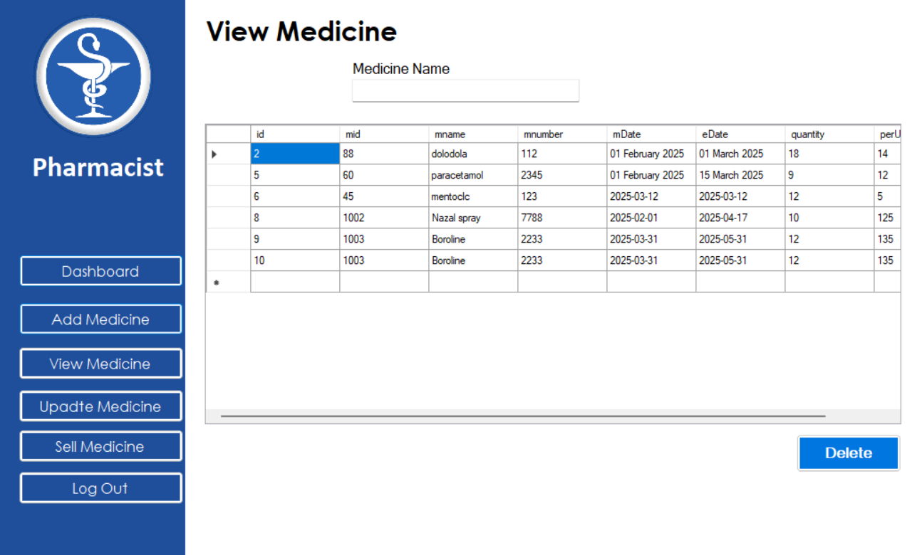
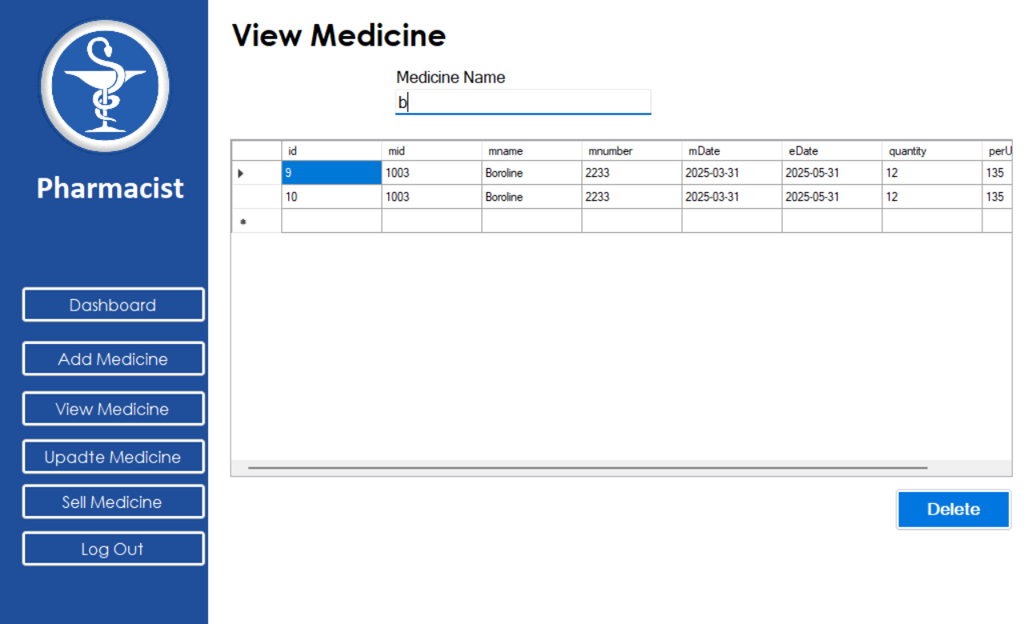

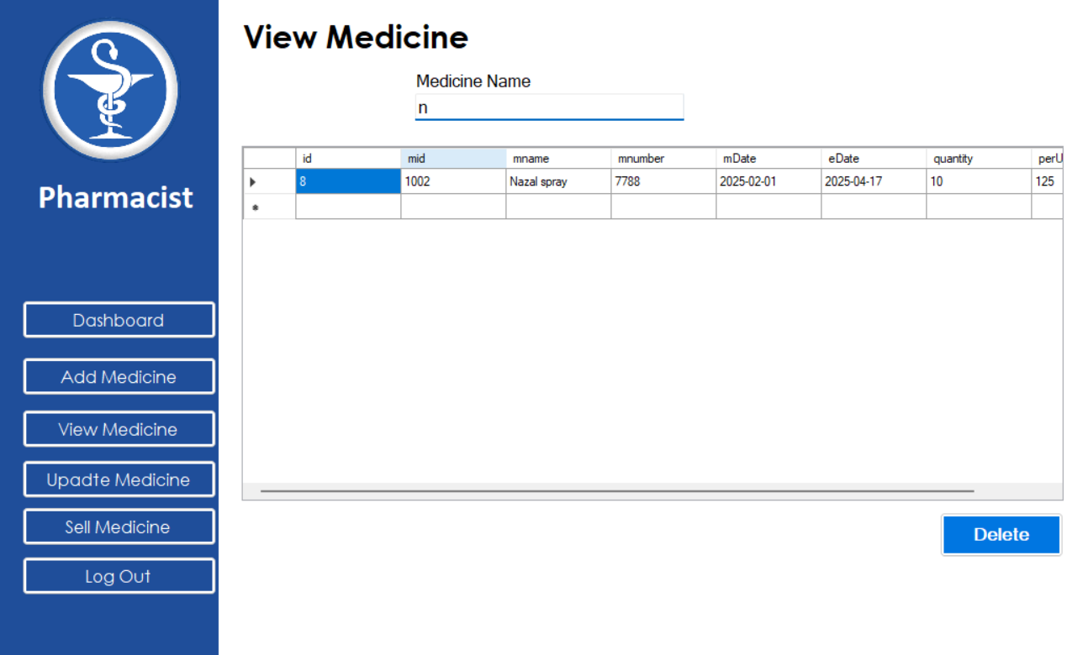

Code:UpdateMed.cs

using System;

using System.Collections.Generic;

using System.ComponentModel;

using System.Data;

using System.Drawing;

using System.Text;

using System.Windows.Forms;

namespace PMS

{

public partial class UpdateMed : PMS.Pharmacist

{

function fn = new function();

DataSet ds = new DataSet();

String query;

Int64 ttlquant;

public UpdateMed()

{

InitializeComponent();

}

private void UpdateMed_Load(object sender, EventArgs e)

{

}

private void button7_Click(object sender, EventArgs e)

{

if (txtMedID.Text != "")

{

query = $"select * from medic where mid = {txtMedID.Text}";

DataSet ds = fn.getData(query);

if (ds.Tables[0].Rows.Count != 0)

{

txtMedName.Text = ds.Tables[0].Rows[0][2].ToString();

txtMedNo.Text = ds.Tables[0].Rows[0][3].ToString();

dtpMedMgf.Text = ds.Tables[0].Rows[0][4].ToString();

dtpMedExp.Text = ds.Tables[0].Rows[0][5].ToString();

txtAddQuant.Text = "0";

txtMedQuant.Text = ds.Tables[0].Rows[0][6].ToString();

txtMedppu.Text = ds.Tables[0].Rows[0][7].ToString();

}

else

{

MessageBox.Show($"No Medicine found with ID: {txtMedID.Text}", "Information", MessageBoxButtons.OK, MessageBoxIcon.Information);

}

}

else

{

MessageBox.Show($"Medicine ID not provided", "Requirement", MessageBoxButtons.OK, MessageBoxIcon.Information);

clearall();

}

}

private void clearall()

{

txtMedID.Text = string.Empty;

txtMedName.Text = string.Empty;

txtMedNo.Text = string.Empty;

txtMedppu.Text = string.Empty;

txtMedQuant.Text = string.Empty;

dtpMedExp.Value = DateTime.Now;

dtpMedMgf.Value = DateTime.Now;

txtAddQuant.Text = string.Empty;

}

private void btnUpdate_Click(object sender, EventArgs e)

{

if (txtMedID.Text == "")

{

MessageBox.Show("Medicine ID is not provided", "Requirement", MessageBoxButtons.OK, MessageBoxIcon.Warning);

}

else

{

string mname = txtMedName.Text;

string mnumber = txtMedNo.Text;

string mdate = dtpMedMgf.Text;

string edate = dtpMedExp.Text;

Int64 quant = Int64.Parse(txtMedQuant.Text);

Int64 ppu = (Int64.Parse(txtMedppu.Text));

Int64 addquant = Int64.Parse(txtAddQuant.Text);

ttlquant = quant + addquant;

query = $"update medic set mname='{mname}',mnumber='{mnumber}',mDate='{mdate}',eDate='{edate}',quantity={ttlquant},perUnit={ppu} where mid = {txtMedID.Text}";

fn.setData(query, "Medicine Updated Successfully");

}

}

private void btnReset_Click(object sender, EventArgs e)

{

if (txtMedID.Text == "")

{

clearall();

}

else

{

try

{

query = $"SELECT * FROM medic WHERE mid = {txtMedID.Text}";

DataSet ds = fn.getData(query);

if (ds.Tables[0].Rows.Count != 0)

{

txtMedName.Text = ds.Tables[0].Rows[0][2].ToString();

txtMedNo.Text = ds.Tables[0].Rows[0][3].ToString();

dtpMedMgf.Text = ds.Tables[0].Rows[0][4].ToString();

dtpMedExp.Text = ds.Tables[0].Rows[0][5].ToString();

txtAddQuant.Text = "0";

txtMedQuant.Text = ds.Tables[0].Rows[0][6].ToString();

txtMedppu.Text = ds.Tables[0].Rows[0][7].ToString();

}

else

{

MessageBox.Show("No medicine found with this ID.", "Information", MessageBoxButtons.OK, MessageBoxIcon.Information);

clearall();

}

}

catch (Exception ex)

{

MessageBox.Show("Error: " + ex.Message, "Error", MessageBoxButtons.OK, MessageBoxIcon.Error);

}

}

}

}

}

Summary of the UpdateMed Page
The UpdateMed page in the Pharmacy Management System (PMS) allows pharmacists to retrieve, update, and reset medicine records. It enables users to fetch a medicine by its ID, update its details, and modify the quantity available.

Key Functionalities:

1. Fetching Medicine Details (button7_Click Method)
- Retrieves medicine details based on the entered Medicine ID (txtMedID).
- If found, it displays the details (name, number, manufacturing date, expiry date, quantity, and price per unit).
- If the medicine is not found, a message is displayed.

2. Updating Medicine Information (btnUpdate_Click Method)
- Ensures a valid Medicine ID is entered before updating.
- Retrieves and updates:
  - Medicine Name
  - Medicine Number
  - Manufacturing Date
  - Expiry Date
  - Quantity (existing + newly added quantity)
  - Price per Unit
- Displays a confirmation message on successful update.

3. Resetting Fields (btnReset_Click Method)
- If no Medicine ID is provided, it clears all input fields.
- If an ID is provided, it reloads the original medicine details from the database.
- If the ID is invalid, it displays a warning message and clears fields.

4. Clearing Fields (clearall() Method)
- Resets all text fields, including medicine name, number, quantity, price, and dates.

Output:
Before Update: Have a look on medicine of mid 60.
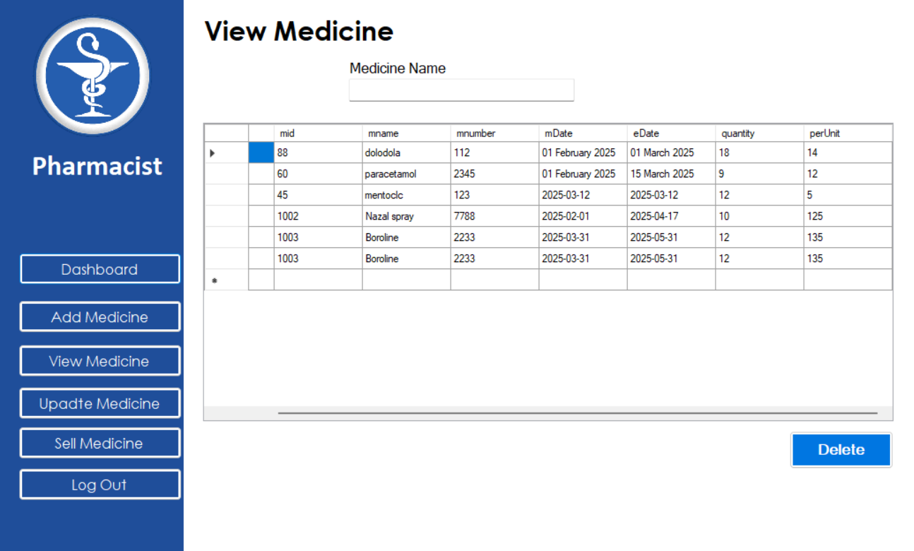
After update: Here i changed the quantity of medicine of med id 60.
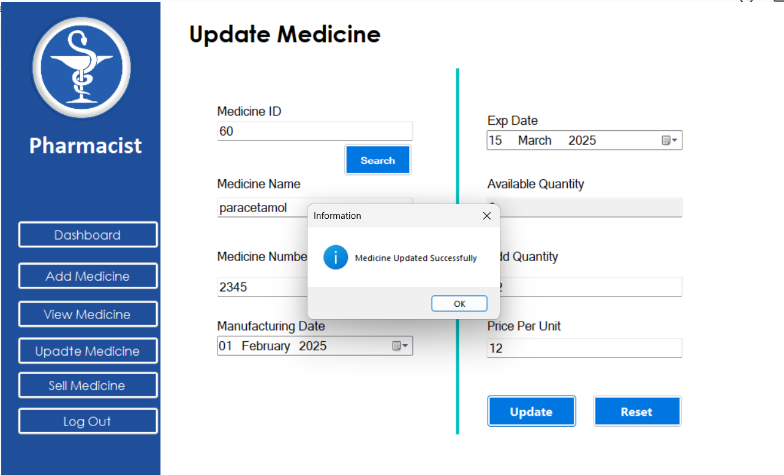

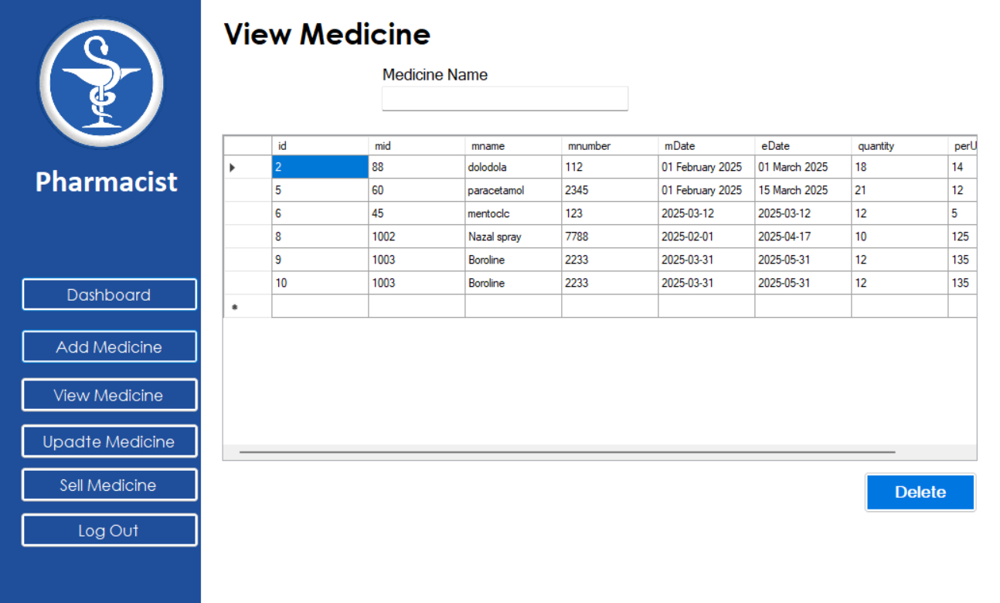

Code:Sales.cs

using System;

using System.Collections.Generic;

using System.ComponentModel;

using System.Data;

using System.Drawing;

using System.Text;

using System.Windows.Forms;

namespace PMS

{

public partial class Sales : PMS.Pharmacist

{

function fn = new function();

String query;

DataSet ds;

public Sales()

{

InitializeComponent();

}

private void Sales_Load(object sender, EventArgs e)

{

query = $"select mname from medic where eDate>getdate() and quantity>0";

ds = fn.getData(query);

for(int i = 0; i < ds.Tables[0].Rows.Count; i++)

{

listBox1.Items.Add(ds.Tables[0].Rows[i]["mname"].ToString());

}

}

private void textBox1_TextChanged(object sender, EventArgs e)

{

listBox1.Items.Clear();

query = $"select mname from medic where mname like '{textBox1.Text}%' and eDate>getdate() and quantity>0";

ds = fn.getData(query);

for (int i = 0; i < ds.Tables[0].Rows.Count; i++)

{

listBox1.Items.Add(ds.Tables[0].Rows[i]["mname"].ToString());

}

}

private void listBox1_SelectedIndexChanged(object sender, EventArgs e)

{

txtUnits.Clear();

String name = listBox1.GetItemText(listBox1.SelectedItem);

txtMedName.Text = name;

query = $"select mid,eDate,perUnit,quantity from medic where mname = '{txtMedName.Text}'";

ds = fn.getData(query);

if (ds.Tables[0].Rows.Count > 0)

{

txtMedID.Text = ds.Tables[0].Rows[0]["mid"].ToString();

txtMedppu.Text = ds.Tables[0].Rows[0]["perUnit"].ToString();

dtpMedExp.Text = ds.Tables[0].Rows[0]["eDate"].ToString();

}

else

{

MessageBox.Show("No data found for the selected medicine.", "Error", MessageBoxButtons.OK, MessageBoxIcon.Warning);

}

}

private void txtUnits_TextChanged(object sender, EventArgs e)

{

if (txtUnits.Text !="")

{

Int64 eu = Int64.Parse(txtUnits.Text);

Int64 availqty = Int64.Parse(ds.Tables[0].Rows[0]["quantity"].ToString());

if (eu <= availqty)

{

Int64 up = Int64.Parse(txtMedppu.Text);

Int64 ttl = up * eu;

textBox2.Text = ttl.ToString();

}

else

{

MessageBox.Show("Entered units exceed available stock!", "Error", MessageBoxButtons.OK, MessageBoxIcon.Warning);

txtUnits.Clear();

}

}

else

{

textBox2.Clear();

MessageBox.Show("Enter valid purchasing units.", "Required", MessageBoxButtons.OK, MessageBoxIcon.Information);

}

}

private void button7_Click(object sender, EventArgs e)

{

txtMedID.Clear();

txtMedName.Clear();

txtMedppu.Clear();

txtUnits.Clear();

dtpMedExp.ResetText();

textBox2.Clear();

}

private void button8_Click(object sender, EventArgs e)

{

String expDate = dtpMedExp.Text;

Int64 units, pricePerUnit, totalAmount;

if (txtMedID.Text == "" || txtMedName.Text=="" || txtMedppu.Text=="" || txtUnits.Text =="")

{

MessageBox.Show("Please select the valid medicine and enter the purchasing units.", "Error", MessageBoxButtons.OK, MessageBoxIcon.Error);

return;

}

else {

units = Int64.Parse(txtUnits.Text);

pricePerUnit = Int64.Parse(txtMedppu.Text);

totalAmount = Int64.Parse(textBox2.Text);

String message = $"Medicine Purchased!\n\n" + $"Expiry Date: {expDate}\n" + $"Units: {units}\n" + $"Price per Unit: {pricePerUnit}\n" + $"Total Amount: {totalAmount}";

MessageBox.Show(message, "Purchase Confirmation", MessageBoxButtons.OK, MessageBoxIcon.Information);

DeductMedicineStock(units);

}

}

private void DeductMedicineStock(Int64 purchasedunit)

{

try

{

string medicinename = listBox1.SelectedItem.ToString();

string query = $"update medic set quantity = quantity - {purchasedunit} where mname = '{medicinename}'";

fn.setData(query, "Stock updated successfully!");

//MessageBox.Show("Stock updated successfully!", "Success", MessageBoxButtons.OK, MessageBoxIcon.Information);

}

catch (Exception ex)

{

MessageBox.Show($"Database error: {ex.Message}", "Error", MessageBoxButtons.OK, MessageBoxIcon.Error);

}

}

}

}

Summary of the Sales Page in PMS
- The Sales page in the Pharmacy Management System (PMS) allows pharmacists to:
- Search for available medicines
- Select a medicine and view its details
- Enter purchase quantity and calculate the total cost
- Confirm purchase and deduct the stock

Key Functionalities:

1. Loading Available Medicines (Sales_Load Method)
- Fetches medicines that have not expired and are in stock.
- Populates the listBox1 with available medicine names.

2. Searching Medicines (textBox1_TextChanged Method)
- Filters the list of medicines based on user input.
- Updates the list dynamically as the user types.

3. Selecting a Medicine (listBox1_SelectedIndexChanged Method)
- Retrieves and displays:
  - Medicine ID
  - Expiry Date
  - Price per Unit
  - Quantity available
- Clears the previous unit selection field.

4. Entering Purchase Quantity (txtUnits_TextChanged Method)
- Validates if the entered quantity is less than or equal to the available stock.
- Calculates the total amount:
Total Price=Units×Price per Unit\text{Total Price} = \text{Units} \times \text{Price per Unit}Total Price=Units×Price per Unit
- Displays a warning if the entered quantity exceeds stock or is invalid.

5. Resetting Fields (button7_Click Method)
- Clears all input fields and resets the date picker.

6. Confirming Purchase (button8_Click Method)
- Ensures all required fields are filled.
- Displays a purchase confirmation message with:
  - Expiry Date
  - Purchased Units
  - Price per Unit
  - Total Amount
- Calls the DeductMedicineStock method to update stock.

7. Updating Medicine Stock (DeductMedicineStock Method)
- Reduces the available stock of the purchased medicine in the database.
- Displays a confirmation message when stock is updated.

Output: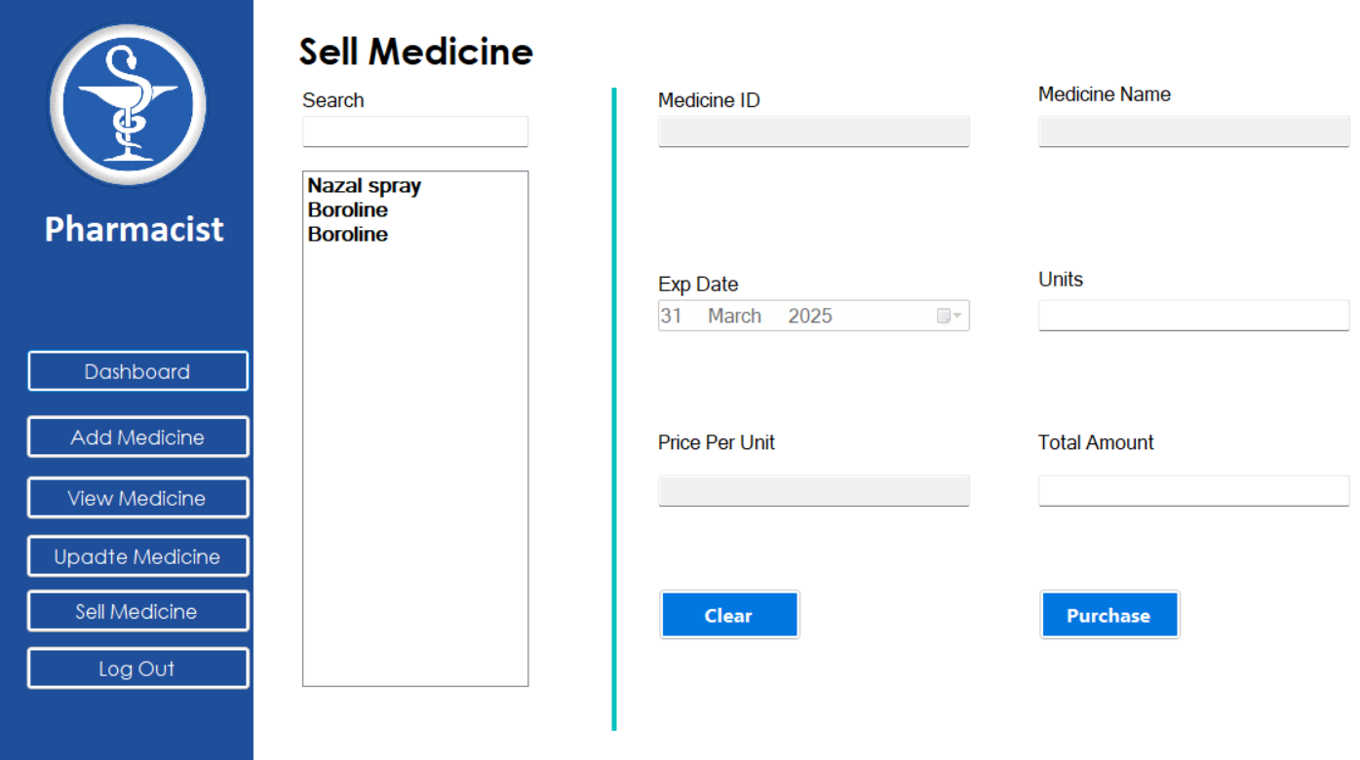
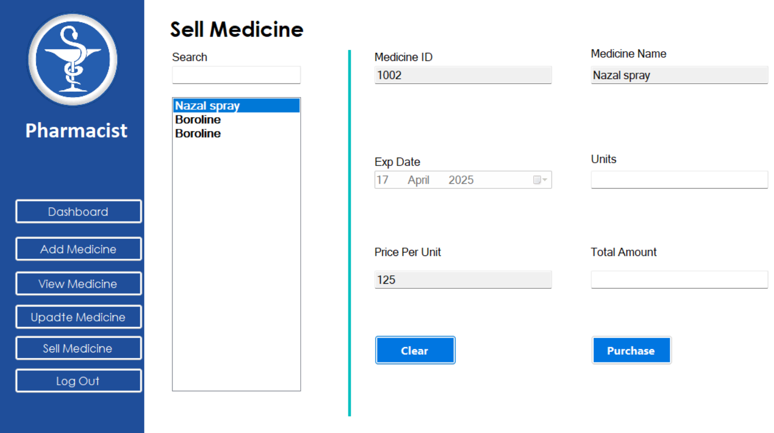
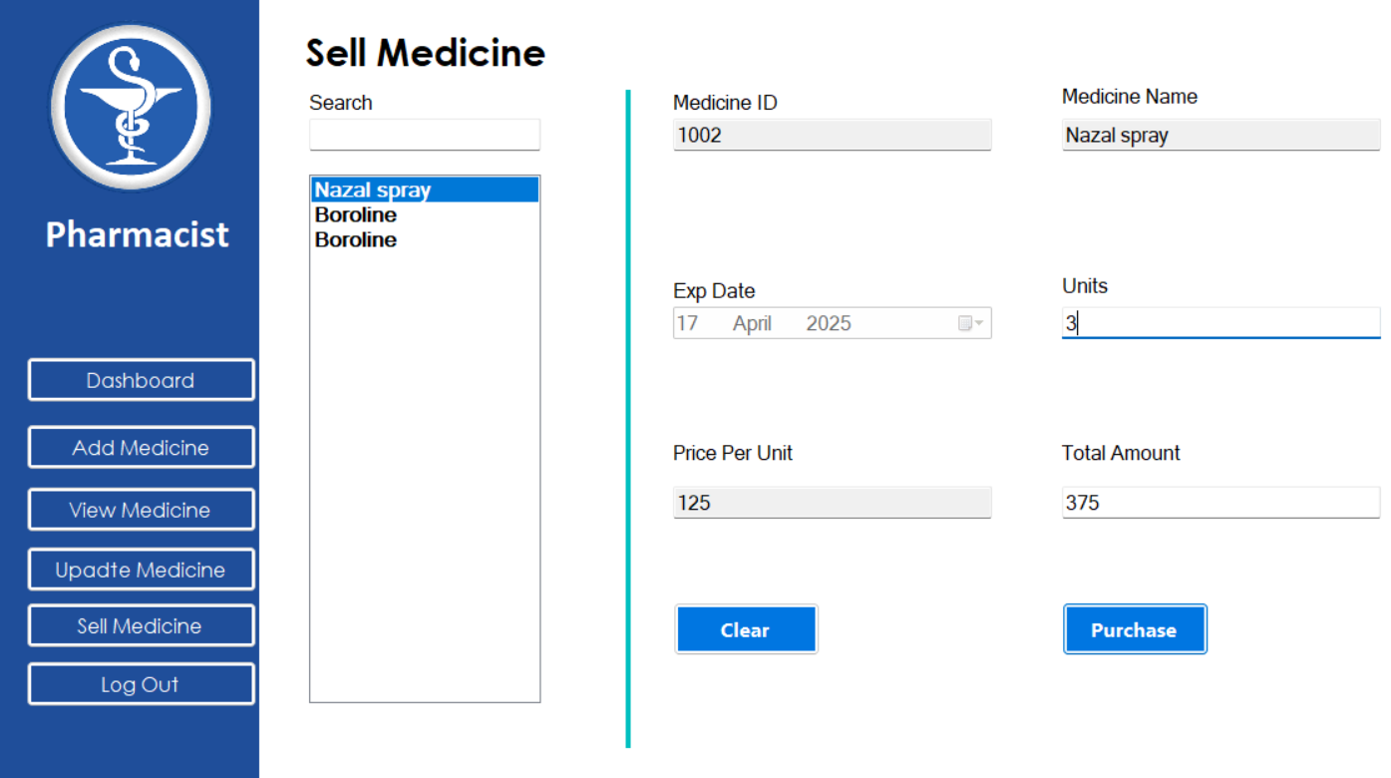
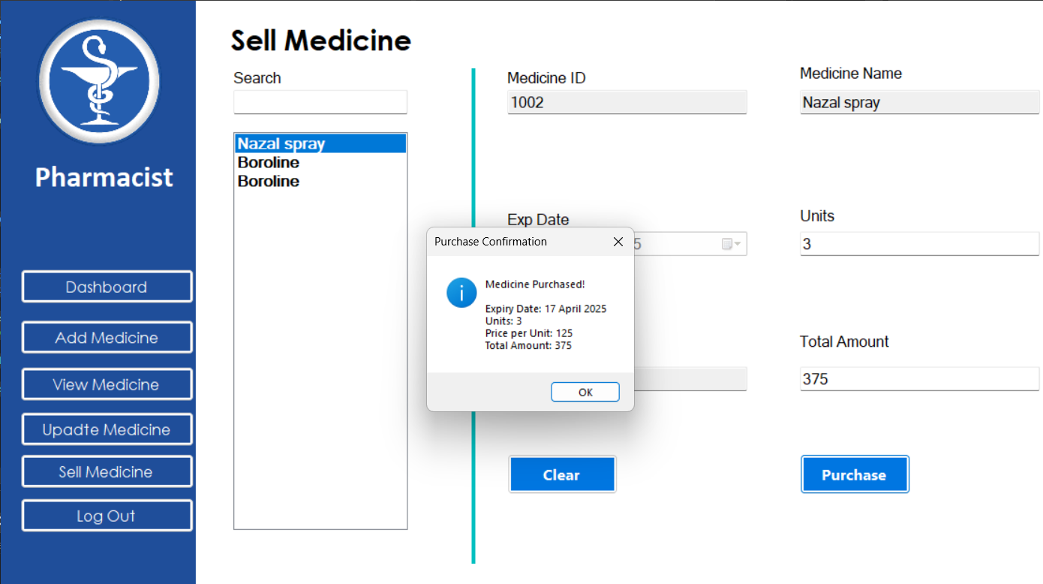
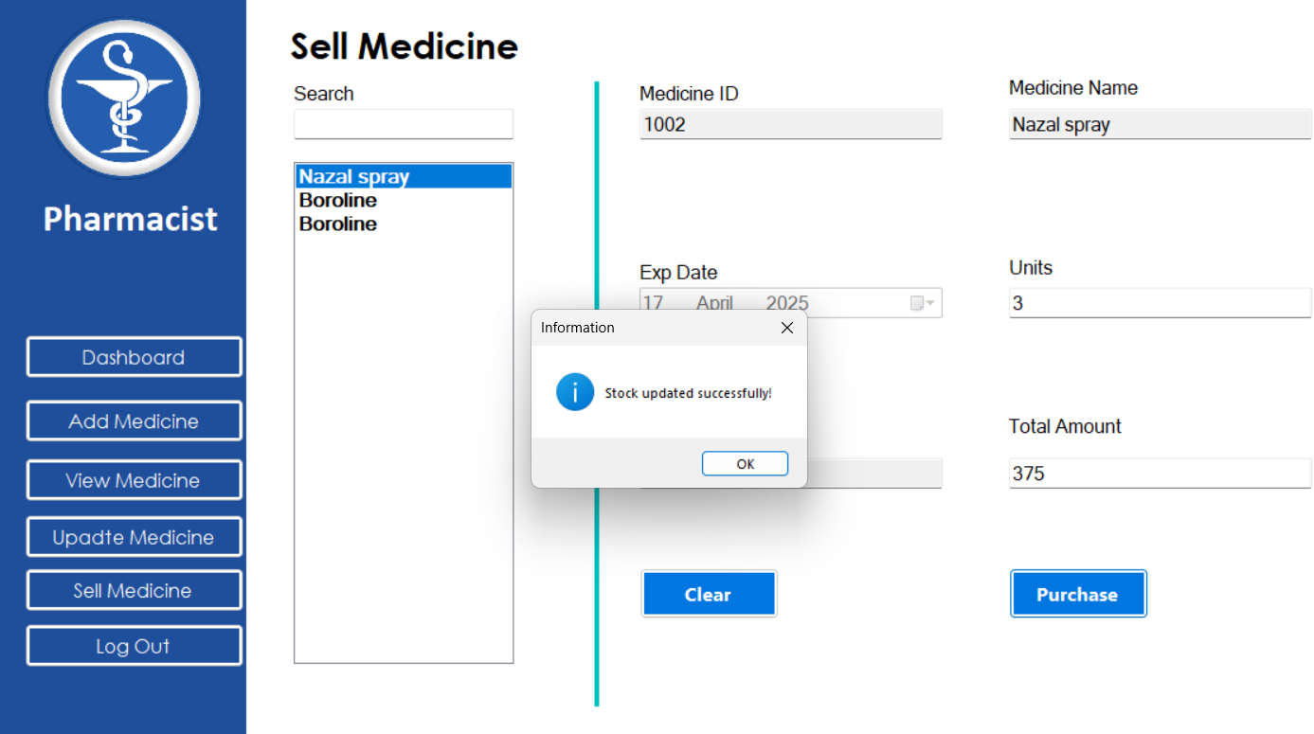
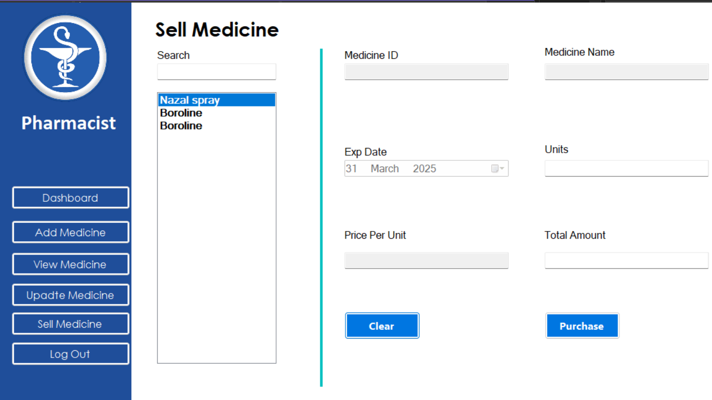

Code: function.cs
using System;
using System.Collections.Generic;
using System.Data;
using System.Data.SqlClient;
using System.Linq;
using System.Text;
using System.Threading.Tasks;
using System.Windows.Forms;

namespace PMS
{
internal class function
{
protected SqlConnection getConnection() {

SqlConnection con = new SqlConnection();
con.ConnectionString = "data source = ANKITA-OT8QKGR2\\TEW_SQLEXPRESS;database=pharmacy;Integrated Security=True";
return con;

}
public DataSet getData(String query)
{
SqlConnection con = getConnection();
SqlCommand cmd = new SqlCommand();
cmd.Connection = con;
cmd.CommandText = query;
SqlDataAdapter da = new SqlDataAdapter(cmd);
DataSet ds = new DataSet();
da.Fill(ds);
return ds;
}

public void setData(String query,String msg)
{
SqlConnection con = getConnection();
SqlCommand cmd = new SqlCommand();
cmd.Connection = con;
con.Open();
cmd.CommandText = query;
cmd.ExecuteNonQuery();
con.Close();
MessageBox.Show(msg,"Information",MessageBoxButtons.OK,MessageBoxIcon.Information);
}
}
}

Summary of the function Class:
The function class in the Pharmacy Management System (PMS) handles database operations using SQL Server.

Key Functionalities:
- getConnection() → Establishes and returns a database connection.
- getData(String query) → Executes a SELECT query and returns the result as a DataSet.
- setData(String query, String msg) → Executes INSERT, UPDATE, or DELETE queries and displays a success message.

Usage:
- This class is a utility/helper for interacting with the database.
- It ensures code reusability for database operations across different forms in the PMS.

Code: Program.cs
using System;
using System.Collections.Generic;
using System.Linq;
using System.Threading.Tasks;
using System.Windows.Forms;

namespace PMS
{
internal static class Program
{
/// <summary>
/// The main entry point for the application.
/// </summary>
[STAThread]
static void Main()
{
Application.EnableVisualStyles();
Application.SetCompatibleTextRenderingDefault(false);
Application.Run(new Form1());
}
}
}

Database:
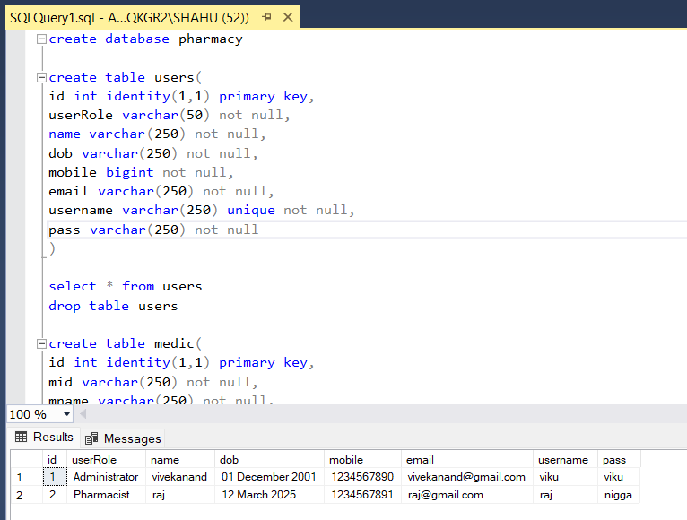

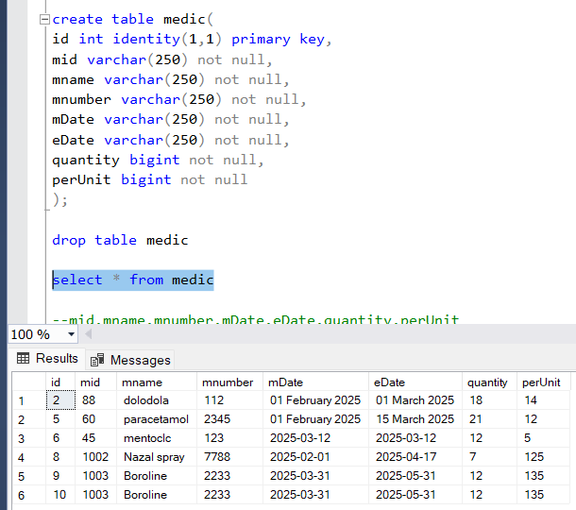

Department of Information Technology & Computer Science Year 2024-25 Page 26

