

TOPIC: MINI PROJECT SYNOPSIS ON CAR RENTAL SYSTEM

Submitted By

- Name: Vivek Dubey Submitted to:

ID:2315002503
- Name: Priyanshu Singh Faculty Name: Mr.Akash Kumar
Chaudhary
ID:2315001710
(Technical Trainer)
3. Name: Yuvraj Singh
ID: 2315002579
- Name: Kartikey Varshney
ID: 2315001083

ACKNOWLEDGEMENT(Optional) It is optional just for synopsis but mandatory in final report submissions

I would like to express my sincere gratitude to my project guide, Mr. Akash Kumar Choudhary (Technical Trainer, GLA University), for his continuous guidance, encouragement, and valuable support throughout the development of this mini project. His suggestions and feedback greatly helped in improving the quality and outcome of this work.

I would also like to thank all the faculty members of the Department of Computer Science and Engineering, GLA University, Mathura, for their constant support, motivation, and constructive suggestions during the project duration.

I am deeply thankful to my friends and family members who directly or indirectly supported me, motivated me, and helped me stay focused during the completion of this project.

Finally, I extend my heartfelt thanks to everyone who contributed, in any manner, to the successful completion of this mini project.

CERTIFICATE
This is to certify that the project report entitled “Car Rental System” is a bona fide and original work carried out by the following students of the Department of Computer Science & Engineering, GLA University, Mathura:
1. Vivek Dubey
University Roll No.: 2315002503
2. Priyanshu Singh
University Roll No.: 2315001710
3. Yuvraj Singh
University Roll No.: 2315002579
4. Kartikey Varshney
University Roll No.: 2315001083
This project work has been completed under the supervision and guidance of Mr. Akash Kumar Choudhary (Technical Trainer). The report is submitted in partial fulfillment of the requirements for the award of the degree Bachelor of Technology (B.Tech) for the academic year 2025–2026.
We hereby declare that this project embodies our original work and has not been submitted, either fully or partially, for the award of any other degree.
Project Guide
Mr. Akash Kumar Choudhary
Technical Trainer,
Department of Computer Engineering & Applications
GLA University, Mathura

INTRODUCTION

The Car Rental System is a web-based application developed to streamline and automate the process of renting cars. In traditional car rental setups, customers have to visit rental offices, check vehicle availability manually, fill paperwork, and wait for approval. This process is time-consuming, inefficient, and prone to human errors. To overcome these limitations, the Car Rental System provides a digital platform where users can easily browse available cars, select their preferred model, check pricing, and make online bookings within minutes.
The system focuses on delivering a simple, fast, and user-friendly experience to customers while offering powerful tools for administrators to manage cars, bookings, users, and payment records. By automating the rental workflow, the system reduces manual work, improves accuracy, and enhances customer satisfaction.
This application is designed using modern web technologies such as HTML, CSS, JavaScript (for the frontend), and Node.js with Express.js for backend development. The database is managed using MongoDB, ensuring efficient data storage, quick retrieval, and scalability. These technologies together provide a strong foundation for building a secure, responsive, and reliable web application.
The Car Rental System not only serves as an online booking platform but also acts as a complete management solution for rental agencies. It bridges the gap between customers and service providers by offering real-time availability, transparent pricing, and a smooth rental experience. This project demonstrates how technology can simplify everyday tasks and bring convenience to both businesses and users.
OBJECTIVES

The main objectives of the Car Rental System are as follows:
- Automate the Car Rental Process
To replace the traditional manual booking system with an efficient, online platform for customers and administrators.
- Provide Real-Time Car Availability
To allow users to view available cars instantly, check prices, and make bookings without delays.
- Enhance User Experience
To provide a user-friendly interface that simplifies the booking process and improves customer satisfaction.
- Efficient Booking Management
To maintain all booking records digitally, including booking dates, customer details, and payment status, ensuring accuracy and easy retrieval.
- Admin Dashboard for Management
To enable administrators to manage cars, monitor bookings, and maintain customer and payment records effectively.
- Reduce Manual Effort and Paperwork
To minimize human errors and streamline operations by automating repetitive tasks such as record-keeping, billing, and availability tracking.
- Scalability and Future Enhancements
To design a system that can be upgraded in the future with features like online payments, mobile apps, GPS tracking, and analytics for better business insights.

Scope Of the Project :

The Car Rental System has a wide scope as it is applicable to both customers and rental agencies.

1. It provides a user-friendly platform for customers to search, compare, and book cars online.
2. It reduces manual work by automating bookings, payments, and car availability management.
3. It is scalable, meaning more cars, users, and features can be added easily in the future.
4. It supports real-time updates of car availability and booking confirmation.
5. It ensures secure data management for users and administrators.
6. The system can be extended to include features like payment gateway integration, driver assignment,

PROBLEM STATEMENT
In traditional car rental systems, customers are required to visit rental offices in person to book vehicles. This manual process often leads to several challenges:
- Time-Consuming Process
Customers spend considerable time visiting offices, checking vehicle availability, and completing paperwork.
- Lack of Real-Time Information
Vehicle availability is not updated instantly, which can result in double bookings or unavailability of desired cars.
- Manual Record-Keeping Errors
Maintaining booking records, customer details, and payment information manually is prone to human errors.
- Limited Accessibility
Customers cannot book vehicles remotely or outside office hours, reducing convenience and flexibility.
- Administrative Challenges
Managing car details, tracking bookings, and generating reports manually is inefficient and requires more manpower.

EXISTING SYSTEM

In the traditional car rental process, most operations are manual and rely heavily on physical paperwork and in-person interactions. The typical workflow is as follows:

- Manual Booking
Customers need to visit the rental office to inquire about car availability and fill booking forms manually.

- Limited Accessibility
Booking is only possible during office hours, making it inconvenient for customers who want to rent a car at odd hours.

- Time-Consuming Procedures
Checking car availability, confirming bookings, and processing payments require significant time and effort from both customers and staff.

- Prone to Errors
Manual record-keeping for customer details, car information, and payment records increases the chances of mistakes.

- Administrative Challenges
Admin staff have to manually manage cars, track bookings, and maintain reports, which is inefficient and labor-intensive.

- Lack of Transparency
Customers cannot check real-time availability or pricing online, leading to confusion and delays.

Limitations of Existing System
- Inefficient and slow
- No online access
- Higher risk of human errors
- Inconvenient for customers and staff
- Difficult to generate reports and track records
The Existing System clearly demonstrates the need for an automated, online solution that allows real-time bookings, digital record-keeping, and a user-friendly interface for both customers and administrators.

ADVANTAGES / BENEFITS

The Car Rental System provides multiple advantages over the traditional manual rental process:

- Time Efficiency
Customers can browse, book, and confirm car rentals online within minutes, saving significant time compared to manual procedures.
- Real-Time Availability
The system displays the current status of all vehicles, preventing double bookings and ensuring customers have accurate information.
- User-Friendly Interface
A simple and intuitive interface allows both customers and administrators to easily navigate and use the system.
- Reduced Manual Effort
Automating bookings, payments, and record-keeping significantly reduces human effort and operational workload.
- Error Minimization
Digital storage of customer details, booking records, and payment data reduces the chances of mistakes associated with manual entries.
- Accessibility & Convenience
Users can book cars anytime and from anywhere using a web browser, offering flexibility beyond office hours.
- Efficient Administration
Admins can easily add, update, and remove cars, track bookings, manage customers, and generate reports digitally.
- Scalability
The system can be enhanced in the future to include online payments, mobile apps, GPS tracking, analytics, and other advanced features.
- Improved Customer Satisfaction
Faster booking, transparent pricing, and smooth operations lead to better customer experience.
10.Educational Value
The project demonstrates practical usage of web technologies (HTML, CSS, JavaScript, Node.js, Express, MongoDB) and provides learning for future application development.

Hardware

The following hardware specifications are recommended for running the system:

- Minimum 4 GB RAM
- Processor: Intel i3 or equivalent
- Hard Disk Space: At least 500 MB free space
- Display: 1024x768 resolution or higher

SOFTWARE REQUIREMENTS

The following software specifications are recommended for running and developing the Car Rental System:

- Operating System: Windows 10/11, Linux, or MacOS
- Web Browser: Google Chrome, Mozilla Firefox, or any modern browser
- Code Editor / IDE: Visual Studio Code, Sublime Text, or Atom
- Backend Platform: Node.js with Express.js (or PHP/Python based on implementation)
- Database: MongoDB or MySQL for storing user, car, and booking data
- Version Control: Git and GitHub for project management and collaboration
- Optional Tools: Postman for API testing and Browser Developer Tools for debugging

DATA FLOW DIAGRAM (DFD)
1. DFD LEVEL 0 (Context Level Diagram)
Purpose:
DFD Level 0 provides a high-level overview of the system, showing it as a single process interacting with external entities.
External Entities:

- Customer → Requests car booking, registration, login.
- Admin → Manages cars, bookings, and users.

Main Process:

- Car Rental System

Data Flow:

- Customer → Login/Register → Car Rental System
- Customer → Booking Request → Car Rental System
- Admin → Manage Cars/Bookings → Car Rental System
- Car Rental System → Confirmation / Feedback → Customer
- Car Rental System → Updated Records → Admin

DFD LEVEL 1 (Decomposition of Level 0)
Purpose:
Level 1 DFD breaks the system into sub-processes and shows interaction with data stores.
Sub-Processes:
- User Management → Handles registration, login, and profile management.
- Car Management → Add, update, delete, and view cars.
- Booking Management → Book cars, cancel bookings, process payments.
- Admin Management → View reports, track users, update records.
Data Stores:
- D1: Users → Stores customer login and profile details.
- D2: Cars → Stores car information and availability.
- D3: Bookings → Stores booking details and status.
Data Flow Example:
- Customer → Login/Register → User Management → Users (D1)
- Customer → Browse Cars → Car Management → Cars (D2)
- Customer → Book Car → Booking Management → Bookings (D3)
- Admin → Manage Cars/Bookings → Admin Management → Cars/Bookings (D2/D3)
- System → Confirmation → Customer

Diagram Description
Customer ---> [User Management] ---> D1: Users
Customer ---> [Car Management] ---> D2: Cars
Customer ---> [Booking Management] ---> D3: Bookings
Admin -----> [Admin Management] ---> D2/D3
[User Management / Car Management / Booking Management] ---> Customer (Confirmation)

PROJECT MODULES / FUNCTIONALITIES
The Car Rental System is divided into several modules to make the development structured and organized. Each module handles specific functionality of the system.

1.User Module

Description:
This module allows users to interact with the system. It handles registration, login, profile management, and booking requests.
Functionalities:
- User Registration
- User Login / Logout
- Update User Profile
- View Available Cars
- View Booking History

2.Car Management Module

Description:
This module is managed by the administrator and is responsible for handling all car-related operations.
Functionalities:
- Add New Cars
- Update Car Details
- Delete Cars
- View All Cars
- Search Cars by Type, Model, or Availability

3. Booking Management Module
Description:
This module handles the booking process, ensuring customers can book, cancel, or modify bookings easily.
Functionalities:
- Book a Car Online
- Cancel or Modify Booking
- Automatic Rent Calculation
- Generate Booking Confirmation / Invoice
- Track Booking Status

4. Admin Module
Description:
The admin module provides a dashboard for administrators to manage the entire system efficiently.
Functionalities:
- Manage Users (Add/Edit/Delete)
- Manage Cars (Add/Edit/Delete)
- View All Bookings
- Generate Reports (Bookings, Revenue, Users)
- Monitor System Activities

5. Database Module
Description:
This module manages all data storage, ensuring secure, structured, and easily retrievable information.
Functionalities:
- Store User Information
- Store Car Details
- Store Booking Records
- Maintain Data Integrity and Security

MODULES DESCRIPTION

The Car Rental System is divided into different modules, each responsible for specific functionalities to ensure smooth operation of the system. Detailed descriptions of each module are given below:

1. User Module
Purpose:
The User Module is designed to handle all customer interactions with the system. It allows users to register, log in, browse cars, and make bookings.
Features:
- User Registration: New customers can create accounts by providing personal details.
- Login / Logout: Secure login functionality with username and password authentication.
- Profile Management: Users can update personal information such as contact details.
- Browse Cars: View all available cars with details like type, model, and rental price.
- Booking History: Users can see a record of past bookings and current active bookings.

2. Car Management Module
Purpose:
This module allows the administrator to manage all car-related information and maintain an updated car inventory.
Features:
- Add Car: Admin can add new cars with details such as model, type, rent, and availability.
- Update Car Details: Modify car information like price, availability, or specifications.
- Delete Car: Remove cars that are no longer available for rent.
- View Cars: List all cars in the system and search by type, model, or availability.

3. Booking Management Module
Purpose:
The Booking Management Module handles all operations related to renting cars. It ensures that booking, payment, and confirmation processes are smooth and automated.
Features:
- Book a Car: Customers can book available cars online.
- Cancel/Modify Booking: Users can cancel or modify existing bookings.
- Automatic Rent Calculation: System calculates total rent based on car type, duration, and discounts (if any).
- Generate Booking Confirmation: System generates a digital confirmation or invoice after booking.
- Track Booking Status: Users can track whether their booking is confirmed, pending, or canceled.

4. Admin Module
Purpose:
The Admin Module provides control over the entire system. Administrators can manage users, cars, and bookings effectively.
Features:
- User Management: Admin can view, edit, or remove user accounts.
- Car Management: Admin can manage all car details as explained in Car Management Module.
- Booking Management: Admin can view all bookings, approve or reject them if necessary.
- Reports Generation: Generate various reports like revenue, bookings, and user activity.
- System Monitoring: Monitor system operations to ensure smooth performance.

5. Database Module
Purpose:
The Database Module stores all data related to users, cars, and bookings in a structured and secure manner.
Features:
- User Data Storage: Secure storage of all user details including login credentials.
- Car Data Storage: Maintain car inventory details and availability status.
- Booking Data Storage: Store all booking records including customer details, payment status, and dates.
- Data Integrity & Security: Ensures that all information is accurate, safe, and retrievable when needed.

USER ROLES

The Car Rental System has different user roles to define access levels and responsibilities. Each role has specific permissions to perform tasks within the system.

1. Customer (User Role)
Purpose:
The Customer is the primary user of the system who interacts with the platform to book cars.
Responsibilities / Permissions:
- Register and create a personal account.
- Log in securely to the system.
- Browse available cars with details such as type, model, and price.
- Book a car online and choose rental duration.
- Cancel or modify existing bookings.
- View booking history and booking confirmation.
- Make online payments (if implemented).
Limitations:
- Cannot add, delete, or update cars.
- Cannot access other users’ personal information.
- Cannot generate reports or access admin functionalities.

2. Administrator (Admin Role)
Purpose:
The Administrator manages the overall system operations and ensures smooth functioning of the car rental platform.
Responsibilities / Permissions:
- Add, update, or remove car details from the system.
- Approve or reject bookings if required.
- View all user accounts and manage their access.
- Monitor booking records, payment status, and system activities.
- Generate reports like total bookings, revenue, and user activity.
- Ensure data security and proper system maintenance.
Limitations:
- Admin does not book cars as a customer (unless implemented for testing purposes).
- Admin functions are restricted to system management and monitoring.

DATABASE TABLES

The Car Rental System uses multiple database tables to store data related to users, cars, and bookings. The following tables are designed for this project:

Column Name | Data Type | Description
user_id | INT / ObjectId | Primary Key, unique user ID
name | VARCHAR / String | Full name of the user
email | VARCHAR / String | User email (unique)
password | VARCHAR / String | Encrypted user password
contact_number | VARCHAR / String | User contact number
role | VARCHAR / String | Role of the user (Customer/Admin)
created_at | DATETIME | Account creation timestamp

Column Name | Data Type | Description
car_id | INT / ObjectId | Primary Key, unique car ID
name | VARCHAR / String | Car model name
type | VARCHAR / String | Car type (SUV, Sedan, Hatchback)
rent_per_day | FLOAT / Number | Rent of car per day
availability | BOOLEAN / String | Availability status (Available/Booked)
created_at | DATETIME | Car entry creation timestamp

Column Name | Data Type | Description
booking_id | INT / ObjectId | Primary Key, unique booking ID
user_id | INT / ObjectId | Foreign Key, references Users table
car_id | INT / ObjectId | Foreign Key, references Cars table
booking_date | DATETIME | Date of booking
rental_start | DATETIME | Start date of rental
rental_end | DATETIME | End date of rental
total_amount | FLOAT / Number | Total rent amount
status | VARCHAR / String | Booking status (Pending/Confirmed/Cancelled)
created_at | DATETIME | Booking record creation timestamp

- Payments Table → Stores payment details and transaction IDs.
- Reviews Table → Stores customer feedback and ratings for cars.
- Admin Logs Table → Tracks admin actions for system monitoring

FRONTEND
The Frontend of the Car Rental System is the part of the application that users interact with directly. It is responsible for presenting data to the users and providing an intuitive, responsive, and user-friendly interface.
Technologies Used
- HTML (HyperText Markup Language): Provides the basic structure and layout of web pages.
- CSS (Cascading Style Sheets): Used to design attractive, responsive, and visually appealing pages.
- JavaScript: Adds interactivity, validation, and dynamic behavior to the website.

Key Frontend Pages / Features
- Home Page:
  - Welcomes users to the system.
  - Shows an overview of available cars and offers navigation to login/register.
- User Registration & Login Page:
  - Allows new users to create an account and existing users to log in securely.
  - Includes input validation and user-friendly forms.
- Car Listing / Browse Page:
  - Displays all available cars with details such as name, type, rent per day, and availability.
  - Allows users to filter or search cars based on preferences.
- Booking Page:
  - Lets users select a car, choose rental dates, and make a booking.
  - Shows total rent and booking confirmation.
- User Dashboard:
  - Displays booking history, upcoming bookings, and profile management options.
- Admin Dashboard:
  - Provides administrators with tools to manage cars, bookings, users, and generate reports.

BACKEND
The Backend of the Car Rental System is the server-side part of the application that handles data processing, business logic, and database interactions. It ensures that all frontend requests are processed correctly and securely.
Technologies Used
- Node.js: Provides a server-side runtime environment for executing JavaScript code.
- Express.js: A web framework for Node.js used to build robust APIs and handle routing.
- MongoDB: A NoSQL database used to store user details, car information, and booking records.
- Mongoose: An Object Data Modeling (ODM) library for MongoDB to manage data schemas and relationships.

Key Backend Functionalities
- User Management:
  - Handles user registration and login authentication.
  - Encrypts passwords for security.
  - Manages user profiles and stores data in the database.
- Car Management:
  - Adds, updates, and removes car information.
  - Updates car availability status after booking.
  - Retrieves car details for frontend display.
- Booking Management:
  - Processes new booking requests from users.
  - Calculates total rent based on car type and rental duration.
  - Updates booking status (Confirmed, Pending, Cancelled).
  - Stores booking history and generates invoices.
- Admin Management:
  - Provides admin access to manage users, cars, and bookings.
  - Generates reports like revenue, total bookings, and system activity logs.
- Database Interaction:
  - Connects the system to MongoDB for data storage and retrieval.
  - Ensures data consistency, integrity, and security.
  - Handles queries for booking, user, and car data efficiently.

Login & Signup Page
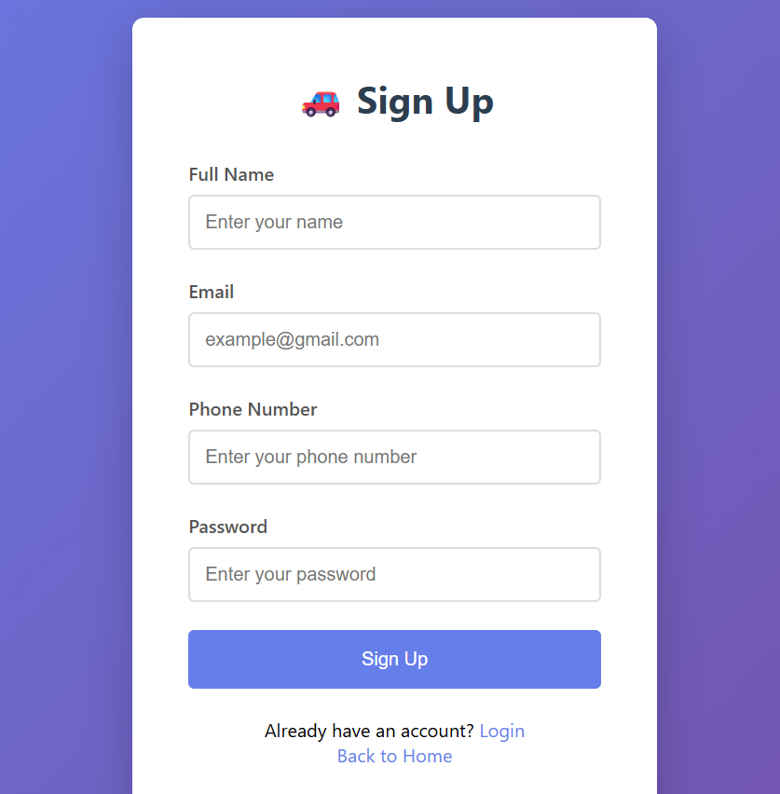

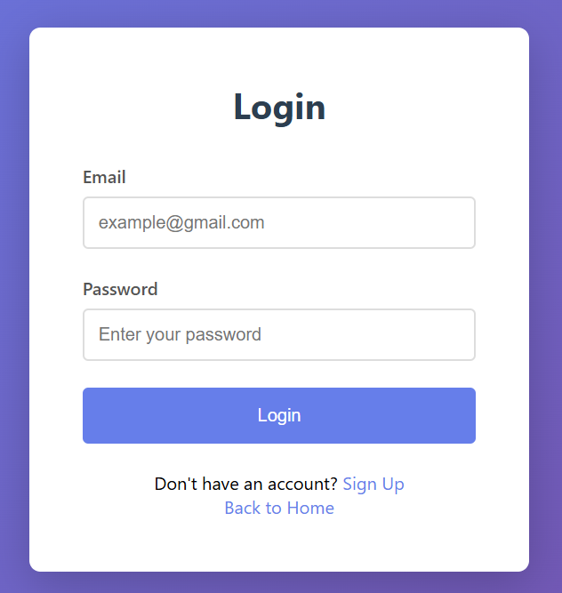

Car Listing Page

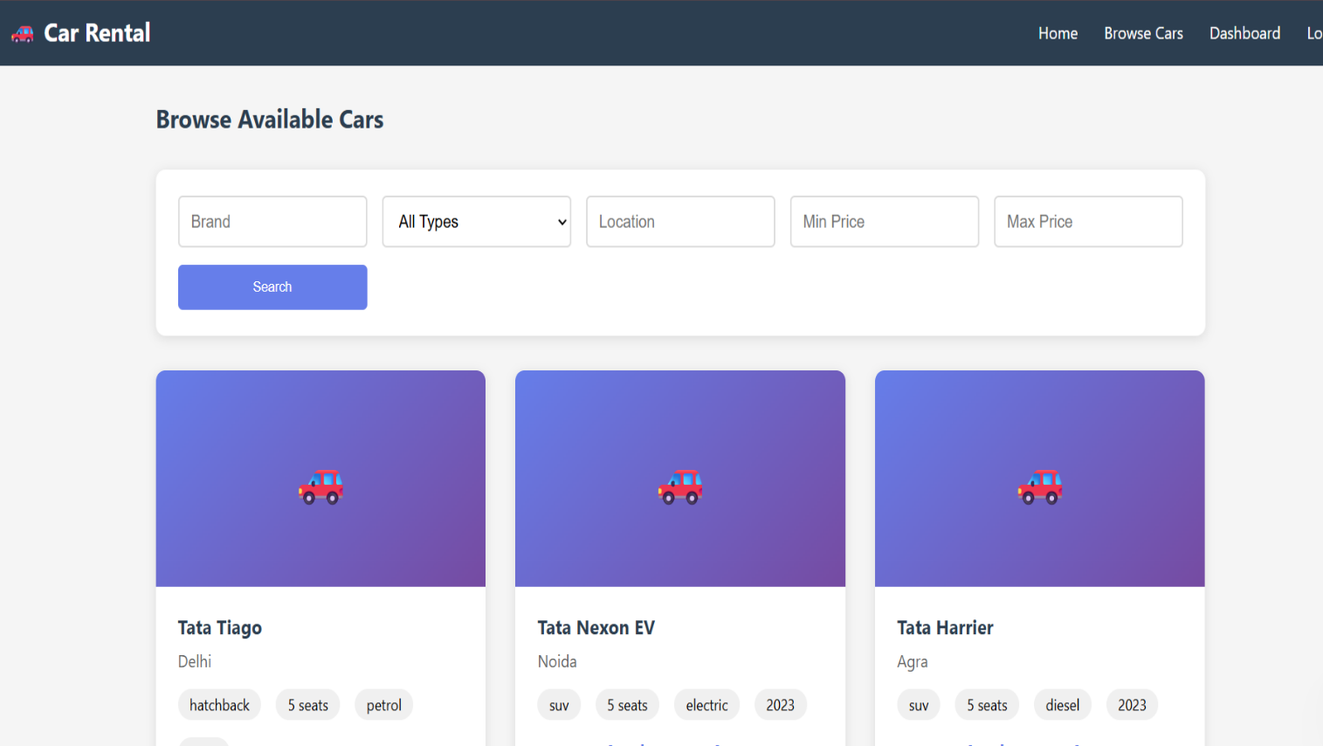

Booking Page

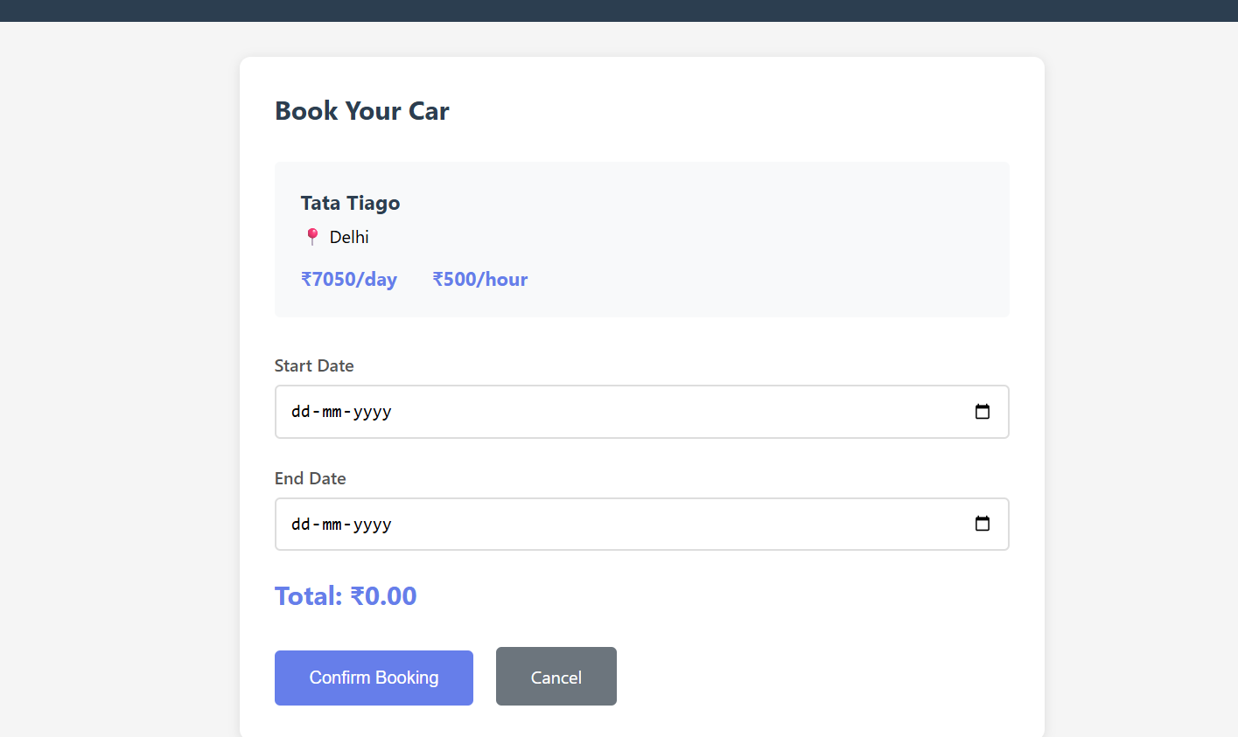

Admin Dashboard

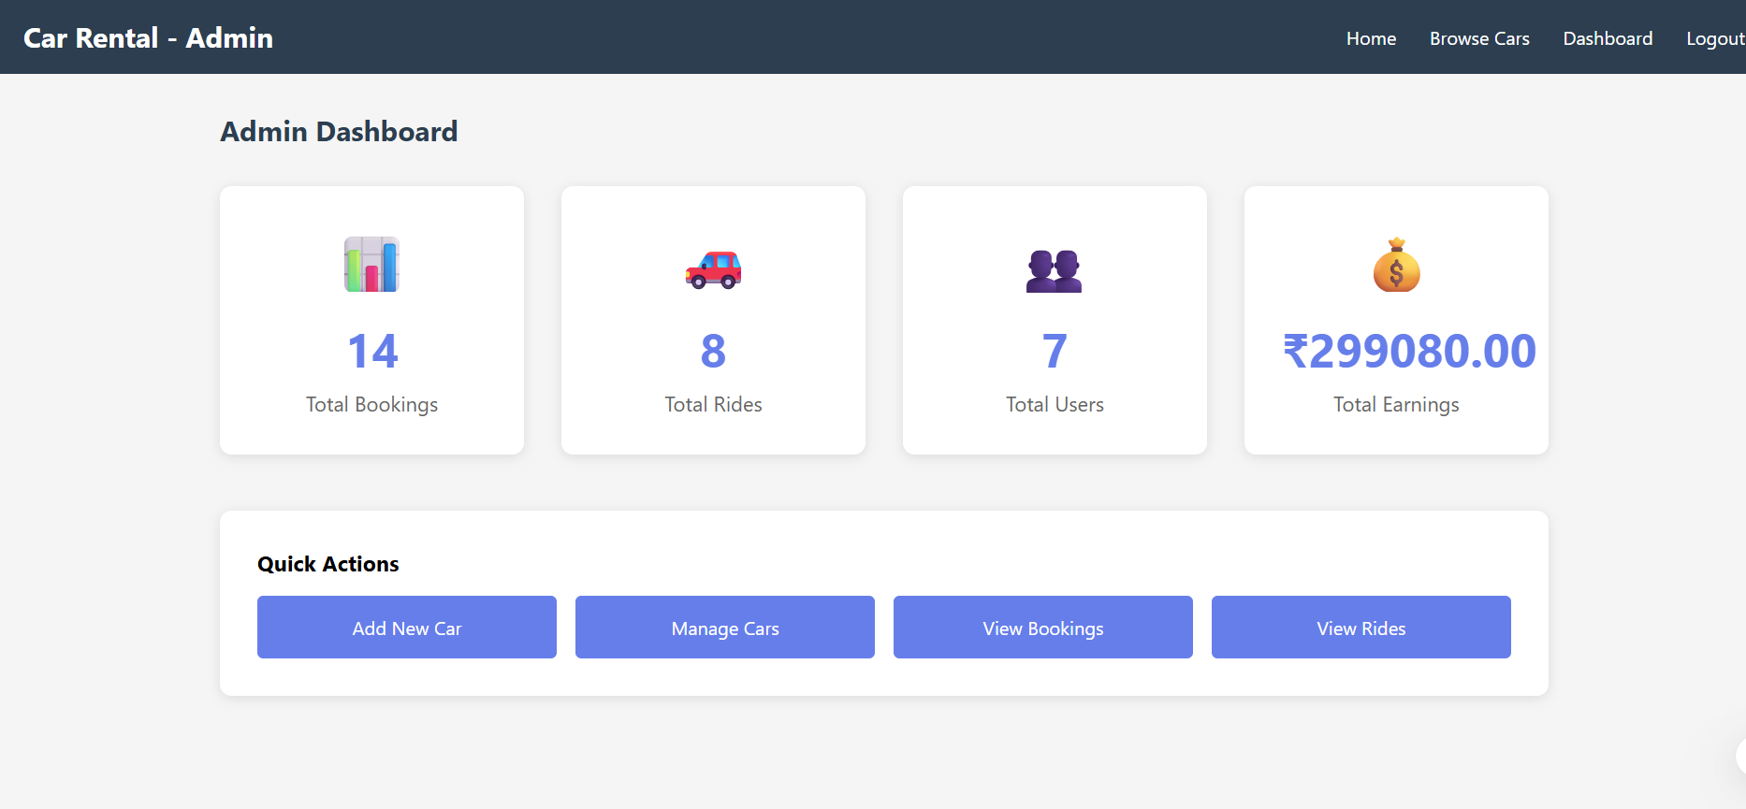

HOSTING DETAILS
The Car Rental System project has been deployed on a free hosting platform to make it accessible online. This allows users and administrators to access the system from any device with an internet connection.
Free Hosting
.Github Page
Link
(Car Rental - Home)
(Githuhttps://github.com/VIVEKDUBEY2712/Car-Rentalb URL)

Summary
The Car Rental System is a web-based application developed to automate and simplify the process of renting cars. This system provides an easy-to-use interface for customers to browse available cars, check prices, make bookings, and manage their reservations online. For administrators, it offers features to add, update, or delete cars, monitor bookings, and maintain user records efficiently.
The project has been implemented using HTML, CSS, JavaScript for the frontend, Node.js and Express.js for the backend, and MongoDB as the database. The system has been tested thoroughly through unit testing, integration testing, functional testing, and user acceptance testing, ensuring that all modules work as intended and deliver a smooth user experience.
The system has also been deployed on a free hosting platform (GitHub Pages / Netlify / Vercel), making it accessible online for demonstration and practical use. This ensures that the project can be presented and evaluated easily without depending on local setups.
In conclusion, the Car Rental System is a reliable, efficient, and user-friendly platform that reduces manual effort, minimizes errors, and provides a complete solution for both customers and administrators. It demonstrates the effective use of web technologies to solve real-world problems in car rental service

Reference
- W3Schools/Apna college – HTML, CSS, JavaScript Tutorials – https://www.w3schools.com
- Node.js Official Documentation – https://nodejs.org/en/docs/
- Express.js Official Documentation – https://expressjs.com
- MongoDB Official Documentation – https://www.mongodb.com/docs/
- GitHub URL – https://github.com/VIVEKDUBEY2712/Car-Rental

- Free Hosting Platforms (Netlify, Vercel, GitHub Pages)

- Zoomcar, Revv, Ola Drive – Online Car Rental Platforms

