Heuristic Analysis

The following, are the results obtained for the whole process including all the different cases being tested:

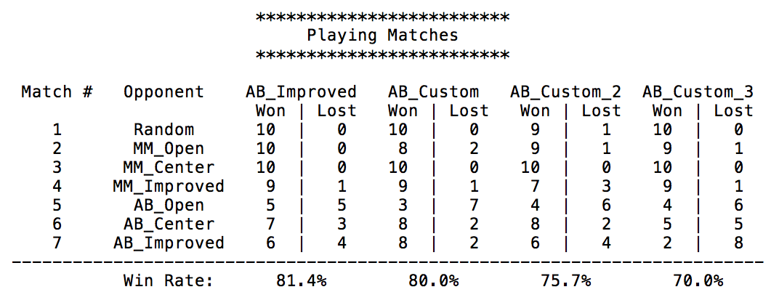

Further detail regarding each case will be indicated below.

**Case 1:** *Custom score 1*

What I intended with this heuristic was to force the opponent to the limits, since that's where most of the losses take place. To do this, I built it over the AB_Improved heuristic. This case maximizes the distance from the center for the opponent and minimizes the distance from the center for the player. However, it is true that after a certain number of moves, it becomes rarer to carry out moves towards the center of the board and these moves may as well not be the optimum ones since they may limit more than at the beginning the movement of the player. For this reason, Hence, I am reducing the weight of this distance parameter as more moves are played. 0.7, which I found gave better results when playing against AB_Improved.

Results analysis:

This case performs adequately. Although the winning rate isn’t as good as the winning rate for AB_Improved, it gets quite close when playing 40 games. It is quick to compute and involves additional information about the state of the board. The varying weight defines the importance given to the distance to the center during the game, being the constant used obtained after testing several cases iteratively against the AB_improved model. Given that the tested cases may not cover all combinations, this number could still be improved by further testing in order to obtain a higher accuracy.

**Case 2:** *Custom score 2*

What I intended with this case was to stay in the center and use Manhattan distance to process the distance to the middle instead of the Euclidean one. During the initial 10 % of the game, the program tries to capture the center positions. After this initial point, it tries to maximize the number of moves left.

Results analysis:

This case performs adequately, although it is clear that the result is worse than the AB_Improved. The Manhattan distance formula to calculate distance to the middle might be performing better than the Euclidean formula, given it is faster to process and it is more related to the player. The part of switching strategies depending on the status of the game may also be a good strategy, but the precise moment to switch strategy and the optimal strategy for each case may be more complex to define. Like before, the movement towards the center after the beginning of the game may not be the optimum strategy, and therefore most moves will be far from the middle of the board and towards the limits.

**Case 3:** *Custom score 3*

The intuition behind this heuristic was to penalize moves that are on the walls of the board and assess the quality of a move by the distance to the center for each of the future moves. Lesser the distance, better the quality of the move. Towards, the end, the agent aggressively tries to minimize the moves of the opponent.

Results analysis:

Clearly this heuristic performs significantly worse than AB_Improved. Even though this heuristic takes multiple inputs to assess the quality of the board state, just a summation is clearly not enough. Adding weights to the inputs might help in improving the win rate. This heuristic is also more expensive to compute since we must go through future moves and compute the distance to the center for each. Again, switching strategies based on the stage in the game might be a good idea, but it is difficult to predict when the switch strategies.

**Overall comparison and results:**



As you can see from the above visualization, the custom heuristic #1 and AB_Improved perform comparably. It is possible that after tuning the constant portion of the weight, custom heuristic #1 can achieve better results than AB_Improved. Custom heuristic #1 is also computationally least expensive. By using the distance to the center for the opponent and the player, it captures more information about the board state when compared to AB_Improved. Hence, I recommend this heuristic over the others. The remaining two evaluation functions have good ideas like switching strategies and penalization. But these ideas require further research before they can achieve better results than AB_Improved.