Heuristic Analysis

(Implement a planning search project)

Artificial Intelligence nano degree, Udacity

2018

## Problem Definition

#### GIVEN: classical PDDL problems

All problems are in the Air Cargo domain. They have the same action schema defined, but different initial states and goals.

* Air Cargo Action Schema:

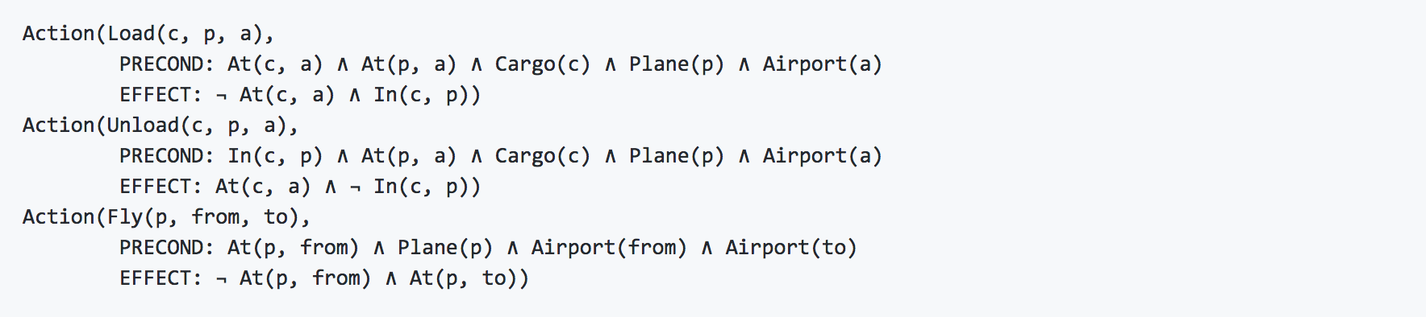

Given this schema, provide an optimal plan for Problems 1, 2, and 3.

Compare and contrast non-heuristic search result metrics (optimality, time elapsed, number of node expansions) for Problems 1,2, and 3. Include breadth-first, depth-first, and at least one other uninformed non-heuristic search in your comparison; Your third choice of non-heuristic search may be skipped for Problem 3 if it takes longer than 10 minutes to run, but a note in this case should be included.

Compare and contrast heuristic search result metrics using A* with the "ignore preconditions" and "level-sum" heuristics for Problems 1, 2, and 3.

What was the best heuristic used in these problems? Was it better than non-heuristic search planning methods for all problems? Why or why not?

Provide tables or other visual aids as needed for clarity in your discussion.

## Problem number 1

### Initial state & goal

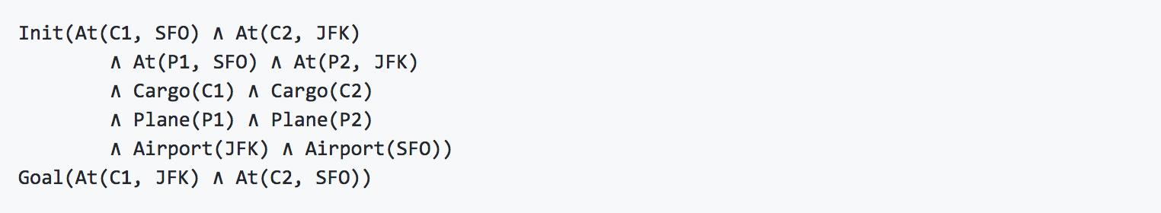

### Optimal plan (length=6):

## Load(C1, P1, SFO)

## Load(C2, P2, JFK)

## Fly(P1, SFO, JFK)

## Fly(P2, JFK, SFO)

## Unload(C1, P1, JFK)

## Unload(C2, P2, SFO)

### Results obtained:

|  |  |  |  |  |
| --- | --- | --- | --- | --- |
| Search method | Nodes expanded | Plan Length | Time elapsed (seconds) | Optimal result |
| Breadth first search | 43 | 6 | 0.0428 | Yes |
| Depth first graph search | 21 | 20 | 0.0188 | No |
| Greedy best first search | 7 | 6 | 0.0073 | Yes |

For this first problem, it can be seen that the *greedy best first search* performs best in both takin less time and obtaining an optimal solution, at the same time it consumes the least amount of memory (nodes expanded). In the case of the *breadth first search* it obtains the optimal result, although it takes more time and consumes more memory than the case of the *greedy best first search*. In the case of the *depth first search*, it doesn’t obtain the optimal result, although it requires less memory than the *breadth first search* and takes less time to obtain the result.

|  |  |  |  |  |
| --- | --- | --- | --- | --- |
| Search method | Nodes expanded | Plan Length | Time elapsed (seconds) | Optimal result |
| A* search with ignore preconditions | 41 | 6 | 0.05088 | Yes |
| A* search with level sum | 11 | 6 | 0.9000 | Yes |

It can be clearly seen in the results that heuristics search obtains better results than non-heuristic search.

When comparing both methods for the heuristic search, *search with* *level sum* takes some more time, although it uses less memory, resulting both cases in the optimal solution.

## Problem number 2

### Initial state & goal

## 

### Optimal plan (length=9):

## Load(C1, P1, SFO)

## Fly(P1, SFO, JFK)

## Load(C2, P2, JFK)

## Fly(P2, JFK, SFO)

## Load(C3, P3, ATL)

## Fly(P3, ATL, SFO)

## Unload(C3, P3, SFO)

## Unload(C2, P2, SFO)

Unload(C1, P1, JFK)

### Results obtained:

|  |  |  |  |  |
| --- | --- | --- | --- | --- |
| Search method | Nodes expanded | Plan Length | Time elapsed (seconds) | Optimal result |
| Breadth first search | 3343 | 9 | 16.1973 | Yes |
| Depth first graph search | 624 | 619 | 4.8855 | No |
| Greedy best first search | 990 | 17 | 5.1360 | No |

For this second problem, it can be seen that the *breadth first search* is the only one to reach an optimal result, although in comparison to the *depth first graph search* and the *greedy best first search*, these last two use up far less memory and take a far less amount of time to reach the result. In the case of the *depth first graph search* the path length is very large compared to the other two option.

Like in problem number 1, the *breadth first search* case obtains an optimal result, although the number of nodes expanded is very large compared to the other two methods.

|  |  |  |  |  |
| --- | --- | --- | --- | --- |
| Search method | Nodes expanded | Plan Length | Time elapsed (seconds) | Optimal result |
| A* search with ignore preconditions | 1450 | 9 | 7.8313 | Yes |
| A* search with level sum | 86 | 9 | 80.8422 | Yes |

Regarding the heuristic search, in this case it can be observed that the *search with* *level sum* takes a significantly greater amount of time in comparison with the *search with ignore preconditions*. The *search with level sum* also consumes less memory compared to the other method.

In this problem, both methods achieve an optimal result.

## Problem number 3

### Initial state & goal

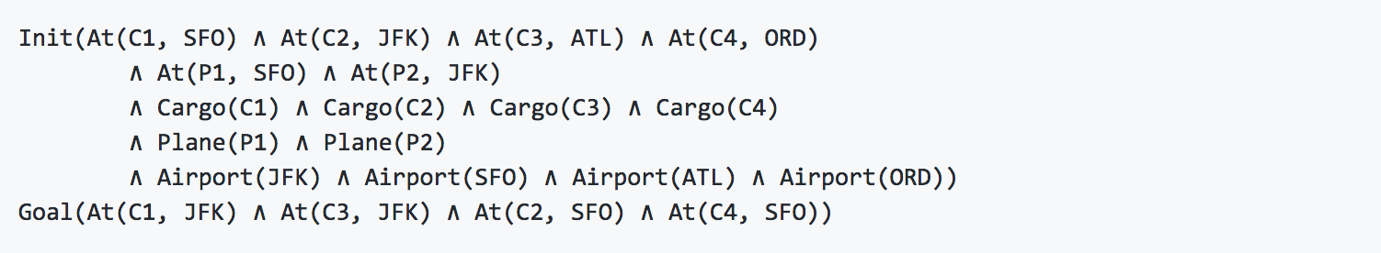

### Optimal plan (length=12):

Load(C1, P1, SFO)

Fly(P1, SFO, ATL)

Load(C3, P1, ATL)

Fly(P1, ATL, JFK)

Load(C2, P2, JFK)

Fly(P2, JFK, ORD)

Load(C4, P2, ORD)

Fly(P2, ORD, SFO)

Unload(C4, P2, SFO)

Unload(C3, P1, JFK)

Unload(C2, P2, SFO)

Unload(C1, P1, JFK)

### Results obtained:

|  |  |  |  |  |
| --- | --- | --- | --- | --- |
| Search Method | Nodes expanded | Plan Length | Time elapsed (seconds) | Optimal result |
| Breadth first search | 14663 | 12 | 98.6335 | Yes |
| Depth first graph search | 408 | 392 | 3.0904 | No |
| Greedy best first search | 5614 | 22 | 37.9533 | No |

For this third problem, it can be seen that the *breadth first search* obtains once again an optimal result, although as in problem 2, it requires both a greater use of memory than the other two methods and takes a significantly greater amount of time (33 times the time required for *depth first graph search* and 3 times the time required for *greedy best first search*).

On the other hand, the *depth first graph search* takes a significantly low amount of time and uses up the smallest amount of memory from all three methods, but it doesn’t achieve an optimal result. The *greedy best first search* lays somewhere in between the other two methods, using up less memory than the *breadth first search* and reaching a result closer to the optimal than the *depth first graph search*.

|  |  |  |  |  |
| --- | --- | --- | --- | --- |
| Search Method | Nodes expanded | Plan Length | Time elapsed (seconds) | Optimal result |
| A* search with ignore preconditions | 5040 | 12 | 36.4486 | Yes |
| A* search with level sum | 318 | 12 | 392.8886 | Yes |

Regarding the heuristic search for this third problem, the result is similar to the previous cases. The *search with level sum* takes a significantly greater amount of time than the *search with ignore preconditions*, although it uses up a significantly smaller amount of memory.

Like in the previous cases, both methods achieve an optimal result.

## Conclusion

Based on the previous results, it can be concluded that the *a-star search with ignore preconditions* obtains the best results from all methods in terms of time taken and optimal results, although it uses up more memory than the *search with level sum* method. Therefore, in cases where memory is indeed a priority over processing time, the *search with level sum* option would be the preferred choice.

The heuristic based searches provide optimal results in a reasonable amount of time, although for simpler problems with fewer literals, the *non-heuristic* methods have a better performance (case of the *greedy best first search* in problem 1). In the case of using such methods instead of the heuristic ones, the *breadth first search* method would be the one to choose in terms of reaching optimal results and the *greedy best first search* for cases similar to problem 1 in order to improve processing time.