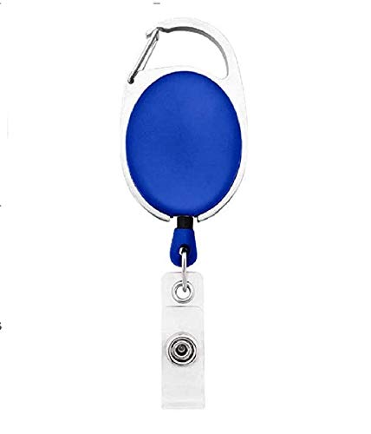

|  |  |
| --- | --- |
| **Brittney Carignan** | PHOTO |
| **Human Resource** |
| **02/12/2022 00:00:00** |
| **O +ve** |
| **8880087700** |