

A Project Report On

**Grocery Ecommerce Application**

**Project**

**By**

**VIJAYARAJ V**

**Batch:** 2021 – 6518

**Center: Chennai Chromepet**

Under the Guidance of,

**Chittaranjan Ghosh.**

**Technical Trainer**

**EduBridge**

(School of coding)

**Introduction:**

Our project explains the E-commerce Shopping Website named My Cart. This project mainly explains the various process related to shopping online. You can

search various products and shuffle according to category. Our Project Include

.

**Modules:-**

* Admin Module
* Customer Module
* Category Module
* Delivery Module
* Transaction Module
* Order Module

|  |
| --- |
|  |

I have developed this application in **Java, JSP, Servlets, Hibernate, and MySQL.** It’s a web-based project so I have used **HTML, CSS, JavaScript and Bootstrap also**. The main feature of the project is to make shopping easier. You can access this website from anywhere and everywhere.

In the **Admin module**, the admin can add the Category and Products in the specific category. He can view the total number of users at present on the website, category, and product details also. Admin can only see the admin page and cart if he wants to order something. Admin can change the status of the ordered product of customers.

In the **Customer module**, the Customer can register and login into the application

And view products by their category. And they can see the user interface and

Public interface in the application. They can purchase products by adding them to the cart and then check out.

In the **Category module**, users can access the website and see the product, add products to the cart, buy and shuffle by category. New users can register and login after that to shop. In Cart, admin and user both can access, they can add the products and buy if they want.

In the **Delivery module**, the Delivery mode will help store delivery details and

Address and other ids when the customer will place the order.

In the **Transaction module**, the transaction can have the details about the transaction of the product and this can be managed by the admin when they submit the report.

In the **Order module**, the Order table will contain all the orders from the customer only after the customer login and after that, they can place the order. Order will show the order data and it helps to connect delivery and Transaction and Order Products to serve the customer.

**Software Requirements:**

**Front end:** Java/J2EE technologies (Servlet, JSP), HTML, CSS, JavaScript,

Bootstrap, Hibernate.

**Back end**: MySQL workbench 8.0.23CE.

**Middleware/Server:**

Apache Tomcat v8.5. IDE: Spring Test Suits

Developers

**Browser:** Best result on Google Chrome

**Operating System:** Windows 11.

# Data Dictionary:

**Table creation:**

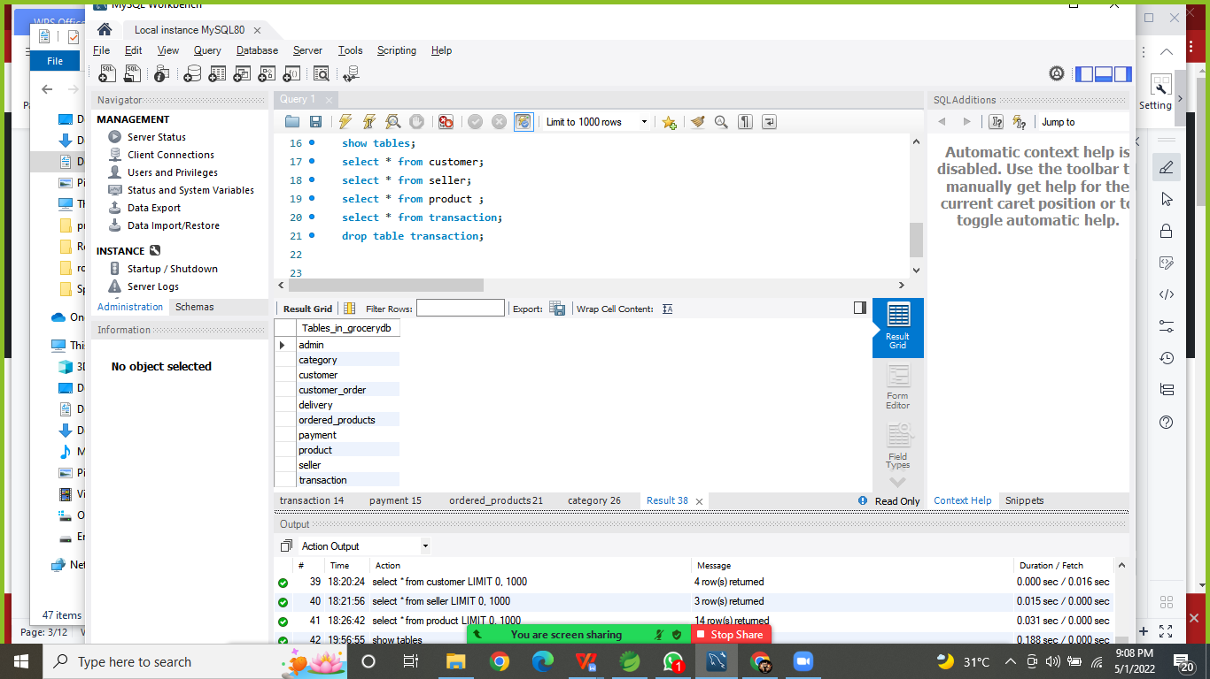

**Home Screen (1):**

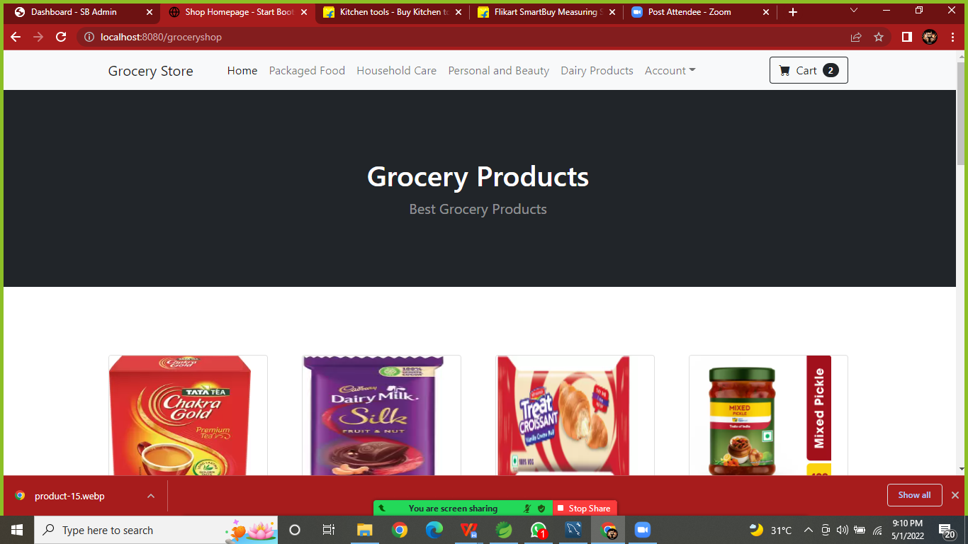

**Home Page (2):**

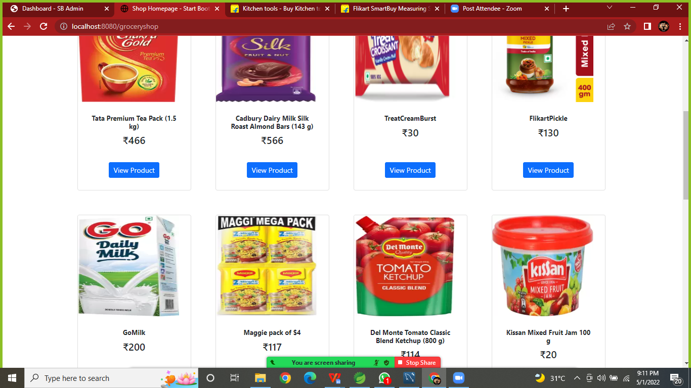

**View Single product:**

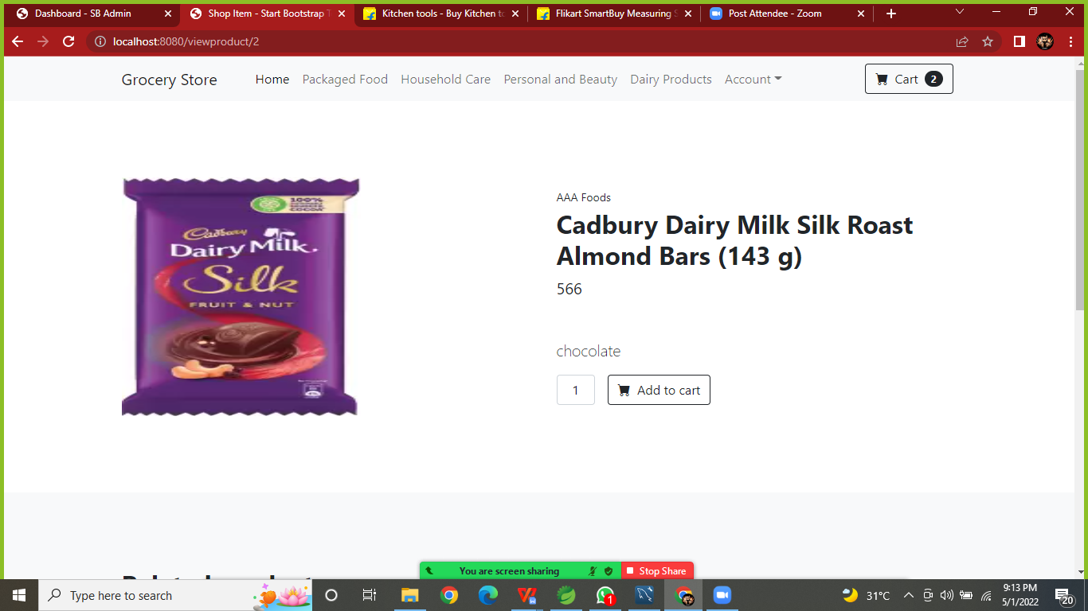

**Category Page(package Food(1)):**

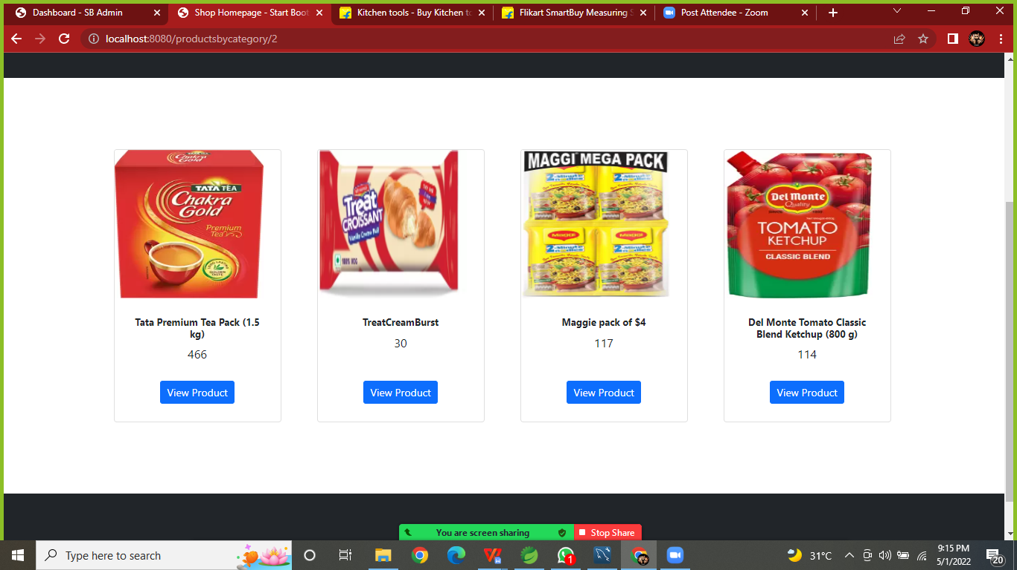

**Category Page (HouseHold Care(2)):**

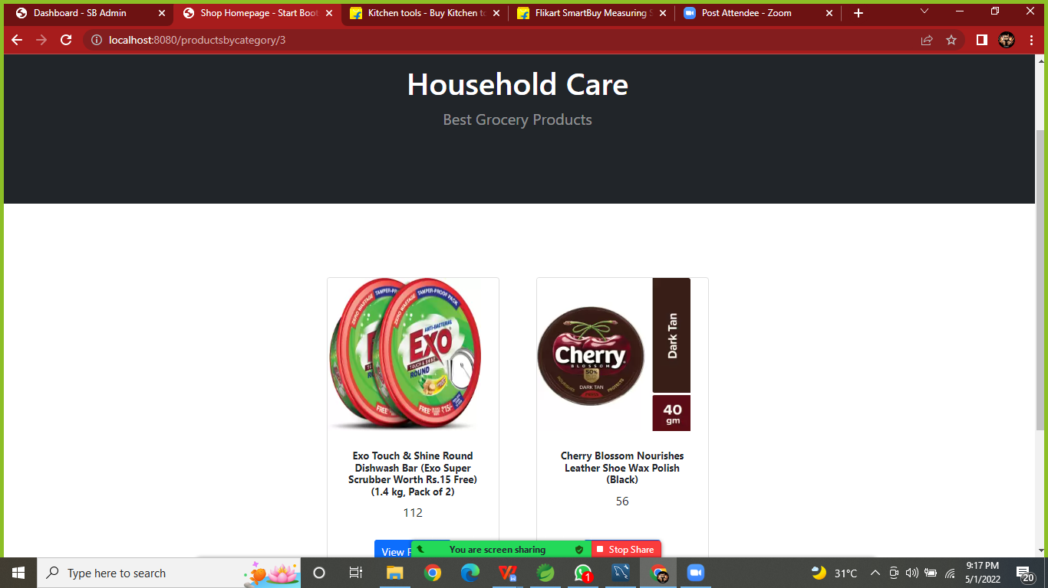

**Category page(Personal & Beauty):**

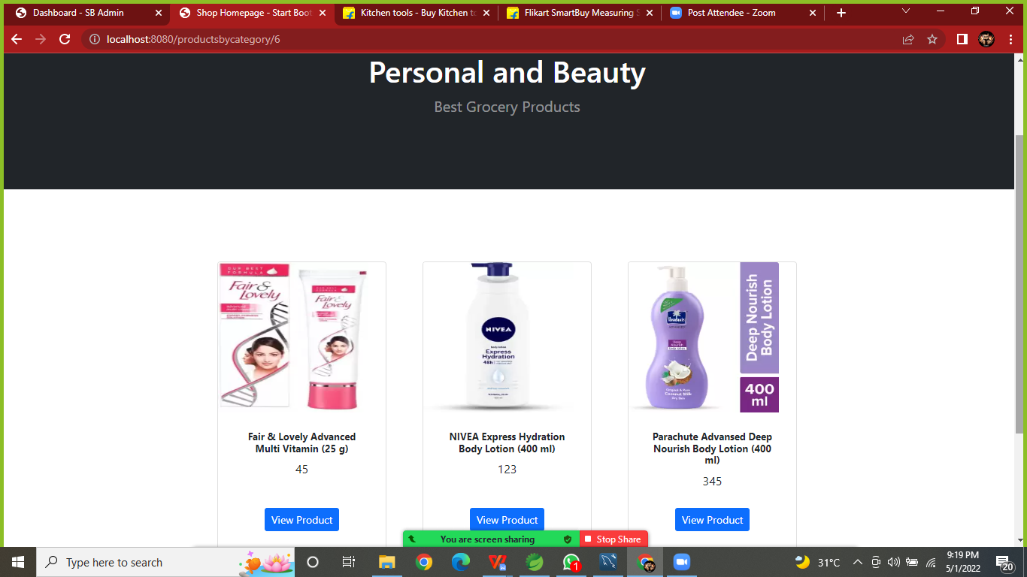

**Category page (Daily Product):**

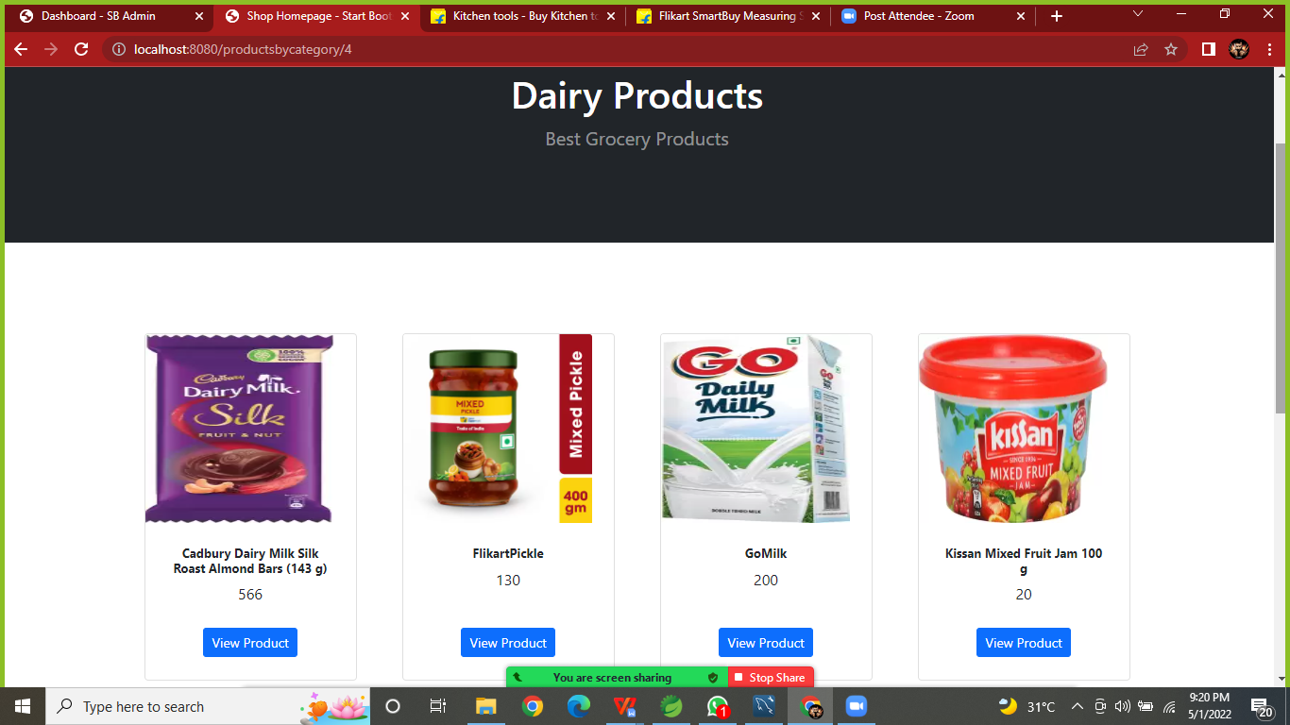

**Cart Page:**

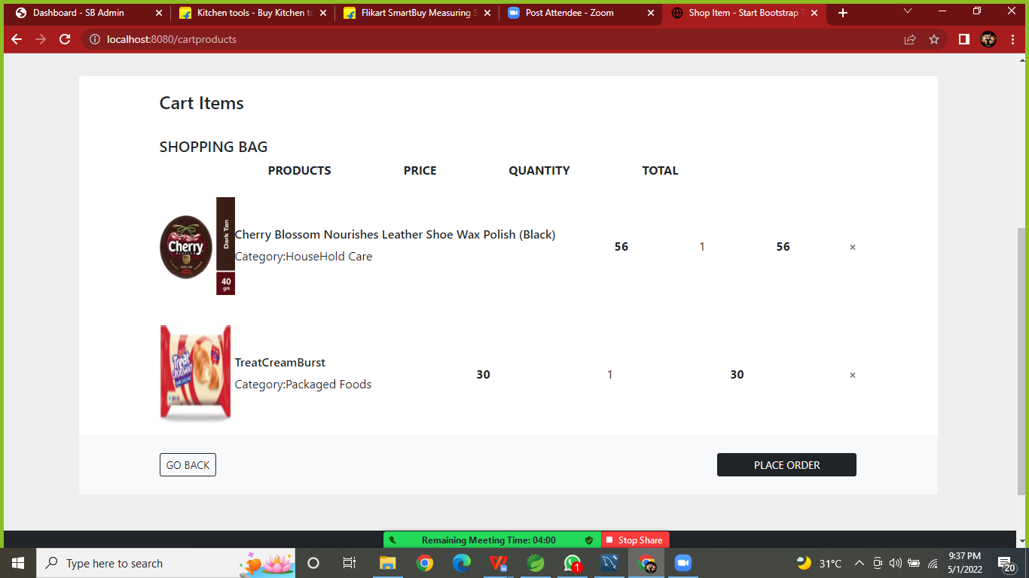

Empty Cart:

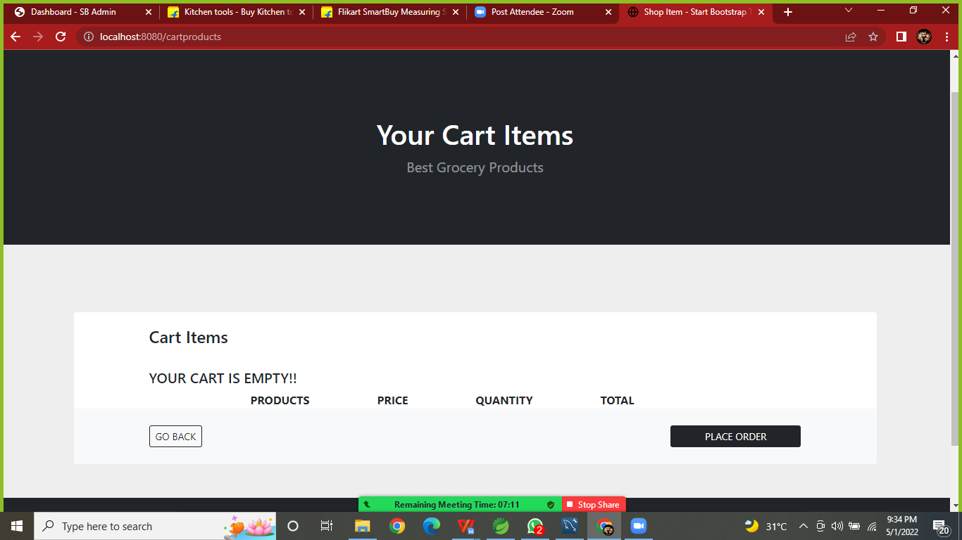

Register Form:

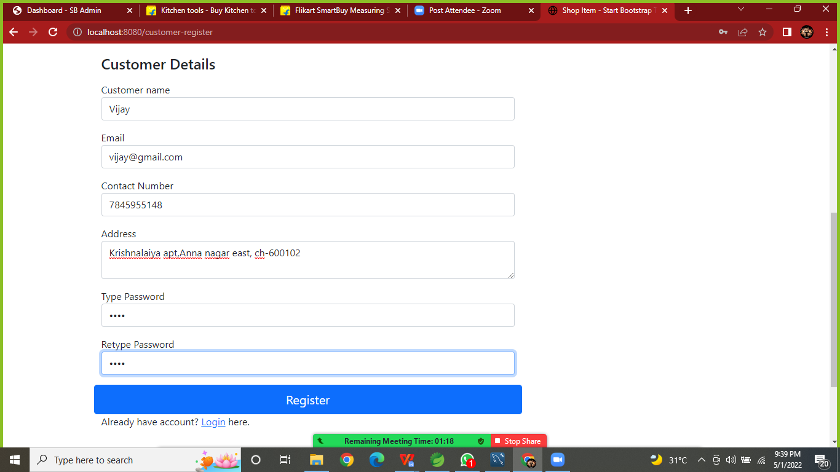

**Registration Successful Alert:**

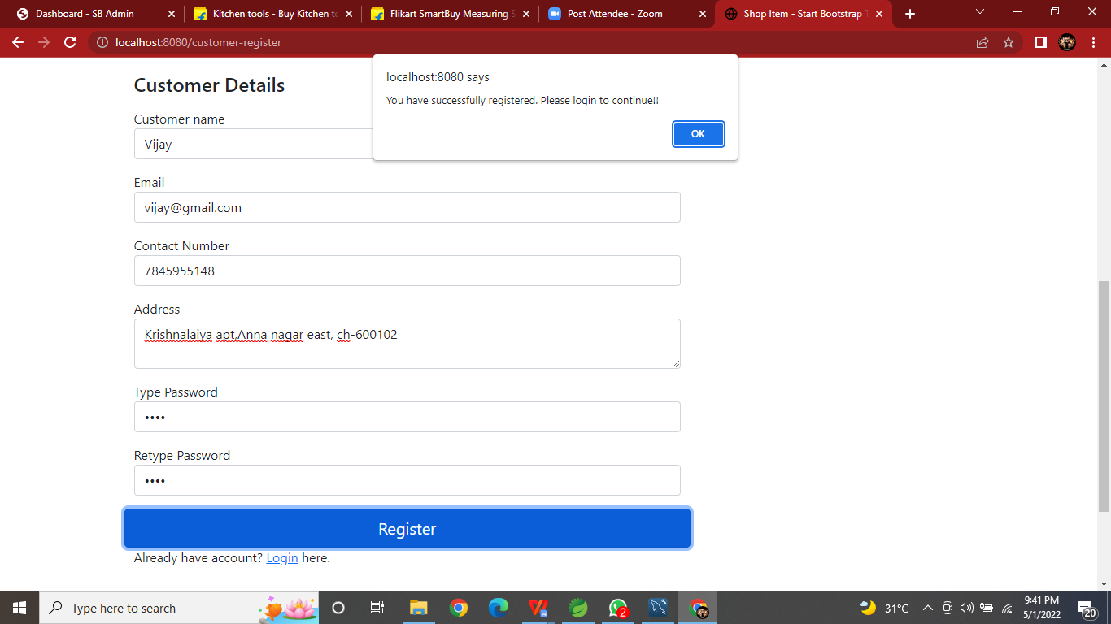

**Login Successful Page:**

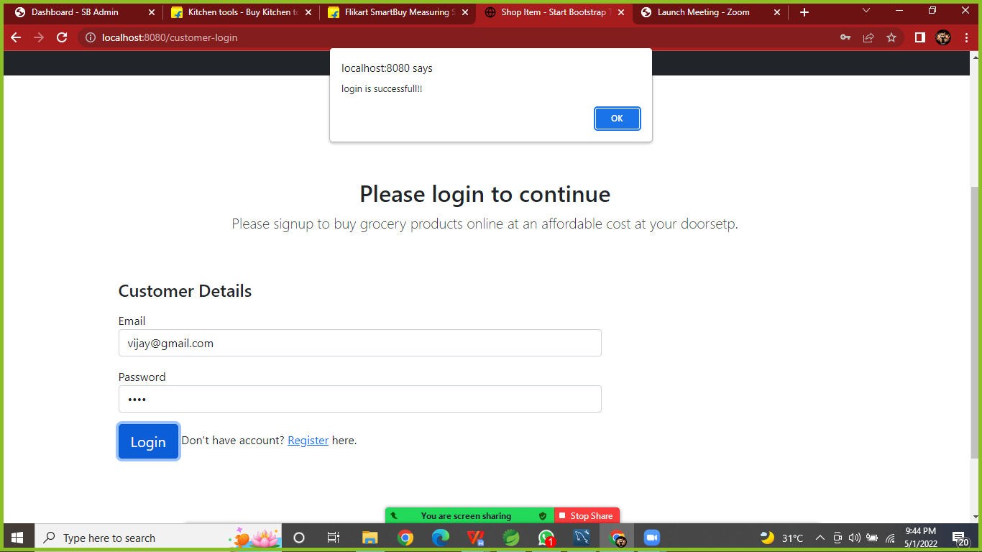

**Check Out Form (1):**

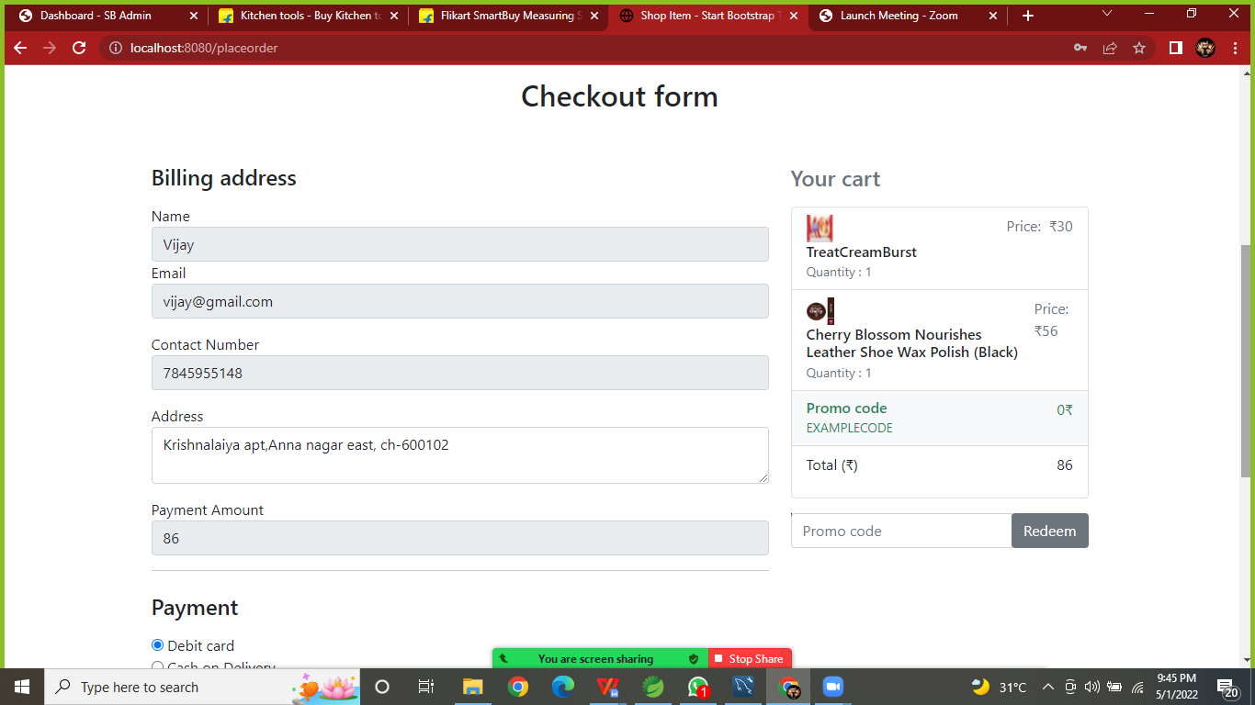

**Checkout Form (2):**

**Debit Card Required form:**

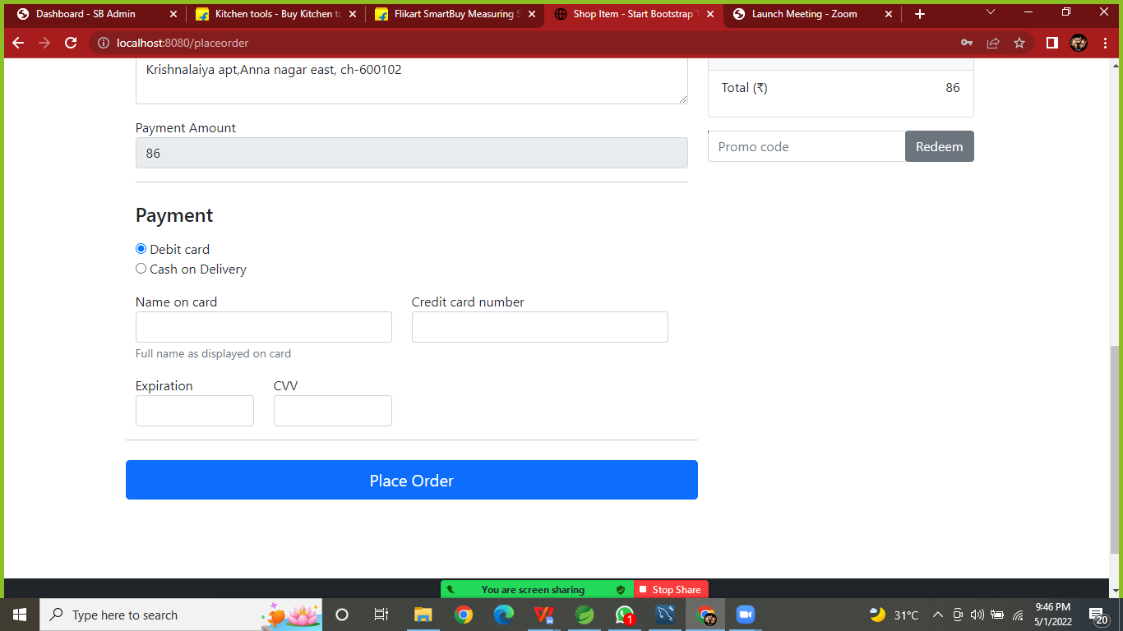

**Cash on delivery request:**

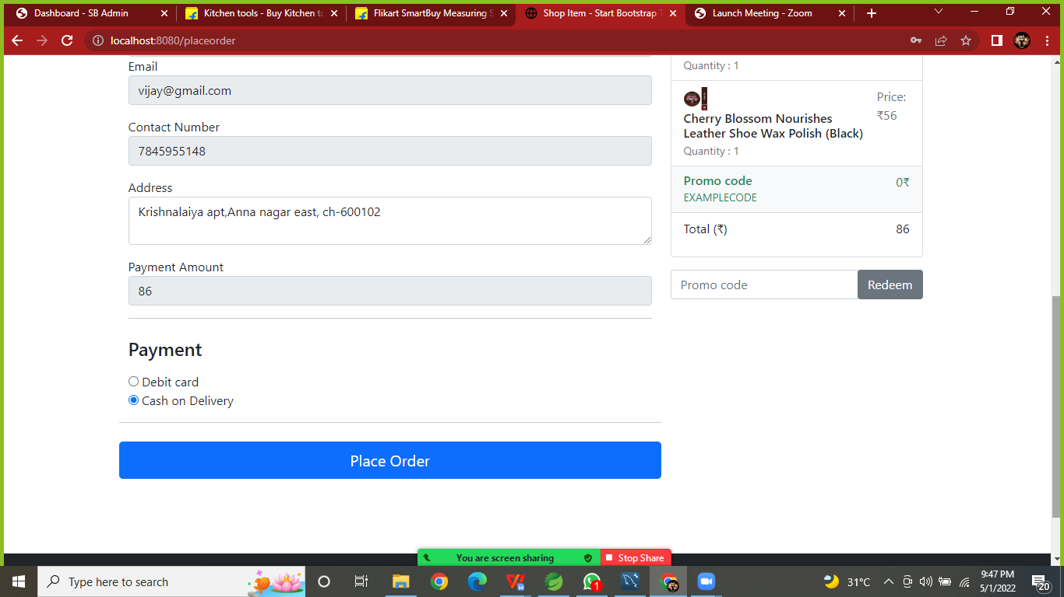

**Order Confirmed Page:**

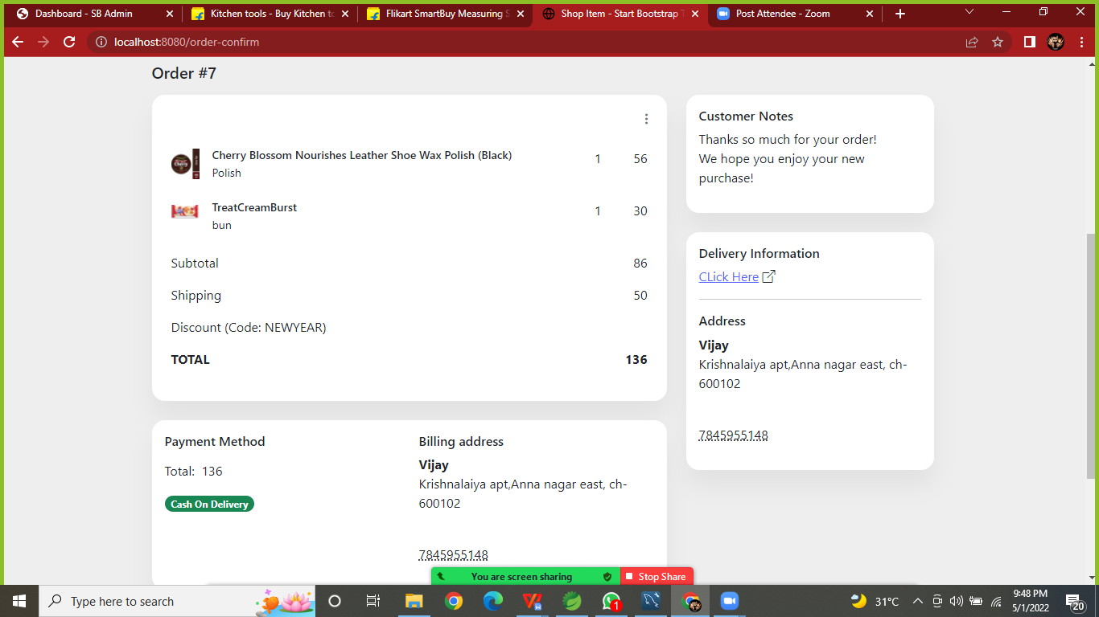

**ADMIN MODULE**

**Admin Login Page:**

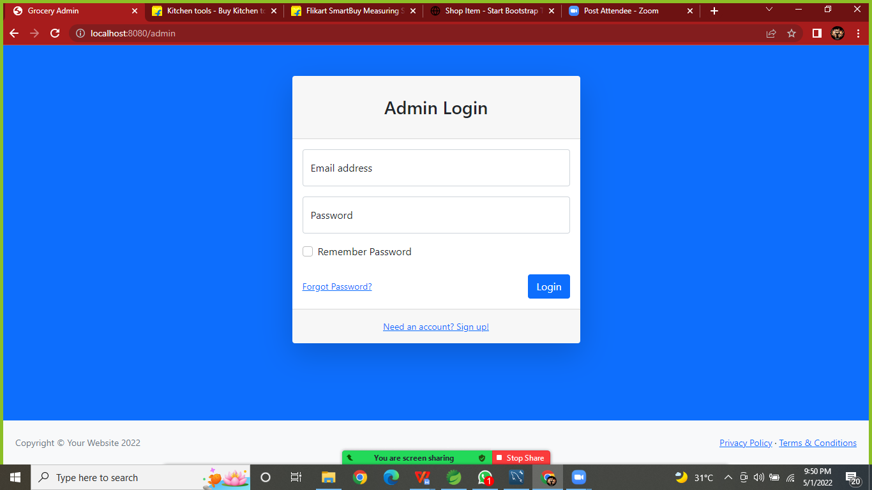

**Admin Home Page:**

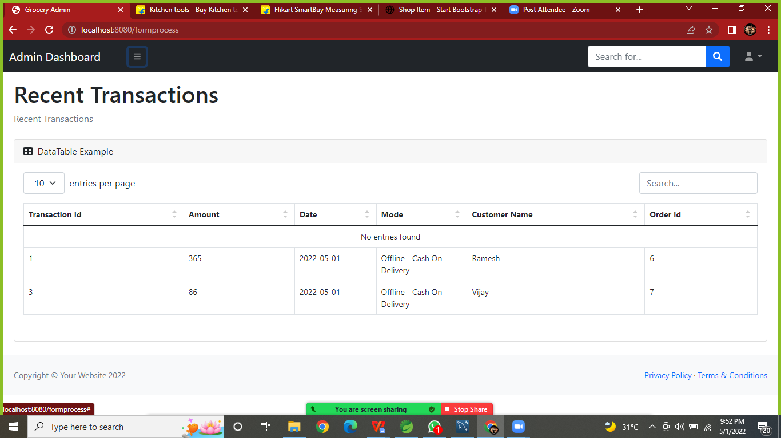

**Manage Product by Admin:**

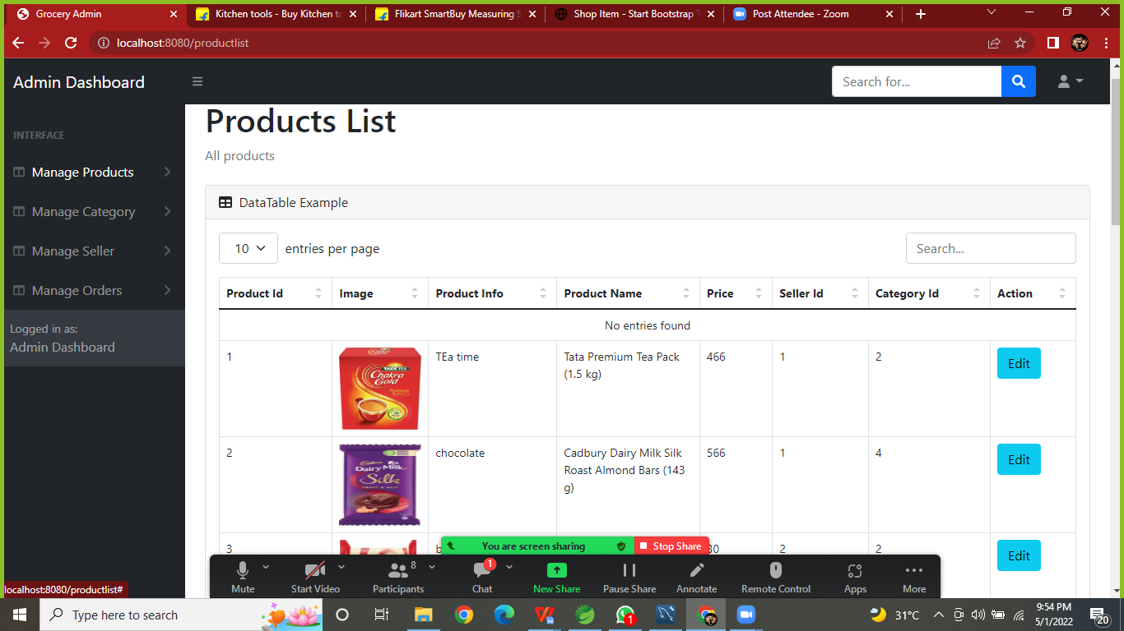

**Add Product:**

**In Add Product page required product information in that.**

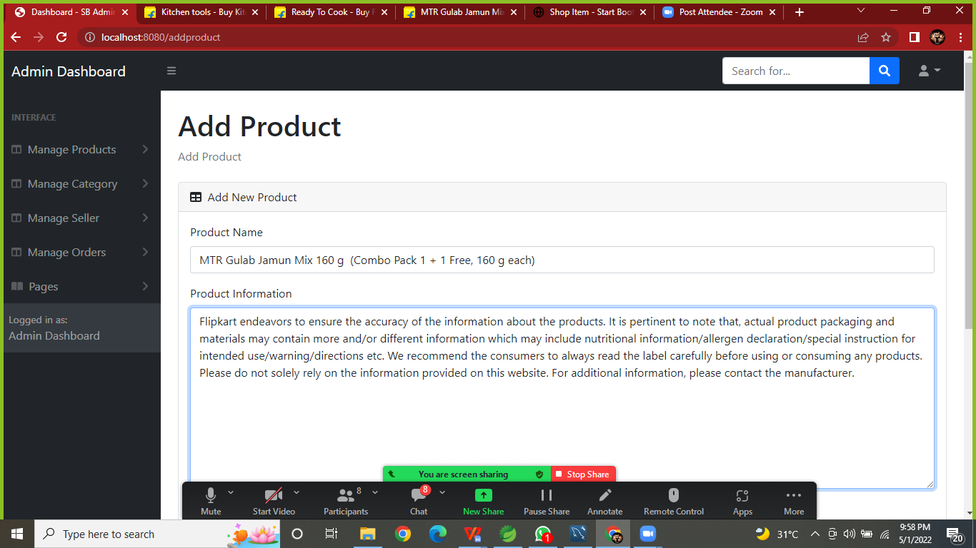

**Add Product(2):**

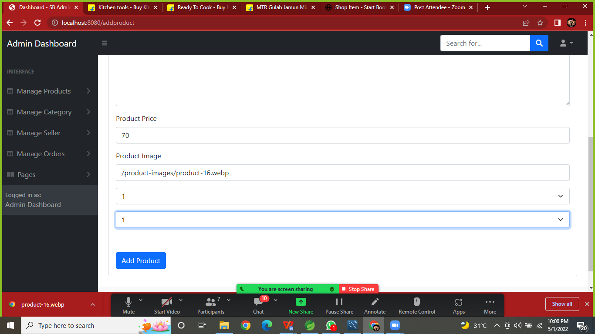

**Product Added /Updated page:**

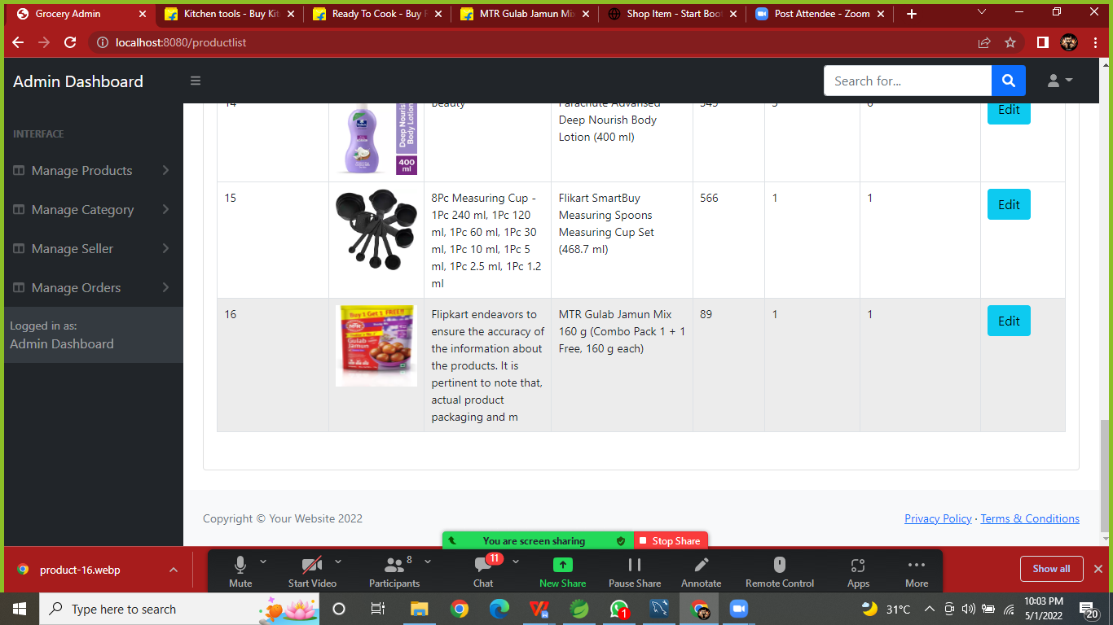

**Managed Category List:**

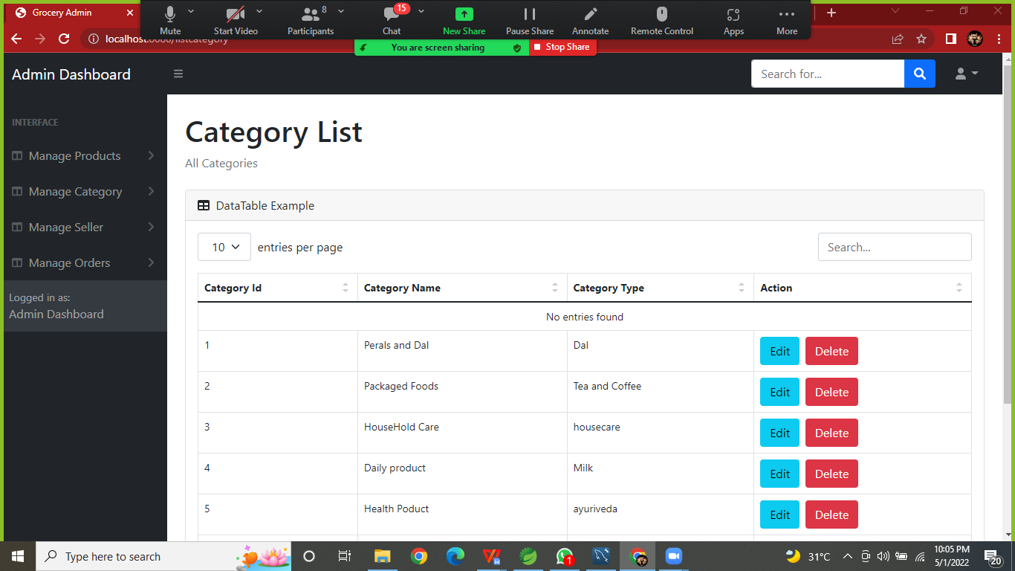

**Managed Category Add/Update:**

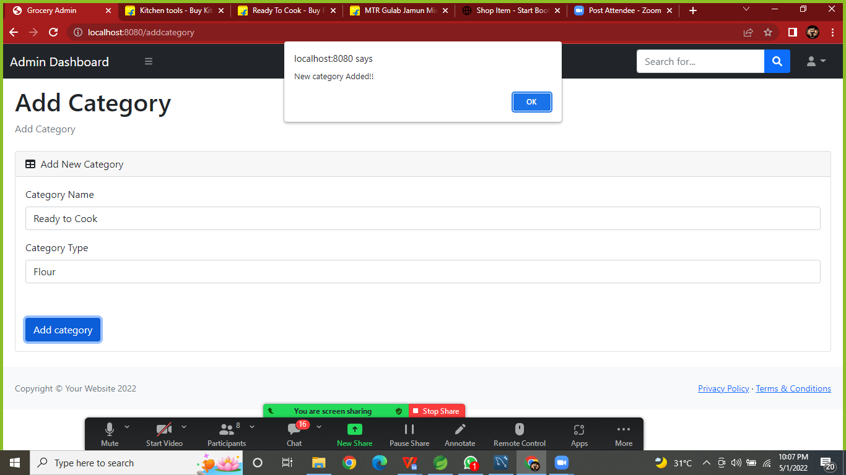

**2.Managed Category:**

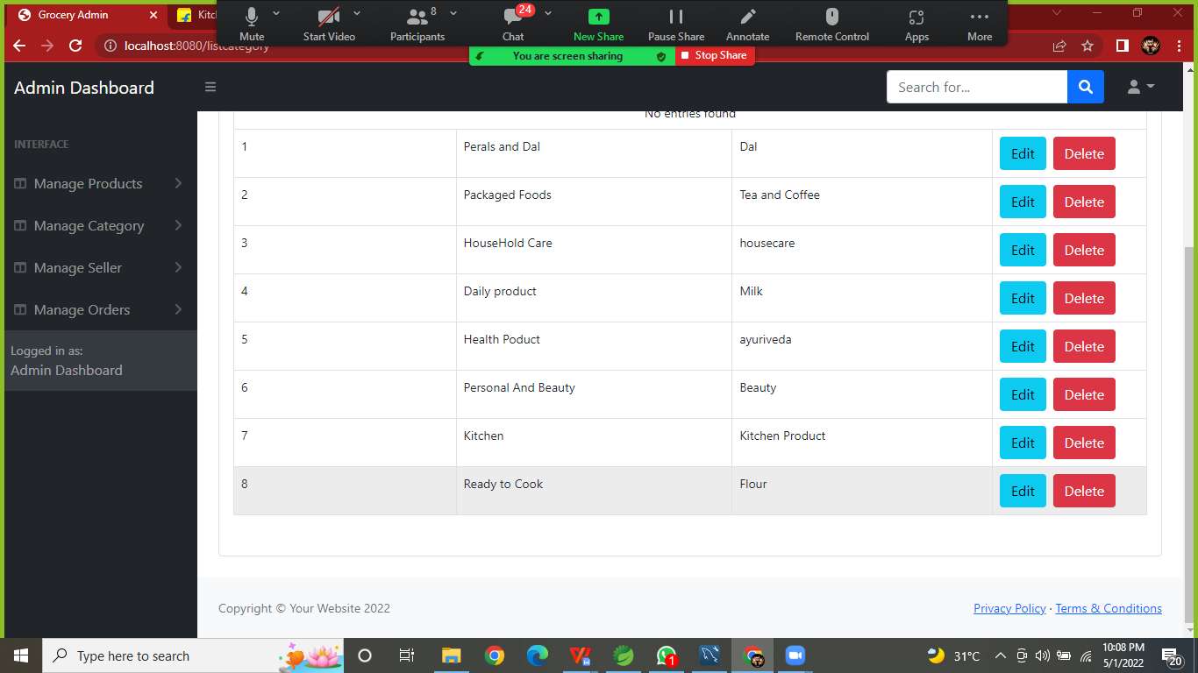

**Admin can Update Delivery Status:**

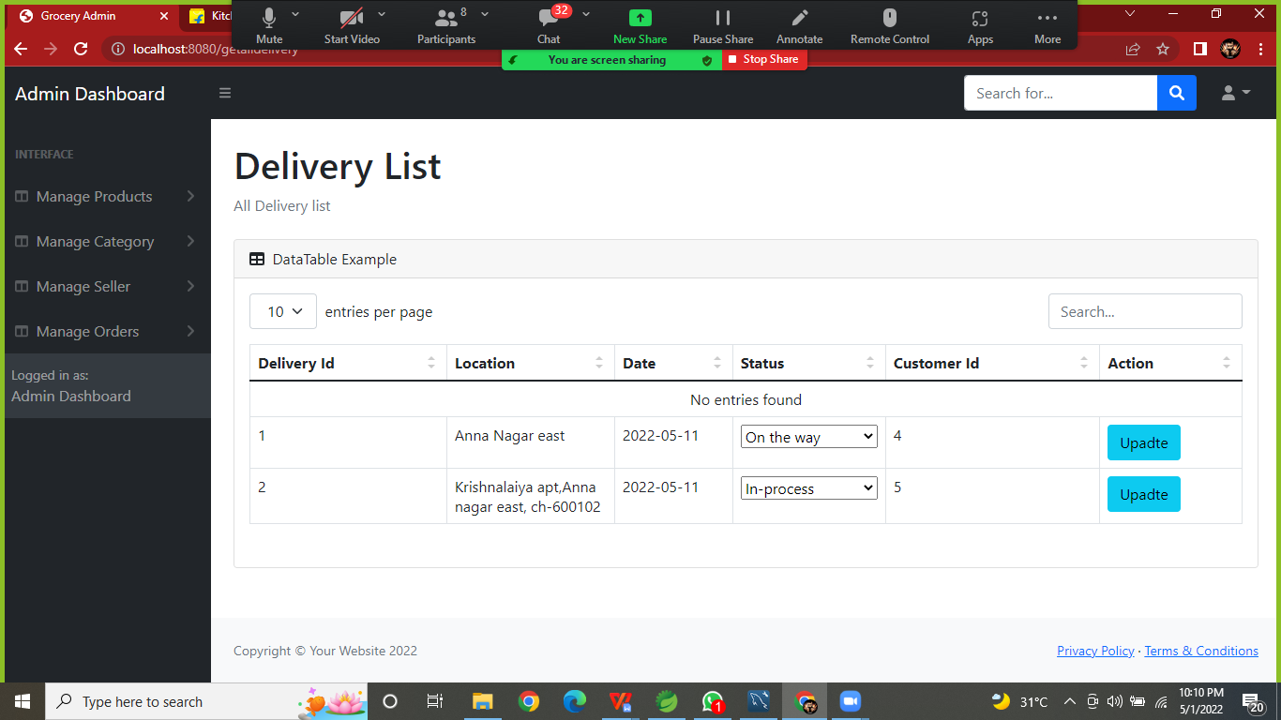

1. **Delivery Status Page in user-interface:**

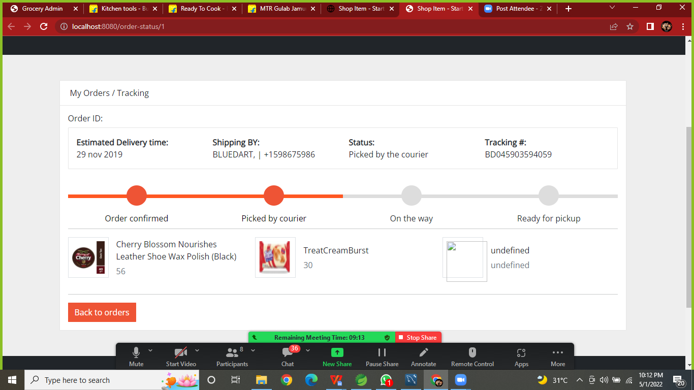

**Conclusion:**

This is our project is running process is displaced on presented in above. We believe this application will help to manage the grocery order anywhere..

**Thank You**