Vaijayanti Deshmukh
Joshua Gray
Lasya Raghavendra
Assignment 4

Step 1: Create S3 Bucket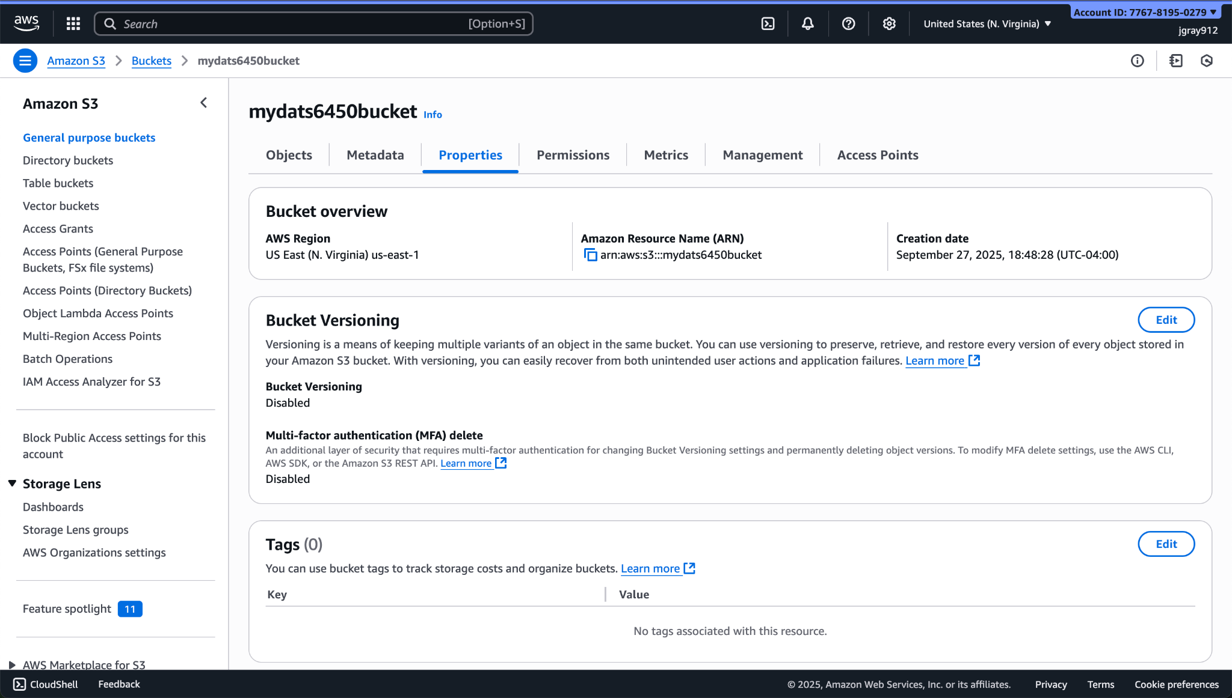

Step 2: Launch EC2 and connect using ssh command
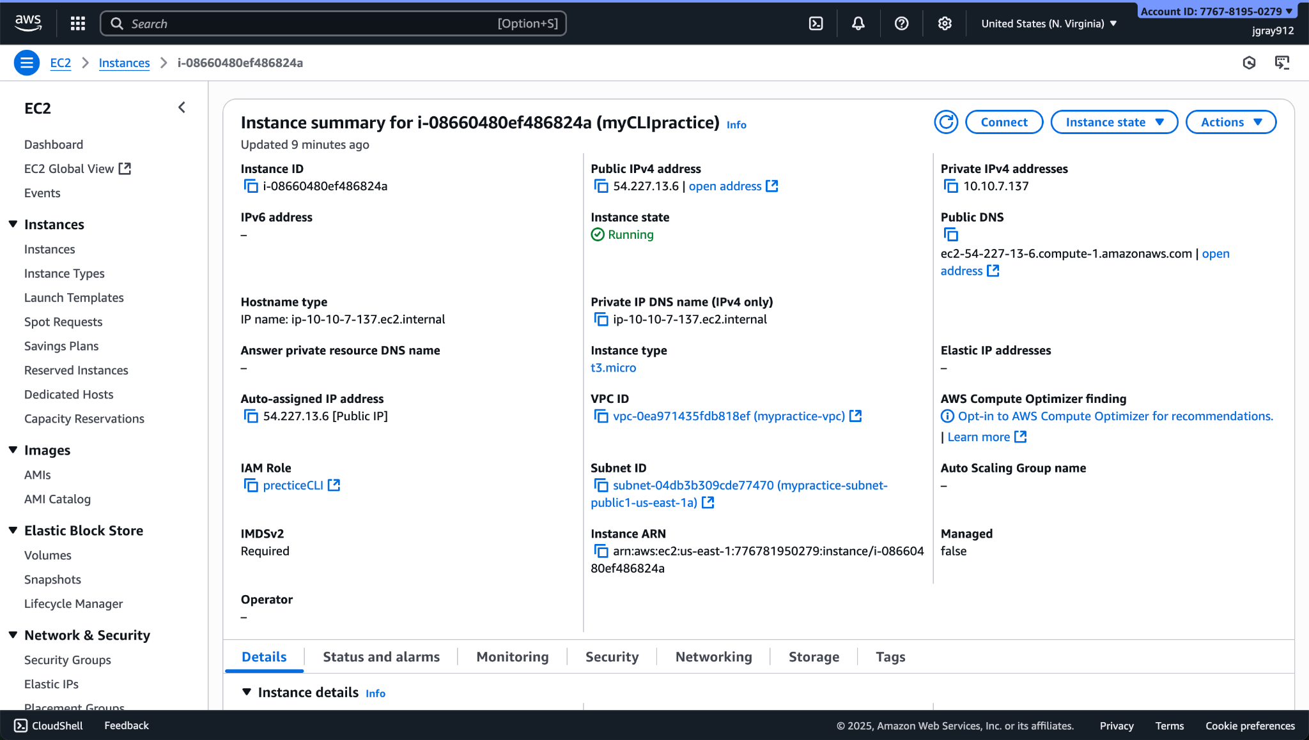
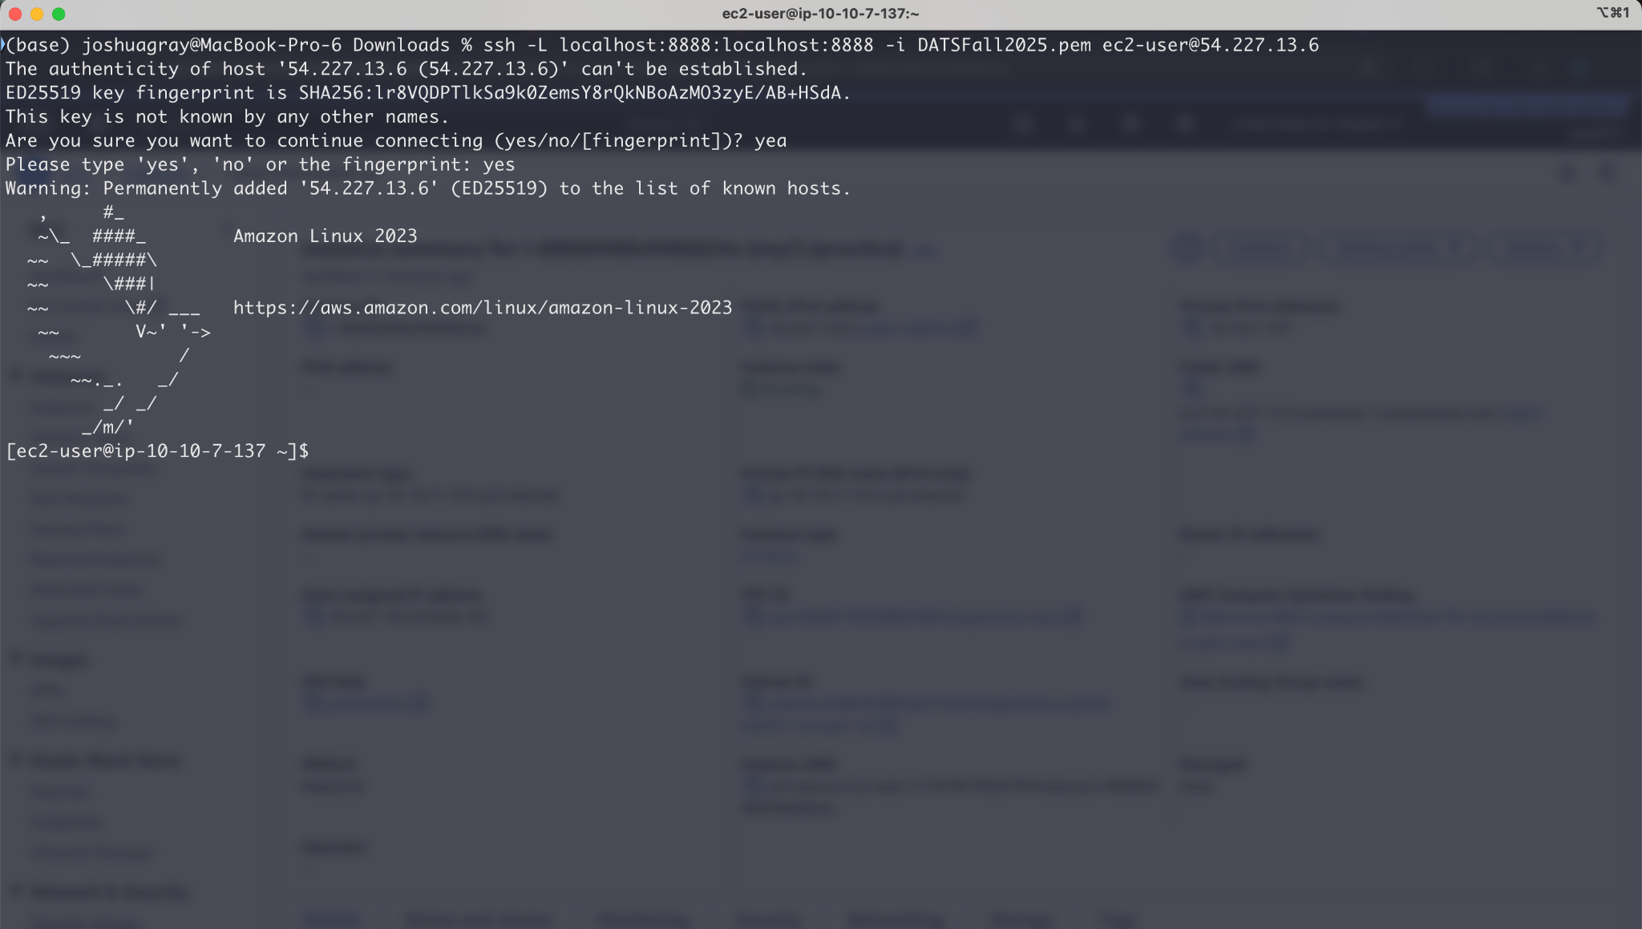

Step 3: Download baby names to EC2 instance
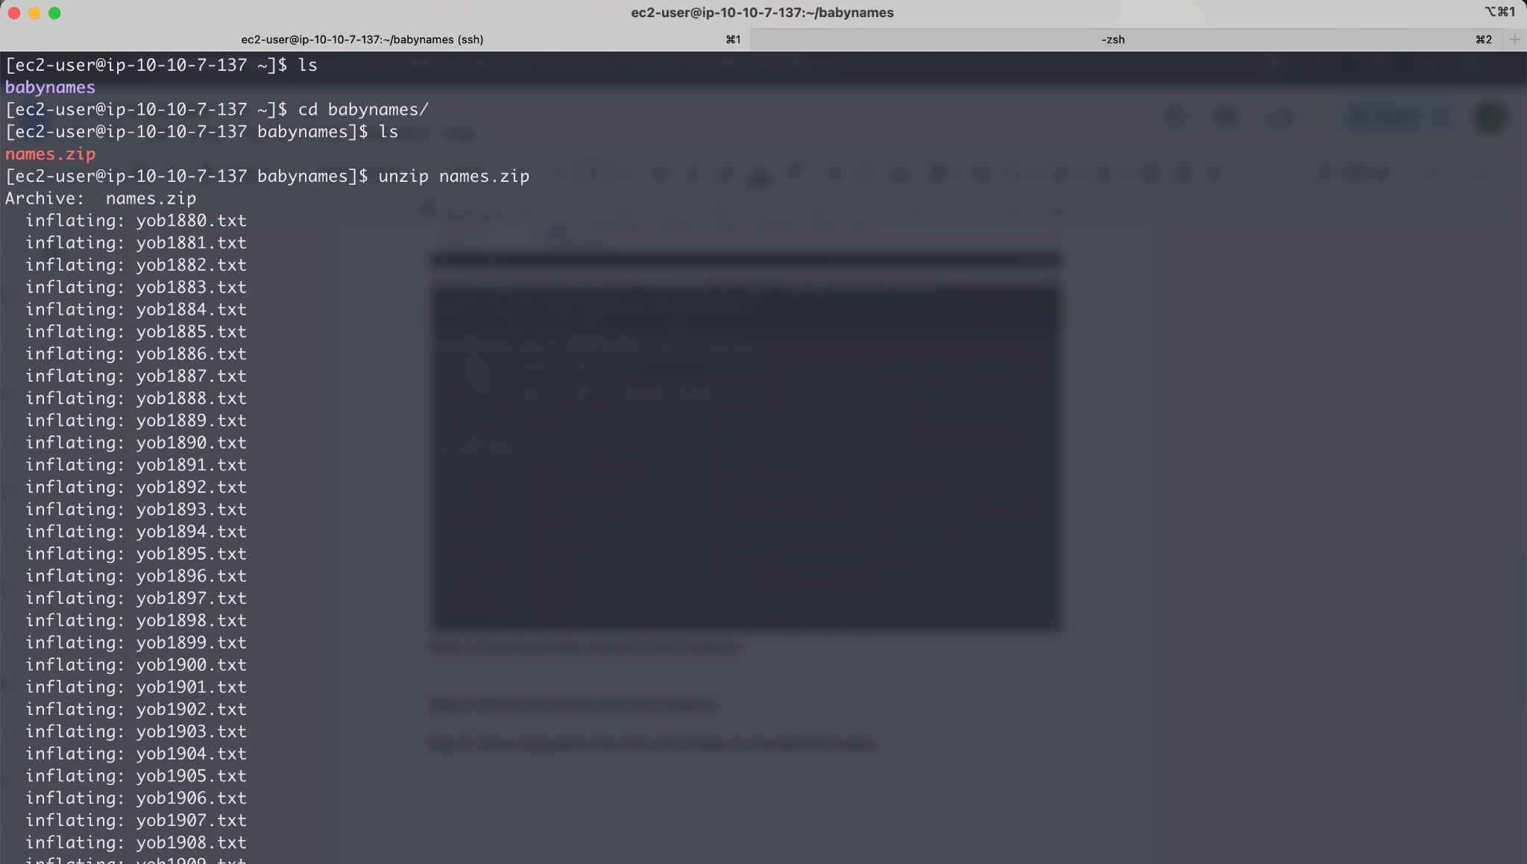

Step 4: Mount S3 bucket onto EC2 instance
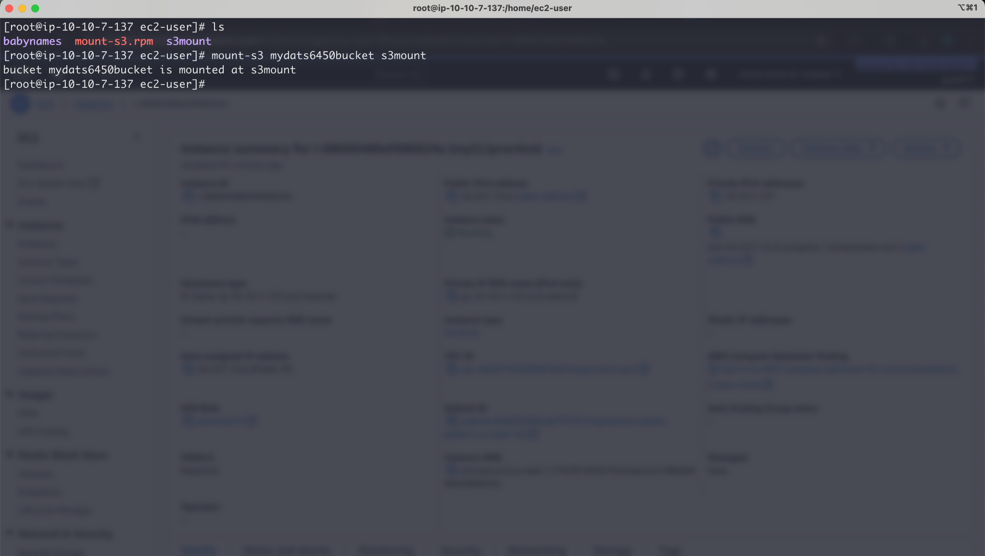

Step 5: Move babyname files from EC2 folder to mounted S3 bucket
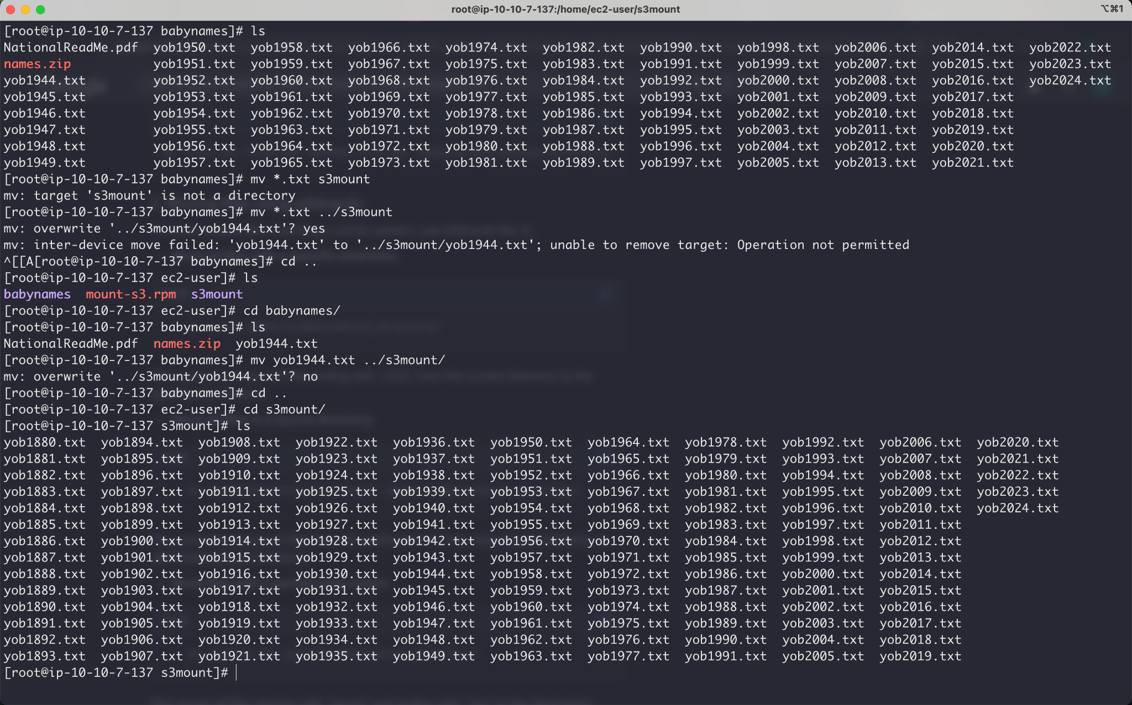

Step 6: Write boto program to list files in S3 bucket
