A5 – Computing
Group 1
- Using AWS console launch an EC2 instance (you can also use the EC2 instance you created previously) in the default VPC. Make sure you have enabled the public address
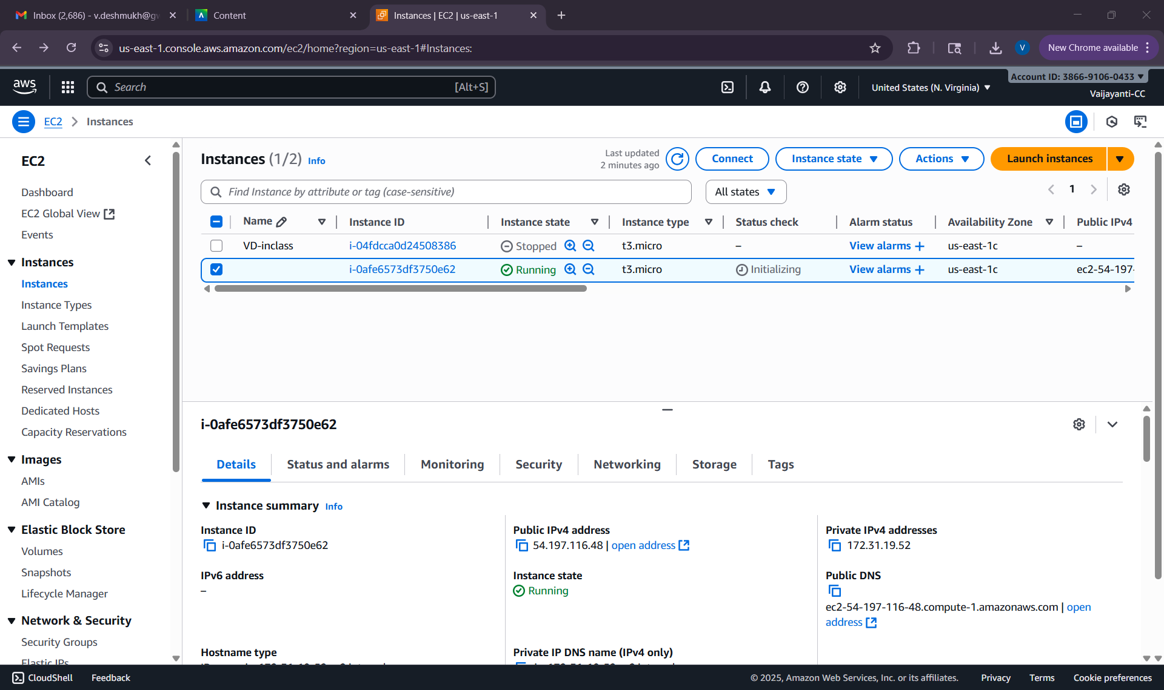
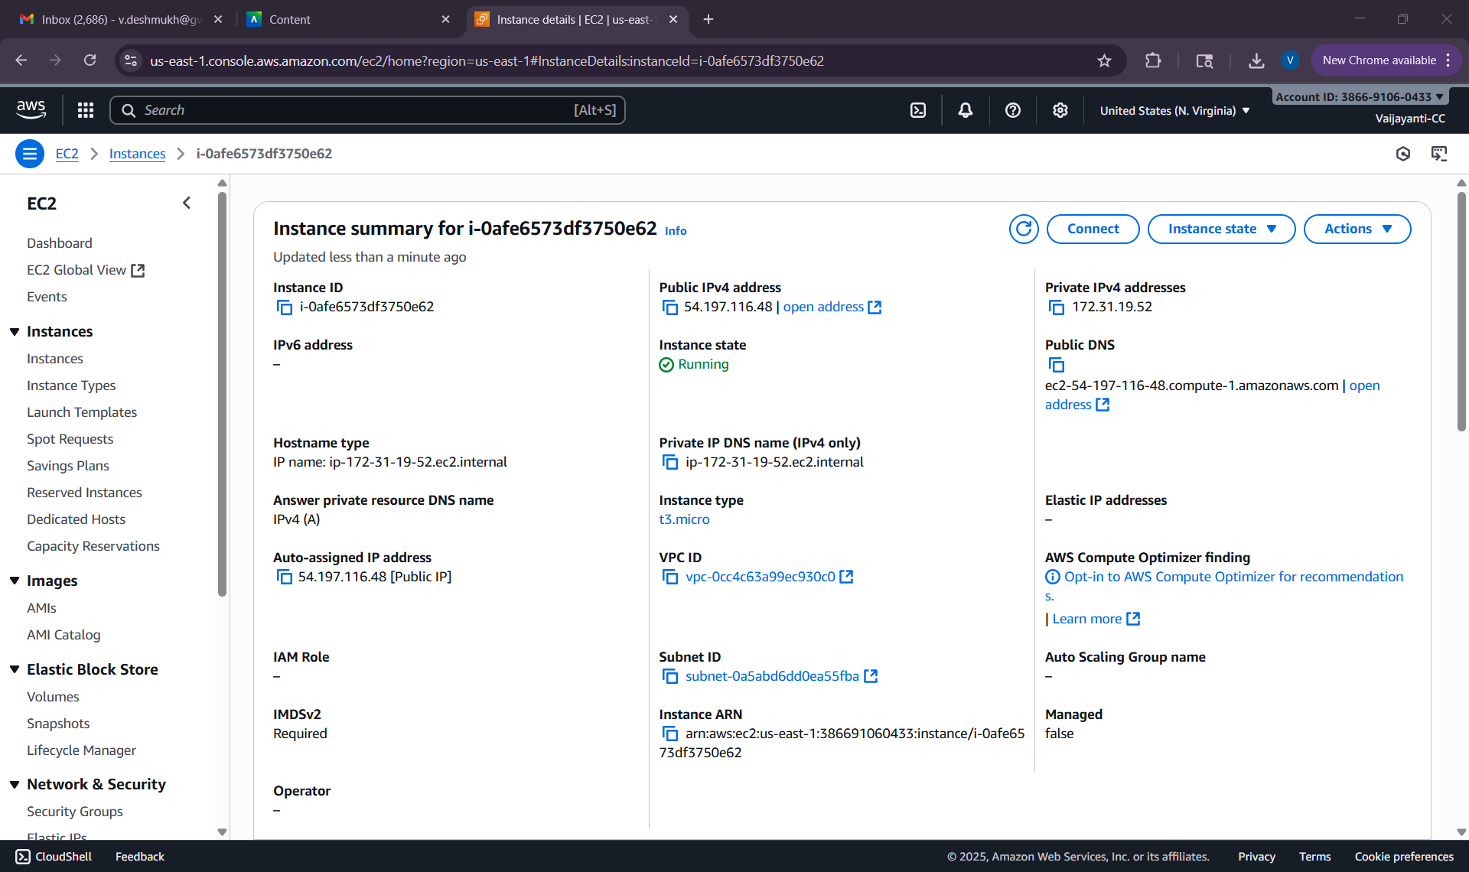
- login into your EC2 (via putty or via SSH as described in previous assignments). Since you might want to use Jupyter, make sure you establish a tunnel between your laptop and your EC2
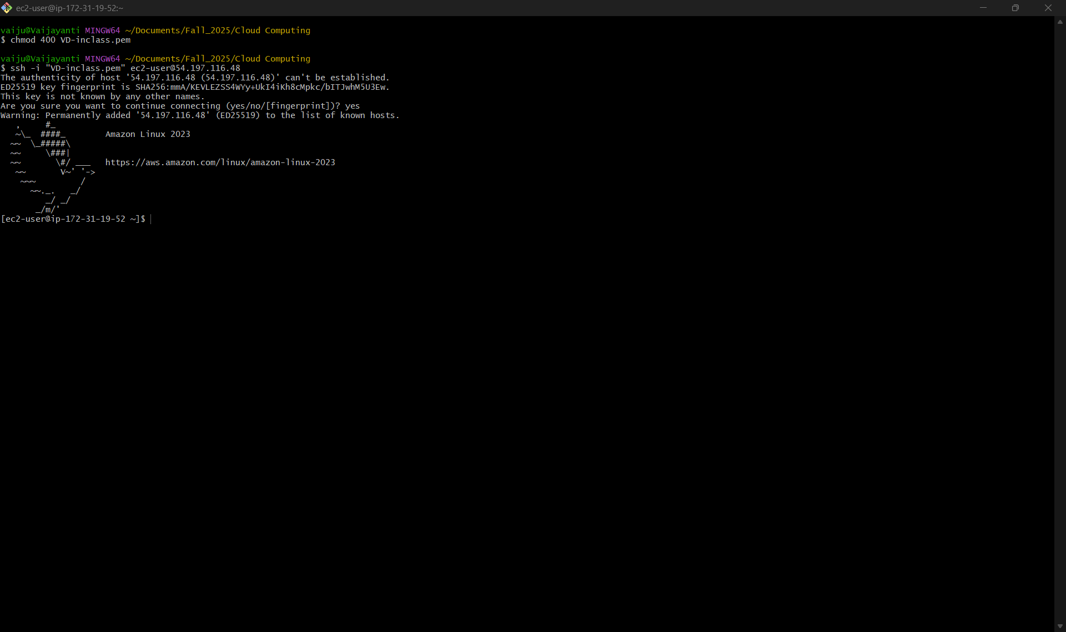
Open a tunnel for jupyter notebook
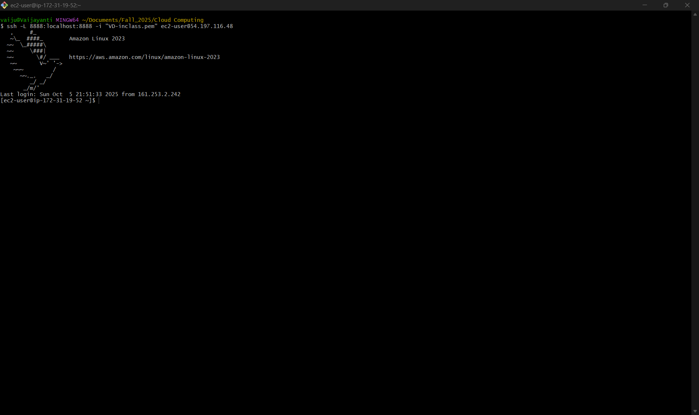
- Update the operational system (sudo yum update)
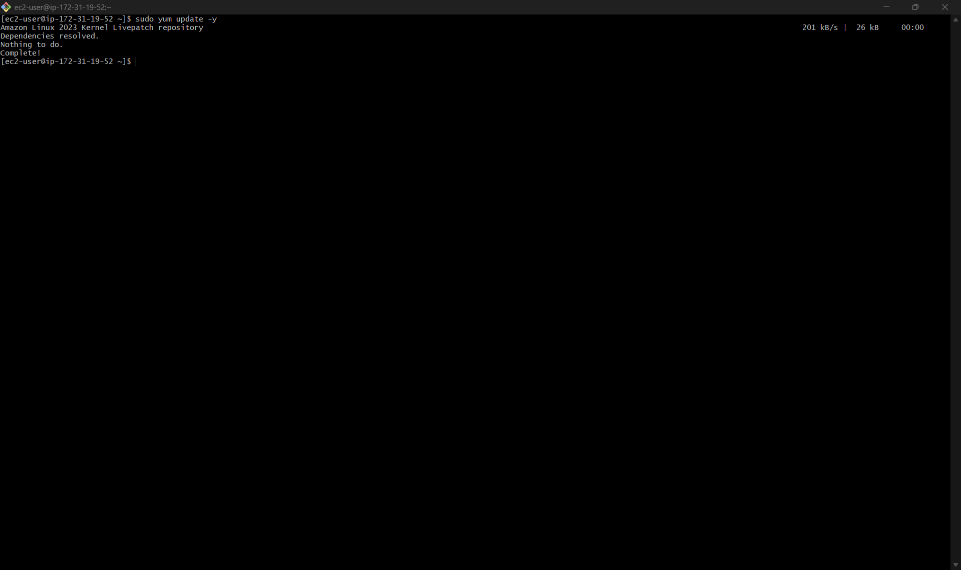
- you can install miniconda or create a virtual environment. Conda is normally VERY big, so I would recommend you create a virtual environment, e.g.:
  - cd ~/
  - mkdir ec2_assignement
  - cd ec2_assignement
  - python3 -m venv venv
  - source venv/bin/activiate
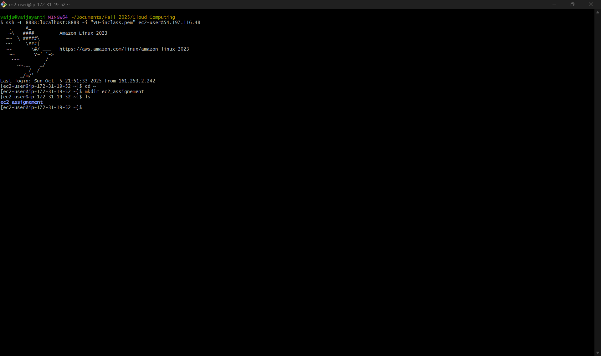
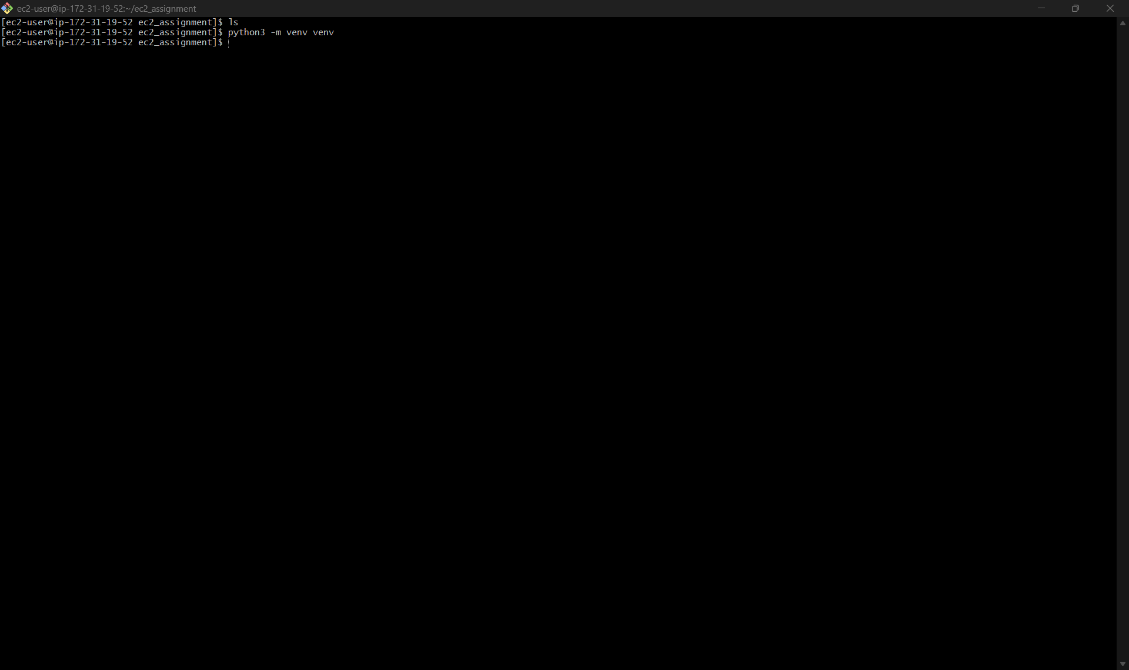
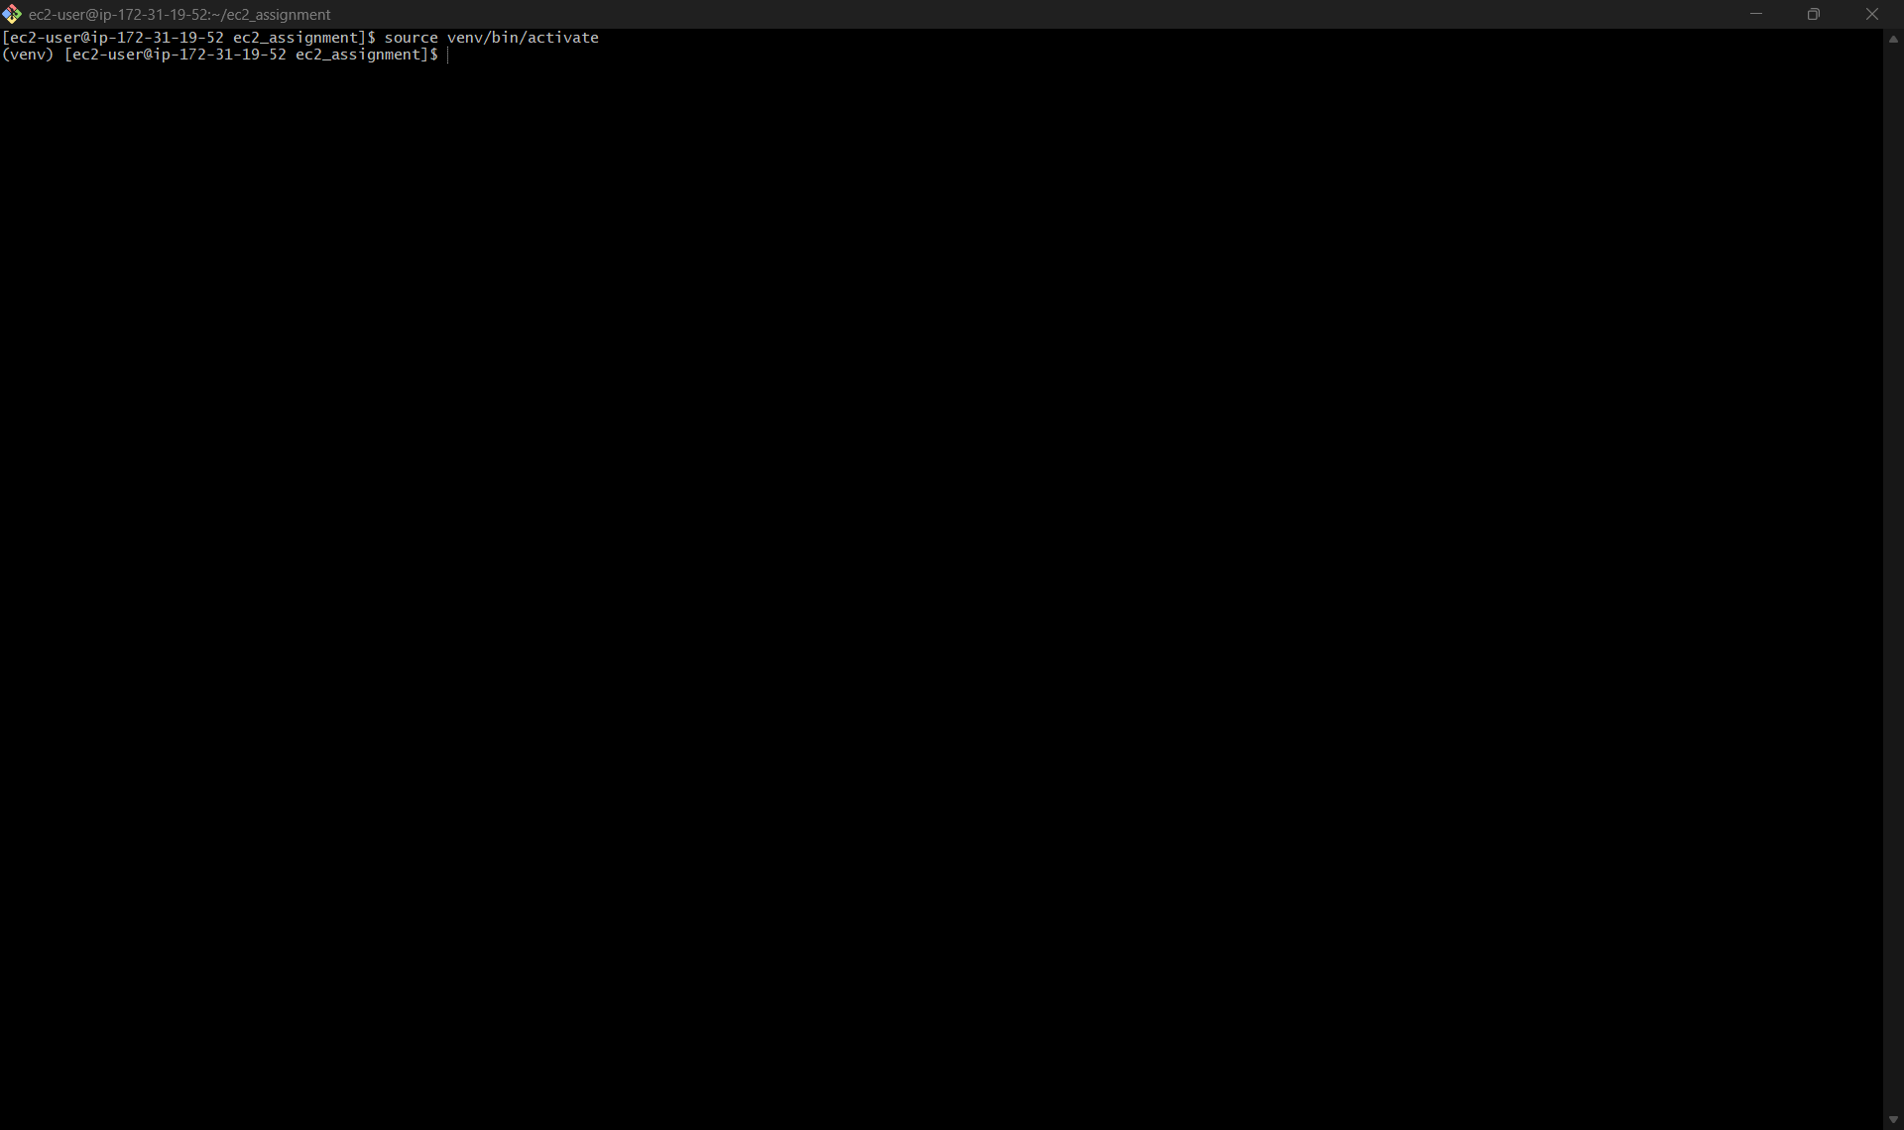
- install the required packages, e.g., jupyter
  - pip install pandas
  - pip install jupyter
  - pip install matplotlib
  - jupyter notebook # this will call launch jupyter notebook. then you should open in your browser (in your laptop) the URL indicated
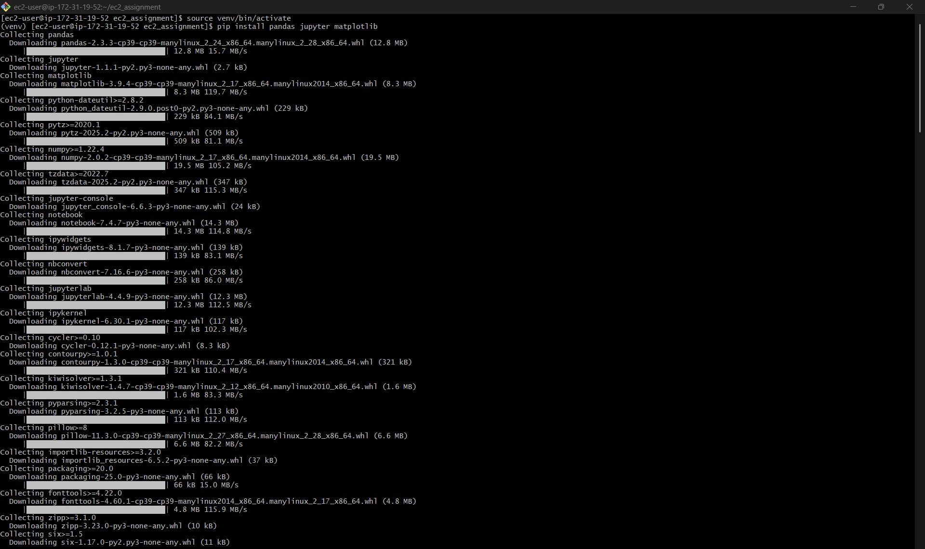
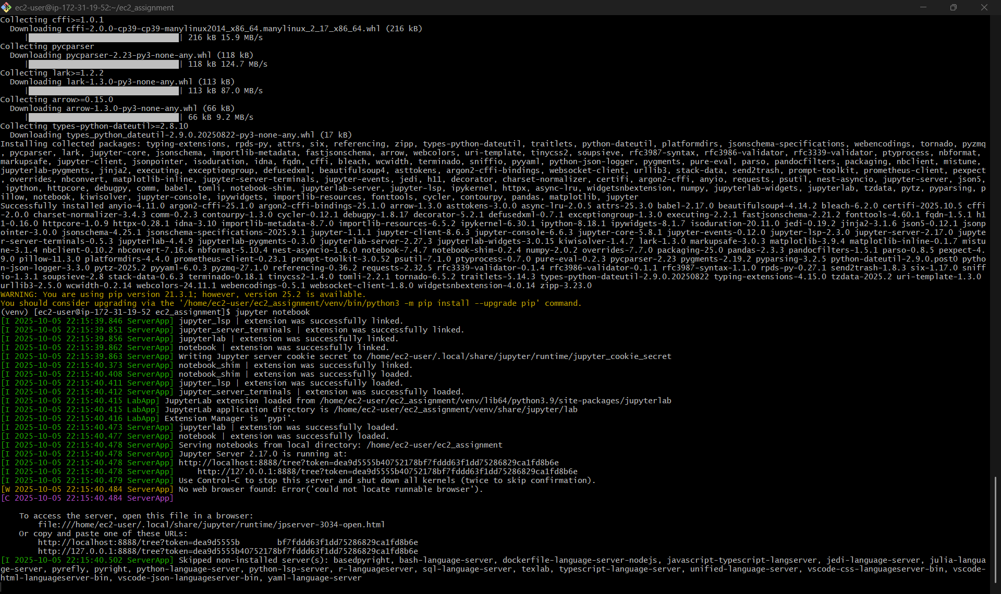
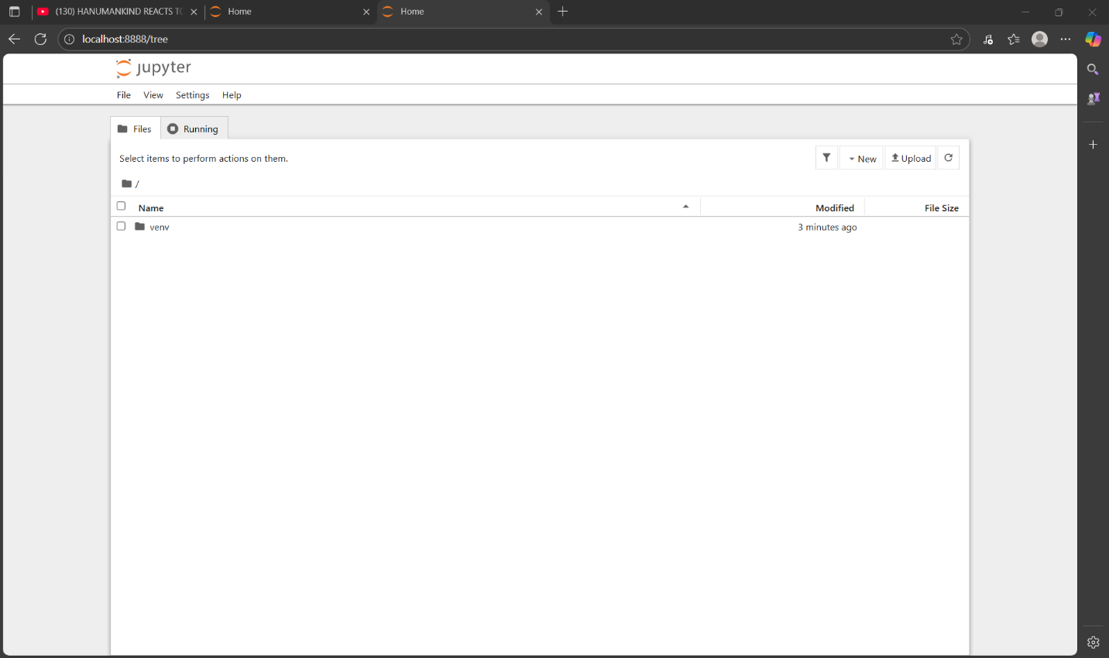
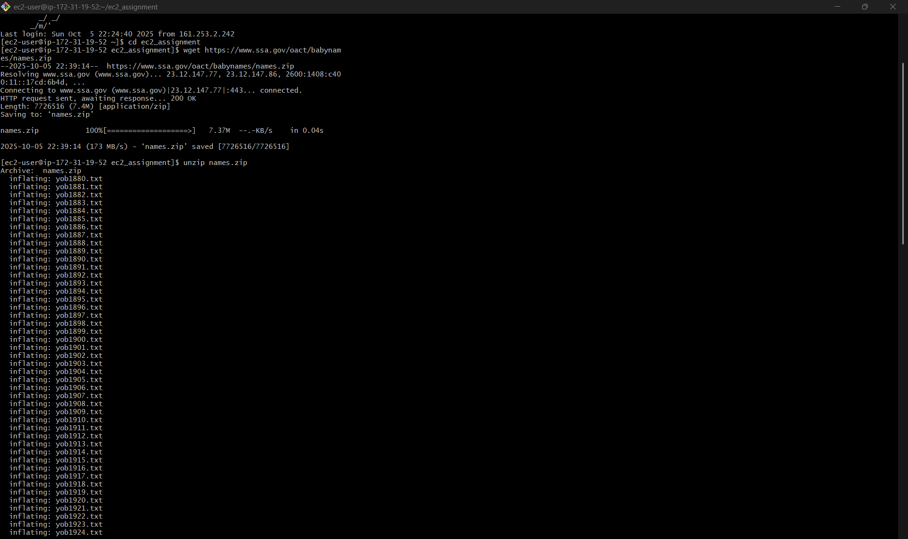
- Follow the instructions provided in the attached file and perform all the analyses required
