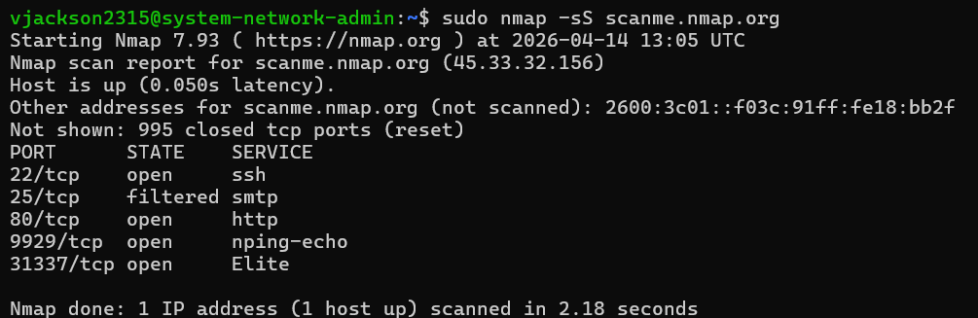
- The services ssh, http, nping-echo and Elite are all accepting connections of packets. The port that was unreachable was smtp, and 995 other ports closed, and was sent back an RST packet.
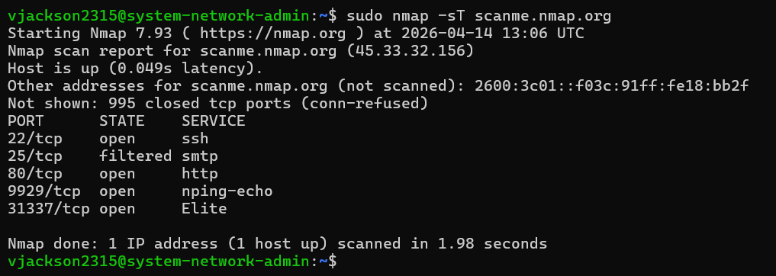
- Similar to the SYN scan, but instead of getting an RST for the closed ports, the connection was refused.
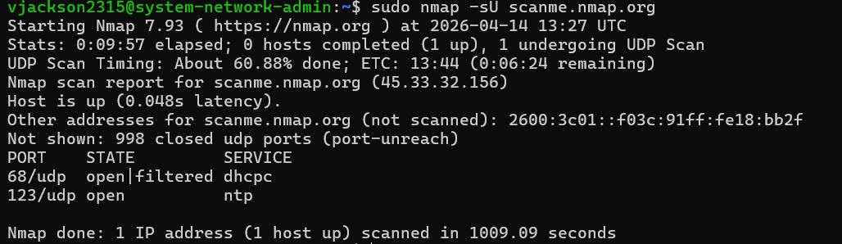
- The ntp port was open for connection, but the dhcpc ignored it.
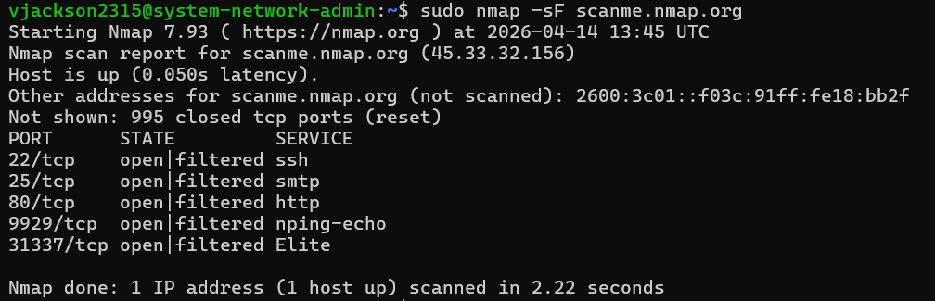
- All packets that were open in the SYN scan were ignored
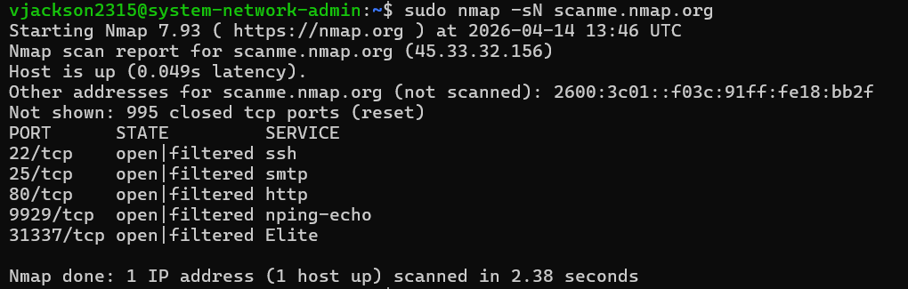
- All packets that were open in the SYN scan were ignored
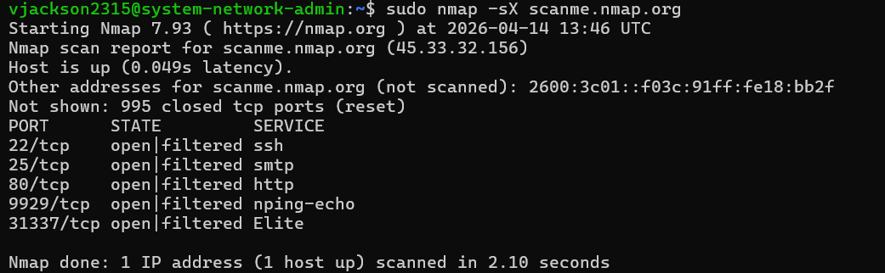
- All packets that were open in the SYN scan were ignored
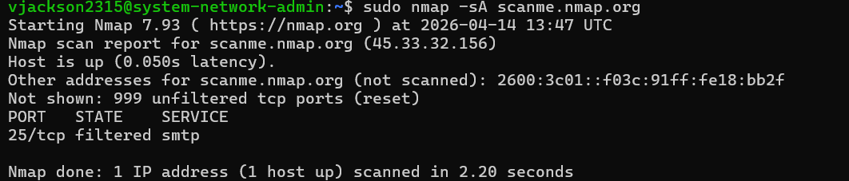
- The smtp packet was unreachable, and everything else send back an RST packet
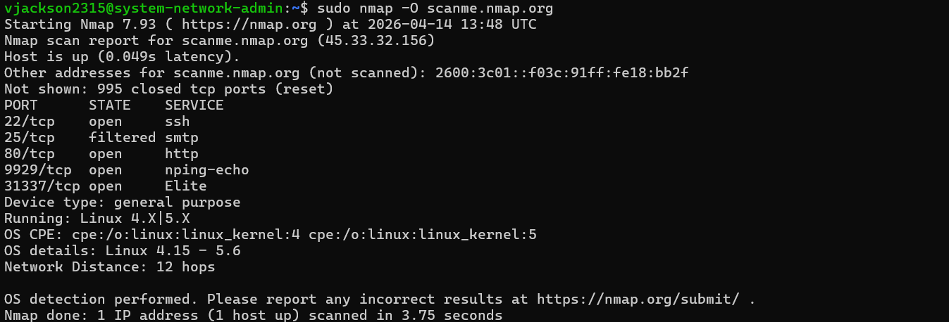
- Operating System: Linux
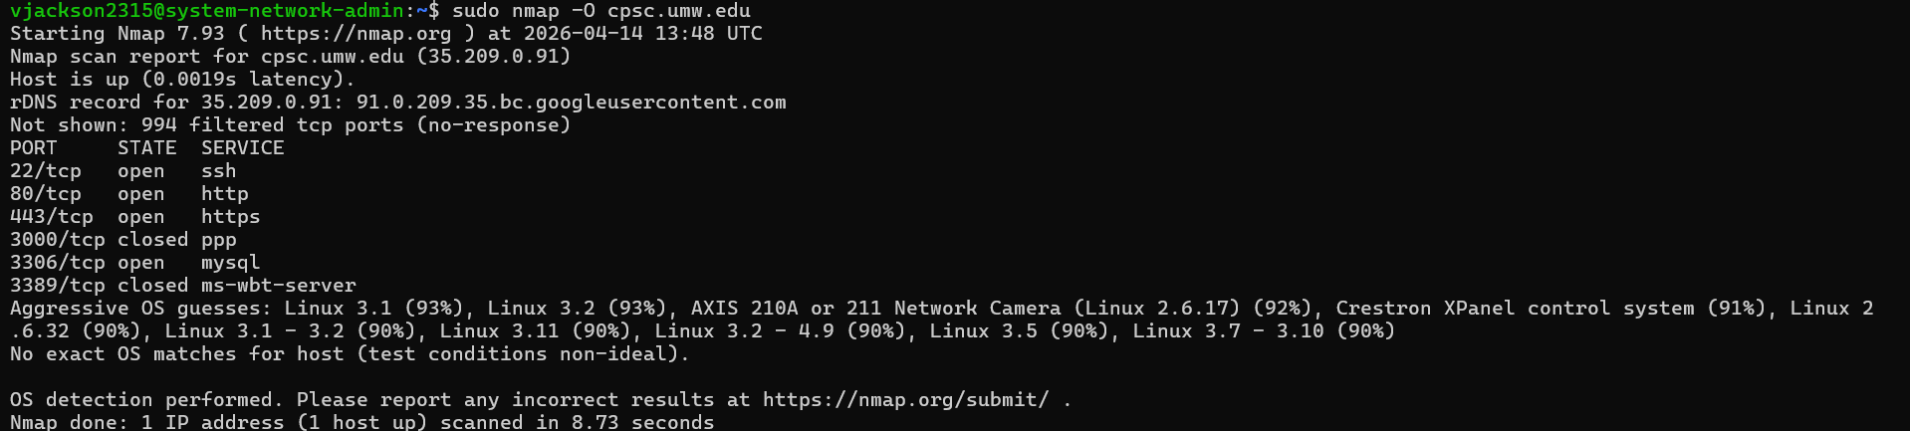
- The results were incorrect, since it tried to guess what the OS for the server was, but could not find an exact match for it.

