This is a real time dataset of the ineuron technical consultant team. You have to perform hive analysis on this given dataset.
Download Dataset 1 - https://drive.google.com/file/d/1WrG-9qv6atP-W3P_-gYln1hHyFKRKMHP/view
Download Dataset 2 - https://drive.google.com/file/d/1-JIPCZ34dyN6k9CqJa-Y8yxIGq6vTVXU/view
Note: both files are csv files.
------------------------------------------------------------------------------------------

1. Create a schema based on the given dataset
create table agentlogin
(
sl_no int,
Agent string,
dates string,
login_time string,
logout_time string,
duration string
)
row format delimited
fields terminated by','
tblproperties("skip.header.line.count"="1");

create table agentperformance
(
sl_no int,
dates string,
agent_name string,
total_chats string,
avg_response_time string,
avg_resolution_time string,
average_rating float,
total_feedback int
)
row format delimited
fields terminated by ','
tblproperties("skip.header.line.count"="1");

------------------------------------------------------------------------------------------
2. Dump the data inside the hdfs in the given schema location.

hadoop fs -put AgentLogingReport.csv /tmp
load data inpath '/tmp/AgentLogingReport.csv' into table agentlogin;
select * from agentlogin limit 5;

hadoop fs -put AgentPerformance.csv /tmp
load data inpath '/tmp/AgentPerformance.csv' into table agentperformance;
select * from agentperformance limit 5;
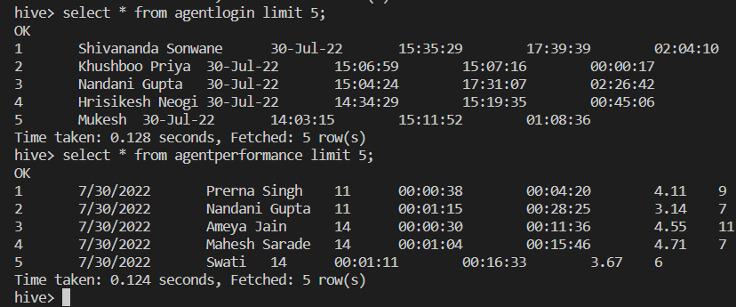
------------------------------------------------------------------------------------------
3. List of all agents' names.
select distinct agent from agentlogin;
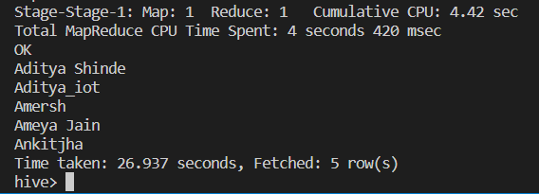
4. Find out agent average rating.
select agent_name, avg(average_rating) from agentperformance group by agent_name;

5. Total working days for each agents
select Agent, count(dates) from agentlogin group by Agent limit 10;
OK
Aditya Shinde 1
Aditya_iot 9
Amersh 4
Ameya Jain 10
Ankitjha 4
Anurag Tiwari 37
Aravind 10
Ayushi Mishra 18
Bharath 9
Boktiar Ahmed Bappy 17
Time taken: 28.157 seconds, Fetched: 10 row(s)

6. Total query that each agent have taken
select agent_name, sum(total_chats) from agentperformance group by agent_name limit 10;
OK
Abhishek 0.0
Aditya 0.0
Aditya Shinde 277.0
Aditya_iot 231.0
Amersh 0.0
Ameya Jain 322.0
Anirudh 81.0
Ankit Sharma 0.0
Ankitjha 5.0
Anurag Tiwari 4.0
Time taken: 23.333 seconds, Fetched: 10 row(s)

7. Total Feedback that each agent have received
select agent_name, sum(total_feedback) from agentperformance group by agent_name;

8. Agent name who have average rating between 3.5 to 4
select agent_name from agentperformance where average_rating BETWEEN 3.5 AND 4 limit 10 ;

9. Agent name who have rating less than 3.5
select agent_name from agentperformance where average_rating < 3.5 limit 5;

10. Agent name who have rating more than 4.5
select agent_name from agentperformance where average_rating > 4.5 ;

11. How many feedback agents have received more than 4.5 average
select agent_name, avg(total_feedback) as result from agentperformance group by agent_name having result>4.5 limit 10 ;

12. average weekly response time for each agent
select s.agent_name,avg(col1[0]*3600+col1[1]*60+col1[2])/3600 from(
select agent_name,split(average_response_time,':') as col1 from agent_performance)s group by s.agent_name;

13. average weekly resolution time for each agents
select s.agent_name,avg(col1[0]*3600+col1[1]*60+col1[2])/3600 from(
select agent_name,split(average_resolution,':') as col1 from agent_performance)s group by s.agent_name;

14. Find the number of chat on which they have received a feedback
select agent_name, sum(total_chats), total_feedback from agentperformance where total_feedback > 0 group by agent_name, total_feedback limit 5;
Total MapReduce CPU Time Spent: 17 seconds 280 msec
OK
Aditya Shinde 8.0 7
Aditya Shinde 17.0 8
Aditya Shinde 67.0 9
Aditya Shinde 18.0 11
Aditya Shinde 27.0 14
Time taken: 24.407 seconds, Fetched: 5 row(s)

- Total contribution hour for each and every agents weekly basis.

select s.agent, sum( col1[0]*3600 + col1[1]*60 + col1[2]) / 3600, s.weekly from( select agent, split(duration,':') as col1 , weekofyear(Date) as weekly from agent_logging_report) s group by s.agent, s.weekly limit 2;

Aditya Shinde 0.03611111111111111 30
Aditya_iot 6.095277777777778 29

16. Perform inner join, left join and right join based on the agent column and after joining the table export that data into your local system.
## INNER JOIN
select a.agent, a.dates, p.total_chats, p.total_feedback from default.agentlogin a JOIN default.agentperformance p on a.agent = p.agent_name limit 5;
Total MapReduce CPU Time Spent: 4 seconds 140 msec
OK
Prerna Singh 30-Jul-22 11 9
Prerna Singh 29-Jul-22 11 9
Prerna Singh 29-Jul-22 11 9
Prerna Singh 29-Jul-22 11 9
Prerna Singh 27-Jul-22 11 9
Time taken: 30.044 seconds, Fetched: 5 row(s)

## LEFT JOIN
select a.agent, a.dates, p.total_chats, p.total_feedback from default.agentlogin a LEFT JOIN default.agentperformance p on a.agent = p.agent_name limit 5;
Total MapReduce CPU Time Spent: 3 seconds 980 msec
OK
Shivananda Sonwane 30-Jul-22 4 1
Shivananda Sonwane 30-Jul-22 14 9
Shivananda Sonwane 30-Jul-22 5 4
Shivananda Sonwane 30-Jul-22 26 18
Shivananda Sonwane 30-Jul-22 24 14
Time taken: 28.201 seconds, Fetched: 5 row(s)

## RIGHT JOIN
select a.agent, a.dates, p.total_chats, p.total_feedback from default.agentlogin a RIGHT JOIN default.agentperformance p on a.agent = p.agent_name limit 5;
Total MapReduce CPU Time Spent: 3 seconds 940 msec
OK
Prerna Singh 30-Jul-22 11 9
Prerna Singh 29-Jul-22 11 9
Prerna Singh 29-Jul-22 11 9
Prerna Singh 29-Jul-22 11 9
Prerna Singh 27-Jul-22 11 9
Time taken: 28.662 seconds, Fetched: 5 row(s)

17. Perform partitioning on top of the agent column and then on top of that perform bucketing for each partitioning.
Create table ALR_partition_Bucket
(
sr_no int,
Dates string,
Login_time string,
Logout_time string,
Duration string
)partitioned by (Agent string)
CLUSTERED BY (Dates) sorted by (Dates) INTO 4 BUCKETS
ROW FORMAT DELIMITED
FIELDS TERMINATED BY ',';

set hive.exec.dynamic.partition=true;
set hive.exec.dynamic.partition.mode=nonstrict;

insert into table ALR_partition_Bucket partition(Agent) select sl_no,Dates,Login_time,Logout_time,Duration,Agent from agentlogin;

