CONVEYOR BELT

A conveyer belt in coal handling plant is used to transport the coal from one point to the other point as per the requirement. A **conveyor belt** (or **belt conveyor**) consists of two or more pulleys with a continuous loop of material - the conveyor belt - that rotates about them. One or both of the pulleys are powered, moving the belt and the material on the belt forward. The powered pulley is called the drive pulley while the unpowered pulley is called the driven pulley. There are two main industrial classes of belt conveyors; Those in general [material handling](http://en.wikipedia.org/wiki/Material_handling) such as those moving boxes along inside a factory and [bulk material handling](http://en.wikipedia.org/wiki/Bulk_material_handling) such as those used to transport industrial and agricultural materials, such as grain, coal, ores, etc. generally in outdoor locations. Generally companies providing general material handling type belt conveyors do not provide the conveyors for bulk material handling. In addition there are a number of commercial applications of belt conveyors such as those in [grocery stores](http://en.wikipedia.org/wiki/Grocery_store).

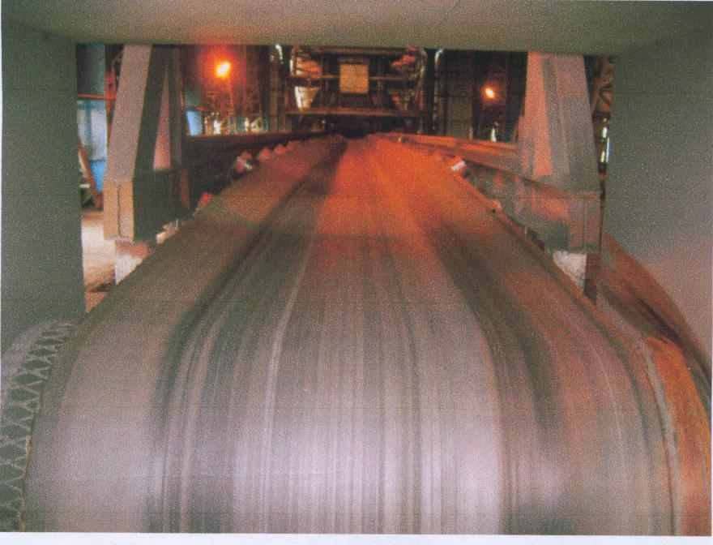

The [belt](http://en.wikipedia.org/wiki/Belt_(mechanical)) consists of four layers of material. They can be made out of [rubber](http://en.wikipedia.org/wiki/Rubber), fibre, here it is made of **ethylene polyamide**. An under layer of material to provide linear strength and shape called a carcass and an over layer called the cover. The carcass is often a cotton or plastic web or mesh. The cover is often various rubber or plastic compounds specified by use of the belt. Covers can be made from more exotic materials for unusual applications such as silicon for heat or gum rubber when traction is essential.

Conveyor technology is also used in [conveyor transport](http://en.wikipedia.org/wiki/Conveyor_transport_(disambiguation)) such as [moving sidewalks](http://en.wikipedia.org/wiki/Moving_sidewalk) or [escalators](http://en.wikipedia.org/wiki/Escalator), as well as on many manufacturing [assembly lines](http://en.wikipedia.org/wiki/Assembly_line). Stores often have conveyor belts at the [check-out counter](http://en.wikipedia.org/wiki/Check-out_counter) to move shopping it.

A wide variety of related conveying machines are available, different as regards principle of operation, means and direction of conveyance, including [screw conveyors](http://en.wikipedia.org/wiki/Screw_conveyor), vibrating conveyors, pneumatic conveyors, the [moving floor](http://en.wikipedia.org/wiki/Moving_floor) system, which uses reciprocating slats to move cargo, and roller conveyor system, which uses a series of powered rollers to convey boxes or [pallets](http://en.wikipedia.org/wiki/Pallet).

**HISTORY**

Primitive conveyor belts were used since the 19th century. In 1892, Thomas Robins began a series of inventions which led to the development of a conveyor belt used for carrying coal, ores and other products. In 1901, [Sandvik](http://en.wikipedia.org/wiki/Sandvik" \o "Sandvik) invented and started the production of [steel](http://en.wikipedia.org/wiki/Steel) conveyor belts. In 1905 [Richard Sutcliffe](http://en.wikipedia.org/wiki/Richard_Sutcliffe) invented the first conveyor belts for use in [coal mines](http://en.wikipedia.org/wiki/Coal_mines) which revolutionized the mining industry. In 1913, [Henry Ford](http://en.wikipedia.org/wiki/Henry_Ford) introduced conveyor-belt assembly lines at [Ford Motor Company](http://en.wikipedia.org/wiki/Ford_Motor_Company)'s Highland Park, Michigan factory. Hyacynthe Marcel Bocchetti was the concept designer. In 1957, the B. F. Goodrich Company patented a conveyor belt that it went on to produce as the Turnover Conveyor Belt System. Incorporating a half-twist, it had the advantage over conventional belts of a longer life because it could expose all of its surface area to wear and tear. In 1963-64, First Indian Small Scale Industrial Unit with Japanese Plant for Rubber Belts for Conveyor was installed near National Capital Territory of Delhi and its MrBelts Conveyor Belting has been widely used in Steel, Cement, Fertilizer, Thermal Power, Sponge Iron Plants and Coal / Mineral establishments / Mines, Port Trusts and similar material handling applications of Industry for the last over 4 decades.

**TYPES OF BELTS**

There are three different types of [conveyor](http://www.wisegeek.com/what-is-a-conveyor.htm) belts:

* Basic belt
* Snake sandwich belt
* Long belt.

A basic belt conveyor consists of two or more pulleys that hold one continuous length of material. These types of belts can be motorized or require manual effort. As the belt moves forward, all the items on the belt are carried forward.

A common installation sites for conveyor belts include packaging or parcel delivery services. This industry often requires a method of relocating materials from one place to another, quickly and with minimal human intervention. The belt is typically installed at waist height to improve the ergonomics for the staff that are interacting with the materials.

The conveyor structure consists of a metal frame with rollers installed at various intervals along the length of the [conveyor belt](http://www.wisegeek.com/what-are-conveyor-belts.htm). The belt is typically a smooth, rubberized material that covers the rollers. As the belt moves over the rollers, the items placed on the belt are transferred with a reduced amount of friction, due to the use of multiple rollers. Basic belt conveyors also have curved sections to allow the belt to move product around corners.

**BELT SWAYING**

Shifting of a belt to one side from its mean position while running is called BELT SWAYING. This causes the coal to spill out from the belt. The major problem that arises is the capacity of the transportation of coal through conveyor belts decreases significantly which takes more time to fill the bunkers. The conveyor belts are of very long length which causes the housekeeping problem. It is very difficult to clean and remove the coal along the length of the conveyor. In NTPC Ramagundam, there are 68 conveyors which constitute a total length of 31KM. hence it is necessary for normal running of the belt with acceptable swaying, to transport the required coal. This is also called lining out of the belt. Many factors determine the belt sway. Hence the design of the belt is to be done keeping all the considerations.

**DESIGNING OF BELT**

Belt shall be designed for heavy duty condition and shall be suitable for 24 effective. working hours operations per day and 365 working days per year. It shall be suitable for installation over conveyor system having 35º troughing angle and shall be suitable for operation at an ambient temperature of 50ºC. It shall have sufficient resistant against exposure to open sunlight so that its qualities do not deteriorate while working in open sun. It also may have to work in rain and or in conditions where relative humidity goes upto 100%.The fabric for belting shall be of Nylon/Nylon heavy duty type. The belting shall be pre-stretched, straight ply, skin coated with open ends. It shall have sufficient strength to give required tension at 10 safety factor and 80% tension utilisation. All belts shall be joined by

vulcanized splicing.

**PROBLEMS CAUSED BY BELT SWAYING**

Due to swaying many problems occur running of the belt with acceptable swaying is a crucial factor in fuel management. The problems caused by belt swaying are listed below

* Shifting of belt to a side from its main position.
* Coal spills out from the belt along it entire length.
* Conveying capacity of the belt decreases significantly there by causing power loss and wastage of time.
* Due to spillage house keeping problem occurs which becomes complex to remove the coal along the length of the conveyer.
* Wear and tear of belt occurs which causes the longitudinal or snapping of the belt.

**FACTORS AFFECTING BELT SWAY**

There are many factors affecting the belt sway. All the factors have to be minimized in order to run the belt with the acceptable swaying.

* Cross feeding of the belt which causes the belt to load only at a single place on the conveyor.
* Lagging of the pulley
* Mis alignment in the axial direction of joining the belt. If Centre to centre alignment of the belt is not done this is seen
* Troughing angle of the rollers in the frame which should vary from 5º to 35º.
* Take up weight which affects the tension. If less take up weight is given it causes the belt to move freely and slipping of the belt .

**MEASURES**

To protect the belt to sway we need to have equipment which improves the belt carrying capacity and helps in the long life of the belt. Some of the equipment are pull chord, belt sway switch, zero speed switch, under belt switch, chute bloackage switches.

1. **Pull Chord Switch**

Pull chord type (manually reset type) emergency stop switches shall be located on both sides of belt conveyors along the walkways for the entire length of conveyors for emergency stopping of conveyor at spacing of 30 Meters. The enclosure shall be of cast aluminum with degree of protection IP-65. It shall have a separate terminal box with a separate hinged cover which shall be totally sealed from main box containing actuating mechanism / limit switch etc. Local pull chord actuation shall be provided by means of mechanical flap. Each switch shall have two NO and two NC contacts, which shall be wired out to the terminal block. The terminal block shall have facilities of cable looping. The Contact rating of the switches shall be rated for atleast 5 Amps, breaking at 240 VAC at 0.3 p.f. lagging. Adequate length of rope and all accessories shall be furnished.

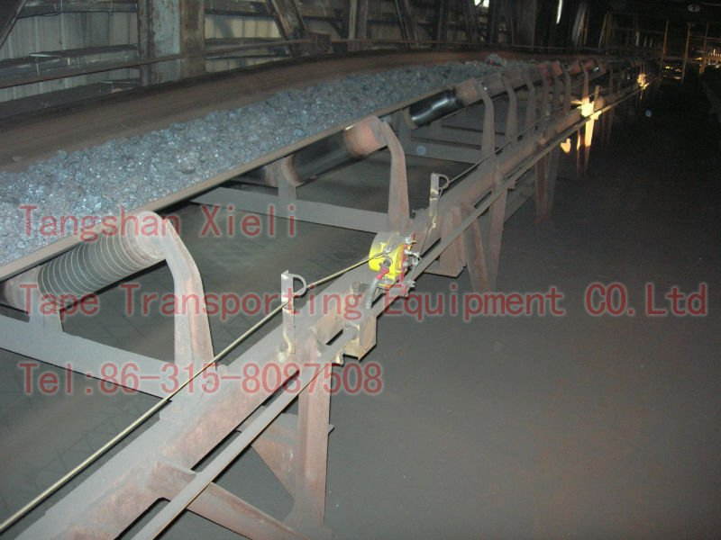

**2. Belt Sway Switches**

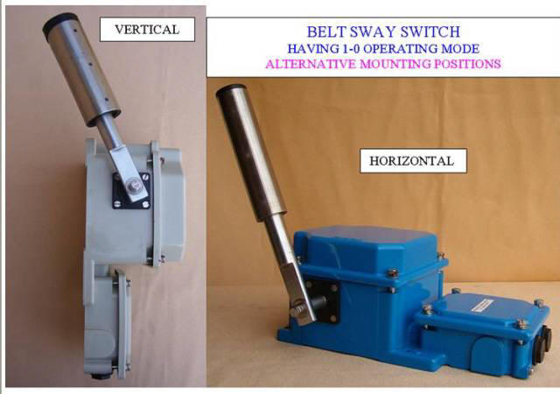

Belt sway switches of self resetting type shall be furnished one pair at 50 meter intervals to limit belt sway to permissible extent. The enclosure shall  be of cast aluminum having degree of protection of IP-65. It shall have a separate terminal box with a separate hinged cover totally sealed from the main box containing actuating mechanism/ limit switch etc. Each switch shall have two NO and two NC contacts one for alarm and one for trip, which shall be wired upto terminal block. The terminal block shall have facilities for cable looping. The contacts of the switches shall be rated for at least 5 Amps. breaking at 240 VAC at 0.3 p.f. lagging.

**3.Zero speed switch**

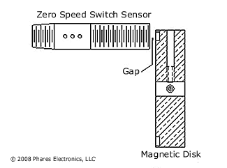

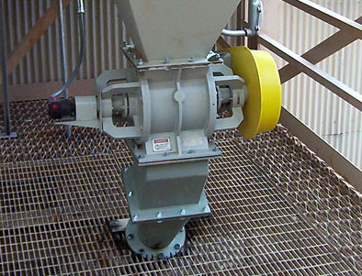

Zero speed switch shall be non-contact (proximity) type electronic switch. Mounting arrangement/ location shall be such that operation, effective sensing distance, sensitivity etc. shall not be effected by accumulation of dust on rotating part or surface of probe. Adequate mechanical protection by means of non-metallic shields shall be provided on top of the switch to prevent any damage due to falling coal / metallic pieces etc. In built initial start up delay and nuisance, tripping delay through timers shall be provided. Each switch shall have two NO and two NC contacts wired out to the terminal blocks. The contact of the switches shall be rated for atleast 5 Amps. Breaking at 240 VAC at 0.3 p.f. lagging. The monitoring unit shall have cast aluminum body having IP-65 degree of protection. A separate terminal box with a separate cover, which shall be totally sealed from main box, shall be provided. Terminal blocks shall be suitable for terminating 1.5 mm sq. standard copper cab.

**4**.  **Under belt switch**

These switches shall be installed under the belt for detecting the presence of material on the belt whose contacts shall in turn be used for operating solenoid valves of dust suppression system elaborated elsewhere. The switch and its operating arrangement shall be suitable for working in dusty areas. The minimum degree of protection of switch shall be IP-62. The switch shall be capable of detecting three events simultaneously as follows :

i)          Belt loaded

ii)         Belt running at more than preset speed.

iii)        Preset initial start delay.

5. **Chute Blockage Switches**

One no. chute blockage switch of proven type (subject to approval of the Employer) shall be provided at a suitable height on each leg of the conveyors chute nearest to the skirt boards. Chute blockage switch shall trip the feeding conveyor in case of Chute blockage and protect the feeding conveyor equipment.

The switch and its operating arrangement shall be suitable for working in dusty areas.  The minimum degree of protection of switch shall be IP-62.  Local indication of chute blockage switch actuation shall also be provided.  Location of chute block switch shall be such that washing/cleaning of chute by pipe / rod does not affect it.

In addition to the above equipment some of the other preventive measures should be taken. They are

1. Deflector plate should be used to control the direction of flow of coal as per requirement. It should be provided to feed the coal at the Centre of the belt.

2.Troughing angle should be provided for the belt to carry the coal at the Centre of the belt. The belt is flat at the pulley and it should be inclined to help the coal to be at the Centre hence troughing angle should be given and it should increase from 5º to 35º.

3.Belt should be joined axially. If it is not so joined then snapping chances of the belt are more.

4. Idlers should rotate freely. If they are not so then swaying occurs.

5. Self aligned frames should be provided

6. Snub pulley is provided to create maximum angle of contact. If the pulley is not positioned properly then the pulley is of no use. Slipping might occur.

**ADVANCEMENTS**

1.Automatic adjustment of the conveyor to correct the sway. Adjustment of the conveyor is the only way to correct the deviation or sway. Motor-Operated adjusted carrier detects the conveyor sway and automatically detects it, greatly reduces the time and cost needed for operation control and maintainence.

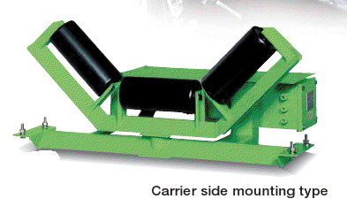

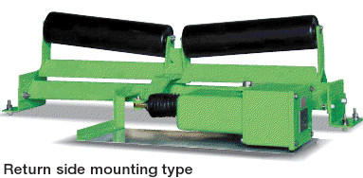

FEAUTURES

* Ideal protection for conveyor belts and material
* Easy installation and maintenance

