EGR 7020

Systems Engineering and Analysis

Militarium

(A Board game, can engage up to 8 players)

**[ M!M ]**

**Submitted to:**  Dr. Victor E Middleton

**Team Name:** Mechs in Marketing

**Team Members:** Anusha Anisetti, Abdalsalam Fadeel, Hongtao Yu,

Vijay Kiran Yellamraju





Spring 2016

[1 Introduction 3](#_Toc448847081)

[1.1 Mission Statement 3](#_Toc448847082)

[1.2 General Product Description 4](#_Toc448847083)

[1.3 Expected Customer Base 4](#_Toc448847084)

[1.4 Project Milestones 4](#_Toc448847085)

[2 Customer Requirements 5](#_Toc448847086)

[2.1 Voice of the customer 5](#_Toc448847087)

[2.2 Translation to Customer Requirements 6](#_Toc448847088)

[3 Project Planning 7](#_Toc448847089)

[3.1 Customer Requirement Importance Weighting 7](#_Toc448847090)

[3.2 Ranking Competitors 8](#_Toc448847091)

[3.3 Benchmarking and Initial Market Plan 11](#_Toc448847092)

[3.3.1 Benchmarking 11](#_Toc448847093)

[3.3.2 Initial Market Plan 12](#_Toc448847094)

[4 Technical Requirements 14](#_Toc448847095)

[4.1 Product Performance Measures 14](#_Toc448847096)

[4.2 Requirement Trade-offs and Interactions 15](#_Toc448847097)

[5 Design 16](#_Toc448847098)

[5.1 Component Concept Development 16](#_Toc448847099)

[5.2 Concept Selection and Refinement 19](#_Toc448847100)

[5.3 Detailed System Design 20](#_Toc448847101)

[6 Design for X Considerations 27](#_Toc448847102)

[6.1 Design for reliability 27](#_Toc448847103)

[6.2 Design for maintainability 27](#_Toc448847104)

[7 Final Marketing Plan 28](#_Toc448847105)

[7.1 Final Product Packaging: 28](#_Toc448847106)

[7.2 Licensing and Patent Issues 28](#_Toc448847107)

[7.3 Objectives 28](#_Toc448847108)

[7.4 Budgeting 29](#_Toc448847109)

[7.5 Advertising and Promotion 30](#_Toc448847110)

[8 Game Play Details 30](#_Toc448847111)

[8.1 Game Components 30](#_Toc448847112)

[8.2 Game Rules 31](#_Toc448847113)

[9 Project Summary 32](#_Toc448847114)

[9.1 Future Scope 32](#_Toc448847115)

[Appendices 32](#_Toc448847116)

[Appendix A 32](#_Toc448847117)

[Test Plan 34](#_Toc448847118)

# Introduction

## Mission Statement

The following mission statement provides a concise idea of our business concept. It also gives information about the direction of business approach and business strategies.

|  |
| --- |
| **Mission Statement** |
| *Product Description:*   * A challenging board game with very simple and user friendly rules, where the players need to reach the destination. The game can engage up to 8 players. |
| *Benefit Proposition:*   * For social interactions – to bring Family/friends together and entertain them. * Interesting to play * Simple rules make the game to reach more audience |
| *Key Business Goals:*   * Provide a new game that is portable and user attachable * Provide a game that can be played at any geographic location. * Market the game at a selling point of ≤ $20 |
| *Primary Market:*   * Family and party games * People interested in Multi player games * Ages 8 and up |
| *Secondary Market:*   * Commercial places to entertain consumers (ex: restaurants) * Hobbies |
| *Assumptions and Constraints:*   * The game can be played for ≤ 60 minutes * Users will be able to understand the game rules within 5 minutes of playing the game * Creativity in forming levels * Multiple levels can be created based on the board design |
| *Potential Problems/Obstacles:*   * Penetrating the board games market * Setting up levels in the game |
| *Individual Team Member Roles:*  Fadeel: Design Engineer  Anusha: Design Engineer  Hongtao: Design Engineer  Vijay: Design Engineer |
| *Stakeholders:*   * Design team * Customers * Dr. Middleton * Quality Assurance Team |

## General Product Description

Product design and development is the process of creating a new product to be sold by a business or enterprise. The activities comprising product architecture, work, materials and processes, and any engineering required fall under design, while development relates to the entire process of identifying market, customer needs, creating the product based on the identified market, testing and refining the product until production is ready.

Utilizing tools and methods for product design and development learned in the class, this project is to design and conceive a new game and a prototype of the product. **Militarium** conceptis designed by Team Mechs in Marketing. The team will develop the necessary skills in marketing, industrial design, mechanical engineering, manufacturing processes and materials, packaging design, graphic art and project management in order to develop this game.

Apart from being just board game, the game is user attachable, portable, and apt for both kids and adults. The game can be played by any even number of players up to 8. It is easy to understand and language independent. Games strategies make the game fun as well as develop problem solving skills, enhances creativity and improves concentration and skills in mathematics especially in kids. It is perfect for social interactions and develops social skills.

## Expected Customer Base

After the game evolves from abstract idea to prototype and primitive objects, we aim to sell our game to our primary market that is for family and party activities. The game is designed to be language independent and have gender equality. These qualities can aid in marketing to customers globally. If the brand, Mechs in Marketing penetrates into the board game market, the game can be modified and customize to aim specific customers.

## Project Milestones

|  |  |  |  |
| --- | --- | --- | --- |
| **Milestone** | **Status** | **Due** | **Done** |
| Team Formation | Complete | 01/21/2016 | 01/21/2016 |
| Mission Statement | Complete | 02/02/2016 | 02/02/2016 |
| Market Plan/Customer Base/Benchmark | Complete | 02/24/2016 | 02/24/2016 |
| System Level Detailed Design | Complete | 03/17/2016 | 03/17/2016 |
| Test Plan/Marketing plan/Final requirements | Complete | 04/07/2016 | 04/07/2016 |
| Draft Final Report | Complete | 04/19/2016 | 04/19/2016 |
| Presentation in PowerPoint | Complete | 04/19/2016 | 04/19/2016 |
| Final Report | Complete | 04/25/2016 | 04/25/2016 |

# Customer Requirements

## Voice of the customer

The information from the customer is gathered in various ways: focus groups, individual interviews, surveys etc. Voice of the customer is description of customer needs in the customer’s own words.

A Basic electronic survey was conducted for a sample size of 60 and shared through e-mail, Facebook to collect the responses from wide range of probable consumers. It is ensured to keep the survey questions short, clear, avoiding technical terms and that the choices are not broad in perspective. The questions are laid out in a hierarchical order of importance of the needs as obtained from the team members (internal customers).

**Survey link**: <https://www.surveymonkey.com/r/Y39GSZK>

The questionnaire and the respective results are as follows:

|  |  |  |
| --- | --- | --- |
| **1** | What is your age? | Aged between ***21 – 44*** years: ***84.12%*** |
| Aged between ***8 - 20*** years: ***15.88%*** |
| **2** | Average time you typically spend in a day, to play games? | 1 - 2 hours: ***82.54%*** |
| < 30 min of time: ***16.45%*** |
| **3** | Average price you usually spend on purchasing a game? | Less than $25: ***87%***  More than $25: 13.7% |
| **4** | Reason to play a game? | To Relax: ***8.7%*** |
| Entertainment/Party:***85.9%*** |
| **5** | Preferred game genre? | Strategic and competitive: ***85.71***% |
| Role playing: **14.29 %** |
| **6** | Preferred game type? | Indoor: ***80.20%*** |
| Outdoor: ***6.64%*** |
| Video games/apps: ***13.16%*** |
| **7** | Number of players? | More than 5: ***84.13%*** |
| **8** | Preferred games? | Electronic games: ***79.03%*** |
| Card games: ***24.64%*** |
| Board games: ***47.88%*** |
| Single player app: ***31.77%*** |
| **9** | Why do you usually stop playing a game? | Repetitive: ***74.13%*** |
| Game ends: ***7.62%*** |
| Too easy/hard: ***18.25%*** |
| **10** | Would you buy add-ons to the existing game (another level, theme etc.)? | Yes: ***40.7%*** |
| No: ***57.36%*** |
| May be: ***1.92%*** |

We created online survey as informational channel to define a concept that would satisfy our customers. We obtained data on age, needs, characteristics of the game etc. This helped the team to think about designing acceptable game features such as number of players, characters, rules, prices, and play time. From this, we decided to develop a game product that is suitable for people over 8 years of age, setting the main target as to attract people aged 8 and above.

|  |  |
| --- | --- |
| No. | Voice of the Customer |
| 1 | I prefer a game for party environments to break ice and social interactions. |
| 2 | A game that my kids can also play with their friends. Do not like to buy another kids game. |
| 3 | I like to have an interesting and attractive board that will fascinate kids |
| 4 | I do not like to lose the game pieces and buy it again |
| 5 | I want the game to be competitive and fun |
| 6 | Most of the board games available are only for four players. I want the game to be played by 2 or up to 8 players |
| 7 | The game should not be complicated to setup |
| 8 | Rolling a dice is boring in between game throws |
| 9 | Game should not take lot of storage space |
| 10 | Game rules should be short and easy to understand. Not too many complicated rules like in Monopoly. |
| 11 | Some players should not have an advantage over other players |
| 12 | My friends will lose interest if the game is too long |
| 13 | I do not like to spend too much to buy the game |

## Translation to Customer Requirements

Some aspects of voice of the customer are defining customer needs, arranging them in hierarchy, and establishing priorities for each. One of our team members played a role of external customer. The voice of the customer is captured and analyzed to obtain the key ‘what’s?’ of the customer requirements and tabulated as shown below:

|  |  |  |
| --- | --- | --- |
| No. | Voice of the Customer | Customer Needs |
| 1 | I prefer a game for party environments to break ice and social interactions. | A game for more than two or four players. |
| 2 | A game that my kids can also play with their friends. Do not like to buy another kids game. | Avoid adult content in the game. |
| 3 | I like to have an interesting and attractive board that will fascinate kids | Interesting and attractive game board design |
| 4 | I do not like to lose the game pieces and buy it again | Adequate coin sizes and proper storage pouches |
| 5 | I want the game to be competitive and fun | The game should be Challenging |
| 6 | Most of the board games available are only for four players. I want the game to be played by 2 or up to 8 players | Game should engage up to 8 number of players. |
| 7 | The game should not be complicated to setup | Easy to understand game setup |
| 8 | Rolling a dice is boring in between game throws | Attention-grabbing type of random number generator |
| 9 | Game should not take lot of storage space | Standard board sizes that does not take lots of space |
| 10 | Game rules should be short and easy to understand. Not too many complicated rules like in Monopoly. | Succinct game rules, easy language |
| 11 | Some players should not have an advantage over other players | Equal chance for players to win |
| 12 | My friends will lose interest if the game is too long | Game time should not be long |
| 13 | I do not like to spend too much to buy the game | Reasonably priced |

# Project Planning

## Customer Requirement Importance Weighting

Customer needs are prioritized in terms of relative importance. Importance levels are valuable in decision making and fulfill the customer need. These priorities are rated 1 to 5 where *1* being least important and *5* being highly important or mandatory requirement.

|  |  |  |
| --- | --- | --- |
|  | Customer Needs | Importance |
| 1 | A game for more than two or four players. | 5 |
| 2 | Avoid adult content in the game. | 2 |
| 3 | Interesting and attractive game board design | 5 |
| 4 | Adequate coin sizes and proper storage pouches | 3 |
| 5 | Challenging | 5 |
| 6 | Game can be played by any set of number of players. | 4 |
| 7 | Easy to understand game setup | 4 |
| 8 | Attention-grabbing type of random number generator | 5 |
| 9 | Standard board sizes that does not take lots of space | 3 |
| 10 | Succinct game rules, English as the language | 5 |
| 11 | Equal chance for players to win | 1 |
| 12 | Game time should not be long | 3 |
| 13 | Reasonably | 5 |

## Ranking Competitors

We, then started researching the popular board games existing in the market. Utilizing the data available in two major websites ‘Boardgamesgeek” and “amazon”, we have considered a sample of 8 games and made a table of comparison, after refining them into two categories:

1. Highly successful
2. Comparatively low successful or Un successful

We defined the game popularity based on three factors:

1. Number of reviews – A minimum of 1,000
2. User Assigned rank – A minimum of 9 out of 10
3. Developers Assigned Rank – A minimum of 7 out of 10

In comparison, we chose seven attributes as parameters namely:

1. Time
2. Cost
3. # of players
4. Game Mechanism
5. # of Levels
6. Age
7. Language dependence

|  |  |  |  |  |  |  |  |  |
| --- | --- | --- | --- | --- | --- | --- | --- | --- |
| **Attributes** | **Reversi** | **Pacheesi** | **King me** | **Ludo** | **Checkers** | **The Doom that came to Atlantic City** | **Dread ball: The futuristic sports game** | **Back Gammon** |
| Time (Minutes) | 45 | 45 | 30 | 30 | 30 | 45 | 90 | 30 |
| Cost **($$)** | 19.99 | 15.99 | 10.00 | 24.96 | 14.99 | 57.28 | 56.85 | 52.99 |
| # of Players | 1-2 | 2-6 | 3-6 | 2-4 | 2 | 2-4 | 2 | 2 |
| # of Levels | 1 | 1 | 1 | 1 | 1 | 1 | 1 | 1 |
| Age | 8 and up | 8 and up | 8 and up | 8 and up | 6 and up | 6 and up | 12 and up | 8 and up |
| Game Mechanism | - | Dice Rolling | Voting | Dice Rolling | Grid Movement | Dice Rolling | Dice Rolling | Dice Rolling |
| Language Dependence | No | English  (Basic) | English  (Basic) | No | No | English  (Moderate) | English  (Moderate) | No |

How did we confine to 3 competitors? on what basis

Ranking competitors for each customer requirement and comparing to spot the differences from successful games. The competitors are assigned weightage (*1* being least and *5* being highest).

|  |  |  |  |  |
| --- | --- | --- | --- | --- |
|  | Customer Needs | LUDO | CHECKERS | REVERSI |
| 1 | A game for more than one or two players. | 3 | 1 | 1 |
| 2 | Avoid adult content in the game. | 4 | 4 | 4 |
| 3 | Interesting and attractive game board design | 2 | 2 | 1 |
| 4 | Adequate coin sizes and proper storage pouches | 3 | 3 | 3 |
| 5 | Variety of strategies, Challenging | 3 | 1 | 1 |
| 6 | Game can be played by any set of number of players. | 2 | 1 | 1 |
| 7 | Easy to understand game setup | 3 | 4 | 4 |
| 8 | Attention-grabbing type of random number generator | 1 | 1 | 1 |
| 9 | Standard board sizes that does not take lots of space | 3 | 4 | 3 |
| 10 | Succinct game rules, easy language | 4 | 3 | 4 |
| 11 | Equal chance for players to win | 4 | 2 | 2 |
| 12 | Game time should not be long | 3 | 4 | 4 |
| 13 | Reasonably priced | 3 | 3 | 3 |
|  | Average | 2.92 | 2.53 | 2.46 |

## Benchmarking and Initial Market Plan

### Benchmarking

After the initial market research, the major competitors are assumed to be Ludo game, Checkers game, and Reversi. There are several reasons that why we chose these three games as competitors.

1. The new game is designed as a board game, so the competitors should be in same game level which are board games.
2. The new game is a multi-player game compared to the competitors (Ludo- Maximum of 4 players, Checkers- Maximum of 3 players, Reversi- Maximum of 2 players). It is demonstrated that the challenging levels are comparable with these three board games.
3. The new game and competitors have a close sale price and similar sales platforms, such as supermarkets.

The three competitors were:

Ludo: Ludo is a board game for up to 4 players where players race to the finish according to die rolls.

Checkers: This game is played by two opponents where the players jump over opponent’s coins to remove from the game. The player who sweeps all the coins of the opponent wins.

Reversi: This game is similar to Checkers board game for two players. Any opponents’ coin bounded by the players’ coins will convert the bounded coin into current player’s color.

|  |  |  |  |  |  |  |  |
| --- | --- | --- | --- | --- | --- | --- | --- |
|  | # of Players | Game Play Time | Genre | Cost | Product Size | Weightage (Least 1, Highest 5) | Benchmarking |
| LUDO | 4 | 60 | Strategy | $19.95 | 18” X 18 “ | 3 |
| CHECKERS | 2 | 30 | Strategy | $19.99 | 9.5”X 12.2” | 1 |
| REVERSI | 3 | 30 | Strategy | $24.99 | 11” X 9.5” | 1 |

The team has evaluated all these competitors with voice of the customer in the QFD matrix as shown in Appendix A, we obtained a useful hint about aspects of new design as shown in the following chart.

### Initial Market Plan – ADD MILITARIUM NAME TO EVERY CONTEXT

We anticipate using the following steps to improve the customer base:

1. *Providing a description about the game to attract customers*: The game will be fun and enjoyable as well as aesthetic and portable. Also, the game will be designed to be easy to learn for everyone and avoiding complicating rules. We are looking for way to make the game flexible for any number of players, from individual players to …. Next, the game will test the players’ abilities and skills with different levels of challenge and playing time. Finally, the game will be affordable.
2. *Asking for Opinions*: Conducting surveys and research, measuring the customer experience and fulfilling their requirements.
3. *Create a Referral Program*: since we are going to create a new game concept and design, we should consider the ways to make this game well-known and reachable for as many people as possible. We will design a referral program that rewards customers for bringing others into the customer base, and these referral rewards are in the form of discount coupons, gift cards, etc. Next, many customers have friends, family members or some known people who require the same product and service, we will try to use existing customers as a resource for community outreach as a natural process of growing the customer base..
4. *By Increasing Visible Exposure*: Brand recognition is powerful, and we live in a visual world of shapes and colors that are constantly competing for our attention. Capitalize on visible exposure at every possible opportunity and it will soon increase the customer base while strengthening the brand. Our team decided to use “Mechs in Marketing” as the brand name too. We worked on a unique brand logo **M!M**
5. *Customer Support*: Setting up a dedicated customer support team that can provide a good customer service and monitoring their satisfaction timely definitely tends to sales growth.
6. *Affiliate marketing*: By partnering with other non-competitive product businesses or services that are reaching out to the same audiences, it is possible to collaborate through shared outreach efforts such as newsletters, mailings or co-branding opportunities. By choosing good alliances it is possible to build all sorts of creative campaigns to increase the customer base.
7. Developing a website and updating it with fresh content while providing visuals of game design and the description. It can also be used to communicate with the existing customers.
8. Another affordable and effective tactic is to use press release. For instant, while a business owner may not see the overall picture, an advertising rep from a local radio station will – and can help to design and implement a successfully tailored and pinpointed campaign.
9. By promoting ‘Militarium’ game or brand visual logo **M!M** and basic one-page summary of the game (as shown in page 27) with a one liner on a restaurant menu book.
10. Advertising through radio, highlighting the game description with a catchy one liner. For instant, while a business owner may not see the overall picture, an advertising rep from a local radio station will – and can help to design and implement a successfully tailored and pinpointed campaign.
11. We believe social media networking sites like Facebook, Twitter, and Instagram and so on are the perfect platforms in order to promote and advertise the final product.

**Financial Plan**

|  |  |  |  |  |
| --- | --- | --- | --- | --- |
| Primary Category | Secondary Category | Estimated Quantity | Estimated Cost per Unit | Estimated Subtotal |
| Research | Web research | 1 | $10.00 | $10.00 |
| Research | Independent research | 4 | $5.00 | $20.00 |
| Research | Other research | 0 | $0.00 | $0.00 |
| Development | Material, design, testing | 50 | $35.00 | $1,750.00 |
| Communications | Promotional brochures | 20 | $0.50 | $10.00 |
| Communications | Web | 1 | $20.00 | $20.00 |
| Networking | Networking |  |  | $0.00 |
| Additional Costs | Time & Expense (T&E) |  | $0.00 | $0.00 |
| Additional Costs | Company staff T&E |  | $0.00 | $0.00 |
| Additional Costs | Customer testimonial T&E | 1 | $20.00 | $20.00 |
| Promotions | Product discounts | 10 | $3.00 | $30.00 |
| Promotions | Special offers | 10 | $1.50 | $15.00 |
| Advertising | Brochures (development and production) | 20 | $0.50 | $10.00 |
| Advertising | Mailings | 0 | $0.04 | $0.00 |
| Public Relations | Advertising | 0 | $0.00 | $0.00 |
| Public Relations | Employee promotions | 4 | $0.00 | $0.00 |
| Total |  |  |  | $1885 |

The following **SWOT** analysis helped us to understand the strengths and opportunities.

|  |  |
| --- | --- |
| **Strength**   * *It’s fun & attractive* * *Innovative and Competitive* * *Easy to Understand* | **Weakness**   * *May only appeal to like-minded people* |
| **Opportunities**   * *Would work in Overseas* * *Finding a market niche which is unique* | **Threats**   * *May lead to mistakes due to insufficient knowledge in board games market.* |

# Technical Requirements

## Product Performance Measures

Translating customer needs into measurable specifications and then meeting the target specifications should increase customer satisfaction. Also, mathematical models can be applied to these measurable quantities and qualities that may provide valuable information and analysis of the metrics and thus critical success factor.

For developing a game as per customer needs in Section 2, performance measures are identified.

|  |  |  |
| --- | --- | --- |
|  | Performance Measure | Units |
| 1 | Number of Players | ## |
| 2 | Game time | minutes |
| 3 | Product size (thickness, length, width etc.) | inches |
| 4 | Number of colors | ## |
| 5 | Number of coins | ## |
| 6 | Aesthetic | Rating |
| 7 | Product cost | $$ |
| 8 | Package size ((thickness, length, width etc.) | inches |
| 9 | Number of difficulty levels in game | ## |
| 10 | Spinner size | inches |
| 11 | Letters/Words size (to be printed) | inches |

A mapping of the needs and performance measures is generated using a graphical technique, House of Quality, is shown inAppendix A

House of Quality

## Requirement Trade-offs and Interactions

Considering the board game concept as the basis of a set of design problems, components capable of being part of the system include spindle, coins, box to store coins, box to store spindle, a board and the whole packaging. In general, the requirements are identified with the stakeholder code and a number. Here, for an example the requirements are identified with the design team members.

There are several design team member viewpoints represented in the initial system requirements. These include:

* Customer support personnel called in to fix or replace particular part failures
* Components that are part of the board game
* Support personnel who added new components to the board game

Requirements that result as interaction with ancillary organization include those from:

* Consumer assist personnel from dealer, third party websites through which the product was sold
* Consumer court

These requirements are confined from a much larger set of requirements for the purpose of illustration. For an example, here our design team members are the consumer who configures the board game and the consumer who analyzes the feedback. Here, the same requirements can be presented in multiple viewpoints, as demonstrated by requirements.

**Consumer Administrator (configures overall system):**

* It must be easy to check all the components included in the package.
* Initial game setup, game rule book and other information presented to the customer must reflect the actual state of component parts used in the board game

**Consumer analyzer (Analyzes Feedback to conserve resources):**

* Board game must be easily set to initial positions by someone not familiar with board games
* Board game must be easily set to initial positions by someone not familiar with board games
* Feedback reports need to suggest ways to minimize any existing components failure issues or errors
* Feedback reports must be up-to-date and accurate
* Feedback must be available on demand or automatically

# Design

## Component Concept Development

1. Clarify the problem: As stated in mission statement, the goal is to “design a new game”. Based on the voice of customer, the team has identified the following functions and sub-functions.

* Fun oriented
  + Interesting
  + Simple and easy to understand
* Strategic game
  + Challenging and Competitive
  + Tactical and racing
* Multi-player
  + Flexibility

The team then gathered supplemental information from the customer to quantify the needs and translated into design measures as listed below:

1. Number of players = 2 to 8
2. Product size = 14 inches
3. Game time = 60-120 minutes
4. Cost = <$25
5. Levels: At least 2
6. Search Externally:

* A detailed evaluation of competitive products with the same customer needs is searched. Broad information is gathered and ensured if the game concepts, the team has come up already exist. For example, one of the team members had an idea of developing an environmental waste sorting game. But literature search provided information that a similar game exists and is patented. During the external search, the team is familiar with the competitive and closely related games. Some of the closely related games based on our customer needs are LUDO, Reversi, Checkers and Bookworm.

1. Search Internally:

* After several brainstorming sessions, individual team member opinions are integrated.

1. Explore Systematically: With the set of customer needs and design measures in place, and the results of external and internal searches, the team generated three ideas for game.

Concept A: A four-player board game which is similar to Trouble game.

* 1 or 2 dice number, player gets to move one step backward.
* 3 or 4 dice number, player gets to move one step forward.
* 5 or 6 dice number, player gets to move two steps forward.
* When a player comes across a ladder, he/she can move an extra step forward.
* When a player enters danger block, then the player has to miss a turn.
* Initial sketch:

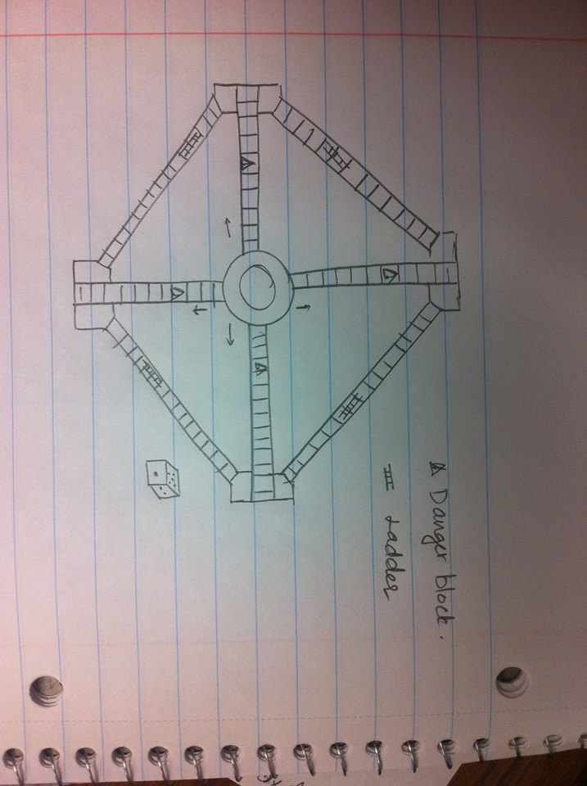

Concept B: A multi-players board game (>6 players). This board game is inspired from the game concepts of LUDO, Reversi and Checkers. Instead of a square board, we will develop different pattern board.

* Two levels of difficulty.
* This game can be played in less than 120 minutes.
* Initial sketch:

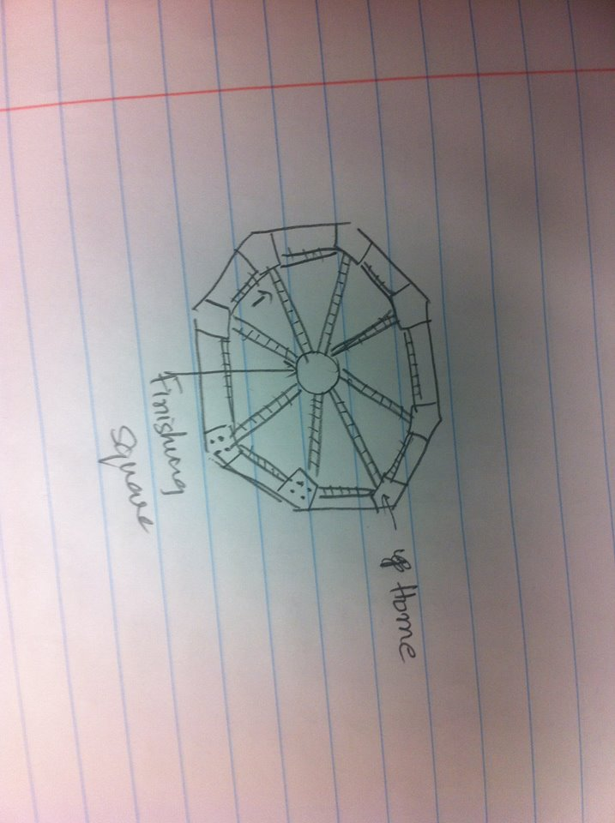

Concept C: A two-player players. This game was inspired by an online game called Bookworm.

* The board is filled with block of letters in random order. The player has to make words out of the connecting letters.
* More letter words will get more points. Once the word is made, the letters are removed and the letters above will be moved into the empty spaces similar to Blokus. This can go until the board is empty or no more words can be formed.
* Initial sketch:

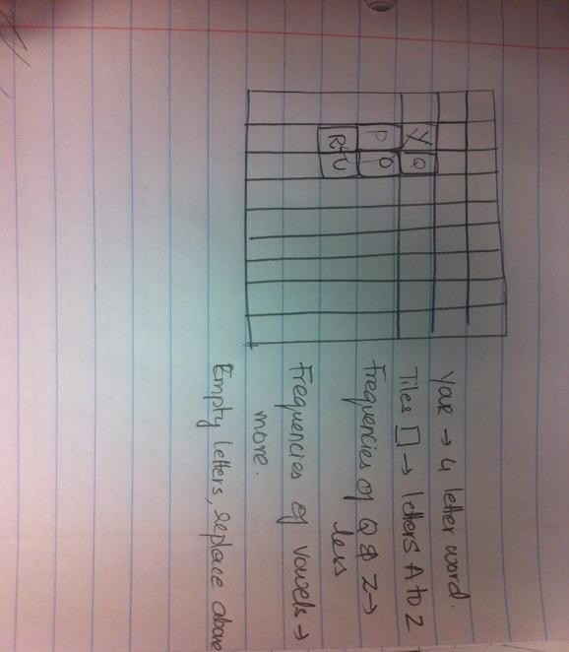

1. Reflect on the results and the process: The team members then focused to discuss if all the customer requirements are addressed, if the design is safe.

## Concept Selection and Refinement

1. **Concept Screening**: From the comparison of attributes with the competitors existing in the market, here we have considered the selection criteria as listed in the below table to screen Concepts A, B and C and the best fit concept as per customer requirements.

|  |  |  |  |  |  |
| --- | --- | --- | --- | --- | --- |
|  | Concepts | | | | |
|  | **Selection Criteria** | **A** | **B** | **C** | **Concept Screening** |
| 1 | Multi-player | 0 | 0 | 0 |
| 2 | Ease of Use | 0 | 0 | - |
| 3 | Challenging | + | + | + |
| 4 | Appearance | 0 | + | 0 |
| 5 | Product size | 0 | 0 | 0 |
| 6 | Innovative | 0 | + | - |
| 7 | Manufacturing Ease | 0 | 0 | - |
| 8 | Manufacturing cost | 0 | 0 | - |
|  |  |  |  |  |
|  | *PLUSES* | 1 | 3 | 1 |
|  | *SAMES* | 7 | 6 | 3 |
|  | *MINUSES* | 0 | 0 | 4 |
|  | *NET* | 1 | 3 | -3 |
|  | *RANK* | 2 | 1 | 3 |
|  | *CONTINUE?* | Combine | Combine | No |

1. **Concept Scoring**: After concept screening, there is only one concept left that can be selected and implemented to develop a game. Concept scoring provides information on relative importance of selection criterion hence it is tabulated for the selected concept. Selected concept is generated and a test plan given in section **Test Plan** is used to evaluate if the concept met the customer requirements.

|  |  |  |  |  |  |  |
| --- | --- | --- | --- | --- | --- | --- |
|  | Concepts | | | | | |
|  |  | |  | **AB** | |  |
|  | Selection Criteria | | **Weight** | **Rating** | **Weighted Score** | **Concept Scoring** |
| 1 | Multi-player | | 10% | 4 | 0.4 |
| 2 | Ease of Use | | 10% | 2 | 0.2 |
| 3 | Easy to understand | | 10% | 2 | 0.3 |
| 4 | Appearance | | 5% | 3 | 0.15 |
| 5 | Product size | | 10% | 3 | 0.3 |
| 6 | Innovative | | 25% | 3 | 0.75 |
| 7 | Manufacturing Ease | | 10% | 3 | 0.3 |
|  | Manufacturing cost | | 10% | 3 | 0.3 |
|  |  |  |  |  |  |
|  |  | | **Total Score** | 2.7 | |
|  |  | | **Rank** | 1 | |
|  |  | | **Continue?** | **Yes**  **Continue to Develop** | |

## Detailed System Design

The system level design begins with product development and packaging. [15] Product development begins with meeting primary targets and product specifications that were set after the initial market research. For our game ‘Militarium’, the primary components that were required are the user assembled game board, player coins and spinner set. The possibility to accommodate at least 6 or 8 players can be achieved by designing the board either in a circular format or in an octagonal format. We preferred to choose circular format, because of simple design.

Thus, by using such simple components, the product development process is expected to be easy and quick.

Board: Team had ideas of circular board or octagonal board and decided to go with circular board.

Track: For players’ yard, team had ideas whether to include the yard design on the game track. Then there were further ideas to have a small board design yet enough space to integrate the yard. An idea to have trays to save space is then chosen.

Game coins: There are various coin designs available in the market. Team decided to choose coins for pawns.

Spinner Set: One of the ideas is to go with traditional dice rolling. But the plan to design a board with 8 spaces gave an idea to develop a unique random number generator. Taking the fun of toy into consideration, team developed a spinner set where selecting a number is fun part of the game as well.

Packaging:

Customers are predominantly visual creatures and are inevitable to judge a book by its cover. Hence packaging is as important as developing a board game. The appeal of board game and its package depends on customer requirements such as storage space, appearance, quality etc. As per one of the customers’ requirements, the game should not take lots of storage space. In order to meet this requirement and at the same time keep the size of the board as the standard board size, a unique design is incorporated.

Bi-fold and quad-fold game boards are commonly available in the market (for example Monopoly, Chess boards, Ludo boards etc.). The shortcoming of folding game board is the possibility of wear and tear after extensive use. Avoiding drawbacks and meeting customer requirements, the team has come up with Package design that incorporate following design specifications

1. The game board is designed as two halves that can be conjoined at the center using snap fits.
2. Storage space, an important product measure, is reduced by half in width. The package size is 14.25”x7.25”x3”.
3. Due to the circular shape of the board, ample space at the corners of the package can be used for small package boxes.
4. Small package pouches are used to safely pack coins.
5. Quality package paper and image prints on the package to appeal the customers.
6. Sketch:

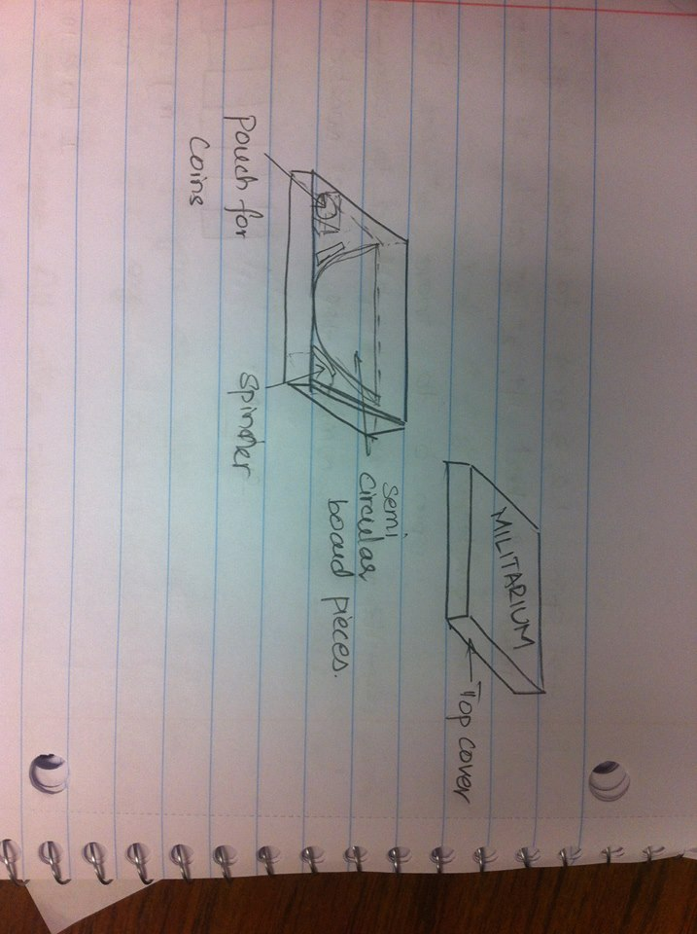

All the design ideas were integrated and initial sketches for the design and rules are prepared as shown.

|  |  |
| --- | --- |
| **Game Components/Parts**   1. A Circular board with game track printed. 2. 8 Trays for player’s yard 3. 32 coins (4 of each color for each player) 4. A small board with spinner to generate numbers (1-8) randomly (not shown in figure). 5. Game rule book (not shown in figure) 6. Number of spaces in the track changes based on the board size. This picture only depicts small version of the board with less number of places in track for the player to move. |  |
| **Initial Game Setup:**   1. Each player chooses their favorite color/themed players. 2. Each players gets 4 coins to play. 3. The coins are placed in players’ yard. |  |
| **Start Game:**   1. If player 1 is the one who chose yellow color. He/she has to spin an 8 to walk into the game track. 2. Once the player is on the track, the coins move in clockwise direction. 3. The players have to follow the set of game rules available in game rule book to complete one orbit along the track. |  |
| **Final step:**   1. After orbiting around by following all the game rules, the coin can now move toward the destination (center of the board towards logo). 2. All players have to move all the coins to the destination to win the game. 3. More rules are provided in detail in the ‘Game Rule Booklet’ that will come with the game. |  |

The game rules are then studied and modified in order to have a unique game which can aid in developing themes in future. To manufacture the game components, AUTOCAD is used for manufacturing drawings of the board. 3D printing is utilized to generate coins and the spinner set. Blue prints are shown below

Game Board:

A 14-inch circular board with game layout printed. The game board is user attachable.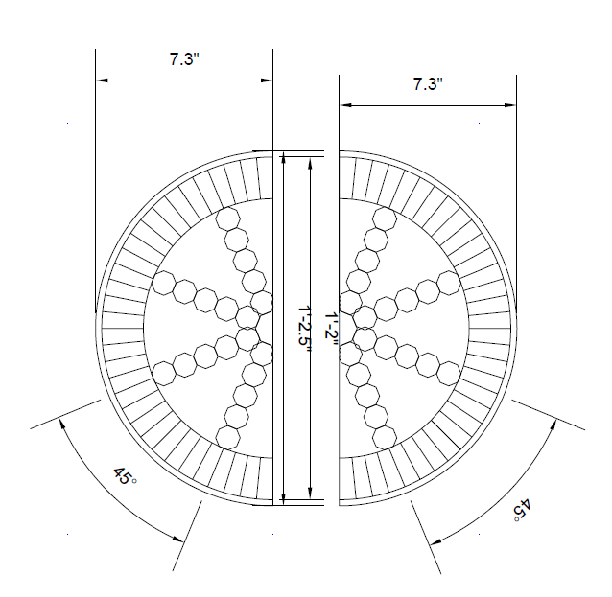

Tray:

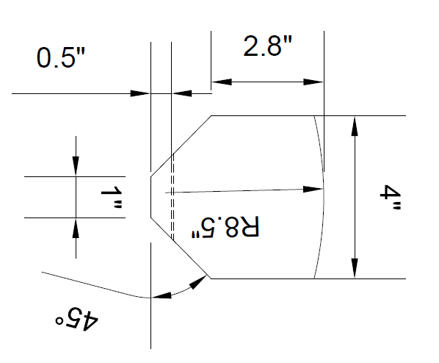

Spinner Set:

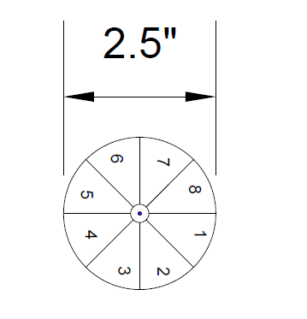

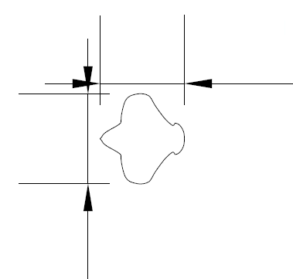

**1.5”**

**1.6”**

Final Board Design:

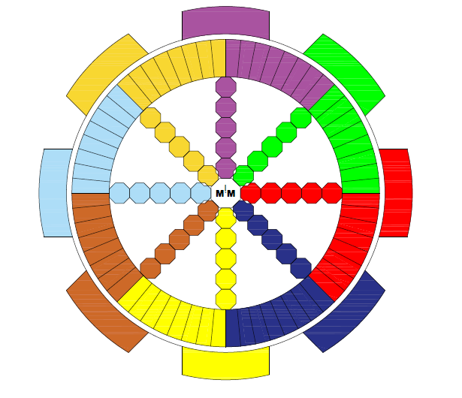

**Overall Final Design:**

|  |  |
| --- | --- |
|  |  |
| ../../Users/VIJAY/Desktop/Snip20160419_ | |

***A sales sheet of the final product is as follows:***

Game Title**:** MILITARIUM

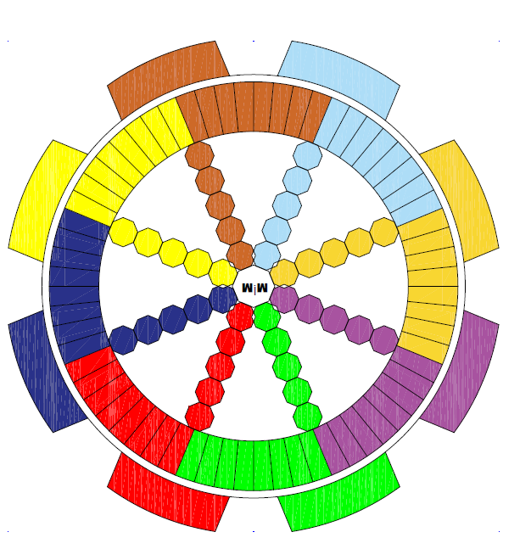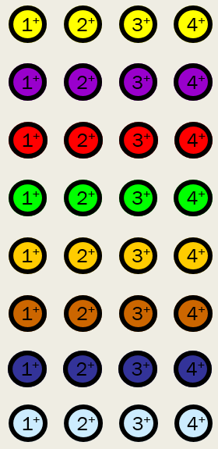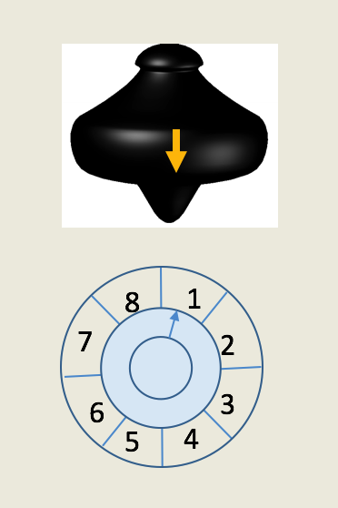

***Objective***:

*To bring at least 1 coin or all the 4 coins to the destination in the first place to win the game.*

**What’s the idea?**

*A board with 8 differently colored territories which contain 8 grid spaces. Each player will have 4 coins 1****+*** *2****+*** *3****+*** *4****+****. A Spinner set is used to select a random number (from 1 to 8) in order to begin the game by occupying the initial grid space. Adjacent territories are allies. Being good with your adjacent neighbors and protecting yourself with their help will lead to the destination which is to come out from the home yard.*

**Game Components**

****

***2 – 8 Players***

***2-8 Players***

****

***60+ Min***

****

*Age* ***8+***

***Format***: *Board Game*

***Why will this game sell?***

* *Fast and Easy to learn & Play*
* *2 Levels (User friendly)*
* *Easily adapted to game characters*
* *Engages up to 8 number of players*
* *Interesting game board design and a spinner to generate random number*

***Game Components:***

**^ 14” Circular board – 2 Parts (User Attachable)**

**^ 1 – Spinner set – To generate Random Number from 1 to 8**

**^ 32 Coins (A set of 4 coins with 8 different colors)**

**^ Game Rule Book**

**Reach Us at:**

Team Mechs in Marketing

Russ Engineering, Wright State University

Dayton, Ohio.

|  |
| --- |
| Title: MILITARIUM |
| 1. General Administrative Details    * This game can be played by even number of players (2, 4, 6 or 8), with a minimum of 2 players and a maximum of 8 players.    * This game can be played by people aged 8 and above irrespective of gender and disability.    * On average, it takes at least 60 to 120 minutes to play this game |
| 1. Introduction    * Interesting board design, fun and good for ice-breaking activities. |
| 1. Summary of the game system and objectives    * The objective of the game is to bring at least 1 coin or all the 4 coins to the destination in the first place to win the game    * Game Play Orientation: Clockwise direction |
| 1. Components of the Game: 2. 14” Circular Board – User attachable 3. 8 Trays attached to the board to place the coins during the game play 4. 1 Spinner set with numbers ranging from 1 to 8 5. 32 Coins ( A set of 4 coins with 8 different colors) |
| 1. Set-Up    * Each player begins with 4 set of coins. A spindle is passed around among the players. The players proceed around the game track in clockwise direction to complete a round and enter the destination. |
| 1. Basic Game Structure    * Every player will get a turn in Clockwise direction |
| 1. Ending the Game: Any one of the four coins or all the four coins should reach the destination (depends up on the level, players choose). Player who brings any 1 of his coins or all his/her coins to destination in the first place wins the game. |

# Design for X Considerations

## Design for reliability

The designed function of the game is in a simple manner; players can enjoy the game by following the game manual. More players could increase the period of playing time. In this game, each player has four characters, once a player loss all characters, he/she will lose the game, and so that only one player will win. Thus, there is no draw situation which avoids the game failure.

## Design for maintainability

The game itself is designed in plastic, so that the material has abilities including anti-wrestling, compression, and allowing small deformation.

# Final Marketing Plan

The final marketing plan can again be broken down into multiple levels to ensure that each of the goals and requirements are met now that the testing phase has been completed and distribution of the product is becoming available.

## Final Product Packaging:

The game board package will have a rectangular shaped eco-friendly cardboard and the circular board will be fitted tightly into a one sided opening box, making it easy to remove and store the game board in the box whenever required. The game board will be supported with Styrofoam material at all edges to prevent any sort of damage to the game board. The spindle will be kept in a side pocket inside the box. Onto the outer box, the name of the game is printed, with an image of 8 people playing the game. The key attractions of the games will be written to the bottom right hand corner of the box.

## Licensing and Patent Issues

Copyright is a way of protection provided by the laws to the authors of original works of authorship,” including literary, dramatic, musical, artistic, and certain other intellectual works. This protection is available to both published and unpublished works. The circular board game created by us is a new design concept. Incase if our game resembles any other type of board games we must make sure the modifications do not violate the copyright criteria of other games.

## Objectives

Objectives are the key statements to drive the business further. Combined with the mission statement and the SWOT analysis presented in Initial Marketing Plan, the objectives are confined to:

1. Sales goals: during the timeframe from the launch time to the end of the year, the target sale units will be 0.1 million (the sale units of Monopoly is 275 million).
2. Prospect goals: We will identify 5000 prospects within three months of launch.
3. Product awareness goals: Within the first month after launch, we will see 500 retweets and reface books of our launch announcement and 150,000 visits on the official website.
4. Customer goals: more than 1,000 customers will show interest in improving with the first month of launch.
5. Product defect goals: The game should permit minimal errors/defects. If any unnoticed issues arise after the release, address all high-priority issues within no time less than 24 hours.
6. Determine and forecast the total revenue based on the sales situation after the *first month* of release. By the end of the year after release, we expect to bring in 0.1 million in revenue.
7. Pricing: From individual game set budgeting, the team thrived the sale price is <$20.

Selecting suitable strategy:

* 1. Commercial market penetration: Supermarkets: Albertsons, Aldi, Delhaize, Kmart Super Center, Supervalu, Trader Joe’s, Meijer, Walmart, Target, and Kroger.
  2. Awareness Platforms: Blogs, Wikis, Videos sharing webs, Picture sharing webs, Products feedback sharing webs.

## Budgeting

|  |  |  |  |  |
| --- | --- | --- | --- | --- |
| Primary Category | Secondary Category | Estimated Quantity | Estimated Cost per Unit | Estimated Subtotal |
| Research | Web research | 1 | $10.00 | $10.00 |
| Research | Independent research | 4 | $5.00 | $20.00 |
| Research | Other research | 0 | $0.00 | $0.00 |
| Development | Material, design, testing | 50 | $35.00 | $1,750.00 |
| Communications | Promotional brochures | 20 | $0.50 | $10.00 |
| Communications | Web | 1 | $20.00 | $20.00 |
| Networking | Networking |  |  | $0.00 |
| Additional Costs | Time & Expense (T&E) |  | $0.00 | $0.00 |
| Additional Costs | Company staff T&E |  | $0.00 | $0.00 |
| Additional Costs | Customer testimonial T&E | 1 | $20.00 | $20.00 |
| Promotions | Product discounts | 10 | $3.00 | $30.00 |
| Promotions | Special offers | 10 | $1.50 | $15.00 |
| Advertising | Brochures (development and production) | 20 | $0.50 | $10.00 |
| Advertising | Mailings | 0 | $0.04 | $0.00 |
| Public Relations | Advertising | 0 | $0.00 | $0.00 |
| Public Relations | Employee promotions | 4 | $0.00 | $0.00 |
| Total |  |  |  | $1885 |

## Advertising and Promotion

1. By promoting game or brand visual logo **M!M** and basic one-page summary of the game (as shown in pg.22) with a one liner on a restaurant menu book.
2. Advertising through Radio, highlighting the game description with a catchy one liner. For instant, while a business owner may not see the overall picture, an advertising rep from a local radio station will – and can help to design and implement a successfully tailored and pinpointed campaign.
3. We believe social media networking sites like Facebook, twitter, Instagram and so on are the perfect platforms in order to promote and advertise the final product.

# Game Play Details

## Game Components

|  |  |
| --- | --- |
| Board | Militarium board is circular with a pattern on it in the shape of track around the circumference. The board has trays where the coins are setup at the start of game and is called ‘yard’. The center of the board is the goal to reach and is called ‘Destination’.  The board consist of 8 territories with different colors and 8 grid spaces for each of the territories making a total of 64 grid spaces. when a player begins the game with his coin, he/she steps on to the first grid space of their territory. The grid space track and ‘yard’ blocks are colored to match corresponding coins.  8 yards with 8 different colors  8 grid space tracks  1 Destination |
| Spinner set | Spinner set has a spinner and a spinning board. The spinning board has numbers 1-8 printed and a groove for the spinner to rotate. The spinner has markings that help player to make a choice of the random number for player’s next move  A spinner set to generate random number (From 1 to 8) |
| 32 Coins | A set of 4 coins to each player. Each set will have 8 different colors, a total of 32 coins.  The set of 4 coins are indicated as **1+ 2+ 3+ 4+** |
| Game Rules Page | Game rule page has set of rules to play the game. |

## Game Rules

**Goal**

**Easy Level:**

1.      At least one Player coin orbit around the track and continues towards destination to win.

2.      Any coin eliminated on the track by enemy players is out of the game.

**Difficult Level:**

1.      All four Player coins orbit around the track and continues towards destination to win.

2.      Any coin eliminated on the track by enemy players goes back to yard and plays again.

**General rules**

1.      Spin 1, 2, 3 or 4 to begin to play with coin supremacies 1+, 2+, 3+, 4+ respectively

Example: Spin 2 to move 2+ on to the first grid space on the track

2.      Adjacent players are allies. All other players are enemies.

3.      Safe zone: Player is safe in allies and own territory.

4.      Danger zone: Player coin can be eliminated by enemy player coin when landed in same grid space in any of the danger zones.

5.      Second player coin can only begin to play when the first player coin is either in danger zone or eliminated.

6.      Scoring:

* Every time a player eliminates enemy players’ coin, the sum of supremacies of both coins forms score.

Example: 2+ eliminates 4+ coin, the player score = 2+4 = 6

* If one player reaches destination, the game ends. The rankings for other players depend on hierarchy of their scores (in short the score totals from number of eliminations).

7.      If a player coin in its own territory overtakes enemy player coin, enemy player coin has penalty and moves back 8 spaces.

Note: Ally over enemy – A player’s ally protects before they can join hands with the enemy. This way, an adjacent player who plays role of an ally to the player and the enemy player chooses to protect the player instead.

All the set of rules can be played to make a strategic, challenging, interesting and fun game.

Game Rule Book:

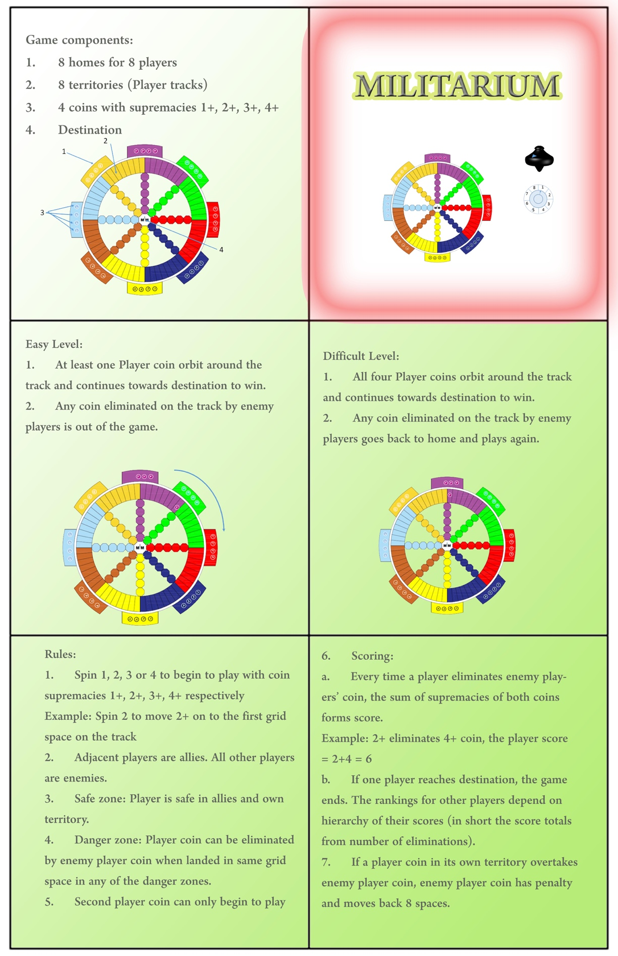

# Project Summary - WRITE

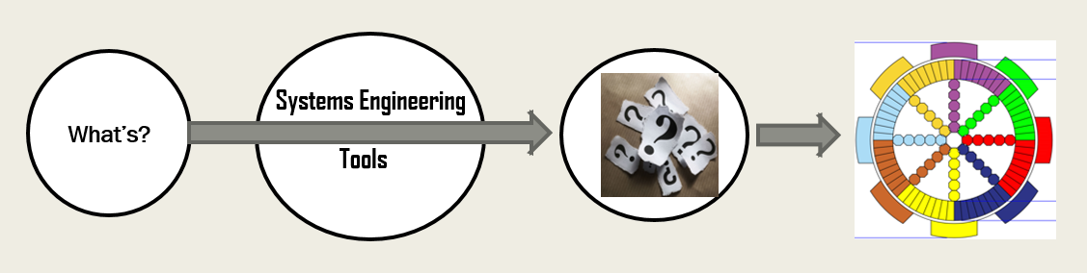

## Future Scope

* + Game can be developed in electronic format
  + Game layout can be modified with themes (movie references, sports etc.)
  + Introduce more difficulty levels
  + Introduce more rules
  + Market globally
  + Design modifications:
    1. Add gripping pin to the spinner for easy spinning
    2. Adapt new game component materials for easy and cost efficient manufacturing
    3. Different joint mechanisms for better durability

# Appendices

## Appendix A

House of Quality

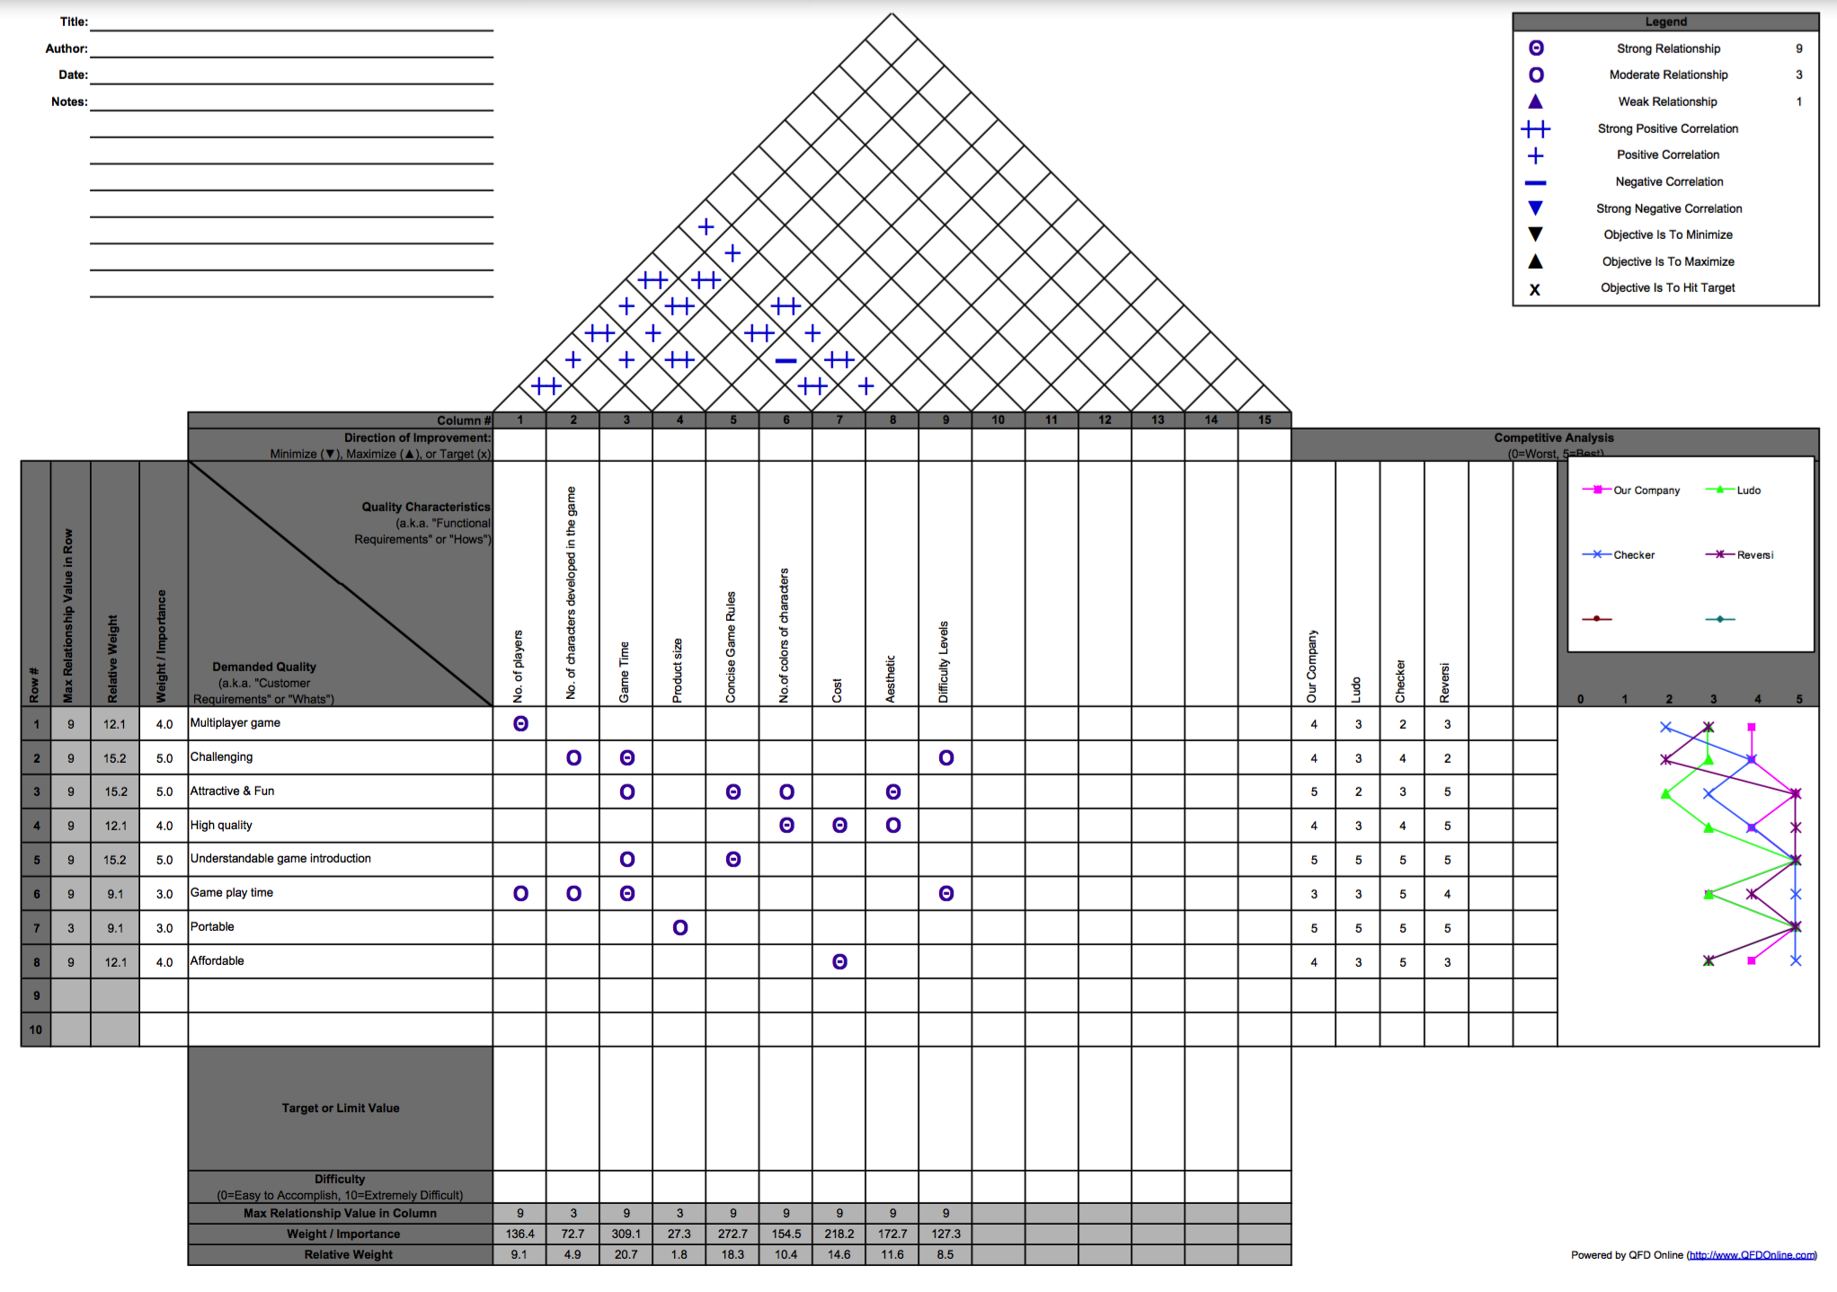

## Test Plan

**Concept Test Plan**

The objective of testing the final product is to gather feedback from various players such that the final concept, which is assumed to appeal the target market can be further modified. Any unnoticed issues and overlooked aspects known from the feedback will be reviewed and modified. Our team has come up with the following two market plans.

**Plan 1**:

By releasing a short commercial through YouTube, explaining the game rules with a sample of play, a quick electronic questionnaire survey will be conducted to gather responses from different viewers, making sure that each individual response is assessed without sharing. We believe this will definitely help in gathering different opinions. This survey will be in electronic format with the help of surveymonkey.com and can be shared through email, social networking platforms like Facebook, twitter, etc.

The questionnaire is as follows:

1. Did the game meet your game experience?

|  |  |  |  |  |  |  |  |
| --- | --- | --- | --- | --- | --- | --- | --- |
| o | Less than expected | o | As expected | o | More than expected | o | Consistently more |

2. Did you feel the game was easy?

|  |  |  |  |  |  |  |  |
| --- | --- | --- | --- | --- | --- | --- | --- |
| o | Less than expected | o | As expected | o | More than expected | o | Consistently more |

3. Were the game rules difficult to follow?

|  |  |  |  |  |  |  |  |
| --- | --- | --- | --- | --- | --- | --- | --- |
| o | Less than expected | o | As expected | o | More than expected | o | Consistently more |

4. Did the game provide you the fun element?

|  |  |  |  |  |  |  |  |
| --- | --- | --- | --- | --- | --- | --- | --- |
| o | Less than expected | o | As expected | o | More than expected | o | Consistently more |

5. How long did you play the game for?

|  |  |  |  |  |  |  |  |
| --- | --- | --- | --- | --- | --- | --- | --- |
| o | Less than desirable | o | As expected | o | Better than expected | o | Consistently better |

7. How inclined are you towards buying or gifting this game?

|  |  |  |  |  |  |  |  |
| --- | --- | --- | --- | --- | --- | --- | --- |
| o | Less than expected | o | As expected | o | More than expected | o | Consistently more |

8. Please elaborate on any additional experience throughout the game that you would like to share with us.

|  |  |  |  |  |  |  |  |
| --- | --- | --- | --- | --- | --- | --- | --- |
|  |  |  |  |  |  |  |  |

Please check this box if you are willing to act as a reference for our company in the future.

**Plan 2**:

**Face to Face Testing**: The Testing was performed in the Wright State University campus. A sample of 48 people are chosen from the campus on a random basis to be a part in the testing plan. The game details are clearly explained to them. They were requested to play at least 1 complete game. An optional iterative survey was conducted to collect the player’s feedback.

**Results**:

|  |  |  |  |  |
| --- | --- | --- | --- | --- |
| Level | #  of Players | Games | Game time (Estimated time Easy<60 mins  Difficult<120 mins) | # of eliminations |
| Easy | 8 | 1  2 | 55  45 | 4  3 |
| Difficult | 8 | 1  2 | 130  90 | 8  4 |

**References**

[1] Ulrich, K. T., & Eppinger, S. D. (2008). Product design and development.

[2] [www.boardgamesgeek.com](http://www.boardgamesgeek.com)

[3] www.youtube.com

[4] www.wikipedia.org