

**JOB_APPLICATION_TRACKING_SYSTEM**

1. **INTRODUCTION :**
   1. **OVERVIEW:**

Salesforce is game-changing technology, with a host of productivity-boosting features, that will help you sell smarter and faster.

A CRM Application which helps the applicant to track the No. of jobs he applied and helps him to find the job posted by the various recruiters, find the best attributes to be involved to run the process in a smooth way and easily to track

Create a CRM Application which helps the applicant to track the No. of jobs he applied and helps him to find the job posted by the various recruiters, find the best attributes to be involved to run the process in a smooth way and easily to track.

**1.2 PURPOSE**:

To make the existing app more efficient for the Job application we create custom objects and

relationships to store and access the data more efficiently

1. **PROBLEM DEFINITION & DESIGN THINKING:**
   1. **EMPATHY MAP**

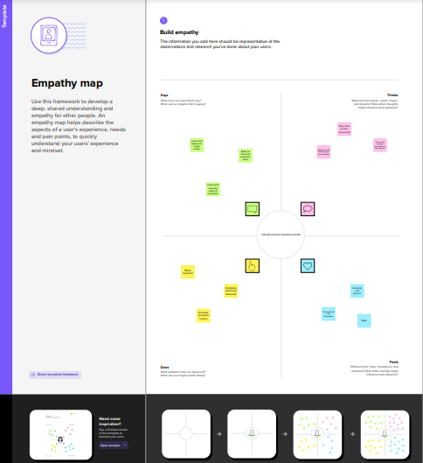

* 1. **IDEATION & BRAINSTORMING MAP:**

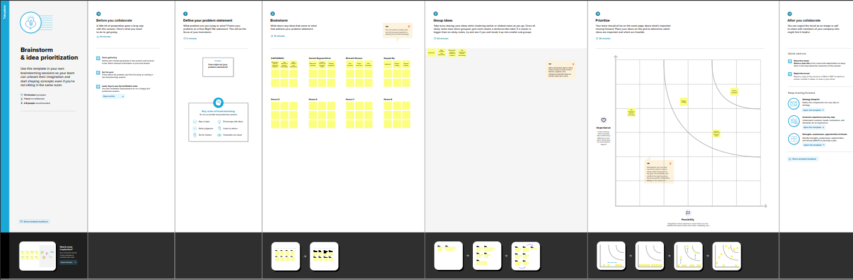

1. **RESULT :**
   1. **Data Model:**

|  |  |  |
| --- | --- | --- |
| **Object name** | **Fields in the Object** | |
| obj1 | Field label | Data type |
| Recruiter | Field Label - Recruiter | Data type -  Auto Number |
|  |  |  |
|  |  |  |
| Obj2 | Field label | Data type |
|  |  |  |
|  |  |  |
|  |  |  |

* 1. Activity & Screenshot

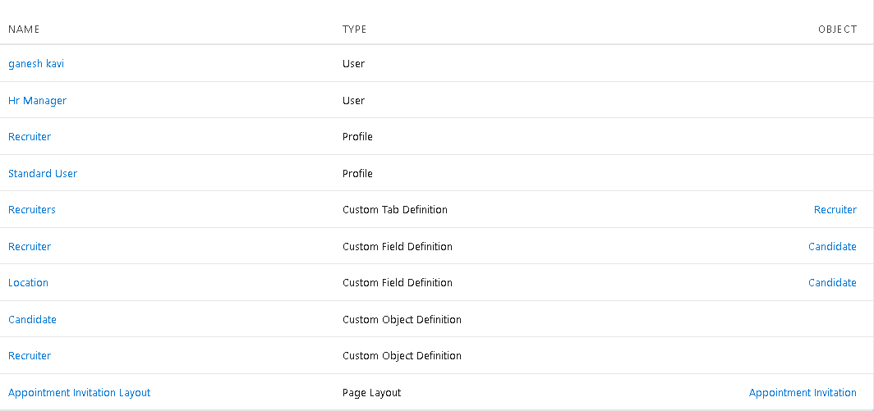Create a CRM Application which helps the applicant to track the No. of jobs he applied and helps him to find the job posted by the various recruiters, find the best attributes to be involved to run the process in a smooth way and easily to track.

1. **TRAILHEAD PROFILE PUBLIC URL :**

**Team Lead - https://trailblazer.me/id/vkavi15**

**Team Member 1 - https://trailblazer.me/id/lganesh17**

**Team Member 2 - https://trailblazer.me/id/bnivasanj**

**Team Member 3 –https://trailblazer.me/id/deraj59**

1. **ADVANTAGES & DISADVANTAGE :**

* Saves Time for Value Added Work
* Flexible System for Both Employer & the Agency
* Better Overview of Applications.
* Easy Job Posting.
* Improved Cost-per-Hire.
* Improved Quality of Hire. ...
* Improved Inter-Departmental Communication. ..

1. **APPLICATIONS :**

An applicant tracking system (ATS) is software for recruiters and employers to track candidates throughout the recruiting and hiring process.

1. **CONCLUSION :**

Applicant Tracking System for recruiters is a very effective hiring solution that most of the successful recruiters utilize. Because without it, there is a good chance that your process of moving applicants through different stages can become very difficult..

1. **FUTURE SCOPE :**

* According to a recently released survey report, the majority of staffing firms worldwide will opt for an Applicant Tracking System by the end of 2020 to improve the overall talent acquisition efficacy, in this scope the future of ATS definitely looks bright..