COEN 241 HW1
Name: Zelu Liang
W1608029

1.Configurations of experimental setup
(1) OS: Windows 11 Home 64-bit
(2) Processors: 11th Gen Inter Core i5-1135G7 @ 2.40GHz(8 CPUs)
(3) Memory: 16GB
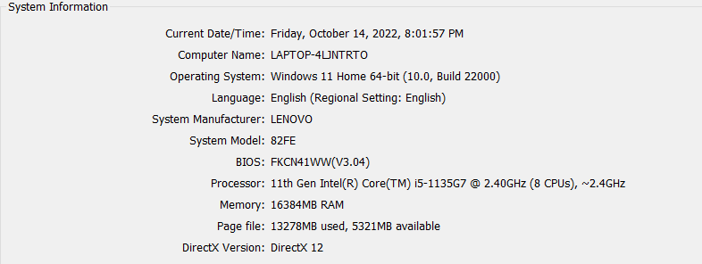
2. QEMU VM
(1) Main steps
- Install QEMU:
$ sudo apt-get install qemu
$ sudo apt-get install qemu-utils
$ sudo apt-get install qemu-system-x86
- Download Ubuntu 20.04 server ISO image
- Create the QEMU image
$ sudo qemu-img create ubuntu.img 10G -f qcow2
- Install QEMU VM
$ sudo qemu-system-x86_64 -hda ubuntu.img -boot d -cdrom ./ubuntu-20.04.5-live-server-amd64.iso -m 2046 -boot strict=on
- Boot ubuntu
sudo qemu-system-x86_64 -hda ubuntu.img -boot c -m 2046 -boot strict=on

(2) QEMU command details
- -smp
$ qemu-system-x86_64 -smp cores=2
Set CPU core count as 2 for QEMU VM
- -m
$ qemu-system-x86_64 -m 256
Set memory Size(RAM) as 256MB for QEMU VM
- -accel
$ qemu-system-x86_64 -accel tcg,thread=single
Select accelerator of QEMU VM
- -nographic
$ qemu-system-x86_64 -nographic
Run directly in the terminal
(3) QEMU running environment
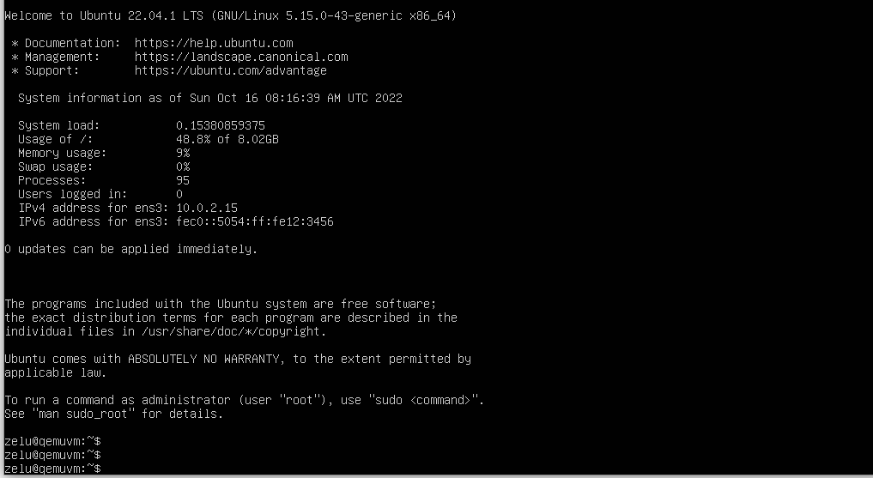

3. Docker container
(1) Main steps
- Install docker
- Pull the latest image og ubuntu
$ docker pull ubuntu
- Create container
$ docker run -it ubuntu bin/bash
- Install sudo/ping/sysbench in container
$ apt update
$ apt insatll sudo
$ apt install iputils-ping
$ sudo apt install sysbench
- Create own image
$ docker commit --message "ubuntu+sysbench" 401adc40ae38 my_ubuntu:v1
- Check history
$ docker history my_ubuntu:v1
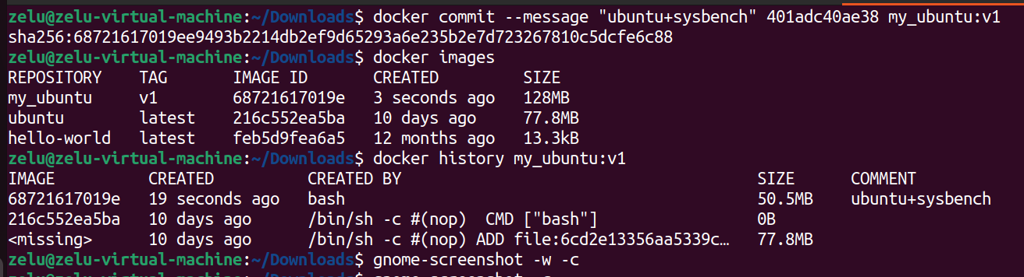

(2) Commands
- Create a container: $ docker run -ti ubuntu bin/bash
- Check running containers: $ docker ps
- Run the existed container: $ docker start <container ID>
- Stop running container: $ docker stop <container ID>
- Remove container: $ docker rm <container ID>
- Check logs: $ docker logs <container ID>
- Enter a running container: $ docker exec -ti <container ID> /bin/bash
(3) Docker running environment
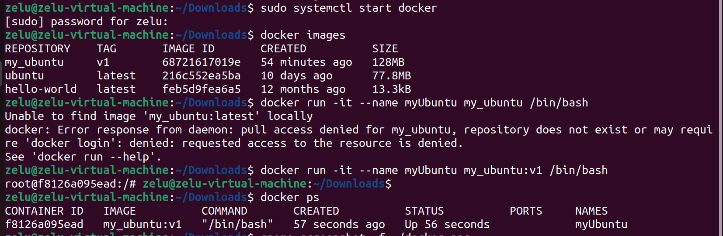
4. Sysbench tests
(1) Steps
- Run into docker container or QEMU VM environment.
- Git clone the repository from GitHub to get the shell scripts.
- Under folder /HW1, using command “ chmod +x sysbench_script.sh & ./sysbench_script.sh” to start the test.
- Git pull the test results after finishing.

(2) Docker tests
Sysbench version: 1.0.20 (using system LuaJIT 2.1.0-beta3)
Each test case has run for 5 times.

###CPU performance tests###

Test case1: --cpu-max-prime=10000
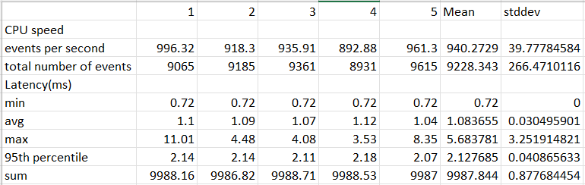

Test case2: --cpu-max-prime=20000
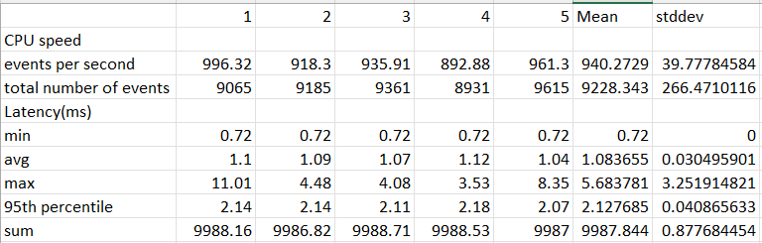

Test case3: --cpu-max-prime=30000
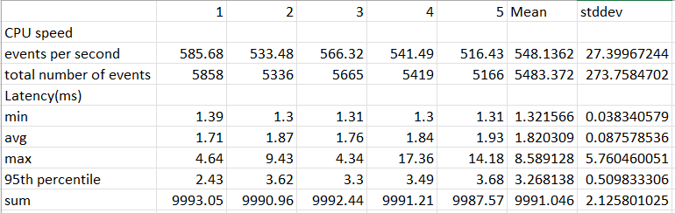
###I/O performance tests###

Test case1: --file-test-mode=rndrw
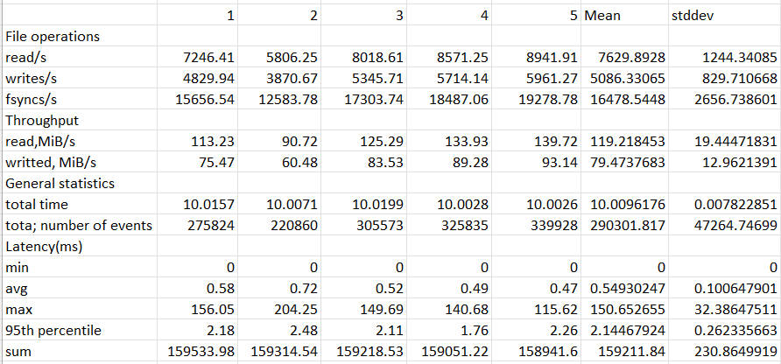

Test case2: --file-test-mode=seqwr
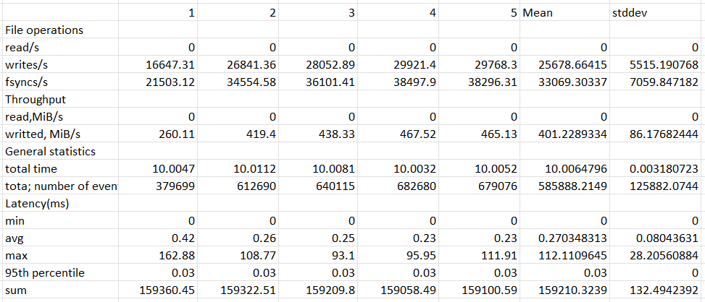

Test case3: --file-test-mode=seqrd
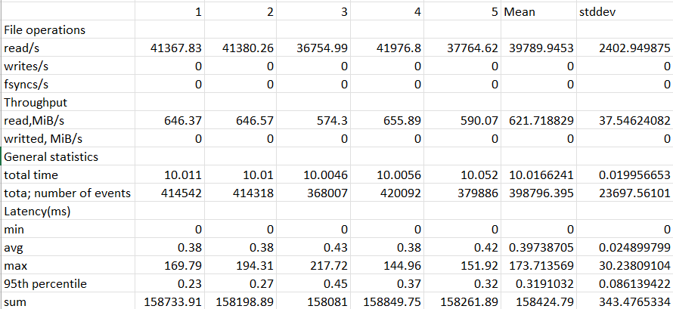

(3) QEMU VM tests
Sysbench version: 1.0.20 (using system LuaJIT 2.1.0-beta3)

### CPU performance tests ###

Test case1: --cpu-max-prime=10000
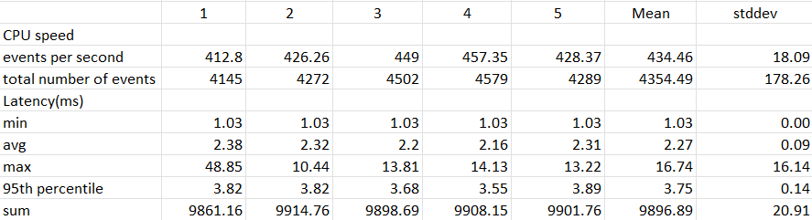

Test case2: --cpu-max-prime=20000
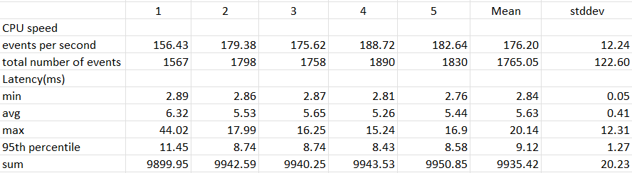

Test case3: --cpu-max-prime=30000
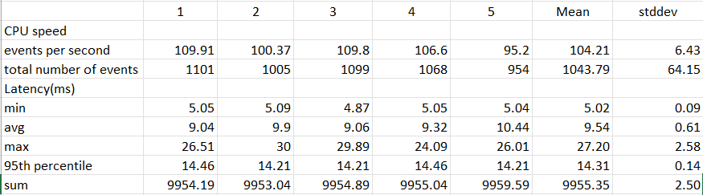

### I/O performance tests ###

Test case1: --file-test-mode=rndrw
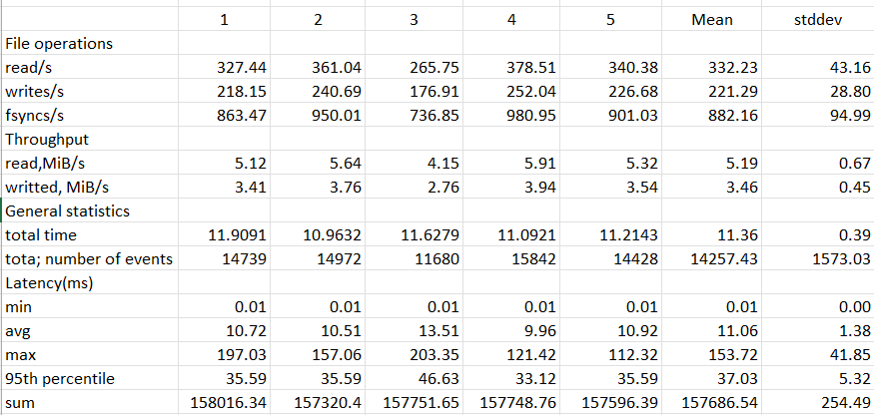

Test case2: --file-test-mode=seqwr
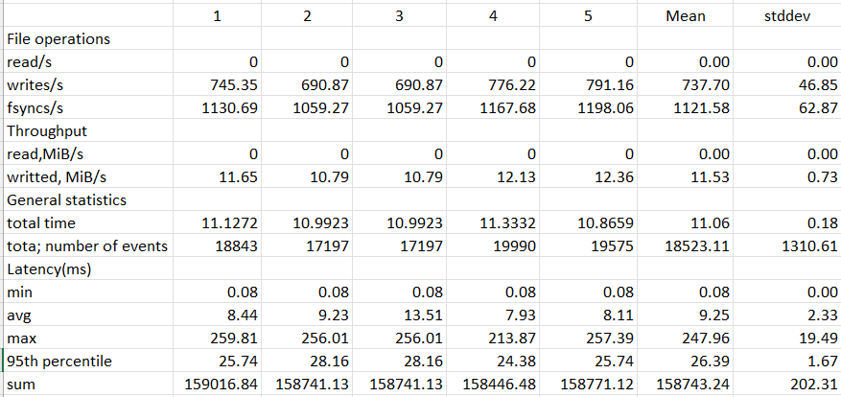

Test case3: --file-test-mode=seqrd
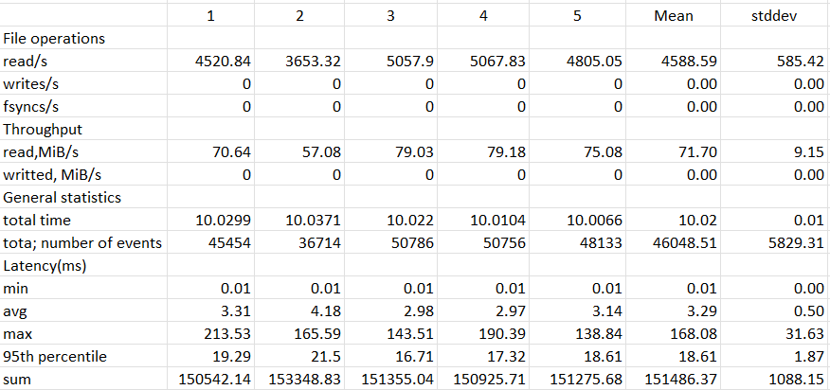

5. Shell scripts

All the shell scripts are under folder /HW1/shell_scripts

### CPU test: parameter –cpu-max-prime ###

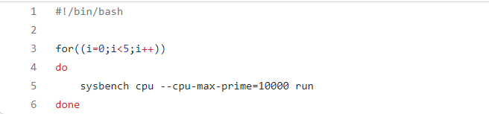
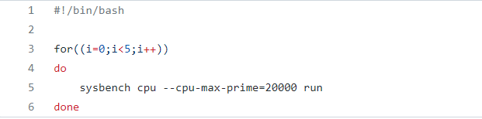
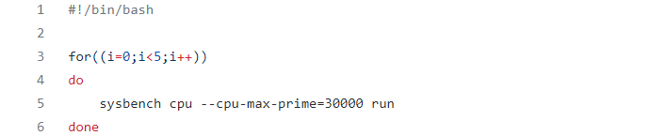

### Fileio test: parameter --file-test-mode ###

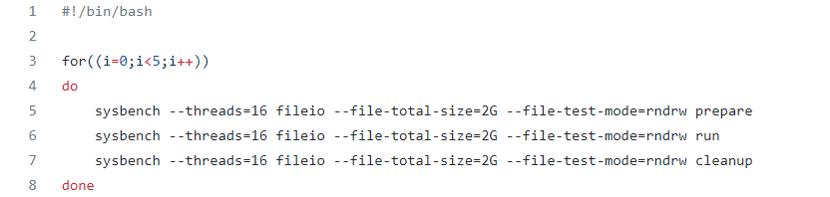
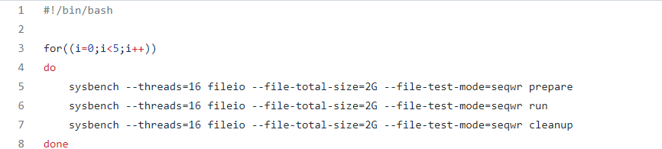
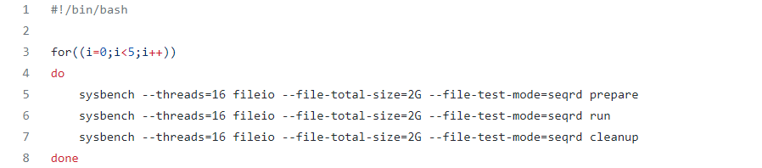

### sysbench_script.sh ###
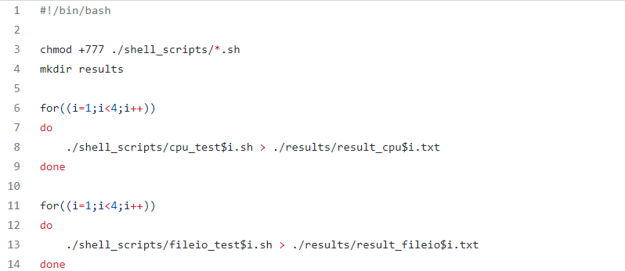

6. Performance data --- CPU utilization
Docker:
user-level: 50.0% kernel-level: 0.2%
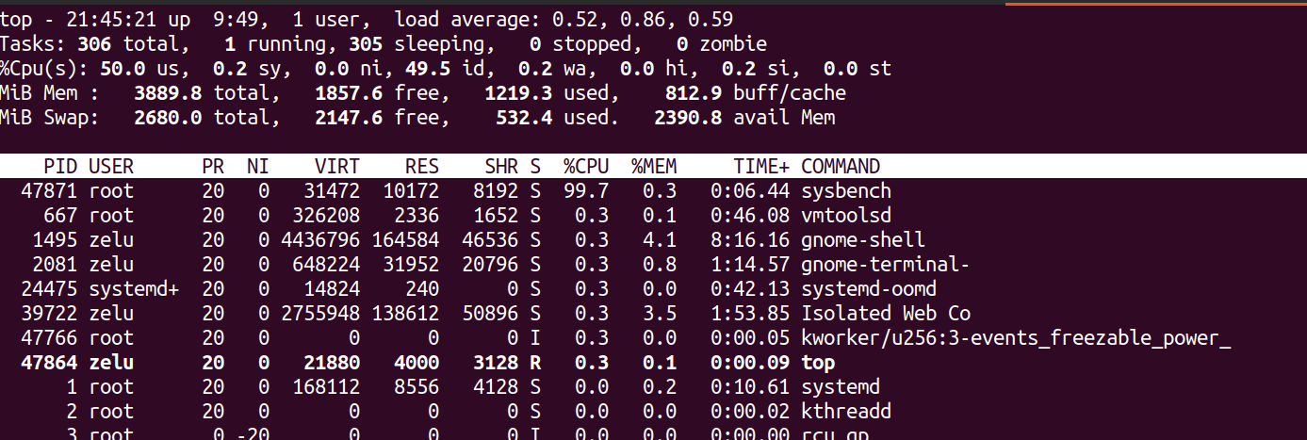
QEMU:
User-level: 49.8% kernel-level: 13.7%
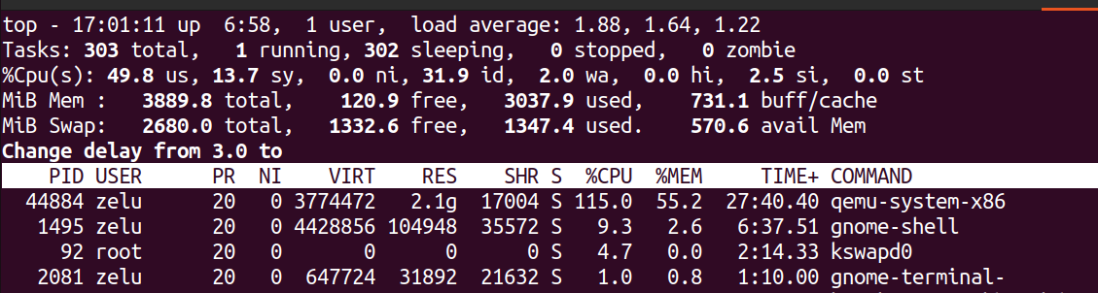

7. Analysis
(1) From the results of CPU performance tests, no matter in Docker container or QEMU VM, more –cpu-max-prime will result in lower cpu speed and longer latency which is more obvious in QEMU VM.
(2) The cpu speed can be faster in docker than in QEMU.
(3) From the results of Fileio performance tests, single read or single write perform better than random read or write, considered latency and throughput.
(4) Fileio performance for docker is better than in QEMU (throughput and latency).

8. Git repository

https://github.com/VKLED/COEN241-2022FALL.git
commit id: 8eedb2db63f96af0eb654b221481fc836e0cfa32

