Module 1: SQL Server Overview

Lab A: SQL Server Overview
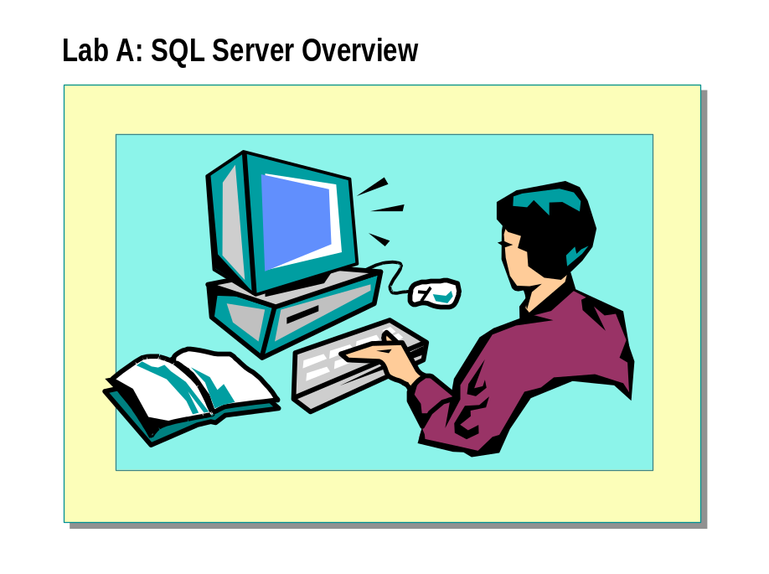

After completing this lab, you will be able to view the contents, use the index, and search for information in Microsoft SQL Server Setup Help, as well as save the location of information on the Favorites tab.

Estimated time to complete this lab: 15 minutes

Exercise 1
Using SQL Server Setup Help
In this exercise, you will use SQL Server Setup Help to retrieve information on SQL Server architecture.
- To view the contents of SQL Server Setup Help
In this procedure, you will view the contents of SQL Server Setup Help.
    - Log on to the NWTraders classroom domain by using the information in the following table.
Option | Value
User name | SQLAdminx (where x corresponds to your computer name as designated in the nwtraders.msft classroom domain)
Password | Password

    - Insert the Microsoft SQL Server 2000 compact disc into the CD-ROM drive, and when the Microsoft SQL Server 2000 Enterprise Edition dialog box appears, click Browse Setup/Upgrade Help.
    - In the console tree, review the organization of SQL Server Setup Help.
    - In the console tree, expand Related Topics, and then click Database Architecture.
    - Review the information in the details pane.

- To use the SQL Server Setup Help index to obtain information on SQL Server architecture
In this procedure, you will use the SQL Server Setup Help index to view information on SQL Server architecture quickly.
    - Click the Index tab, type Architecture and then double-click Database.
    - Click the Favorites tab, and then click Add.
    - Click the Contents tab, and then in the console tree, expand Database Architecture, expand Logical Database Components, and notice the available topics.

- To search SQL Server Setup Help for a word or phrase
In this procedure, you will use SQL Server Setup Help to search for information about SQL Server architecture.
    - Click the Search tab, type sql NEAR architecture and then click
List Topics.
    - Double-click Database Architecture.
    - Click anywhere in the details pane, and then press CTRL+F.
    - In the Find box, type tempdb and then click Find Next.
Notice that the search finds the first instance of tempdb.
    - Click Cancel and then close the SQL Server Setup Help dialog box.
Close the Microsoft SQL Server 2000 Enterprise Edition dialog box.

Module 2: Planning to Install SQL Server

Lab A: Installing SQL Server
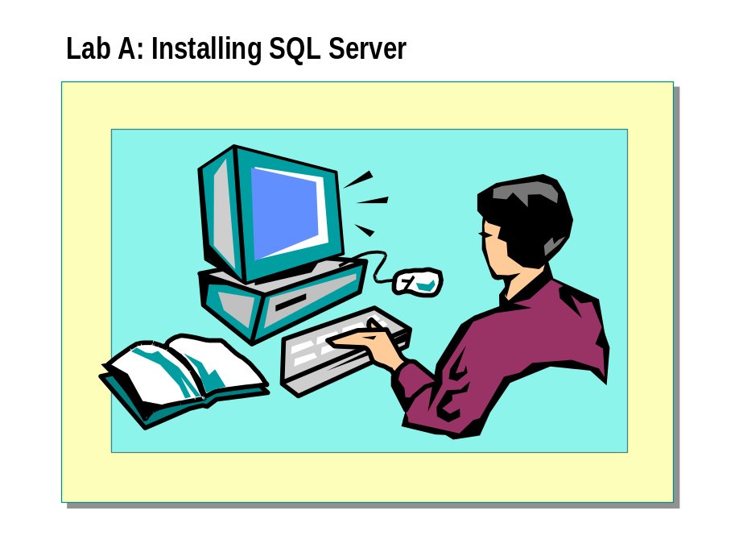

Objectives
After completing this lab, you will be able to:
- Install SQL Server 2000 by using SQL Server Setup.
- Verify the installation of SQL Server by starting an instance of the SQL Server and SQL Server Agent services.
- Configure the SQL Server Agent service.
- Share registration information.
- Troubleshoot installation problems.
- Create a database diagram.

For More Information
If you require help in executing files, search SQL Query Analyzer Help for “Execute a query”.
Other resources that you can use include:
- The Northwind database schema.
- SQL Server Books Online.

Estimated time to complete this lab: 45 minutes

Exercise 1
Installing a Default Instance of SQL Server

In this exercise, you will run SQL Server Setup and install the default instance of SQL Server database engine and all management tools on your computer.
- To install the default instance of SQL Server
In this procedure, you will install SQL Server.
    - Log on to the NWTraders classroom domain by using the information in the following table.
Option | Value
User name | SQLAdminx (where x corresponds to your computer name as designated in the nwtraders.msft classroom domain)
Password | password

    - Insert the SQL Server 2000 compact disc into the CD-ROM drive.
    - When the Microsoft SQL Server 2000 Enterprise Edition dialog box appears, click SQL Server 2000 Components.
    - Click Install Database Server.
    - Use the information in the following table to complete the installation.
Option | Value
Computer name | Local computer
Installation selection | New instance of SQL Server
Name | Your name
Company | Your company name
Software license agreement | Yes
Instance name | Default
Setup type | Typical
Service accounts | Same account for each service and auto  start SQL Server service
Service settings | Domain user account
User name | SQLService
Password | sqlservice
Domain | NWTraders
Authentication mode | Windows authentication mode

    - After installing SQL Server, click Finish.

Exercise 2
Verifying the Installation

In this exercise, you will use the SQL Server Service Manager to start the SQL Server service. You then will connect to and test the SQL Server service on your computer by using SQL Query Analyzer.
- To start the SQL Server service by using SQL Server Service Manager
In this procedure, you will start the SQL Server service by using SQL Server Service Manager.
    - On the taskbar, click Start, point to Programs, point to Microsoft SQL Server, and then click Service Manager.
    - Start the SQL Server service on your computer.
    - After SQL Service Manager indicates that the SQL Server service is running, close SQL Server Service Manager.
Notice that the SQL Server Service Manager icon remains on the taskbar.

- To connect to SQL Server and execute a query to verify the installed databases
In this procedure, you will connect to SQL Server by using SQL Query Analyzer and execute a query to verify the installed databases.
    - On the taskbar, click Start, point to Programs, point to Microsoft SQL Server, and then click Query Analyzer.
    - Click Windows authentication and then click OK to log in by using Windows Authentication.
You have permission to log in to and administer SQL Server because you are logged on as SQLAdminx, which is a member of the Windows 2000 local group, Administrators. All members of this group are automatically mapped to the SQL Server sysadmin role.
    - On the toolbar, verify that your database is master.
    - In the query window, type and execute the following query:
SELECT * FROM INFORMATION_SCHEMA.SCHEMATA

The results pane displays the installed databases: master, tempdb, model, msdb, pubs, and Northwind. Notice the additional information that is displayed.
    - On the Query menu, click Results in Text.
This changes the default destination for query results.
    - Execute the query again.
Notice the difference in the manner in which information is displayed.

- To verify the installed version of SQL Server

In this procedure, you will execute a query to verify the installed version of SQL Server.
    - On the toolbar, click Clear Window.
    - In the query window, type and execute the following query:
SELECT @@VERSION

@@VERSION is a global system variable that returns current product version information.
The results pane displays the installed version of SQL Server.
    - On the Query menu, click Results in Grid.
This changes the destination for query results.

- To verify the installed files
In this procedure, you will verify the installed files.
    - Open Windows Explorer, and expand the C:\Program Files\Microsoft SQL Server folder.
    - Open each subfolder, and review the installed files.
In particular, notice the files in the C:\Program Files\Microsoft SQL Server\Mssql\Binn and C:\Program Files\Microsoft SQL Server\Mssql\Log folders.
    - Close Windows Explorer.

Exercise 3
Configuring SQL Server Agent and SQL Server Enterprise Manager

In this exercise, you will review the registration information in SQL Server Enterprise Manager. You then will configure the SQL Server Agent service to start automatically. Finally, you will start the SQL Server Agent service.
- To review SQL Server registration in SQL Server Enterprise Manager
In this procedure, you will verify and modify the registration information in SQL Server Enterprise Manager for the default instance.
    - On the taskbar, click Start, point to Programs, point to Microsoft SQL Server, and then click Enterprise Manager.
    - In the console tree, expand Microsoft SQL Servers, and then expand SQL Server Group.
Notice that the default instance of SQL Server is registered automatically using your computer name.
How can you tell whether SQL Server is started?

    - Right-click your server name, and then click Edit SQL Server Registration Properties.
Notice the default properties of this registration.
What type of authentication is used to connect to SQL Server?

    - Click OK to close the Registered SQL Server Properties dialog box.

- To configure the SQL Server Agent service to start automatically
In this procedure, you will modify the properties SQL Server to start the SQL Server Agent service automatically.
    - On the taskbar, double-click SQL Server Service Manager.
    - In the Services list, click SQL Server Agent.
    - Select the Auto-start service when OS starts check box.
    - Click Start/Continue.
After a few moments, notice that the green arrow indicates that the SQL Server Agent service is running.
    - Close SQL Server Service Manager.

Exercise 4
Creating Shared Registration Information
In this exercise, you will use SQL Server Enterprise Manager to share registration information, and you will use the Register SQL Server Wizard to register additional servers.
- To create shared registration information
In this procedure, you will create shared registration information by using SQL Server Enterprise Manager.
    - In the SQL Server Enterprise Manager console tree, verify that your server is selected.
    - On the Tools menu, click Options.
    - In the SQL Server Enterprise Manager Properties dialog box, clear the Read/Store user independent check box, and then click OK.
    - Expand SQL Server Group.
Are any instances of SQL Server registered? Why or why not?

    - Right-click SQL Server Group, and then click New SQL Server Registration.
The Register SQL Server Wizard appears.
    - Use the information in the following table to register SQL Server on your computer in a newly created SQL Server group.
Option | Value
Available servers | Your server
Authentication mode | Windows Authentication
SQL Server group | Create a new top-level SQL Server group
Group name | Shared SQL Server Group

In the SQL Server Enterprise Manager console tree, notice that the newly created group appears.
    - Expand Shared SQL Server Group.
Notice that your server is registered.
    - On the Tools menu, click Options.
    - In the SQL Server Enterprise Manager Properties dialog box, select the Read/Store user independent check box, and then click OK.
Notice that Shared SQL Server Group no longer appears.

Exercise 5
Troubleshooting Installation Problems

In this exercise, you will view the SQL Server error log and the Windows 2000 application log in Event Viewer.
- To view the SQL Server error log
In this procedure, you will review the entries in SQL Server error log.
    - In the SQL Server Enterprise Manager console tree, expand SQL Server Group, expand your server name, and then expand Management.
    - Click SQL Server Logs.
    - In the details pane, double-click Current to open the current SQL Server error log.
    - Scroll through the SQL Server error log.
What has caused all of the entries in this file?

- To view the Windows 2000 application log in Event Viewer
In this procedure, you will open the application logs and review the entries that relate to the installation and startup of SQL Server.
    - On the taskbar, click Start, point to Programs, point to Administrative Tools, and then click Event Viewer.
    - In the console tree, click Application Log.
Does the Windows 2000 application log contain any entries as a result of the installation or startup of SQL Server?

    - Close Event Viewer.

Exercise 6
Creating a Database Diagram

In this exercise, you will use the Create Database Diagram Wizard to generate a diagram for the Northwind database automatically. You will then use Query Designer to build a query.
- To create a database diagram
In this procedure, you will create a database diagram of the Northwind database by using the Create Database Diagram Wizard.
    - In the SQL Server Enterprise Manager console tree, expand your server name, expand Databases, and then expand Northwind.
    - Right-click Diagrams, and then click New Database Diagram.
The Create Database Diagram Wizard appears.
    - Add all user tables to the diagram. User tables appear with initial caps.
    - Maximize the New Diagram dialog box.
    - On the toolbar, click Zoom, and then click 50%.
    - Arrange the tables to fit on the screen.
    - Save the database diagram as Northwind.

- To build a query by using Query Designer
In this procedure, you will use Query Designer to build a query joining
the Products and Categories tables.
    - In the diagram, right-click Products, point to Task, and then click
Open Table.
This will display all rows in the Products table.
    - On the toolbar, click Show/Hide Diagram Pane.
This will display the Products table in the diagram pane.
    - Right-click an open area of the diagram pane, and then click Add Table.
    - Double-click Categories, and then click Close.
This will add the Categories table to the diagram pane and display the relationship between the Categories and Products tables.
    - On the toolbar, click Show/Hide SQL Pane.
This will display the Transact-SQL script that has been created for you.
    - In the Products table, select the ProductName and UnitPrice check boxes, and in the Categories table, select the CategoryName check box.
    - In the Products table, click UnitPrice, and then on the toolbar, click
Sort Descending.
Notice the modifications that occur to the Transact-SQL script.
    - In the SQL pane, in the select list, delete the asterisk and comma.

    - On the toolbar, click Run.
What is the highest-priced product, and what is its price?

Query Designer is running as a Microsoft Management Console (MMC) snap-in. Note that you now have three active MMC windows—SQL Server Enterprise Manager, Database Designer, and Query Designer.
Note

    - Close Query Designer and Database Designer. Do not close Enterprise Manager.

Module 3: Managing Database Files

Lab A: Managing Database Files
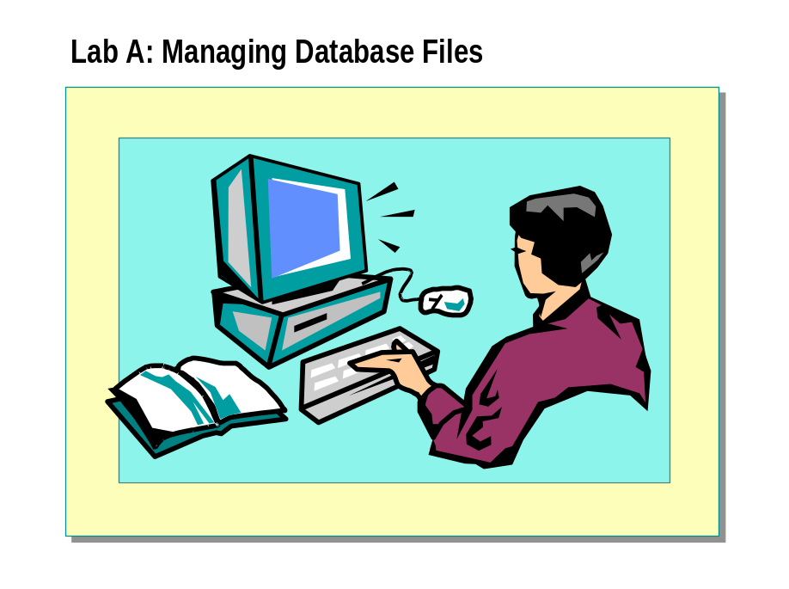

Objectives
After completing this lab, you will be able to:
- Create a database by using the Create Database Wizard.
- Create a database by using SQL Server Enterprise Manager or the CREATE DATABASE statement.
- Modify a database by using SQL Server Enterprise Manager or Transact-SQL statements.
- View and modify database options by using SQL Server Enterprise Manager or Transact-SQL statements.
- Delete a database by using SQL Server Enterprise Manager or TransactSQL-statements.

Prerequisites
Before working on this lab, you must have script files for this lab. These script files are located in C:\Moc\2072A\Labfiles\L03.

For More Information
If you require help in executing files, search SQL Query Analyzer Help for “Execute a query”.
Other resources that you can use include:
- The Northwind database schema.
- SQL Server Books Online.

Estimated time to complete this lab: 30 minutes

Exercise 1
Using the Create Database Wizard

In this exercise, you will create a database by using the Create Database Wizard in SQL Server Enterprise Manager.
- To create a database by using the Create Database Wizard in SQL Server Enterprise Manager
In this procedure, you will use the Create Database Wizard in SQL Server Enterprise Manager to create a database.
    - Log on to the NWTraders classroom domain by using the information in the following table.
Option | Value
User name | SQLAdminx (where x corresponds to your computer name as designated in the nwtraders.msft classroom domain)
Password | password

    - Start SQL Server Enterprise Manager.
    - In the console tree, expand Microsoft SQL Servers, and then expand SQL Server Group.
    - Click your server.
    - On the Tools menu, click Wizards.
    - In the Select Wizard dialog box, expand Database, and then double-click Create Database Wizard.
    - Complete the wizard by using the information in the following table. Use the defaults provided by the wizard for any options that the table does
not specify.
Database name: SampleDBWizard
File | Location | File name | Initial size | Growth size | Maximum file size
Database | C:\Program Files\Microsoft SQL Server\MSSQL\Data | SampleDBWizard_Data | 2 MB | 2 MB | Unrestricted
Log | C:\Program Files\Microsoft SQL Server\MSSQL\Data | SampleDBWizard_Log | 2 MB | 1 MB | Unrestricted

Do not create a maintenance plan at this time.
    - In the console tree, expand Databases, right-click SampleDBWizard, and then click Properties.
Review the properties of the SampleDBWizard database to verify that the database has been created properly.
    - Close the SampleDBWizard Properties dialog box.

Exercise 2
Creating a Database

In this exercise, you will create a database by using SQL Server Enterprise Manager and Transact-SQL statements.
- To create a database by using SQL Server Enterprise Manager
In this procedure, you will create a database by using SQL Server Enterprise Manager.
    - In the SQL Server Enterprise Manager console tree, right-click Databases, and then click New Database.
    - Use the information in the following table to create a new database. Use
the defaults for any options that the table does not specify.
Database name: SampleDBEM
Collation name: Use the server default
File | Location | File name | Initial size | Growth size | Maximum file size
Database | SampleDBEM_Data | C:\Program Files\Microsoft SQL Server\MSSQL\Data | 5 MB | 25% | 15 MB
Log | SampleDBEM_Log | C:\Program Files\Microsoft SQL Server\MSSQL\Data | 2 MB | 50% | 5 MB

    - View the database properties of the SampleDBEM database to verify that the database has been created properly.

- To create a database by using Transact-SQL statements in SQL Query Analyzer
In this procedure, you will use the CREATE DATABASE statement to create a database by using the information in the following table.
Database name: SampleDBTsql
File | File name | Location | Initial size | Maximum file size | Growth size
Database | SampleDBTsql_Data.mdf | C:\Program Files\Microsoft SQL Server\MSSQL\Data | 7 MB | Unrestricted | 3 MB
Log | SampleDBTsql_Log.ldf | C:\Program Files\Microsoft SQL Server\MSSQL\Data | 3 MB | 10 MB | 1 MB

    - Open SQL Query Analyzer and, if requested, log in to the (local) server with Windows Authentication.
You have permission to log in to and administer SQL Server because you are logged as SQLAdminx, which is a member of the Windows 2000 local group, Administrators. All members of this group are automatically mapped to the SQL Server sysadmin role.
    - Open C:\Moc\2072A\Labfiles\L03\Creasmpl.sql, review its contents, and then execute it.
This script creates the SampleDBTsql database by using the CREATE DATABASE statement
    - Switch to SQL Server Enterprise Manager.
    - In the console tree, right-click Databases, and then click Refresh.
    - View the database properties of the SampleDBTsql database to verify that the database has been created properly.

Exercise 3
Modifying a Database

In this exercise, you will modify a database by changing the initial size, the growth increment, and the maximum size specification of a database file.
- To modify a database by using SQL Server Enterprise Manager
In this procedure, you will change the initial size, the growth increment and the maximum size of the SampleDBEM database that you created in Exercise 2.
    - In SQL Server Enterprise Manager, in the console tree, expand Databases, right-click SampleDBEM, and then click Properties.
    - Use the information in the following table to modify the properties of the SampleDBEM database.
File name | Space allocated | Growth increment | Maximum file size
SampleDBEM_Data | 10 MB | 10% | Unrestricted
SampleDBEM_Log | 5 MB | 20% | 15 MB

    - View the database properties for the SampleDBEM database to verify that the database has been modified properly.

- To modify a database by using Transact-SQL statements
In this procedure, you will increase the maximum size of the log file to 20 megabytes (MB) for the SampleDBTsql database that you created in Exercise 2.
    - Switch to SQL Query Analyzer.
    - Open C:\Moc\2072A\Labfiles\L03\Modismpl.sql, review its contents, and then execute it.
This script alters the SampleDBTsql database by using the ALTER DATABASE statement.
    - Switch to SQL Server Enterprise Manager and view the database properties for the SampleDBTsql database to verify that the database has been modified properly.

Exercise 4
Viewing Database Information and Changing Database Options

In this exercise, you will view information about databases and change database options.
- To view information about databases by using SQL Server Enterprise Manager
In this procedure, you will use SQL Server Enterprise Manager to view information about the SampleDBEM database.
    - In the SQL Server Enterprise Manager console tree, expand Databases, and then click SampleDBEM.
    - On the View menu, click Taskpad.
    - In the details pane, review the displayed information.

- To view information about databases by using Transact-SQL statements
In this procedure, you will use system stored procedures to view information about previously created databases.
    - Switch to SQL Query Analyzer and, on the toolbar, click Clear Window.
    - In the query window, type and then execute the following system stored procedure to display information about all databases in this instance of SQL Server.
EXEC sp_helpdb

    - Type and then execute the following system stored procedure to display information about the SampleDBTsql database.
EXEC sp_helpdb SampleDBTsql

    - On the toolbar, click Clear Window.
    - Type and then execute the following system stored procedure to display information about the amount of space used in the SampleDBTsql database.
USE SampleDBTsql
EXEC sp_spaceused

    - On the toolbar, click Clear Window.
    - Type and then execute the following system stored procedure to display information about space usage for the sysobjects table in the SampleDBTsql database.
EXEC sp_spaceused sysobjects

- To change the database to read-only mode by using SQL Server Enterprise Manager

In this procedure, you will use SQL Server Enterprise Manager to change database options.
    - In the SQL Server Enterprise Manager console tree, expand Databases, right-click SampleDBEM, and then click Properties.
    - Click the Options tab, and review the available database options.
    - Select the Read-only check box to change the SampleDBEM database to read-only mode, and then click OK.

- To view database options and change database options by using Transact-SQL statements
In this procedure, you will use the sp_dboption system stored procedure to view database options and change the SampleDBTsql database to read-only mode.
    - Switch to SQL Query Analyzer and, on the toolbar, click Clear Window.
    - In the query window, type and then execute the following system stored procedure to view a list of settable database options.
EXEC sp_dboption

    - Type and execute the following system stored procedure to view a list of database options that are enabled for the SampleDBTsql database.
EXEC sp_dboption SampleDBTsql

    - Type and then execute the following sp_dboption system stored procedure to change the SampleDBTsql database to read-only mode.
EXEC sp_dboption SampleDBTsql, 'read only', 'true'

    - On the toolbar, click Clear Window.
    - Type and then execute the following sp_dboption system stored procedure to verify that the SampleDBTsql database is now in read-only mode.
EXEC sp_dboption SampleDBTsql

Exercise 5
Deleting a Database

In this exercise, you will delete a database by using SQL Server Enterprise Manager and Transact-SQL statements.

- To delete a database by using SQL Server Enterprise Manager
In this procedure, you will use SQL Server Enterprise Manager to delete the SampleDBEM database.
    - In the SQL Server Enterprise Manager console tree, expand Databases, right-click SampleDBEM, and then click Delete.
    - Click Yes to delete the SampleDBEM database and all backup and restore history for the database.
    - Verify that the SampleDBEM database has been deleted.

- To delete one or more databases by using Transact-SQL statements
In this procedure, you will use Transact-SQL statements to delete two databases that you created in a previous exercise.
    - Switch to SQL Query Analyzer.
    - Open C:\Moc\2072A\Labfiles\L03\Dropdb.sql, review its contents, and then execute it.
This script deletes the SampleDBTsql and SampleDBWizard databases by using a single DROP DATABASE statement.
Review the output in the results pane and verify that you have deleted the SampleDBTsql and SampleDBWizard databases.

Module 4: Managing Security

Lab A: Managing Security
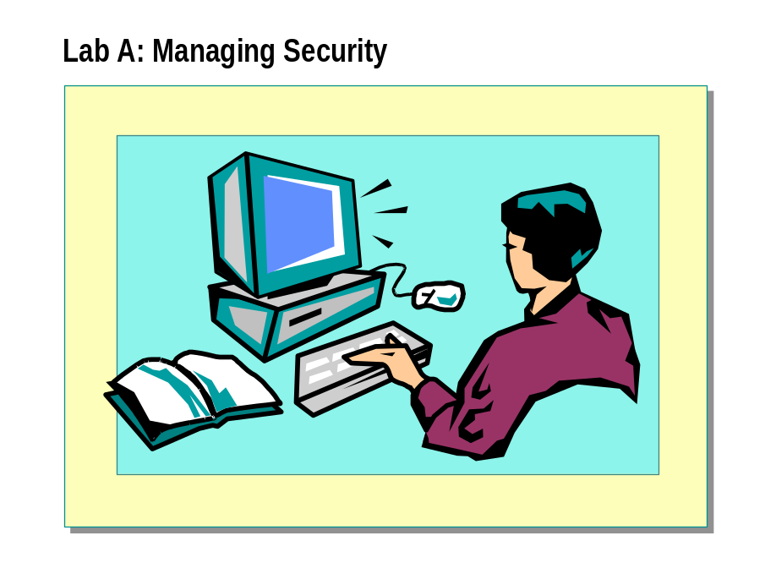

Objectives
After completing this lab, you will be able to:
- Configure Windows Authentication Mode.
- Authorize Windows 2000 groups and users to access SQL Server 2000.
- Revoke and deny access for Windows 2000 groups and users.

For More Information
If you require help in executing files, search SQL Query Analyzer Help for “Execute a query”.
Other resources that you can use include:
- The Northwind database schema.
- SQL Server Books Online.

Estimated time to complete this lab: 30 minutes

Exercise 1
Configuring Windows Authentication Mode

In this exercise, you will verify that SQL Server is configured to use Windows Authentication to allow trusted connections to access SQL Server.
- To verify that SQL Server is using Windows Authentication
In this procedure, you will use SQL Server Enterprise Manager to verify that Windows Authentication is enabled.
    - Log on to the NWTraders classroom domain by using the information in the following table.
Option | Value
User name | SQLAdminx (where x corresponds to your computer name as designated in the nwtraders.msft classroom domain)
Password | password

    - Start SQL Server Enterprise Manager.
You have permission to log in to and administer SQL Server because you are logged as SQLAdminx, which is a member of the Windows 2000 local group, Administrators. All members of this group are automatically mapped to the SQL Server sysadmin role.
    - In the console tree, expand Microsoft SQL Servers, and then expand SQL Server Group.
    - Right-click your server, and then click Properties.
    - Click the Security tab.
    - Verify that Windows only is selected, and then click OK.

Exercise 2
Authorizing Users to Access SQL Server

In this exercise, you will authorize Windows 2000 users and groups to access SQL Server with a trusted connection.
For the purpose of this lab, each user will be allowed to use a trusted connection. You will use the users and groups that you create in this exercise in subsequent exercises in this lab.
The following table lists the Windows 2000 users and groups that have already been created on the NWTraders classroom domain.
Windows 2000 group | Members | User password
customer_mgmt | carl  kathy  lisa  david | password  password  password  password
Domain Users | paul  max | password  password

- To authorize a Windows 2000 user or group to access SQL Server
In this procedure, you will use SQL Server Enterprise Manager to authorize existing Windows 2000 user and group accounts to use trusted connections to access SQL Server.
    - In SQL Server Enterprise Manager, expand your server, and then expand Security.
    - Right-click Logins, and then click New Login.
    - Use the information in the following table to allow these Windows 2000 accounts to access your SQL Server.
Name | Default database | Database access
NWTraders\paul | Northwind | Northwind
NWTraders\carl | Northwind | Northwind
NWTraders\Kathy | Northwind | Northwind
NWTraders\customer_mgmt | Northwind | Northwind

- To test the new Windows 2000 login accounts
In this procedure, you will use SQL Query Analyzer to verify the Windows 2000 login accounts that you set up in previous steps.
    - Log off Windows 2000, and log on to the NWTraders classroom domain by using the information in the following table.
Option | Value
User name | david
Password | password

    - Open SQL Query Analyzer and, if requested, log in to the (local) server with Windows Authentication.

You have permission to log in to and administer SQL Server because you are logged as SQLAdminx, which is a member of the Windows 2000 local group, Administrators. All members of this group are automatically mapped to the SQL Server sysadmin role.
How did david connect to the database when his Windows 2000 login account is not authorized to use SQL Server?

    - Log off Windows 2000.
    - Log on to the NWTraders classroom domain by using the information in the following table.
Option | Value
User name | max
Password | password

    - Open SQL Query Analyzer and, if requested, log in to the (local) server with Windows Authentication.
    - You have permission to log in to and administer SQL Server because you are logged as SQLAdminx, which is a member of the Windows 2000 local group, Administrators. All members of this group are automatically mapped to the SQL Server sysadmin role.
What happens and why?

    - Log off Windows 2000.

Exercise 3
Revoking Access from, and Denying Access to, Windows 2000 Users or Groups

In this exercise, you will revoke access from and deny access to Windows 2000 users and groups.
- To revoke access from a Windows 2000 user or group
In this procedure, you will revoke access from the NWTraders\customer_mgmt group.
    - Log on to the NWTraders classroom domain by using the information in the following table.
Option | Value
User name | SQLAdminx (where x corresponds to your computer name as designated in the nwtraders.msft classroom domain)
Password | password

    - Start SQL Server Enterprise Manager.
    - Expand Microsoft SQL Servers, expand SQL Server Group, and then expand your server.
    - Expand Security, and then click Logins.
    - In the Details pane, right-click NWTraders\customer_mgmt, and then click Delete.
    - Confirm that you want to delete the login account.
Can Windows 2000 users who are members of this group access SQL Server after the group has been removed from SQL Server?

- To deny access to a Windows 2000 group or user

In this procedure, you will deny access to the NWTraders\paul account.
    - Start SQL Server Enterprise Manager.
    - Expand Microsoft SQL Servers, expand SQL Server Group, and then expand your server.
    - Expand Security, and then click Logins.
    - In the Details pane, right-click NWTraders\paul, and then click Properties.
    - In Security access, select Deny access, and then click OK.
Can paul access SQL Server?

Now assume that NWTraders\paul is a member of another Windows 2000 group that has been granted access to SQL Server. Can paul access SQL Server?

Log off Windows 2000.

Lab B: Managing Permissions
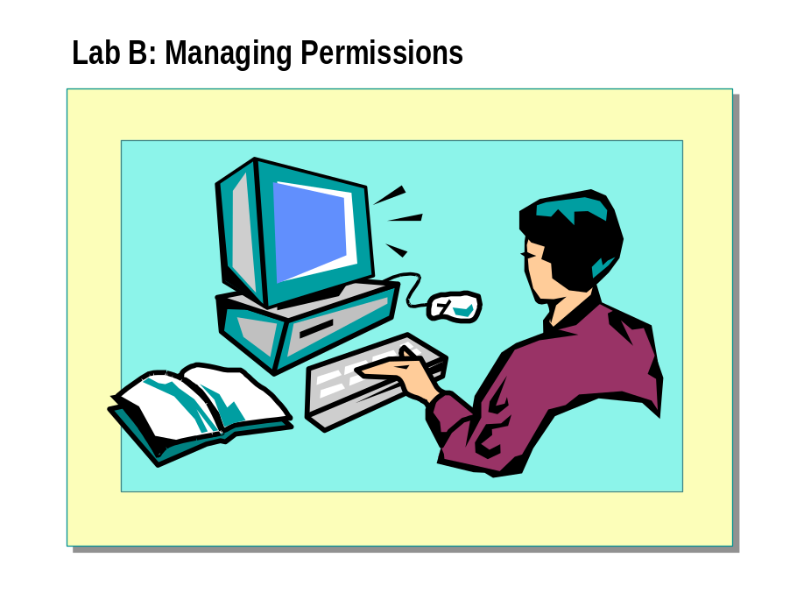

Objectives
After completing this lab, you will be able to:
- Assign security accounts to server and database roles.
- Create database roles.
- Assign statement and object permissions.

For More Information
If you require help in executing files, search SQL Query Analyzer Help for “Execute a query”.
Other resources that you can use include:
- The Northwind database schema.
- SQL Server Books Online.

Estimated time to complete this lab: 30 minutes

Exercise 1
Creating Database Roles

In this exercise, you will create user-defined database roles and add users to database roles in the Northwind database. You will assign permissions to these roles later in this lab.
- To create a role and add members
In this procedure, you will use SQL Server Enterprise Manager to create a new database role and add members to the Northwind database. For now, do not set any permissions. You will use the information in the following table to create a role for users who maintain customer information stored in the Customer table.
Role name | Role members
cust_mgmt | carl  kathy

    - Log on to the NWTraders classroom domain by using the information in the following table.
Option | Value
User name | SQLAdminx (where x corresponds to your computer name as designated in the nwtraders.msft classroom domain)
Password | password

    - Start SQL Server Enterprise Manager.
You have permission to log in to and administer SQL Server because you are logged as SQLAdminx, which is a member of the Windows 2000 local group, Administrators. All members of this group are automatically mapped to the SQL Server sysadmin role.
    - In the console tree, expand Microsoft SQL Servers, and then expand SQL Server Group.
    - Expand your server, expand Databases, and then expand the Northwind database.
    - Right-click Roles, and then click New Database Role.
    - Under Name, type cust_mgmt
    - Verify that Standard role is selected, click Add, and then select carl and kathy from the list.
    - Click OK to close the Add Role Members dialog box, and then click OK to create the new role.

Exercise 2
Assigning Statement Permissions

In this exercise, you will use SQL Server Enterprise Manager to assign statement permissions to SQL Server security accounts.
- To assign statement permissions
In this procedure, you will assign statement permissions. You will allow the user kathy to create views and stored procedures.
    - Start SQL Server Enterprise Manager.
    - In the console tree, expand Microsoft SQL Servers, expand SQL Server Group, and then expand your server.
    - Expand Databases, right-click Northwind, click Properties, and then click the Permissions tab.
    - Select Create View and Create SP for kathy, and then click OK to grant the permissions.
    - Log off Windows 2000, and then log on to the NWTraders classroom domain by using the information in the following table.
Option | Value
User name | kathy
Password | password
    - Open SQL Query Analyzer and, if requested, log in to the (local) server with Windows Authentication.
You have permission to log in to and administer SQL Server because you are logged as SQLAdminx, which is a member of the Windows 2000 local group, Administrators. All members of this group are automatically mapped to the SQL Server sysadmin role.
    - Execute the following Transact-SQL statements to create a view:
USE Northwind
GO
CREATE VIEW testview as
SELECT FirstName, LastName
FROM Employees

Were you able to create the view?

    - Execute a CREATE TABLE statement:

USE Northwind
CREATE TABLE testtable
(column1 INT NOT NULL,
column2 CHAR(10) NOT NULL)

Did the statement execute successfully? Why or why not?

    - Log off Windows 2000.

Exercise 3
Assigning Object Permissions

In this exercise, you will use SQL Server Enterprise Manager to assign object permissions to SQL Server security accounts. You will assign permissions for the users, groups, and roles that you created in previous exercises.
- To assign object permissions
In this procedure, you will use SQL Server Enterprise Manager to assign object permissions to roles.
    - Log on to the NWTraders classroom domain by using the information in the following table.
Option | Value
User name | SQLAdminx (where x corresponds to your computer name as designated in the nwtraders.msft classroom domain)
Password | password

    - Start SQL Server Enterprise Manager.
    - In the console tree, expand Microsoft SQL Servers, and then expand SQL Server Group.
    - Expand your server, expand Databases, expand Northwind, and then click Tables.
    - In the Details Pane, right-click Categories, point to All Tasks, and then click Manage Permissions.
    - Use the following table to grant, revoke, and deny permissions on Northwind objects for users and roles.
Object | Account | Permission
Categories | public | Grant all
Customers | kathy | Deny all
Customers | cust_mgmt | Grant all
Customers | public | Revoke all
Employees | public | Revoke all
OrderDetails | public | Revoke all
Orders | public | Revoke all
Products | public | Revoke all

    - Log off Windows 2000.

- To test object permissions

In this procedure, you will test the permissions of users and roles.
    - Log on to the NWTraders classroom domain by using the information in the following table.
Option | Value
User name | carl
Password | password

    - Open SQL Query Analyzer and, if requested, log in to the (local) server with Windows Authentication.
You have permission to log in to and administer SQL Server because you are logged as SQLAdminx, which is a member of the Windows 2000 local group, Administrators. All members of this group are automatically mapped to the SQL Server sysadmin role.
Remember that carl is a member of the cust_mgmt role.
    - Execute each of the following Transact-SQL statements to test permissions for carl:
USE Northwind
SELECT * FROM Employees
SELECT * FROM Customers
SELECT * FROM Categories
SELECT * FROM Products

Which tables can carl query? Which tables is he not able to query? Why?

    - Log off Windows 2000.
    - Log on to the NWTraders classroom domain by using the information in the following table.
Option | Value
User name | kathy
Password | password

    - Open SQL Query Analyzer and, if requested, log in to the (local) server with Windows Authentication.

You have permission to log in to and administer SQL Server because you are logged as SQLAdminx, which is a member of the Windows 2000 local group, Administrators. All members of this group are automatically mapped to the SQL Server sysadmin role.
Remember that kathy is a member of the cust_mgmt role.
    - Execute the following Transact-SQL statement to test permissions for kathy:
USE Northwind
SELECT * FROM Customers

Can kathy access the table? Why or why not?

Log off Windows 2000.

Lab C: Managing Application Security
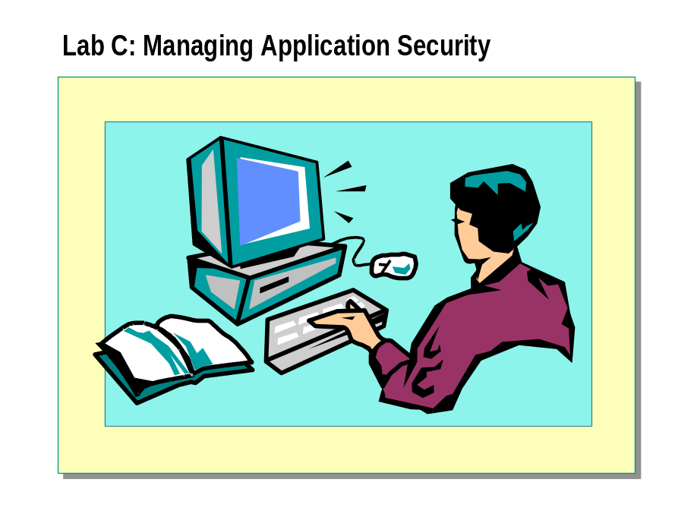

Objectives
After completing this lab, you will be able to:
- Create and activate an application role.
- Use views and stored procedures to simplify permissions management.

For More Information
If you require help in executing files, search SQL Query Analyzer Help for “Execute a query”.
Other resources that you can use include:
- The Northwind database schema.
- SQL Server Books Online.

Estimated time to complete this lab: 30 minutes

Exercise 1
Creating and Activating an Application Role

In this exercise, you will create an application role, assign role permissions, and activate the application role. You will use this role in other exercises later in this lab.
- To define an application role
In this procedure, you will define an application role called order_entry in the Northwind database by using SQL Server Enterprise Manager. This process is very similar to creating a database role, with the exception that you do not define any members.
    - Log on to the NWTraders classroom domain by using the information in the following table.
Option | Value
User name | SQLAdminx(where x corresponds to your computer name as designated in the nwtraders.msft classroom domain)
Password | password

    - Start SQL Server Enterprise Manager.
You have permission to log in to and administer SQL Server because you are logged as SQLAdminx, which is a member of the Windows 2000 local group, Administrators. All members of this group are automatically mapped to the SQL Server sysadmin role.
    - In the console tree, expand Microsoft SQL Servers, expand SQL Server Group, and then expand your server.
    - Expand Databases, and then expand Northwind.
    - Right-click Roles, and then click New Database Role.
    - Create an application role called order_entry with a password of password.
    - Use SQL Server Enterprise Manager to assign permissions for the order_entry application role that you just created. Use the information in the following table.
Table | Permissions
Northwind..Categories | SELECT
Northwind..Customers | SELECT, INSERT, UPDATE
Northwind..Order Details | SELECT, INSERT, UPDATE
Northwind..Orders | SELECT, INSERT, UPDATE
Northwind..Products | SELECT

    - Log off Windows 2000.

- To activate an application role

In this procedure, you will use SQL Query Analyzer to log in as a user and activate the order_entry application role.
    - Log on to the NWTraders classroom domain by using the information in the following table.
Option | Value
User name | carl
Password | password

Remember that carl is a member of the cust_mgmt role.
    - Open SQL Query Analyzer and, if requested, log in to the (local) server with Windows Authentication.
You have permission to log in to and administer SQL Server because you are logged as SQLAdminx, which is a member of the Windows 2000 local group, Administrators. All members of this group are automatically mapped to the SQL Server sysadmin role.
    - Execute the sp_setapprole system stored procedure to activate the role:
USE Northwind
EXEC sp_setapprole 'order_entry', 'password'

Execute the following statement to query the Products table:
SELECT * FROM Products

Were you able to query the table? Why or why not?

How long will the order_entry role be activated for carl?

    - Close the query window to end the session. This will also deactivate the order_entry role for carl.
    - Log off Windows 2000.

Exercise 2
Implementing Permissions by Using Views and Stored Procedures

In this exercise, you will grant permissions for users to use a view and stored procedure to access a table without having permissions to access the table directly.
You will use both SQL Server Enterprise Manager and Transact-SQL statements in this exercise.
- To use a view or stored procedure to implement permissions
In this procedure, you will create a view called employees_view and a stored procedure called employee_proc. You then will grant permissions on employees_view and employee_proc to the public role and revoke permissions on the Employees table from the public role.
    - Log on to the NWTraders classroom domain by using the information in the following table.
Option | Value
User name | SQLAdminx (where x corresponds to your computer name as designated in the nwtraders.msft classroom domain)
Password | Password

    - Start SQL Server Enterprise Manager.
    - In the console tree, expand Microsoft SQL Servers, expand SQL Server Group, and then click your server.
    - On the Tools menu, click Wizards.
    - Expand Database, click Create View Wizard, and then click OK.
    - Use the information in the following table to create a view.
Option | Value
Database | Northwind
Objects | Employees
Columns | LastName  FirstName  Title
Name | Employees_View

    - Open SQL Query Analyzer and, if requested, log in to the (local) server with Windows Authentication.
You have permission to log in to and administer SQL Server because you are logged as SQLAdminx, which is a member of the Windows 2000 local group, Administrators. All members of this group are automatically mapped to the SQL Server sysadmin role.
    - Execute the following statement to create a stored procedure that queries the FirstName, LastName, and Title columns of the Employees table:

USE Northwind
GO
CREATE PROCEDURE employee_proc AS
SELECT FirstName, LastName, Title
FROM Employees

    - Execute the following statements to allow the public role to select from employees_view and execute employee_proc:
USE Northwind
GRANT SELECT ON employees_view TO public
GRANT EXEC ON employee_proc TO public

    - Execute the following statement to remove the right of the public role to select from the Employees table:
USE Northwind
REVOKE SELECT ON employees FROM public

    - Log off Windows 2000.

- To test permissions on the view and stored procedure
In this procedure, you will query data from the employees_view view and execute the employee_proc stored procedure. You will then attempt to query the Employees table directly.
    - Log on to the NWTraders classroom domain by using the information in the following table.
Option | Value
User name | Carl
Password | Password

    - Open SQL Query Analyzer and, if requested, log in to the (local) server with Windows Authentication.
You have permission to log in to and administer SQL Server because you are logged as SQLAdminx, which is a member of the Windows 2000 local group, Administrators. All members of this group are automatically mapped to the SQL Server sysadmin role.
    - Execute the following statement to query the employees_view view:
SELECT * FROM employees_view

Were you able to query the view? Why or why not?

    - Execute the employee_proc stored procedure:

EXEC employee_proc

Were you able to execute the stored procedure? Why or why not?

    - Execute the following statement to query the Employees table:
SELECT * FROM Employees

Were you able to query the table? Why or why not?

Log off Windows 2000.

Module 5: Performing Administrative Tasks

Lab A: Configuring SQL Server
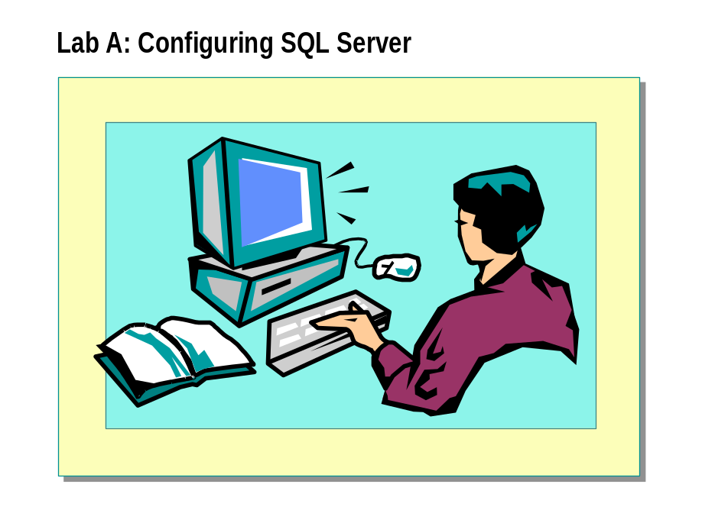

Objectives
After completing this lab, you will be able to:
- Configure a Microsoft Exchange Server profile to use SQLAgentMail for the SQLService domain user account.
- Configure SQL Mail.

Prerequisites
Before working on this lab, you must have script files for this lab. The script files are located in C:\Moc\2072A\Labfiles\L05.

For More Information
If you require help in executing files, search SQL Query Analyzer Help for “Execute a query”.
Other resources that you can use include:
- The Northwind database schema.
- SQL Server Books Online.

Estimated time to complete this lab: 30 minutes

Exercise 1
Configuring SQL Server Agent to Send Messages

In this exercise, you will use Microsoft Outlook® to configure an Exchange Server profile for the SQLService domain user account to enable SQL Server Agent to send and receive messages. You will then configure an Exchange profile for your domain user account, SQLAdminx, to send and receive messages with Outlook. Finally, you will use SQL Server Enterprise Manager to configure SQL Server Agent to use the mail profile that is configured for the SQLService domain user account.
- To configure an Exchange profile for your administrative account
In this procedure, you will use Outlook to configure an Exchange profile for your domain user account, SQLAdminx.
    - Log on to the NWTraders classroom domain with the information in the following table.
Option | Value
User name | SQLAdminx (where x corresponds to your computer name as designated in the nwtraders.msft classroom domain)
Password | password

    - On the desktop, double-click Microsoft Outlook.
The Outlook 2000 Startup dialog box appears.
    - Configure Outlook by using the information in the following table. Accept the defaults for any options that are not listed.
Option | Value
E-mail Service Options | Corporate or workgroup
Information service | Microsoft Exchange Server
Microsoft Exchange Server | London
Mailbox | SQLAdminx (where x corresponds to your computer name as designated in the nwtraders.msft classroom domain)

    - Click Yes to make Outlook your default manager for Mail, News, and Contacts.
    - Compose and send an e-mail message to your e-mail alias.
    - Verify that the message appears in the Inbox.
    - Close Outlook.
    - Log off Microsoft Windows 2000.

- To configure an Exchange profile for the SQLService domain user account

In this procedure, you will use Outlook to configure an Exchange profile for the domain user account, SQLService.
    - Log on to the NWTraders classroom domain with the information in the following table.
Option | Value
User name | Sqlservice
Password | Sqlservice

    - On the desktop, double-click Microsoft Outlook. Use the information in the following table to configure Outlook. Accept the defaults for any options that are not listed.
Option | Value
Information service | Microsoft Exchange Server
Microsoft Exchange Server | London
Mailbox | SQLService

- To test and verify that the SQLService domain user account received an e-mail message
In this procedure, you will send an e-mail message to the SQLService domain user account and verify its receipt.
    - Compose and send a message in Outlook to SQLService.
    - Verify that the message appears in the Inbox.

- To verify the profile name
In this procedure, you will verify that the MS Exchange Settings profile name was created for the SQLService domain user account.
    - On the Tools menu, click Options, and then click the Mail Services tab.
    - Under Startup Settings, in the Always use this profile box, verify that MS Exchange Settings is displayed.
    - Close the Options dialog box, and then close Outlook.
    - Log off Windows 2000.

- To configure SQL Server Agent to use the mail profile
In this procedure, you will use SQL Server Enterprise Manager to configure SQL Server Agent to start a mail session that uses the MS Exchange
Settings profile.
    - Log on to the NWTraders classroom domain with the information in the following table.
Option | Value
User name | SQLAdminx (where x corresponds to your computer name as designated in the nwtraders.msft classroom domain)
Password | Password

    - Open SQL Server Enterprise Manager.
    - In the console tree, expand Microsoft SQL Servers, expand SQL Server Group, expand your server, and then expand Management.
    - Verify that SQL Server Agent has started.
    - Right-click SQL Server Agent, and then click Properties.
    - On the General tab, in the Mail profile list, select MS Exchange Settings.
    - Click Test, and then click OK to acknowledge the message indicating that a mail session was successfully started (and stopped) with this profile.
    - Click OK to close the SQL Server Agent Properties dialog box.
    - Click Yes to stop and restart SQL Server Agent, and then click OK when SQL Server Agent has been successfully restarted.
    - In the console tree, right-click SQL Server Agent, and then click Display Error Log.
    - In the Type list, click All Types.
    - Verify that a mail session was started when SQL Server Agent was started.
    - Close the SQL Server Agent Error Log dialog box.

Exercise 2
Using SQL Mail

In this exercise, you will configure SQL Mail and execute the xp_sendmail extended stored procedure to send the result set of a query to your e-mail account in Outlook.
- To configure SQL Mail
In this procedure, you will configure SQL Mail by specifying a mail profile name for SQL Mail.
    - In the SQL Server Enterprise Manager console tree, expand Support Services.
    - Right-click SQL Mail, and then click Properties.
    - In the Profile name list, select MS Exchange Settings, and then click Test.
The mail session of SQL Server Agent also uses this profile, because both the SQL Server Agent and the SQL Server services use the SQLService Windows 2000 domain user account.
    - When the test completes successfully, click OK.
    - Click OK to close the SQL Mail Configuration dialog box.

- To send a query result by using SQL Mail
In this procedure, you will execute the xp_sendmail extended stored procedure to send the result set of a query to yourself to verify that the SQL Mail session works as expected.
    - Open SQL Query Analyzer and, if requested, log in to the (local) server with Windows Authentication.
You have permission to log in to and administer SQL Server because you are logged as SQLAdminx, which is a member of the Windows 2000 local group, Administrators. All members of this group are automatically mapped to the SQL Server sysadmin role.
    - Open C:\Moc\2072A\Labfiles\L05\Sqlmail.sql, and review its contents.
    - Modify the script to specify your SQLAdminx (where x corresponds to your computer name as designated in the nwtraders.msft classroom domain) e-mail account, and then execute the script.
The result pane indicates that mail was sent.
    - Open Outlook and review your Inbox to ensure that you received an e-mail message with your query result.
What was the query result?

Lab B: Creating Jobs and Operators


Objectives
After completing this lab, you will be able to:
- Create operators for notification.
- Create a job with the Create Job Wizard.
- Create a job that consists of multiple job steps.

Prerequisites
Before working on this lab, you must have script files for this lab. These script files are located in C:\Moc\2072A\Labfiles\L05.
This lab requires that you have completed lab A, “Configuring SQL Server.”

For More Information
If you require help in executing files, search SQL Query Analyzer Help for “Execute a query”.
Other resources that you can use include:
- The Northwind database schema.
- SQL Server Books Online.

Estimated time to complete this lab: 60 minutes

Exercise 1
Creating Operators

In this exercise, you will create an operator to receive notifications from SQL Server Agent.
- To create operators
In this procedure, you will create an operator and verify that a message was received.
    - Log on to the NWTraders classroom domain by using the information in the following table.
Option | Value
User name | SQLAdminx (where x corresponds to your computer name as designated in the nwtraders.msft classroom domain)
Password | password

    - Open SQL Server Enterprise Manager.
    - In the console tree, expand Microsoft SQL Servers, expand SQL Server Group, expand your server, expand Management, and then expand SQL Server Agent.
    - Right-click Operators, and then click New Operator.
    - Use the information in the following table to create an operator to receive messages.
Option | Value
Name | Your name
E-mail name | SQLAdminx@NWTraders.msft (where x maps to your computer name as designated in the NWTraders classroom domain)
net send address | servername (where servername maps to your computer name as designated in the NWTraders classroom domain)

    - Click Test for both e-mail and net send command.
    - Verify that the operator received the messages through e-mail and net send command.
    - Click OK to close the New Operator Properties dialog box.

Exercise 2
Using the Create Job Wizard

In this exercise, you will use the Create Job Wizard to create a job that is scheduled to back up the master database every Monday at 5:00 P.M.
- To use the Create Job wizard
In this procedure, you will use the Create Job wizard to define a job that backs up the master database every week on Monday at 5:00 P.M.
    - In SQL Server Enterprise Manager, on the Tools menu, click Wizards.
    - Expand Management, and then double-click Create Job Wizard.
    - Use the information in the following table to create a job that is scheduled to back up the master database every Monday at 5:00 P.M. Accept the defaults for any options that are not listed.
Option | Value
Type | Transact-SQL command
Database | master
Transact-SQL statement | BACKUP DATABASE master TO DISK = 'C:\Program Files\Microsoft SQL Server\Mssql\Backup\MasterDB.bak'  WITH INIT
Schedule | Recurring, every Monday at 5:00 P.M.
Notifications | E-mail message to yourself  net send command to yourself
Job name | Master DB Backup

- To execute the job manually
In this procedure, you will verify that your job was created successfully and that notifications were sent.
    - In the console tree, expand SQL Server Agent, and then click Jobs to display all jobs in the details pane.
    - In the details pane, right-click Master DB Backup, and then click Start Job.
This executes the job manually. It will take a few minutes.
    - Click OK when the net send message appears on your computer screen informing you that the backup job completed successfully.
    - In the details pane, right-click Master DB Backup, and then click View Job History to verify that the job was completed successfully.

What information is displayed in the job history when the Show step details checkbox is selected? What information is displayed when this option is cleared?

    - Close the Job History dialog box.
    - Switch to Outlook to verify that you received an e-mail message.
    - Minimize Outlook.

Exercise 3
Creating a Job with Multiple Steps

In this exercise, you will use SQL Server Enterprise Manager to create a job that consists of multiple job steps to import data by using an operating system command, and then back up the database by using Transact-SQL.
- To create a job with multiple job steps
In this procedure, you will create a job that imports a text file into the Products table in the Northwind database, and then backs up the database after the data import successfully completes.
    - In the SQL Server Enterprise Manager console tree, right-click Jobs, and then click New Job.
    - In the Name box, type Nwind Monthly Data Import
    - Click the Steps tab, click New, and then use the information in the following table to create the first job step.

Operating system commands must be written on one line, as if you were typing the command at a command prompt.
Note

Option | Value
Step name | Copy new product data
Type | Operating system command (CmdExec)
Command | C:\Moc\2072A\Labfiles\L05\Import.cmd
On success action | Go to the next step
Retry attempts | One attempt, at one minute intervals
Output file | C:\Prodcopy.out (overwrite)

    - Click New, and then use the information in the following table to create the second job step.
Option | Value
Job step name | Back up Northwind DB
Type | Transact-SQL
Database | Northwind
Command | BACKUP DATABASE Northwind TO  DISK = 'C:\Program Files\Microsoft SQL Server\Mssql\Backup\Nwind.bak'  WITH INIT
On success action | Quit the job reporting success
Output file | C:\Prodcopy.out (append)

    - Use the information in the following table to schedule the Nwind Monthly Data Import job and specify notifications. Accept the defaults for any options that are not listed.

Option | Value
Schedule name | First day of the month
Schedule | Recurring, monthly on the first day at 1:00 A.M.
Notifications | E-mail message to yourself  When the job fails  net send command sent to yourself  When the job completes  Windows application log  When the job fails

    - Start the Nwind Monthly Data Import job.
After a few moments, a net send message appears, indicating that the job succeeded.
    - Click OK to close the Messenger Service dialog box.

- To simulate a failure and verify that a job step failed
In this procedure, you will rename the data import file to simulate a failure that causes the first job step to fail.
    - Open Microsoft Windows Explorer.
    - Using Notepad, open C:\Prodcopy.out, review its contents, and then close the file.
    - Rename the C:\Moc\2072A\Labfiles\L05\Prods.txt file as Prodsnew.txt
    - Switch to SQL Server Enterprise Manager.
    - Start the Nwind Monthly Data Import job.
    - When you receive the net send message indicating that the job failed, click OK to close the Messenger Service dialog box.
    - Review the job history, looking at the step details.
What did you notice in the history?

    - Open Event Viewer and review the application log to confirm that the job failure was logged.

What information is displayed in the log?

    - Close Event Viewer.
    - Switch to Outlook to confirm that you received an e-mail message notifying you that the job failed.
    - Open Notepad and review the contents of C:\Prodcopy.out.
What information is displayed in the output file?

    - Close the file.
Switch to SQL Server Enterprise Manager and disable the Nwind Monthly Data Import Job.

Lab C: Creating Alerts
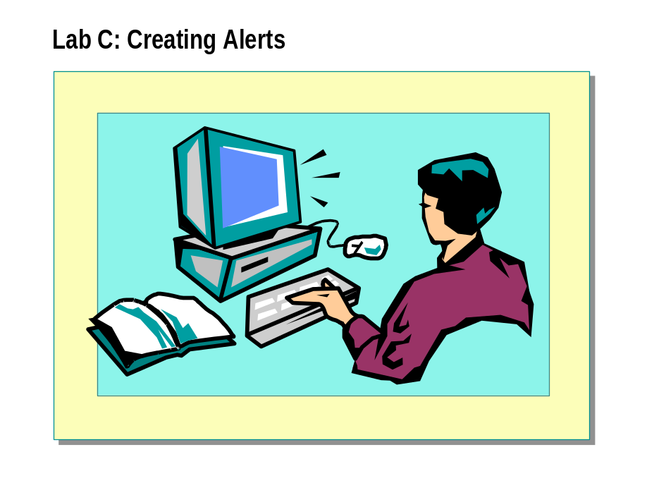

Objectives
After completing this lab, you will be able to:
- Create an alert by using the Create Alert Wizard.
- Create an alert on a user-defined message.
- Create a performance condition alert.

Prerequisites
Before working on this lab, you must have script files for this lab. These script files are located in C:\Moc\2072A\Labfiles\L05.
This lab requires that you have completed lab A, “Configuring SQL Server” and lab B, “Creating Jobs and Operators.”

For More Information
If you require help in executing files, search SQL Query Analyzer Help for “Execute a query”.
Other resources that you can use include:
- The Northwind database schema.
- SQL Server Books Online.

Estimated time to complete this lab: 45 minutes

Exercise 1
Using the Create Alert Wizard

In this exercise, you will create an alert to respond to errors with severity level 18 by using the Create Alert Wizard.
- To create an alert by using the Create Alert Wizard
In this procedure, you will use the Create Alert Wizard to create an alert that is defined to send an e-mail message and a net send command to yourself when an error with severity level 18 occurs.
    - Log on to the NWTraders classroom domain with the information in the following table.
Option | Value
User name | SQLAdminx (where x corresponds to your computer name as designated in the nwtraders.msft classroom domain)
Password | password

    - Open SQL Server Enterprise Manager, expand Microsoft SQL Servers, expand SQL Server Group, and then expand your server.
    - On the Tools menu, click Wizards.
    - Expand Management, and then double-click Create Alert Wizard.
    - Create an alert with the information in the following table. Accept the defaults for any items that are not listed.
Option | Value
For any error severity | 018 – NonFatal Internal Error
Database name | All databases
Notify operators | Select yourself as the operator to receive notification by e-mail and net send command
Include error message text in: | E-mail and Net Send
Alert name | Severity level 18 errors

    - In the console tree, expand Management, expand SQL Server Agent, and then click Alerts.
    - In the details pane, verify that the alert was created.
    - Right-click the Severity level 18 errors alert, and then click Properties to review the alert definition.
    - Click OK to close the Severity Level 18 Errors Properties dialog box.

Exercise 2
Creating an Alert on a User-defined Error Message

In this exercise, you will create a user-defined (custom) error message that indicates when the stock units reach the reorder level for any product.
- To create a user-defined error message
In this procedure, you will use SQL Server Enterprise Manager to create a user-defined error message.
    - In the console tree, right-click your server, point to All Tasks, and then click Manage SQL Server Messages.
    - On the Messages tab, click New.
    - Use the information in the following table to create a user-defined message that indicates that the number of stock units for a particular product has reached the reorder level. Accept the defaults for any items that are not listed.
Option | Value
Error number | 50001
Severity | 010 – Information
Message text | The units in stock for %s has reached %d. Please reorder
Always write to Windows eventlog | Select this check box

- To create an alert for a user-defined error message
In this procedure, you will create an alert called Reorder Inventory that sends an e-mail message to the warehouse manager when error number 50001 occurs.
    - In the console tree, expand Management, expand SQL Server Agent, right-click Alerts, and then click New Alert.
    - Create an alert with the information in the following table. Accept the defaults for any items that are not listed.
Option | Value
Alert name | Reorder Inventory
Error number | 50001
Database | Northwind
Operators to notify | Select yourself as the operator to receive notification by E-mail and Net Send
Include alert error text in: | E-mail and Net Send

    - Verify that the alert was created.
The Reorder Inventory alert should appear in the details pane.

- To raise a user-defined error message

In this procedure, you will use SQL Query Analyzer to create and execute a stored procedure that will raise error 50001 to test that the Reorder Inventory alert works as expected.
    - Open SQL Query Analyzer and, if requested, log in to the (local) server with Microsoft Windows® authentication.
You have permission to log on to and administer SQL Server because you are logged as SQLAdminx, which is a member of the Windows 2000 local group, Administrators. All members of this group are automatically mapped to the SQL Server sysadmin role.
    - Open C:\Moc\2072A\Labfiles\L05\Reorder.sql, review its contents, and then execute it.
This script creates a stored procedure named reorder.
    - Open a new query window and execute the stored procedure by supplying any valid product ID value. For example:
USE Northwind
EXEC ReOrder
@prodid = 2

Did you receive the defined notifications in response to the alert?

Exercise 3
Creating Performance Condition Alerts

In this exercise, you will execute a script that creates a job to back up the Northwind database. You will then execute a script that alters the size of the Northwind database transaction log. Next, you will create a performance condition alert in SQL Server Enterprise Manager on the Percent Log Used counter that is defined to notify you when the Northwind database transaction log has reached 60 percent capacity. Finally, you will verify that the condition alert works as expected.
- To execute a script that creates a job to back up the Northwind transaction log
In this procedure, you will execute a script that creates a job that backs up the Northwind transaction log every four hours.
    - Open C:\Moc\2072A\Labfiles\L05\Nwlog.sql, review its contents, and then execute it.
    - Switch to SQL Server Enterprise Manager.
    - Right-click Jobs, and then click Refresh.
    - Click Jobs, and then, in the details pane, verify that the Backup Northwind Log job was created.
    - Edit the job properties to specify that you should be notified by e-mail and net send command whenever the job completes and write the event to the Windows application log when the job fails.

- To disable auto grow, change the database recovery model, and back up the Northwind database
In this procedure, you will alter the Northwind database so that the transaction log does not auto grow, set the database recovery model to full, and then back up the Northwind database.
    - In the console tree, expand Databases, right-click Northwind, and then click Properties.
    - On the Transaction Log tab, clear the Automatically grow file check box.
    - On the Options tab, change the database recovery model to full, and then click OK to the close the Northwind Properties dialog box.
    - Switch to SQL Query Analyzer.
    - Open C:\Moc\2072A\Labfiles\L05\NWBackup.sql, review its contents, and then execute it.

- To create a performance condition alert

In this procedure, you will create a performance condition alert when the Percent Log Used counter rises above 60 percent for the Northwind database.
    - In the SQL Server Enterprise Manager console tree, expand Management, and then expand SQL Server Agent.
    - Right-click Alerts, and then create a new alert by using the information in the following table.
Option | Value
Alert name | Northwind Log 60% Full
Alert type | SQL Server performance condition alert
Object | SQLServer:Databases
Counter | Percent Log Used
Instance | Northwind
Alert if counter | Rises above 60
Execute job | Select the Execute job check box, and click Backup Northwind Log
Operators to notify | Yourself by e-mail and Net Send
Delay between responses | 0 minutes, 0 seconds

    - Review the schedule properties of the Backup Northwind Log job.
What schedule exists?

- To monitor the percent log used with Windows System Monitor
In this procedure, you will create a new chart in Windows System Monitor to monitor the percent log used.
    - Click Start, point to Programs, point to Administrative Tools, and then click Performance.
    - In the console tree, verify that System Monitor is selected.
    - On the toolbar, click Add, click the SQLServer:Databases object, click the Percent Log Used counter, click the Northwind instance, and then click Add.
    - Click Close to close the Add Counters dialog box.

- To test the performance condition alert

In this procedure, you will review and execute a script that generates activity in the Northwind database to fill up the transaction log. Then, you will verify that SQL Server Agent fired the alert and executed the job as defined.
    - Switch to SQL Query Analyzer.
    - Open C:\Moc\2072A\Labfiles\L05\Fulltlog.sql, review its contents, and then execute it.
This script generates activity in the Northwind database and fills up the transaction log.
    - Switch to Windows System Monitor to observe the transaction
log activity.
    - When the alert is fired, you will receive a net send message.
Notice that when the job executes, backing up the transaction log, and reduces the percent of the transaction log that is used.
    - Close the Messenger Service dialog boxes, and then switch to SQL Query Analyzer.
    - On the toolbar, click Cancel Query to stop the execution of the script.
    - Open Outlook and review your Inbox to ensure that you received one or more e-mail messages.
    - Switch to SQL Server Enterprise Manager.
    - Review the job history on Backup Northwind Log.
    - Review the alert history on Northwind Log 60% Full.
Refresh the alert to show the most recent date and time that the alert was fired.
    - In the console tree, expand Databases, right-click Northwind, and then click Properties.
    - On the Transaction Log tab, select the Automatically grow file check box.
    - On the Options tab, change the recovery model to simple, and then click OK to close the Northwind Properties dialog box.

If Time Permits
Assigning a Fail-Safe Operator

In this exercise, you will define yourself as the fail-safe operator for your server. You will also execute a script that creates an alert on error 9002 (transaction log is full) and a multistep job that addresses the alert. Next, you will modify the Northwind database properties and execute a script that will fill the transaction log. Finally, you will verify that the alert executed the job to clear the transaction log and that the fail-safe operator was notified.
- To assign a fail-safe operator
In this procedure, you will designate yourself as a fail-safe operator for your server.
    - In the console tree, expand Management, right-click SQL Server Agent, and then click Properties.
    - In the SQL Server Agent Properties dialog box, click the Alert System tab.
    - In the Failsafe Operator list, define yourself as the fail-safe operator for your server to be notified by e-mail and net send command.
    - Click OK to close the SQL Server Agent Properties dialog box.

- To execute a script that creates an alert
In this procedure, you will execute a script that creates an alert on error 9002 and designates the Northwind backup log job to execute in response to the alert firing.
    - Switch to SQL Query Analyzer.
    - Open C:\Moc\2072A\Labfiles\L05\Alert.sql, review its contents, and then execute it.
You will receive notification that non-existing steps were referenced. This is expected behavior.
    - Switch to SQL Server Enterprise Manager.
    - In the console tree, refresh Alerts to verify that the Northwind 9002 Log Full alert was created.

- To disable auto grow, change the database recovery model, and the Northwind database
In this procedure, you will alter the Northwind database so that the transaction log does not auto grow, set the database recovery model to full, and then back up the Northwind database.
    - In the console tree, expand Databases, right-click Northwind, and then click Properties.
    - On the Transaction Log tab, clear the Automatically grow file check box.
    - On the Options tab, change the database recovery model to full, and then click OK to close the Northwind Properties dialog box.
    - Switch to SQL Query Analyzer.

    - Open C:\Moc\2072A\Labfiles\L05\ NWBackup.sql, review its contents, and then execute it.

- To raise an alert that will notify the fail-safe operator
In this procedure, you will create an operator and an on duty pager schedule specifying the times that the new operator is on duty. You will specify that this new operator be notified by pager whenever the alert that you created in the previous procedure is activated. You will then disable the performance condition alert that you created in the previous exercise so that it is not activated. Finally, you will execute a script to fill the transaction log, which raises error 9002 with severity level 17.
    - Switch to SQL Server Enterprise Manager.
    - In the console tree, expand Management, expand SQL Server Agent, and then click Operators to display all operators in the details pane.
    - Create the Administrator as a new operator by using the information in the following table:
Option | Value
Name | Administrator
E-mail name | Administrator@NWTraders.msft
Pager e-mail name | Administrator@NWTraders.msft
net send address | London
Pager on duty schedule | Saturday only

    - On the Notifications tab, select the Pager check box for the Northwind 9002 Full Log alert, and then click OK.
    - In the console tree, click Alerts.
    - In the details pane, right-click Northwind Log 60% Full, and then click Properties.
    - Clear the Enabled check box, and then close the Northwind Log 60% Full Properties dialog box.
This will prevent this alert from firing and executing the associated job.
    - Switch to SQL Query Analyzer and open a new query window.
    - Open C:\Moc\2072A\Labfiles\L05\Fulltlog.sql, review its contents, and then execute it.

This will fill the Northwind database transaction log and raise error 9002 with severity level 17. The error is also written to the Windows application log.
What occurred when the Northwind database transaction log became full?

- To verify that the fail-safe operator is working correctly
In this procedure, you will verify that the fail-safe operator is contacted when an alert is fired when the operator who is designated to receive the notification is off-duty.
    - Switch to SQL Server Enterprise Manager and review the alert history for the Northwind 9002 Full Log alert. You may have to refresh the alert.
How many times has the alert occurred? What was the date and time of the last occurrence?

    - Review the operator notification attempts for the Northwind 9002 Full Log alert.
One pager notification will have occurred.
    - Verify that you also received an e-mail message as the fail-safe operator.
How can you distinguish this message from other alert system messages?

    - Open Event Viewer and review the application log. List the events related to the error and the failed pager notification.

    - Close Event Viewer.
    - In the SQL Server Enterprise Manager console tree, expand Databases, right-click Northwind, and then click Properties.
    - On the Transaction Log tab, select the Automatically grow file check box.
On the Options Log tab, change the recovery model to simple, and then click OK to close the Northwind Properties dialog box.

Module 6: Backing Up Databases

Lab A: Backing Up Databases
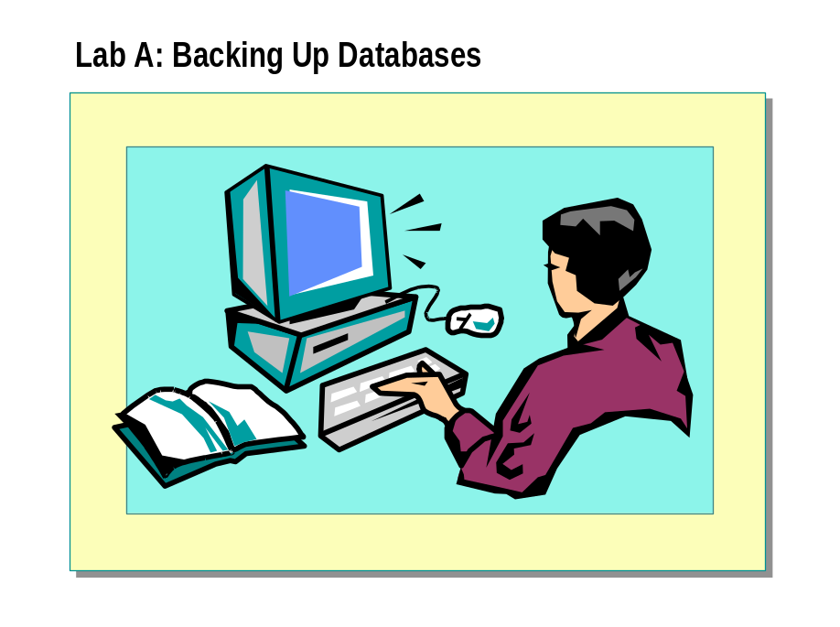

Objectives
After completing this lab, you will be able to:
- Create a permanent backup file.
- Back up a database.
- Back up and clear a transaction log.
- Perform a differential backup.

Prerequisites
Before working on this lab, you must have:
- Script files for this lab, which are located in C:\Moc\2072A\Labfiles\L06.
- Answer files for this lab, which are located in C:\Moc\2072A\Labfiles\L06\Answers.

For More Information
If you require help in executing files, search SQL Query Analyzer Help for “Execute a query”.
Other resources that you can use include:
- The Northwind database schema.
- SQL Server Books Online.

Estimated time to complete this lab: 45 minutes

Exercise 1
Creating Backup Devices

In this exercise, you will use SQL Server Enterprise Manager and Transact-SQL statements to create backup devices to contain database and transaction log backups.
- To create a backup device using SQL Server Enterprise Manager
In this procedure, you will use SQL Server Enterprise Manager to create two backup devices. Labfiles\L06\Answers\MakeDev1.sql is a completed script for
this procedure.
    - Log on to the NWTraders classroom domain by using the information in the following table.
Option | Value
User name | SQLAdminx (where x corresponds to your computer name as designated in the nwtraders.msft classroom domain)
Password | password

    - Open SQL Server Enterprise Manager.
    - In the console tree, expand Microsoft SQL Servers, and then expand SQL Server Group.
    - Expand your server, expand Management, right-click Backup, and then click New Backup Device.
    - Using Windows Explorer, create a folder named Backup in the root directory of drive C.
    - Use the information in the following table to create two permanent backup files with SQL Server Enterprise Manager.
Name | Disk file name
Nw1 | C:\Backup\Nw1.bak
Nwlog | C:\ Backup\Nwlog.bak

    - Close SQL Server Enterprise Manager.

- To create backup devices using Transact-SQL

In this procedure, you will create two backup devices by using
the sp_addumpdevice system stored procedure. Labfiles\L06\Answers\MakeDev2.sql is a completed script for this procedure.
    - Open SQL Query Analyzer and, if requested, log in to the (local) server with Windows Authentication.
You have permission to log in to and administer SQL Server because you are logged as SQLAdminx, which is a member of the Windows 2000 local group, Administrators. All members of this group are automatically mapped to the SQL Server sysadmin role.
    - Write and execute a Transact-SQL statement to create two permanent backup files based on the information in the following table.
Device type | Logical name | Physical name
Disk | Nwstripe1 | C:\ Backup\Nwstripe1.bak
Disk | Nwstripe2 | C:\ Backup\Nwstripe2.bak

- To confirm that new devices were created
In this procedure, you will use SQL Server Enterprise Manager to confirm that Nwstripe1 and Nwstripe2 were created.
    - Open SQL Server Enterprise Manager.
    - In the console tree, expand Microsoft SQL Servers, and then expand SQL Server Group.
    - Expand your server, expand Management, right-click Backup, and then click Refresh.
    - Confirm that the Nwstripe1 and Nwstripe2 devices were created.

Exercise 2
Backing Up Databases

In this exercise, you will perform several full database backups using SQL Server Enterprise Manager and Transact-SQL statements.
- To clear the database options
In this procedure, you will clear any database options that are set for the Northwind database.
    - In the console tree, expand your server, and then click Databases.
    - In the details pane, right-click Northwind, and then click Properties.
    - On the Options tab, clear any selected options.
    - Click OK.

- To back up a database using SQL Server Enterprise Manager
In this procedure, you will perform a full database backup of the Northwind database to the Nw1 backup file on disk.
    - In the console tree, right-click Backup, and then click Backup a database.
    - In the SQL Server Backup window, fill in the options using the information in the following table.
Field | Value
Database | Northwind
Name | NorthwindFull
Description | The first backup of Northwind
Backup type | Database—complete
Destination | Nw1
Overwrite | Overwrite existing media

    - Click OK to perform the backup.

- To append subsequent backups to one backup file using Transact-SQL

In this procedure, you will write and execute a Transact-SQL statement to perform another full database backup of the Northwind database and append the backup to the Nw1 backup file. Labfiles\L06\Answers\Append.sql is a completed script for this procedure.
    - Switch to SQL Query Analyzer.
    - Write and execute a Transact-SQL statement that backs up the Northwind database and appends the backup to the Nw1 backup file. Use the options in the following table.
Option | Value
Database name | Northwind
Backup file (logical device) | Nw1
Append, overwrite, or initialize | Append(NOINIT)
Description | The second full backup of Northwind

- To view the contents of a backup device
In this procedure, you will use SQL Server Enterprise Manager to view the contents of the Nw1 backup file to ensure that it contains two complete database backups.
    - Switch to SQL Server Enterprise Manager.
    - In the console tree, expand Management, and then click Backup.
    - In the details pane, right-click Nw1, and then click Properties.
    - Click View Contents.
    - Confirm that the backup file contains two complete database backups.

- To overwrite an existing backup using Transact-SQL
In this procedure, you will write and execute a Transact-SQL statement to back up the Northwind database and overwrite any existing backups on the Nw1 backup file. Labfiles\L06\Answers\Overwrite.sql is a completed script for this procedure.
    - Switch to SQL Query Analyzer.
    - Write and execute a Transact-SQL statement to back up the Northwind database onto the Nw1 backup file. Use the information in the
following table.
Option | Value
Database name | Northwind
Backup file (logical device) | Nw1
Append, overwrite, or initialize | Overwrite(INIT)
Description | A third backup of Northwind overwrites all others

- To back up one database to multiple backup files

In this procedure, you will use SQL Server Enterprise Manager to perform a full database backup of the Northwind database onto two existing backup files: Nwstripe1 and Nwstripe2. You will also overwrite any existing data, including header information.
    - Switch to SQL Server Enterprise Manager.
    - In the console tree, right-click Backup, and then click Backup a database.
    - In the SQL Server Backup window, fill in the options using the information in the following table.
Field | Value
Database | Northwind
Name | Northwind striped
Description | A parallel backup of Northwind
Backup type | Database—complete
Destination | Nwstripe1 and Nwstripe2  (If the Nw1 backup file is the Destination list, remove it.)
Overwrite | Overwrite existing media

    - Click OK to perform the backup.

What do the Nwstripe1 and Nwstripe2 backup files contain?
1.

- To back up a database and create a temporary backup device

In this procedure, you will write and execute a single Transact-SQL statement to back up the Northwind database to a new, temporary backup file. Labfiles\L06\Answers\BacToTmp.sql is a completed script for this procedure.
    - Switch to SQL Query Analyzer.
    - Write and execute a single Transact-SQL statement that backs up the Northwind database to a new, temporary backup file. Use the information in the following table.
Option | Value
Database name | Northwind
File location | C:\ Backup\MyNewBackup.bak
Append, overwrite, or initialize | Initialize(FORMAT)
Description | New temporary backup device, not recorded in system tables

    - Start Windows Explorer.
    - Expand C: \Backup to confirm that the MyNewBackup.bak file was created and populated.
    - Switch to SQL Server Enterprise Manager.
    - In the console tree, right-click Northwind, point to All Tasks, and then click Backup Database.
    - In the SQL Server Backup dialog box, in the Destination list, click MyNewBackup.bak and then click Contents to view information about the contents of the temporary device.

Exercise 3
Backing Up a Transaction Log

In this exercise, you will back up a transaction log to capture changes to the database. You will use SQL Server Enterprise Manager, as well as Transact-SQL statements, to back up a transaction log.
- To back up a transaction log using SQL Server Enterprise Manager
In this procedure, you will use SQL Server Enterprise Manager to back up the transaction log for the Northwind database onto the Nwlog backup file.
    - In the console tree, right-click Northwind, and then click Properties.
    - On the Options tab, change the Recovery Model to Full, and then click OK.
    - In the console tree, right-click Backup, and then click Backup a database.
    - In the SQL Server Backup window, fill in the options using the information in the following table.
Field | Value
Database | Northwind
Name | NwindLog
Description | Northwind transaction log
Backup type | Transaction log
Destination | Nwlog
Overwrite | Overwrite existing media

    - Click OK to perform the backup.
    - After the backup completes, review the contents of the Nwlog backup file with SQL Server Enterprise Manager.

- To back up a transaction log using Transact-SQL statements
In this procedure, you will write and execute a Transact-SQL statement to append a second backup of the transaction log onto the Nwlog backup file. Labfiles\L06\Answers\AppendLg.sql is a completed script for this procedure.
    - Switch to SQL Query Analyzer.
    - Write and execute a Transact-SQL statement to append a second backup of the transaction log onto the Nwlog backup file. Use the information in the following table.
Option | Value
Database name | Northwind
Backup file (logical device) | Nwlog
Append, overwrite, or initialize | Append(NOINIT)

- To clear a transaction log without making a backup copy

In this procedure, you will write and execute a Transact-SQL statement to
clear the transaction log of the Northwind database. Assume that the log has become full. After you clear the transaction log, you must back up the database. Labfiles\L06\Answers\ClearLog.sql is a completed script for this procedure.
    - Write and execute a Transact-SQL statement to clear the transaction log of all committed transactions.
    - Write and execute a Transact-SQL statement to back up the database to the Nw1 backup file.

Exercise 4
Performing a Differential Backup

In this exercise, you will perform a differential backup to capture the latest changes to all rows in the Northwind database with SQL Server Enterprise Manager or Transact-SQL statements.
- To perform a differential backup
In this procedure, you will perform a differential backup of the Northwind database and append the differential backup to the Nwdiff.bak backup file. Labfiles\L06\Answers\DiffBac.sql is a completed script for this procedure.
    - In the console tree, right-click Backup, and then click Backup a database.
    - In the SQL Server Backup window, fill in the options using the information in the following table.
Field | Value
Database | Northwind
Name | Nwind differential
Description | Changes since the last full database backup
Backup type | Database—differential
Destination | C:\Backup\Nwdiff.bak  (Enter this in the File name field)
Overwrite | Append to media

    - Click OK to perform the backup.
    - After the backup operation completes, right-click Northwind, point to All Tasks, and then click Backup Database.
    - In the Backup Database dialog box, in the Destination list, click Nwdiff.bak, and then click Contents to view information about the contents of the temporary device.

Module 7: Restoring Databases

Lab A: Restoring Databases
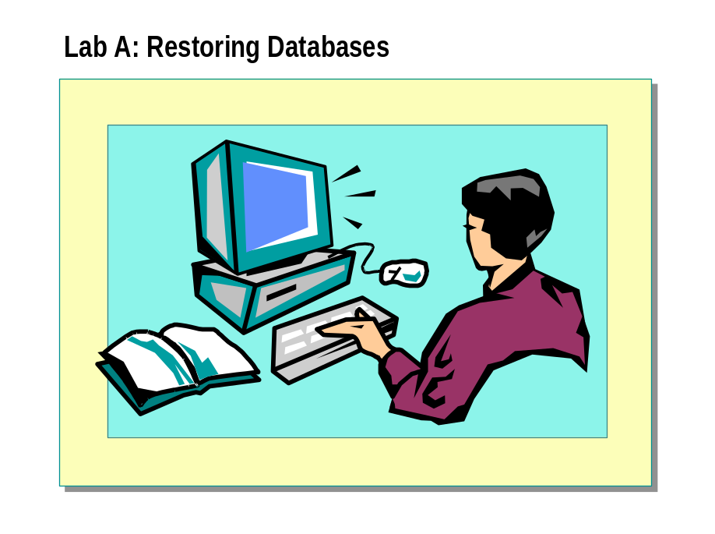

Objectives
After completing this lab, you will be able to:
- Restore a database from a full database backup.
- Retrieve information about backup sets.
- Restore differential and transaction log backups.

Prerequisites
Before working on this lab, you must have script files for this lab, which are located in C:\Moc\2072A\Labfiles\L07.

For More Information
If you require help in executing files, search SQL Query Analyzer Help for “Execute a query”.
Other resources that you can use include:
- The Northwind database schema.
- SQL Server Books Online.

Estimated time to complete this lab: 45 minutes

Exercise 1
Restoring from a Full Database Backup

In this exercise, you will review and execute multiple scripts that modify, back up, and intentionally corrupt the NWCOPY database. You will use SQL Server Enterprise Manager to restore the NWCOPY database from a full database backup and confirm that data was recovered.
- To create the NWCOPY database
    - Log on to the NWTraders classroom domain by using the information in the following table.
Option | Value
User name | SQLAdminx (where x corresponds to your computer name as designated in the nwtraders.msft classroom domain
Password | password

    - Copy the Labfiles\L07\NWC1.bak file to C:\Backup on your local hard disk.
    - Open SQL Query Analyzer and, if requested, log in to the (local) server with Windows Authentication.
You have permission to log in to and administer SQL Server because you are logged as SQLAdminx, which is a member of the Windows 2000 local group, Administrators. All members of this group are automatically mapped to the SQL Server sysadmin role.
    - Execute Labfiles\L07\SetupNWC.sql.
This script restores the NWCOPY database that is used in this lab.

- To modify the NWCOPY database
In this procedure, you will execute a script that adds a row to the Products table. You then will write and execute a query that returns the new row.
    - Open a query window, open Labfiles\L07\AddProd.sql, review its contents, and then execute it.
This script adds the new product Maple Flavor Pancake Mix to the Products table.
    - Review the results to confirm that the new row was added.

- To back up the NWCOPY database
In this procedure, you will execute a script that backs up the NWCOPY database to a single backup file.
- Open Labfiles\L07\MakeBack.sql, review its contents, and then execute it.
This script backs up the NWCOPY database to a single backup file. This backup file has a logical name of NWC2 and a physical name of C:\Backup\NWC2.bak.

- To simulate accidental data modification

In this procedure, you will execute a script that damages the database by updating all rows in the Products table. You then will write and execute a query to confirm that the product name Maple Flavor Pancake Mix was removed from the Products table.
    - Open a query window, open Labfiles\L07\DataLoss.sql, review its contents, and then execute it.
This script damages the database by updating all rows in the Products table.
    - Review the result to confirm that the product name Maple Flavor Pancake Mix was removed from the Products table.
    - Close the query window.

You must close the query window and break the connection to the NWCOPY database in order to perform the next procedure. The restore operation requires that no users be connected to the database.
Important

- To restore the NWCOPY database from a full database backup
In this procedure, you will use SQL Server Enterprise Manager to restrict access to the NWCOPY database, restore from a full database backup, and then allow access to the database after the restore process is complete.
    - Open SQL Server Enterprise Manager.
    - In the console tree, expand Microsoft SQL Servers, and then expand SQL Server Group.
    - Expand your server, expand Databases, right-click NWCOPY, and then
click Properties.
    - On the Option tab, select Restrict Access, select the Members of db_owner, dbcreator, or sysadmin option to restrict access to the database during the restore process, and then click OK to continue.
    - In the console tree, right click NWCOPY, point to All Tasks, and then click Restore Database.
    - On the General tab, in the Restore as Database field, type the name of the database to restore.
    - On the General tab, select Database.
    - In the First backup to restore list, select <Date Time> - NWCOPY-Full.
    - In the Restore list, select the database backup to restore.
    - On the Options tab, select Leave database operational. No additional transaction logs can be restored.
    - Click OK to close the dialog box and restore the NWCOPY database.

- To confirm that data was recovered

In this procedure, you will write and execute a query that returns a list of all products in the Products table, including the new product Maple Flavor Pancake Mix.
- Open a query window. Write and execute the following query to confirm that all products, including Maple Flavor Pancake Mix, are included in
the list:
USE NWCOPY
SELECT *
FROM Products

Exercise 2
Simulating and Capturing Database Activity

In this exercise, you will review and execute multiple files that add data to the NWCOPY database and perform full database, differential, and transaction log backups. You will simulate damaging the device that contains the NWCOPY database and review the error message in the Microsoft Windows NT® application log.
- To perform a full database backup of the NWCOPY database
In this procedure, you will execute a script that backs up the NWCOPY database to the NWC3 disk backup device.
- Open a query window, open Labfiles\L07\FullBack.sql, review its contents, and then execute it. This script backs up the NWCOPY database to the NWC3 disk backup device.

- To modify the NWCOPY database and back up the transaction log
In this procedure, you will execute a script that adds a customer to the Customers table and confirms that the customer was added. Then, you will execute another script that backs up the transaction log to the NWCHANGE disk backup device.
    - Open a query window, open Labfiles\L07\AddCust1.sql, review its contents, and then execute it.
This script adds the Health Food Store as a customer to the Customers table and queries the table to return the new customer.
    - Open a query window, open Labfiles\L07\LogBack1.sql, review its contents, and then execute it.
This script backs up the transaction log of the NWCOPY database to the NWCHANGE disk backup device.

- To modify the NWCOPY database and perform a differential backup
In this procedure, you will execute a script that adds another customer to the Customers table and returns that customer to confirm that the customer was added. Then, you will execute another script that performs a differential backup and appends it to the NWCHANGE disk backup device.
    - Open a query window, open Labfiles\L07\AddCust2.sql, review its contents, and then execute it.
This script adds the Volcano Coffee Company to the Customers table and queries the table to return the new customer.
    - Open a query window, open Labfiles\L07\DiffBack.sql, review its contents, and then execute it.
This script performs a differential backup to capture all changes since the last full database backup. The differential backup is appended to the NWCHANGE disk backup device.

- To modify the NWCOPY database and perform another transaction log backup

In this procedure, you will execute a script that adds another customer to the NWCOPY database and confirms that the customer was added. Then, you will execute another script that performs a second transaction log backup and appends it to the NWCHANGE disk backup device.
    - Open a query window, open Labfiles\L07\AddCust3.sql, review its contents, and then execute it.
This script adds The Wine Cellar as a customer to the Customers table and queries the table to return the new customer.
    - Open a query window, open Labfiles\L07\LogBack2.sql, review its contents, and then execute it.
This script backs up the transaction log of the NWCOPY database and appends it to the NWCHANGE disk backup device.

- To simulate damage to the database
In this procedure, you will simulate damaging the device that stores the
NWCOPY database.
    - Open SQL Server Service Manager and stop the SQL Server service.
    - Switch to SQL Server Enterprise Manager and exit.
    - Rename the data file for the NWCOPY database from Mssql\Data\Nwcopy_data.mdf to Nwcopy_data.bad
    - Restart the SQL Server service.
    - Open SQL Server Enterprise Manager.
    - In the console tree, expand your server, and click Databases.
SQL Server indicates that the NWCOPY database is suspect.
    - Open the Event Viewer and examine the contents of the application log.
Error messages should be present, stating that the NWCopy_Data.mdf file could not be found and that the device could not be opened.
What should you do to restore and recover the NWCOPY database?

Exercise 3
Restoring Full Database, Differential, and Transaction Log Backups

In this exercise, you will use SQL Server Enterprise Manager to examine all backup devices that contain backups of the NWCOPY database and will determine whether the selected backup strategy is appropriate. You will go through a series of restore operations and review the contents of the database after each restore process.
- To examine available backups
In this procedure, you will use SQL Server Enterprise Manager to examine the contents and creation date of all NWCOPY database backups.
    - Switch to SQL Server Enterprise Manager.
    - Expand your server, expand Management, and then click Backup.
    - In the details pane, right-click NWC3, and then click Properties.
    - Click View Contents to examine the contents of the NWC3 device. Notice the type, description, and date and time of each backup on the device.
What does the NWC3 device contain?

    - Examine the contents of the NWCHANGE device. Notice the type, description, and date and time of each backup on the device.
What does the NWCHANGE device contain?

- To review the selected restore strategy
In this procedure, you will review the restore strategy that SQL Server Enterprise Manager suggests automatically and determine whether it is appropriate.
    - In the console tree, right-click NWCOPY, point to All Tasks, and then click Restore Databases.
    - The Restore Databases dialog box appears. Verify that the NWCOPY database is selected.
Notice that four backups are listed. SQL Server automatically selects the backups that should be restored to return the database to a consistent state. Three out of four backups are selected (full database, differential, and one transaction log).
Do you agree that the selected backups should be restored?

Why is the first transaction log backup not selected?

    - Click Cancel to close the Restore Database dialog box.

- To restore full database and differential backups
In this procedure, you will use SQL Server Enterprise Manager to restore only the full database and differential backups, and then allow read-only access to the database after the restore process is complete.
    - In the console tree, expand Microsoft SQL Servers, and then expand SQL Server Group.
    - Expand your server, expand Databases, right-click the database, point to All Tasks, and then click Restore Database.
    - Under Restore as Database, type NWCOPY
    - On the General tab, select Database.
    - In the Show backups of database list, select NWCOPY.
    - In the First backup to restore list, select the full database backup.
    - In the Restore list, select the full database backup and differential database backup files.
    - On the Options tab, select Leave database read-only and able to restore additional transaction logs.
    - Click OK to begin the restore process.
    - Click OK when the restore completes.
- To examine the contents of a database
In this procedure, you will execute a script that lists all of the customers in the Customers table in order to evaluate the restore process.
    - Open a query window, open Labfiles\L07\ListCust.sql, review its contents, and then execute it.
This script determines whether the three new customers that were added to the Customers table in Exercise 2 were recovered.
Have all three new customers been recovered?

    - Close the query window.

- To restore the transaction log backup
In this procedure, you will use SQL Server Enterprise Manager to restore the transaction log, and then allow access to the database after the restore process is complete.
    - Switch to SQL Server Enterprise Manager.
    - Expand Databases, right click the database, point to All Tasks, and then click Restore Database.
    - Under Restore as Database, type NWCOPY
    - On the General tab, select Database.
    - In the Show backups of database list, select NWCOPY.
    - In the First backup to restore list, select the full database backup.
    - In the Restore list, select the latest transaction log (backup set #3 on the NWCHANGE device).
    - On the Options tab, select Leave database operational. No additional transaction logs can be restored.
    - Click OK to begin the restore process.
    - Click OK when the restore completes.
    - In the details pane, right click NWCOPY, and then click Properties.
    - On the Option tab, clear Restrict Access, and then click OK to continue.
- To examine the contents of a database
In this procedure, you will execute a script that lists all of the customers in the Customers table in order to evaluate the restore process.
- Open a query window, open Labfiles\L07\ListCust.sql, review its contents, and then execute it. This script determines whether the three new customers that were added to the Customers table in Exercise 2 were recovered.

Have all three new customers been recovered?

Module 8: Monitoring SQL Server for Performance

Lab A: Monitoring SQL Server
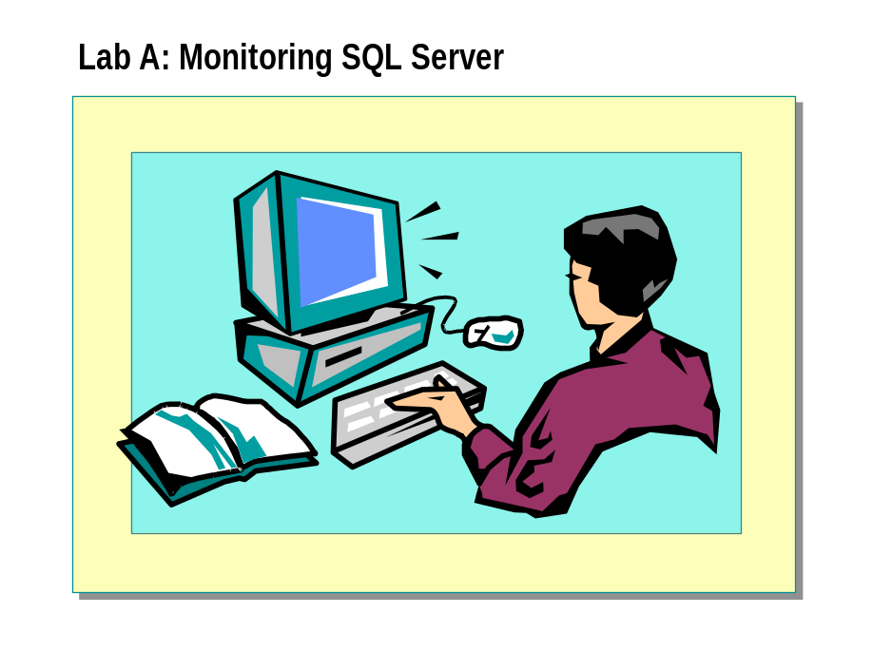

Objectives
After completing this lab, you will be able to:
- Monitor server performance by using Microsoft® Windows® 2000 System Monitor.
- Monitor Microsoft SQL Server™ 2000 activity by using SQL Profiler.
- View an execution plan by using SQL Query Analyzer.
- Monitor locks by using system stored procedures and SQL Server Enterprise Manager.

Prerequisites
Before working on this lab, you must have script files for this lab. These script files are located in C:\Moc\2072A\Labfiles\L08.

For More Information
If you require help in executing files, search SQL Query Analyzer Help for “Execute a query”.
Other resources that you can use include:
- The Northwind database schema.
- Microsoft® SQL Server™ Books Online.

Estimated time to complete this lab: 60 minutes

Exercise 1
Using Windows System Monitor

In this exercise, you will use Windows System Monitor to observe the impact of user activity on SQL Server and Windows resources. You also will open and modify a performance monitor configuration file (.pmc file) to specify the information to monitor. Finally, you will simulate user activity by running several batch files, and you will note the response of various counters.
- To create the NorthwindCopy database
In this procedure, you will restore a backup of the NorthwindCopy database to add it to your server.
    - Log on to the NWTraders classroom domain by using the information in the following table.
Option | Value
User name | SQLAdminx (where x corresponds to your computer name as designated in the nwtraders.msft classroom domain)
Password | password

    - Open SQL Query Analyzer and, if requested, log in to the (local) server with Windows Authentication.
You have permission to log in to and administer SQL Server because you are logged as SQLAdminx, which is a member of the Windows 2000 local group, Administrators. All members of this group are automatically mapped to the SQL Server sysadmin role.
    - Open C:\MOC\2072A\Labfile\L08\RestoreNorthwindCopy.sql, review its contents, and then execute it.
This script restores the NorthwindCopy database that is used in this lab.

- To configure Windows System Monitor
In this procedure, you will add performance counters to monitor SQL Server activity.
    - Click Start, point to Programs, point to Administrative Tools, and then click Performance.
    - On the toolbar, click Add (+).
    - In the Add Counters dialog box, add counters by using the information in the following table. Click Add after each counter is configured. Click Close when you have added all of the counters.
Object | Counter | Instance
SQL Server: Access Methods | Full Scans/sec | Not applicable
SQL Server: Access Methods | Index Searches/sec | Not applicable
SQL Server: Buffer Manager | Buffer Cache Hit Ratio | Not applicable
SQL Server: Databases | Active Transactions | NorthwindCopy
SQL Server: Databases | Percent Log Used | NorthwindCopy
SQL Server: Databases | Transactions/sec | NorthwindCopy
SQL Server: Memory Manager | Lock Blocks | Not applicable
SQL Server: SQL Statistics | Batch Requests/sec | Not applicable

    - Observe System Monitor to familiarize yourself with the baseline before a load is placed on SQL Server.

- To simulate server activity
In this procedure, you will execute a batch file to simulate server activity.
This batch file creates several command-prompt sessions that interact with
SQL Server.
    - On the taskbar, click Start, and then click Run.
    - In the Open dialog box, type C:\Moc\2072A\Labfiles\L08\Monitor.bat and then click OK.
This generates server activity by executing several queries on tables in the NorthwindCopy database.
    - Switch to Windows System Monitor.
Watch the Chart window while the monitoring batch files execute. What trends do you notice?

- To monitor memory and processor use
In this procedure, you will add counters to a new chart in order to monitor memory and processor use.
    - On the toolbar, click New Counter Set.
    - On the toolbar, click Add (+).
    - In the Add Counters dialog box, add counters by using the information in the following table. Click Add after each counter is configured. Click Close when you have added all of the counters.
Object | Counter | Instance
Memory | Page faults/sec | Not applicable
Memory | Pages/sec | Not applicable
Process | % Processor time | sqlservr
Process | Page faults/sec | sqlservr
SQL Server: Cache Manager | Cache Hit Ratio | Adhoc Sql Plans
SQL Server: Memory Manager | Connection Memory (KB) | Not applicable
SQL Server: Memory Manager | Total Server Memory (KB) | Not applicable

    - Watch the Chart window while the Monitoring batch files continue
to execute.
What trends do you notice?

    - Close all command-prompt windows.
The Windows System Monitor counters will reflect the lack of activity on the server.
    - Close Windows System Monitor.

Exercise 2
Using SQL Profiler

In this exercise, you will use SQL Profiler to record and examine SQL Server activity. You will define traces to capture SQL Server events and queries to a file, as well as to organize and filter this information.
- To configure SQL Profiler
You suspect that users are submitting queries that take a long time to execute, and that unauthorized users are trying to gain access to your SQL Server. In this procedure, you will create a trace to detect long running queries and events, record query activity, and organize the output by duration.
    - On the taskbar, click Start, point to Programs, point to Microsoft SQL Server, and then click Profiler.
    - On the toolbar, click New Trace, and then connect to your server by using Windows Authentication.
    - Create a new trace by using the information in following table.
Option | Value
Trace name | Security Audit
Template name | SQLProfilerStandard
Save to file | Security Audit
Events | Add Audit Login Failed (in Security Audit) to the default events for this trace
Data columns | Move NTUserName to the Groups section
Filters | NTUserName not like SQLService

    - Click Run to start the trace.

- To detect login attempts
In this procedure, you will monitor an unauthorized login attempt. To do this, you will attempt to log in by using several invalid accounts, and then you will review SQL Profiler.
    - Start SQL Query Analyzer.
    - Try to connect to SQL Server with SQL Server Authentication, the Gloria login account, and no password.
    - Try to connect to SQL Server with SQL Server Authentication, and the sa login account.
    - Switch to SQL Profiler.
What information is recorded?

    - Switch to SQL Query Analyzer and connect to SQL Server by using Windows Authentication.

    - Switch to SQL Profiler, and examine the trace details.
What information is recorded?

    - Stop and close the active trace.

- To configure a new trace
In this procedure, you will configure a new trace and set up a filter to exclude the activity generated by SQL Server Agent and some system stored procedures.
    - On the toolbar, click New Trace, and then connect to your server by using Windows Authentication.
    - Modify the new trace by using the information in the following table. Remove any other data columns or events from the trace properties. Order them as listed in the following table.
Option | Value
Trace name | Long Running Queries
Template name | SQLProfilerTSQL_Duration
Save to file | Long Running Queries
Events | RPC:Completed  SQL:Batch Completed
Data columns (in the following order) | Groups: Duration, TextData  Columns: NTUserName, CPU, Event Class, SPID
Filters | NTUserName not like SQLService

    - Click Run to start the trace.
- To detect long running queries
In this procedure, you will use the current trace to detect the longest-running queries in a batch of Transact-SQL statements.
    - Switch to SQL Query Analyzer.
    - Open C:\MOC\2072A\Labfiles\L08\OrdersWorkload.sql, review its contents, and then execute it.
This simulates server activity by executing several queries on tables in
the NorthwindCopy database.
    - After the query completes, switch to SQL Profiler.
    - Stop the trace.
    - Notice that the longest running SELECT statement is as follows:
SELECT e.LastName, p.ProductName, SUM(d.Quantity * d.UnitPrice)
FROM Employees e JOIN Orders o ON e.EmployeeID = o.EmployeeID
JOIN [Order Details] d ON o.OrderID = d.OrderID
JOIN Products p ON d.ProductID = p.ProductID
GROUP BY e.LastName, p.ProductName

    - Copy the long running query from the lower pane of SQL Profiler.
You will use this query in the next exercise.
    - Close SQL Profiler.

Exercise 3
Using SQL Query Analyzer

In this exercise, you will use SQL Query Analyzer to generate a graphical execution plan to analyze a long running query.
- To generate performance statistics and a graphical execution plan
In this procedure, you will use SQL Query Analyzer to generate performance statistics and an execution plan for a long running query.
    - Switch to SQL Query Analyzer.
    - Paste the long running query from exercise 2 into a new query window.
    - On the DB list, click NorthwindCopy.
    - On the Query menu, click Current Connection Properties.
    - Select the Set Statistics Time and Set Statistics IO check boxes, and then click OK.
    - Execute the query.
    - In the results pane, click the Messages tab.
In particular, notice the CPU times, the elapsed times, the scan counts, and the logical reads.
    - On the Query menu, click Display Estimated Execution Plan.
How many table scans and indexes were used to process this query? What can be done to improve performance?

- To generate performance statistics and a graphical execution plan when appropriate indexes are used
In this procedure, you will use SQL Query Analyzer to generate performance statistics and an execution plan for the long running query by using appropriate indexes.
    - Open a new query window (do not open a new connection).
    - In the DB list, click Northwind.
The Northwind database has the appropriate indexes that have been removed from the NorthwindCopy database.
    - Paste the long running query in the new query window.
    - Execute the query.
    - In the results pane, click the Messages tab.
In particular, notice the CPU times, the elapsed times, the scan counts, and the logical reads.
    - Compare these numbers with the information that you received when the long running query was run against the NorthwindCopy database.

    - On the Query menu, click Display Estimated Execution Plan.
How many table scans and indexes were used to process this query? What can be done to improve performance?

    - Close all open query windows.

Exercise 4
Monitoring Locking Information

In this exercise, you will execute multiple transactions simultaneously and monitor the locking behavior of SQL Server by using Transact SQL statements and the Current Activity window in SQL Server Enterprise Manager. You will open three connections by using SQL Query Analyzer to generate multiple client activity.
The scripts for this exercise do not always include a COMMIT TRAN or ROLLBACK TRAN statement. The absence of these statements keeps the transactions open and the associated locks active so that you can view locking information.
- To view locking information
In this procedure, you will use the BEGIN TRANSACTION and ROLLBACK TRANSACTION statements to control how an UPDATE statement is processed on the Member table.
    - Using SQL Query Analyzer, open a new connection (connection 1), and then, in the DB list, click NorthwindCopy.
    - Execute the following system stored procedure by using connection 1 and review the output:
EXEC sp_lock

    - Review the output in the results pane and record the SQL Server Process ID (SPID) number of the process holding a table lock.
SPID number:
What types of locks is this SPID holding?

What is the resource lock mode of each lock?

    - Execute the following system stored procedures by using connection 1 and replace SPID_Number with the SPID number that you recorded in the previous step:
EXEC sp_who SPID_Number

What is the login name of the user associated with this process and this lock?

    - In the SQL Server Enterprise Manager console tree, expand your server, expand the Management folder, expand Current Activity, expand Locks/Process ID, and then click the SPID number that you recorded above.
    - In the details pane, review the process and lock information.

- To hold locks on the server
In this procedure, you will execute Transact-SQL statements that obtain and hold locks on server resources. You will use system stored procedures, as well as SQL Server Enterprise Manager, to examine locking information.
    - Switch to SQL Query Analyzer and open a new connection (connection 2) by using Windows Authentication. Do not close the first connection.
    - Using connection 2, open C:\MOC\2072A\Labfiles\L08\Lock.sql, review its contents, and then execute it.
Notice that a transaction is started with the BEGIN TRAN statement, but a corresponding COMMIT TRAN or ROLLBACK TRAN statement to complete the transaction does not exist.
    - Execute Lock.sql by using connection 2 and review the results. Record the SPID number. It will be the next SPID number in sequence from the SPID number that you recorded above.
SPID number:
What types of locks is this SPID holding on the NorthwindCopy database?

What is the resource lock mode of each lock?

    - Switch to SQL Server Enterprise Manager, right-click Current Activity, and then click Refresh. Expand Locks/Process ID to review the locks held by the process ID of connection 2.

- To detect lock blocking

In this procedure, you will create and observe a blocking situation in which one query must wait while another query uses a resource.
    - Switch to SQL Query Analyzer and open a new connection (connection 3) by using Windows Authentication. Do not close connection 1 or connection 2.
    - Using connection 3, open C:\MOC\2072A\Labfiles\L08\Lock.sql, review its contents, and then execute it.
Does the query complete?

    - Switch to connection 1 and execute the sp_lock system stored procedure.
Is the SPID for connection 3 waiting for any resources?

    - Switch to SQL Server Enterprise Manager, right-click Current Activity, and then click Refresh.
    - Expand Locks/Process ID.
Review the locking information for the process ID of connection 3.
Why can’t connection 3 complete the query?

    - In the console tree, click the blocking connection.
    - In the details pane, double-click the row lock, and then click Kill Process.
    - Click Yes, and then click Close.
    - Switch to SQL Query Analyzer connection 1 and execute the sp_lock system stored procedure.
You will see that the locks that were acquired by the transaction in connection 2 have now been released.
    - Switch to connection 3. Notice the query has now executed.
    - Complete the transaction by executing a ROLLBACK TRAN statement.
    - Switch to the Current Activity window in SQL Server Enterprise Manager and refresh the locking information. Confirm that connection 3 holds only shared locks.
    - Close all SQL Query Analyzer connections.

Module 9: Transferring Data

Lab A: Transferring Data
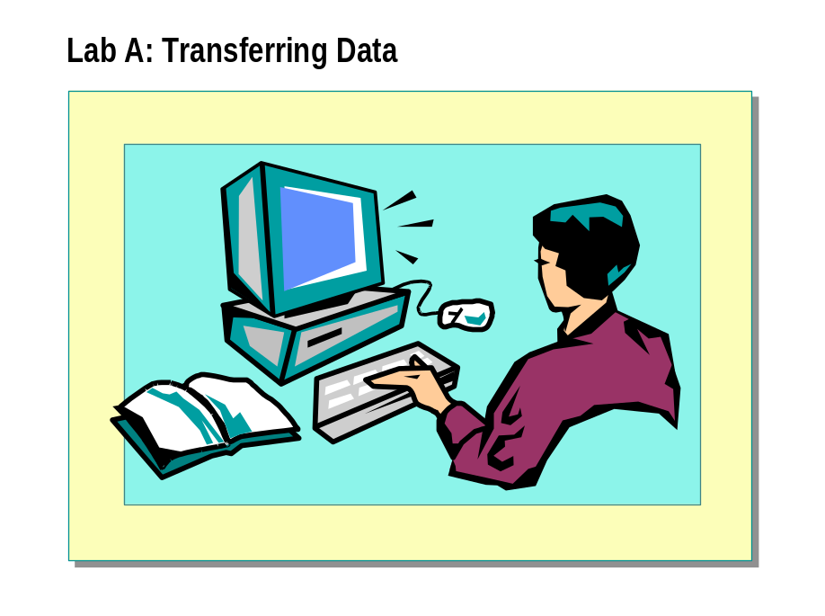

Objectives
After completing this lab, you will be able to:
- Import the result set from a query into a new table by using the Data Transformation Services (DTS) Import/Export Wizard.
- Modify a DTS package by using DTS Designer.
- Import SQL Server objects into a new database by using the DTS Import/Export Wizard.

Prerequisites
Before working on this lab, you must have script files for this lab, which are located in C:\Moc\2072A\Labfiles\L09.

For More Information
If you require help in executing files, search SQL Query Analyzer Help for “Execute a query”.
Other resources that you can use include:
- The Northwind database schema.
- Microsoft® SQL Server™ Books Online.

Estimated time to complete this lab: 45 minutes

Exercise 1
Importing Data from a Query

In this exercise, you will import the result set from a query into a new table in the Northwind database by using the DTS Import/Export Wizard.
- To import data from a Transact-SQL query
In this procedure, you will import data into a new table by using the DTS Import/Export wizard.
    - Log on to the NWTraders classroom domain by using the information in the following table.
Option | Value
User name | SQLAdminx (where x corresponds to your computer name as designated in the nwtraders.msft classroom domain)
Password | password

    - Start SQL Server Enterprise Manager.
    - In the console tree, expand Microsoft SQL Servers, and then expand SQL Server Group.
    - Click your server.
    - From the Tools menu, click Wizards. In the Select Wizard dialog box, expand Data Transformation Services, and then double-click DTS Import Wizard.
This starts the DTS Import/Export Wizard.
    - Complete the wizard by using the information in the following table to import data into a new table. Accept the defaults for any options that are not listed.
Option | Value
Data source and destination | Microsoft OLE DB Provider for SQL Server
Server name  (source and destination) | (local)
Security context  (Both source and destination) | Windows Authentication
Database  (Both source and destination) | Northwind
Table copy or query | Use a query to specify the data to transfer
(continued)

Option | Value
SQL query statement | Use the query from C:\Moc\2072A\Labfiles\L09\SumOrderDetails.SQL or type:  SELECT ProductName,  SUM(o.UnitPrice * Quantity)  AS Total  FROM [Order Details] AS o  INNER JOIN Products AS p  ON o.ProductID = p.ProductID  GROUP BY ProductName
Parse | Yes
Destination table name  (Change Results to a new table name) | Product_Totals
Transform | Drop and recreate destination table  Do not allow NULLs in the Total column (clear)
Run DTS package immediately | Yes
Save DTS package  on SQL Server | Yes
DTS package name | Northwind_Product_Totals
DTS package description | Year to date product totals
Server name | (local)
DTS package security context | Windows Authentication

Why do you receive an error on the Drop table Results step when you execute the DTS package?

Did this DTS package execute successfully?

    - Open SQL Query Analyzer and, if requested, log in to the (local) server with Microsoft Windows® Authentication.
You have permission to log in to and administer SQL Server because you are logged as SQLAdminx, which is a member of the Windows 2000 local group, Administrators. All members of this group are automatically mapped to the SQL Server sysadmin role.
    - To view the imported results in the Product_Totals table, execute the following Transact-SQL statement by using SQL Query Analyzer. The table and product summary data should exist.
SELECT * FROM Northwind..Product_Totals

Exercise 2
Modifying a DTS Package Using DTS Designer

In this exercise you will modify a DTS package by using DTS Designer.
- To restore the Customer database
In this procedure, you will restore the Customer database from a backup. The Customer database contains 50 new customers that must be added to the existing Customers table in the Northwind database.
    - Using SQL Query Analyzer, execute the following statement to restore the Customer database. Change the path if your lab files are in a different location.
RESTORE DATABASE customer FROM DISK='C:\Moc\2072A\Labfiles\L09\cust_bkup.dat'

    - Verify that there are 50 customers in the Customer database new_customers table. Type the following statement.
SELECT * FROM customer..new_customers

- To open an existing DTS package
In this procedure, you will open new_data DTS package and run it. The new_data DTS package is stored externally, outside of SQL Server. The package imports new products from a text file into the newprods table in the Northwind database. You must first create the newprods table.
    - Open a new query window, and execute the C:\Moc\2072A\Labfiles\ L09\newprods.sql script to create the newprods table.
    - Switch to SQL Server Enterprise Manager and, in the console tree, expand your server.
    - Right-click Data Transformation Services, and then click Open Package.
You now are in DTS Designer.
    - Open the C:\Moc\2072A\Labfiles\L09\New_data.dts DTS package, selecting the most recent version.
If lab script files are stored on a different drive, edit the text file data source connection to reflect the correct location of the newprods.txt text file. To do this, right-click New Products connection, and click Properties in the new_data package.
    - Execute the package. You should see that 1343 rows were imported into the newprods table successfully.

- To add tasks to an existing DTS package

In this procedure, you will modify the new_data DTS package by adding tasks.
    - Make sure that the new_data package is still open in DTS Designer.
    - Using DTS Designer, drag and drop one Execute SQL Task icon from the Tasks section of the tool palette onto your DTS Designer workspace.
    - Complete the information in the Execute SQL Properties dialog box with the information in the following table.
Option | Value
Description | Drop the Northwind..newprods table task
Existing connection | SQL Server Destination (Northwind)
SQL statement | DROP TABLE Northwind.dbo.newprods
Parse query | OK

    - Click OK to close the Execute SQL Properties dialog box.
    - Drag and drop a second Execute SQL Task icon from the Tasks section of the tool palette onto your DTS Designer workspace.
    - Complete the information in the Execute SQL Properties dialog box with the information in the following table.
Option | Value
Description | Create the Northwind..newprods table task
Existing connection | SQL Server Destination (Northwind)
SQL statement | Paste in the CREATE TABLE statement found in C:\Moc\2072A\Labfiles\L09\newprod2.sql
Parse query | OK

    - Click OK to close the Execute SQL Properties dialog box.

- To add precedence constraints to an existing DTS package
In this procedure, you will modify the New_data DTS package by adding precedence constraints on the tasks created in the previous procedure.
    - On the DTS Designer workspace, highlight the task that drops the table. Press and hold down the CTRL key, and then select the task that creates the newprods table.
This selects both icons.
    - From the Workflow menu, select On Completion.
    - Double-click the blue arrow to review the workflow properties.
    - Close the dialog box.
    - On the DTS Designer workspace, highlight the task that creates the newprods table. Press and hold down the CTRL key, and then select
New Products text file.
This selects both icons.
    - From the Workflow menu, select On Success.
    - Double-click the green arrow to review the workflow properties.

    - Close the dialog box.
    - Save the DTS package, and then execute it.
The package first will drop the newprods table and then create the newprods table. It finally will import data from the newprods.txt file into the newprods table in the Northwind database.
    - Close the DTS Designer.

Exercise 3
Transferring SQL Server Objects

In this exercise, you will import SQL Server objects from the Northwind database into a new database by using the DTS Import/Export Wizard.
- To import objects from the Northwind database
In this procedure, you will import Northwind database objects into a new database by using the DTS Import/Export Wizard.
    - Using SQL Query Analyzer, execute the following statement to create a new database named nwind2.
CREATE DATABASE nwind2

    - Switch to SQL Server Enterprise Manager.
    - In the console tree, click your server.
    - From the Tools menu, click Wizards, expand Data Transformation Services, and then double-click DTS Import Wizard.
This starts the DTS Import/Export Wizard.
    - Complete the wizard by using the information in the following table to import data into a new table. Accept the defaults for any options that are not listed, and click OK when prompted.
Option | Value
Data source and destination | Microsoft OLE DB Provider for SQL Server
Server name  (source and destination) | (local)
Security context  (source and destination) | Windows Authentication
Database (source) | Northwind
Database (destination) | nwind2
Table copy or query | Copy objects and data between SQL Server databases
Objects to transfer | Clear Include all dependent objects  Clear Copy all objects
Select objects | Orders table  Order Details table  Order Subtotals view  Summary of Sales by Quarter view  Summary of Sales by Year view
Use default options | Clear
Options (Security options) | Clear Copy database users and database roles  Clear Copy object-level permissions
(continued)

Option | Value
Options (Table options) | Clear Copy triggers  Clear Copy full text indexes  Clear Copy PRIMARY and FOREIGN keys
Script file directory | C:\Moc\2072A\Labfiles\L09\DB_xfer
Run DTS package immediately | Yes

    - Switch to SQL Query Analyzer.
    - Execute the following Transact-SQL statement to view the transferred results in the nwind2 database. The specified table and view objects should exist. You may want to execute your query into a grid for better viewing of the results.
SELECT * FROM information_schema.tables
WHERE table_type in ('BASE TABLE','VIEW')
AND table_schema = 'dbo'

    - Review the contents of the C:\Moc\2072A\Labfiles\L09\DB_xfer script file directory. Open and review the .tab file type by using Notepad or SQL Query Analyzer.
What file type are the view definitions stored in?

If Time Permits
Exporting Data to a Text File

In this exercise, you will export data from the Customers table in the Northwind database to a text file.
- To export data by using the DTS Export Wizard
In this procedure, you will export data by using the DTS Export Wizard and will then save the DTS package. The DTS package will copy a list of South American customers into a delimited text file.
    - Switch to SQL Server Enterprise Manager.
    - In the console tree, click your server.
    - From the Tools menu, click Wizards, expand Data Transformation Services, and then double-click DTS Export Wizard.
This starts the DTS Import/Export Wizard.
    - Complete the wizard by using the information in the following table to export data into a delimited text file. Accept the defaults for any options that are not listed.
Option | Value
Data source | Microsoft OLE DB Provider for SQL Server
Server name  (source and destination) | (local)
Security context  (source and destination) | Windows Authentication
Database (source) | Northwind
Data destination | Text file
Destination file name | C:\Moc\2072A\Labfiles\L09\SoAmer.txt  (type file name)
Table copy or query | Use a query to specify the data to transfer
Query Builder | Yes
Source table | Customers
Selected columns | All columns except Phone and Fax
Sorting order | Country column, CompanyName column
Query criteria | Only rows meeting the following criteria  Customers.Country = 'Argentina'  OR  Customers.Country = 'Brazil'  OR  Customers.Country = 'Venezuela'
SQL query statement | Parse
Destination file format | Delimited
Column delimiter | Tab
(continued)

Option | Value
Run DTS package immediately | Yes
Schedule DTS package for later execution | Yes
Recurring job schedule | Weekly, on Monday, Wednesday, and Friday  at 9:00 A.M.
Save DTS package on SQL Server | Yes
DTS package name | SouthAmerican_Customers
DTS package description | South American Customer list
Server name | (local)
DTS package security context | Windows Authentication

    - Open Notepad to review the text file. The file should contain all of the rows where Customer.country equals Argentina, Venezuela, or Brazil. You should see all columns except phone or fax.
    - Close Notepad.

- To verify that the schedule was created
In this procedure, you will review the job schedule that was created to execute your DTS package. Make sure that SQL Server Agent is started.
    - Switch to SQL Server Enterprise Manager.
    - To view the schedule that was created to execute your DTS package, in the console tree, expand Management, expand SQL Server Agent, and then click Jobs.
    - In the details pane, right-click the job name, SouthAmerican_Customers, and then click Properties. View the properties, and then click OK.

You cannot view the step command for this job because it is encrypted.
Note

Importing Data Using the Bulk Insert Task

In this exercise, you will import data into SQL Server by using the Bulk Insert task in DTS Designer.
- To create a bulk insert task
In this procedure, you will create a new local package that will import data from a text file into the Products table in the Northwind database.
    - Using SQL Server Enterprise Manager, in the console tree, right-click Data Transformation Services, and then click New Package.
    - On the Data menu, select Microsoft OLE DB Provider for SQL Server as the data source.
    - Use the information in the following table to define additional data source connection properties. Accept the defaults for any options that are not listed.
Option | Value
New Connection | Bulk Insert Connection
Database | Northwind

    - Using DTS Designer, drag and drop one instance of Bulk Insert Task from the Tasks section of the tool palette onto your DTS Designer workspace.
    - Complete the information in the Bulk Insert Properties dialog box by using the information in the following table.
Option | Value
Description | NewProducts
Existing connection | Bulk Insert Connection
Destination table | [Northwind].[dbo].[newprods]
Source data file | C:\Moc\2072A\Labfiles\L09\Newprods.txt
Column Delimiter | Comma

    - Click Execute to begin importing the data into the newprods table.
When the package execution completes successfully, save the package as BulkInsertNewProducts.

Module 10: Maintaining High Availability

Lab A: Automating the Maintenance of a Standby Server
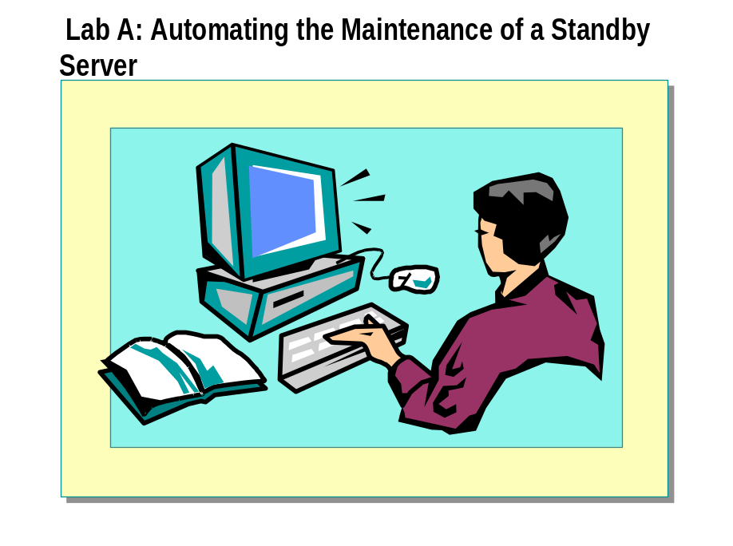

Objectives
After completing this lab, you will be able to:
- Set up a standby server to increase data availability.
- Use log shipping to automate the copying of transaction logs from the primary server and loading them onto the standby server.
- Replace the primary server with the standby server.

Before You Begin
In this lab, you will work with a partner to configure a standby server and log shipping between two computers running Microsoft® SQL Server™ 2000 Enterprise Edition.
One computer will be designated as the primary server, and the other will be designated as the standby server. Write the names of the primary server and standby server in the space provided below.
Your partner’s server name: _________________________________________
Primary server name:
Standby server name:

Prerequisites
Before working on this lab, you must have script files for this lab, which are located in C:\Moc\2072A\Labfiles\L10.

For More Information
If you require help in executing files, search SQL Query Analyzer Help for “Execute a query”.
Other resources that you can use include:

- The Northwind database schema.
- SQL Server Books Online.

Estimated time to complete this lab: 45 minutes

Exercise 1
Preparing the Primary Server and the Standby Server

In this exercise, you will register your partner’s SQL Server and place it in the default server group. You will then use the DTS Import/Export Wizard to create a copy of the Northwind database, which will simulate creating a standby server for a new database. Finally, you will create shares to store the backups of the database and the logs.
This exercise uses two computers. It is recommended that you work with a partner to complete this exercise. You must complete each procedure on the specified computer in sequence.
- To add your partner to the local administrators group (on both servers)
In this procedure, you will add your partner’s SQLAdminx login to your Microsoft Windows® 2000 local group, Administrators. Do this procedure only if you have not previously added your partner to the local administrators group.
    - Log in to the NWTraders classroom domain by using the information in the following table.
Option | Value
User name | SQLAdminx (where x corresponds to your computer name as designated in the nwtraders.msft classroom domain)
Password | Password

    - On the desktop, right-click My Computer, and then click Manage.
    - Expand Local User and Groups, and then expand Groups.
    - In the details pane, double-click Administrators, and then click Add.
    - Add your partner’s login NWTraders\SQLAdminx (where x corresponds to your partner’s computer name as designated in the nwtraders.msft classroom domain) to your local group Administrators.
    - Close Computer Management.

- To register your partner’s SQL Server (on both servers)
In this procedure, you will use the Register SQL Server Wizard to register your partner’s SQL Server and place it in the default server group. Do this procedure only if you have not previously registered your partner’s server in SQL Server Enterprise Manager.
    - Open SQL Server Enterprise Manager.
You have permission to log in to and administer SQL Server because you are logged as SQLAdminx, which is a member of the Windows 2000 local group, Administrators. All members of this group are automatically mapped to the SQL Server sysadmin role.
    - In the console tree, expand Microsoft SQL Servers, and then expand SQL Server Group.
    - Right-click SQL Server Group, and then click New SQL Server Registration.

    - Register your partner’s SQL Server by using Windows Authentication.
    - Add your partner’s server to SQL Server Group.
    - In the console tree, expand your partner’s SQL Server to verify that you can connect to it.

- To create a copy of the Northwind database (on the primary server)
In this procedure, you will use the DTS Import/Export Wizard to create a copy of the Northwind database on the primary server.
    - Open SQL Server Enterprise Manager.
    - In the console tree, expand Microsoft SQL Servers, expand SQL Server Group, expand your server, and then expand Databases.
    - Right-click Northwind, point to All Tasks, and then click Export Data.
    - Use the information in the following table to make a local copy of the Northwind database. Accept the defaults for any options that are not listed.
Options | Value
Source | Microsoft OLE DB Driver for  SQL Server
Destination database | <new>
Name | NorthwindLogShip
Source tables and views | Select All

- To configure NorthwindLogShip to allow transaction log backups (on the primary server)
In this procedure, you will verify that the full recovery model is selected to allow transaction log backups.
    - In the console tree, right-click Databases, and then click Refresh.
    - In the console tree, right-click NorthwindLogShip, and then click Properties.
    - Click the Options tab.
    - Change the recovery mode to Full.

- To add the SQLService domain user account to the Administrators local group (on both servers)
In this procedure, you will add the SQLService domain user account to the Administrators local group on the primary server.
    - On the desktop, right-click My Computer, and then click Manage.
    - Expand System Tools, expand Local Users and Groups, and then click Groups.
    - In the details pane, double-click Administrators, and then click Add.

    - Use the information in the following table to add the SQLService domain user to the local group, Administrators.
Option | Value
Look in: | NWTraders
Name | SQLService

    - Close Computer Management.

- To verify that the SQL Server Agent service is started (on both servers)
In this procedure, you will use SQL Server Enterprise Manager to verify that the SQL Server Agent service is started.
    - Open SQL Server Enterprise Manager.
    - In the console tree, expand Microsoft SQL Servers, expand SQL Server Group, expand your server, and then expand Management.
    - Verify that the SQL Server Agent service has started.

- To create a folder for backup (on the primary server)
In this procedure, you will create a folder to contain backups of the NorthwindLogShip database.
    - Use the information in the following table to create a new folder.
Folder name | Purpose
C:\ProductionLogs | Contains transaction log backups from the primary database

    - Use the information in the following table to share the new folder.
Folder | Share name | Permissions
C:\ProductionLogs | ProductionLogs | NWTraders\SQLService—Full Control  Administrators—Read

- To create folders for restore (on the standby server)
In this procedure, you will create a folder to contain the backups of the NorthwindLogShip database logs that SQL Server Agent will restore to the standby server database. You will also create a folder to contain backups of the NorthwindLogShip database after a role change.
    - Use the information in the following table to create new folders.
Folder name | Purpose
C:\ShippedLogs | Contains transaction logs from the primary database to be loaded onto the standby database
C:\ProductionLogs | Contains transaction logs from the new primary database (used after a role change)

    - Use the information in the following table to share the new folder.

Folder | Share name | Permissions
C:\ProductionLogs | ProductionLogs | NWTraders\SQLService—Full Control  Administrators—Read

Exercise 2
Creating the Standby Database and Configuring Log Shipping

In this exercise, you will set up a standby server that mirrors the activity of the NorthwindLogShip database. You will use the Database Maintenance Plan Wizard to create a backup of the database, copy it to the standby server and automate the log backup process.
- To configure the standby server and log shipping (on the primary server)
In this procedure, you will run the Database Plan Maintenance Wizard to configure the standby server and log shipping.
    - Open SQL Server Enterprise Manager.
    - In the console tree, expand Microsoft SQL Servers, expand SQL Server Group, and click your server.
    - Click the Tools menu, and then click Database Maintenance Planner.
    - Use the information in the following table to configure the standby server and log shipping. Accept the defaults for any options that are not listed.
Option | Value
Database | NorthwindLogShip
Ship the transaction logs to other  SQL Servers (Log Shipping) | Select
Back up the database as part of the maintenance plan | Clear (this will be done once at the start of the plan)
Transaction log backup disk directory | C:\ProductionLogs
Remove files older than | 2 hours
Network share name for C:\ProductionLogs | \\NameOfPrimaryServer\ProductionLogs
Log ship destination  Server  Transaction log destination  directory  Database load mode  Allow to assume primary role  Transaction log backup directory | Add  Name of standby server  C:\ShippedLogs  Standby mode  Selected  \\NameOfStandbyServer\ProductionLogs
Perform full back up now | Selected
Log shipping schedule  Backup schedule  Copy/load frequency  Load delay  Retention | Every 2 minutes  2 minutes  0 minutes  1 hour
Monitor server | Name of standby server
(continued)

Option | Value
Maintenance history  Remote server – write history to  the server | Selected  Name of standby server
Plan name | LogShipPlan

- To generate activity (on the primary server)
In this procedure, you will execute a script that adds records to the NorthwindLogShip database on the primary server.
    - Open SQL Query Analyzer and, if requested, log in to the (local) server with Windows Authentication.
You have permission to log in to and administer SQL Server because you are logged as SQLAdminx, which is a member of the Windows 2000 local group, Administrators. All members of this group are automatically mapped to the SQL Server sysadmin role.
    - Open C:\MOC\2072A\Labfiles\L10\AddOrder.sql, review its contents, and then execute it.

- To confirm data inserted (on the primary server)
In this procedure, you will confirm that data has been inserted into the Orders table in the NorthwindLogShip database.
    - Using SQL Query Analyzer, type and execute the following query to confirm that rows were inserted into the Orders table.
USE NorthwindLogShip
SELECT * FROM Orders
WHERE OrderDate > (GetDate()-1)

    - Examine the results to confirm that the new rows were added to the NorthwindLogShip.dbo.Orders table.
    - Close SQL Query Analyzer.

- To monitor the log shipping process (on the standby server)
In this procedure, you will view the Log Shipping Pair Properties to monitor the log shipping process.
    - Open SQL Server Enterprise Manager.
    - In the console tree, expand Microsoft SQL Servers, expand SQL Server Group, expand your server, and then expand Management.
    - Click Log Shipping Monitor, and then, in the details pane, double-click PrimaryServer.NorthwindLogShip-StandbyServer.NorthwindLogShip (where PrimaryServer is the name of your primary server and StandbyServer is the name of your standby server).
    - Review the information found on all of the tabs of the Log Shipping Pair Properties.

- To view the backup files (on the standby server)

In this procedure, you will use Windows Explorer to verify the existence of backup files and shipped logs on the standby server.
    - Open Windows Explorer.
    - Navigate to the contents of C:\ShippedLogs.
    - Verify that the original database backup, NorthwindLogShip_init.bak, exists and that at least one transaction log backup (named NorthwindLogShip_tlog_<date&time>.trn) exists.
You may need to refresh the window to view the files.

Exercise 3
Changing the Role of the Standby Server

In this exercise, you will use system stored procedures to disable log shipping from the primary server, promote the standby server to be a primary server, and refresh the monitor server with the new role information. Finally, you will verify that log shipping succeeded and that the new records are present in the original standby database.
- To change the role of the primary server (on the primary server)
In this procedure, you will execute a system stored procedure to change the role of the primary server.
    - Open SQL Query Analyzer and, if requested, log in to the (local) server with Windows Authentication.
You have permission to log in to and administer SQL Server because you are logged as SQLAdminx, which is a member of the Windows 2000 local group, Administrators. All members of this group are automatically mapped to the SQL Server sysadmin role.
    - Type and execute the following statement to change the role of the primary server. Substitute the job ID obtained in the previous exercise for the jobID in the statement.
USE msdb
EXEC sp_change_primary_role 'NorthwindLogShip', @final_state=3

- To change the role of the standby server (on the standby server)
In this procedure, you will execute a system stored procedure to change the role of the standby server.
    - Open SQL Query Analyzer and, if requested, log in to the (local) server with Windows Authentication.
    - You have permission to log in to and administer SQL Server because you are logged as SQLAdminx, which is a member of the Windows 2000 local group, Administrators. All members of this group are automatically mapped to the SQL Server sysadmin role. Type and execute the following statement to change the role of the standby server.
USE msdb
EXEC sp_change_secondary_role 'NorthwindLogShip'

- To update the monitor server (on the original standby server)

In this procedure, you will execute a system stored procedure to update the information stored on the monitor server with the new roles.
- Using SQL Query Analyzer, type and execute the following statements to update the information stored on the monitor server. Substitute the primary_server and secondary_server with the names of the servers assuming the original roles.
USE msdb
EXEC sp_change_monitor_role 'primary_server', 'secondary_server', 'NorthwindLogShip', 'C:\ProductionLogs'

- To verify that log shipping succeeded (on the original standby server)
In this procedure, you will confirm that the data added to the NorthwindLogShip database was copied to the standby database.
    - Using SQL Query Analyzer, type and execute the following query to confirm that rows were copied to the standby database:
USE NorthwindLogShip
SELECT * FROM Orders
WHERE OrderDate > (GetDate() – 1)

Examine the results to confirm that new rows were added to the NorthwindLogShip.dbo.Orders table.

Module 11: Introducing Replication

Lab A: Implementing Replication
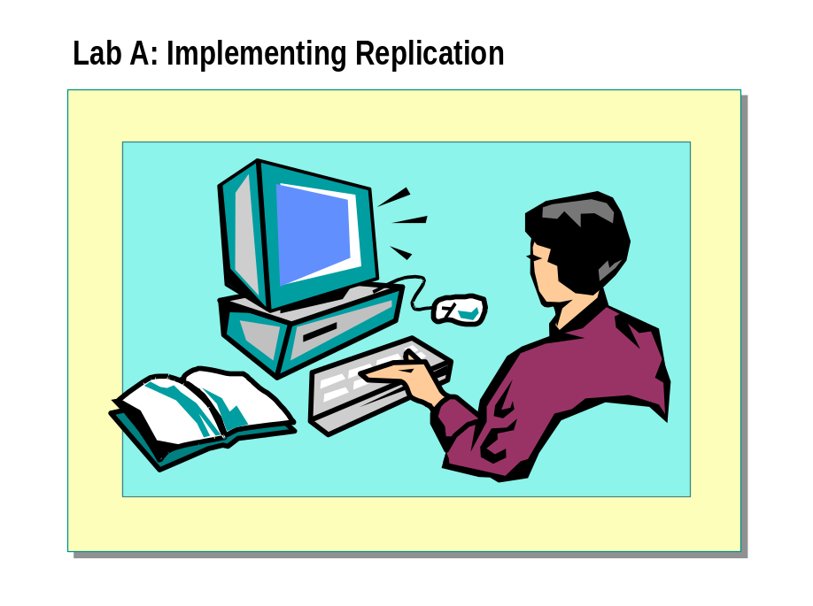

Objectives
After completing this lab, you will be able to:
- Configure transactional replication.
- Configure merge replication.
- Resolve replication conflicts by using merge replication.

Before You Begin
In this lab, you will work with a partner to configure replication between two computers running Microsoft SQL Server 2000. It is possible to configure replication entirely from a single computer, but the tasks in this lab are divided between two computers to provide both students with tasks to perform.
In exercise 2, one computer running SQL Server will be designated as the Distributor and Publisher server, and one will be designated as the Subscriber server. Write the names of the Distributor and Publisher server and Subscriber server in the space provided below.
Your partner’s server name: _________________________________________
Distributor and Publisher server name:
Subscriber server name:

For More Information
If you require help in executing files, search SQL Query Analyzer Help for “Execute a query”.
Other resources that you can use include:

- The Northwind database schema.
- Microsoft SQL Server Books Online.

Estimated time to complete this lab: 90 minutes

Exercise 1
Logging In to and Registering a Server

In this exercise, you log in to SQL Server and register your partner’s server by using SQL Server Enterprise Manager on your computer.
- To register a your partner’s server
Do this procedure only if you have not previously registered your partner’s server in SQL Server Enterprise Manager.

This procedure must be performed on each participating computer in the classroom.
Note

    - Log on to the NWTraders classroom domain by using the information in the following table.
Option | Value
User name | SQLAdminx (where x corresponds to your computer name as designated in the nwtraders.msft classroom domain)
Password | password

    - Start SQL Server Enterprise Manager.
    - Expand Microsoft SQL Servers, expand SQL Server Group, expand your server, expand Security, right-click Logins, click New Login, and add a login for your partner to your SQL Server and make it a member of the sysadmin role.
    - Right-click your server, click New SQL Server Registration, register your partner’s server, and specify Microsoft Windows Authentication.

Exercise 2
Configuring Transactional Replication

In this exercise, you will use the Distributor and Publisher server to create
a publication that uses the Products table in the Northwind database. The Products table will be replicated to a table called ReplProducts on the Subscriber. The Subscriber will subscribe to the publication. You will update the Products table on the Publisher and verify its successful replication to
the Subscriber.
- To create a publication (on the Distributor and Publisher server)
In this procedure, the Publisher will create a new publication of the Products table in the Northwind database.
    - On the Distributor and Publisher server, in the console tree of SQL Server Enterprise Manager, expand SQL Server Group, and then click
your server.
    - In the details pane, click the Wizards tab, and then click Create Publication.
If the Wizards tab is not visible, click Taskpad on the View menu.
    - In the Create and Manage Publications dialog box, click Northwind, and then click Create Publication.
    - Use the Create Publication Wizard and the information in the following table to create your publication. Use the default values for any option and value not specified.
Option | Value
Distributor | Your server
Snapshot folder | (default)
Publication database | Northwind
Publication type | Transactional publication
Subscriber types | Servers running SQL Server 2000
Articles for publication | dbo.products
Publication name  Publication description | NorthwindProductsTablePublication  Transactional publication of Products table in Northwind database

    - Close the Create and Manage Publications dialog box.
    - In the console tree, expand Replication Monitor.
    - Click Yes to automatically refresh Replication Monitor by polling the Distributor, and then click OK.
    - Expand Publishers, expand your server, and then click NorthwindProductsTablePublication:Northwind.
    - In the details pane, review the NorthwindProductsTablePublication Agents and note their properties and histories.
When is the Log Reader Agent scheduled to run?

What time is the Snapshot Agent scheduled to run?

- To create a subscription (on the Subscriber server)
In this procedure, the Subscriber will create a subscription to pull the publication that was published by the Publisher in the previous procedure.
    - On the Subscriber server, in the SQL Server Enterprise Manager console tree, expand SQL Server Group, and then click the subscriber server.
    - In the details pane, click the Wizards tab, and then click Create a Pull Subscription.
If the Wizards tab is not visible, click Taskpad on the View menu.
    - Use the Pull Subscription Wizard and the information in the following table to pull NorthwindProductsTablePublication from the Publisher.
Option | Value
Look for publications | From registered servers
Publisher | Your partner’s server
Publication | NorthwindProductsTablePublication:  Northwind
Synchronization agent login | Impersonate the SQL Server Agent account
Destination database | Create a new database named ReplicatedNorthwind using default values
Initialize subscription | Yes, initialize the schema and data
Snapshot delivery | Use snapshot files from the default snapshot folder
Distribution Agent schedule | Continuously
Start required services | SQL Server Agent on Subscriber

    - After the subscription has been created, in the console tree of SQL Server Enterprise Manager, expand your server, expand Management, expand SQL Server Agent, and then click Jobs.
Review the Repl-Distribution job that was created and note its schedule.
Whose system resources will this job consume? Would a push subscription change the resources being used?

- To run the Snapshot Agent (on the Distributor and Publisher server)
In this procedure, the Distributor will start the Snapshot Agent to create a snapshot of the data and schema of the publication.
    - On the Distributor and Publisher server, in the console tree of SQL Server Enterprise Manager, expand Replication Monitor, expand Publishers, expand your server, and then click NorthwindProductsTablePublication:Northwind.
    - In the details pane, right-click Snapshot Agent, and then click Start Agent.
    - After the Snapshot Agent has generated a snapshot successfully, review the Snapshot Agent history and session details.
    - In the console tree, expand Replication Monitor, expand Agents, and then click Distribution Agents.
    - In the details pane, right-click the pull subscription agent, and then click Agent History.
View the agent history.
    - Open SQL Query Analyzer and, if requested, log in to the (local) server with Windows Authentication.
You have permission to log on to and administer SQL Server because you are logged as SQLAdminx, which is a member of the Windows 2000 local group, Administrators. All members of this group are automatically mapped to the SQL Server sysadmin role.
    - Connect to the Subscriber by using Windows Authentication. Verify that the article was published to the Products table by executing the following statement:
USE ReplicatedNorthwind
SELECT * FROM Products

    - Close this connection to the Subscriber.

- To update the published article (on the Distributor and Publisher server)
In this procedure, the Publisher will update the Products table and verify that the updated information replicates to the Subscriber.
    - On the Distributor and Publisher server, by using SQL Query Analyzer, type and execute the following:
USE Northwind
SELECT * FROM Products

    - Review the result set. Notice the reorder level on ProductID = 1.
    - Type and execute the following script:

USE Northwind
UPDATE Products
SET ReorderLevel = 20
WHERE ProductID = 1
GO

SELECT * FROM Products

    - Switch to SQL Server Enterprise Manager, open the Log Reader Agent history and review the session details.
    - Open the Distribution Agent history and review the session details.
    - Switch to SQL Query Analyzer and connect to the Subscriber server. Execute the following statement to view the reorder level in the Products table and verify that the data was replicated:
USE ReplicatedNorthwind
SELECT * FROM Products
WHERE ProductID = 1

    - Verify the ReorderLevel has changed to 20.

Exercise 3
Creating a Merge Publication

On the computer designated as the Distributor and Publisher server, you will create a repldata share with custom permissions. You then will create the distribution database and configure the Distributor properties. Finally, you will create a publication of the Northwind database.
You will reverse the roles used in exercise 2. The computer that served as the Distributor and Publisher server in exercise 2 will serve as the Subscriber in exercises 3 and 4. The computer that served as the Subscriber in exercise 2 will server as the Distributor and Publisher server in exercises 3 and 4.
Consider the following scenario for this exercise:
The sales representatives of the Northwind Traders company must have copies of the Customers, Employees, Orders, Order Details, Products, and Shippers tables while traveling out of the office on sales calls. They must be able to add new customers, take orders, and then merge the new information into the Northwind database while they are away.
- To create a Repldata share with custom permissions (on the new Distributor and Publisher server)
In this procedure, you will create a Repldata share with custom permissions.
    - On the new Distributor and Publisher server, open Windows Explorer.
    - Share the C:\Program Files\Microsoft SQL Server\MSSQL\Repldata folder as Repldata.
    - Set the permissions on this share to Everyone: Read and NWTraders\SQLService: Full Control.

- To configure the properties of the Distributor (on the Distributor and Publisher server)
In this procedure, you will configure the properties of the Distributor.
    - On the new Distributor and Publisher server, open SQL Server Enterprise Manager.
    - In the console tree, click the Distributor server.
    - In the details pane, click the Wizards tab, and then click Configure Publishing and Distribution.
    - Configure your computer as a Distributor by using the information in the following table.
Option | Value
Use your computer as the Distributor | Yes
Snapshot folder | \\your_servername\Repldata
Customize publishing and distribution settings | Yes
Distribution database name | Distribution
Folder for distribution database file | (default)
Folder for distribution log file | (default)
(continued)

Option | Value
Enable publishers to use this Distributor | Your distribution server
Enable publication databases | Northwind (Merge)
Enable Subscribers | Your partner’s server

- To create a merge publication on the Publisher (on the Distributor and Publisher server)
In this procedure, you will create a merge publication on the Publisher.
    - On the new Distributor and Publisher server, in the console tree, click the Publisher.
    - In the details pane, click the Wizards tab, and then click Create Publication.
    - Verify that Northwind is selected, and then click Create Publication.
    - Use the information in the following table to create a new publication.
Option | Value
Publication database | Northwind
Publication type | Merge publication
Subscriber types | Servers running SQL Server 2000
Specify articles | Customers  Employees  Order Details  Orders  Products  Shippers
Add uniqueidentifier column | Click Next
Publication name | Northwind
Define data filters, enable anonymous subscriptions, or customize other properties | Yes
Filter data | No
Allow anonymous subscriptions | No, allow only named subscriptions
Set snapshot schedule | Use the default schedule  Create the first snapshot immediately

- To review the Snapshot Agent job history (on the Distributor and Publisher server)

In this procedure, you will open Replication Monitor and review the history
of the creation of the snapshot files.
    - On the new Distributor and Publisher server, close the Create and Manage Publications dialog box.
    - In the console tree, expand Replication Monitor.
    - Click Yes to automatically refresh Replication Monitor by polling the Distributor, and then click OK.
    - Expand Publishers, expand the Publisher server, and then click Northwind:Northwind.
Notice that the Last Action column in the details pane indicates that the creation of the snapshot files is under way. This process will take several minutes. You may need to refresh this publication.

Do not continue. Wait until the Last Action column in the
details pane displays the following message: “A snapshot of 6 articles
was generated”.
Warning

    - When the snapshot is complete, in the details pane, right-click Snapshot, and then click Agent History.
    - Click Session Details.
Review the session details that are associated with the creation of
the snapshot.

Exercise 4
Creating a Pull Subscription and Resolving Conflicts

In this exercise, you will work with your partner to create a pull subscription. You will configure SQL Server permissions on the Distributor and Publisher server. You then will update the Northwind database on the Publisher and verify the replication of the change to the Subscriber. Next, the Subscriber and the Publisher will each update the Customers table with conflicting information and observe the results. Finally, you will view the conflict that was generated and resolved.
- To pull a publication (on the Subscriber server)
In this procedure, the Subscriber will pull the articles that were published by the Publisher in the previous exercise.
    - On the Subscriber server, open SQL Server Enterprise Manager, expand SQL Server Group, and then click the Subscriber.
    - In the details pane, click the Wizards tab, and then click Create a Pull Subscription.
    - Verify that Northwind is selected, and then click Pull New Subscription.
    - Use the information in the following table to create a pull subscription.
Option | Value
Look for publications | From registered servers
Publisher | Your partner’s server
Publication | Northwind: Northwind
Destination database | Create a new database named NorthwindMergeDB using default values
Initialize subscription | Initialize the schema and data at the Subscriber  Start the Merge Agent to initialize the subscription immediately
Snapshot delivery | Use default snapshot folder
Merge agent schedule | Every day, every two minutes
Set subscription priority | 25
Start required services | SQL Server Agent on the Subscriber server

    - After the subscription is created, in the console tree of SQL Server Enterprise Manager, expand your server, expand Databases, expand NorthwindMergeDB, and then click Pull Subscriptions.
    - In the details pane, after the Status column indicates that the Merge Agent has succeeded, review the Job History.
Whose system resources does this Merge Agent consume? Would a push subscription change the resources that are used?

- To update the source table on the Publisher (on the Distributor and Publisher server)

In this procedure, the Publisher will update the Customers table and verify that the updated information replicates to the Subscriber.
    - On the Distributor and Publisher server, switch to SQL Query Analyzer, and then open a new query window.
    - Type and execute the following script:
USE Northwind
SELECT * FROM Customers

    - Review the result set. Notice the first row with the value Maria Anders in the ContactName column.
    - Type and execute the following script:
USE Northwind
UPDATE Customers
SET ContactName = 'Maria Anders-Smith'
WHERE CustomerID = 'ALFKI'
SELECT * FROM Customers

How long will it take for this update to be replicated?

    - On the Subscriber server, switch to SQL Query Analyzer, and then open a new connection to your server
    - Type and execute the following script to verify that the update has been replicated to the NorthwindMergeDB database:
USE NorthwindMergeDB
SELECT * FROM Customers

    - On the Distributor and Publisher server, switch to SQL Server Enterprise Manager.
    - Expand Replication Monitor, expand Agents, and then click Merge Agents.
You may need to click Refresh.
    - In the details pane, right-click Northwind, and then click Agent history.
    - Click the session indicating data changes were merged, and then click Session Details.
Review the actions that were taken during the session.
Can you start the Merge Agent job from the Distributor and Publisher server?

- To update simultaneously from a Publisher and a Subscriber

In this procedure, the Publisher and the Subscriber each will update the Customers table with conflicting information and will review the results.
    - On the Distributor and Publisher server, switch to SQL Server
Query Analyzer.
    - Type and execute the following script:
USE Northwind
UPDATE Customers
SET ContactName = 'Maria Anders-Smyth'
WHERE CustomerID = 'ALFKI'
SELECT * FROM Customers

    - On the Subscriber server, open a query window.
    - Type and execute the following script:
USE NorthwindMergeDB
UPDATE Customers
SET ContactName = 'Maria Anders-Smythe'
WHERE CustomerID = 'ALFKI'
SELECT * FROM Customers

Make sure that you use the correct database context for each of these UPDATE statements.
Caution

    - On the Distributor and Publisher server, switch to SQL Server Enterprise Manager.
    - In the Merge Agent details pane, verify that the update has been replicated and that there was a conflict that was resolved.
This will take up to two minutes.
Which update was applied? Was it the update made on the Distributor and Publisher server, or the Subscriber server?

- To review the resolution of the conflict (on the Distributor and Publisher server)

In this procedure, you will review the resolution of the conflict by using the Microsoft Replication Conflict Viewer.
    - On the Distributor and Publisher server, on the Tools menu, point to Replication, and the click Create and Manage Publications.
    - Expand the Northwind database, and then click the Northwind publication.
    - Click Properties and Subscriptions.
    - Click OK to acknowledge that many properties of the subscription cannot be modified.
    - Click Subscriptions, and then click View Conflicts.
The Microsoft Replication Conflict Viewer appears, indicating a conflict in the Customers table of the Northwind database.
    - Click View.
    - Edit the data of the losing conflict.
    - In the ContactName box, type Maria Anders and then click Resolve With This Data.
    - Click Close.
Using SQL Query Analyzer, verify that the revised data was applied to both servers.

