* **Read Or Create A CSV File Using R language :**

**Code:-**

cat ("The Current File Path : ",getwd()

setwd('D:/22IT603 ADVANCE PROGRAMMING PRACTICE')

cat ("After Change The path : ",getwd())

data1<- read.csv("InfoStudent.csv")

view(data1)

deatils <- subset(data1,Department=="IT")

write.csv(deatils,"ITDept.csv")

new <- read.csv("ITdept.csv")

view(new)

**Output:-**

**Data1:-**

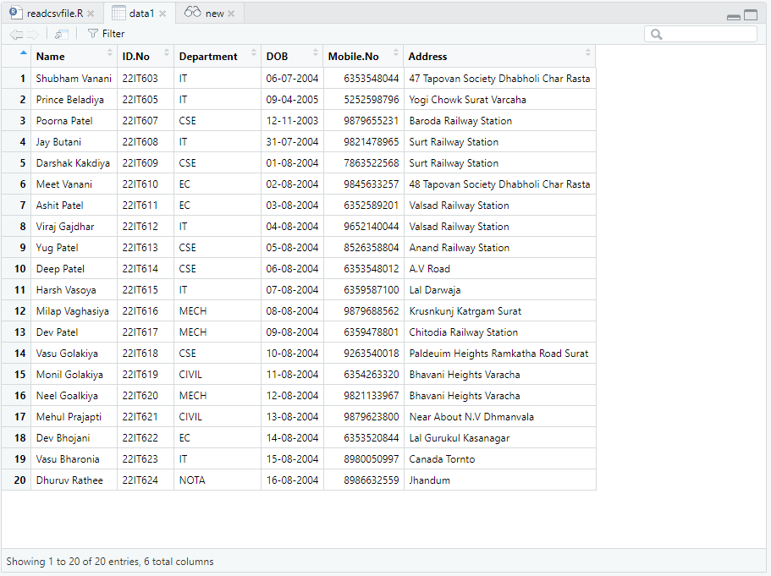

**Details:-**

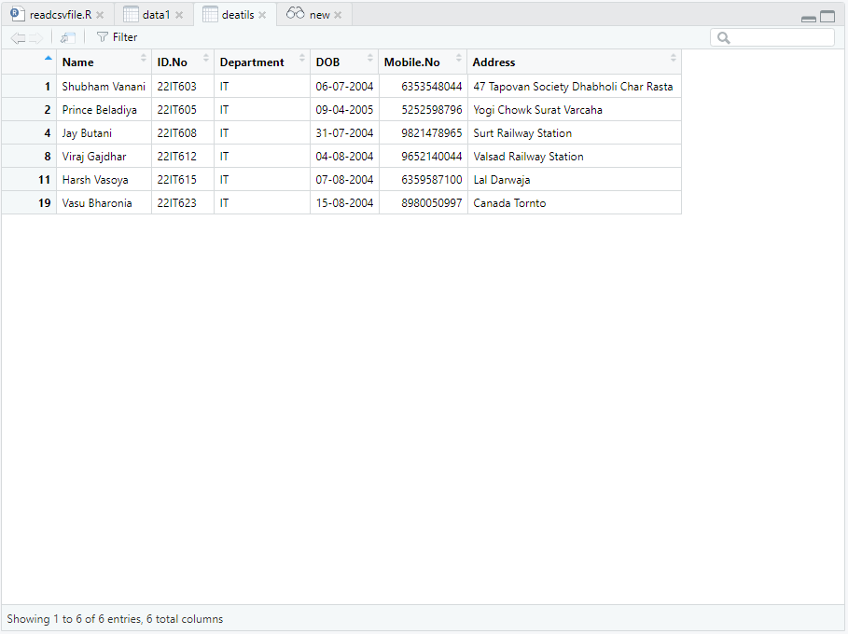

**New:-**

