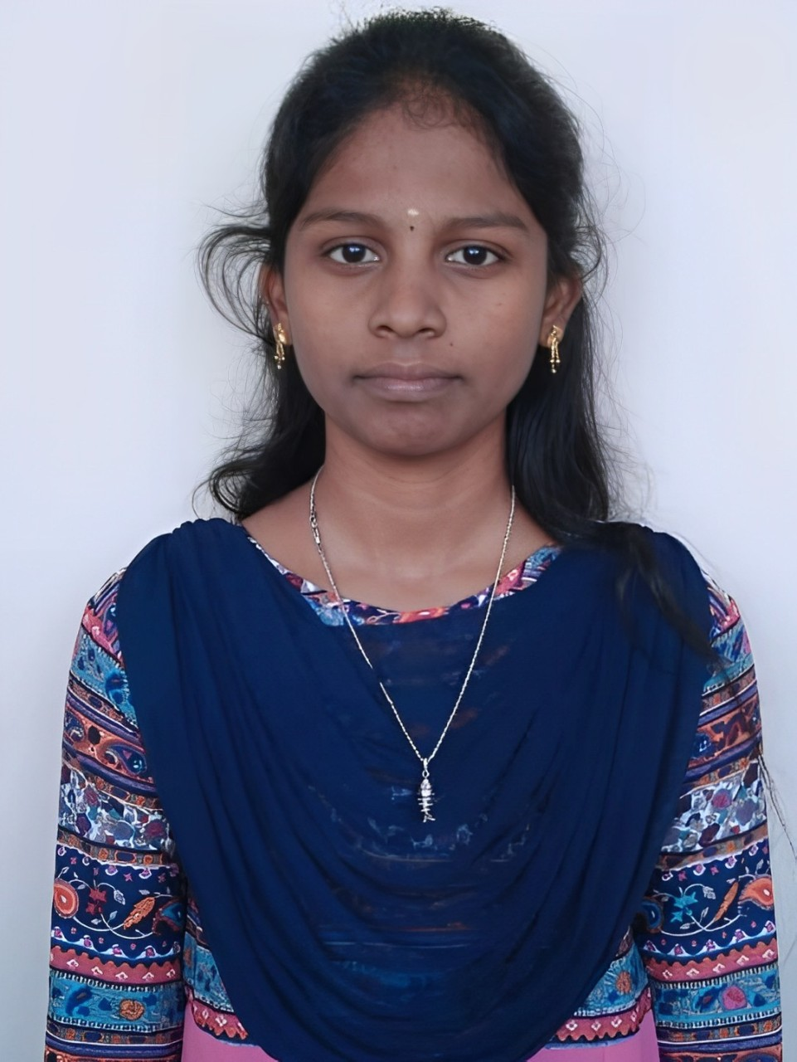

**KAVIYA V**

(+91)7539916614 [kaviyaveerapandi21@gmail.com](mailto:kaviyaveerapandi21@gmail.com)

[Kaviya Veerapandiyan](https://www.linkedin.com/in/kaviya-veerapandiyan-77893b257/)  [V Kaviya](https://github.com/VKaaviya)

# Education

## B.E -Computer Science and Engineering (2022– 2026)

Karpagam Institute of Technology, Coimbatore CGPA 7.8

# Certifications



## Data Structures and Algorithms (Oct 2024)

NPTEL

* Topics: Basic Java Syntax, Data Structures, Java Collection Framework,

and Basic OOP Concepts

* Skills: Proficient in Logical Thinking and Programming in Java

## AWS Cloud Infrastructure (June 2024)

AWS

* Learned core concepts of cloud computing.
* Explored cloud deployment models, scalability, and resource management.

## Web Development (May 2024)

LinkedIn

* Learned the basics of creating responsive websites with HTML, CSS, and JavaScript.
* Gained experience in working with modern frameworks for both frontend and backend development.

## Front End development- HTML (Aug 2023)

Great Learning

* Learned the fundamentals of HTML for structuring web pages.
* Gained experience in designing responsive layouts using HTML5 elements.

# Projects

**Employee Chatbot | (Present)**

* EmpBot is an AI-powered personal assistant for industry employees, streamlining HR support, task
* management, and knowledge access with secure, real-time responses to enhance productivity and
* user experience
* Technological Stack:Llama index,Crew AI,Milvus,React js,Node js

**PresenceAI| (Present)**

* FaceScan is a video-based facial recognition tool designed to automatically extract and verify faces
* for seamless attendance tracking, enhancing accuracy and efficiency in identity management

**Technical Skills**  **Soft Skills**

* Programming | Java, Python,C++,C ,HTML Leadership
* Technology | OCR,NLP Team Work
* Machine Learning | Tensorflow,PyTorch,Spacy Critical Thinking
* Database | Mysql

**Achievement**

* Won 2nd prize in Queen Bee Women’s Hackathon-2024 conducted by Karpagam

Institute of Technology.