Drone Co-ordination Mini Project)

I have created a program that will allow a user to input a drone ID (4 drones would have IDs from 1-4) as well x, y and z co-ordinates and it will output appropriate responses to the drone drifting out of the defined axis or if it will collide with another drone if it moves there.

The program will tell the user whether the drone is going to drift out of the 20x20x20 co-ordinate space. The program has 7 possible outputs relating to the co-ordinates: 0, 1, 2, 3, 4, 5 and 6.

0: The drone is within a suitable margin (3-17) and it will not drift out of the co-ordinate space

1: The x co-ordinate is between 18-20 so it must move left to avoid drifting
2: The x co-ordinate is between 0-2 so it must move right to avoid drifting

3: The y co-ordinate is between 18-20 so it must move backwards to avoid drifting
4: The y co-ordinate is between 0-2 so it must move forwards to avoid drifting

5: The z co-ordinate is between 18-20 so it must move down to avoid drifting
6: The z co-ordinate is between 0-2 so it must move up to avoid drifting

The program also stores the position of the drones if they are within the safety margin. This allows the program to tell the user whether moving a drone to a position will cause there to be a collision due to a different drone already being there and it will not store the drones position until it is chooses an empty position.

0: No collision and the drone can move there
1: There is a collision and the drone must choose an empty position

Drone.p4)

The ethernet header contains the destination address, source address and ether type as 48 bits, 48 bits and 16 bits respectively.

The drone header are all 32 bit and containers the drone id, x, y and z position, x, y and z actions and whether there is a collision.
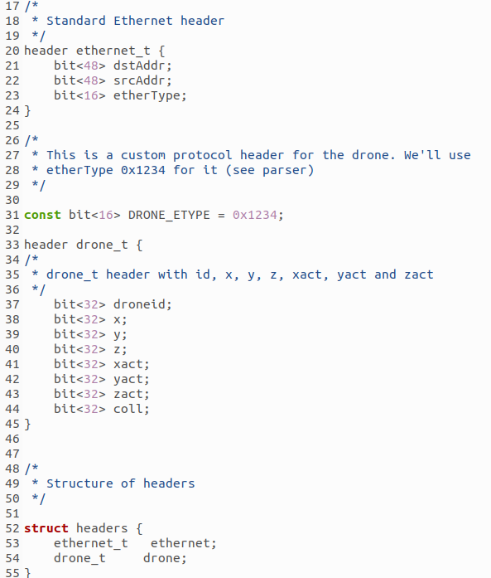

The meta data contains 2 triples of variables that store the x, y and z positions during the registerread() and registerwrite() actions.

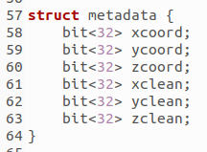

There are 2 triples of registers that store the x, y and z coordinates of the drones and the other register stores the IDs at appropriate x, y and z co-ordinates.

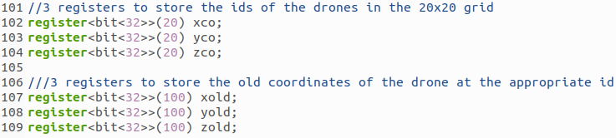

The send_back() action sends the packet back.

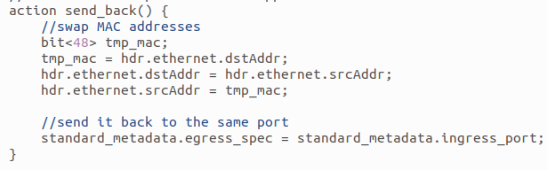

These actions tell the drone which directions to move if any:

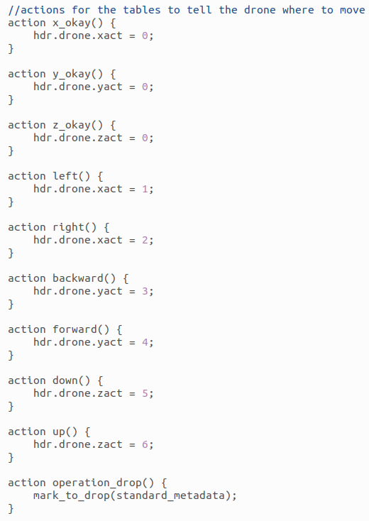

The 3 tables provides the conditions of when the drone is not in the safety margin.

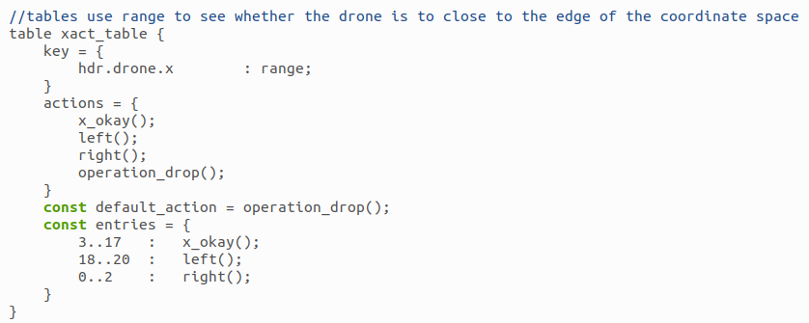

These actions determine

