Exercise 2

Ping:

1)
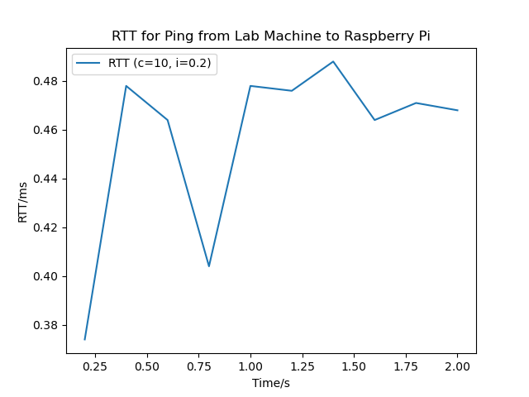
The rtt has a minimum value of 0.405 and a maximum value of 0.486.

2)
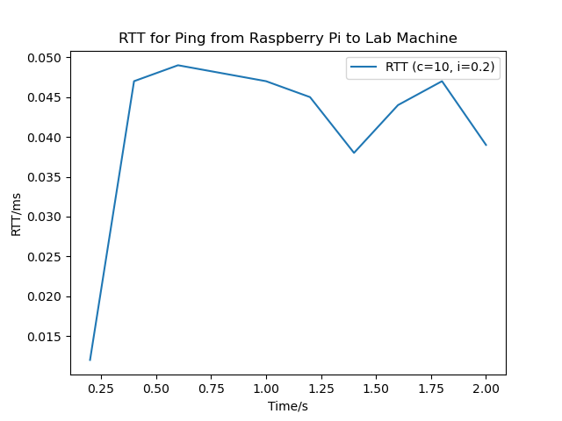
The rtt has a minimum value of 0.037 and a maximum value of 0.48.

3)
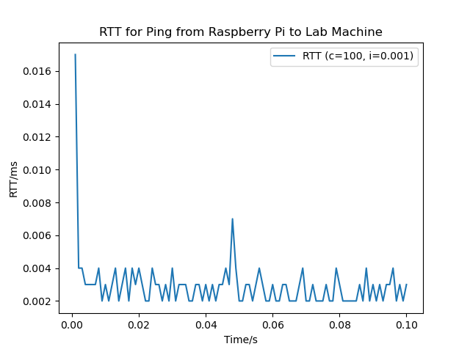

rtt has a minimum of 0.002, a mean of 0.003 and a maximum of 0.022

The peak at the start of the graph is due to the small time interval of 0.001. When the time interval is increased to 0.01, the spike disappears and the same happens for i=0.1.

4)

The rtt for flooding minimum is 0.002ms, the mean is 0.002ms and the maximum value is 0.033ms

5)

rtt min/avg/max/mdev = 0.016/0.044/0.099/0.005 ms
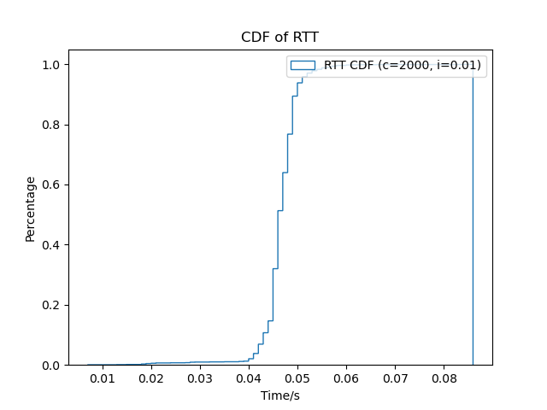

rtt min/avg/max/mdev = 0.002/0.002/0.026/0.001 ms

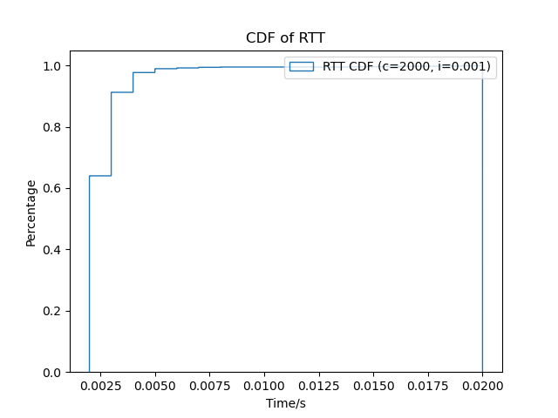

rtt min/avg/max/mdev = 0.002/0.003/0.031/0.001 ms, ipg/ewma 0.010/0.004 ms
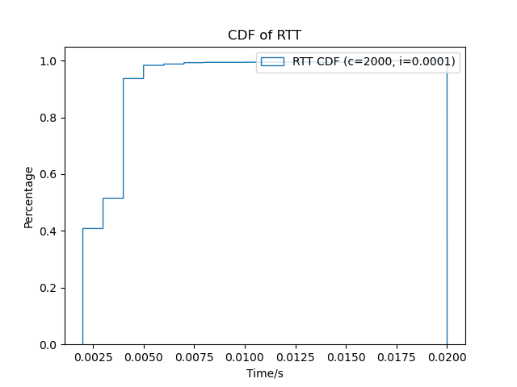

6)
The CDF for 0.001 and 0.0001 are nearly identical since the shape is similar and the time scale is the same. The CDF for 0.01 is a typical CDF shape but the time scale is much larger.
I think the different intervals lead to different round trip times since the ping is trying to communicate at faster speeds so it requires the trip to be shorter. When the interval is too small, it caps out at a certain rtt distribution since the trips reach their maximum speed.

The mean is the most accurate measure to estimate propagation time since it takes into account all the values. The minimum and maximum are prone to outliers so they are not as reliable

iperf:

1)
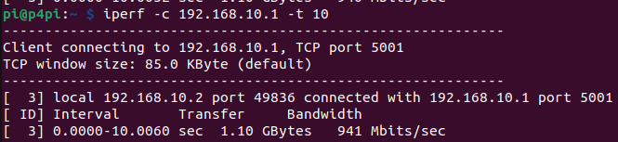
Effective Bandwidth is 941Mbits/s

2)
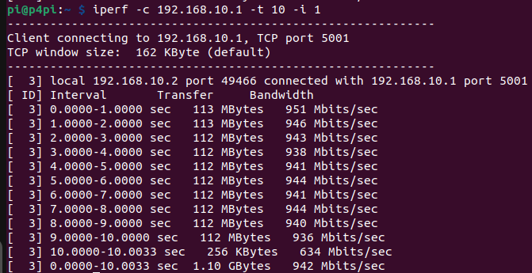

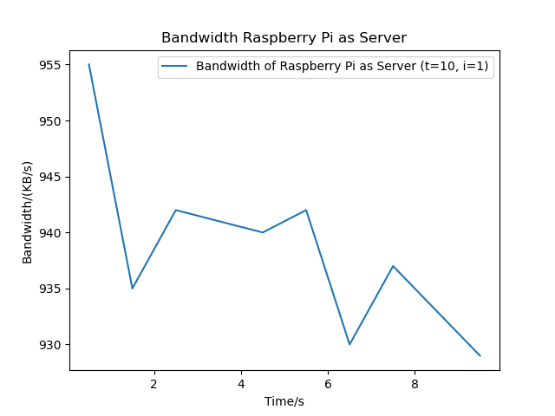

3)
The effective bandwidth of the lab machine to the raspberry pi is 932 Mbits/sec and the effective bandwidth of the raspberry pi to the lab machien is 850 Mbits/sec.

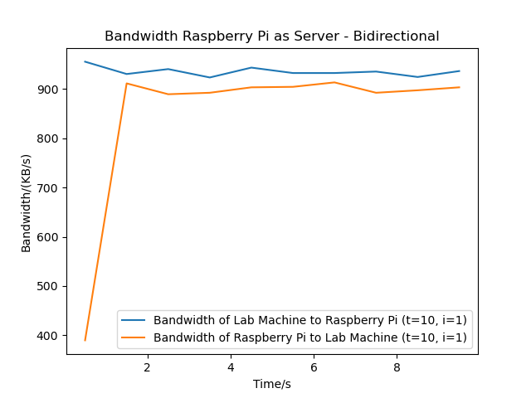

4)
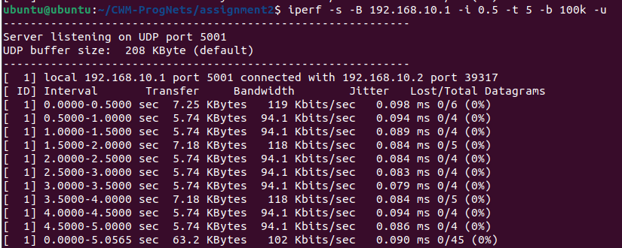
[ 1] 0.0000-5.0565 sec 63.2 KBytes 102 Kbits/sec 0.090 ms 0/45 (0%)

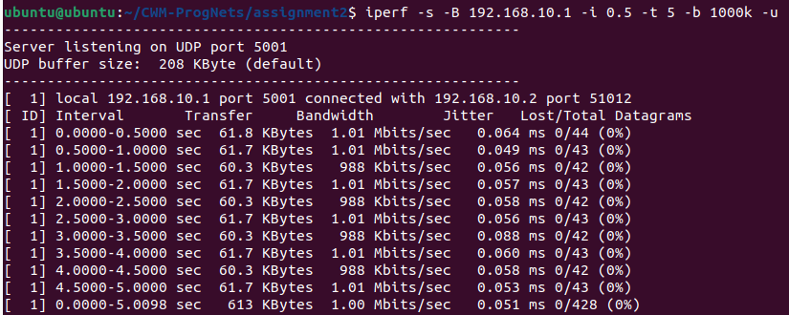
[ 1] 0.0000-5.0098 sec 613 KBytes 1.00 Mbits/sec 0.051 ms 0/428 (0%)

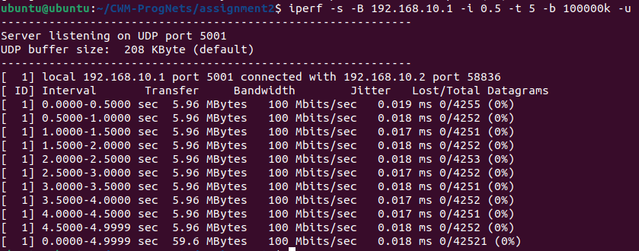
[ 1] 0.0000-4.9999 sec 59.6 MBytes 100 Mbits/sec 0.018 ms 0/42521 (0%)

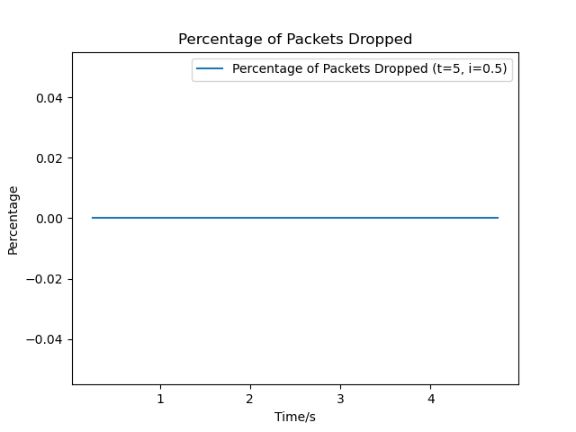

No packets are dropped so the line is flat.

iperf3)

1)

Effective bandwidth of sender is 943 Mbits/sec.
Effective bandwidth of receiver is 937 Mbits/sec.
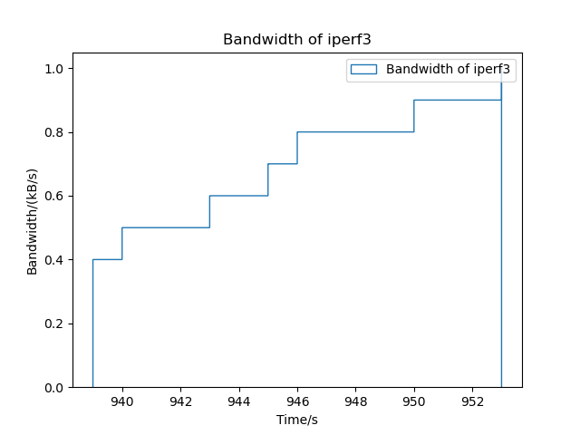

2)
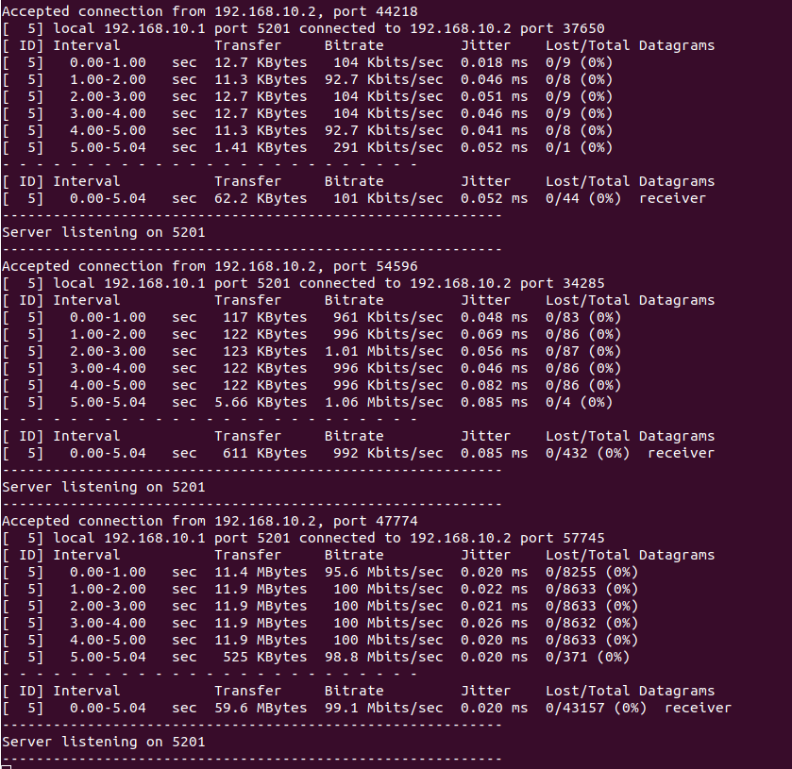

3) In both iperf and iperf3, there are no packets dropped so both graphs are identical. There is no noticeable difference due to there being no packets dropped on either.

Link to directory:
https://github.com/VKing15/CWM-ProgNets.git

