Exercise 4)

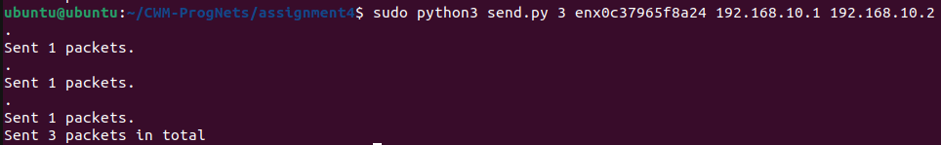
I sent 3 packets but wireshark showed that I had 6 packets. This is because the packets were reflected.

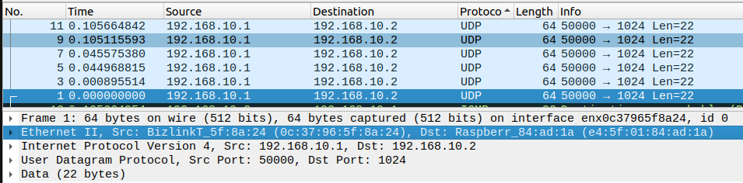
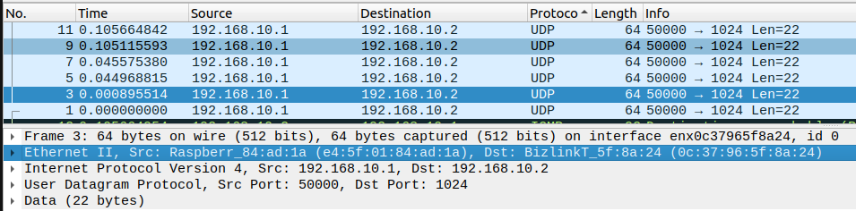
If you look at the MAC addresses of packets that are consecutive to one another, you can see that
the source and destination are swapped. This is as expected due to the swap_mac_addresses action being the default action.

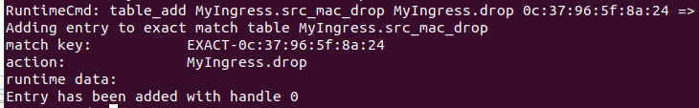
Now when I send 3 packets, wireshark only picks up 3 as well since the drop command is used so there are no longer and packets reflected.

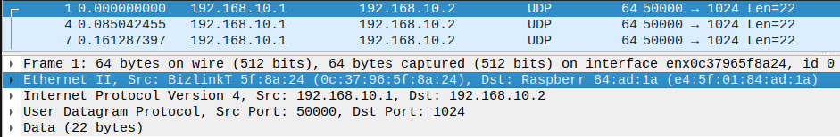
The MAC addresses of the 3 packets have the original source and destination addresses so you can tell that none of them have been swapped.

Link to directory: https://github.com/VKing15/CWM-ProgNets.git

