Exercise 1

Traffic Capture:
Task 1
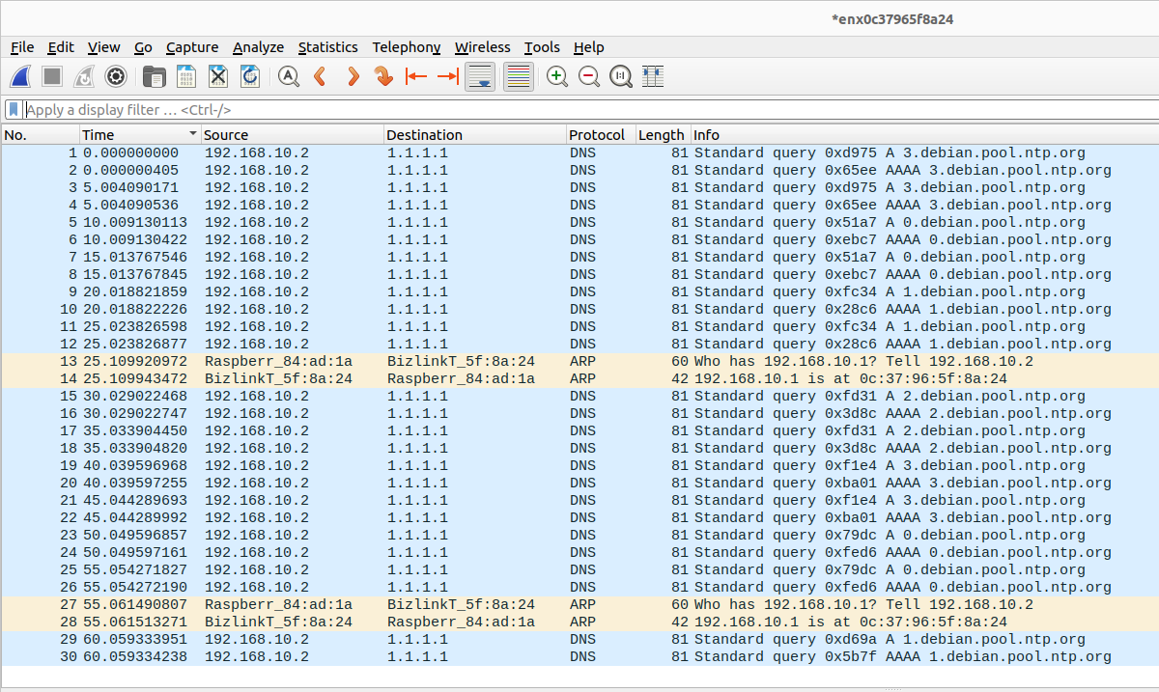
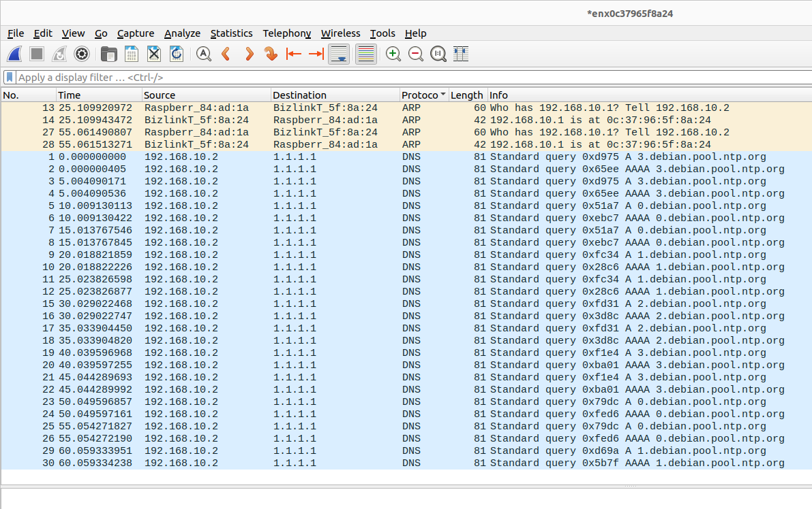
There are 2 different types of packets that are captured. Packets with an ARP protocol and packets with a DNS protocol.
The Address Resolution Protocol packets have different destinations. The ARP protocol tries to find the IP addresses of neighbouring devices when a device connects the the network.
The Domain Name System packets have the destination 1.1.1.1. The DNS protocol links IP addresses with domain names that are written with english characters rather than needing to remember the actual IP address

Task 2
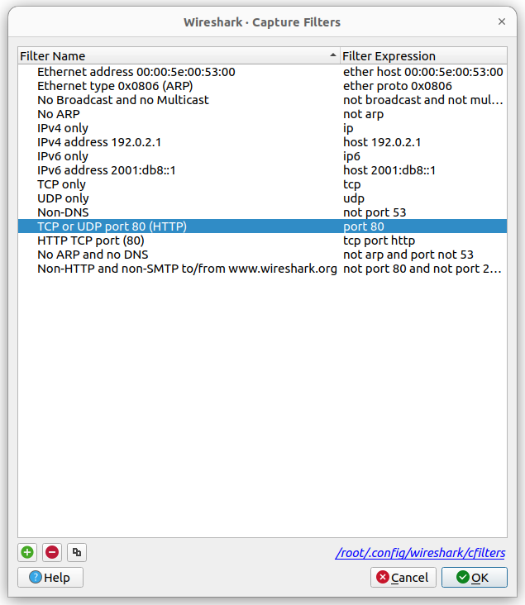

First I used the TCP or UDP port 80 capture filter so I was only left with HTTP and TCP packets.

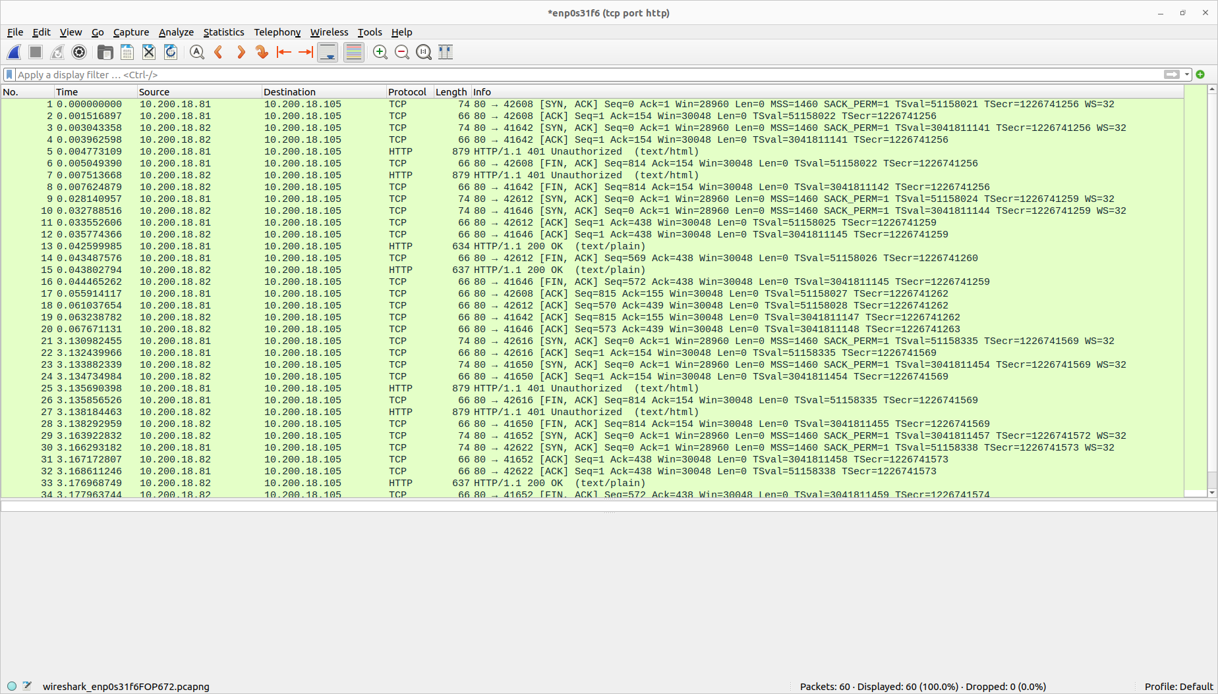

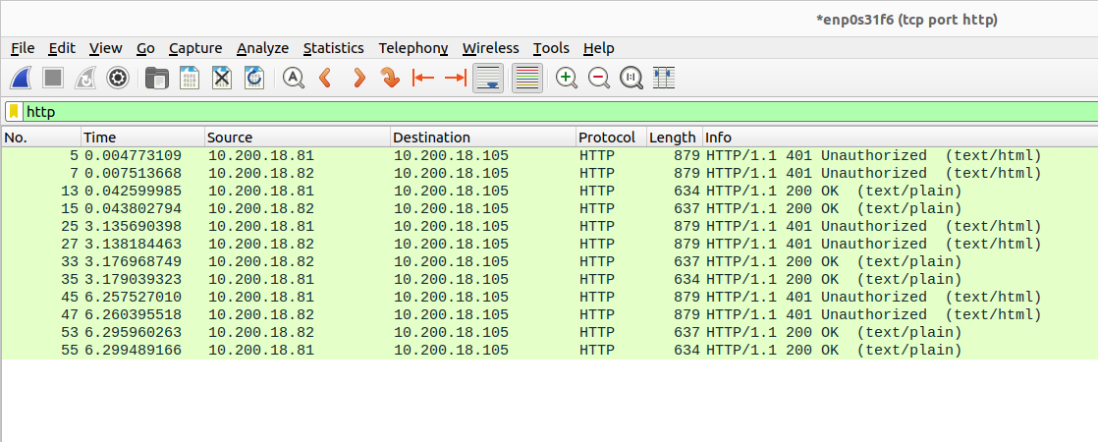
I then used the display filter to filter out the HTTP packets

Task 3
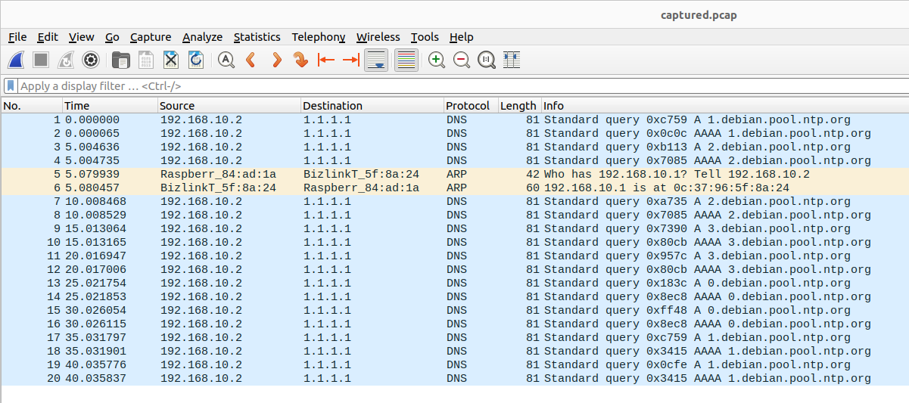
I used the tcpdump command to send 20 packets and then I opened it with wireshark to view them.

Sending traffic
Task 1

100 packets from lab machine to Raspberry PI:
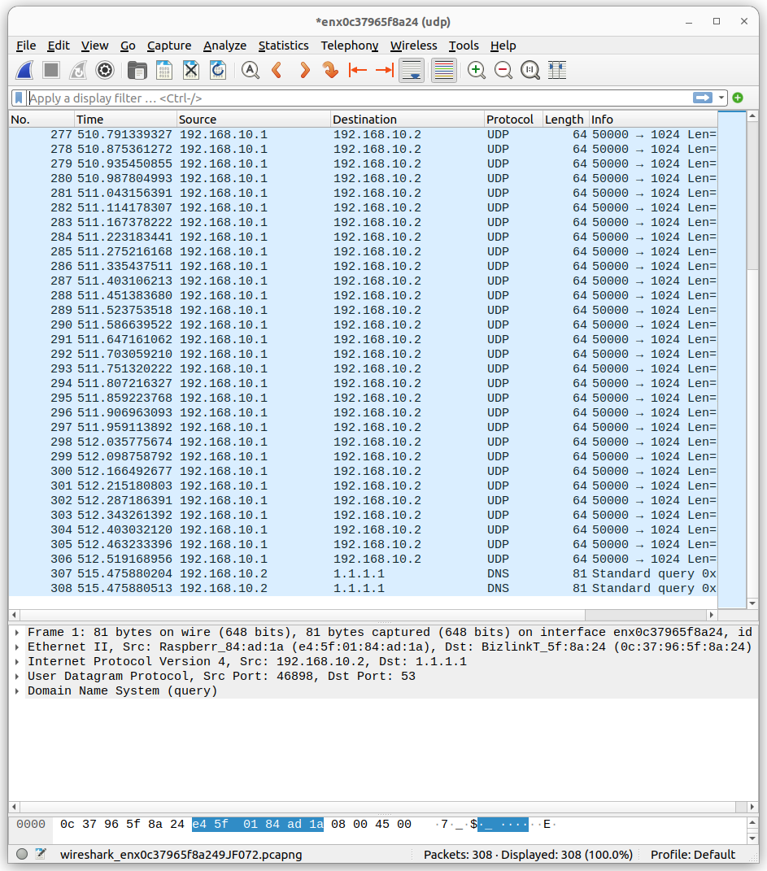

100 packets from Raspberry PI to lab machine:
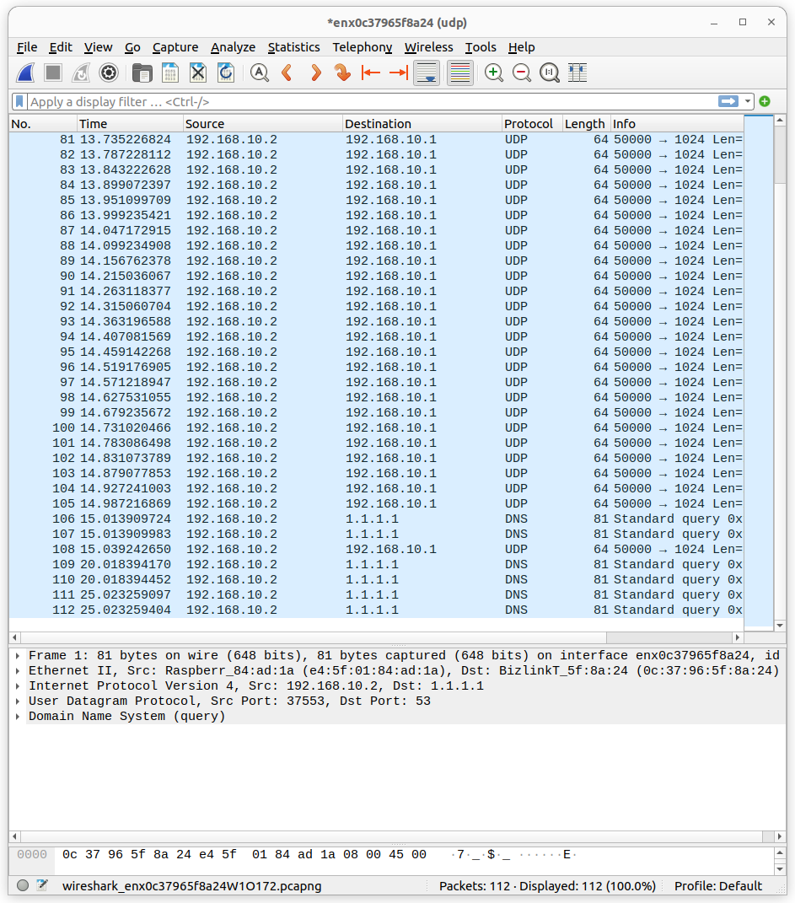

Task 2.1:

Capturing only the 100 sent packets to the lab machine from the Raspberry PI by using the filter “ether host = 00:00:00:00:00:02”:
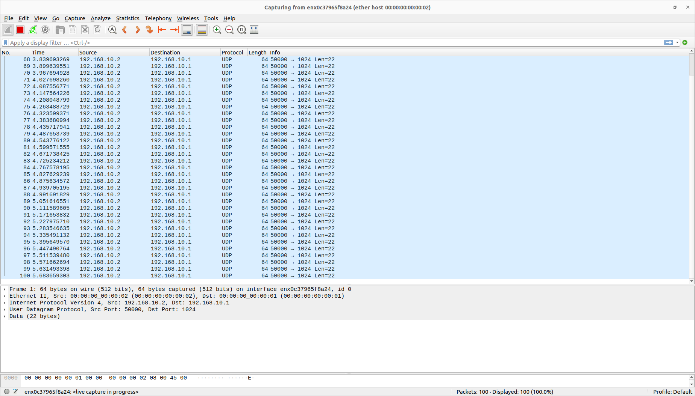

Task 2.2:

The packet size is 64 bits as seen from the length column or the frame window.

Task 2.3:

The protocol of the packet is UDP as seen from the protocol column.

Task 3:

The output from the modified send.py:
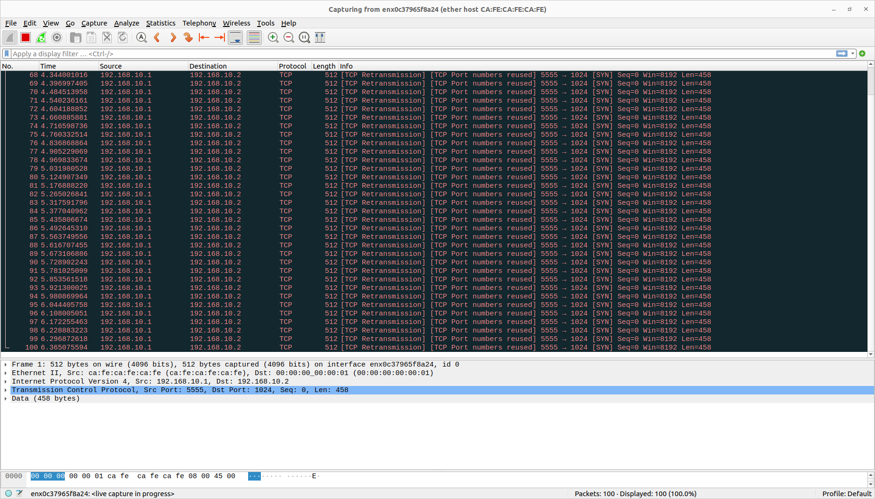

Link to repository:
https://github.com/VKing15/CWM-ProgNets.git

