Exercise 3)

Simple Measurements)

The watts used start off low but they increase while oscillating at a decreasing rate. It is a simple shape to the response of a lightly damped system to a unit step.

The power consumption on average reaches a steady state of around 4.7W but the actual readings oscillate around that average by about ±0.25W. The voltage reading is around 5.148V but sometimes increases to 5.156v and the current reading is around 0.912A but it increases to up 0.96A.

Network Activity)

1) I let the tcpdump command to run for 5 minutes by timing it on a stopwatch.

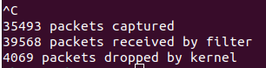

The total packets received are 39,568. The frequency of messaging on the network interface is around 7,914 events/min or 132 events/sec.

2.1) V = 5.15V, I = 1.05A, P = 5.4W (Raspberry Pi to Lab Machine)
Power drawn has increased by 14.9%

2.2) V = 5.15V, I = 0.97A, P = 5.0W (Lab Machine to Raspberry Pi)
Power drawn has increased by 6.4%

2.3) The user-generated network traffic increases the energy consumption. It is more expensive for the Raspberry Pi to send packets than receive. This is likely because it must first communicate with the Lab Machine to gather relevant information such as its address.

3)
Raspberry Pi as server:

V = 5.15V, I = 1.11A, P = 5.7W
Power drawn has increased by 21.3% in comparison to idle power.

Lab Machine as server:

V = 5.15V, I = 1.10A, P = 5.6W
Power drawn has increased by 19.1% in comparison to idle power.

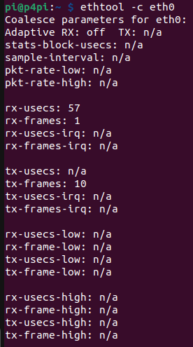

The rx-usecs is 57.

Raspberry Pi as server:

V = 5.15V, I = 1.11A, P = 5.71W
Power drawn has increased by 21.5% in comparison to idle power.

Lab Machine as server:

V = 5.15V, I = 1.10A, P = 5.65W
Power drawn has increased by 20.2% in comparison to idle power.

The power drawn has increased slightly in both cases. This is to be expected since the decrease in rx-usecs will make the packet frequency increase which means more power must be drawn.

CPU activity)

V = 5.13V, I = 1.25A, P = 6.45W

This has increased the power drawn by the Raspberry Pi by 37.2% in comparison to idle power which is much larger than the other power increases. This power increase is nearly double the other changes which is surprising since most of the changes were around 15%-20%.

Theoretical Experiments)

1)

Country chosen: Sri Lanka
Carbon intensity: 0.2 kgCO₂/kWh
Energy consumption: 30Wh = 0.03kWh

CF = CI x EC = 0.2 x 0.03 = 0.0006 kg of CO₂ = 0.6 g of CO₂

2a) Collective carbon footprint = 30,000,000,000 x 0.0006 kg of CO₂ = 18,000,000 kg of CO₂

2b) 77,800,000 kg of CO₂ is produced by London in a single day roughly. This means that this number is not significant since it is a small fraction relative to London and an even smaller fraction relative to all of Europe.

2c) This is not a fair estimate since many things connected to the internet are much more energy consumptive than a Raspberry Pi so this is a gross underestimate.

Link to directory:
https://github.com/VKing15/CWM-ProgNets.git

